First understand: What is Jinja2?
Suppose you want both Ubuntu servers to have a file called:
server-info.txt
But you want the content to be different.
For example:

ansibleclient1
Server Name: ansibleclient1
IP Address: 10.0.1.10
Operating System: Ubuntu

ansibleclient2
Server Name: ansibleclient2
IP Address: 10.0.2.10
Operating System: Ubuntu
Instead of manually creating two files, we create one template:
server-info.j2
and Ansible fills in the values automatically.
That's the purpose of Jinja2 templates.

Practical 87 — Introduction to Jinja2 Templating

Step 1: Make sure Ansible works
On CentOS:
ansible dev -m ping
You should get:
ansibleclient1 | SUCCESS
ansibleclient2 | SUCCESS

Step 2: Create a project directory
On CentOS:
mkdir -p ~/ansible-jinja
Go inside:
cd ~/ansible-jinja
Check:
pwd
You should see something like:
/home/ansible/ansible-jinja
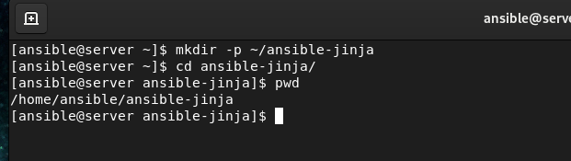

Step 3: Create a Jinja2 template
Create:
vi server-info.j2
Put:
Server Name: {{ ansible_hostname }}
Operating System: {{ ansible_distribution }}
IP Address: {{ ansible_default_ipv4.address }}
Save:
ESC
:wq
Enter

What are these {{ }}?
This is the important part.
{{ ansible_hostname }}
means:
Insert the hostname of the remote server here.
And:
{{ ansible_distribution }}
means:
Insert the operating system distribution.
And:
{{ ansible_default_ipv4.address }}
means:
Insert the server's default IPv4 address.
These values come from Ansible Facts.
We'll learn facts properly in Practical 90.

Step 4: Create a Playbook
Create:
vi template.yml
Put:
---
- name: Create server information file
hosts: dev
become: yes

tasks:

- name: Create server info file
template:
src: server-info.j2
dest: /tmp/server-info.txt
Save:
ESC
:wq
Enter

Step 5: Run the playbook
ansible-playbook template.yml
You should see:
PLAY [Create server information file]

TASK [Create server info file]
changed: [ansibleclient1]
changed: [ansibleclient2]

PLAY RECAP
ansibleclient1 : changed=1
ansibleclient2 : changed=1

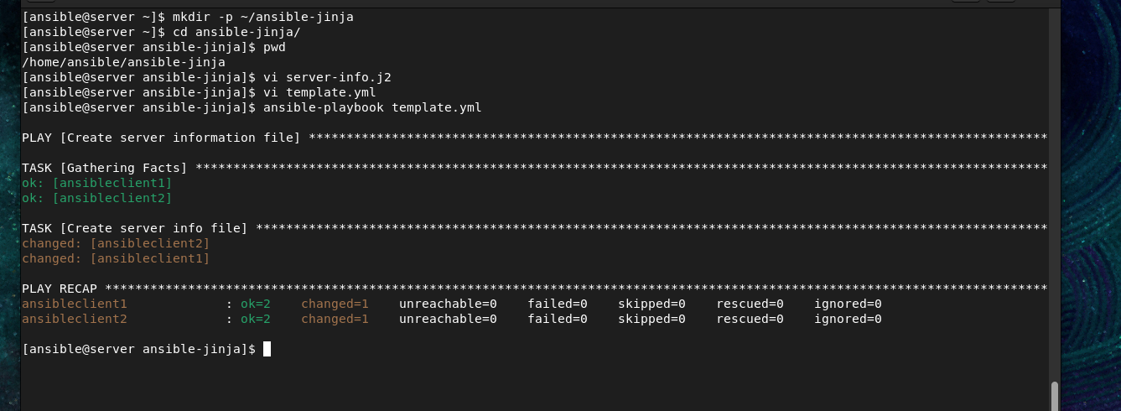

Step 6: Check the result
Run:
ansible dev -m command -a "cat /tmp/server-info.txt"
You should get different information from each server.
For example:
ansibleclient1 | CHANGED | rc=0 >>
Server Name: ansibleclient1
Operating System: Ubuntu
IP Address: 10.0.1.10
and:
ansibleclient2 | CHANGED | rc=0 >>
Server Name: ansibleclient2
Operating System: Ubuntu
IP Address: 10.0.2.10
This is the basic idea of Jinja2.

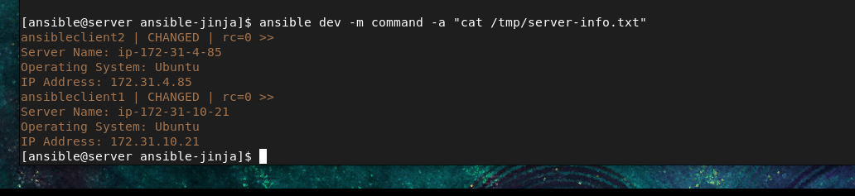

Practical 88 — Control Structures with Loops and Variables
Now we learn variables and loops.
Instead of writing the same thing repeatedly, we can use a variable.

Step 7: Create a variable playbook
vi variables.yml
Put:
---
- name: Variables example
hosts: dev

vars:
company: ABC Technologies
department: IT

tasks:

- name: Display company
debug:
msg: "Company is {{ company }}"

- name: Display department
debug:
msg: "Department is {{ department }}"
Save and run:
ansible-playbook variables.yml
You should see:
Company is ABC Technologies
Department is IT

Step 8: Create a loop
Create:
vi loop.yml
Put:
---
- name: Loop example
hosts: dev

tasks:

- name: Create multiple directories
file:
path: "/tmp/{{ item }}"
state: directory
loop:
- app
- database
- logs
Run:
ansible-playbook loop.yml
Ansible will create:
/tmp/app
/tmp/database
/tmp/logs

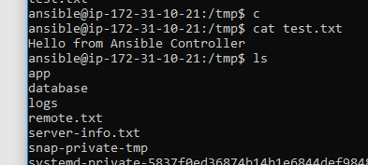
on both Ubuntu servers.
Verify:
ansible dev -m shell -a "ls -ld /tmp/app /tmp/database /tmp/logs"

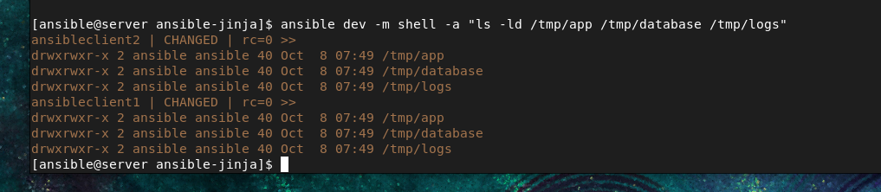

Practical 89 — Hands-On Control Structures
Now let's combine variables + loop + Jinja2.
Create:
vi control.yml
Put:
---
- name: Control structure practical
hosts: dev
become: yes

vars:
users:
- raj
- rohan
- amit

tasks:

- name: Create users
user:
name: "{{ item }}"
state: present
loop: "{{ users }}"
Run:
ansible-playbook control.yml
This creates:
raj
rohan
amit
on both AWS Ubuntu servers.
Verify:
ansible dev -m shell -a "id raj"

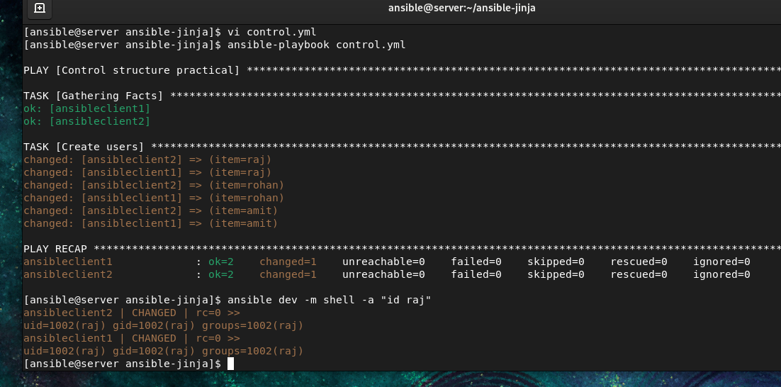

Practical 90 — Using Ansible Facts in Jinja2
This is very important.
Ansible automatically collects information about the remote server.
These are called facts.
For example:
Hostname
Operating System
IP address
CPU
Memory
Architecture
Kernel

Step 9: See all facts
Run:
ansible ansibleclient1 -m setup
This produces a lot of information.
You can search for hostname:
ansible ansibleclient1 -m setup -a "filter=ansible_hostname"
You might get:
"ansible_hostname": "ansibleclient1"
Check OS:
ansible ansibleclient1 -m setup -a "filter=ansible_distribution"
Check IP:
ansible ansibleclient1 -m setup -a "filter=ansible_default_ipv4"

Step 10: Use facts in a template
Create:
vi facts.j2
Put:
Server Information
==================

Hostname: {{ ansible_hostname }}
OS: {{ ansible_distribution }}
OS Version: {{ ansible_distribution_version }}
Architecture: {{ ansible_architecture }}
IP Address: {{ ansible_default_ipv4.address }}
Kernel: {{ ansible_kernel }}
Create playbook:
vi facts.yml
Put:
---
- name: Create server facts file
hosts: dev
become: yes

tasks:

- name: Generate facts file
template:
src: facts.j2
dest: /tmp/facts.txt
Run:
ansible-playbook facts.yml
Verify:
ansible dev -m command -a "cat /tmp/facts.txt"
Now each server automatically gets its own information.
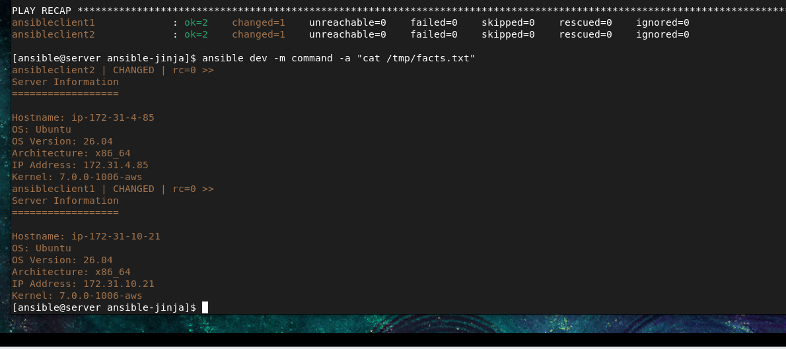

Practical 91 — Guided Exercise 1
Let's make a practical project.

Objective
Create a web-server information file automatically.
Create:
vi webserver.j2
Put:
Web Server Information
======================

Hostname: {{ ansible_hostname }}
IP Address: {{ ansible_default_ipv4.address }}
Operating System: {{ ansible_distribution }}
Version: {{ ansible_distribution_version }}
Architecture: {{ ansible_architecture }}
Create:
vi webserver.yml
Put:
---
- name: Generate Web Server Information
hosts: dev
become: yes

tasks:

- name: Create web server information file
template:
src: webserver.j2
dest: /tmp/webserver-info.txt
Run:
ansible-playbook webserver.yml
Check:
ansible dev -m command -a "cat /tmp/webserver-info.txt"

Practical 92 — Guided Exercise 2
Now let's use a variable inside a template.
Create:
vi company.j2
Put:
Company Information
===================

Company Name: {{ company }}
Department: {{ department }}
Server: {{ ansible_hostname }}
IP Address: {{ ansible_default_ipv4.address }}
Create:
vi company.yml
Put:
---
- name: Company information
hosts: dev
become: yes

vars:
company: ABC Technologies
department: Cloud Computing

tasks:

- name: Create company information
template:
src: company.j2
dest: /tmp/company-info.txt
Run:
ansible-playbook company.yml
Verify:
ansible dev -m command -a "cat /tmp/company-info.txt"

Practical 93 — Guided Exercise 3
Now let's combine:
Variables
+
Loops
+
Facts
+
Jinja2
Create:
vi final.j2
Put:
Server Report
============

Server Name: {{ ansible_hostname }}
IP Address: {{ ansible_default_ipv4.address }}
Operating System: {{ ansible_distribution }}

Installed Applications:
{% for app in applications %}
- {{ app }}
{% endfor %}
Notice this:
{% for app in applications %}
This is a Jinja2 loop.
And:
{% endfor %}
ends the loop.

Create the playbook:
vi final.yml
Put:
---
- name: Final Jinja2 practical
hosts: dev
become: yes

vars:
applications:
- Apache
- MySQL
- Docker
- Ansible

tasks:

- name: Generate server report
template:
src: final.j2
dest: /tmp/server-report.txt
Run:
ansible-playbook final.yml
Check:
ansible dev -m command -a "cat /tmp/server-report.txt"
You should see something like:
Server Report
============

Server Name: ansibleclient1
IP Address: 10.0.1.10
Operating System: Ubuntu

Installed Applications:
- Apache
- MySQL
- Docker
- Ansible
The second server will automatically show its own hostname and IP.

