1. What is AMI?
AMI = Amazon Machine Image
An AMI is a template of an EC2 instance.
If you create an AMI from an EC2 that already has:
- Amazon Linux
- Apache
- Website files
- Apache configuration
then you can use that AMI to launch another EC2 with that setup.

Project: EC2 → User Data Website → AMI → New EC2
Step 1: Create the first EC2
Go to:
AWS Console → EC2 → Instances → Launch instance
Choose:
Name:
WebServer-1
AMI
Select an Amazon Linux AMI.
For example:
Amazon Linux 2023
Instance type
For a practice project, choose an eligible small instance type available in your account/region.
Key pair
Select your existing key pair or create a new one.
Security Group
Create/select a security group and allow:
SSH TCP 22
HTTP TCP 80
For SSH, ideally allow port 22 only from your own IP.
For HTTP:
Port: 80
Source: 0.0.0.0/0
This allows people to access your website over HTTP.

Step 2: Add User Data
While creating the EC2, open:
Advanced details → User data
Put this script:
#!/bin/bash

dnf install -y httpd

systemctl enable httpd
systemctl start httpd

cat > /var/www/html/index.html <<'EOF'
<!DOCTYPE html>
<html>
<head>
<title>My AMI Website</title>
</head>
<body>
<h1>Hello from WebServer-1</h1>
<p>This website was created using EC2 User Data.</p>
</body>
</html>
EOF
Then click:
Launch instance

Step 3: What happens automatically?
When EC2 starts, the User Data script runs.
It performs:
dnf install httpd
↓
Apache installed
↓
systemctl enable httpd
↓
Apache starts automatically
↓
Create /var/www/html/index.html
↓
Website ready
You don't have to manually SSH into the server to install Apache.

Step 4: Test the website
Wait until the EC2 status checks are successful.
Copy the Public IPv4 address.
For example:
13.234.xx.xx
Open your browser:
http://13.234.xx.xx
You should see:
Hello from WebServer-1

This website was created using EC2 User Data.
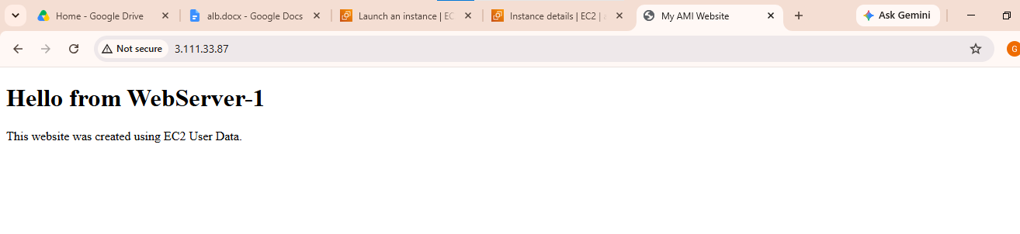

Step 5: Create an AMI from WebServer-1
Now we have a working EC2:
WebServer-1
│
├── Amazon Linux
├── Apache
├── Website
└── Configuration
Go to:
EC2 → Instances

Select:
WebServer-1
Then:
Actions → Image and templates → Create image
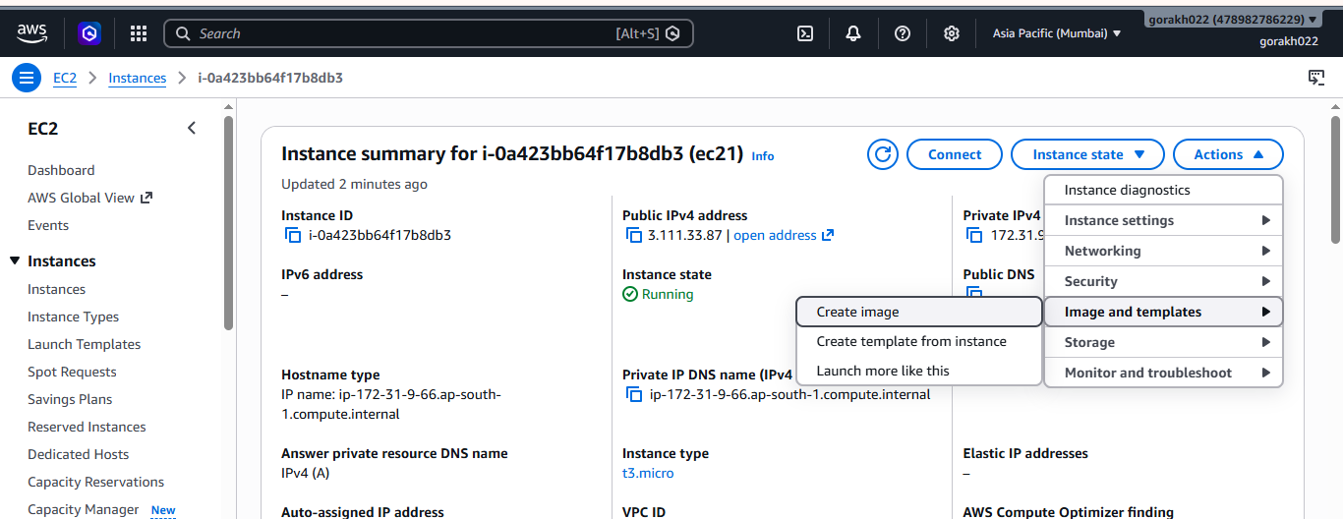
Enter:
Image name:
my-webserver-ami
Description:
AMI containing Apache and website
Then click:
Create image
AWS will create the AMI.

Step 6: Check your AMI
Go to:
EC2 → AMIs
Select:
Owned by me
You should see:
Name State
--------------------------------
my-webserver-ami Available
Wait until the state becomes:
Available
Now your AMI is ready.
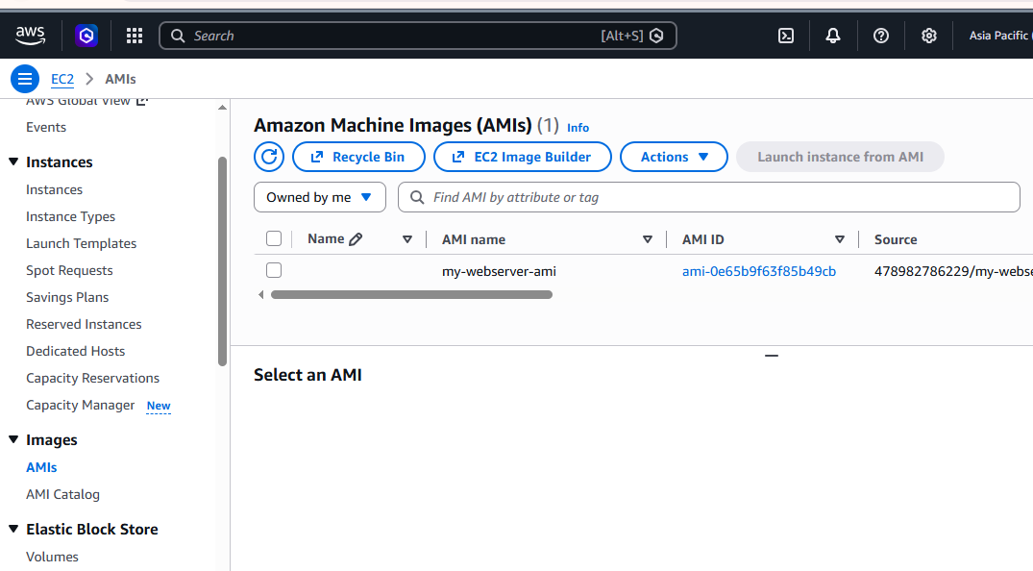

Step 7: Launch a new EC2 using your AMI
Go to:
EC2 → AMIs → Owned by me
Select:
my-webserver-ami
Click:
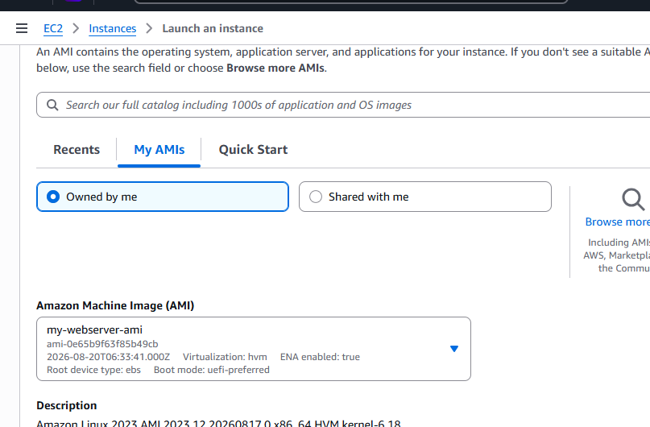
Launch instance from AMI
Give the new server a name:
WebServer-2
Choose your instance type.
Choose your key pair.
Security group
Use a security group that allows:
SSH 22
HTTP 80
Then launch the instance.
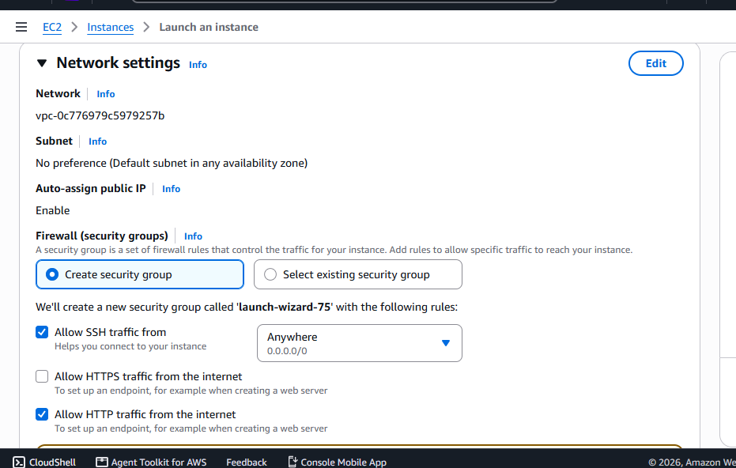

Step 8: Test WebServer-2
After the new EC2 starts, copy its new Public IPv4 address.
For example:
WebServer-1
13.234.10.20

WebServer-2
13.234.20.30
Open:
http://13.234.20.30
You should see the same website:
Hello from WebServer-1

This website was created using EC2 User Data.

