1)What it EBS
Amazon EBS is a cloud storage service that provides block-level storage volumes for use with virtual machines (EC2 instances) in AWS.
Think of it like a virtual hard drive in the cloud.

Key features
- Persistent storage
Data is saved even if your server (EC2 instance) is stopped or restarted.
- Attachable volumes
You can attach EBS volumes to Amazon EC2 instances just like attaching a disk to a computer.
- High performance
Suitable for databases, applications, and file systems.
- Scalable
You can increase size or performance as needed.
- Snapshots (backups)
Easily create backups stored in Amazon S3.

Example
If you run a website on an EC2 server:
- The server = computer (CPU + RAM)
- EBS = hard drive (stores files, database, OS)

You can attach multiple EBS to one ec2 but cant attach 1 EBS to another ec2 at a same time.

2) Delete on Termination means:
When you delete (terminate) an EC2 instance, the attached EBS volume will also be automatically deleted.

3)HOW TO CREATE THE EXTRA EBS AND ATTACH TO EC2 :-
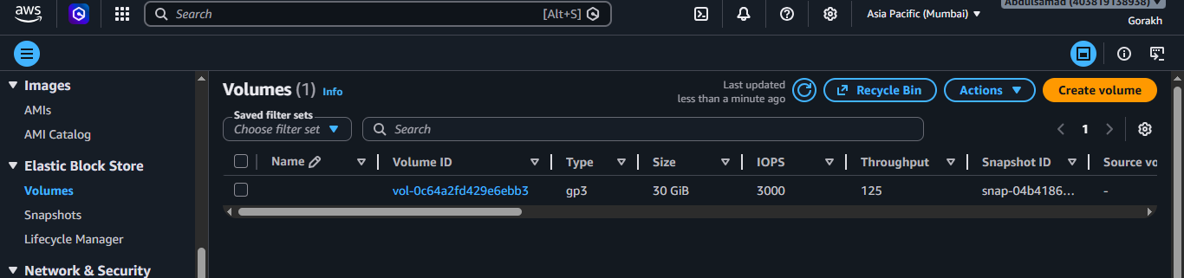
GO TO EC2-EBS- VOLUME CAN CREATE NEW VOLUME
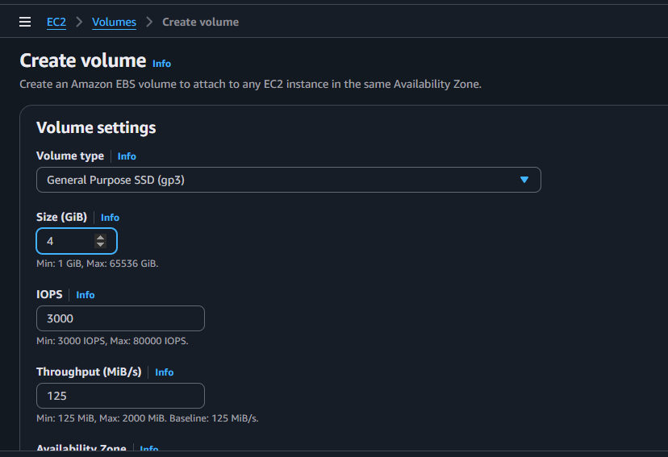
GIVE VOLUME EXAMPLE LIKE TYPE ..ETC AND CREATE VOLUME
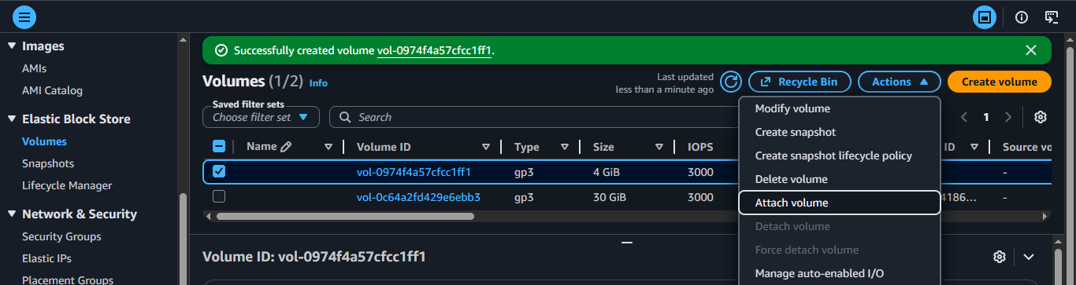
NOW CLICK ON THE VOLUME-ACTIONS-CLICK ON ATTACH VOLUME TO EC2
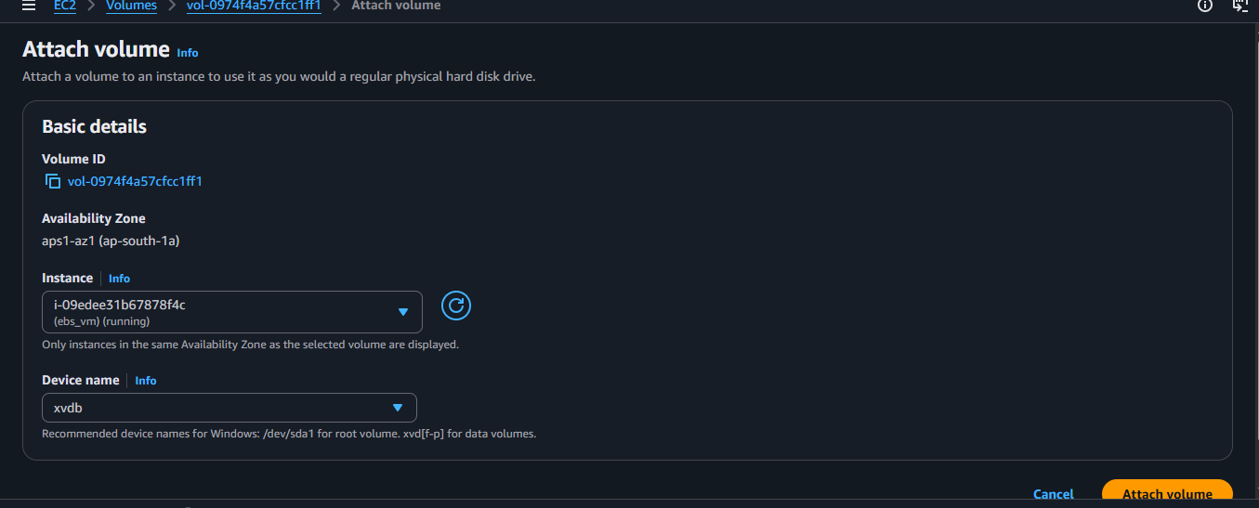
ATTACH VOLUME

4) Steps to Create Partition in Windows EC2 (after attaching EBS)

1. Open Disk Management
Inside your Windows EC2:
- Press Windows + R
- Type: diskmgmt.msc
- Press Enter
This opens Disk Management.
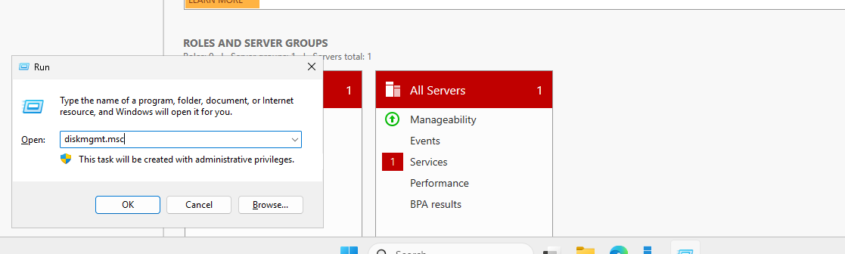

2. Find the New EBS Disk
You will see a disk like:
- “Disk 1”
- “Unknown”
- “Not Initialized”

3. Initialize the Disk (Important First Step)
If it shows “Not Initialized”:
- Right-click on the disk (left side where it says Disk 1)
- Click Initialize Disk
- Choose:
  - GPT (recommended) for modern systems
- Click OK
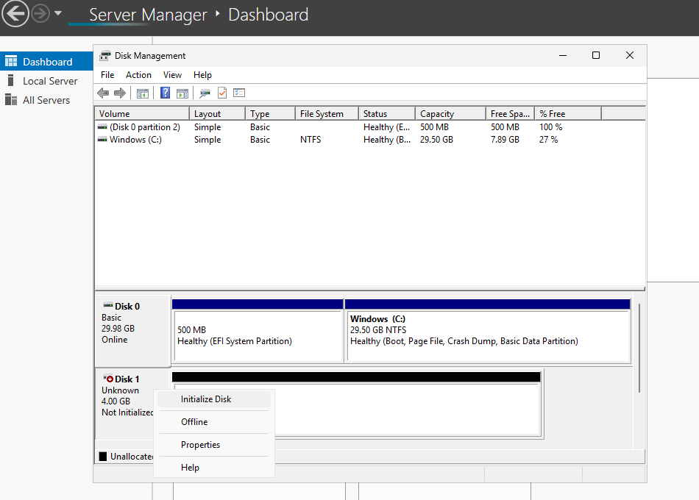

4. Create New Volume (Partition)
Now:
- Right-click on Unallocated Space
- Click New Simple Volume
- Click Next
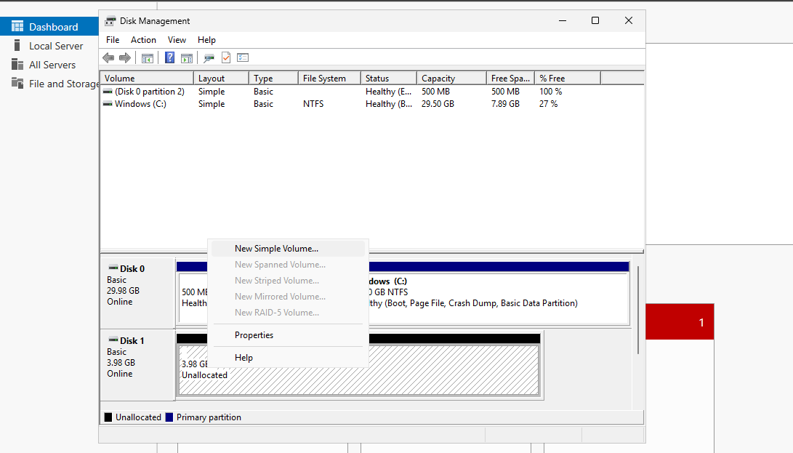

5. Set Partition Size
- Choose size (or keep full size)
- Click Next

6. Assign Drive Letter
- Example: E:, F:, G:
- Click Next

7. Format the Partition
Choose:
- File system: NTFS
- Allocation unit: Default
- Volume label: (example: DATA)
✔ Check: Quick Format
Click Finish
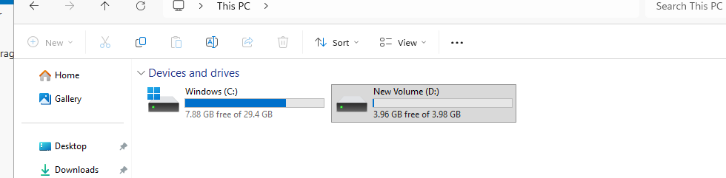

5) Types of Amazon EBS volumes (AWS)
Amazon EBS (Elastic Block Store) is used with Amazon EC2 instances.

1️)gp3 – General Purpose SSD (Recommended)
- Balanced performance + cost
- Default choice for most workloads
- You can independently set IOPS and throughput
Use cases:
Web servers, application servers, small/medium databases

2️)gp2 – General Purpose SSD (Older)
- Performance depends on volume size
- Being replaced by gp3
Use cases:
Legacy systems

3️) io1 / io2 – Provisioned IOPS SSD
- Very high and consistent IOPS
- Designed for mission-critical workloads
Use cases:
Large databases (Oracle, MySQL, SQL Server)

4️) st1 – Throughput Optimized HDD
- Optimized for high throughput
- Not good for random access
Use cases:
Big data, log processing, data warehouses

5️)sc1 – Cold HDD
- Lowest cost
- Lowest performance
Use cases:
Archive data, infrequently accessed data

6)What is IOPS?
IOPS (Input/Output Operations Per Second)
Number of read/write operations a disk can perform per second.

Simple example
- Database reading many small records = High IOPS needed
- 10,000 small reads/sec = 10,000 IOPS

SSD vs HDD
- SSD → High IOPS
- HDD → Low IOPS

7)What is Throughput?
Throughput = Amount of data transferred per second
Measured in MB/s or GB/s

Simple example
- Copying a large video file = High throughput needed
- Streaming logs or backups = throughput-focused

8) What is AMI in AWS EC2?
AMI stands for Amazon Machine Image.
An AMI is a template that contains:
- Operating System (Linux / Windows)
- Installed software & packages
- Configuration settings
- Application code (if any)
It is used to launch EC2 instances in Amazon Web Services.
👉 Think of an AMI like a snapshot of a fully configured server.

Why AMI is used?
- To create identical EC2 instances
- For backup & recovery
- For scaling (Auto Scaling)
- To save time (no need to install OS/software again)

Relationship between EC2 and AMI
- AMI → blueprint (image)
- EC2 instance → running server created from that image
Every EC2 instance must start from an AMI.

Types of AMIs
- AWS Provided AMI – Amazon Linux, Ubuntu, Windows
- Marketplace AMI – Pre-installed software (paid/free)
- Custom AMI – Created by you
- Community AMI – Shared by others

How to Create an AMI from an EC2 Instance

Step-by-step (AWS Console)
- Go to Amazon EC2 Dashboard
- Click Instances
- Select your running EC2 instance
- Click Actions → Image and templates → Create image
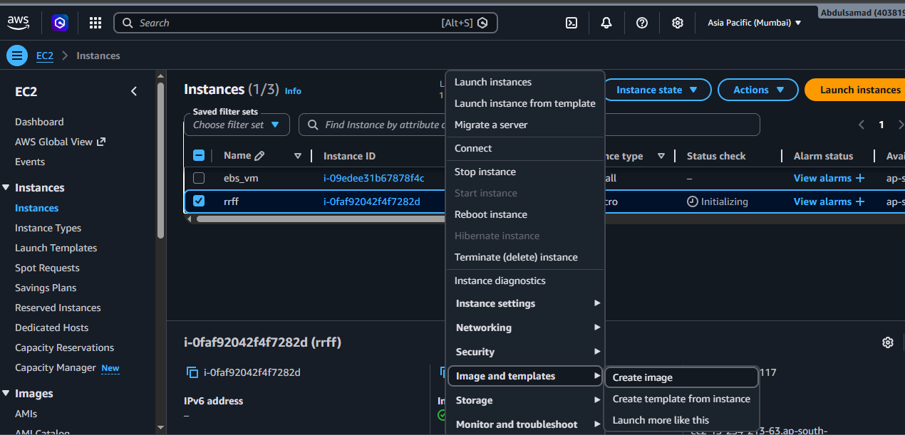
- Enter:
  - Image name
  - Description (optional)
- Click Create image
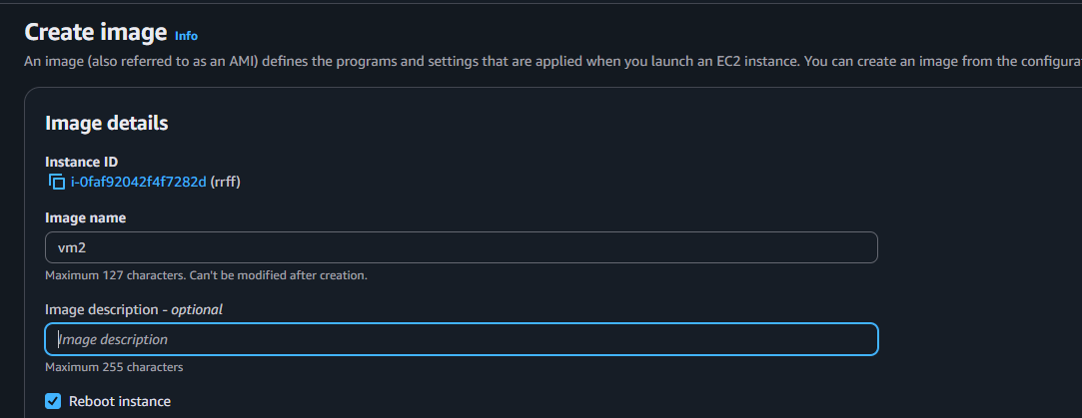
✅ AWS will:
- Take snapshots of attached EBS volumes
- Create an AMI
- Store it under AMIs
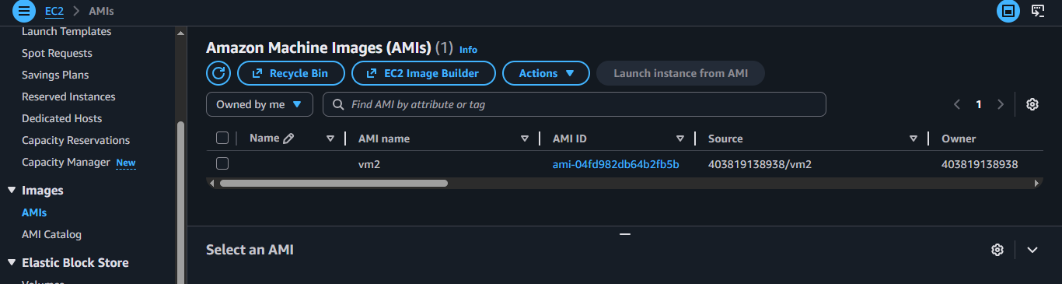

Where to find your AMI?
- EC2 Dashboard → AMIs
- Filter: Owned by me

How to Use an AMI to Create a New EC2 Instance

Steps:
- Go to EC2 → AMIs
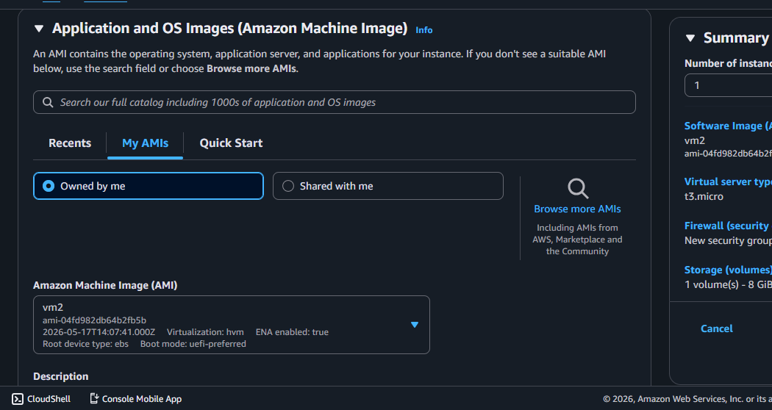
- Select your AMI
- Click Launch instance from AMI
- Choose:
  - Instance type (t2.micro, t3.micro, etc.)
  - Key pair
  - Security group
- Click Launch
