An EBS snapshot is a point-in-time backup of an Amazon Elastic Block Store volume in Amazon Web Services. It’s commonly used in Amazon Web Services to back up disks attached to EC2 instances.
You can think of it like this:
- EBS Volume = virtual hard drive
- Snapshot = saved image/backup of that hard drive at a specific moment

Important concept: block-level backup
Snapshots do not copy files individually.
They work at the block storage level.
If even a small part of a block changes, that block is saved again in the next snapshot.

Snapshot creation process
Typical flow:
EC2 Instance
↓
EBS Volume
↓
Create Snapshot
↓
AWS stores changed blocks in S3

Crash-consistent snapshots
Snapshots are usually crash-consistent, meaning:
- similar to unplugging a server suddenly
- filesystem state is preserved
- but in-memory data may not be flushed
For databases, best practice is:
- pause writes
- flush buffers
- or use application-consistent backup methods

Restoring from a snapshot
You can create:
- a new EBS volume
- attach it to an EC2 instance
- recover data
Flow:
Snapshot
↓
Create New EBS Volume
↓
Attach to EC2

Lazy loading behavior
When restoring a volume from snapshot:
- AWS does not immediately load all data blocks
- blocks are fetched on demand when accessed
This is called lazy loading.
To improve performance:
- use Fast Snapshot Restore (FSR)
- or pre-warm the volume

Key features
Encryption
Snapshots inherit encryption settings from encrypted volumes.
Cross-region copy
You can copy snapshots across AWS regions.
Sharing
Snapshots can be shared with other AWS accounts.

CREATE ONE EC2 INSTANCE:-
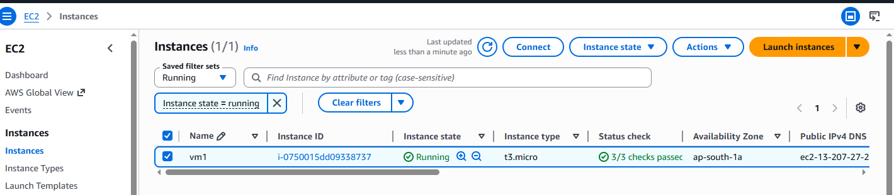
CREATE ANOTHER EBS AND ATTACH TO FIRST EC2 INSTANCE:
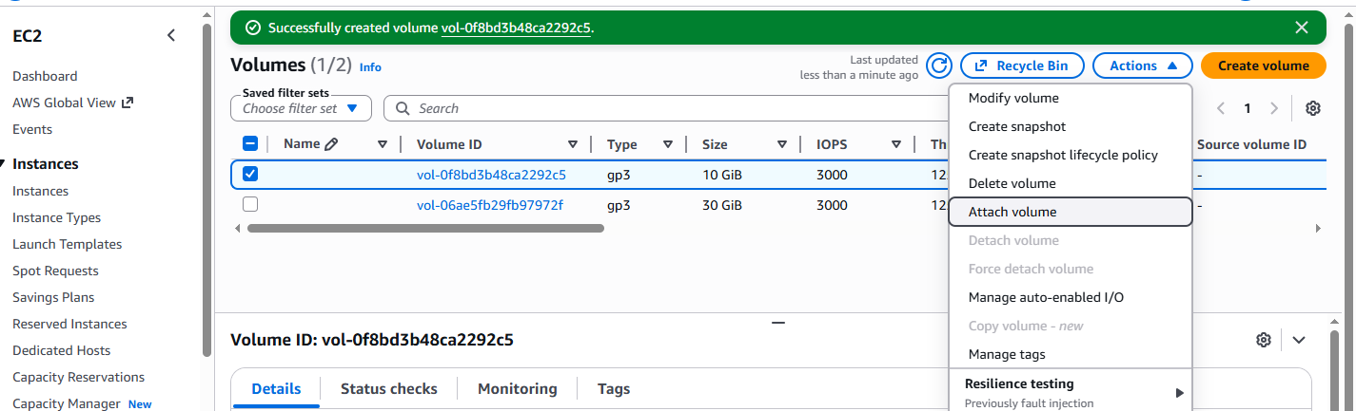
THEN CREATE NEW SIMPLE VOLUME IN EC2 INSTANCE TO USE NEW EBS
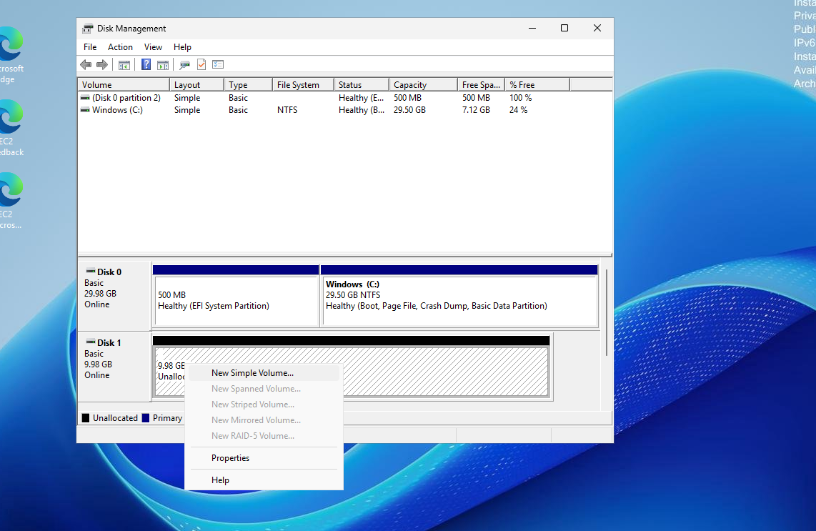
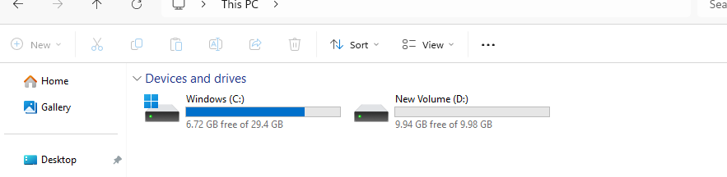

AFTER THAT CREATE ONE FILE AND STORE IN NEW VOLUME
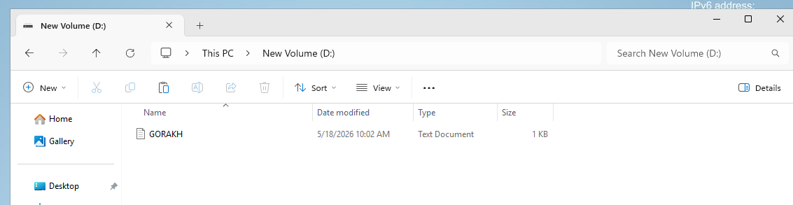

NOW WE CREATE THE SNAPSHOT OF THIS EBS AND ATTACH THAT SNAPSHOT’S VOLUME TO ANOTHER EC2.

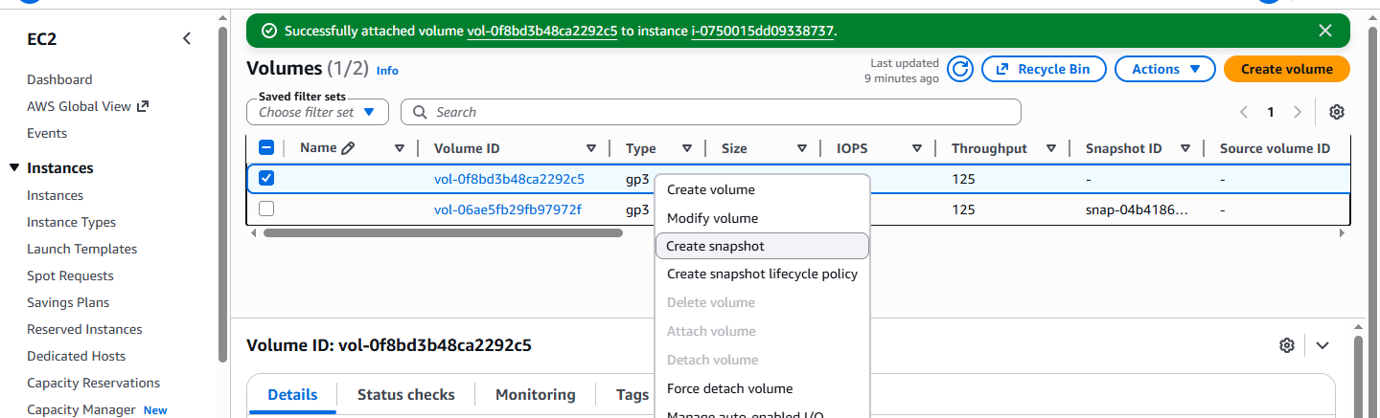
SELECT THE EBS AND RIGHT CLICK AND CREATE SNAPSHOT-
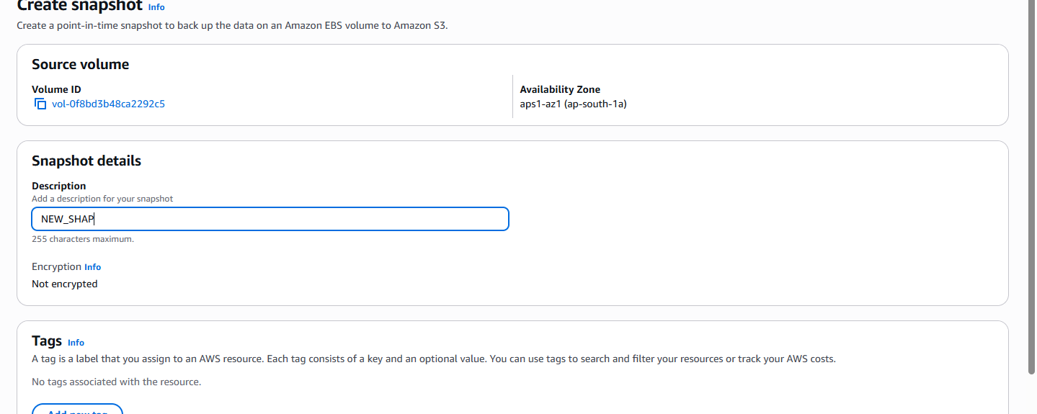
NOW GO TO SHAPSHOT AND CREATE NEW VOLUME FROM THE SNAPSHOT
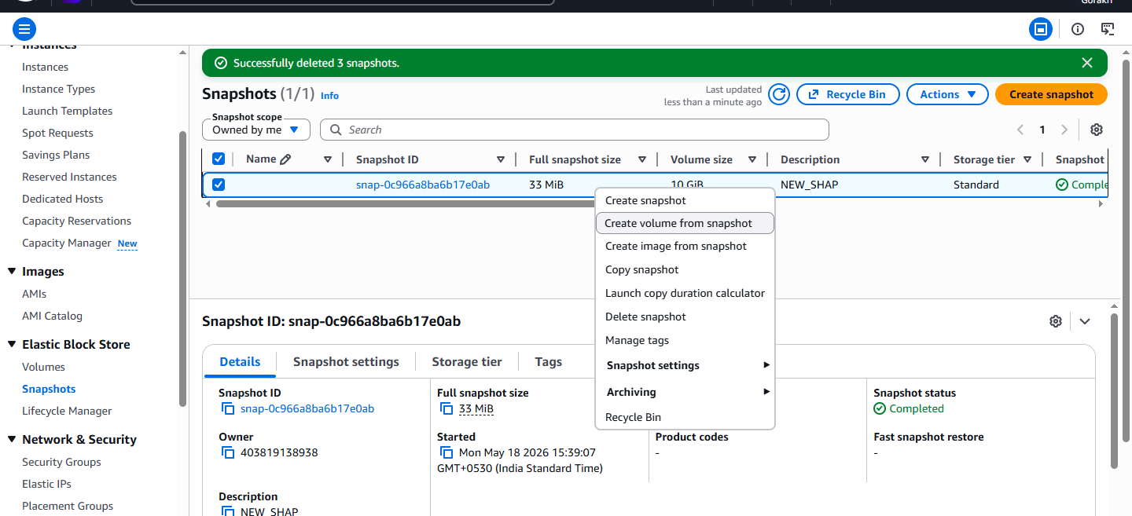

CREATE NEW VM AND ATTACH THIS NEW CREATED VOLUME TO NEW EC2 AND CHECK THAT YOUR PRIVIOUS DATA IS HERE OR NOT.
