- What is IAM in AWS?
IAM (Identity and Access Management) is an AWS service that lets you:
- Create users
- Create groups
- Assign permissions
- Control who can access what in AWS
Official service:
AWS IAM (Identity and Access Management)

Key IAM Facts (Exam Important)
Feature | Explanation
Global Service | IAM is GLOBAL (not region-based)
Cost | Free
Root User | Do NOT use root user for daily work
Users | Individual identities
Groups | Collection of users
Roles | Temporary access
Policies | Permissions (JSON)
MFA | Extra security

“Root Cannot be used and shared”
- IAM users should NOT be shared
- One user = One person
- Use groups & roles instead

Authentication vs Authorization in AWS

Authentication (WHO are you?)
Authentication means verifying your identity.
In AWS, authentication checks:
- Username & password
- Access key & secret key
- MFA code
AWS first confirms who you are.

Examples
- Logging into AWS Console with IAM user
- Using Access Key + Secret Key with AWS CLI

Authorization (WHAT can you do?)
Authorization means what actions are allowed after login.
It checks:
- Policies
- Permissions
- Allowed services & actions
AWS decides what you can access.

Examples
- Can you create EC2?
- Can you delete S3 bucket?

Easy Difference
Term | Meaning
Authentication | Who are you?
Authorization | What can you do?
Authentication first | Authorization second
IAM user login | IAM policy permission

IAM Core Components
1️. IAM User
An identity for one person
2️. IAM Group
A collection of users with same permissions
3️. IAM policy
Defines what actions are allowed/denied

PRACTICAL 1: Create IAM User with Full Access
Step-by-Step
- Login as Root user
- Go to IAM → Users → Create user
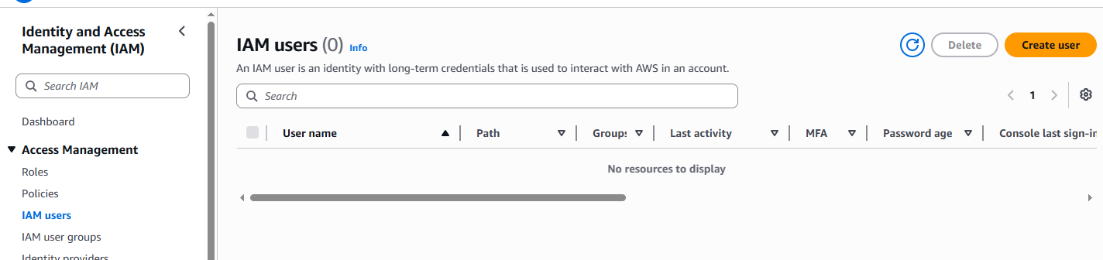
- Username: aws-admin
- Select:
  - AWS Management Console access
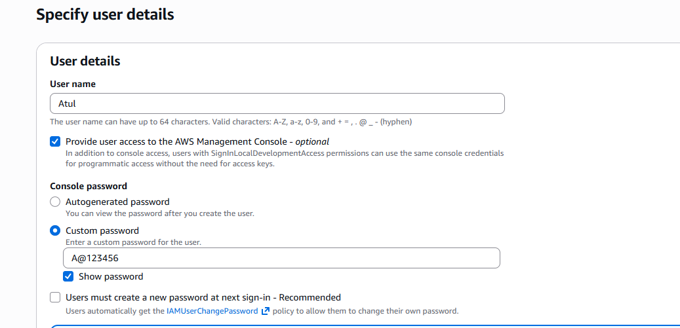

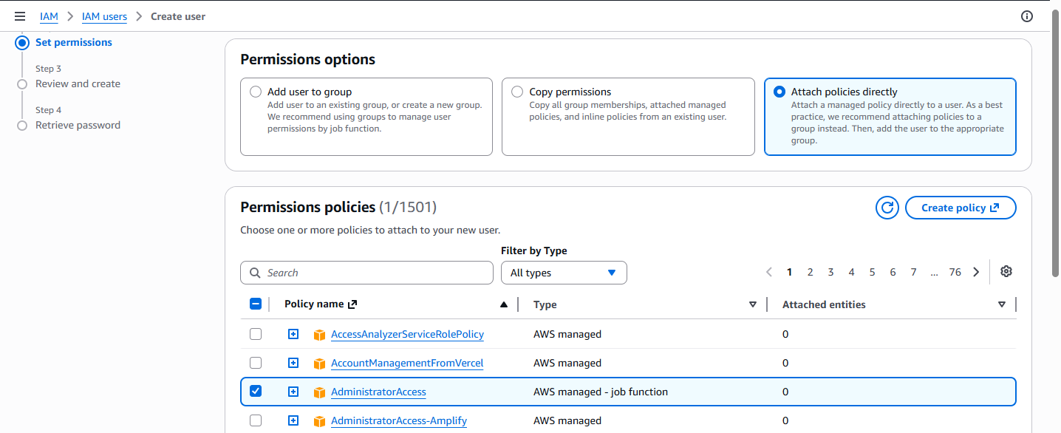
- Create user
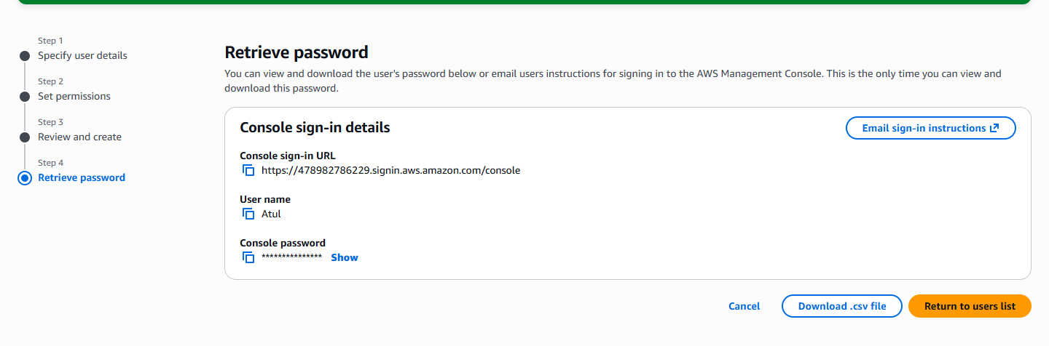
Download the user file.
Result: User can do ALL AWS practicals
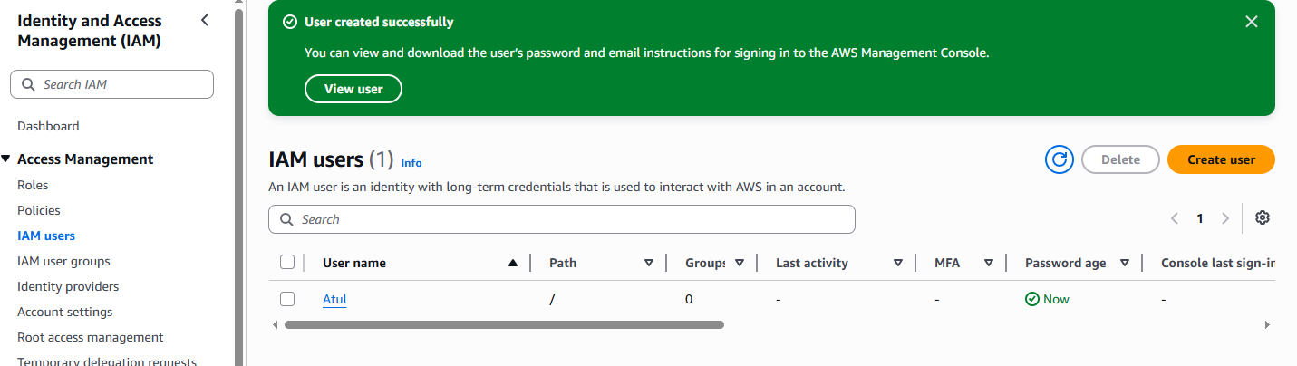

PRACTICAL 2: Create Group & Add User
Step-by-Step
- IAM → User groups → Create group
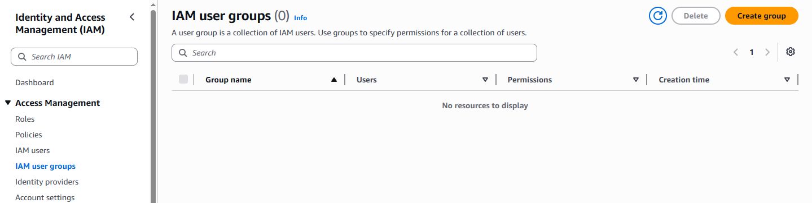
- Group name: Admins
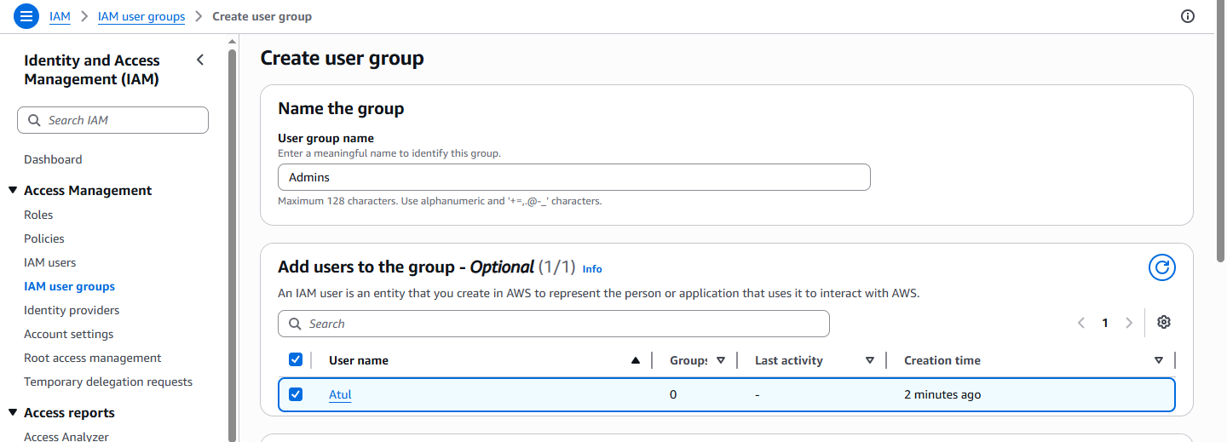
3. Add user to group.
4. Attach policy:
  - AdministratorAccess
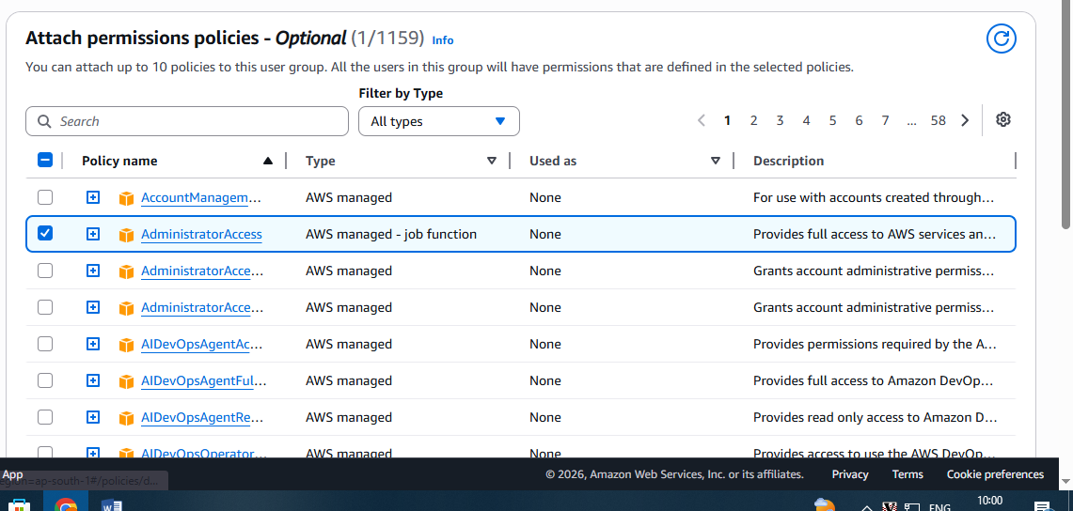
5. Create group
Best Practice: Permissions go to GROUP, not user

PRACTICAL 3: Create Limited User (S3 Only)
Create Group
- IAM → Groups → Create group
- Name: S3-Users
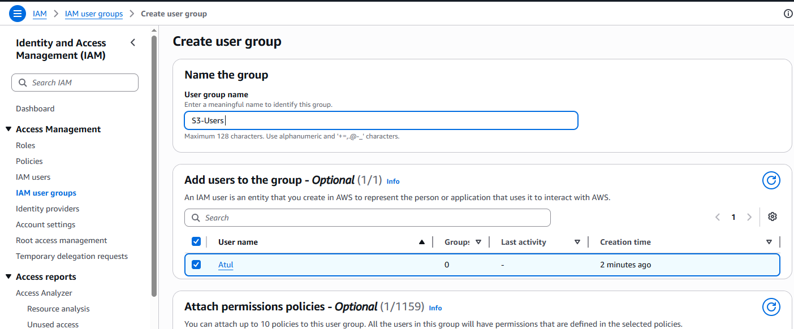
- Attach policy:
  - AmazonS3FullAccess
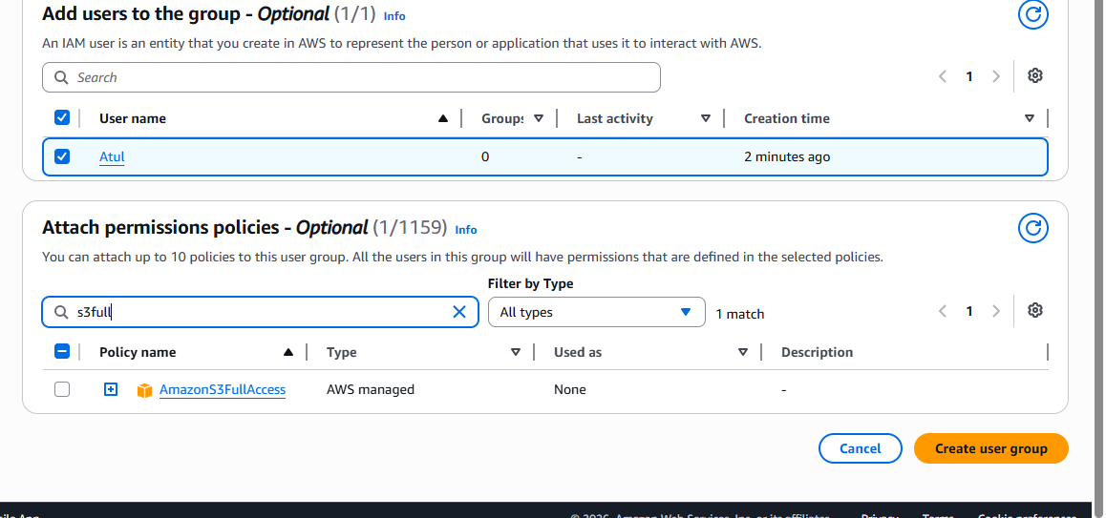
Create User
- IAM → Users → Create user
- Username: s3-user
- Console access enabled
- Add user to group S3-Users
Result:
- User can access Amazon S3
- Cannot access EC2, IAM, VPC

PRACTICAL 4: Enable MFA for IAM User (VERY IMPORTANT)
Steps
- IAM → Users → Select user
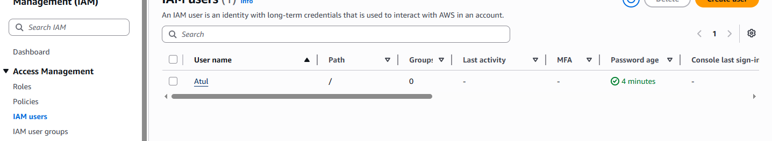
- Security credentials tab
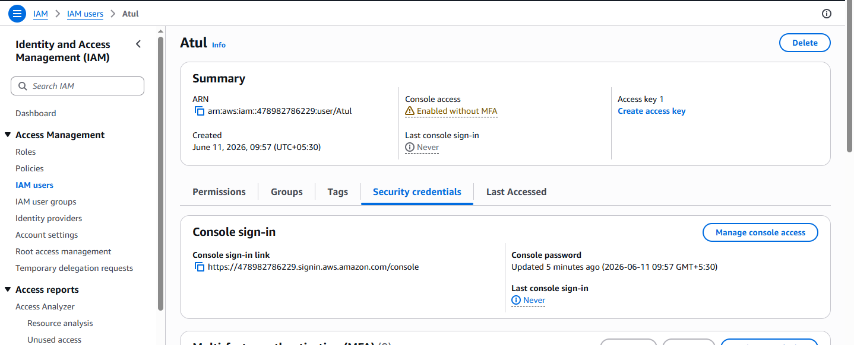
- MFA → Assign MFA
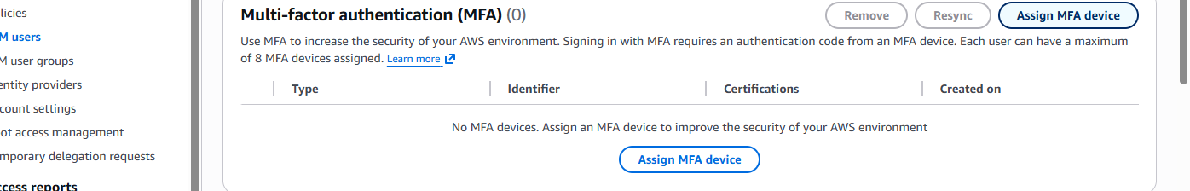
- Choose:
  - Authenticator app (Google Authenticator)

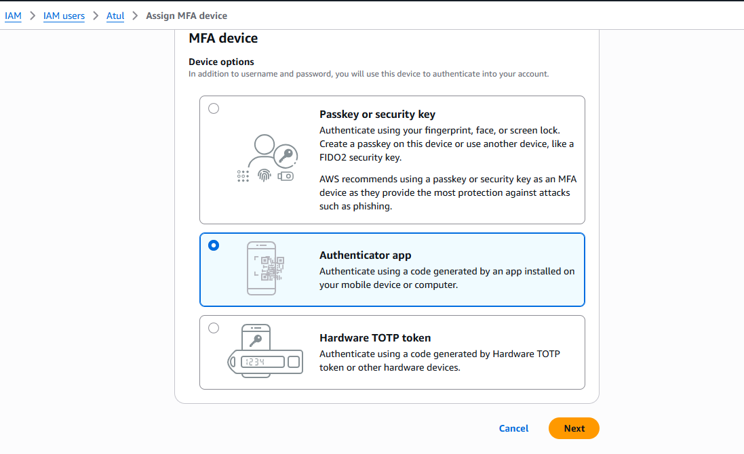
- Scan QR → Enter 2 codes
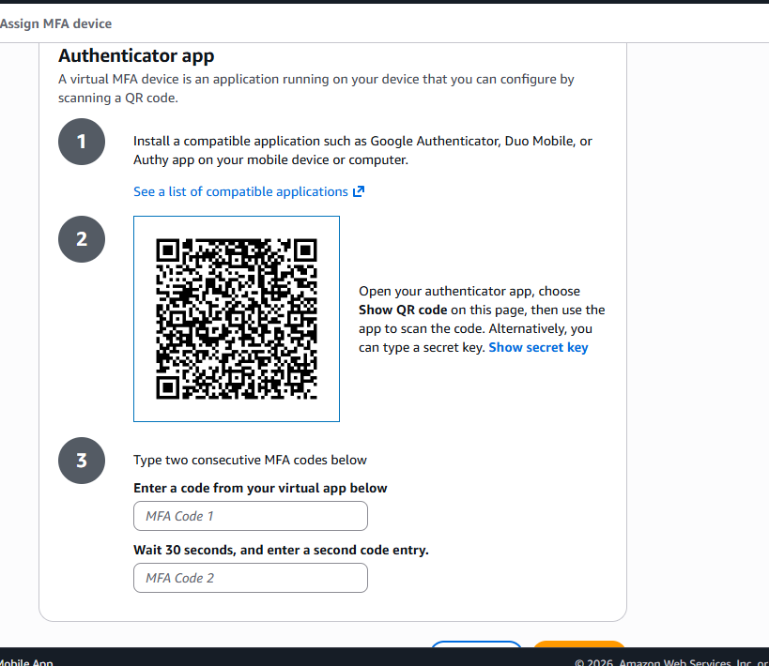
- Activate
Now login requires:
- Password
- OTP code

2️) Different Ways to Use AWS Services
AWS services can be accessed in 3 main ways:

1. AWS Management Console (Browser)

What it is
- Web-based GUI
- Login using browser

Used by
- Beginners
- Admins
- Learning & testing

Example
- Create EC2
- Create S3 bucket
- IAM user creation
Easy
Not automation-friendly

2. AWS Console + CloudShell

What is CloudShell?
- Browser-based terminal
- AWS CLI pre-installed
- No setup needed
Official service:
AWS CloudShell

Features
- Runs AWS CLI commands
- Uses console login permissions
- Temporary storage

Example Command
aws s3 ls
No local setup
Limited customization

3. AWS CLI (Command Line Interface)

What is AWS CLI?
Command-line tool to manage AWS from:
- Laptop
- Server
- VM
Official tool:
AWS CLI

Used for
- Automation
- Scripts
- DevOps

4. AWS SDK (Software Development Kit)

What is AWS SDK?
- Used inside applications
- Works with programming languages
Supported languages:
- Python (boto3)
- Java
- JavaScript
- Go
Example service access using SDK:
- Create EC2 from Python code
- Upload file to S3 from app
- Access Aws using cli from local machine

STEP 1: Create Access Key for User atul
- Login to AWS Console
- Go to IAM → Users → atul
- Open Security credentials tab
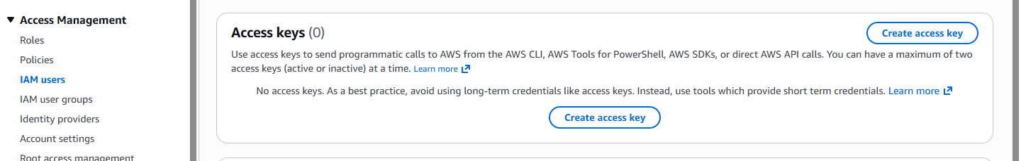
- Scroll to Access keys
- Click Create access key
- Select:
  - ✅ Command Line Interface (CLI)
- Click Next → Create access key
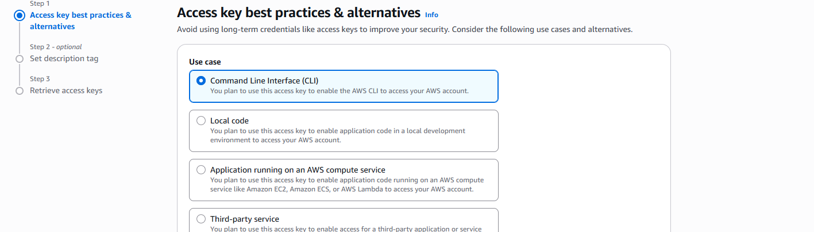
- DOWNLOAD or COPY:
  - Access Key ID
  - Secret Access Key
❗ You cannot see secret key again So download it.
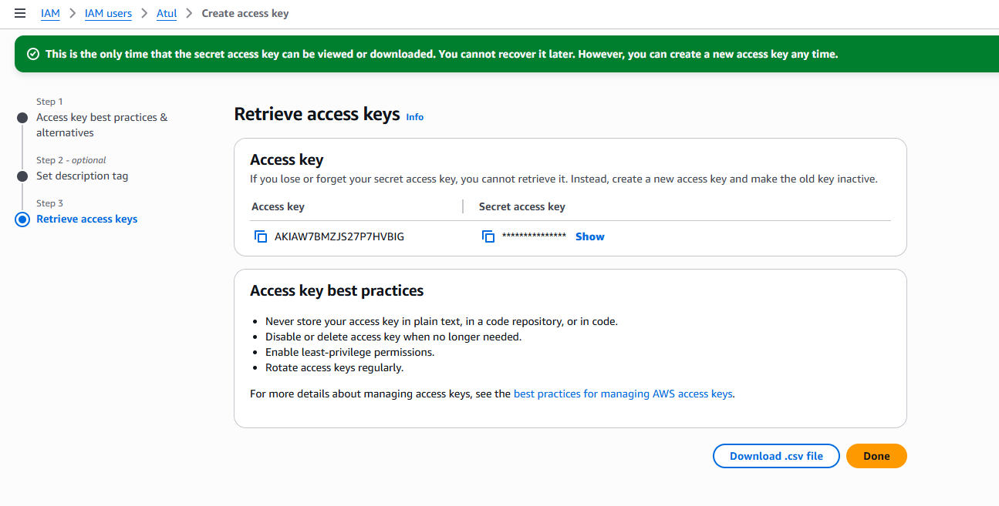
📌 This step is AUTHENTICATION setup

STEP 2: Install AWS CLI on Your Laptop

Download from official AWS site:

https://awscli.amazonaws.com/AWSCLIV2.msi

After installation, verify:
aws --version
Output example:
aws-cli/2.xx Python/3.xx

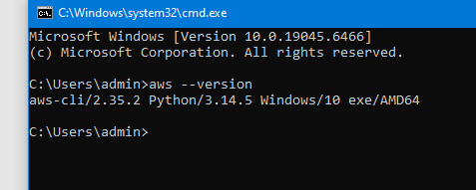
If command not found → installation failed

⚙️ STEP 3: Configure AWS CLI (VERY IMPORTANT)
Open Command Prompt / PowerShell / Terminal
Run:
aws configure
Enter values one by one:
AWS Access Key ID: <PASTE access key>
AWS Secret Access Key: <PASTE secret key>
Default region name: ap-south-1
Default output format: json
ap-south-1 = Mumbai region (recommended)
This step completes:
- Authentication
- Authorization setup via IAM policy

STEP 4: Test Connection (Proof It Worked)
Run:
aws sts get-caller-identity
Expected output:
{
"UserId": "AIDA....",
"Account": "123456789012",
"Arn": "arn:aws:iam::123456789012:user/atul"
}
Your laptop is now successfully connected to AWS
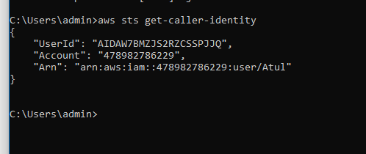

STEP 5: Test Real AWS Services

Test S3
aws s3 ls

Test EC2
aws ec2 describe-instances
If permission exists → works
If not → AccessDenied (authorization issue)

- User 1 — EC2 Read Only: Can view EC2 instances and their details but cannot start, stop, modify, or delete them.
- User 2 — EC2 Modify Only: Can start, stop, reboot, and modify EC2 instances but cannot terminate (delete) them.
AWS provides a default managed policy for read-only access. For modify access without deletion, you should create a custom IAM policy.

1. Which IAM policies should you use?
IAM user | Policy | Purpose
ec2-reader | AmazonEC2ReadOnlyAccess | View EC2 resources
ec2-manager | Custom policy | Modify and manage EC2 without terminating instances
AmazonEC2ReadOnlyAccess is an AWS-managed policy, so you don't need to create your own for the first user.

2. Create User 1 — EC2 Read Only
- Open the AWS IAM console.
- Go to Users → Create user.
- Enter username: ec2-reader.
- Select the option to provide user access to the AWS Management Console, if needed.
- Under permissions, select Attach policies directly.
- Search for AmazonEC2ReadOnlyAccess.
- Select the policy and create the user.
This user can view EC2 instances, AMIs, security groups, and other EC2 details, but cannot modify or delete them.
Amazon Elastic Compute Cloud

3. Create User 2 — EC2 Modify, but No Delete
For this user, create a custom policy that allows viewing, starting, stopping, rebooting, and modifying instance attributes, while explicitly denying instance termination.
IAM → Policies → Create policy → JSON
Copy this policy:

{
"Version": "2012-10-17",
"Statement": [
{
"Sid": "ViewEC2Resources",
"Effect": "Allow",
"Action": "ec2:Describe*",
"Resource": "*"
},
{
"Sid": "ManageEC2Instances",
"Effect": "Allow",
"Action": [
"ec2:StartInstances",
"ec2:StopInstances",
"ec2:RebootInstances",
"ec2:ModifyInstanceAttribute"
],
"Resource": "*"
},
{
"Sid": "PreventInstanceDeletion",
"Effect": "Deny",
"Action": "ec2:TerminateInstances",
"Resource": "*"
}
]
}

The policy uses an explicit Deny for ec2:TerminateInstances, which overrides an Allow from another attached identity policy.
Amazon Elastic Compute Cloud
+1

Create and attach the policy
- Click Next.
- Policy name: EC2-Modify-No-Terminate.
- Click Create policy.
- Go to IAM → Users → Create user.
- Enter username: ec2-manager.
- Choose Attach policies directly.
- Search for and attach EC2-Modify-No-Terminate.
- Create the user.

