1. EC2 Instance Store (Instance Storage)
Instance Store is temporary storage physically attached to the EC2 host machine.
Think of it like:
“Local SSD/HDD directly connected to the server.”
Key characteristics
- Very fast I/O and low latency
- Storage exists only while the instance exists
- Data is lost if:
  - instance stops
  - instance terminates
  - underlying host fails
- Not shared with other instances
- Usually used for temporary or cache data
Best use cases
- Caching
- Temporary files
- Buffers
- Scratch data
- Big data processing
- High-speed local databases with replication
Example
Suppose you launch an EC2 instance with:
- 1 TB NVMe SSD instance store
You can use it for:
- Redis cache
- Spark temporary processing
- Video rendering temp files
But if the instance stops:
❌ data disappears.

Launch an EC2 with Instance Store
Not all EC2 types have instance storage.
Examples that support it:
- i3
- i4i
- d3
- c5d
- m5d
- r5d
The d usually means:
“instance store disks included”
Example:
m5d.large

2. EFS (Elastic File System)
Amazon Elastic File System (EFS) is a managed network file system provided by AWS.
Think of it like:
“A shared cloud drive for Linux EC2 instances.”
Key characteristics
- Persistent storage
- Data survives instance stop/termination
- Multiple EC2 instances can mount the same filesystem
- Automatically scales
- Accessible over the network using NFS
- Managed by AWS
Best use cases
- Shared application files
- Web server shared content
- Kubernetes persistent storage
- Machine learning shared datasets
- CMS uploads
- Home directories
Example
You have:
- 5 EC2 web servers
All can mount the same EFS filesystem:
/mnt/shared
If one server uploads an image:
- all other servers can immediately access it.

3)What is AWS User Data?
User Data helps you automate server setup during boot.
Instead of manually:
- installing software
- updating packages
- configuring applications
you provide a startup script, and EC2 executes it automatically.

Simple Analogy
Without User Data:
Launch EC2
→ SSH into server
→ Install nginx
→ Configure app
→ Start services
With User Data:
Launch EC2
→ Everything installs automatically

Where is it Used?
Mostly used in:
- EC2 launch configuration
- Auto Scaling Groups
- Launch Templates
- Infrastructure automation

Common Uses
- Install web servers (Apache/Nginx)
- Install Docker
- Pull code from GitHub
- Configure applications
- Start services
- Run bootstrap scripts

Example User Data Script (Amazon Linux)
#!/bin/bash
yum update -y
yum install nginx -y
systemctl start nginx
systemctl enable nginx
echo "Hello from EC2 User Data" > /usr/share/nginx/html/index.html
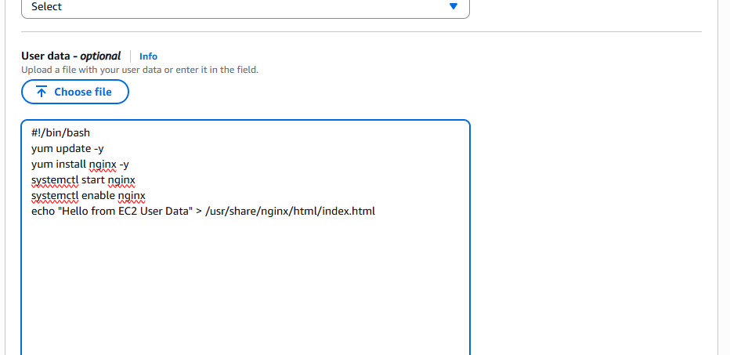

What Happens Here?
When EC2 starts:
- Updates packages
- Installs Nginx
- Starts Nginx service
- Enables it on reboot
- Creates homepage
After launch:
- visiting EC2 public IP shows:
Hello from EC2 User Data


Important Points

1. Runs at First Boot by Default
Normally User Data executes:
only once during first launch.
If instance reboots:
script usually does not rerun automatically.

2. Runs as Root User
So it has admin permissions.

3. Supports Shell Scripts and Cloud-Init
Linux:
- bash scripts
- cloud-init directives
Windows:
- PowerShell scripts

4) High Availability (HA)
High Availability means:
Your application remains available even if some components fail.
The goal is:
- minimize downtime
- avoid single points of failure
- keep services running continuously

Example in AWS
Suppose your app runs on:
- only 1 EC2 instance
If that instance crashes:
❌ app goes down.
Instead, AWS HA architecture uses:
- multiple EC2 instances
- multiple Availability Zones (AZs)
- load balancer
Example:
Users
↓
Load Balancer
↓
EC2 in AZ-1
EC2 in AZ-2
If one AZ fails:
traffic goes to the other AZ.

AWS services used for HA
- EC2
- Auto Scaling
- Elastic Load Balancer (ELB)
- RDS Multi-AZ
- Route 53
- S3

5. Scalability
Scalability means:
Ability to handle increasing workload by adding resources.
Example:
- today → 100 users
- tomorrow → 1 million users
Your system should still perform well.

Types of Scalability

A. Vertical Scaling (Scale Up)
Increase power of one server.
Example:
- 2 GB RAM → 16 GB RAM
- t2.micro → m5.large
Small Server → Bigger Server

Advantages
- simple

Disadvantages
- hardware limit exists
- downtime sometimes required
Used mostly in:
- databases

B. Horizontal Scaling (Scale Out)
Add more servers.

Traffic distributed using Load Balancer.

Advantages
- better fault tolerance
- almost unlimited scaling
- cloud-native approach
Used in:
- web applications
- microservices

6. Elasticity
Elasticity means:
Automatically increasing or decreasing resources based on demand.
This is one of the biggest cloud advantages.

Example
During sale traffic:
Normal Day → 2 EC2
Sale Time → 20 EC2
After Sale → back to 2 EC2
Resources automatically adjust.

7. Load Balancing
A Load Balancer distributes incoming traffic across multiple servers.
Without load balancing:
All users → One EC2
Server overloads.
With load balancing:
Users
↓
Load Balancer
↙ ↘
EC2 EC2
Traffic is distributed evenly.

Benefits of Load Balancing
- high availability
- fault tolerance
- scalability
- better performance
- SSL termination
- health checks

Types of AWS Load Balancers
AWS service:
Elastic Load Balancing (ELB)

A. Application Load Balancer (ALB)
Layer 7 (HTTP/HTTPS)
Used for:
- websites
- REST APIs
- microservices
Features:
- path-based routing
- host-based routing
- WebSocket support
Example:
/api → Server A
/images → Server B

B. Network Load Balancer (NLB)
Layer 4 (TCP/UDP)
Used for:
- ultra high performance
- low latency applications
- gaming
- financial systems
Features:
- millions of requests/sec
- static IP support

C. Gateway Load Balancer (GWLB)
Layer 3
Used for:
- security appliances
- firewalls
- packet inspection

D. Classic Load Balancer (CLB)
Older generation.
Supports:
- HTTP
- HTTPS
- TCP
Mostly legacy now.

AWS ALB PROJECT ARCHITECTURE
Internet
│
▼
Application Load Balancer
↙ ↘
EC2-1 EC2-2
(Apache Server) (Apache Server)
When you refresh the ALB DNS URL:
- one time → EC2-1 hostname
- another time → EC2-2 hostname

STEP 1 — CREATE SECURITY GROUPS

ALB Security Group
SEARCH SECURITY-GROUP AND CREATE ONE.
Create security group:
alb-sg

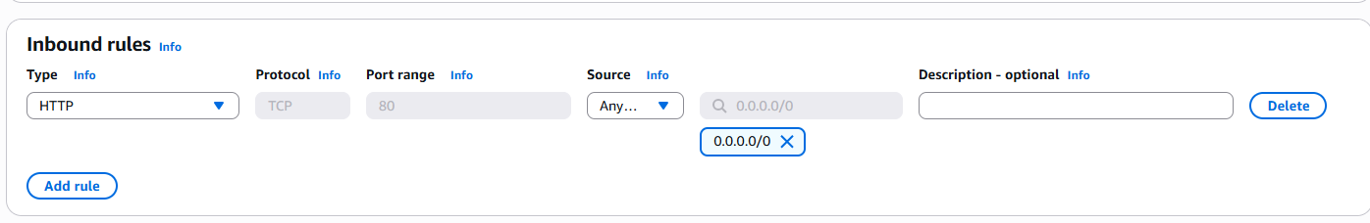
Inbound Rules:
Type | Port | Source
HTTP | 80 | Anywhere

B. EC2 Security Group
Create security group:
ec2-sg
Inbound Rules:
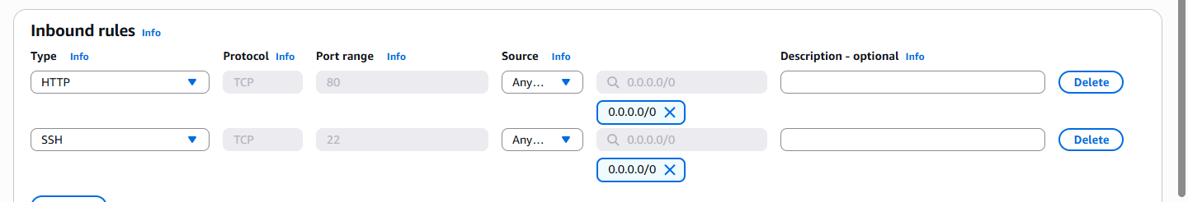
Type | Port | Source
HTTP | 80 | alb-sg
SSH | 22 | My IP

STEP 2 — CREATE EC2 INSTANCE 1
Go to:
EC2 → Launch Instance
Configure:
- Name: EC2-1
- AMI: Amazon Linux 2
- Type: t2.micro
- Security Group: ec2-sg
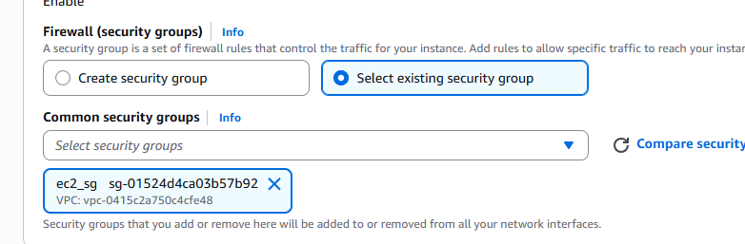

USER DATA SCRIPT (USE SAME SCRIPT FOR BOTH EC2)

#!/bin/bash
yum update -y
yum install httpd -y
systemctl start httpd
systemctl enable httpd
HOSTNAME=$(hostname)
echo "<h1>This is $HOSTNAME</h1>" > /var/www/html/index.html
Launch instance.
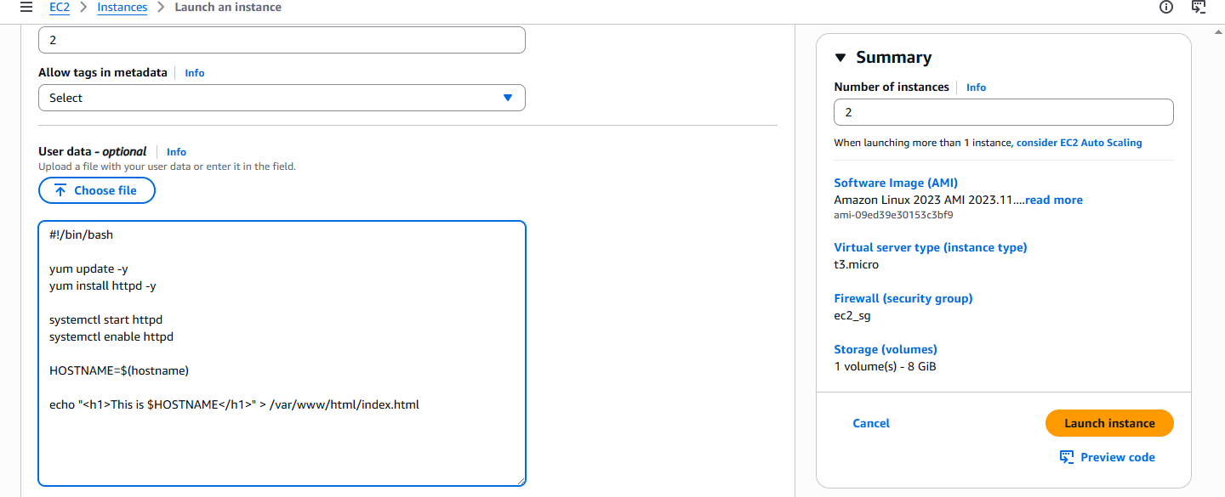

STEP 3 — CREATE EC2 INSTANCE 2
Launch another EC2 with:
- same AMI
- same security group
- same User Data script
Only change:
Name = EC2-2

STEP 4 — VERIFY EC2 INSTANCES
Open browser:
http://EC2-Public-IP
Example output:
This is ip-172-31-34-131
Second EC2:
This is ip-172-31-42-28


STEP 5 — CREATE TARGET GROUP
Go to:
EC2 → Target Groups
Create:
- Target type: Instances
- Protocol: HTTP
- Port: 80
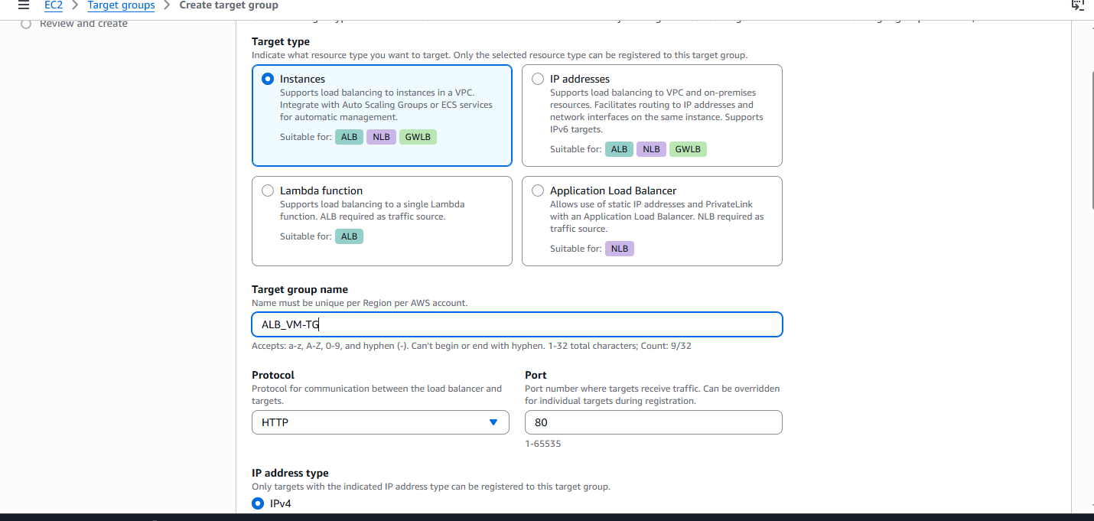
Name:
alb-target-group
Register:
- EC2-1
- EC2-2
Create target group.
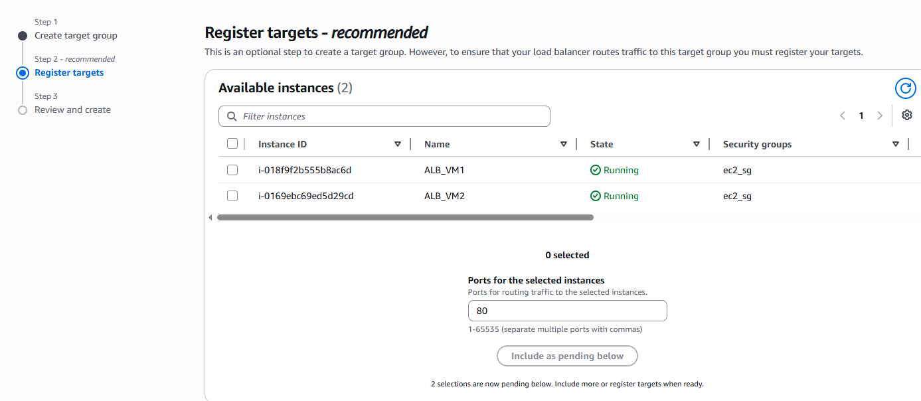
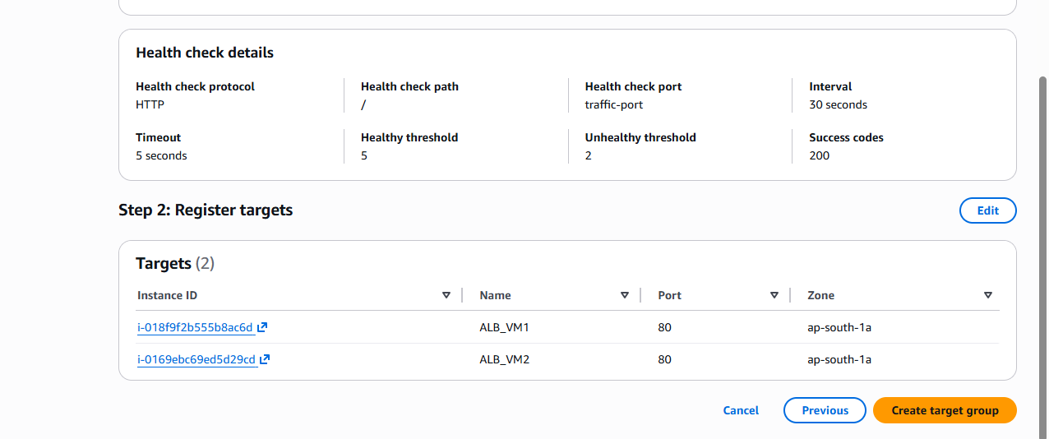

STEP 6 — CREATE APPLICATION LOAD BALANCER
Go to:
EC2 → Load Balancers
→ Create Load Balancer
→ Application Load Balancer

ALB CONFIGURATION

Basic Settings
Setting | Value
Name | my-alb
Scheme | Internet-facing
IP Type | IPv4
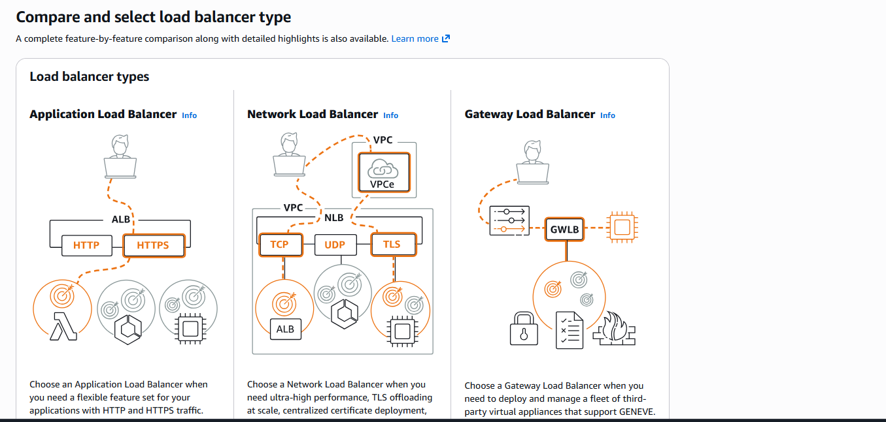

Network Mapping
Select:
- minimum 2 AZs
Example:
us-east-1a
us-east-1b
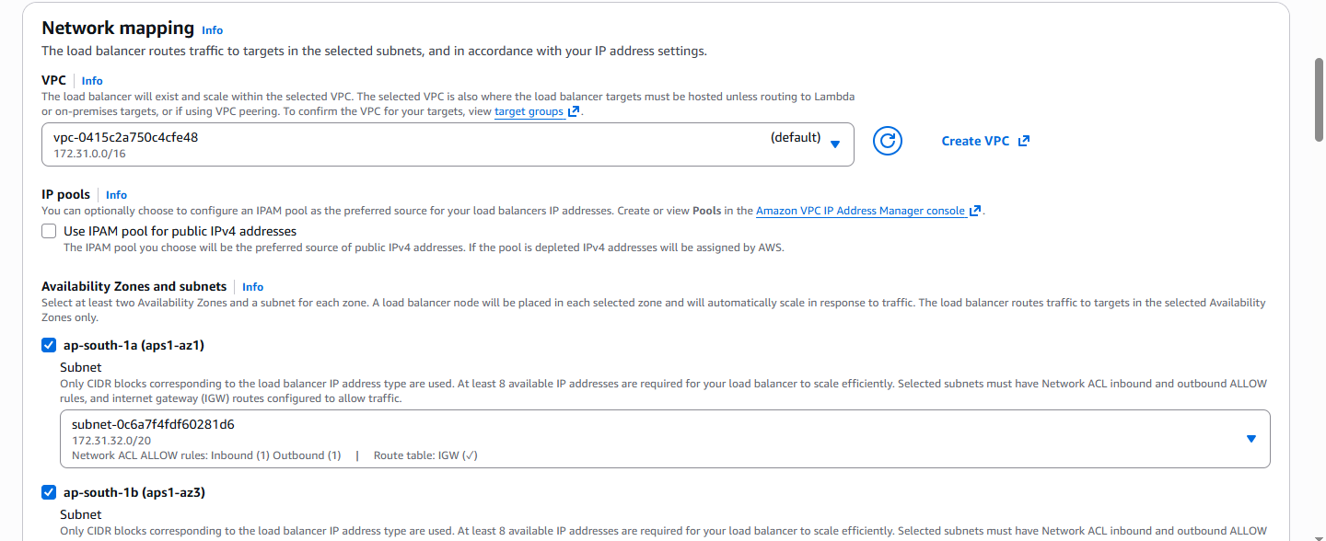

Security Group
Attach:
alb-sg
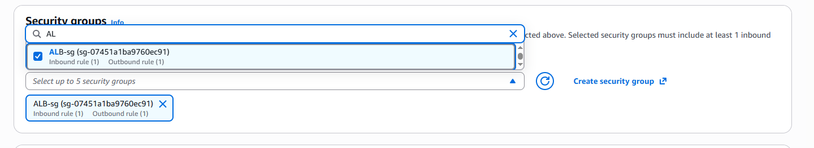

Listener
Protocol | Port
HTTP | 80
Forward to:
alb-target-group
Create ALB.
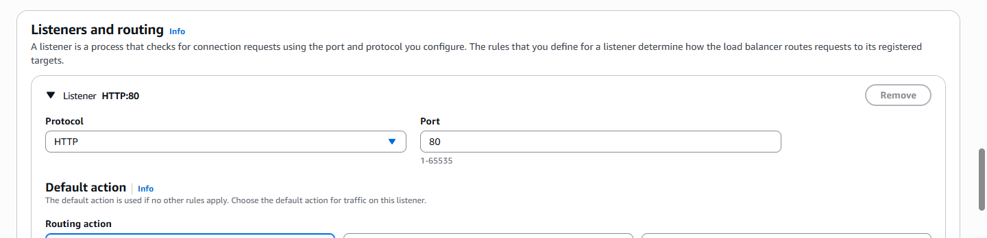
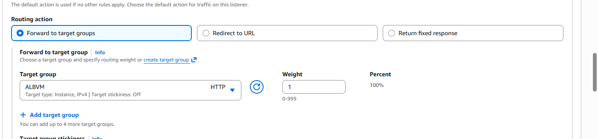

STEP 7 — WAIT FOR HEALTH CHECKS
Go to:
Target Groups → Targets
Wait until:
Healthy
appears for both EC2 instances.

STEP 8 — TEST APPLICATION LOAD BALANCER
Copy:
ALB DNS Name
Example:
http://my-alb-123456.us-east-1.elb.amazonaws.com
Refresh multiple times.
You’ll see:
This is ip-172-31-14-120
then:
This is ip-172-31-25-85

HOW THIS PROJECT WORKS

User Flow
User Request
↓
Application Load Balancer
↙ ↘
EC2-1 EC2-2

