1. What is IAM in AWS
IAM stands for Identity and Access Management.
IAM is a service provided by Amazon Web Services that allows you to:
- Create users
- Create groups
- Control access to AWS services
IAM helps you decide who can log in and what they can do in AWS.
Important point: IAM is a global service.

2. How to Create an IAM User (Step by Step)
- Login to AWS Management Console
- Open the IAM service
- Click Users from the left menu
- Click Create user
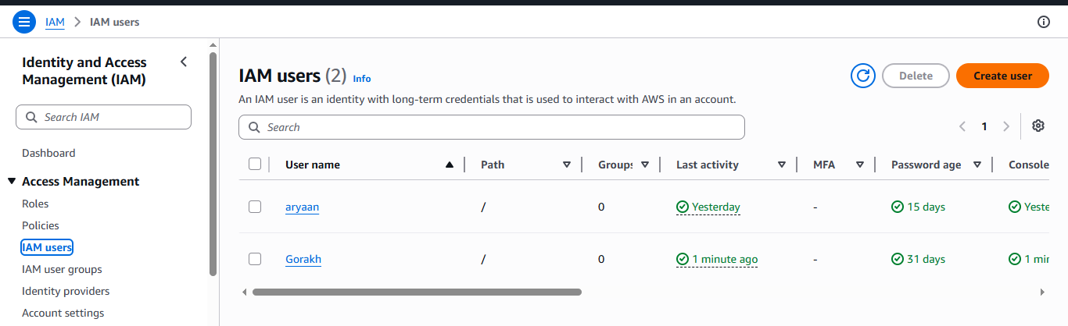
- Enter user name
dev-user
- Select Provide user access to AWS Management Console
- Choose Autogenerated password
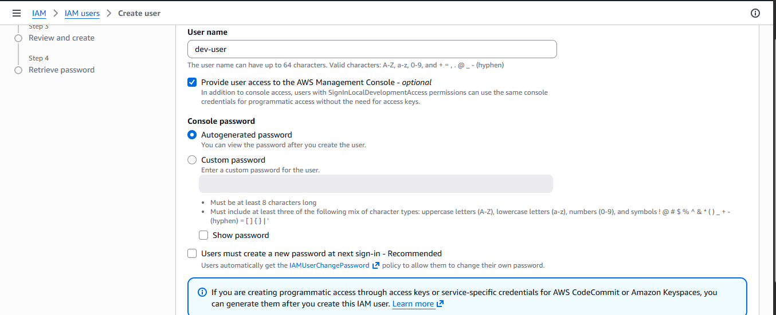
- Click Next

3. How to Create an IAM Group (Step by Step)
- In IAM dashboard, click User groups
- Click Create group
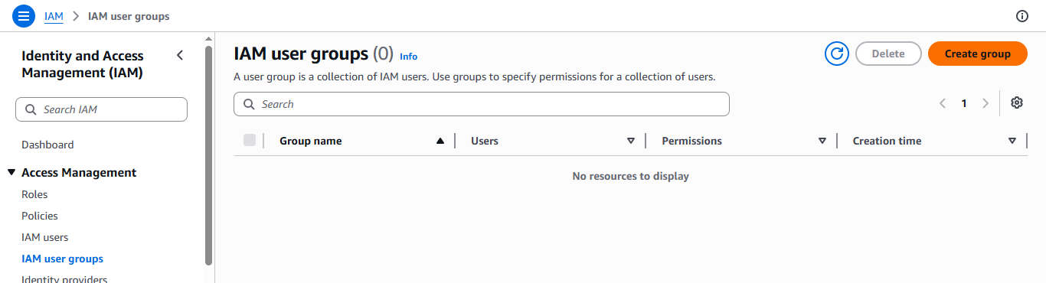
- Enter group name
Admin-Group
- Click Create group

4. How to Assign Policy to a Group (Step by Step)
- While creating the group or after creation
- In policy list, search:
AdministratorAccess
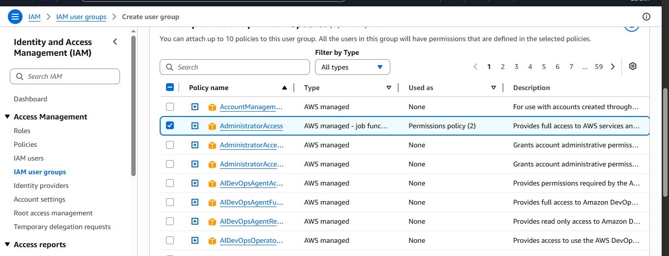
- Select the policy
- Click Attach policy
Now the group has full AWS access.

5. How to Add User to Group (Step by Step)
- Go to IAM → Users
- Click the user name
dev-user
- Open Groups tab
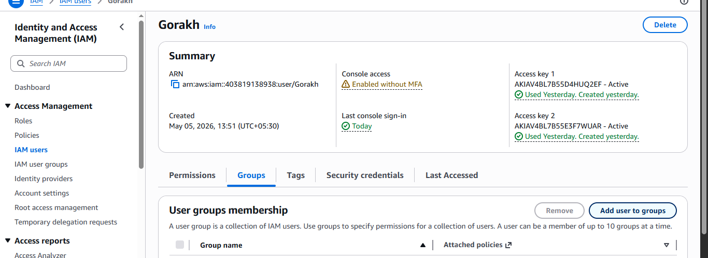
- Click Add user to groups
- Select:
Admin-Group
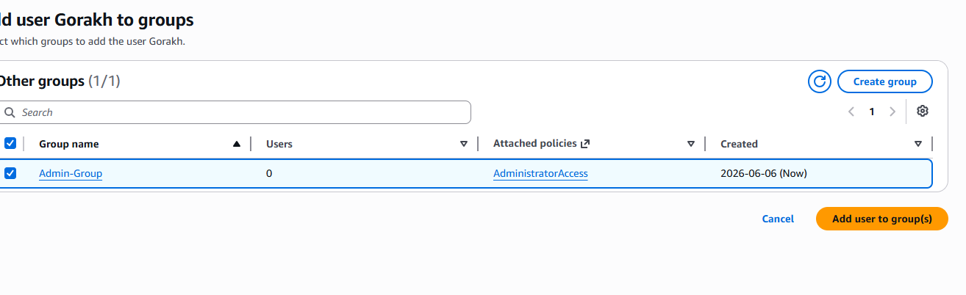

- Click Add
Now the user gets permissions from the group.

6. Login Using IAM User
- Open IAM dashboard
- Copy IAM user sign-in URL
- Open a new browser window
- Enter the URL
- Login using:
  - User name
  - Password
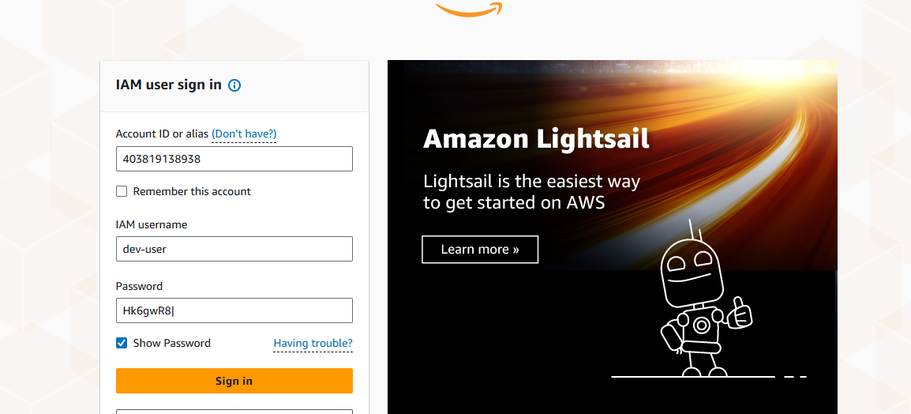
Now you are logged in as an IAM user.

2) What is the Billing Section in AWS
The Billing and Cost Management section in Amazon Web Services is used to:
- View your AWS bill
- Track service-wise costs
- Control and reduce spending
- Set alerts for high usage
- Manage payments and invoices
Only the root user or users with billing permissions can access this section.

2. Where to Find Billing in AWS Console
- Login to AWS Console
- Click your account name (top right corner)
- Click Billing and Cost Management
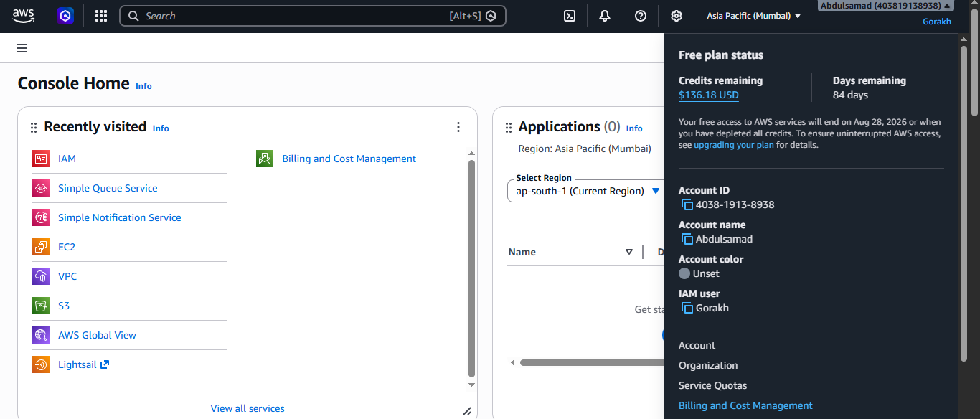

3. Important Services in AWS Billing Section

3.1 Bills
Purpose:
Used to see monthly AWS charges.
You can view:
- Total monthly bill
- Service-wise charges (EC2, S3, RDS, etc.)
- Region-wise charges
- Taxes and credits

Why useful:
- Understand where money is spent
- Identify expensive services

3.2 Payments
Purpose:
Used to manage payment methods.
You can:
- Add or update debit or credit card
- View completed payments
- See pending payments
Why useful:
- Avoid payment failure
- Ensure uninterrupted services

3.3 Cost Explorer
Purpose:
Used to analyze AWS spending visually.
You can:
- View cost graphs
- Compare daily or monthly usage
- Filter by service, region, or account
- Predict future costs
Why useful:
- Identify cost trends
- Find unused or costly resources
Important:
Cost Explorer must be enabled first.

3.4 Budgets
Purpose:
Used to set spending limits.
You can:
- Set monthly cost budget
- Set usage budget (EC2 hours, data transfer)
- Receive email alerts when cost exceeds limit
Why useful:
- Prevent unexpected bills
- Very important for beginners
Example:
Set budget of 1000 INR per month.

3.5 Cost Allocation Tags
Purpose:
Used to organize costs using tags.
You can:
- Tag resources (Project, Environment)
- Track cost per project or team
Why useful:
- Helps companies track project-wise billing
- Improves cost reporting

3.6 Billing Preferences
Purpose:
Used to manage billing notifications and settings.
You can:
- Enable billing alerts
- Receive invoices by email
- Enable PDF invoices
Why useful:
- Get billing updates automatically
- Important for finance teams

3.7 Credits
Purpose:
Used to view AWS promotional credits.
You can:
- See free tier credits
- Training or promotional credits
Why useful:
- Reduce AWS bill
- Track remaining credit balance

3.8 Free Tier
Purpose:
Used to monitor Free Tier usage.
You can:
- See how much Free Tier is used
- Identify services exceeding Free Tier
Why useful:
- Avoid accidental charges
- Very important for new users

3.9 Invoices
Purpose:
Used to download monthly invoices.
You can:
- Download PDF invoice
- View tax details
Why useful:
- Accounting and audits
- Company billing records
3. What are AI Services in AWS
AI services in Amazon Web Services are ready-to-use services that allow you to add artificial intelligence features to applications without building models from scratch.
These services help with:
- Image analysis
- Video analysis
- Speech and text processing
- Chatbots
- Predictions

2. Important AWS AI Services for Cloud Practitioner

2.1 Amazon Rekognition
What it does:
- Analyzes images and videos
- Detects objects, people, text, and activities
- Can recognize faces
Used for:
- Face recognition systems
- Security and surveillance
- Image moderation
Exam point:
Used for image and video analysis

2.2 Amazon Textract
What it does:
- Extracts text from scanned documents
- Reads forms and tables automatically
Used for:
- Invoice processing
- Bank statements
- Automated document handling
Exam point:
Used for document text extraction

2.3 Amazon Comprehend
What it does:
- Understands text content
- Detects sentiment (positive, negative, neutral)
- Finds key phrases and entities
Used for:
- Customer feedback analysis
- Social media analysis
- Review classification
Exam point:
Used for natural language processing

2.4 Amazon Translate
What it does:
- Translates text between languages
Used for:
- Multilingual applications
- Website translation
- Chat translation
Exam point:
Used for language translation

2.5 Amazon Transcribe
What it does:
- Converts speech into text
Used for:
- Meeting transcription
- Call center analysis
- Subtitles generation
Exam point:
Used for speech-to-text

2.6 Amazon Polly
What it does:
- Converts text into speech
- Produces natural-sounding voice
Used for:
- Voice assistants
- Audiobooks
- Accessibility tools
Exam point:
Used for text-to-speech

2.7 Amazon Lex
What it does:
- Builds chatbots and voice bots
- Understands user input using NLP
Used for:
- Customer support chatbots
- Voice-based applications
Exam point:
Same technology used by Amazon Alexa

2.8 Amazon Forecast
What it does:
- Predicts future values using historical data
Used for:
- Sales forecasting
- Demand planning
- Inventory management
Exam point:
Used for prediction and forecasting

2.9 Amazon Personalize
What it does:
- Creates recommendation systems
Used for:
- Product recommendations
- Movie or content suggestions
Exam point:
Used for recommendation engines

2.10 Amazon Kendra
What it does:
- Intelligent search service
- Finds answers from documents
Used for:
- Enterprise search
- Internal knowledge base
Exam point:
Used for AI-powered search

4) What is AWS Lambda

AWS Lambda is a service from Amazon Web Services that lets you run code without managing servers.
Key points:
- You upload code (Python, Node.js, etc.)
- Lambda runs the code when an event happens
- You pay only when the code runs
- Lambda automatically scales
Example events:
- File uploaded to S3
- API request
- Scheduled time

2. What Does “Run a Command” Mean in Lambda
In Lambda, you do not run Linux commands manually like on EC2.
Instead:
- You write code (for example, Python)
- Lambda executes that code
- Output is written to logs
Example Python statements:
print("Hello from Lambda")
This is considered “running a command” in Lambda.

3. How to Test (Run) a Lambda Function Manually
You can run Lambda manually using the Test feature.

Step 1: Open Lambda Function
- Go to AWS Console
- Open Lambda service
- Click your function name

Step 2: Create a Test Event
- Click Test button
- Click Configure test event
- Event name:
test-event
- Leave default JSON as it is
- Click Save

Step 3: Run the Test
- Click Test again
- Lambda runs your code
- You will see:
  - Status: Succeeded or Failed
  - Execution result

4. Example Lambda Code to Print Message
Use this simple Python code:
def lambda_handler(event, context):
print("Hello from AWS Lambda")
Click Deploy before testing.

5. Where Does Lambda Output Go
All print() output goes to CloudWatch Logs.
Lambda automatically sends logs to Amazon CloudWatch.

6. How to View Logs in CloudWatch

Step 1: Open Logs from Lambda
- Open your Lambda function
- Click Monitor tab
- Click View logs in CloudWatch

Step 2: Open Log Stream
- You will see a log group
- Click the latest log stream
- You will see log output
Example output:
Hello from AWS Lambda

7. Common Log Messages You Will See
- START RequestId – Lambda execution started
- Your print output
- END RequestId – Lambda execution finished
- REPORT – execution time and memory usage
These logs help in debugging and monitoring.

5) What is CloudWatch
Amazon CloudWatch is a monitoring service provided by Amazon Web Services.
CloudWatch is used to:
- Monitor AWS resources
- Collect logs
- Track performance
- Set alarms
In simple words:
CloudWatch helps you see what is happening inside AWS services.

2. Why CloudWatch is Used
CloudWatch is used to:
- Check whether a service is working or not
- View logs from services like Lambda and EC2
- Monitor CPU, memory, and usage
- Get alerts when something goes wrong
Example:
If your Lambda function fails, CloudWatch shows the error.

3. What CloudWatch Monitors
CloudWatch can monitor:
- EC2 instances
- Lambda functions
- S3 buckets
- RDS databases
- API Gateway
- Many other AWS services

4. Main Components of CloudWatch

4.1 CloudWatch Metrics
Metrics are numbers that show performance.
Examples:
- EC2 CPU utilization
- Lambda invocation count
- Lambda error count
Metrics help answer:
Is my service slow or overloaded?

4.2 CloudWatch Logs
Logs are text output from services.
Examples:
- Lambda print() output
- Application logs
- Error messages
Very important:
All Lambda logs automatically go to CloudWatch Logs.

4.3 CloudWatch Alarms
Alarms watch metrics and send alerts.
Examples:
- Send email if CPU is above 80 percent
- Alert if Lambda errors increase
Alarms help in automatic monitoring.

4.4 CloudWatch Dashboards
Dashboards show graphs and data in one place.
You can see:
- CPU usage
- Error count
- Request count
Used mainly by operations teams.

5. CloudWatch with Lambda (Very Important)
When Lambda runs:
- It sends logs to CloudWatch
- print() statements appear in CloudWatch Logs
- Errors are recorded automatically
Example log output:
START RequestId
Hello from Lambda
END RequestId

6. How to Open CloudWatch
- Login to AWS Console
- Search for CloudWatch
- Open:
  - Logs
  - Metrics
  - Alarms

