Before cloud companies buy physical server or try to use virtualization and using hypervisor they create VM’s on same machine but for that they need to buy server,storage,deploy virtulization ,create VM. But after azure cloud they need to just create VM on the cloud.

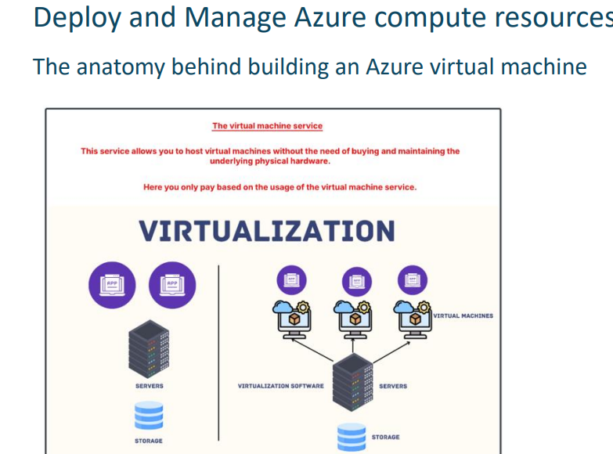

HOW TO CREATE WINDOW VM:- never use window server edition core and server core use datacenter gen 64.
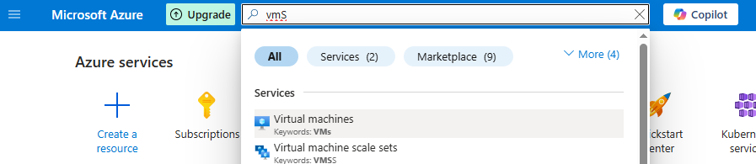
Select virtual machine.
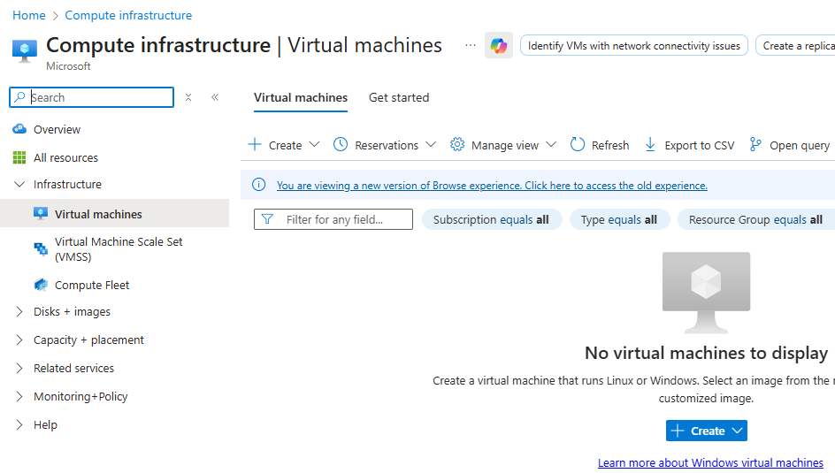
CREATE THE VM.
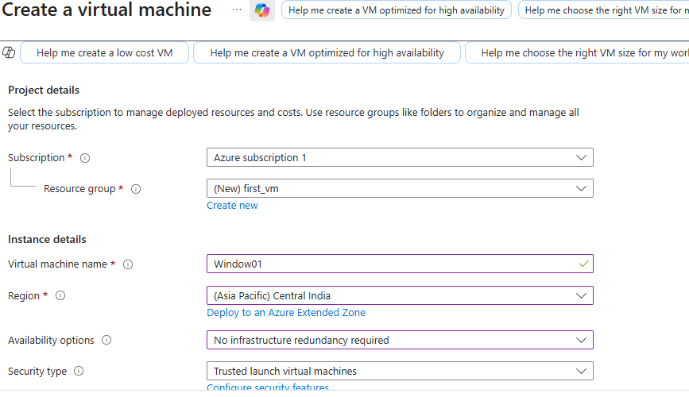
CHOOSE SUBCRIPTION, CREATE NEW RESOURCE GROUP THAT WILL HOLD YOUR ALL RESOURCE OF SAME PROJECT,GIVE NAME TO VM,SELECT REGION AS CENTRAL INDIA AND IN AVAILABILITY ZONE NOW SELECT NO REDUNDANCY RIGHT NOW, WE DON’T WANT AVAILABILITY ZONE TS JUST A PRACTICE,SECURITY TYPE IS DEFAULT.
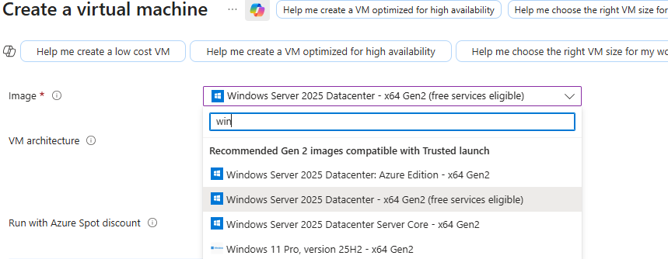
DON’T SELECT AZURE EDITION AND SERVER CORE USE DATACENTER.
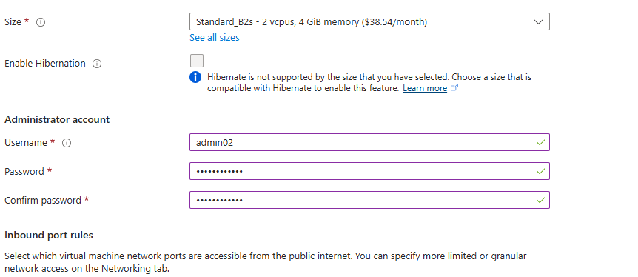
FOR PRACTICE ALL TIME CHOOOSE B2S SIZE.AND COPY THE USERNME AND PASSWORD.
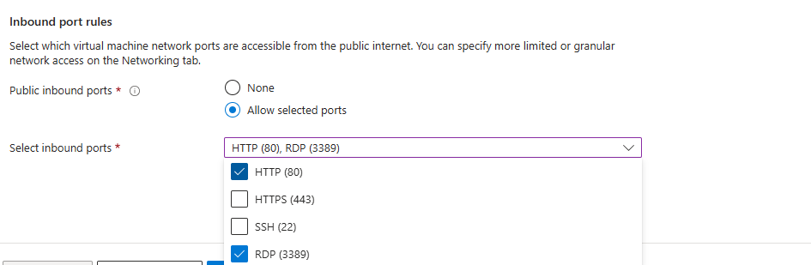
FOR INBOUND HTTP AND RDP OPEN.
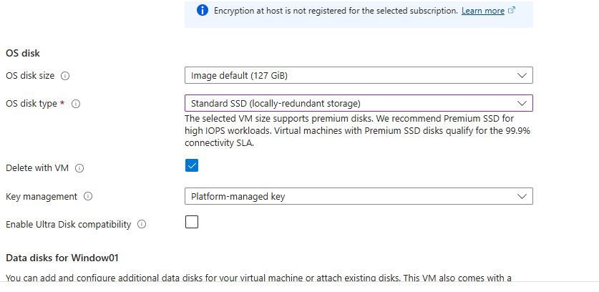
IN DISK SELECT THE DEFAULT ONE.
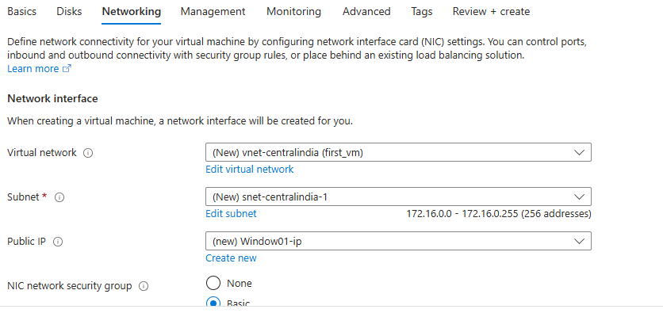
IN NETWORK Y DEFAULT THE V-NET AND SUBNET WAS THERE BUT IF U WANT CUSTOMIE U CAN DO THAT AND CREATE NEW PULIC IP.
FOR PRODUCTION RDP SHOULD BE ALLOW FOR SPECIFIC IP NOW CREATE FOR BASIC VM.
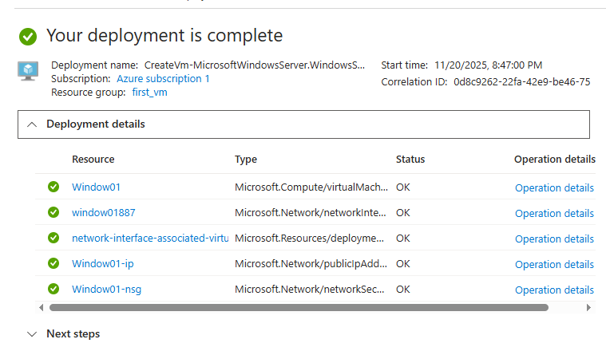
AFTER THAT U WILL SEE THIS RESOURCES IN REOURCE GROUP.

2)HOE TO ACCESS THE VM:-
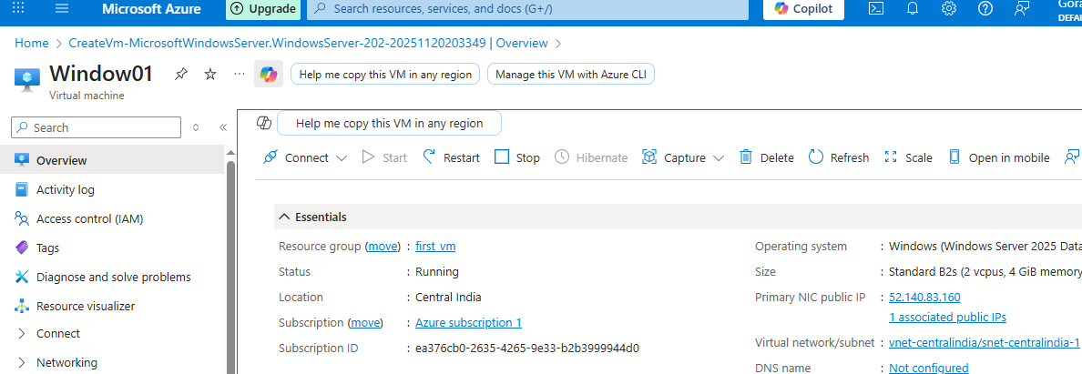
CLICK ON CONNECT:-
IF USER WANT TO ACCESS IT FROM ANYWHERE GO TO THE REMOTE DESTOP CONNECTION APP-ADD PUBLIC IP OF VM,USERNAME AND CONNECT THEN IT WILL ASKED THE PASSWORD.
FOR US IT WILL TELL U TO DOWNLOAD RDP FILE WHERE U PUT USERNAME AND PASSWORD.
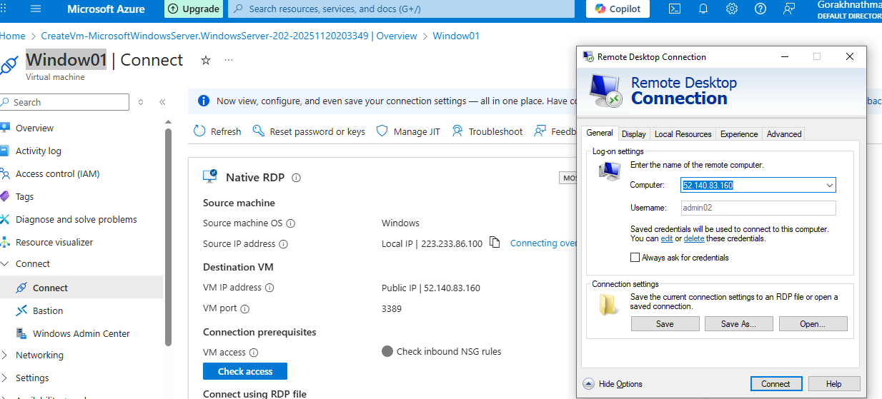
3) FOR HOSTNG THE WEBSITE ON WINDOW SERVER-
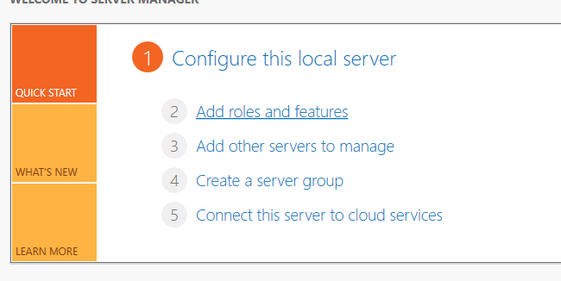

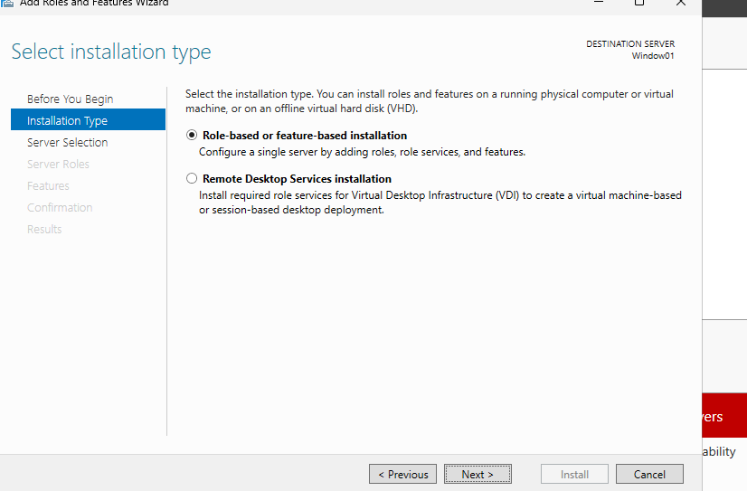

AFTER THAT IN FEATURE IT WIL SHOW U LIST FROM THERE INSTALL THE IIS(WEB SERVER)
NOW TAKE PUBLIC IPOF VM AND PASTE IT TO BROWSER(HTTP://IP), NOW IT WILL SHOW YOU DEFAULT WEB SERVER IF U GOT ANY ERROR U NEED TO GO TO VM-NETWORKING-NETWORK SETTING-INBOUND AND ADD HTTP.
4)HOW TO RESIZE THE VM :-
IN RESOURCE GROUP THERE IS DEFAULT RG NAMED NETWORKWACHERRG.
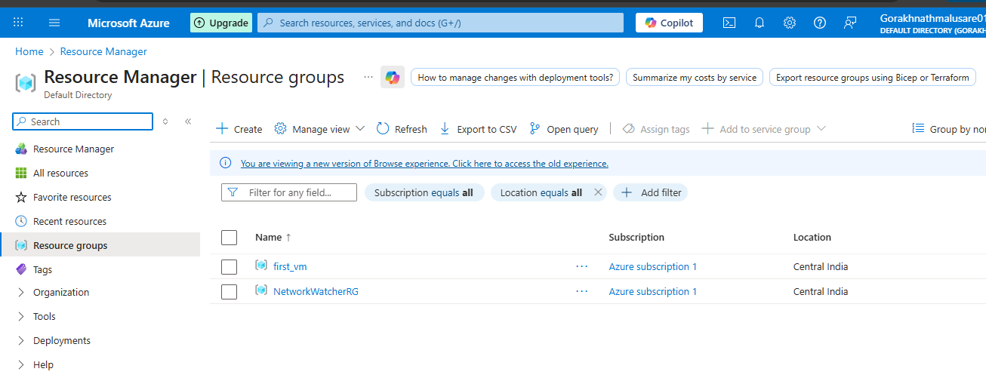
GO TO THE VM THAT WE CREATED – AVALIBILITY AND SIZE – SIZE AND SELECT THE SIZE AND CLICK ON REZISE.

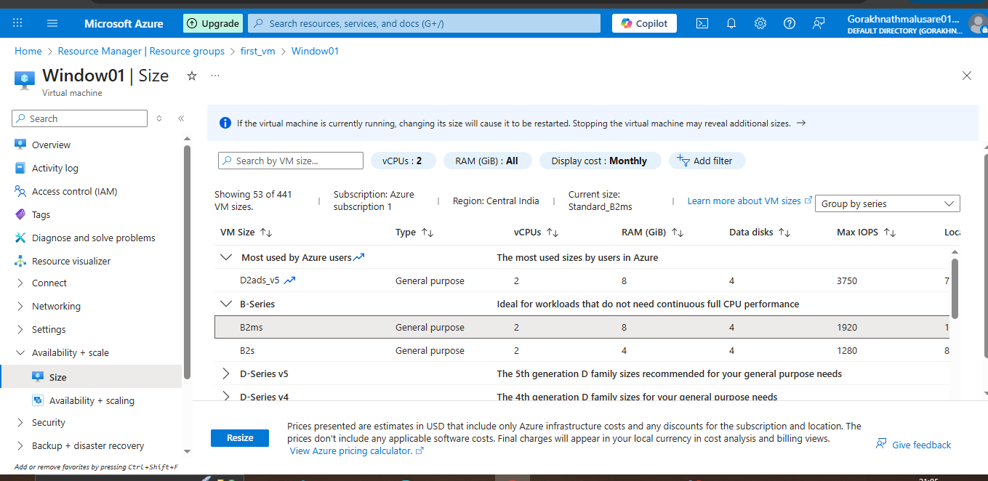
in home page upper rght side there is symbol of bell there u can see notification that process is done of not.
4) how to connect by macos:-install windows app IN MAC0S AND THEN GO TO AZURE VM DOWNLOAD THE RDP FILE THEN U WILL ACCESS THE VM.
5) if u want to see your region quotas and usage:- subscription- setting- usage + quotas
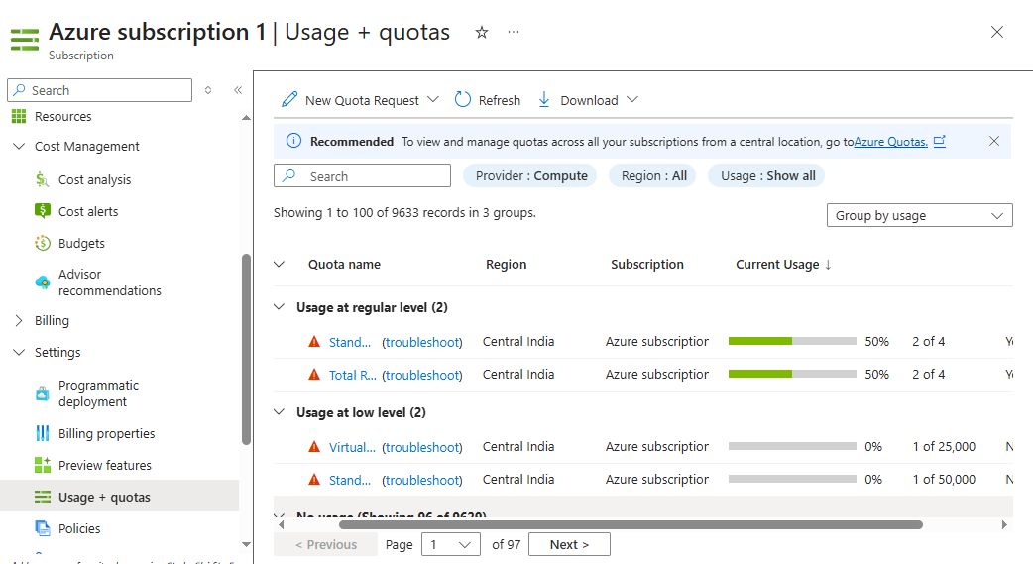

6)TO DELETE THE ALL RESOURCES JUST DELETE HE RESOURCE GROUP SO A THE RESOUCES WITHIN WIL GET DELETED.
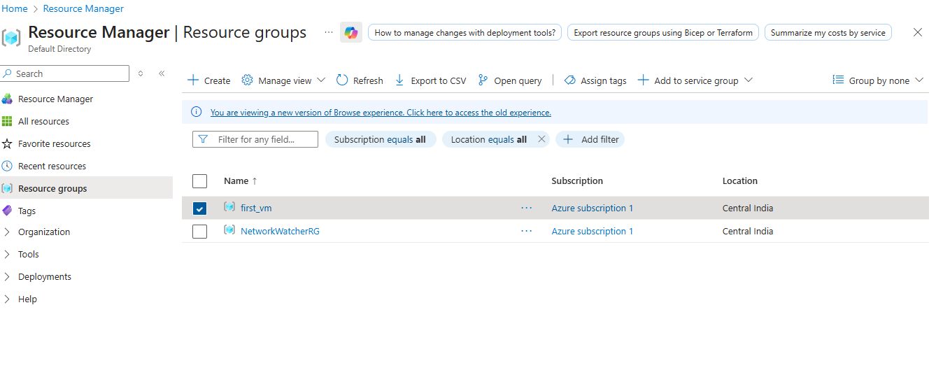
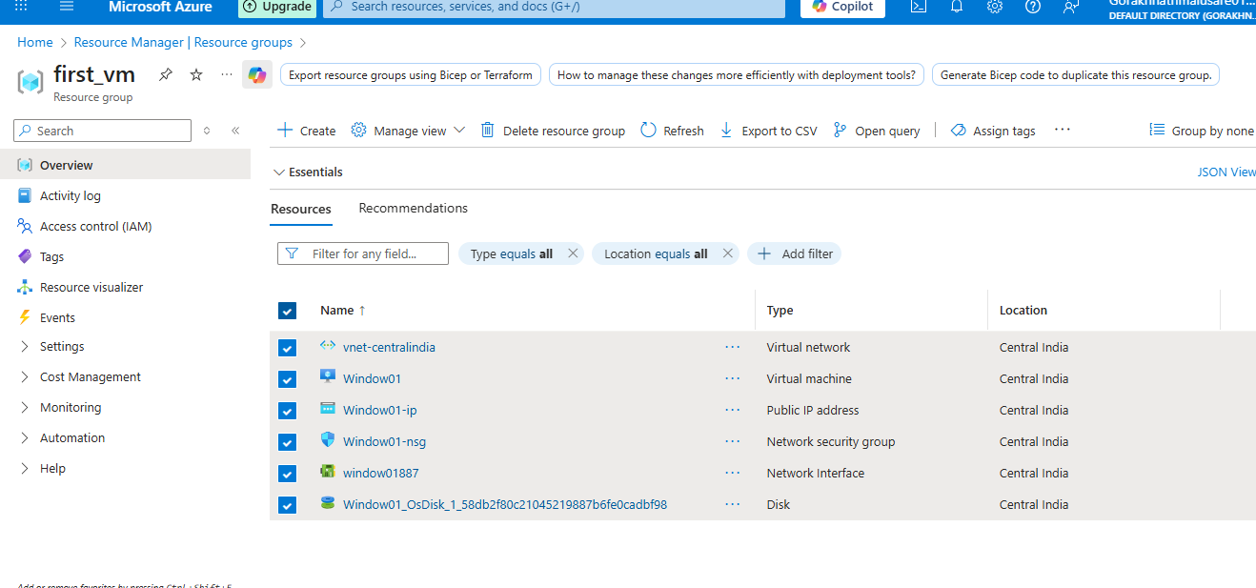
7)IF U HAVE ANY ERROR FOR ACCESSING VM USING RDP PREPER BELOW LINK:-
https://learn.microsoft.com/en-us/troubleshoot/azure/virtual-machines/windows/troubleshoot-rdp-connection

