1)Definition of Virtualization
Virtualization is the technology of creating a virtual version of a computer system, such as an operating system, server, storage device, or network, using software instead of dedicated physical hardware.

Simple Definition
Virtualization allows one physical computer to behave like multiple separate computers.

Example
A single laptop can run:
- Windows 11
- Ubuntu
- Kali Linux
at the same time using virtualization software.

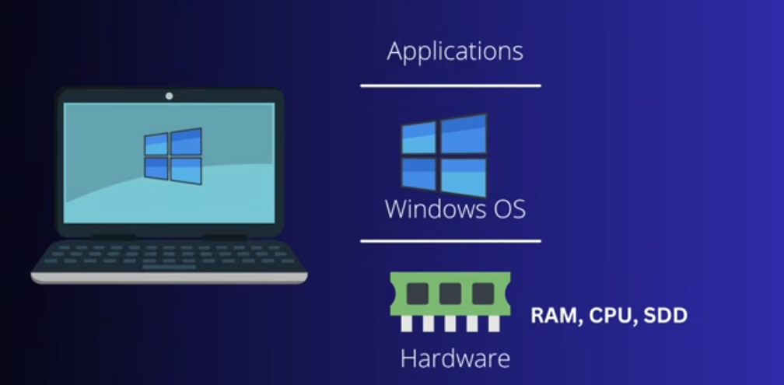

Before Virtualization
In the first image:
Applications
↓
Windows OS
↓
Hardware
This is the traditional setup.
- One computer
- One operating system
- OS directly controls hardware
Example:
- Your laptop runs only Windows 11
- All apps use that single OS

Problem
If you want Linux too:
- You must dual boot
- Or replace Windows
- Or buy another machine
Hardware resources may also stay underused.

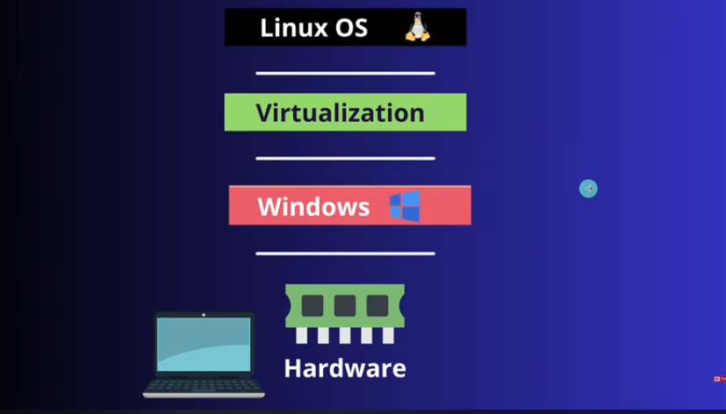

After Virtualization
Second image:
Linux OS
↓
Virtualization Layer
↓
Windows
↓
Hardware
Here:
- Windows is the host OS
- Virtualization software runs on Windows
- Linux runs as a guest OS inside a virtual machine

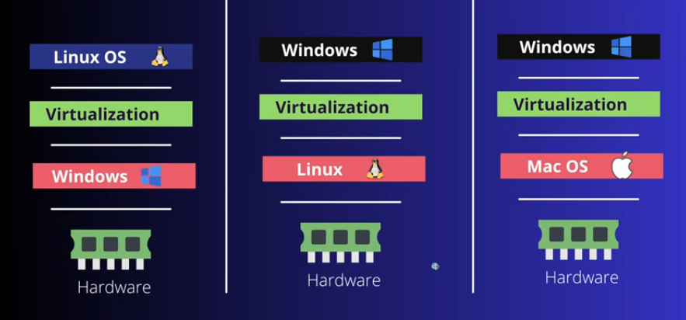

2)What is a Hypervisor?
A hypervisor is a software (or firmware) that creates and runs virtual machines (VMs) on a physical computer.
Simple definition:
A hypervisor is the “manager” that allows multiple operating systems to share one physical machine.
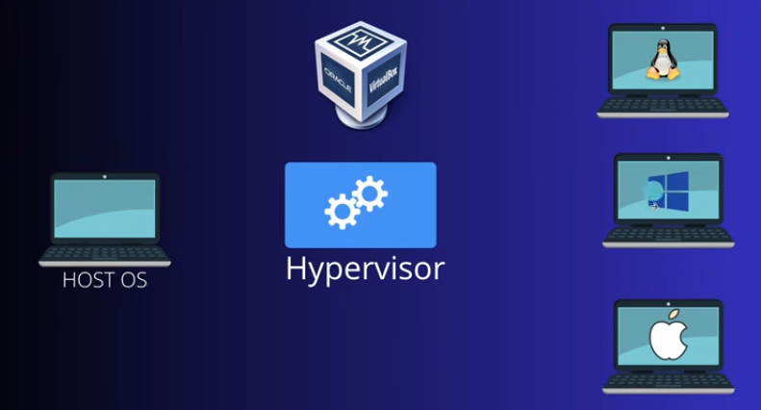
Hardware (CPU, RAM, Disk)
↓
Hypervisor
↓
Multiple Virtual Machines (VMs)
├── Windows OS
├── Linux OS
└── Kali Linux

3)How Hypervisor Creates Virtualization

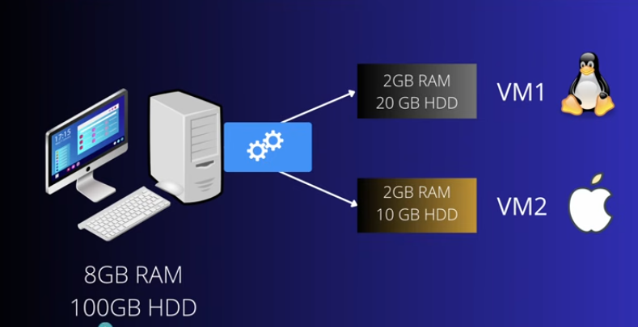
Here’s what actually happens step by step:

1. Access to Hardware
The hypervisor sits directly on hardware or on top of an OS and controls:
- CPU
- RAM
- Storage
- Network

2. Creates Virtual Hardware
For each VM, it creates “fake” hardware:
- Virtual CPU (vCPU)
- Virtual RAM
- Virtual disk
- Virtual network card
So the VM thinks it has its own computer.

3. Runs Multiple Operating Systems
Each VM gets its own OS:
- Windows 11
- Ubuntu
They run independently without interfering.

4)Types of Hypervisors

Type 1 (Bare Metal Hypervisor)
Runs directly on hardware:
Hardware
↓
Hypervisor
↓
Virtual Machines

Examples:
- VMware ESXi
- Hyper-V
- KVM

Type 2 (Hosted Hypervisor)
Runs on top of an OS:
Hardware
↓
Windows / Linux OS
↓
Hypervisor software
↓
Virtual Machines
Examples:
- VirtualBox
- VMware Workstation

5) What is VMware Workstation?
VMware Workstation is a Type-2 hypervisor (virtualization software) that lets you run multiple operating systems on a single computer.

Simple meaning:
It is software that allows you to install and use another OS (like Linux or Windows) inside your current OS without replacing it.

Example:
On your Windows laptop you can run:
- Ubuntu inside a virtual machine
- Windows 11 as the host OS

6) What VMware Workstation does
It creates a virtual computer with:
- Virtual CPU
- Virtual RAM
- Virtual hard disk
- Virtual network
So the guest OS thinks it is running on real hardware.

7)What is an ISO file?
An ISO file is a disk image file (a perfect copy of a CD/DVD or OS installation media).

Simple meaning:
An ISO file contains everything needed to install an operating system.
Example:
- Ubuntu ISO contains Linux installation files
- Windows ISO contains Windows installer

