3️) Linux File Permissions
➤ View permissions
ls –l

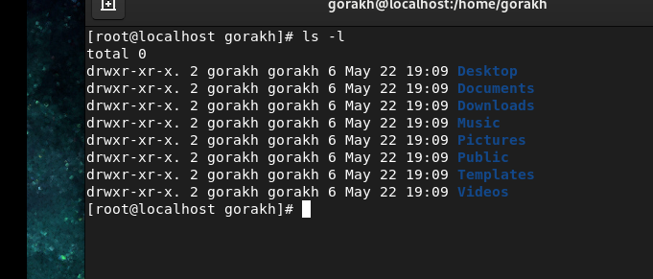
Output meaning:
-rwxr-xr-- 2 root bin 7696 Aug 18 15:20 file1

Field | Meaning
- / d | File / Directory
rwxr-xr-x | Permissions
2 | Hard links
root | Owner
bin | Group
7696 | Size
Date | Modified
file1 | Name

Permission Types
- r → Read
- w → Write
- x → Execute

Permission Levels
- User (owner)
- Group
- Others

4️)Change Permissions (chmod)
➤ Method 1: Symbolic Method
Symbol | Meaning
+ | Add permission
- | Remove permission
= | Set exact permission
Examples:
chmod u+x file1
chmod g-w file1
chmod o=r file1

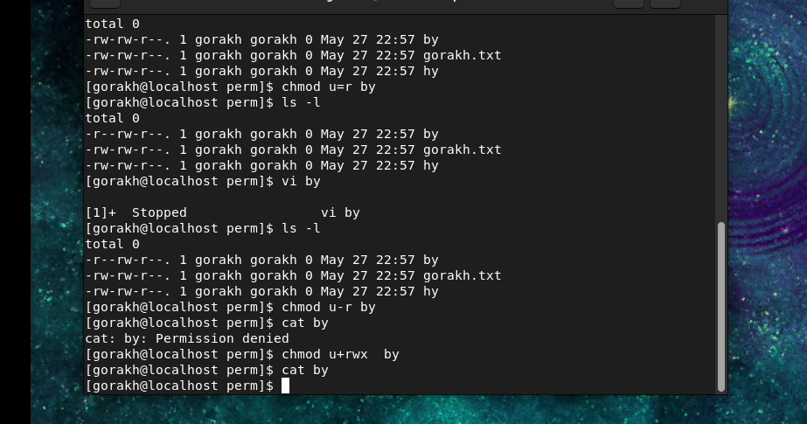

chmod -R u+rwx filename
- chmod → change permissions
- -R → recursive (apply to all files & subdirectories)
- u → user (owner)
- +rwx → add read, write, execute permissions
This affects only the owner of the file/folder.
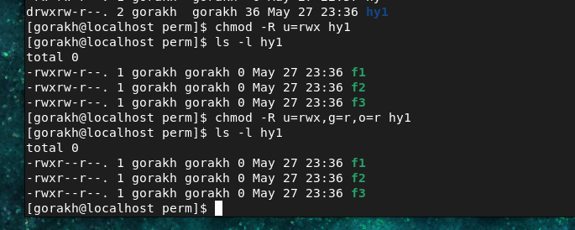

➤ Method 2: Numeric Method
Permission | Value
Read | 4
Write | 2
Execute | 1
Examples:
chmod 755 folder1
chmod 644 file1

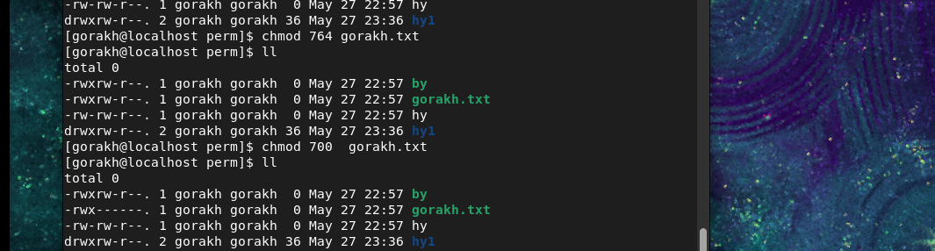

5️)chown – Change Ownership
Used to change owner and group of files/directories.
Syntax:
chown user:group filename
Example:
chown adil:linuxdept folder1/

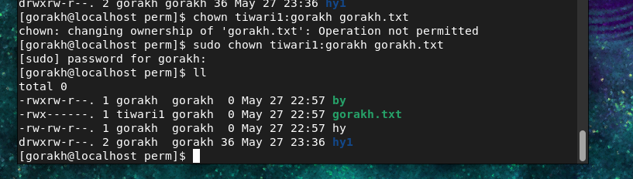
📌 Before using chown: User & group must exist.

6)Umask (User File Creation Mask)
What is Umask?
umask stands for User File Creation Mask.
It is used to set the default permissions for newly created files and directories.
Umask removes permissions from the default maximum permissions.

Default Permissions
Type | Default Permission | Numeric
File | rw-r--r-- | 644
Directory | rwxr-xr-x | 755

How Umask Works
For Files
Maximum permission = 666
For Directories
Maximum permission =
Then subtract the umask value.

Example 1
umask 022
File Permission
666 - 022 = 644
Result:
rw-r--r--
Directory Permission
777 - 022 = 755
Result:
rwxr-xr-x

Example 2
umask 777
Means:
- Remove all permissions for user, group, others.
Result:
- Newly created files/directories will have no permissions

Restore the default umask
On most Linux distributions (RHEL/CentOS/Ubuntu), the default is:
umask 022

Practical Example of umask
Requirement
You want:
- Create one folder
- Apply umask
- Any new file created inside that folder should automatically get permissions
- Others should NOT get read permission

Step-by-Step Practical
Step 1: Create Folder
mkdir project

Step 2: Go Inside Folder
cd project

Step 3: Set Umask
umask 026

Understanding 027
For Files:
666 - 026 = 640
Result:
rw-r-----
Meaning:
- Owner → Read + Write
- Group → Read
- Others → No Permission
✅ Others cannot read the file.
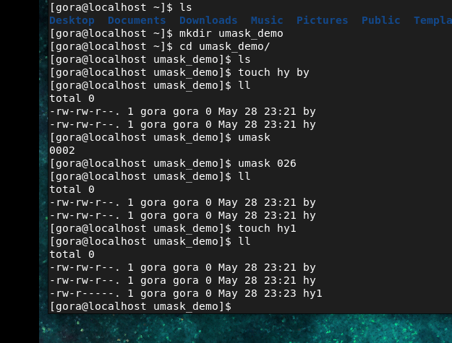

Step 4: Create File
touch data.txt

Step 5: Check Permission
ls -l
Example Output:
-rw-r----- 1 root root 0 May 28 10:00 data.txt

