2.Linux Process Management
What is a Process?
A process is a program in execution.
Whenever you run a command, a process starts.
Example:
firefox
This starts a Firefox process.

Kernel Functions
Kernel is responsible for:
- Managing processes
- Assigning PID
- Giving RAM
- Giving storage

PID and PPID
Term | Meaning
PID | Process ID
PPID | Parent Process ID
One parent process can have multiple child processes.

Process States
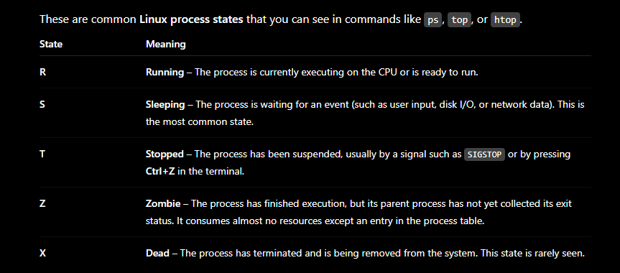

Types of Processes
1. Foreground Process
- Runs on terminal
- User interacts with it
Example:
sleep 100
Terminal waits for 100 seconds.
Stop process:
Press:
CTRL + C
This kills the process.

2. Background Process
- Runs behind terminal
- User can continue work
Example:
sleep 100 &
Example Output:
[1] 2456
Here:
- 1 = Job number
- 2456 = PID

Check Running Processes
Using ps
ps -aux
ps
top

Search Specific Process
ps -aux | grep sleep
Example Output:
root 2456 0.0 sleep 100
PID = 2456
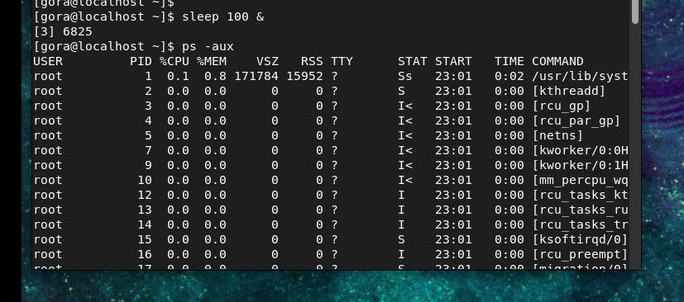

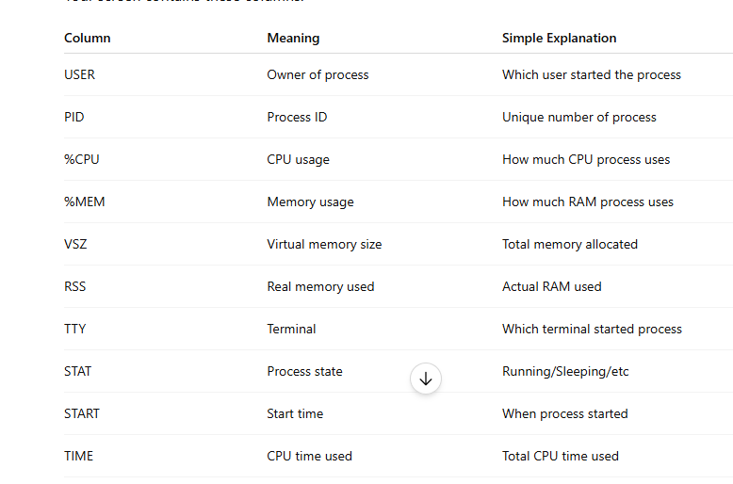

Start Process Example
Start Firefox
firefox &

Start Sleep Process
sleep 500 &

Stop/Delete Process
Method 1: Kill Using PID
Syntax:
kill PID
Example:
kill -9 2456
This stops the process.
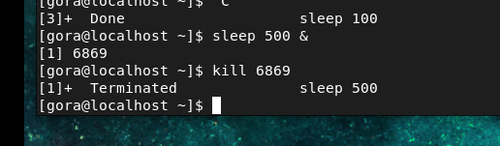

Verify Process Stopped
ps -aux | grep sleep
If no output appears, process is terminated.

Force Kill Process
Sometimes process does not stop normally.
Use:
kill -9 PID
Example:
kill -9 2456
-9 means forcefully kill process.

3. Control Services and Daemons
What is a Daemon?
A daemon is a background service process in Linux.
It runs continuously and performs system tasks.

Examples:
- sshd
- httpd
- named
- nfsd
Most daemon names end with letter d.

What is httpd?
httpd = HTTP Daemon
It is the Apache Web Server service used to host websites.
When httpd runs:
- System provides web pages
- Browser can access website

Features of Daemons
- Run in background
- No controlling terminal
- Start automatically during boot
- Perform important system tasks

systemd
systemd is Linux service manager.
It controls:
- Start service
- Stop service
- Restart service
- Enable service at boot

systemctl Command
systemctl = System Control
Used to manage Linux services.

Offline Service Example: CROND (Cron Service)
What is crond?
crond is a default Linux service used for:
- Scheduling tasks
- Running commands automatically at fixed time
Example:
- Run backup daily
- Run script every hour

Important systemctl Commands (crond)
Command | Meaning
systemctl status crond | Check service status
systemctl start crond | Start service
systemctl stop crond | Stop service
systemctl restart crond | Restart service
systemctl enable crond | Start at boot
systemctl disable crond | Disable at boot
systemctl is-active crond | Check running or not

✔ Practical Using crond

Step 1: Check Status
systemctl status crond
If output:
active (running)
✔ Means service is already running (default service)
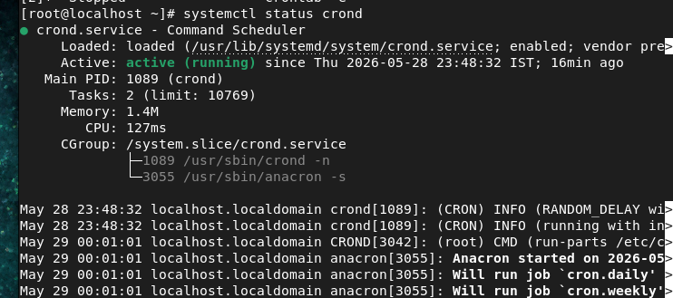

Step 2: Stop Service
systemctl stop crond
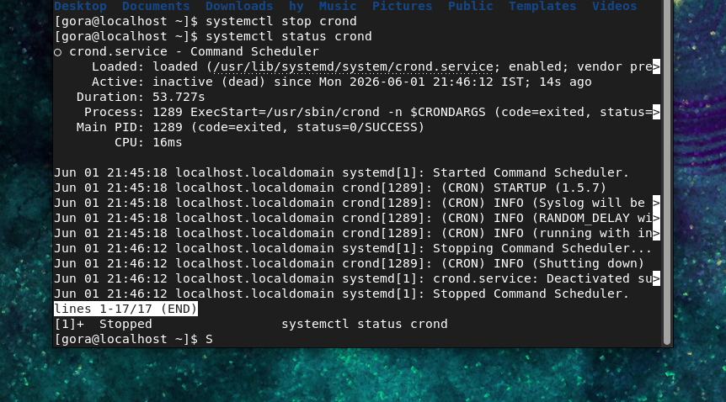

Step 3: Check Again
systemctl status crond
Output:
inactive (dead)

Step 4: Start Service
systemctl start crond
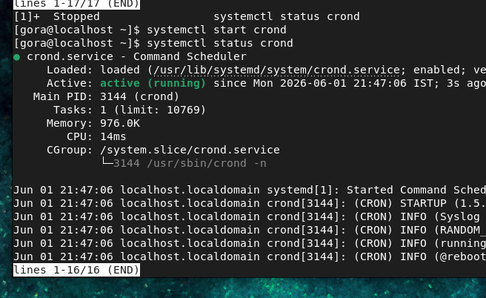

Step 5: Enable at Boot
systemctl enable crond
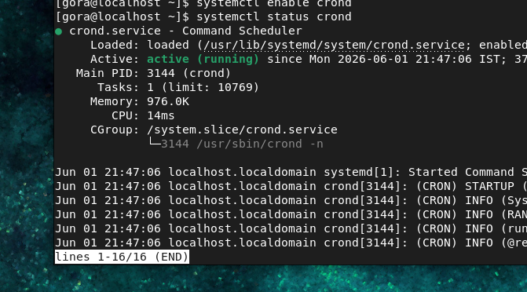
Meaning:
- Service will start automatically after reboot

Step 6: Check Active Status
systemctl is-active crond

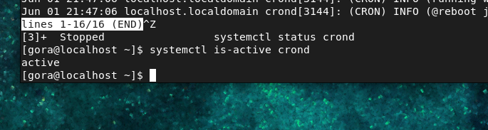
Output:
active

4. VI Editor with Small Project (Practical)
What is vi Editor?
vi is a text editor in Linux/UNIX.
Used for:
- Creating files
- Editing configuration files
- Writing shell scripts
- Editing web pages

Open vi Editor
vi filename
Example:
vi project.txt

Modes of vi Editor
Mode | Work
Command Mode | Default mode
Insert Mode | Type text
Last Line Mode | Save/Quit commands

Important vi Commands
Command | Meaning
i | Insert mode
a | Insert after cursor
o | New line
dd | Delete line
yy | Copy line
p | Paste
u | Undo
/word | Search word
gg | First line
G | Last line
:wq | Save and exit
:q! | Exit without save

Small Project Using vi Editor
Project Name:
Create Simple Student Information File
Goal:
- Create file
- Add student details
- Edit data
- Save file

Step 1: Create Project Folder
mkdir student_project

Step 2: Go Inside Folder
cd student_project

Step 3: Open vi Editor
vi students.txt

Step 4: Enter Insert Mode
Press:
i
Bottom of terminal shows:
-- INSERT --

Step 5: Type Data
Student Information
Name: Rahul
Course: Linux
City: Mumbai

Step 6: Exit Insert Mode
Press:
ESC

Step 7: Save and Exit
Type:
:wq
Then press Enter.

Step 8: Check File
cat students.txt
Output:
Student Information
Name: Rahul
Course: Linux
City: Mumbai

Editing Existing File
Open file again:
vi students.txt

Add New Line
Press:
o
Type:
Phone: 9876543210
Save:
:wq

Delete Line Example
Open file:
vi students.txt
Move cursor to line.
Press:
dd
Line deleted.

Copy and Paste Example
Copy Line
Press:
yy

Paste Line
Press:
p

Undo Changes
Press:
u

Search Word
Type:
/Rahul
Press Enter.

Go to First and Last Line
Command | Work
gg | First line
G | Last line

Real-Time Practical Example
Create Website File
vi index.html
Press:
i
Type:
<html>
<head>
<title>My Website</title>
</head>
<body>
<h1>Welcome to Linux</h1>
</body>
</html>
Press:
ESC
Save:
:wq

View File
cat index.html

Linux File System Structure
Linux uses a single root directory (/). Everything in Linux starts from the root directory.
/
├── /bin -> Essential user commands
├── /boot -> Boot loader & kernel files
├── /dev -> Device files
├── /etc -> Configuration files
├── /home -> User home directories
├── /lib -> Essential shared libraries
├── /lib64 -> 64-bit shared libraries
├── /media -> Auto-mounted removable devices
├── /mnt -> Temporary mount points
├── /opt -> Optional third-party software
├── /proc -> Process & kernel information
├── /root -> Root user's home directory
├── /run -> Runtime process data
├── /sbin -> System administration commands
├── /srv -> Service data
├── /sys -> Hardware & kernel information
├── /tmp -> Temporary files
├── /usr -> User programs & utilities
├── /var -> Variable data (logs, cache, mail)
└── /lost+found -> Recovered filesystem data (on ext2/ext3/ext4)
Note: On modern Linux, /bin, /sbin, /lib, and /lib64 are often symbolic links to directories under /usr, but they still appear in the root directory for compatibility.

1. /etc (Configuration Files)

Purpose
Stores system-wide configuration files.

Examples
/etc/passwd
/etc/shadow
/etc/hostname
/etc/fstab
/etc/ssh/sshd_config

Use Cases
- User accounts
- Network configuration
- SSH configuration
- Service settings
- Filesystem mount configuration

Remember
ETC = Editable Text Configuration

2. /root (Root User Home)

Purpose
Home directory of the root (administrator) user.

Example
/root

Difference
Normal User → /home/john
Root User → /root

Remember
Root user's personal folder.

3. /boot (Boot Files)

Purpose
Contains all files required to start Linux.

4. /home (User Data)

Purpose
Stores users' personal files.
Example
/home/john
/home/alice
Contains
- Desktop
- Documents
- Downloads
- Music
- Pictures
- Videos

Remember
User's personal workspace.

5. /var (Variable Data)

Purpose
Stores data that changes frequently.
Important folders
/var/log
/var/cache
/var/mail
/var/spool
Examples
/var/log/messages
/var/log/secure

Remember
VAR = Variable files

6. /tmp (Temporary Files)

Purpose
Stores temporary files.
Example
/tmp/test.txt
Features
- Used by applications
- Automatically cleaned

Remember
TEMP = Temporary storage

7. /usr (User Programs)

Purpose
Stores installed software.
Structure
/usr
├── bin
├── sbin
├── lib
├── share
└── local
Examples
/usr/bin/python
/usr/bin/vim
/usr/share/man

Remember
Most software lives here.

8. /dev (Device Files)

Purpose
Hardware devices appear as files.
Examples
/dev/sda
/dev/sda1
/dev/null
/dev/tty
/dev/random

Remember
Everything in Linux is a file.

9. /run (Runtime Data)

Purpose
Stores runtime information after boot.
Examples
/run/systemd
/run/lock
/run/user
Contains
- PID files
- Runtime sockets
- Lock files

Remember
Exists only while Linux is running.

10. /proc (Process Information)

Purpose
Virtual filesystem containing process and kernel information.
Examples
/proc/cpuinfo
/proc/meminfo
/proc/version
Useful Commands
cat /proc/cpuinfo
cat /proc/meminfo

Remember
PROC = Process Information

11. /srv (Service Data)

Purpose
Stores data served by network services.
Examples
/srv/www
/srv/ftp
Used by
- Apache
- FTP
- NFS

Remember
SRV = Service Data

12. /sys (System Information)

Purpose
Virtual filesystem containing hardware information.
Examples
/sys/class
/sys/block
/sys/devices

Used For
- Hardware details
- Device management
- Kernel tuning

Remember
SYS = System Hardware View

13. /lib

Purpose
Stores essential shared libraries.
Example
/lib
Windows equivalent
DLL Files
Linux equivalent
.so files

Remember
Programs cannot run without these libraries.

14. /lib64

Purpose
Stores 64-bit shared libraries.
Example
/lib64

Remember
64-bit library folder.

15. /opt

Purpose
Stores optional third-party software.
Examples
/opt/google
/opt/oracle
/opt/tomcat

Remember
OPT = Optional Software

16. /mnt

Purpose
Temporary mount point.
Example
mount /dev/sdb1 /mnt

Remember
MNT = Mount temporarily

17. /media

Purpose
Automatically mounts removable devices.
Examples
/media/usb
/media/cdrom
Devices
- USB
- DVD
- Memory Card

Remember
MEDIA = External Storage

18. /bin

Purpose
Stores essential commands required by all users.
Examples
/bin/ls
/bin/cp
/bin/mv
/bin/cat
/bin/bash

Remember
BIN = Basic Commands

19. /sbin

Purpose
Stores system administration commands.
Examples
/ssbin/fsck
/sbin/reboot
/sbin/shutdown
Usually used by:
- Root
- System administrators

Remember
SBIN = System Administration Commands

