Linux Task Scheduling (at & Cron) – Practical Teaching Notes
What is Task Scheduling?
Task Scheduling means running commands automatically at a specific time without manual intervention.
Linux provides two tools:
1. at
- Runs a task only once.
- Used for one-time scheduling.
2. cron
- Runs tasks repeatedly.
- Used for recurring scheduling.

Part 1: Configure System Time
Before scheduling tasks, verify the system time and timezone.
Check Current Time and Timezone
Timedatectl
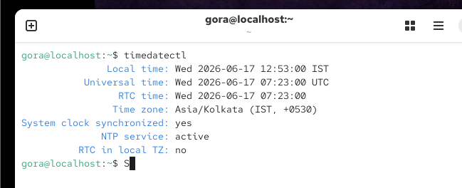
Output shows:
- Current Date
- Current Time
- Timezone

Set Timezone to India
sudo timedatectl set-timezone Asia/Kolkata
Verify:
Timedatectl
1. Check current time
timedatectl

You'll see something like:

Local time: Thu 2026-09-03 15:02:10 IST
Time zone: Asia/Kolkata
NTP enabled: yes
2. Change the time manually

First, disable automatic time synchronization:

sudo timedatectl set-ntp false

Then set the required time. For example, to set it to 8:30 PM:

sudo timedatectl set-time "20:30:00"

Check:

date
3. Change the date and time together

For example:

sudo timedatectl set-time "2026-09-03 20:30:00"

Then verify:

timedatectl

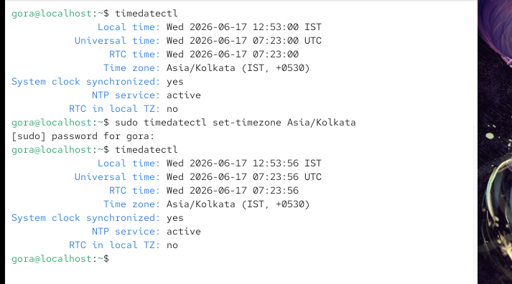
Expected:
Time zone: Asia/Kolkata (IST)

Part 2: One-Time Scheduling Using at
What is at?
The at command schedules a command to run once at a specified future time.
Real-Life Example
Suppose you want a directory to be created automatically after 2 minutes.

Install at Service
RHEL/CentOS
sudo yum install at -y
sudo systemctl start atd
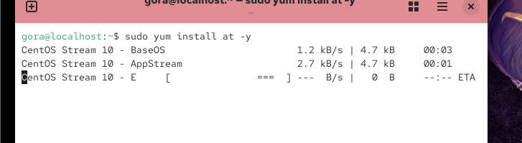

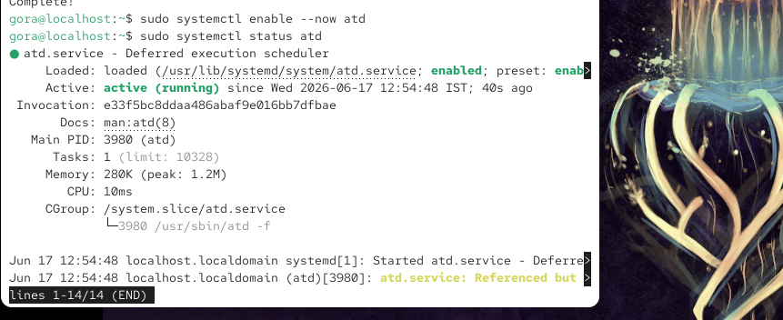
Ubuntu
apt install at -y
systemctl enable --now atd
Verify service:
systemctl status atd

Practical 1: Run Job After 2 Minutes
Schedule job:
at now +2 minutes
You will get:
at>
Type:
mkdir /tmp/gog
Save:
Ctrl + D
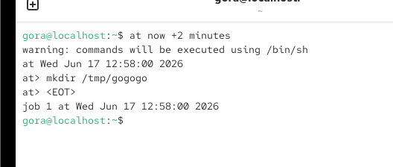

Verify
After 2 minutes:
ls /tmp
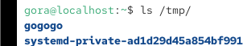
Output:
gogogo

Practical 2: View Scheduled Jobs
List jobs:
atq

OR
at -l
Example:
1 Tue Jun 17 13:30:00 2026 a root
Explanation:
Field | Meaning
1 | Job ID
Tue Jun 17 | Date
13:30 | Execution Time
root | User

Practical 3: Schedule at Specific Time
at 12:58 PM
at> echo "Backup completed" > /tmp/backup.txt
at> Ctrl+D
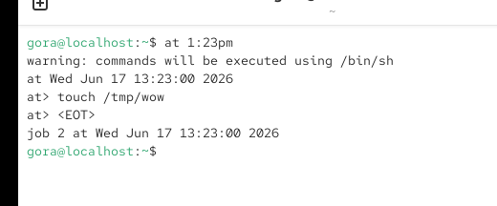
At 1:23 PM the file will be created.
Verify:
ls /tmp

Practical 4: Schedule on Specific Date
Run:
at 1:10pm 17 Jan 2026
Type:
mkdir /tmp/jan17
Save:
Ctrl + D
The directory will be created on 17 January 2026 at 1:28 PM.
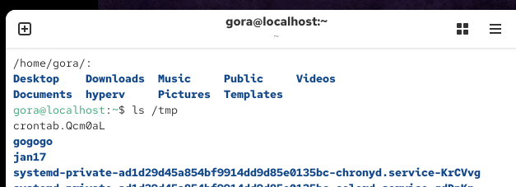

Practical 5: Remove Scheduled Job
View jobs:
atq
Example:
2 Tue Jun 17 15:00:00 2026 a root
Remove job:

atrm 2
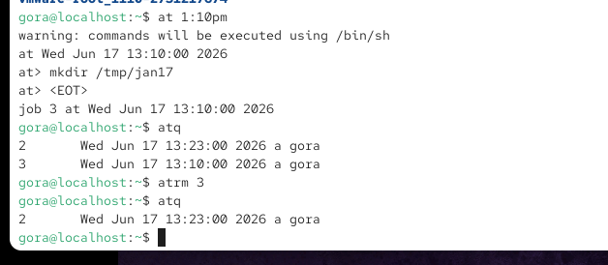
Verify:
atq
Job should disappear.

Summary of at Commands
Command | Purpose
at now +2 minutes | Run after 2 minutes
at 1:30pm | Run at specific time
at 1:30pm 17 Jan 2026 | Run on specific date
atq | List jobs
at -l | List jobs
atrm jobid | Delete job

Part 3: Recurring Tasks Using Cron
What is Cron?
Cron runs commands automatically at fixed intervals.
Examples:
- Every minute
- Every hour
- Every day
- Every Sunday
- Every month

View Existing Cron Jobs
crontab -l

Edit Cron Jobs
crontab -e

Remove All Cron Jobs
crontab -r

Cron Syntax
* * * * * command
│ │ │ │ │
│ │ │ │ └── Day of Week (0-6)
│ │ │ └──── Month (1-12)
│ │ └────── Day of Month (1-31)
│ └──────── Hour (0-23)
└────────── Minute (0-59)

Practical 1: Run Every Minute
Edit cron:
crontab -e
Add:
* * * * * mkdir -p /tmp/testdir
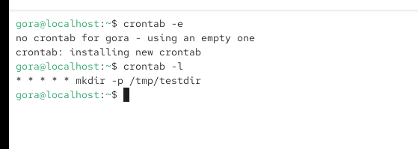
Save and exit.
Verify:
ls /tmp
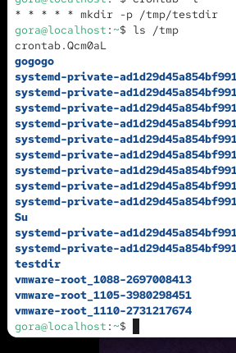
Directory appears after one minute.

Practical 2: Run Every Hour at Minute 5
4 * * * * mkdir -p /tmp/hourlydir
Runs:
1:05
2:05
3:05
4:05

Practical 3: Run Every 2 Minutes
*/2 * * * * mkdir -p /home/gora/hyperv
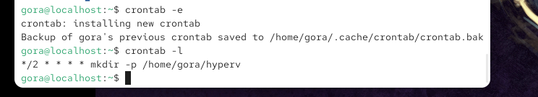
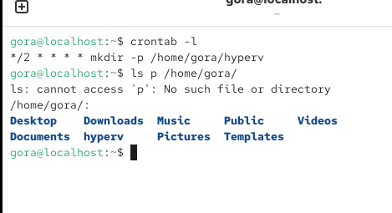
Runs:
00
02
04
06
08
10
...
Explanation:
*/2 = Every 2 minutes

Practical 4: Run Daily at 2:02 AM
2 2 * * * mkdir -p /tmp/dailydir
Meaning:
Field | Value
Minute | 2
Hour | 2
Day | Every Day
Month | Every Month
Weekday | Every Day
Runs:
02:02 AM Daily

Practical 5: Create Backup Every Day
0 22 * * * tar -czf /backup/home.tar.gz /home
Meaning:
10:00 PM every day
Creates backup automatically.

Cron Examples for Students
Schedule | Cron Entry
Every minute | * * * * * command
Every 2 minutes | */2 * * * * command
Every 5 minutes | */5 * * * * command
Every hour | 0 * * * * command
Daily at 2 AM | 0 2 * * * command
Every Sunday | 0 0 * * 0 command
First day of month | 0 0 1 * * command

Where does crontab -e actually store the file?
On RHEL/CentOS, user crontabs are normally stored under:
/var/spool/cron/
For example, if your username is gora:
/var/spool/cron/gora
You can check:
sudo ls -l /var/spool/cron/

Practical 5: Managing Priority of Linux Processes
Objective
Learn how to:
- Understand processes
- Check process priority
- Start a process with a custom priority using nice
- Change the priority of a running process using renice

2.What is a Process?
A process is simply a program that is currently running in memory.
Examples
firefox
vim file1.txt
gedit
sleep 1000
Whenever you run a command or application, Linux creates a process for it.

What is Process Priority?
The CPU can handle many processes, but it cannot execute all of them at the exact same time.
Linux decides which process gets more CPU time using priority.

Real-Life Example
Imagine three people waiting at a ticket counter:
Person A → High Priority
Person B → Normal Priority
Person C → Low Priority
The counter serves Person A first because they have higher priority.
Similarly, Linux gives more CPU time to processes with higher priority.

Nice Value (NI)
Linux uses a value called Nice Value (NI) to control process priority.
Range
-20 -------- 0 -------- +19
High Normal Low
Priority Priority Priority

Important Rule
Lower Nice Value = Higher Priority
Higher Nice Value = Lower Priority
Quick Reference
Nice Value (NI) | Priority
-20 | Highest
0 | Default
+19 | Lowest

Practical 1: Check Default Process Priority
Step 1: Start a Process
sleep 300 &
Example Output:
[1] 1234
Here:
1234 = PID (Process ID)

Step 2: Check Priority
ps -l
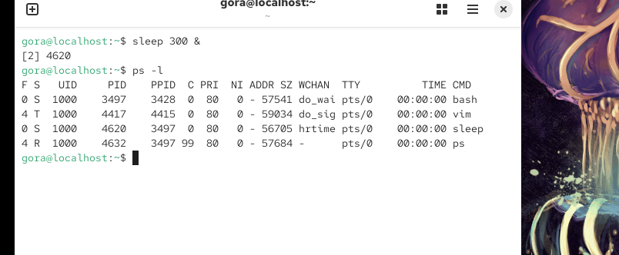
Example Output:
F S UID PID PPID C PRI NI ADDR SZ WCHAN TTY TIME CMD
0 S 1000 1234 1001 0 80 0 - 670 hrtime pts/0 00:00:00 sleep
Important Columns:
Column | Meaning
PID | Process ID
PRI | Process Priority
NI | Nice Value
CMD | Command
Current Process:
PID = 1234
NI = 0
This is the default priority.

NICE Command
What is nice?
The nice command starts a new process with a specific priority.
Syntax
nice -n NICE_VALUE command

Practical 2: Start a Low Priority Process
Step 1: Start Process
nice -n 10 sleep 300 &
Example Output:
[1] 2345
PID:
2345
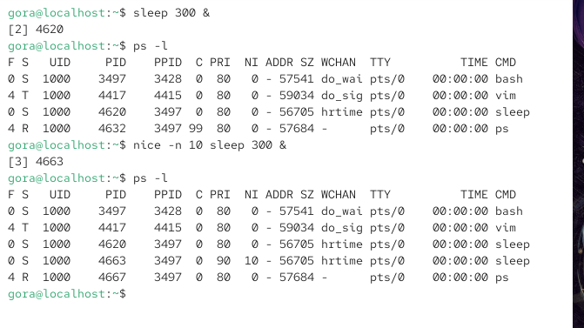

Step 2: Verify Priority
ps -l -p 2345
Example Output:
F S UID PID PPID C PRI NI ADDR SZ WCHAN TTY TIME CMD
0 S 1000 2345 1001 0 90 10 - 670 hrtime pts/0 00:00:00 sleep
Notice:
NI = 10
Meaning:
This process gets less CPU time than normal processes.

Practical 3: Start a Very Low Priority Process
nice -n -10 sleep 300 &
Check:
ps -l
Output:
PID PRI NI CMD
2500 99 19 sleep
Meaning:
Lowest priority process.
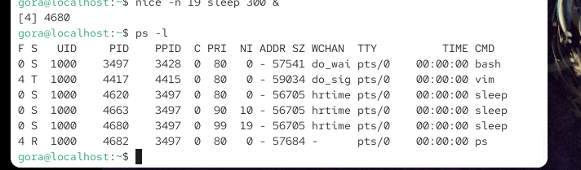

RENICE Command
What is renice?
The renice command changes the priority of a process that is already running.
Syntax
renice -n NICE_VALUE -p P ID

Practical 4: Change Priority of Running Process
Step 1: Start Process
sleep 500 &
Example:
[1] 3456
PID:
3456

Step 2: Check Current Priority
ps -l -p 3456
Example Output:
PID PRI NI CMD
3456 80 0 sleep
Current Nice Value:
NI = 0

Step 3: Change Priority
Make it lower priority:
renice -n -10 -p 33627
Example Output:
3456 (process ID) old priority 0, new priority 10

Step 4: Verify
ps -l -p 3456
Output:
PID PRI NI CMD
3456 90 10 sleep
Now:
NI = 10
The process has lower priority.
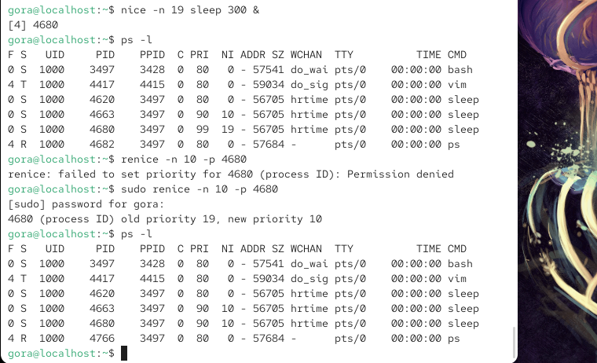

top command formula

1. CPU Usage Formula
The basic idea is:
CPU Usage % = 100% - CPU Idle %
For example:
id = 92%

2. Memory Usage
top may show:
MiB Mem : 7850 total, 1200 free, 3500 used, 3150 buff/cache
A commonly useful calculation is:
Used Memory ≈ Total - Free - Buff/Cache

Practical 6: Access Control Lists (ACL) in Linux
Objective
Learn how to:
- Understand ACL
- Check ACL permissions
- Give permissions to a specific user
- Give permissions to a specific group
- Remove ACL entries
- Apply ACL recursively
- Configure Default ACL

What is ACL?
ACL (Access Control List) is an advanced permission system in Linux.
Normally Linux permissions work with only:
user (u)
Group (g)
Others (o)
Example:
-rwxr-x---
Meaning:
Category | Permission
user | rwx
Group | r-x
Others | ---

Problem with Normal Permissions
Suppose:
Owner = harish
Group = developers
User = ritik
You want only ritik to access a file.
But:
- Ritik is not the owner
- Ritik is not in the group
Normal Linux permissions cannot easily do this.
ACL solves this problem.
ACL allows permissions to be assigned directly to specific users or groups without changing ownership.

Real-Life Example
Imagine a room:
Owner = House Owner
Group = Family
Others = Everyone Else
Normally only these three categories get access.
ACL is like saying:
"Ritik is not family,
but I am giving him a special key."

Practical 1: Create Users and Directory
Step 1: Create Users
useradd harish
groupadd harish1
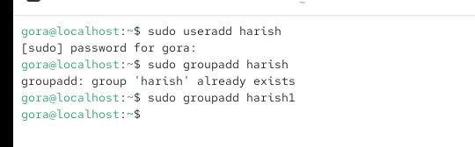

Step 2: Create Directory
mkdir private

Check permissions:
ls -ld private
Example:
drwxr-xr-x
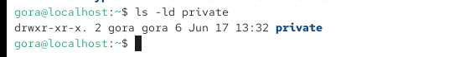

Practical 2: Check Current ACL
View ACL:
getfacl private
Example Output:
# file: private
# owner: root
# group: root
user::rwx
group::r-x
other::r-x
Currently:
No special ACL exists.
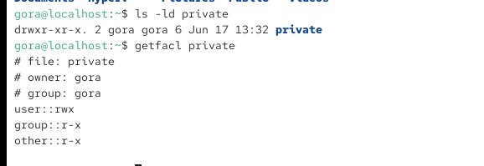

Access ACL
What is Access ACL?
Access ACL gives permissions to an existing file or directory.
It affects only the current object.

Practical 3: Give Permission to a User
Syntax
setfacl -m u:username:rwx filename
Example
setfacl -m u:harish:rwx private
Meaning:
Option | Meaning
-m | Modify ACL
u | User
ritik | Username
rwx | Read, Write, Execute

Verify ACL
getfacl private
Output:
user::rwx
user:ritik:rwx
group::r-x
other::r-x
Notice:
user:ritik:rwx
This is the ACL entry.
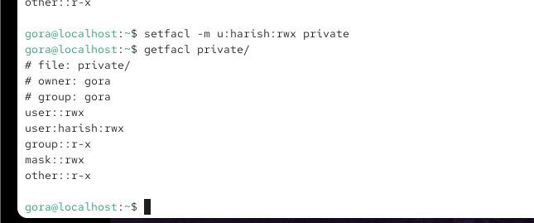

ACL Indicator (+)
Check:
ls -ld private
Output:
drwxrwxr-x+
Notice:
+
Meaning:
ACL is configured on this file/directory.
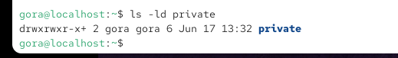

Practical 4: Give Permission to a Group

Step 2: Apply ACL
setfacl -m g:harish1:rwx private

Step 3: Verify
getfacl private
Output:
group:project:rwx
Now all members of group project have rwx access.
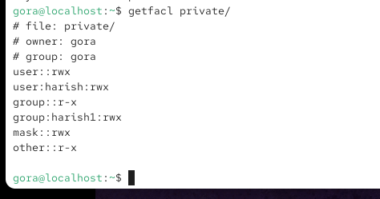

Practical 5: Remove ACL for User
Remove Ritik ACL:
setfacl -x u:harish private
Verify:
getfacl private
Output:
user:ritik:rwx
Entry should disappear.
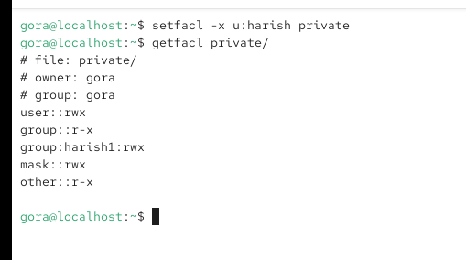

Practical 6: Remove ACL for Group
Remove ACL:
setfacl -x g:harish1 private
Verify:
getfacl private
Group ACL disappears.
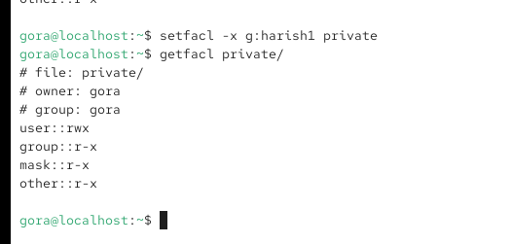

Practical 7: Remove All ACL Entries
Remove all ACLs:
setfacl -b private
Meaning:
-b = Remove all ACL entries
Verify:
getfacl private
Output returns to normal Linux permissions.
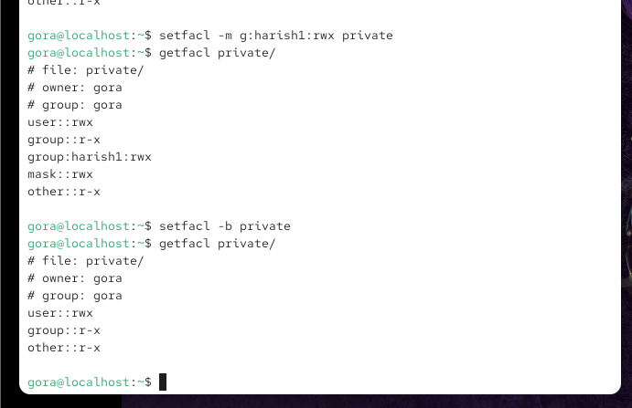

Recursive ACL
What is Recursive ACL?
Suppose:
private/
├── file1
├── file2
└── docs/
You want ACL applied to:
private
file1
file2
docs
Use Recursive ACL.

Practical 8: Apply ACL Recursively
Create test structure:
sudo mkdir -p private/docs
sudo touch private/file1
sudo touch private/file2
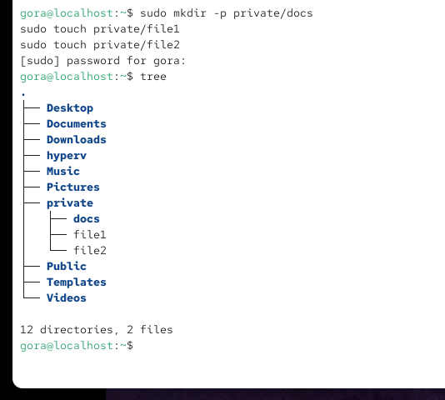
Apply ACL:
setfacl -Rm u:harish:rwx private
Meaning:
Option | Meaning
-R | Recursive
-m | Modify

Verify:
getfacl private/file1
getfacl private/file2
getfacl private/docs
All objects receive ACL.
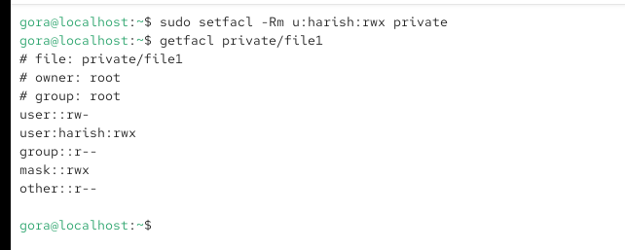

Default ACL
Problem
Suppose ACL is set:
setfacl -m u:harish:rwx private
Later someone creates:
touch private/newfile
Ritik may not automatically get permissions on the new file.

What is Default ACL?
Default ACL automatically applies permissions to future files and directories created inside a directory.

Practical 9: Configure Default ACL
Apply Default ACL:
setfacl -dm u:harish:rwx private
Meaning:
Option | Meaning
-d | Default ACL
-m | Modify

Verify Default ACL
getfacl private
Output:
default:user:ritik:rwx
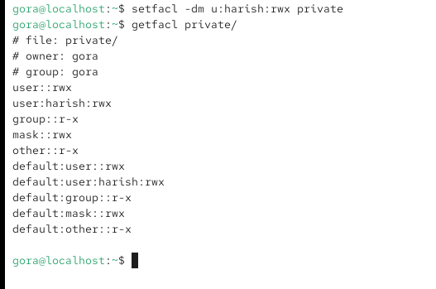

Practical 10: Test Default ACL
Create a new file:
touch private/newfile
Check:
getfacl private/newfile
Output:
user:harish:rwx
Ritik automatically inherits permissions.
