- SELinux (Security-Enhanced Linux)

1️What is SELinux?
SELinux (Security-Enhanced Linux) is a security framework built into Linux that provides Mandatory Access Control (MAC).
🔹 Why SELinux?
- Protects the system even if a service is compromised
- Limits what a process can do
- Prevents:
  - Privilege escalation
  - Buffer overflow attacks
  - Unauthorized file access

2⃣ DAC vs MAC (Easy Explanation)
DAC (Discretionary Access Control)
- Traditional Linux permissions
- Based on:
  - Owner
  - Group
  - Others
- Example: chmod, chown
If a process runs as root → it can access almost everything

🔸 MAC (Mandatory Access Control – SELinux)
- Access controlled by security policies
- Even root user is restricted
- Policies define:
  - What a process can or cannot access
More secure than DAC

3 SELinux Security Context
Every object in Linux has a security context.(label)
Objects include:
- Files
- Directories
- Processes
📌 Security Context Format
user:role:type:level
📌 Example:
system_u:object_r:httpd_sys_content_t:s0

1. system_u → SELinux user
system_u
This is the SELinux user associated with the file.
It is not the same as a normal Linux user like root, ansible, or gora.

2. object_r → SELinux role
object_r
r means role for an object.
Since this context belongs to a file/directory, object_r is commonly seen.

3. httpd_sys_content_t → SELinux type ⭐
This is the most important part when working with web servers.
httpd_sys_content_t
It tells SELinux:
"This file is allowed to be used as content by the Apache/httpd service."
For example:
ls -Z /var/www/html/index.html
You might see:
system_u:object_r:httpd_sys_content_t:s0
This means Apache can normally read the file and serve it to clients.
For example:
Browser
↓
Apache/httpd
↓
index.html
↓
httpd_sys_content_t
SELinux checks the type before allowing access.

4. s0 → Security level
s0
This is the SELinux MLS/MCS security level.
For basic SELinux administration, you generally don't need to change it.

4️⃣ SELinux Modes
SELinux has 3 modes:
Enforcing (Recommended)
- Policies are enforced
- Access denied if not allowed
- Logs violations
Used in production

Permissive
- Policies not enforced
- Only logs violations
- Used for testing/debugging

Disabled
- SELinux completely OFF
- Not recommended

Main SELinux log locations
On RHEL/CentOS, check:
/var/log/audit/audit.log

5️⃣ Check SELinux Status
🔹 Check current mode
getenforce
Output:
- Enforcing
- Permissive
- Disabled
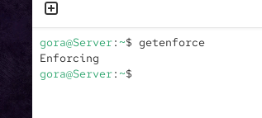

6️⃣ Change SELinux Mode (Temporary)
🔹 Switch to permissive
setenforce 0
# OR
setenforce permissive

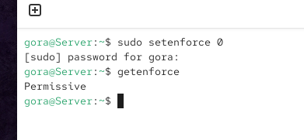
Switch to enforcing
setenforce 1
# OR
setenforce enforcing
📌 Note: Changes lost after reboot

7️⃣ View SELinux Context of Files
Command:
ls -Z

unconfined_u:object_r:user_home_t:s0
Field | Value | Meaning
User | unconfined_u | SELinux user
Role | object_r | Role assigned to files/directories
ls -ZType | user_home_t | Security type (most important)
Level | s0 | Security level

🔹 Example:
ls -Z /var/www/html
Shows:
- File name
- Permissions
- SELinux context

8️⃣ View SELinux Port Information
🔹 Command:
semanage port -l
📌 Shows:
- SELinux type
- Protocol (TCP/UDP)
- Port numbers
Example:
http_port_t tcp 80, 443

9️⃣ SELinux & Firewalld
SELinux | Firewalld
Controls file & process access | Controls network traffic
MAC-based security | Network firewall
Internal protection | External protection
Both should be used together for layered security

PRACTICAL LAB: SELinux with HTTPD

🔟 Install Apache (HTTPD)
sudo yum install httpd -y

1️⃣1️ Create Web Page
sudo cd /var/www/html
sudo vi index.html
Sample HTML:
<html>
<body>
<h1>Welcome to SELinux Demo</h1>
</body>
</html>
Save and exit.
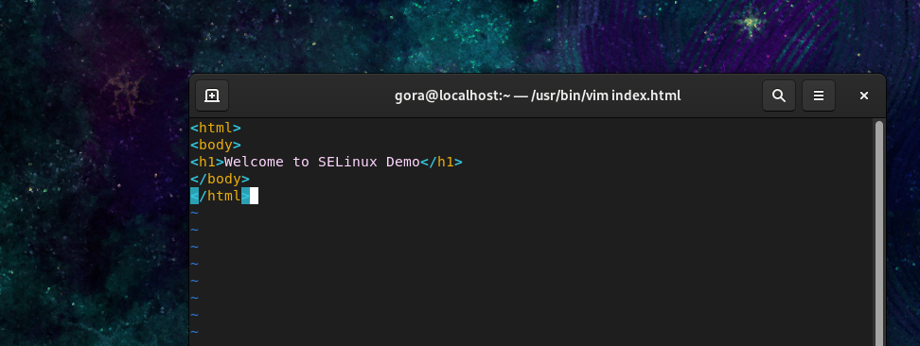

1️⃣2️Start HTTPD Service
systemctl start httpd
systemctl status httpd

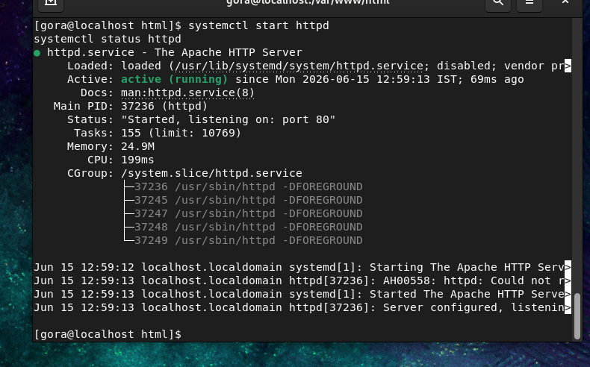

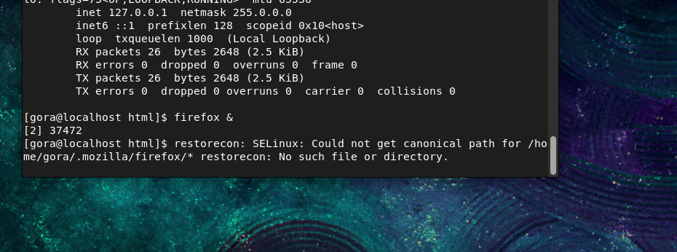

1️⃣3️Test Website
Open browser and search:
http://localhost
c
http://<your-IP>

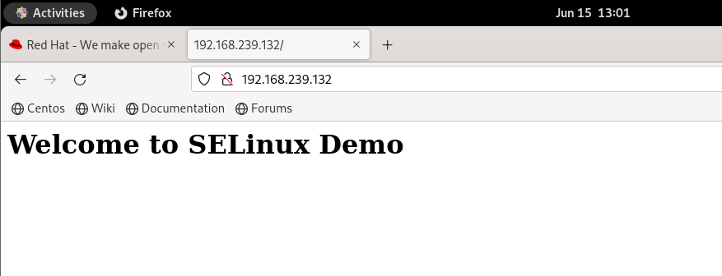

1️⃣4 Check File Context
ls -Z index.html
Correct context should be:
httpd_sys_content_t

1️⃣5️Change Context (Wrong Way – Demo)
chcon -t default_t index.html
ls -Z index.html
📌 Now refresh browser → Page will NOT load
Reason:
- default_t is not allowed for Apache
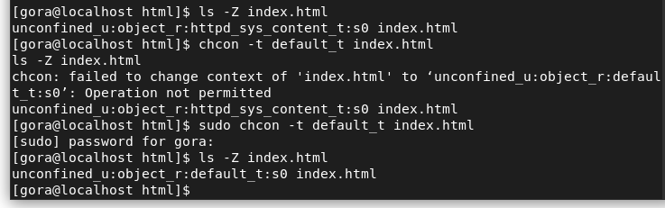

1️⃣6️Why Page Fails?
- SELinux is in Enforcing mode
- Apache can only read files with:
httpd_sys_content_t

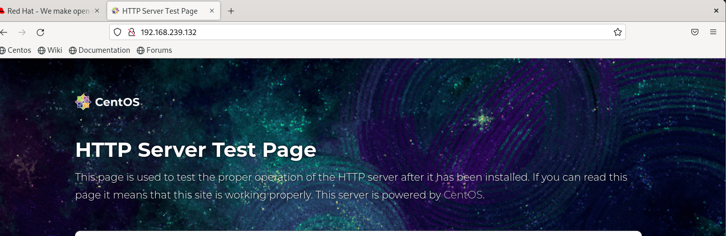

1️⃣7️ Test Permissive Mode
setenforce permissive
Refresh browser → Page works
📌 Because policies are not enforced
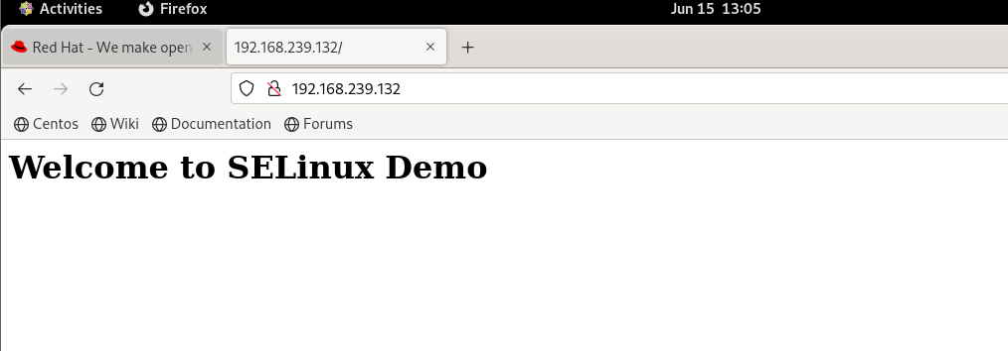

1️⃣8️Fix Properly (Recommended Way)
Restore original context:
restorecon index.html

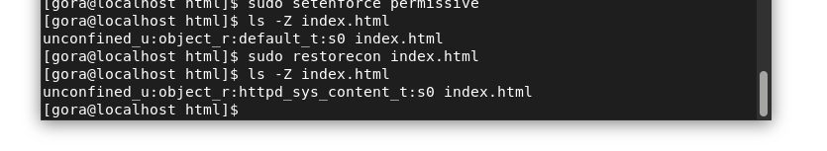
Check:
ls -Z index.html
Context restored to:
httpd_sys_content_t
Switch back to enforcing:
setenforce enforcing

Refresh browser → ✅ Page works

