Cockpit – Linux Web Management Tool (Complete Practical)
What is Cockpit?
Cockpit is a web-based GUI tool to manage Linux servers.
It helps admins manage servers without using too many commands.
You can do:
- Monitor CPU, RAM, Disk
- Manage services
- View logs
- Manage storage
- Configure network
- Create users
- Use terminal from browser

🔹 Which Linux supports Cockpit?
- RHEL
- CentOS
- Rocky Linux
- AlmaLinux
- Fedora
- Amazon Linux 2

🔹 Cockpit Default Port
9090

🔹 PRACTICAL – INSTALL & START COCKPIT
Step 1️⃣ Install Cockpit
sudo yum install cockpit -y
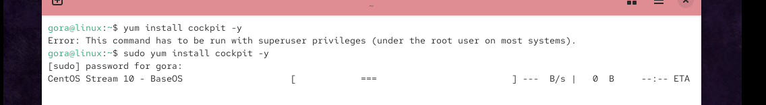

Step 2️⃣ Check Cockpit Service
sudo systemctl status cockpit
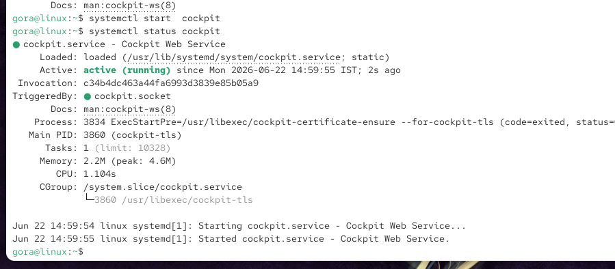

Step 3️⃣ Start Cockpit
systemctl start cockpit

Step 4️⃣ Enable Cockpit at Boot (Important)
systemctl enable cockpit

Step 5️⃣ Check IP Address
ifconfig
(or)
ip a

Step 6️⃣ Open Browser
https://SERVER-IP:9090
Example:
https://192.168.229.171:9090
If warning appears:
- Click Advanced
- Click Accept the Risk and Continue
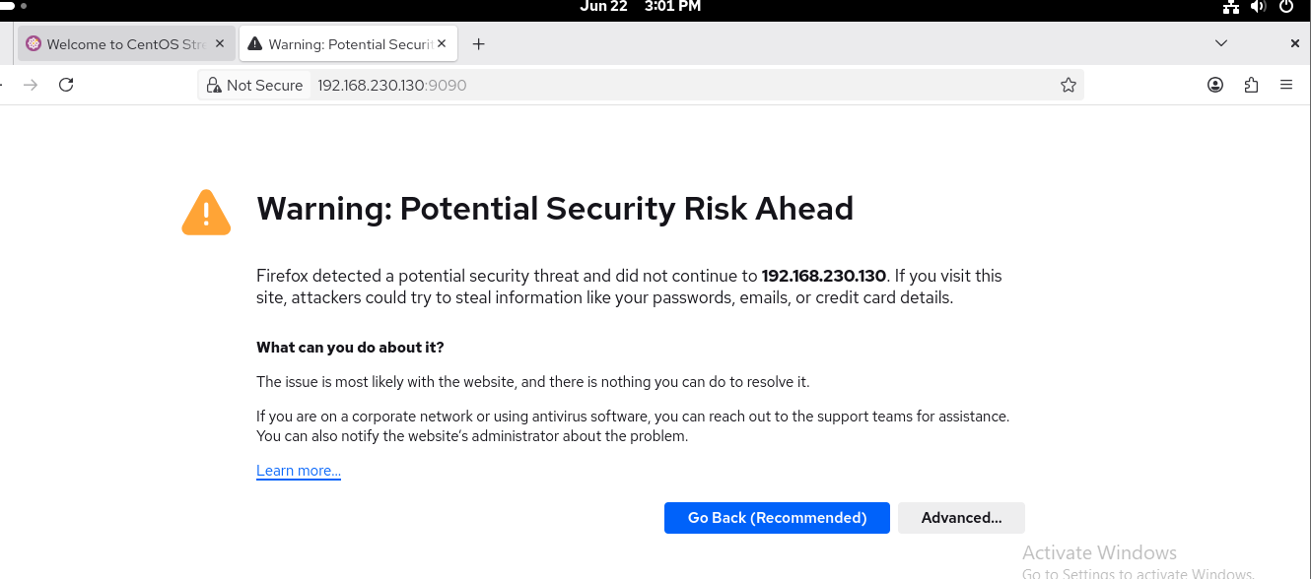

Step 7️⃣ Login
Use Linux username & password
Username: root / normal user
Password: ********
Cockpit Dashboard Opens
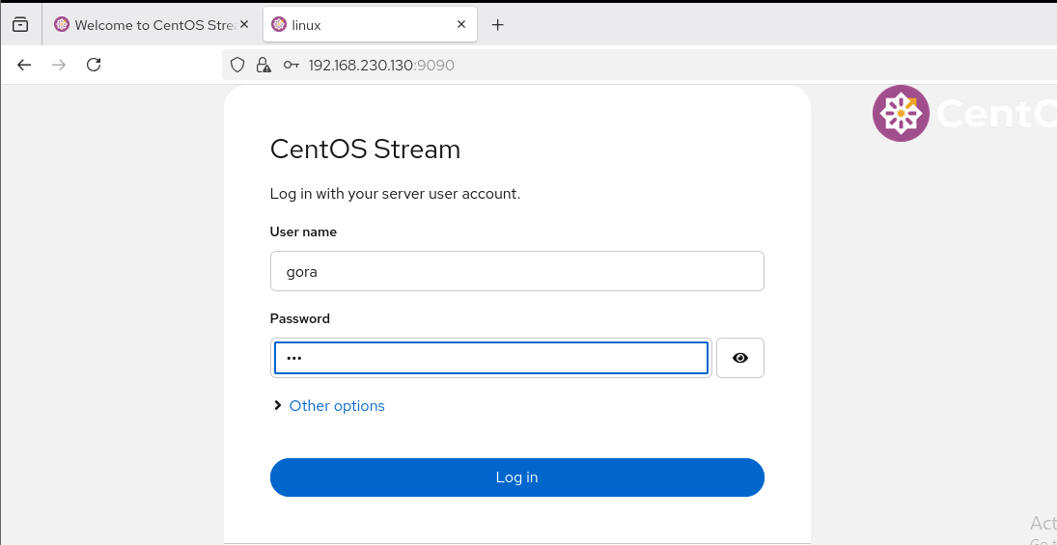

COCKPIT DASHBOARD OVERVIEW
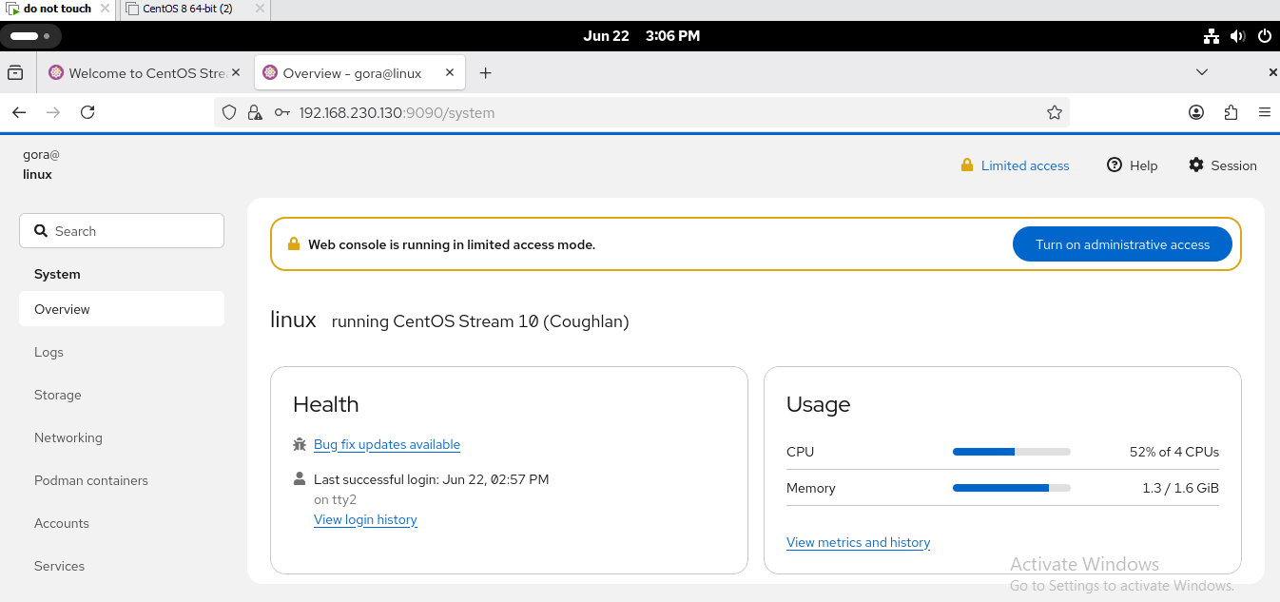

1️⃣ System Overview (Home Page)
What you see:
- CPU usage
- Memory usage
- Disk usage
- OS version
- Uptime
Teaching Tip:
“This page is like Task Manager for Linux”

2️⃣ Log Management Session
Purpose:
View system logs without using journalctl
Practical:
- Click Logs
- Select:
  - Errors
  - Warnings
  - Services logs
Example Use:
- Check why service failed
- Check boot errors
Equivalent CLI:
journalctl

3️⃣ Storage Management Session
Purpose:
Manage disks, partitions, LVM
Practical:
- Click Storage
- View:
  - Disk size
  - Mount points
  - File systems
- Add new disk → format → mount (GUI)
Teaching Example:
“If a new disk is added in VMware/AWS, you can manage it here without CLI.”
Equivalent CLI:
lsblk
df -h

4️⃣ Networking Management Session
Purpose:
Manage network interfaces easily
Practical:
- Click Networking
- See:
  - IP address
  - Interface (eth0, ens33)
- Enable/Disable interface
- Change IP (DHCP → Static)
Teaching Example:
“Without editing files, we can change IP here.”
Equivalent CLI:
nmcli
ifconfig

5️⃣ User Accounts Management Session
Purpose:
Create & manage users
Practical:
- Click Accounts
- Click Create New Account
- Enter:
  - Username
  - Password
- Set:
  - Admin access (sudo)
Teaching Example:
“No need to use useradd command.”
Equivalent CLI:
useradd
passwd

6️⃣ Services Management Session
Purpose:
Start, stop, restart services
Practical:
- Click Services
- Search:
  - sshd
  - httpd
  - nginx
- Click:
  - Start
  - Stop
  - Restart
  - Enable
Teaching Example:
“Students easily understand services lifecycle here.”
Equivalent CLI:
systemctl start httpd
systemctl stop sshd

7️⃣ Terminal Session (MOST IMPORTANT)
Purpose:
Use Linux terminal from browser
Practical:
- Click Terminal
- Run:
ls
df -h
top
Teaching Tip:
“Even if SSH is blocked, Cockpit terminal works.”

