What is HTTPS?
- HTTP (HyperText Transfer Protocol) sends data in plain text.
- HTTPS (HyperText Transfer Protocol Secure) encrypts all communication between the browser and the web server using SSL/TLS certificates.
Example:
HTTP
Browser -------------> Web Server
Plain Text
HTTPS
Browser =====Encrypted=====> Web Server
SSL/TLS Certificate
Port Numbers:
Protocol | Port
HTTP | 80
HTTPS | 443

What is SSL/TLS Certificate? Secure Sockets Layer, and TLS stands for Transport Layer Security
A certificate is a digital identity of a website.
It contains:
- Website name
- Owner
- Public Key
- Validity period
- Issuer
When a browser opens an HTTPS website:
- Browser asks for the certificate.
- Server sends the certificate.
- Browser verifies it.
- Encrypted communication starts.

Practical: Configure HTTPS in Apache
Step 1: Set Hostname
Check current hostname
hostnamectl
Set hostname
sudo hostnamectl set-hostname www.apache.com
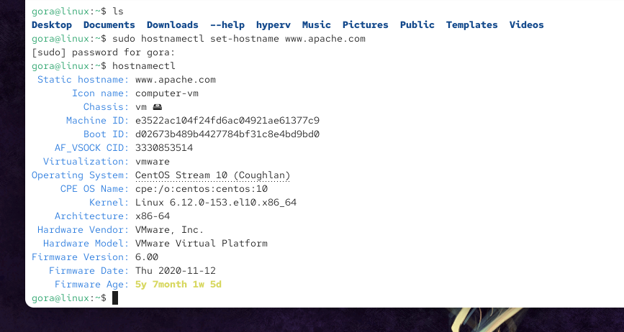
Verify
hostnamectl
Output
Static hostname: www.apache.com

Step 2: Configure Hosts File
Find your IP
ifconfig
Example IP
192.168.1.100
Edit hosts file
sudo vi /etc/hosts
Add
192.168.65.130 www.gorakh.test
Save
:wq
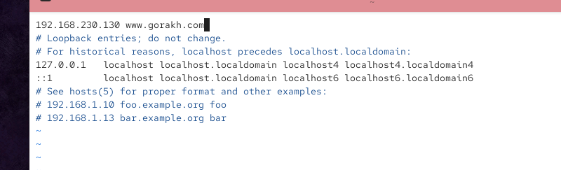
Test
ping www.apache.com
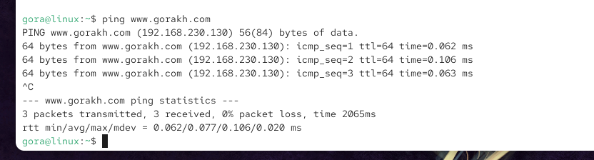

Step 3: Install Apache
sudo dnf install httpd -y
Install SSL module
sudo dnf install mod_ssl -y
Why install mod_ssl?
Without it:
Apache → HTTP only
With it:
Apache → HTTP + HTTPS

Step 4: Start Apache
Enable
sudo systemctl enable httpd
Start
sudo systemctl start httpd
Check
sudo systemctl status httpd
If running, you'll see:
Active: active (running)

Step 5: Allow HTTP and HTTPS in Firewall
sudo firewall-cmd --permanent --add-service=http
sudo firewall-cmd --permanent --add-service=https
Reload firewall
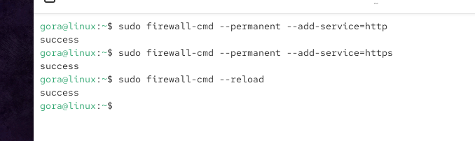
sudo firewall-cmd --reload
Verify
sudo firewall-cmd --list-services
Output
http https
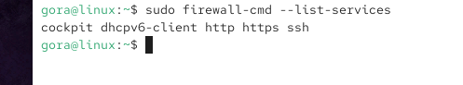

Step 6: Create Website
sudo cd /var/www/html
Create folder
sudo mkdir web1
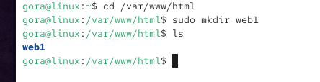
Go inside
cd web1
Create webpage
sudo vi index.html
Example
<html>
<head>
<title>HTTPS Website</title>
</head>
<body>
<h1>Welcome to HTTPS Apache Server</h1>
<h2>This page is secured using SSL/TLS</h2>
</body>
</html>
Save
:wq
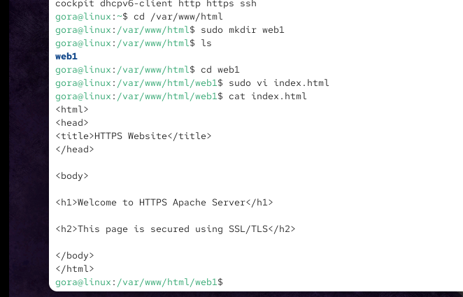

Step 7: Generate SSL Certificate
Move anywhere
cd
Run
sudo openssl req -x509 -nodes -days 365 -newkey rsa:2048 -keyout web1.key -out web1.crt
Meaning
Option | Meaning
req | Create certificate request
-x509 | Self-signed certificate
-nodes | No password
-days 365 | Valid for one year
-newkey rsa:2048 | Generate new 2048-bit RSA key
-keyout | Private key
-out | Certificate
It asks questions like
Country Name
Example
IN
State
Maharashtra
City
Mumbai
Organization
Linux Lab
Common Name
Very Important
Enter
www.apache.com
After completion
web1.crt
web1.key
are created.
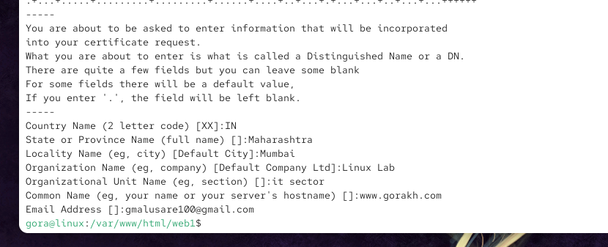

Step 8: Move Certificate Files
Move certificate
sudo mv web1.crt /etc/pki/tls/certs/
Move private key
sudo mv web1.key /etc/pki/tls/private/
Verify
ls /etc/pki/tls/certs
ls /etc/pki/tls/private

Step 9: Configure Apache
Edit
sudo vi /etc/httpd/conf/httpd.conf
Go to bottom
Add
<VirtualHost *:443>
ServerName www.gorakh.test

DocumentRoot /var/www/html/web1

SSLEngine on
SSLCertificateFile /etc/pki/tls/certs/web1.crt
SSLCertificateKeyFile /etc/pki/tls/private/web1.key
</VirtualHost>

Save
:wq

Test Apache configuration
Before restarting:
sudo apachectl configtest

Step 11: Restart Apache
sudo systemctl restart httpd
Check
sudo systemctl status httpd

Step 12: Test Website
Open browser
https://www.gorakh.test
or
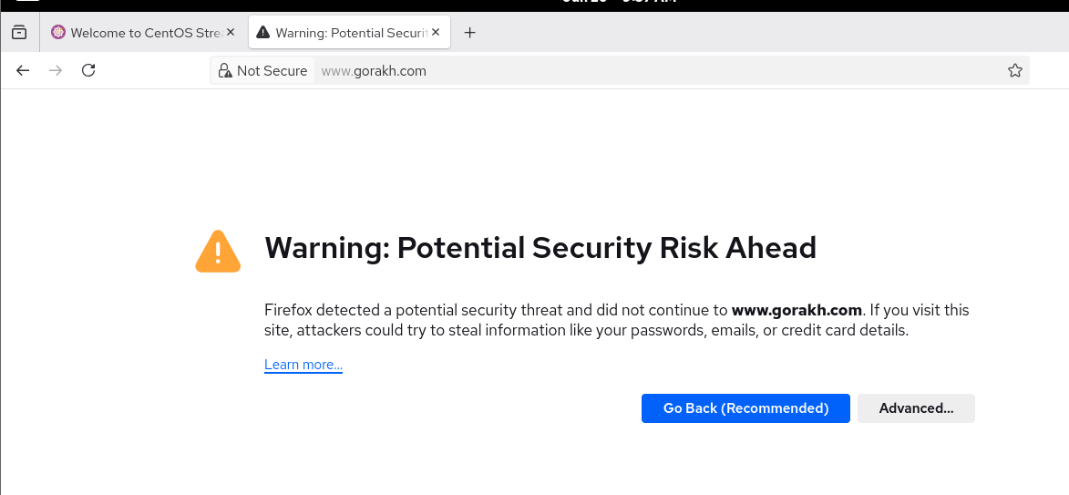
https://192.168.1.100
Browser shows
Your connection is not private
This is normal because you are using a self-signed certificate.
Click
Advanced
↓
Proceed to www.apache.com
Your webpage appears.

Step 13: View Certificate
In Firefox or Chrome:
Open
https://www.apache.com
Click
🔒 Lock Icon
↓
Connection Secure / Certificate
↓
View Certificate
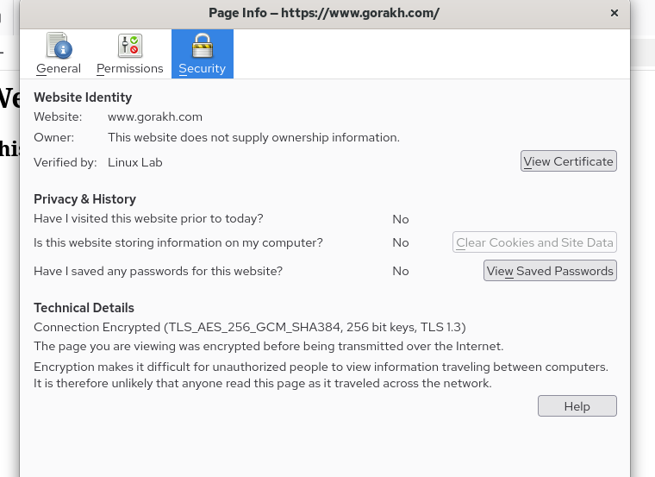
You will see details such as:
- Common Name (CN): www.apache.com
- Organization
- Valid From
- Valid To
- Public Key
- Issuer (your self-signed certificate)

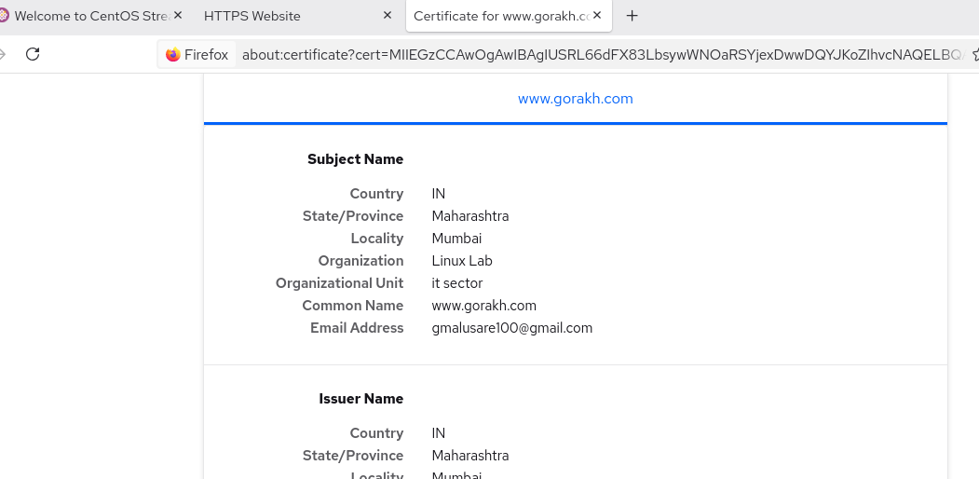

1. You are using a self-signed certificate (Most likely) ✅
You created the certificate using:
openssl req -x509 -nodes -days 365 -newkey rsa:2048 -keyout web1.key -out web1.crt
This creates a self-signed certificate.
Browsers do not trust self-signed certificates because they are not issued by a trusted Certificate Authority (CA) like Let's Encrypt, DigiCert, GlobalSign, etc.
So Firefox displays:
Connection not secure
This is normal in a lab environment.

TO REMOVE ALL:-
Step 1: Stop Apache
sudo systemctl stop httpd

Step 2: Remove Your Website
If your website is in /var/www/html/web1:
sudo rm -rf /var/www/html/web1
Verify:
ls /var/www/html
The web1 directory should no longer be there.

Step 3: Remove SSL Certificate
Delete the certificate:
sudo rm -f /etc/pki/tls/certs/web1.crt
Delete the private key:
sudo rm -f /etc/pki/tls/private/web1.key

Step 4: Remove the Virtual Host Configuration
If you added this block to /etc/httpd/conf/httpd.conf:
<VirtualHost *:443>
SSLEngine on
SSLCertificateFile /etc/pki/tls/certs/web1.crt
SSLCertificateKeyFile /etc/pki/tls/private/web1.key
ServerName www.gorakh.com
DocumentRoot /var/www/html/web1
</VirtualHost>
Open the file:
sudo vi /etc/httpd/conf/httpd.conf
Delete the entire <VirtualHost *:443> ... </VirtualHost> block.
Save:
:wq

Step 5: Remove the Host Entry
Open:
sudo vi /etc/hosts
Delete the line you added, for example:
192.168.1.100 www.gorakh.com
Save:
:wq

Step 6: (Optional) Reset Hostname
Check hostname:
hostnamectl
Set it back if desired:
sudo hostnamectl set-hostname localhost.localdomain
or any hostname you prefer:
sudo hostnamectl set-hostname server1.example.com

Step 7: Restart Apache
sudo systemctl start httpd
Or restart after checking the configuration:
sudo apachectl configtest
sudo systemctl restart httpd

Step 8: Verify Everything Is Removed
Check website:
ls /var/www/html
Check certificate:
ls /etc/pki/tls/certs | grep web1
Check key:
ls /etc/pki/tls/private | grep web1
Check virtual host:
apachectl -S

If you also want to uninstall Apache completely
sudo systemctl stop httpd
sudo dnf remove httpd mod_ssl -y
(Optional) Remove configuration files:
sudo rm -rf /etc/httpd
sudo rm -rf /var/www/html/*

