1) What is STP (Spanning Tree Protocol)?
STP (Spanning Tree Protocol) is a Layer 2 protocol used in switches to prevent network loops.

Simple Definition
STP prevents loops by blocking extra paths and keeping only one safe path active.

2) Why Does a Loop Get Created?
A loop happens when multiple switches are connected with more than one path (redundant links).
Here:
- There are two paths between switches
- This creates a loop

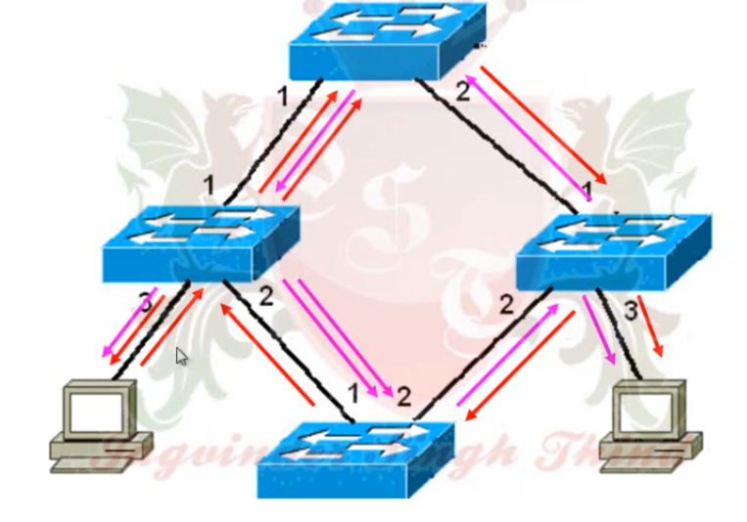

Scenario: Ping with Wrong IP Address and Broadcasting in Switch Network
When PC1 tries to ping PC2 but enters the wrong IP address, the following process happens in the network:
- PC1 sends a ping request to the destination IP address.
- Before sending the packet, PC1 must find the destination MAC address.
- If the MAC address is unknown, PC1 sends an ARP Request, which is a broadcast message to the network.
- The switch receives this broadcast frame and forwards (floods) it to all ports within the same VLAN.
- If multiple switches are connected with redundant links (loops), the broadcast frame can circulate repeatedly between switches.
Because of this continuous broadcasting in a looped network, the following problems can occur:

Problems Caused by Continuous Broadcasting

1) Broadcast Storm
A broadcast storm happens when broadcast packets keep circulating in the network without stopping.
This consumes bandwidth and network resources, causing the network to slow down or become unavailable.

2) MAC Table Instability (MAC Table Confusion)
Switches learn MAC addresses from incoming frames.
When frames loop continuously, the switch keeps updating the same MAC address on different ports.
This frequent change creates instability in the MAC address table.

3) Network Congestion or Network Failure
The excessive traffic generated by looping broadcasts can overload switches and links.
As a result, normal communication becomes very slow or the network may completely stop working.

3) How STP Uses Root Bridge to Prevent the Loop
STP solves the problem by selecting one main switch called the Root Bridge.

Step-by-Step Process

Step 1 — Elect Root Bridge
STP chooses:
Switch with the lowest Bridge ID
Bridge ID:
Priority + MAC Address
That switch becomes:
Root Bridge

Step 2 — Find Best Path to Root
Every switch calculates:
Shortest path to the Root Bridge
That port becomes:
Root Port

Step 3 — Block Extra Path
If there are multiple paths:
STP will:
Block one port
This removes the loop.

4) Why Root Bridge Is Important
The Root Bridge acts like the central reference point.
All switches:
- Send traffic toward the Root
- Use the shortest path
- Block extra paths
So the network becomes:
Loop-free

5) TOPOLOGY
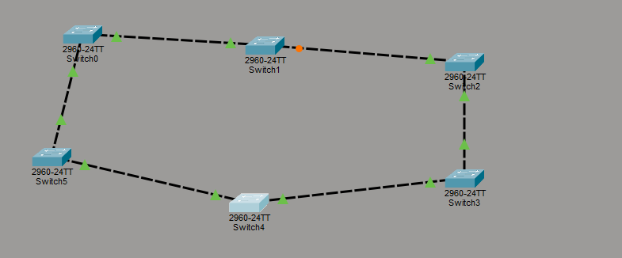

What the Colors Mean in Your Diagram
From your image:
- Green ports = Forwarding state (working normally)
- Orange port = Blocking state (disabled by STP to prevent loop)
You connected all switches in a ring topology, which creates multiple paths. STP must block one path to keep the network loop-free.

6) How to Check Which Switch is the Root Switch (in STP)
In Spanning Tree Protocol (STP) for Cisco Certified Network Associate (CCNA), you can easily identify the Root Switch using simple commands on the switch.

Method 1 — Use the Main Command
en
Conf t
do show spanning-tree

On the Root Switch, you will see:
This bridge is the root
That line confirms:
This switch is the Root Switch.
