1.INTER-VLAN:
Normally, devices in different VLANs cannot communicate with each other. To enable communication between different VLANs, we need a method called Inter-VLAN routing.

Why Do We Use Inter-VLAN Communication?
- To allow communication between devices in different VLANs (e.g., CS talking to Admin).
- Still maintain isolation and security for local traffic.
- Useful in large networks with multiple departments.
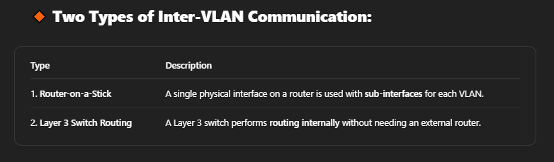

1. Layer 3 Switch Inter-VLAN Routing (Full Layer 3 Routing)
This method uses a Layer 3 switch to perform the routing between VLANs without needing a physical router. A Layer 3 switch is capable of routing traffic between VLANs using its SVI (Switched Virtual Interface).

Layer 3 Switch Configuration Example

Network Design:
- VLAN 10: Computer Science
- VLAN 20: Electrical
- PCs:
  - PC1: 192.168.10.2 (VLAN 10)
  - PC2: 192.168.10.3 (VLAN 10)
  - PC3: 192.168.20.2 (VLAN 20)
  - PC4: 192.168.20.3 (VLAN 20)
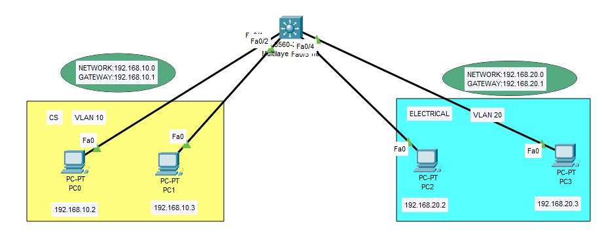
FIRST GO TO ALL PC AND GIVE IP ADDRESS.
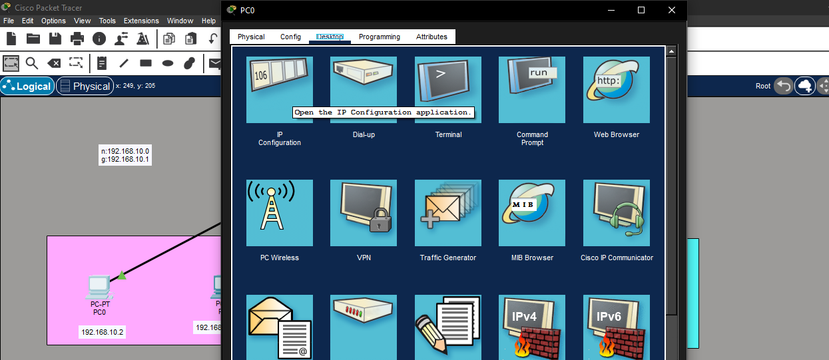
CLICK ON DEVICE – GO TO DESKTOP – IP CONFIGURATION.
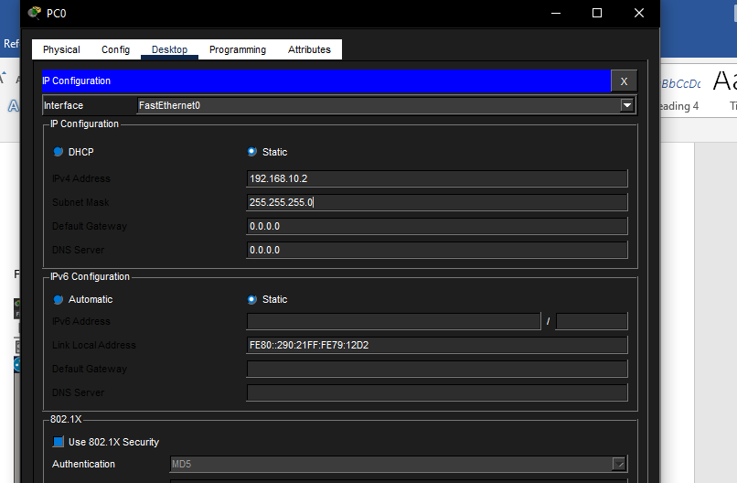
AND PROVIDE IP AND SUBNET MASK AND GETWAY IP. AND DO SAME FOR ALL PCS.

Layer 3 Switch Configuration:
GO TO SWITCH AND CLICK ON CLI
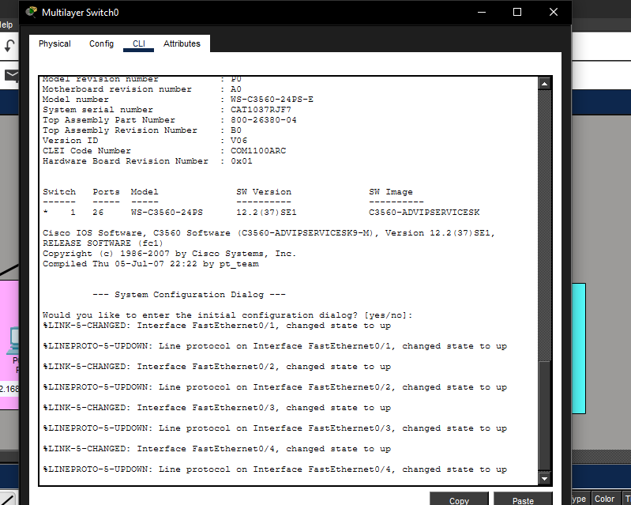
CREATE VLAN.
Switch> enable
Switch# configure terminal
Switch(config)# vlan 10
Switch(config)# name Computer_Science
Switch(config)# vlan 20
Switch(config)# name Electrical
• Assign VLANs to Ports:
Switch(config)# interface range fa0/1 - 2
Switch(config-if-range)# switchport mode access
Switch(config-if-range)# switchport access vlan 10

Switch(config)# interface range fa0/3 - 4
Switch(config-if-range)# switchport mode access
Switch(config-if-range)# switchport access vlan 20
• Enable Routing on the Layer 3 Switch:
Switch(config)# ip routing
• Create SVI Interfaces for Each VLAN:
Switch(config)# interface vlan 10
Switch(config-if)# ip address 192.168.10.1 255.255.255.0
Switch(config-if)# no shutdown

What this does:
- Creates a virtual interface for VLAN 10
- Assigns a gateway IP address
- Enables the interface

Switch(config)# interface vlan 20
Switch(config-if)# ip address 192.168.20.1 255.255.255.0
Switch(config-if)# no shutdown

- NOW PC1 -DESKTOP- COMMAND PROMPT(192.168.10.2) can ping PC3 (192.168.20.2).
- AND PC2 -DESKTOP- COMMAND PROMPT (192.168.10.3) can ping PC4 (192.168.20.3).

2.What is ICMP?
ICMP (Internet Control Message Protocol) is a protocol used to test connectivity and send error messages between network devices.

Simple definition:
ICMP is used to check whether a device is reachable on the network.

Example:
When you run:
ping 192.168.20.10
The system sends:
- ICMP Echo Request → "Are you reachable?"
- ICMP Echo Reply → "Yes, I am reachable"

3.Where ICMP is used
Most common tools:
- ping → Uses ICMP
- tracert / traceroute → Uses ICMP
- Network troubleshooting
- Connectivity testing
So whenever you ping between VLANs, you are using ICMP.

4. Why ping fails the first time in Inter-VLAN (different VLAN)
This is normal behavior, and it usually happens because of ARP (Address Resolution Protocol).

Root Cause: ARP Process
Before sending ICMP, the device must first learn the MAC address of the destination or gateway.
So the first ping is used to:
- Discover MAC address
- Build ARP table
- Then communication works

