2. Router-on-a-Stick (ROAS) Inter-VLAN Routing
In ROAS, a single physical router interface is used to route between multiple VLANs by creating sub-interfaces on the router. Each sub-interface is assigned to a specific VLAN.
#How Router on a Stick Works
•Single Physical Connection: You have a single physical Ethernet connection between the router and a switch.
•Sub interfaces: The router is configured with multiple logical sub interfaces on that single physical interface. Each sub interface is associated with a different VLAN.
•VLAN Tagging: The switch ports that connect to the router must be configured as "trunk" ports, which means they can carry traffic for multiple VLANs. Each VLAN’s traffic is tagged with a unique identifier (VLAN ID).
•Routing: The router performs inter-VLAN routing, meaning it can route traffic between different VLANs because it has interfaces (subinterfaces) in each VLAN.
Router-on-a-Stick Example
Network Design:
-Example Scenario:-
Imagine a small office network where there are two VLANs:
•VLAN 10 for HR'S
•VLAN 20 for EMPLOYEES
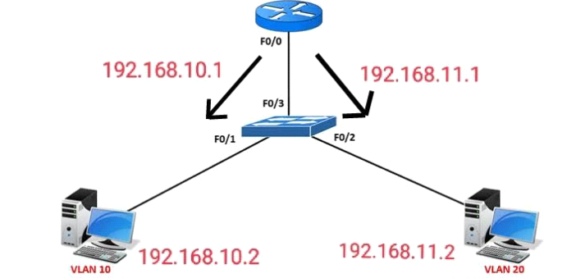
Router name is :- 1941 router
Switch name is :- 2960 switch
-Now, we will make 2 different VLANs on switch namely VLAN 10 and VLAN 20
Switch# enable
Switch# conf t
Switch# vlan 10
Switch# name HR
Switch# vlan 20
Switch# name EMPLOYEE
-now assign the pc to vlans and connect the switch with router using trunk.
Switch# int fa0/1
Switch# switchport mode access
Switch# switchport access vlan 10
Switch# int fa0/2
Switch# switchport mode access
Switch# switchport access vlan 20
Switch#int fa0/3
Switch#switchport mode trunk
- Now The router’s interface will get divided into 2 sub-interfaces (as there are 2 different VLANs) which will acts as a default gateway to their respective VLANs. Then router will perform Inter VLAN Routing and the VLANs will communicate with each other.but before that we will up the gig interface
r1#en
r1#conf t
r1#int gig0/0
r1#no shut
r1#ex
r1# int gig0/0.1
r1# encapsulation dot1q 10
r1# ip address 192.168.10.1 255.255.255.0
r1# int gig0/0.2
r1# encapsulation dot1q 20
r1# ip address 192.168.20.1 255.255.255.0
r1#no shut
r1#ex.

Why These Commands Are Used

1. int gig0/0.1
Creates a logical subinterface under physical interface gig0/0.
Purpose:
- Separate traffic for VLAN 10
Example:
gig0/0.1 → VLAN 10
gig0/0.2 → VLAN 20
One physical port behaves like multiple virtual interfaces.

2. encapsulation dot1q 10
Enables IEEE 802.1Q VLAN tagging.
Purpose:
- Tells router this subinterface handles VLAN 10 traffic.
Without this:
- Router cannot identify VLAN packets.

3. ip address 192.168.10.1 255.255.255.0
Assigns gateway IP for VLAN 10.
Hosts in VLAN 10 use:
192.168.10.1
as their default gateway.

4. int gig0/0.2
Creates another subinterface for VLAN 20.

5. encapsulation dot1q 20
Associates this subinterface with VLAN 20 traffic.

6. ip address 192.168.20.1 255.255.255.0
Gateway for VLAN 20 devices.

7. no shut
Enables the physical interface.
Without:
shutdown
the interface remains administratively down.

