1. VTP (VLAN Trunking Protocol)
VTP is a protocol used on Cisco switches to manage VLANs across a network. It allows VLAN information to be propagated automatically between switches in a network, making it easier to configure and maintain consistent VLAN configurations across switches.
VTP Modes:
- Server Mode:
  - The switch can create, modify, and delete VLANs.
  - It can propagate VLAN information to other switches in the VTP domain.
  - By default, all switches in a VTP domain operate in server mode.
- Client Mode:
  - A switch in client mode cannot create, modify, or delete VLANs.
  - It only receives VLAN information from a VTP server and applies it.
- Transparent Mode:
  - Switches in transparent mode do not participate in VTP (they do not propagate VLAN information).
  - They pass VTP updates through but don't update their own VLAN configurations with the VTP information.
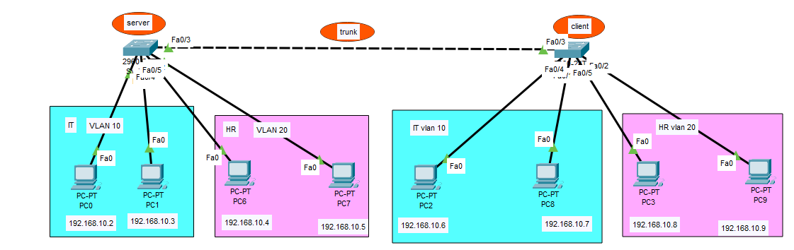
Example: VTP Configuration with 2 Switches:
•Switch1 (VTP Server)
•Switch2 (VTP Client)
-Step 1 create a vlan:
>en
# configure terminal
Switch1(config)# vlan 10
Switch1(config-vlan)# name IT
Switch1(config-vlan)# exit
Switch1(config)# vlan 20
Switch1(config-vlan)# name HR
Switch1(config-vlan)# exit
Switch1(config)# exit
Switch1# show vlan brief
Switch2(config)# vlan 10
Switch2(config-vlan)# name IT
Switch2(config-vlan)# exit
Switch2(config)# vlan 20
Switch2(config-vlan)# name HR
Switch2(config-vlan)# exit
Switch2(config)# exit
Switch2#do show vlan brief
-Step 2 assign PC's to vlan:
Switch1(config)# int range fa0/1-2
Switch1(config-if)# switchport access vlan 10
Switch1(config-if)# exit
Switch1(config)# int range fa0/3-4
Switch1(config-if)# switchport access vlan 20
Switch1(config-if)# exit
Switch2(config)# int range fa0/1-2
Switch2(config-if)# switchport access vlan 10
Switch2(config-if)# exit
Switch2(config)# int range fa0/3-4
Switch2(config-if)# switchport access vlan 20
Switch2(config-if)# exit
-step 3
Switch1> enable
Switch1# configure terminal
Switch1(config)# vtp ?
Switch1(config)# vtp mode server
Switch1(config)# vtp domain IT
Switch1(config)# vtp password 1234
Switch1(config)# exit
Switch1# int fa0/3
Switch1#switchport mode trunk
Switch2> enable
Switch2# configure terminal
Switch1# int fa0/3
Switch1#switchport mode trunk
Switch2(config)# vtp mode client
Switch2(config)# vtp domain IT
Switch2(config)# vtp password 1234
Switch2(config)# exit

Explanation of the Configuration:
- On Switch1 (VTP Server Mode):
Switch1> enable
Switch1# configure terminal
Switch1(config)# vtp ?
  - The vtp ? command displays the available options related to VTP configuration, which helps you see what you can do with VTP.
2.Switch1(config)# vtp mode server
  - This command sets Switch1 as a VTP Server. In this mode, Switch1 can create, modify, and delete VLANs. It also sends VTP advertisements to other switches in the domain to keep VLAN information synchronized.
3.Switch1(config)# vtp domain IT
  - The VTP domain is set to IT. The domain is essentially the "group" name that determines which switches will share VLAN information. All switches within the same VTP domain can share VLAN info.
4.Switch1(config)# vtp password 1234
  - This command sets the VTP password to 1234. The password must be the same across all switches in the domain for them to exchange VTP information securely.
5.Switch1(config)# exit
  - Exits the VTP configuration mode.
6.Switch1# int fa0/5
Switch1# switchport mode trunk
  - The interface fa0/5 is set to trunk mode to carry VLAN information between switches. Trunking allows multiple VLANs to travel over a single physical connection between switches. This interface will send and receive VLAN data between Switch1 and Switch2.

- On Switch2 (VTP Client Mode):
1.Switch2> enable
Switch2# configure terminal
Switch2(config)# vtp mode client
  - This command sets Switch2 as a VTP Client. In client mode, Switch2 cannot create, modify, or delete VLANs. It will only receive VLAN information from a VTP server (Switch1 in this case) and apply it.
2.Switch2(config)# vtp domain IT
  - This sets the VTP domain to IT, ensuring that Switch2 is in the same domain as Switch1, allowing VLAN information to be exchanged.
3.Switch2(config)# vtp password 1234
  - This sets the VTP password to 1234, which must match the password on Switch1 for communication between them to be successful.
4.Switch2(config)# exit
  - Exits the VTP configuration mode.

How to Check if VTP is Successful:
To verify that the VTP configuration is working and VLAN information has been successfully shared between the switches, follow these steps:
- Check VTP Status on Both Switches:
  - On both Switch1 (Server) and Switch2 (Client), you can check the VTP status with the following command:
Switch1# do show vtp status
This will give you detailed information about the VTP configuration, such as:
  - VTP Mode (Server/Client/Transparent)
  - VTP Domain Name
  - VTP Password
  - VTP Version
  - VTP Pruning Mode (if configured)
Check if both switches have the same VTP domain and password.
- Verify VLAN Information:
  - On Switch1 (Server), after creating VLANs, use the following command to check the VLANs:
Switch1#do show vlan brief
This will list all VLANs that have been created, including their status and the ports assigned to them.
  - On Switch2 (Client), use the same command to check if the VLANs from the server are propagated:
Switch2#do show vlan brief
If the VLANs are successfully propagated from Switch1 (Server) to Switch2 (Client), you will see the same VLANs on Switch2.

