Is high social class always beneficial for survival? A study of Northern Sweden 1801--2013

SÃ¶ren Edvinsson and GÃ¶ran BrostrÃ¶m

2017-10-26

Table of Contents

# Introduction

A major theme in demographic and epidemiological studies is the seemingly persistent effect of social class on mortality. In the present study, we challenge common notions of this by taking a long-term perspective on the development of social inequalities in mortality in the adult and elderly population with a special focus on the relative differences. The arguments for our statements are based on an investigation of the Skellefteå and Umeå regions in the north of Sweden for the periods 1801--2013 for Skellefteå and 1901--2013 for Umeå. The main issue is analysed according to gender and age-group (working age vs retired), testing if the same patterns prevails in old age---the retired population---versus the population in working age. We analyse both total and mortality and mortality from the major causes of death (cardiovascular diseases and cancers). Furthermore we put this in the context of how the inequality in mortality is associated with the development of economic inequality in society. The results are discussed in relation to our understanding of the mortality transition and the social determinants of health and mortality, as well as their implications on some of the most influential hypotheses and concepts in health research.

On the basis of the results, we argue that high social class is not necessarily always favourable for survival. Mortality risks in different contexts must be understood in the intersection between class and gender. We suggest that health-related behaviour was important not only in present-day societies, but was decisive also in earlier phases of the mortality transition. The results implicate that the association between social class and health is more complex than is assumed in many of the dominant theories in demography and epidemiology.

## Social class and mortality

One of the central aspects of survival is social class and access to economic and other resources. In present-day welfare societies, social position is a strong determinant when it comes to health and mortality and the impact even seems to be increasing (Kunst et al. 2004; J. P. Mackenbach et al. 2016; Fritzell and Lundberg 2007; Brønnum-Hansen and Baadsgaard 2012; Strand et al. 2010). Bruce G. Link and Phelan (1995) suggest that "... social conditions have been, are and will continue to be irreducible determinants of health outcomes and therefore deserves their appellation as 'fundamental causes' of disease and death". The persistence of social inequality in mortality to the disadvantage of the lower classes is one of the main assumptions in their theory (Bruce G Link et al. 1998). The reigning view has been that socio-economic health and mortality inequalities were large in historical societies, probably larger than in modern societies. This is a reasonable assumption since these societies were often characterised by enormous socioeconomic differences. Knowing that access to different kinds of resources provide advantages in all aspects of life, the health advantage of higher classes ought to be obvious.

Recent studies, investigating social inequality in health and mortality with micro-data, have however questioned the generality of the assumed pattern (Bengtsson and Poppel 2011). Solid empirical evidence about the process is however lacking and studies focusing on the issue are still few. There is a need for additional reliable studies from different geographical and historical settings in order to better understand the role of socio-economic conditions for health and survival over time.

What about life course aspects of the impact of social position for health and mortality ? Either differences converge in old age (status levelling), the differences are constant (status maintenance), or they diverge (cumulative advantage) (on this issue, see (Hoffmann 2008)). Diminishing differences may be a consequence of the circumstance that biological factors becomes increasingly important during the ageing process and in old age, leaving less impact for social factors. The status maintenance hypothesis basically assume continuity in the determinants for social health inequalities from adulthood to old age. The cumulative (dis)advantage hypothesis (Dannefer 2003), imply that advantages and disadvantages tend to persist and ackumulate during life in a negative spiral rewarding some while disfavouring others. This leads to larger differences in old age.

Another aspect of the development of social inequality in mortality, concerns its relation to economic inequality. Wilkinson and Pickett (2009) argue that income inequality has an independent effect on mortality, separate from the direct effect of actual access to economic resources. They argue that unequal societies (basically countries) perform less well when it comes to health (as well as other social conditions) than equal ones in the present-day economically developed world. This has initiated a vital scholarly debate and the topic has been extensively studied (Subramanian and Kawachi 2004; Wagstaff and Van Doorslaer 2000). During the last decades, the association between trends of inequalities in mortality and income respectively is weak or non-existant according to Hoffmann et al. (2016). What the association looked like in previous periods is unknown. This is of particular interest since the levels of economic inequality were very different from those of the recent decades. Even if not a necessary implication, it is reasonable to assume that poorer groups were those most disadvantaged of large inequalities.

When it comes to Sweden both income and wealth distributions were strongly skewed from the 1870's to the early 20th century. Starting during the inter-war period, income and wealth inequality continuously diminished to reach a low point at around 1980. Thereafter, economic inequality has increased substantially until the present, although far from being as high as a century ago (Roine and Waldenström 2008; Roine and Waldenström 2009). The Swedish development resembles that of other European and North American countries in its basic features (Waldenström and Roine 2014).

# The Skellefteå and Umeå regions

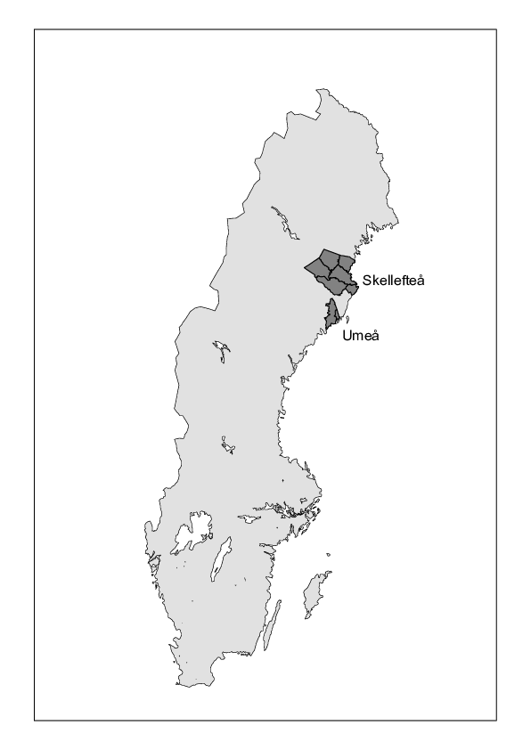 The Skellefteå and Umeå regions (Figure 1) are part of the county of Västerbotten in the north of Sweden along the coast of Gulf of Bothnia. This was a remote part of the country where communication with the rest of Sweden was difficult until the late 19th century. The economy was dominated by agriculture, making it vulnerable to harvest failures, and several severe famines occurred in the regions during the 1800s, for example after the harvest failure in 1867 (S. Edvinsson and Broström 2014). During the long winters, sea communication was hindered due to the Gulf of Bothnia being frozen. The first ships during the year came to this area in May or even as late as June in some cases (Fahlgren 1956). Towards the end of the 19th century, the Swedish railway system reached this part of Sweden. Thereby contacts with the rest of Sweden were facilitated, improving the economy and making it possible to mitigate the effects of harvest failures. During the 19th century, our regions became increasingly integrated in the same epidemiological pattern as the rest of Sweden.

In our dataset, the Skellefteå region before 1950 consists of a selection of parishes surrounding the town of Skellefteå, founded in 1845 but with a very small population during the 19th century. The data from the period after 1975 cover the Skellefteå, Norsjö and Malå municipalities, the same area as for the earlier period but with the addition of two more parishes. The majority of the 19th century population lived in rural villages and hamlets, getting its livelihood from agricultural production. During the 20th century, industrialisation took place. This also led to a population increase both in the town and in the rural parts, resulting in a more diversified economy.

Mortality was fairly low in comparison with other parts of the country and the fertility transition was late (Coale and Watkins 1986). The Skellefteå population size as defined in our data sets (all ages) was 6142 on January 1, 1801, 43212 on January 1, 1901, and 76723 at the end of the 20th century.

The Umeå region in the dataset consists of Umeå urban and rural parish 1901--1950, and from 1976 onwards of Umeå municipality when another three parishes are included. This region has a somewhat different character from that of Skellefteå. Umeå town had a small population but was substantially larger than Skellefteå town during almost the whole studied period and was the administrative, educational and military centre in the county of Västerbotten. During the later part of the 20th century, the establishment of a university in Umeå led to a rapid population increase. Agriculture dominated the rural part, but there were also some foundries as well as forestry industries. Consequently the economy was more diversified compared to Skellefteå.The population size as defined in our data sets (all ages) was 19138 on January 1, 1901 and 103970 when the 20th century ended.

# Data and variables

The recent extension in time of data at the Demographic Data Base (DDB), Umeå University (<http://www.cedar.umu.se>) by including the period between 1900 and 1950 makes it possible to investigate the long-term development of social inequality in mortality in this part of Sweden. The data for the present study come from two large population databases at the DDB, whom provide us with micro-data for the Skellefteå and Umeå regions in northern Sweden. Our dataset constitutes a large population with substantial social diversity that can be followed for a uniquely long time. The period 1801--1950 is covered by the database Poplink (Westberg, Engberg, and Edvinsson 2016). Poplink is based on linked parish records, allowing us to reconstruct life biographies on people as long as they remained in the region. The records are linked within but not between the regions. Data from Poplink are accessed for the period 1801--1950.

The other large data set is extracted from the Linnaeus database (Malmberg, Nilsson, and Weinehall 2010), which is based on different linked national population registers from 1960 to 2013 and is used within the ageing program at CEDAR, Umeå University. Due to data issues, we choose to use Linnaeus data from 1976. The study period from 1976 to 2000 is constructed from censuses every fifth year 1975--1990, with additional information on deaths from National Board of Health and Welfare (we have left out the period 1960--1975 due to more missing data in some variables, for example social class, and additional work required for defining the exact geographical areas for analysis). For the period 2002--2013 we use the information from the yearly population registers from Statistics Sweden (LISA) together with information on mortality from National Board of Health and Welfare.

Individuals are anonymised and the two databases are not linked, thus they are treated as separate units. This prevents us from following individuals between the two databases throughout their lives. It also makes it impossible to add information on individuals in the Linnaeus database from what we potentially could extract from Poplink, for example family background or previous social class.

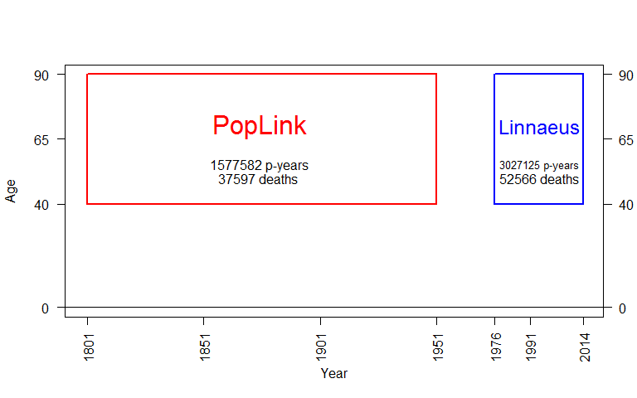

Figure 2 The sampling frame.

In the data set analysed here, all individuals 40 years and older ever being resident in either of the regions are included. The data file contains the variables social class, sex, urban/rural residence, birth date, death date, first and last date of observation and type of entrance/exit. Total number of person years is 1577582 leading to 37597 deaths in Poplink and 3027125 person years leading to 52566 deaths in the Linnaeus database, see Figure 2.

## Presence periods

Differences in available information in the two datasets as well as within the Linnaeus data makes it necessary to apply different approaches when it comes to identification of presence periods. The Poplink data provides us with exact dates or at least year of start and exit of presence, allowing us to have full and continuous control of the population. This is however not the case with the Linnaeus database. For the period 1976--2001 we use presence in the censuses 1975--1990 and information on deaths from the National Board of Health and Welfare to identify the observation periods in our analyses. There is however no full information on what happened in-between the censuses, for example the exact date of exit for persons having moved between two censuses. We have solved this by considering everyone as resident in our regions during the complete five-year period between censuses if the person is missing in the later census (the last period covering eleven years). This marginally overestimates presence, but should not bias the results when it comes to socioeconomic differences. We furthermore miss those that both moved in and moved out or vice versa between censuses. Exit dates are exact if they refer to death. In these cases we consider them as constantly present from the last census to the death data even if the death took place in another part of Sweden.

For the last period, 2002--2013, we use the yearly population registers (LISA data), together with information on deaths from National Board of Health and Welfare. This data allows for full control of the presence periods in the studied regions.

## Social class

Mortality differences are analysed according to social class, based on a modified form of the classification scheme Hisclass (Van Leeuwen and Maas 2011). The only and obvious alternative for making a longitudinal study of socio-economic mortality differences with consistent classification schemes in the two databases, is occupations. Thus, analysing according to social class is apart from being a scientific choice, also a practical one. Social position is treated as a time-dependent variable during working age but defined from the last occupation for the elderly and retired population, that is, from age 65 until death or last observation.

The availability of information on occupations varies over time and between sources. Occupations in Poplink are coded according to the original DDB coding system that then has been adapted to Hisclass. For the Linnaeus data, HISCO is recoded into Hisclass. The censuses include occupational codes based on the system used in Sweden at that time, NYK (Nordisk Yrkesklassificering). We consider the observed social class in a census to be valid for the full period until the next census, corresponding to our definition of presence periods. For the period 1991--2000 the social class in the census 1990 is considered to be kept until 2001.

The use of different data sets forces us to apply different approaches towards defining the social position. Poplink usually only provides occupation for the head of household, thus underestimating female working-force participation as well as that of adult children residing with their parents (Vikström 2010). For the Poplink period, we have chosen to categorise wives according to position of the head of household, usually the husband/father, assuming that the family shares the same socio-economic position.

Female labour is much better covered in the Linnaeus database. A complication is however that it is difficult to define households in the same way as in Poplink. Extra-marital cohabitation became common and female labour force participation developed as the norm in Sweden during this period. The occupation of the husband as signifier of social class became, if not obsolete, at least less relevant. All included persons are signified by their individual occupation for this period. Still, the results for the different periods are not completely comparable. Notice however that there was a strong social homogamy within married couples at this time, indicating that the results would not differ in any decisive way by using occupations on individual level instead of on household level for defining social class from the Linneaus data (Björklund 1992).

Hisclass, the classification system used as a basis for our categorisation, is a "... HISCO-based historical international social class scheme" (Van Leeuwen and Maas 2011; Van Leeuwen, Maas, and Miles 2002). The different classes in Hisclass represent distinct categories, based on whether the work is manual or non–manual, skill level, supervision and sector. Implicitly it reflects large differences in access to economic and other resources, status, social power et cetera. Longitudinal analyses of social classes for such a long period covered in this study involves several problems, related to changes in occupational structure and the meaning and contents of occupations and social positions. We have chosen to work with a broad definition of classes, merging the original 12 classes in Hisclass into the following three and an additional fourth category of unknown class:

Figures 3 and 4 show the distribution (per cent) of exposure time according to class for men and women respectively. The category of workers is fairly stable over time. The highest class has increased substantially, although from a very low level in the 19th century. The increase of academics in connection to the establishment of Umeå University explains much of this increase. What is not apparent from Figure 3 is the transfer within the middle group from a majority of farmers during the 19th century to lower white collar from the middle of the 20th century. Furthermore we observe a rather high percentage of missing social class in the early 19th century. For men the proportion is somewhat higher in the age group 65 and above, those that were retired, but still low enough to be used in our analyses (results not shown). If we disregard the very first period, there were however very few with missing occupation until 1950.

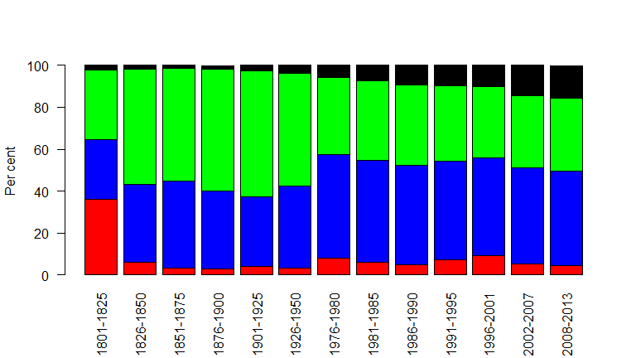

Figure 3 Exposure by social class, men (from the top: elite, middle, workers, missing) and time period.

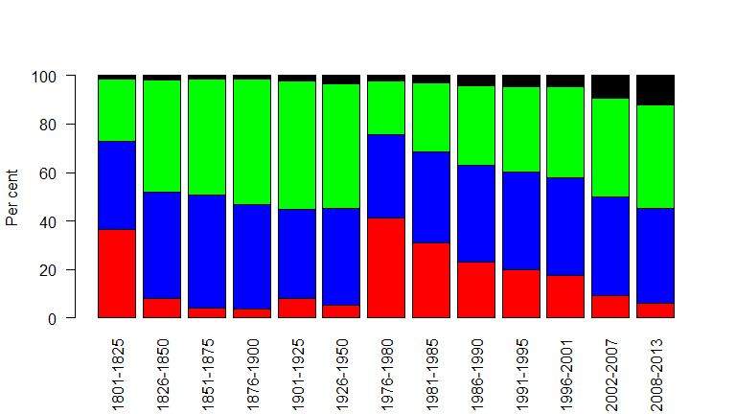

Figure 4 Exposure by social class, women (from the top: elite, middle, workers, missing) and time period.

The proportion with missing values among women is however a larger problem, see Figure 4. Corresponding to what we found for men, the proportion without social position is very low until the middle of the 20th century, reflecting the way womens' social position is defined. The frequency of missing social class is however quite high during particularly the first two periods with data from the Linnaeus database---from 1976. Since female social class for this period is defined according to own occupation, the consequence of many women being outside the workforce is that the proportion missing increases. For the later periods, the results are fairly complete.

## Marital status

Marital status, see Figure 5, is treated as a time-dependent variable in the data file. The statuses used are unmarried, married and dissolved marriages (without distinguishing between widowed and divorces). If no explicit status is given in the sources and partner is missing, the status has been set to unmarried. Notice that it has not been possible to identify cohabitation.

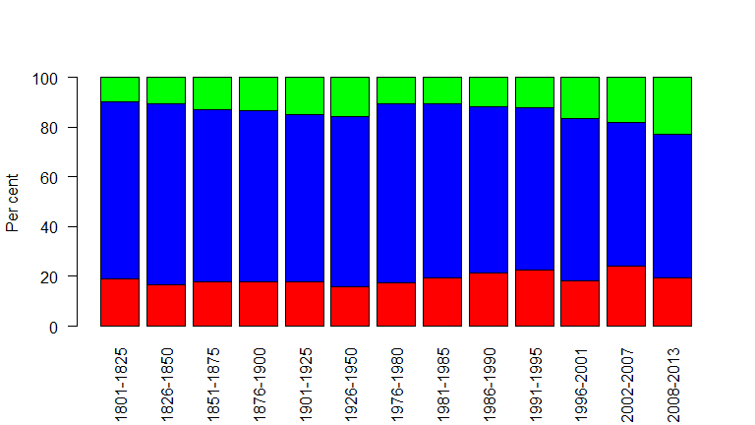

Figure 5 Exposure by marital status (from the top: never married, married and previously married) and time period

## Cause of death

In the present study, we analyse mortality in the two most common disease groups in the ages we are investigating; cardiovascular diseases and cancers. National compulsory reporting of cause of death was introduced in 1911, but our analysis of the two disease groups starts from 1901 since cause of death was fairly frequently reported even before 1911. Classification systems have however changed. Sweden did not join ICD until 1952, but the historical causes of death in the Poplink database have been coded according to an adapted form of the ICD10 system. In the present study, we identify the codes relevant for cardiovascular diseases and cancers in the ICD 8, 9 and 10.

The distribution of causes of death is shown in Figure 6. Notice the high proportion of other causes in the first two periods. This category includes cases with unknown or unspecific causes which has implications for the cause-specific analyses (see later discussion). The total dominance of our two disease groups is apparent.

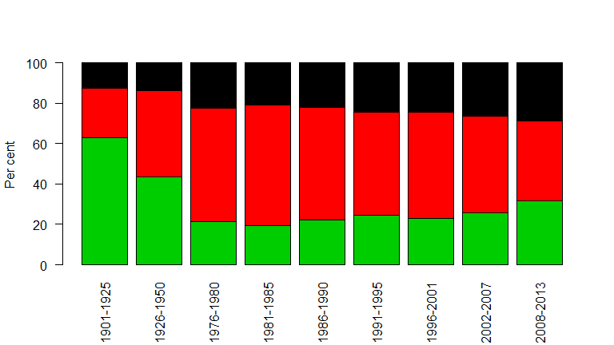

Figure 6 Causes of death by time period (top: cancer, middle: cardiovascular, bottom: other).

## Urban vs rural residence

In 19th and early 20th century Sweden (as in other countries), mortality was much higher in urban environments (H. Nilsson 1994; S. Edvinsson 1992). The unsanitary and overcrowded living conditions as well as the risks for importing infections made the health risks higher in towns and cities. In the present paper, the variable **urban** controls for this aspect by distinguishing between urban and rural residence for the periods after 1900, based on parish or place of residence.

## Periods for analysis

We have made separate analyses for the different time periods. The period 1801--1950 is divided into six subperiods of length 25 years each. The 19th century periods represent a mainly pre-industrial society dominated by agriculture and with only basic welfare provisions. During the years 1901--1950, industrialisation started and the urban environments increased in population size. The modern Swedish welfare state began to develop. For the period 1976 onwards, there are separate analyses on 5- or 6-year periods. Sweden had developed into a wealthy welfare society with low income inequality, particularly until the 1990s. A financial crisis struck Sweden in the early 1990s, which among other things increased unemployment and changed parts of the welfare system towards being less generous. The start of the last period (2008--2013) coincides with the international financial crisis. During the last decades income inequality has increased considerably.

# Models

The proportional hazards model in a survival analysis context is used, allowing for adjustment for marital status and rural/urban environment. The central explanatory variable, social class (Hisclass), does not follow the proportionality property, therefore the analyses are stratified with respect to the variable, and the main results are presented graphically.

Another practical problem is the size of the data set: It contains no less than 4604707 person years and 90163 deaths. This makes it very inconvenient to use the nowadays so popular semi-parametric technique known as (Cox 1972). Instead we use a parametric model that allows for reduction of the data to (Fisher 1922). The idea is to keep all relevant covariates , and then create a table with all possible combinations of levels of the covariates. For each such combination, the total amount of exposure and the number of deaths are calculated. We have two sexes, three marital statuses, ten periods, two urban/rural groups, four social classes, ten age groups, and 22 cohorts, in all 105600 possible combinations. However, in this scheme there are many structural zeroes (impossible combinations) and some random zeros, so the actual number of combinations we end up with is 14084. The data set is thus reduced in size by 99 per cent.

The parametric model we use for the baseline hazard function is piece-wise constant on five-year intervals, so we arrive at the following proportional hazards regression model:

$$ where

$$\begin{matrix}x & =(x_{1},…,x_{n}) is a vector of covariates, \\ β & =(β_{1},…,β_{n}) is the corresponding vector of regression parameters.\end{matrix}$$

and

$$λ(t)=α_{i}, 40+5(i−1)<t≤40+5i, i=1,…,10.$$

Since all components of $x$ are categorical covariates, the estimation of (??) can be performed in two ways, first by the original data set and a survival analysis routine handling a piecewise constant hazard, or second, by the reduced data set (table) and . The second way is faster than the first by a factor of size at least 100, often much more, and the point is that the two ways give exactly the same results. This is because the table is a for (??) and the original data set.

The analyses are performed in the **R** environment for statistical computing and graphics (R Core Team 2016), especially using the package **eha** (Broström 2012; Broström 2017). In the analysis, data are divided into two age groups, 40--64 and 65--89 years of age. The model controls for marital status and whether the individual resides in the urban or rural parts of the regions. Each period are analysed separately, but we then combine results in order to show the development of the social patterning of mortality during the studied period.

The important explanatory variable, social class, is included in the proportional hazards models as a *stratification* variable. The main reason for this choice is that the effect of social class on survival is non-proportional, that is, it varies with age. With the reduced data set and Poisson regression, this is simply achieved by introducing an interaction term between **age** and social class. Then, the main results are presented graphically. The comments on the results are based on the figures and focuses on the central variable in our study, social class.

# The effect of social class, 1801--1950, 1976--2013

## All causes of death

The models are fitted separately for sex and each period, from 1801 to 2013. We stratify on social class and include the covariates **urban** (TRUE or FALSE) and **civst** (marital status). The cumulative hazards at the end of the age period (65 if 40--64, 90 if 65--89), conditional on survival to the start of the age period, are the main target in our analysis. These numbers are used in the process of graphically illustrating the development over time.

### Ages 40--64

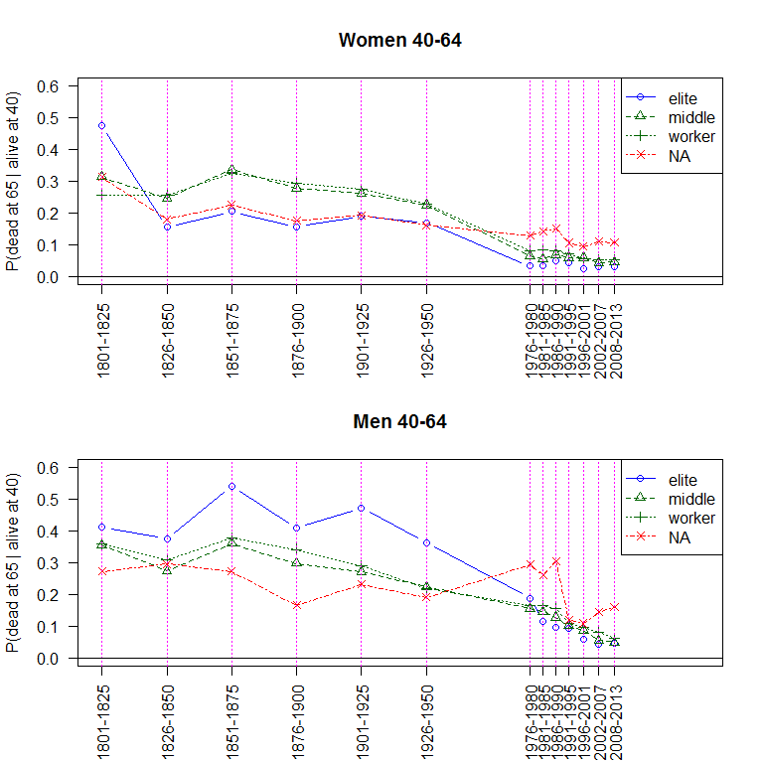

Figure 7 Probability of dying before age 65 for a 40 year old person by social class and period, women (top) and men (bottom).

From Table ?? it is obvious that the statistical significance is strong. The most interesting feature is the three-way interaction with **sex**, **period**, and social class.

Figure 7 shows the summed hazards of dying in the age interval 40--64 during the different periods. Obviously, but not surprisingly, mortality is decreasing over time for both sexes. Women have consistently better survival than men. This is a well-known phenomenon in Swedish demographic history (S. Willner 1999; Sundin and Willner 2007). We also observe a substantial decline in mortality for both sexes, resulting in smaller absolute differences between social classes. We must however distinguish between differences in absolute risks compared to relative risks (Hoffmann et al. 2016). The compression that is visible for later decades is partly explained by the decreasing general mortality and is not necessarily representing a homogenisation of relative risks.

By standardising the levels in each time period for each class, we illustrate the relative risks in Figure 8. In the rest of the paper, we only present these relative mortality levels for the different classes since they are the main focus in this study.

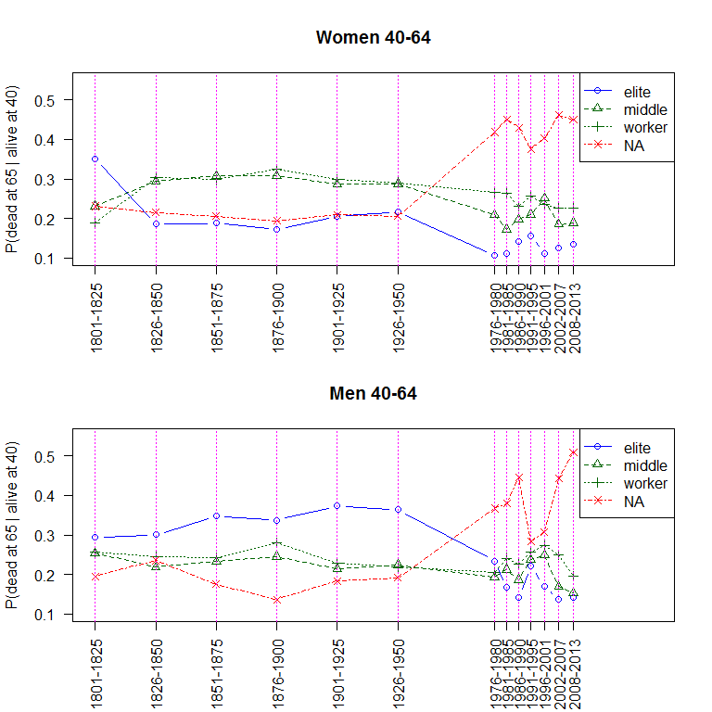

Figure 8 Probability of dying before age 65 for a 40 year old person standardised by social class and period, women (top) and men (bottom).

The changing economy have some consequences for the analysis, particularly when it comes to the agricultural sector. While farmers were common occupations up until the first half of the 20th century, these occupations has constantly decreased in numbers thereafter. This means that the middle category has a different character during the last periods.

The most striking result of the analysis is the different patterns for men and women. The social pattern of mortality among women is quite much in accordance with previous analyses from the present research group on other regions in northern Sweden and for other periods (Edvinsson and Lindkvist 2011; S. Edvinsson and Broström 2012). The highest social class usually have comparatively low mortality (except for the first period when however the statistical power was weak), while working class women have high, but almost constantly about the same level as the middle category. There is however no substantial change in the relative risks between classes. Only the group with unknown social class is distinguished by much higher mortality from the 1980s onwards. This can however have to do with how we have defined social position for women before and after 1950. After 1975 it is based on their own occupation. Being without occupation probably include women that are more frail when it comes to health or are vulnerable due to social characteristics.

A completely different pattern appears among men, being the most surprising finding in our analyses. The groups we expect to have the lowest mortality, if we assume that access to vital resources and belonging to a high social class determines survival, instead have by far the highest hazards of dying during the nineteenth and much of the 20th century. Workers on the other hand have comparatively low mortality until 1950, at the same level as the middle class. The fact that we define social class as a time-dependent variable could otherwise lead to reverse causation -- those having bad health losing social position -- but instead we find better survival among workers compared to the elite.

The relative positions change radically towards the end of the 20th century. From the 1980s, there is a clear advantage when it comes to survival for teh elite. The relative differences are however more compressed than for the periods until 1950. The expected social gradient in mortality has developed. This is also what we usually find in analyses of social health inequalities in present-day Sweden as well as in most other countries. In the regions we are studying, this is however a quite recent phenomenon. Corresponding to what we find for women, those without known occupation have much higher mortality than the others from the late 1970s onwards. The assumption made for women of unknown social class is probably even more relevant for men. They probably represent groups in society that are particularly vulnerable.

A further observation can be made from Figure 7. The gender difference in death hazards is extremely large for the elite group from 1851--1950, men having about three times higher risks than women in the same class (basically living in the same households). In the other classes, the difference was much smaller. It was men in high position that experienced the largest risks.

### Ages 65--89

We now turn to the elderly, those that in most cases have left the workforce. Corresponding to the previous analysis, we use the value of the cumulative hazards at duration 25 (age 90), starting from age 65 as a summary measure.

The general pattern and development of mortality (not shown here) do not differ that much from the younger age group, of course representing a much higher mortality level earlier in history. Mortality among women was, as expected, lower than among men. We find a clear decline in mortality, but the fastest decline did not set in definitely until some time after the Second World War, that is, later than for the age group 40--64 years. This corresponds to the Swedish development where we find a turning point at this time with better survival among elderly.

Concerning the social pattern, the pattern is less clear compared to what we find for the younger age group in line with the status levelling hypothesis (see Figure 9). For women the results are mixed. We do not find the same clear advantage for elite women during the period before 1950, but neither do we find any large disadvantage for working class elderly women at that time. In some periods, the social differences were small, particularly between the worker and the middle group, and the elite even had substantially higher mortality during the early 20th century. The social differences continued to be small until the last decades of the 20th century. Only during the two last periods (after the year 2000) is it possible to establish the expected social gradient in mortality.

For men we find indications of the same intriguing change among elderly as for the adult male population 40--64 years. Mortality was in fact substantially higher among elite men but their disadvantage was mainly apparent during the 19th century. Differences are fairly small during the first half of the 20th century. Not until the second half of the 20th century is the survival much better for the highest social class while workers in the age of retirement had high mortality in comparison. The difference between the worker and middle group have in most periods been small.

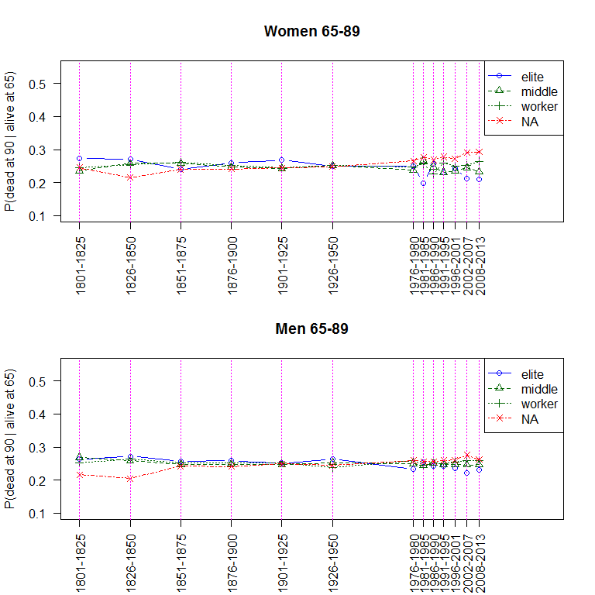

Figure 9 Probability of dying before age 90 for a 65 year old person by social class and period, women (top) and men (bottom). Standardised.

## Cardiovascular mortality

In this and the following section, the focus is on analyses of mortality from the two dominant groups of death causes in the adult and elderly population, using the same models and presentations as for total mortality. We restrict the analyses to the period 1901 onwards. Many studies have shown that socio-economic conditions are strongly associated with mortality in cardiovascular diseases. Belonging to working class, having less education and low income increases mortality risks. We would therefore expect to find a clear social pattern in the present analysis.

A general observation is that the results on causes of death and its development are less clear, partly because the number of cases are fewer but also that the quality and coverage of reported death causes differ in time. Thus, many deaths during the early 20th got quite vague diagnoses reported in the death registers. There was still a substantial part of all deaths where cause was diagnosed as unknown or dying from old age, despite the fact that reporting causes of death had become mandatory. For the period 1901--1925 to 1926--1950, the proportion of deaths from cardiovascular diseases increased from 25 to 43 per cent for the age group 40 and above, thus indicating an increase of these diseases. However, at the same time unknown cause and death in old age decreased from 28 percent to 18 per cent. It is reasonable to suspect that many cardiovascular deaths were disguised in unspecific categories and that the increase is partly explained by improvements in how deaths were diagnosed, something that also seems to have been the case in Scotland at this time (A. Reid et al. 2015).

### Ages 40--64

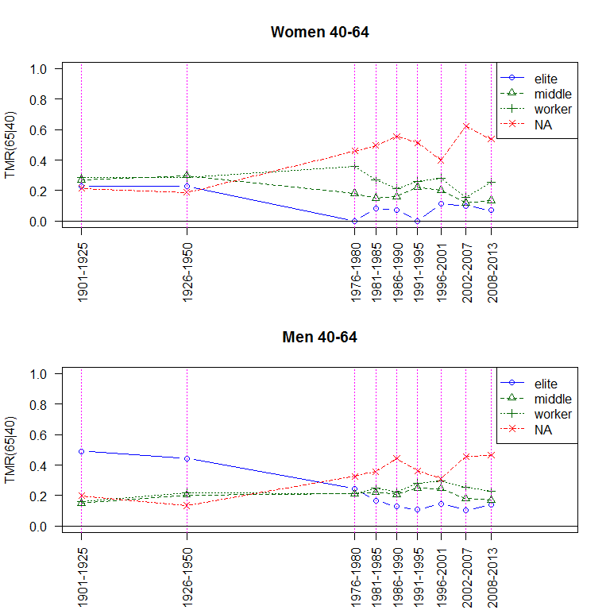

Figure 10 Total hazard of dying before age 65 for a 40 year old person standardised by social class and period, women (top) and men (bottom), cardiovascular death.

Figure 10 shows mortality levels during different periods from 1901 onwards. Women from the highest social class had consistently lower mortality from cardiovascular diseases compared to the others. We also observe increasing social differences from the first half of the century to the last decades. A new pattern has developed from 1981 onwards. Now working class women have substantially higher cardiovascular mortality compared to others. We can however not exclude that this is an artefact of different diagnostics for deaths in different groups. Working class women may have had less precise diagnoses in the early 20th century.

For men, we find a different pattern, however being basically consistent with what we observed concerning all-cause mortality. The elite group had much higher cardiovascular mortality up until the middle of the 20th century, but instead have the lowest mortality from 1980 onwards. Working class men had a fairly low cardiovascular mortality, but in the same way as among women, the levels were fairly similar to the one of the middle category consisting of white collar, lower managers and farmers. In the last decades and similarly as for women, working class men have the highest mortality from this cause of death group. A social hierarchy in cardiovascular mortality developed both for men and women.

### Ages 65--89

Here we focus on cardiovascular mortality among those that mostly have left the workforce, the age group 65--89 years. Much of the decline in mortality among elderly from the middle of the 20th century can be explained by lower death rates in this disease group.

Concerning the social pattern, we find somewhat different results for elderly women compared to the women in working-active age. Cardiovascular mortality among elderly women does not present a consistent class pattern. Female cardiovascular mortality was somewhat higher among the elite and the middle group than among working class women until the last decades. Elderly from a working class background were not disadvantaged for most of the 20th century. The social class pattern has changed somewhat during the last periods becoming more in line with what to expect. The differences are however rather small.

Even if results for elderly men point in different directions for some periods, the general trend resembles that of working-active men. The highest class had high cardiovascular mortality during the first half of the 20th century, while the expected social pattern developed and became apparent only during the most recent periods.

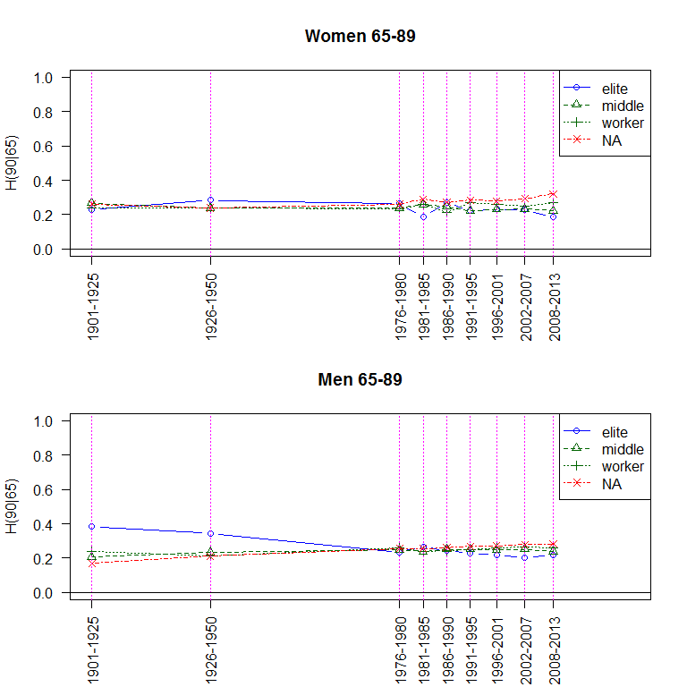

Figure 11 Total hazard of dying before age 90 for a 65 year old person standardised by social class and period, women (top) and men (bottom), cardiovascular death.

## Cancer mortality

While we assume clear social differences in cardiovascular diseases, this is not necessarily an obvious assumption when it comes to cancer. Different forms of cancers have different origin and different pathways to disease and death. The social pattern of higher mortality in classes with less power and accordingly less life chances are considered to be less clear when it comes to cancers. In our analyses, there is a risk that cancer mortality is underestimated during the first half of the 20th century, illustrated by the already mentioned large proportion of unknown or vague causes at that time. We believe however that cancers were better diagnosed than cardiovascular deaths. This is supported by the stability in proportion of cancer deaths between the two first periods, 12.5 per cent 1901--1925 and 13.5 per cent for the period 1926--1950.

### Ages 40--64

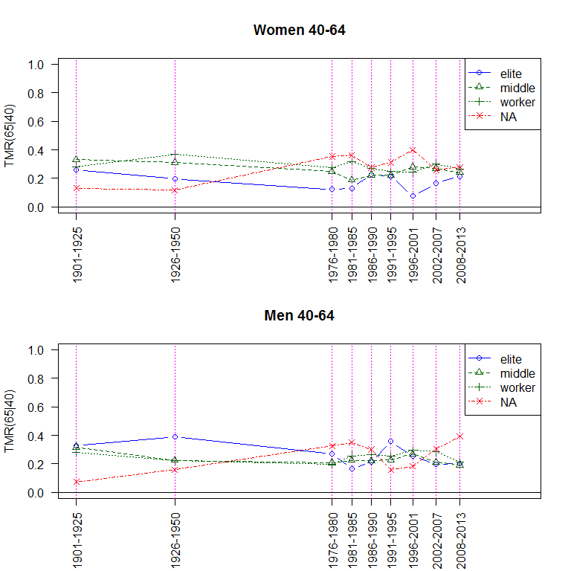

Figure 12 Total hazard of dying before age 65 for a 40 year old person standardised by social class and period, women (top) and men (bottom), cancer death.

Figure 12 shows relative mortality levels according to social class during the different studied periods for the age group 40--64. Cancer mortality among elite women was lower than that of the other classes during the complete studied period, while working class women had the highest levels during almost all periods. Consequently, we find a more consistent advantage of higher class in cancers compared to cardiovascular diseases for women, consistent with the idea of a social hierarchy in health. What is less expected, is that we find a stronger association between social class and survival in cancer than in cardiovascular diseases. We do however not find the same pattern for men. It is difficult to identify any general trends and features of 20th century male cancer mortality when it comes to social differences.

### Ages 65--89

In our analyses of class patterns in mortality, we finally turn to cancer mortality among the elderly. The relation between different classes and cancer mortality fluctuates considerably both for women and men in this age group. For some periods it has to do with quite few events to analyse. Women of the highest class have favourable mortality levels during several periods, consistent with the advantages we found for women in the younger age group, but on the other hand had high levels at other times. The social differences are however quite small during the most recent periods.

For men we find a similar lack of social pattern in cancer mortality as we found for men in working-active ages. There is however a tendency during the last decades of higher mortality among working class men.

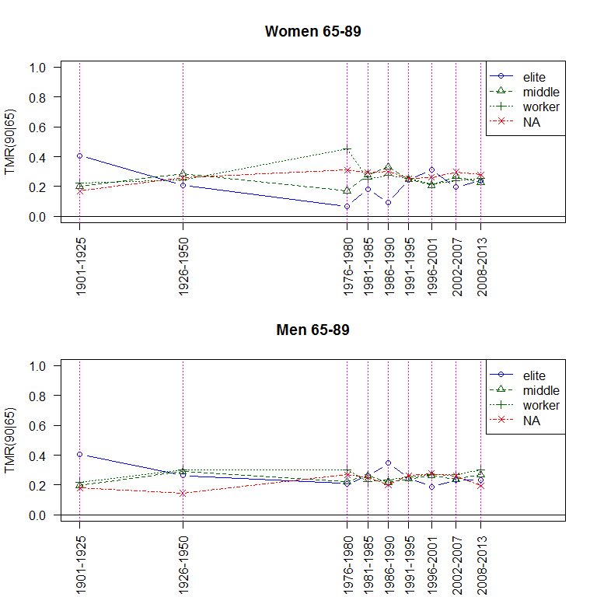

Figure 13 Total hazard of dying before age 90 for a 65 year old person standardised by social class and period, women (top) and men (bottom), cancer death.

# Discussion

The authors of this paper have scrutinised different aspects of the social pattern of mortality in historical northern Sweden for some time, focusing on different regions, age groups and time periods (S. Edvinsson 1992; Edvinsson 2004; Edvinsson and Lindkvist 2011; S. Edvinsson and Broström 2012). When it comes to infant and child mortality during pre- and early-transitional time, the expected socio-economic differences were often but not always confirmed (S. Edvinsson 1992; Edvinsson 2004), something that has been found in other Swedish studies as well (Brändström, Edvinsson, and Rogers 2002; Burström and Bernhardt 2001; Molitoris 2017).

Studies based on microdata on the adult and elderly population in history have been rare, mainly due to lack of adequate data. The results from such studies show other patterns than that for infant and child mortality. Some report substantial differences but many, particularly those based on Swedish data, have found surprisingly small or even reversed socio-economic differences during the 19th and early 20th century, sharply contrasting from the situation in present-day society. The expected social gradient in survival, meaning that people from higher social classes always had an advantage, was in many cases, particularly among adult men, not found despite the well-documented socio-economic differences in society, for example in the Sundsvall region (Edvinsson and Lindkvist 2011; S. Edvinsson and Broström 2012). The results presented here show that the consistent advantage for higher social classes do not appear until surprisingly late in the investigated regions. The basic pattern is the same in the working-age and the retired population, but the differences are smaller in old age in accordance with the status levelling hypothesis.

The results showing a small or even reversed socio-economic gradient in the past and its late development are in accordance with other studies (Bengtsson and Poppel 2011), for example by Bengtsson and Dribe (2011) in a different setting, a couple of Scanian parishes in southern Sweden, although with somewhat different social categories. They find the first indications of an emerging social gradient to be a fairly recent phenomenon, in their case as late as in the 1950s. Similar results have also been found in Estonia (Jaadla, Puur, and Rahu 2017). A study of mortality and social class in Sweden 1960--1968 found that self-employed men and non-manual male workers in fact had higher mortality than manual workers in total and cardiovascular mortality (Vågerö and Norell 1989). These findings are however contrary towards what usually is assumed and what other studies have shown. Those studies usually referred to when discussing the historical large social inequalities in health are mainly based on data from England and Wales (Antonovsky 1967; Woods and Williams 1995; Pamuk 1985). We know less about how general these results are, but apparently the Swedish context differed from the English and Welsh.

The surprising results make it reasonable to consider the validity and possible weaknesses in the study. Some of the limitations have been addressed in the presentation of the variables: the fact that social class was defined according to household until 1950 but individually defined from 1976 (affecting the social class of women), different definitions of presence during the same two periods and some differences in parishes included at different periods. These differences are however not of the magnitude that the main conclusions are affected. Most women end up in the same category as their husbands and the migrations between census dates or census date and death were not frequent.

One obstacle concerns the quality of available information. Occupational titles in historical sources are not always distinct enough to define the correct class. Studies covering long periods face the problem that occupations and classes change character---they do not represent the same thing. We have chosen to work with a few broad groups. Nevertheless, these ambiguities and possible misclassifications should not radically change the basic patterns observed. The social classes identified during the different periods represent distinct groups when it comes to resources, capacities and power.

We have analysed social inequality in health from the perspective of social classes. However, there are alternative ways to analyse social inequality, representing other dimensions, and we cannot exclude that such analyses give other results or modify the conclusions suggested here. In many modern studies categorisations based on income, wealth or education are common for studies of inequality. It would be interesting to compare the results from this study with alternative measures, but reliable data on income and education are unfortunately rarely available in historical population databases stretching back as far as in this article.

An intriguing aspect of this study is the lack of association between level of economic inequality and social differences in mortality. Even though our study do not directly address the hypothesis raised by Wilkinson and Pickett (2009), our results are of relevance for this question as well. The early 20th century, in Sweden as well as in other countries, was characterised by enormous economic differences, still this did in our regions not lead to any consistent advantage for the highest social class. After the Second World War, economic differences diminished, and was at its lowest in Sweden at about 1980, i.e. at a time when the expected pattern of a social hierarchy in survival appeared. The period thereafter is characterized by increasing economic differences, coinciding with increasing health differences as well. The long-term relation between economic inequality and health is still a puzzle requiring further studies.

Our study seems to be in conflict with many of the dominating theories in present-day health research. In an overview of explanations for the persistence of health inequalities (primarily focusing on high-income countries with extensive welfare arrangements), J. P. Mackenbach (2012) identifies a couple of theories, emphasizing different mechanisms and circumstances such as psycho-social pathways, material conditions, cultural capital et cetera. Most of these explanations are however based on the assumption that higher social classes are always advantaged when it comes to health and mortality. One of these leading theories is the hypothesis of Bruce G. Link and Phelan (1995) that social conditions are fundamental causes of disease and not only expressions of different disadvantages connected to the social position. Others emphasize psycho-social factors, for example Marmot (2004), who argues that a higher status leads to better health regardless of where in the status ladder individuals are situated. Psychosocial factors are also suggested by Wilkinson and Pickett (2009) as an explanation why equal societies perform better than unequal ones when it comes to health and other social conditions. In the long-term perspective provided here, neither of these theories fit the historical observations. Their validity are mainly apparent for the most recent decades. To be fair, however, our study do not explicitly test for the possible impact of different material or psycho-social mechanisms. These factors could still be (and probably are) valid and influence the social pattern of mortality. What our study establishes is that there there is no necessary eternal social gradient favouring higher social classes. The lacking social hierarchy may be caused by other mechanisms having stronger impact on the pattern. We might have to consider the possibility of socially countervailing mechanisms (Lutfey and Freese 2005).

The historical perspective shows the complexity of how health and mortality is socially constructed and illustrates the need to contextualize our analyses. The dominant theories are not necessarily wrong but they may need to be further developed and refined. The WHO Commission on Social Determinants of Health framework provides a holistic model on how socio-economic position influences health. Social class works through intermediate determinants (material circumstances, behaviours, biological factors and psycho-social factors) related to exposure and vulnerability (Solar and Irwin 2010). People are situated within socio-economic and political contexts, as well as prevailing societal value systems. The importance of understanding people in their context is also emphasized by Krieger (2005). What she calls embodiment refers to the recognition that human beings are simultaneously social beings and biological organisms. Having a good economy gives advantages in many aspects related to health and mortality, for example good living conditions, access to food, medical care and better working conditions, but even though these advantages were at hand in our studied regions, it did not result in better health for men in the most privileged groups until the late 20th century. It is possible that they had a stressful life, for example entrepreneurs facing the risk of losing an advantagous position.

We must however consider other and potentially more important explanations as well. It is possible that men in high positions had a stressful life, for example entrepreneurs facing the risk of losing an advantagous position. Such stress can also be expressed in unhealthful ways of living. These behaviours can however also have to do with certain expectations on being a man of high status. Our results of the gender aspect is important in this respect. As several researchers have pointed out, demographic research has often ignored power relations and different roles within families (Watkins 1993; Mackinnon 1995; Janssens 2007). The gender difference in mortality may be caused by discrimination on the female part in the household. Historical Sweden was strongly gender segregated, discriminating women and giving them less space for action. In our study, we do not find the lack of power to have negative health consequences for women. Within the same households, the effect of social class leads to different results, high social position being beneficial for women but not for men. Instead, we might consider the role of behaviours based on distinct gendered and class expectations. Having a high social status is sometimes expressed in attitudes, norms and way of living potentially harmful for health. Edvinsson and Lindkvist (2011), finding similar results in another environment, suggest that an explanation for the larger social health inequalities in present-day society is that high status is expressed through health, being fit and physically active, while in many historical contexts higher social status (for men) was expressed in low physical activity, obsessive eating, drinking, smoking and more inclined to take risks. Alcohol has been suggested as part of the large gender differences in the 19th century (S. Willner 1999; S. Edvinsson 1992), and a more risk-taking life may be an important component of male mortality (Courtenay 2000). Different historical contexts promote different ways to spend economic resources (Razzell and Spence 2006; Jaadla, Puur, and Rahu 2017).

In the present-day high-income world including Sweden, smoking and drinking contributes to a substantial part of socio-economic health differences (Martikainen et al. 2014; Sydén and Landberg 2016). Our study suggests a strong impact in historical Sweden as well. If this interpretation is correct, the hypothesis of Antonovsky (1967), on an increasing role of health related behaviour in the modern low-mortality regime while economic inequality determined the social mortality pattern during the early phases of the mortality transition, can be questioned. Instead, health-related inequality can be equally strong earlier in history but expressed in a completely different way. To corroborate this claim, we need to have evidence on the social differentiation of consumption patterns and behaviours in history. Unfortunately, such data are rarely available before the 1960’s. At best, we have circumstantial and anecdotal evidence. Such evidence do however support the idea of less health-beneficial ways of living among elite men (Edvinsson and Lindkvist (2011) ).

Overweight, obesity and physical inactivity were probably more common in higher social classes. Vågerö and Norell (1989) find a higher total as well as cardiovascular mortality among self-employed men and non-manual male workers, something they suggest can be explained by the higher tobacco consumption among men in these groups. The social pattern among women was however reversed in line with the present study. There is no solid information on smoking in different social classes before the 1960s, but there are international studies indicating higher prevalence and consumption of tobacco in higher classes during the early phases of the tobacco epidemic, illustrated for example by the fact that smoking initially was more prevalent among physicians. There was also an association between higher incomes and tobacco consumption (Lopez, Collishaw, and Piha 1994).

The same lack of statistical evidence characterizes knowledge about alcohol consumption in different social classes in Sweden before 1960, but with some exceptions. Access to alcohol was much easier for the wealthy during the period of strong alcohol restriction 1915-1955 and the purchase of alcoholic beverages was substantially higher among those with highest incomes. There was also an over-representation of alcohol-related deaths in higher social classes in the 1960s: Norström and Romelsjö (1998) suggest that during the last decades of the 20th century, there has been an equalization and even reversal of alcohol consumption between social strata, with higher levels among manual labourers but also with an increasingly skewed consumption distribution, indicating more high-consumers in this category. A similar reversal has been observed in England and Wales during the 20th century when it comes to cirrhosis mortality, maybe reflecting a change in consumption patterns. Mortality from this disease was substantially higher in the managerial and professional classes in 1921, being reversed in 1991 with highest mortality in the lowest class (Crombie and Precious 2010). If these indications of changes in health-related behaviour are significant enough to explain the present findings can be discussed. We believe that they certainly are at least an important part of the story.

# Conclusion

In this article we set our task to analyse social differences in mortality from a long-term perspective. Until recently it has not been possible to investigate the really long-term development on mortality differences among adult and elderly populations. Still, the prevailing idea in many parts of the scholarly society is that strong socio-economic differences in health and mortality have always existed and were possibly even stronger in historical societies due to large class differences. The present study is unique in its time perspective by investigating the development from the early 19th century until the present, utilizing micro-data of high quality on a population of considerable size and social diversification. The results probably surprise most readers, and partly surprised us as well. The consistent advantage of belonging to the elite have not always existed and the modern pattern of social divide in health appeared much later than expected in the regions we have studied. Apparently high social class is not always beneficial for survival.

There were however large differences in the pattern between men and women as well as between different age groups. Class as well as gender must be considered. The social pattern of female mortality are in line with the expected, but a social gradient in male adult mortality is a recent phenomenon. Furthermore, inequality in mortality appears clearer for the working-age population, while the differences are smaller among the elderly. Concerning specific causes of death, the analysis shows that cardiovascular diseases contributes to a large proportion of all deaths during the 20th century, and we are not surprised that it has a fairly similar pattern as for all-cause mortality. Cancer is often considered less connected to social class, and we find mixed results in our analyses.

To explain the observed differences is difficult and we can only provide tentative hypotheses. We have discussed the possible role of behavioural influences on mortality in different historical context, suggesting that such aspects are not only important in the modern epidemiological regime but might have been decisive in earlier phases of the epidemiologic transition as well. The results indicate that we should consider the role of gender and class expectations of behaviour. Unfortunately, the evidence for behavioural differences in history are usually circumstantial and anecdotal, at least when it comes to social class. Studies of these aspects and their role for health and mortality in different times and places require further development.

An important question is if our results can be generalised to other historical contexts. We have studied environments in northern Sweden without any large metropolitan areas.Perhaps Sweden or this part of Sweden is a special case. The involvement of government both at the national and local level may have been stronger, thus mitigating socio-economic disadvantages, but this is doubtful concerning the 19th century. The level of income inequality was certainly lower in our regions than in other parts of the country but it was still substantially higher in 1930 than towards the end of the 20th century. In comparison with many other countries, the level of mortality has been fairly low. This is a relevant question, which hopefully can be addressed in other studies, preferrably with a comparative approach.

# Acknowledgements

This work was undertaken within the research program *Ageing and Living Conditions* at the Centre for Demographic and Ageing Research (CEDAR) at Umeå University, financed by the Swedish Research Council (grant No 349-2008-6592) and the project *Old age, health and inequality: Mortality from a life course perspective in Sweden 1986--2009*, financed by the Swedish Research Council (grant No 421-2012-892). We thank the Demographic Data Base, Umeå University, for giving us access to data and Jonas Helgertz, Department of Economic History, Lund University, for providing us with scripts for creating Hisclass from Swedish Census data.

# References

Antonovsky, Aaron. 1967. “Social Class, Life Expectancy and Overall Mortality.” *Milbank Memorial Fund Quarterly* 45 (2): 31–73.

Bengtsson, T., and M. Dribe. 2011. “The Late Emergence of Socioeconomic Mortality Differentials: A Micro-Level Study of Adult Mortality in Southern Sweden 1815–1968.” *Explorations in Economic History* 48: 389–400.

Bengtsson, T., and F. van Poppel. 2011. “Socioeconomic Inequalities in Death from Past to Present: An Introduction.” *Explorations in Economic History* 48: 343–56.

Björklund, Anders. 1992. “Rising Female Labour Force Participation and the Distribution of Family Income—The Swedish Experience.” *Acta Sociologica* 35 (4). Sage Publications Sage CA: Thousand Oaks, CA: 299–309.

Brändström, Anders, Sören Edvinsson, and John Rogers. 2002. “Illegitimacy, Infant Feeding Practices and Infant Survival in Sweden, 1750–1950: A Regional Analysis.” *Hygiea Internationalis* 3 (1).

Broström, G. 2012. *Event History Analysis with R*. Boca Raton: Chapman & Hall/CRC.

Broström, G. 2017. *Eha: Event History Analysis*. <https://CRAN.R-project.org/package=eha>.

Brønnum-Hansen, Henrik, and Mikkel Baadsgaard. 2012. “Widening Social Inequality in Life Expectancy in Denmark. A Register-Based Study on Social Composition and Mortality Trends for the Danish Population.” *BMC Public Health* 12 (1). BioMed Central: 994.

Burström, Bo, and Eva Bernhardt. 2001. “Social Differentials in the Decline of Child Mortality in Nineteenth Century Stockholm.” *The European Journal of Public Health* 11 (1). Oxford Univ Press: 29–34.

Coale, Ansley J., and Susan Cotts Watkins. 1986. *The Decline of Fertility in Europe*. Princeton University Press.

Courtenay, Will H. 2000. “Constructions of Masculinity and Their Influence on Men’s Well-Being: A Theory of Gender and Health.” *Social Science & Medicine* 50 (10). Elsevier: 1385–1401.

Cox, D.R. 1972. “Regression Models and Life Tables.” *Journal of the Royal Statistical Society Series B (with Discussion)* 34: 187–220.

Crombie, Iain K, and Elaine Precious. 2010. “Changes in the Social Class Gradient of Cirrhosis Mortality in England and Wales Across the 20th Century.” *Alcohol and Alcoholism* 46 (1). Oxford University Press: 80–82.

Dannefer, Dale. 2003. “Cumulative Advantage/Disadvantage and the Life Course: Cross-Fertilizing Afw and Social Science Theory.” *Journal of Gerontology* 58B: 327–37.

Edvinsson, S. 1992. “Den osunda staden. Sociala skillnader i dödlighet i 1800-talets Sundsvall.” PhD thesis, Umeå: Umeå University; Demografiska databasen.

Edvinsson, S., and G. Broström. 2012. “Old Age, Health, and Social Inequality: Exploring the Social Patterns of Mortality in 19th Century Northern Sweden.” *Demographic Research* 26: 23. doi:[10.4054/DemRes.2012.26.23](https://doi.org/10.4054/DemRes.2012.26.23).

———. 2014. “Famine Survivors: Long-Term Health Effects of the 1867 Harvest Failure in Northern Sweden.” Umeå University, Sweden.

Edvinsson, Sören. 2004. “Social Differences in Infant and Child Mortality in Nineteenth Century Sweden.” In *The Determinants of Infant and Child Mortality in Past European Populations*, edited by Marco Breschi and Lucia Pozzi. Udine: Forum.

Edvinsson, Sören, and Marie Lindkvist. 2011. “Wealth and Health in 19th Century Sweden. A Study of Social Differences in Adult Mortality in the Sundsvall Region.” *Explorations in Economic History* 48 (3): 376–88.

Fahlgren, Karl. 1956. *Skellefteå Stads Historia, Part 1:2*. Uppsala.

Fisher, R. A. 1922. “On the Mathematical Foundations of Theoretical Statistics.” *Philosophical Transactions of the Royal Society A* 222: 309–68. doi:[10.1098/rsta.1922.0009](https://doi.org/10.1098/rsta.1922.0009).

Fritzell, Johan, and Olle Lundberg. 2007. “Health and Inequalities in Sweden: Long and Short-Term Participation.” In *Health Inequalities and Welfare Resources. Continuity and Change in Sweden*, edited by Johan Fritzell and Olle Lundberg. Bristol: Policy Press.

Hoffmann, Rasmus. 2008. *Socioeconomic Differences in Old Age Mortality*. Springer Science+Business Media.

Hoffmann, Rasmus, Yannan Hu, Rianne De Gelder, Gwenn Menvielle, Matthias Bopp, and Johan P Mackenbach. 2016. “The Impact of Increasing Income Inequalities on Educational Inequalities in Mortality—An Analysis of Six European Countries.” *International Journal for Equity in Health* 15 (1). BioMed Central: 103.

Jaadla, Hannaliis, Allan Puur, and Kaja Rahu. 2017. “Socioeconomic and Cultural Differentials in Mortality in a Late 19th Century Urban Setting: A Linked Records Study from Tartu, Estonia, 1897–1900.” *Demographic Research* 36: 1–40.

Janssens, Angélique. 2007. “‘Were Women Present at the Demographic Transition?’ A Question Revisited.” *The History of the Family* 12 (1). Taylor & Francis: 43–49.

Krieger, Nancy. 2005. “Embodiment: A Conceptual Glossary for Epidemiology.” *Journal of Epidemiology and Community Health* 59 (5). BMJ Publishing Group Ltd: 350–55.

Kunst, Anton E., Vivian Bos, Otto Andersen, Mario Cardano, Giuseppe Costa, Seeromanie Harding, Örjan Hemström, et al. 2004. “Monitoring of Trends in Socioeconomic Inequalities in Mortality: Experiences from a European Project.” *Demographic Research* Special Collection 2 (Article 9): 229–54.

Link, Bruce G, Mary E Northridge, Jo C Phelan, and Michael L Ganz. 1998. “Social Epidemiology and the Fundamental Cause Concept: On the Structuring of Effective Cancer Screens by Socioeconomic Status.” *The Milbank Quarterly* 76 (3). Wiley Online Library: 375–402.

Link, Bruce G., and Jo Phelan. 1995. “Social Conditions as Fundamental Causes of Disease.” *Journal of Health and Social Behavior* 35: 80–94.

Lopez, Alan D, Neil E Collishaw, and Tapani Piha. 1994. “A Descriptive Model of the Cigarette Epidemic in Developed Countries.” *Tobacco Control* 3 (3). BMJ Group: 242.

Lutfey, Karen, and Jeremy Freese. 2005. “Toward Some Fundamentals of Fundamental Causality: Socioeconomic Status and Health in the Routine Clinic Visit for Diabetes.” *American Journal of Sociology* 110 (5). The University of Chicago Press: 1326–72.

Mackenbach, Johan P. 2012. “The Persistence of Health Inequalities in Modern Welfare States: The Explanation of a Paradox.” *Social Science & Medicine* 75 (4). Elsevier: 761–69.

Mackenbach, Johan P, Ivana Kulhánová, Barbara Artnik, Matthias Bopp, Carme Borrell, Tom Clemens, Giuseppe Costa, et al. 2016. “Changes in Mortality Inequalities over Two Decades: Register Based Study of European Countries.” *Bmj* 353. British Medical Journal Publishing Group: i1732.

Mackinnon, Alison. 1995. “Were Women Present at the Demographic Transition? Questions from a Feminist Historian to Historical Demographers.” *Gender & History* 7 (2). Wiley Online Library: 222–40.

Malmberg, Gunnar, Lars-Göran Nilsson, and Lars Weinehall. 2010. “Longitudinal Data for Interdisciplinary Ageing Research. Design of the Linnaeus Database.” *Scandinavian Journal of Public Health*. Sage Publications, 1403494810382812.

Marmot, Michael. 2004. *Status Syndrome—How Your Social Standing Directly Affects Your Health and Life Expectancy*. London; New York: Bloomsbury; Henry Holt.

Martikainen, Pekka, Pia Mäkelä, Riina Peltonen, and Mikko Myrskylä. 2014. “Income Differences in Life Expectancy: The Changing Contribution of Harmful Consumption of Alcohol and Smoking.” *Epidemiology* 25 (2). LWW: 182–90.

Molitoris, Joseph. 2017. “Disparities in Death: Inequality in Cause-Specific Infant and Child Mortality in Stockholm, 1878–1926.” *Demographic Research* 36: 455–500.

Nilsson, Hans. 1994. “Mot Bättre Hälsa: Dödlighet Och Hälsoarbete I Linköping 1860-1894.” PhD thesis, Linköpings universitet.

Norström, Thor, and Anders Romelsjö. 1998. “Social Class, Drinking and Alcohol-Related Mortality.” *Journal of Substance Abuse* 10 (4). Elsevier: 385–95.

Pamuk, Elsie R. 1985. “Social Class Inequality in Mortality from 1921 to 1972 in England and Wales.” *Population Studies* 39 (1). Taylor & Francis: 17–31.

R Core Team. 2016. *R: A Language and Environment for Statistical Computing*. Vienna, Austria: R Foundation for Statistical Computing.

Razzell, Peter, and Christine Spence. 2006. “The Hazards of Wealth: Adult Mortality in Pre-Twentieth-Century England.” *Social History of Medicine* 19 (3): 381–405.

Reid, Alice, Eilidh Garrett, Chris Dibben, and Lee Williamson. 2015. “‘A Confession of Ignorance’: Deaths from Old Age and Deciphering Cause-of-Death Statistics in Scotland, 1855–1949.” *The History of the Family* 20 (3). Taylor & Francis: 320–44.

Roine, Jesper, and Daniel Waldenström. 2008. “The Evolution of Top Incomes in an Egalitarian Society.” *Journal of Public Economics* 92: 366–87.

———. 2009. “Wealth Concentration over the Path of Development: Sweden, 1873–2006.” *Journal of Economics* 11: 151–87.

Solar, O., and A. Irwin. 2010. “A Conceptual Framework for Action on the Social Determinants of Health. Social Determinants of Health. Discussion Paper 2 (Policy and Practice).” Geneva: World Health Organization.

Strand, Bjørn Heine, Else-Karin Grøholt, Ólöf Anna Steingrímsdóttir, Tony Blakely, Sidsel Graff-Iversen, and Øyvind Næss. 2010. “Educational Inequalities in Mortality over Four Decades in Norway: prospective Study of Middle Aged Men and Women Followed for Cause Specific Mortality, 1960-2000.” *Bmj* 340. British Medical Journal Publishing Group: c654.

Subramanian, Subu V, and Ichiro Kawachi. 2004. “Income Inequality and Health: What Have We Learned so Far?” *Epidemiologic Reviews* 26 (1). Oxford University Press: 78–91.

Sundin, Jan, and Sam Willner. 2007. “Social Change and Health in Sweden: 250 Years of Politics and Practice.”

Sydén, Lovisa, and Jonas Landberg. 2016. “The Contribution of Alcohol Use and Other Lifestyle Factors to Socioeconomic Differences in All-Cause Mortality in a Swedish Cohort.” *Drug and Alcohol Review*. Wiley Online Library.

Van Leeuwen, Marco HD, and Ineke Maas. 2011. *HISCLASS: A Historical International Social Class Scheme*. Universitaire Pers Leuven.

Van Leeuwen, Marco HD, Ineke Maas, and Andrew Miles. 2002. *HISCO: Historical International Standard Classification of Occupations*. Leuven Univ Pr.

Vågerö, Denny, and Staffan E Norell. 1989. “Mortality and Social Class in Sweden—Exploring a New Epidemiological Tool.” *Scandinavian Journal of Social Medicine* 17 (1). SAGE Publications Sage UK: London, England: 49–58.

Vikström, Lotta. 2010. “Identifying Dissonant and Complementary Data on Womend Through the Triangulation of Historical Sources.” *International Jorunal of Social Research Methodology* 13: 211–21.

Wagstaff, Adam, and Eddy Van Doorslaer. 2000. “Income Inequality and Health: What Does the Literature Tell Us?” *Annual Review of Public Health* 21 (1). Annual Reviews 4139 El Camino Way, PO Box 10139, Palo Alto, CA 94303-0139, USA: 543–67.

Waldenström, Daniel, and Jesper Roine. 2014. “Long Run Trends in the Distribution of Income and Wealth.”

Watkins, Susan Cotts. 1993. “If All We Knew About Women Was What We Read in Demography, What Would We Know?” *Demography* 30 (4). Springer: 551–77.

Westberg, Annika, Elisabeth Engberg, and Sören Edvinsson. 2016. “A Unique Source for Innovative Longitudinal Research: The Poplink Database.” *Historical Life Course Studies* 3: 20–31.

Wilkinson, Richard, and Kate Pickett. 2009. *The Spirit Level. Why More Equal Societies Almost Always Do Better*. Penguins books.

Willner, S. 1999. “Det svaga könet? Kön och vuxendödlighet i 1800-talets Sverige.” PhD thesis, Linköping University.

Woods, Robert, and Naomi Williams. 1995. “Must the Gap Widen Before It Can Be Narrowed? Long-Term Trends in Social Class Mortality Differentials.” *Continuity and Change* 10 (1). Cambridge University Press: 105–37.