LABORATORY OBSERVATION

Course: Full Stack Web Development
Course Code: 23CM4121
Experiment No.: 7
Student Name: Gorapalli Sravya
Roll No.: A24126552257
Date: 26-08-2026

1. TITLE
Design a College Information Portal Webpage

2. AIM
To design a multi-section College Information Portal webpage using HTML5 and CSS3 that presents information about the college, its departments and contact details.

3. OBJECTIVE
The objectives of this experiment are:
- To design a webpage with multiple sections using semantic HTML5 tags.
- To display structured information such as departments using a card-based layout.
- To present contact details using an HTML table.
- To style the portal using CSS3, including Flexbox for a responsive department grid.

4. THEORY
An information portal is a webpage that organizes and presents structured information about an organization through clearly defined sections such as an introduction, categorized listings and contact details.
HTML5 semantic elements such as <header>, <nav>, <section> and <footer> are used to structure a portal page in a way that is meaningful to both browsers and assistive technologies.
CSS3 Flexbox (display: flex) allows department cards to be arranged in a flexible, wrapping row that adapts to the available screen width, while properties such as border-radius and box-shadow give each card a clean, modern appearance.

5. ALGORITHM / PROCEDURE
1. Create an HTML file, index.html.
2. Add a header section containing the college name and a navigation bar.
3. Add an 'About' section describing the college.
4. Add a 'Departments' section containing a card for each department.
5. Add a 'Contact' section with a table of contact details.
6. Add a footer with a copyright line.
7. Create a style.css file and link it to the HTML page.
8. Style the header, navigation, department cards (using Flexbox) and table.
9. Save both files and open index.html in a browser to verify the layout.

6. PROGRAM
index.html
<!DOCTYPE html>
<html>
<head>
<title>ANITS College Information Portal</title>
<link rel="stylesheet" href="style.css">
</head>
<body>

<header>
<h1>Anil Neerukonda Institute of Technology &amp; Sciences</h1>
<nav>
<a href="#about">About</a>
<a href="#departments">Departments</a>
<a href="#contact">Contact</a>
</nav>
</header>

<section id="about">
<h2>About the College</h2>
<p>ANITS is an autonomous engineering college offering undergraduate
and postgraduate programs in engineering and technology.</p>
</section>

<section id="departments">
<h2>Departments</h2>
<div class="dept-grid">
<div class="dept-card">
<h3>CSE</h3>
<p>Computer Science &amp; Engineering</p>
</div>
<div class="dept-card">
<h3>CSE (AI &amp; ML)</h3>
<p>Artificial Intelligence &amp; Machine Learning</p>
</div>
<div class="dept-card">
<h3>ECE</h3>
<p>Electronics &amp; Communication Engineering</p>
</div>
</div>
</section>

<section id="contact">
<h2>Contact Us</h2>
<table border="1">
<tr><th>Field</th><th>Details</th></tr>
<tr><td>Address</td><td>Sangivalasa, Visakhapatnam</td></tr>
<tr><td>Phone</td><td>+91-891-2790101</td></tr>
<tr><td>Email</td><td>info@anits.edu.in</td></tr>
</table>
</section>

<footer>
<p>&copy; 2026 ANITS College Information Portal</p>
</footer>

</body>
</html>
style.css
header {
background-color: #1a2b4c;
color: white;
padding: 24px 20px;
text-align: center;
}

nav a {
color: white;
margin: 0 12px;
text-decoration: none;
font-weight: bold;
}

.dept-grid {
display: flex;
flex-wrap: wrap;
gap: 16px;
}

.dept-card {
background: white;
border-radius: 8px;
padding: 16px;
width: 180px;
box-shadow: 0 2px 6px rgba(0,0,0,0.12);
text-align: center;
}

table { border-collapse: collapse; }
th { background-color: #1a2b4c; color: white; padding: 8px 12px; }
td { padding: 8px 12px; }

footer {
text-align: center;
background-color: #1a2b4c;
color: white;
padding: 12px;
}

7. CODE EXPLANATION
Tag / Code | Explanation
<header>, <nav> | Defines the top banner and navigation links of the portal
<section id=""> | Groups related content and provides an anchor target for nav links
.dept-grid { display: flex } | Arranges department cards in a flexible, wrapping row
.dept-card | Styles each department card with padding, radius and shadow
<table>,<tr>,<th>,<td> | Displays contact details in a structured row/column format
<footer> | Defines the bottom section of the portal with copyright text
box-shadow / border-radius | CSS3 properties giving cards a soft, modern appearance

8. TEST CASES AND EXECUTION DATA
The portal page was opened in a browser and each section was verified.
Test Case | Description | Expected Result | Actual Result | Status
TC-01 | Open index.html in a browser | Header, sections and footer all display | All sections displayed correctly | Pass
TC-02 | Click a navigation link | Page scrolls to the corresponding section | Scrolled to correct section | Pass
TC-03 | Check department cards | Cards display in a wrapping grid layout | Cards displayed in a grid | Pass
TC-04 | Check contact table | Table displays address, phone and email | Table displayed correctly | Pass
TC-05 | Resize the browser window | Department cards wrap responsively | Cards wrapped correctly | Pass

9. OUTPUT
Output: College Information Portal Rendered in Browser
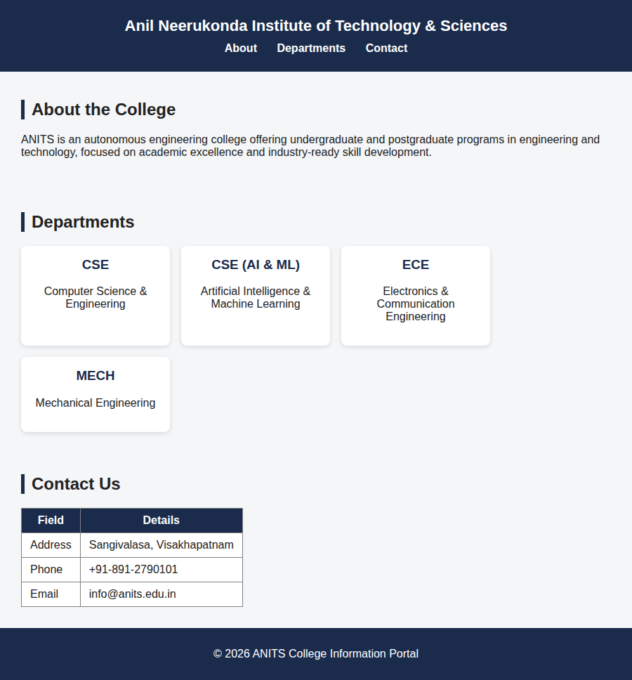
Portal page showing header/nav, About, Departments grid, Contact table and footer

10. RESULT
Thus, a College Information Portal webpage was successfully designed using HTML5 and CSS3, and the layout was verified in a web browser.

