LABORATORY OBSERVATION

Course: Full Stack Web Development
Course Code: 23CM4121
Experiment No.: 10
Student Name: Gorapalli Sravya
Roll No.: A24126552257
Date: 26-08-2026

1. TITLE
Develop an Interactive To-Do List Using DOM and Event Listeners

2. AIM
To develop an interactive to-do list web application using DOM manipulation and JavaScript event listeners, allowing tasks to be added, marked complete and deleted.

3. OBJECTIVE
The objectives of this experiment are:
- To understand and use the addEventListener() method to handle click and keyup events.
- To dynamically add tasks to a list using the DOM.
- To mark a task as complete by toggling a CSS class.
- To delete a task from the list using event delegation.

4. THEORY
The addEventListener() method attaches an event handler to an element without overwriting any existing handlers on that element, and supports common events such as click and keyup.
Event delegation is a technique where a single event listener is attached to a parent element (such as a <ul>) to handle events triggered by its child elements. This is especially useful for elements such as list items that are created dynamically at runtime, since a listener does not need to be attached individually to each new item.
The event object's target property identifies the exact element that triggered the event, which allows a delegated listener to determine which button (Complete or Delete) was actually clicked and act on the corresponding list item.

5. ALGORITHM / PROCEDURE
1. Create an HTML file with a text input, an Add button and an empty unordered list.
2. Select the input, button and list elements using the DOM.
3. Define an addTask() function that creates a new <li> containing the task text, a Complete button and a Delete button.
4. Attach addTask() to the Add button's click event using addEventListener().
5. Attach a keyup listener to the input so pressing Enter also adds the task.
6. Attach a single click listener to the <ul> (event delegation) to handle Complete/Delete clicks on any current or future item.
7. On a Complete click, toggle a 'completed' CSS class on the parent <li> to show a strikethrough.
8. On a Delete click, remove the parent <li> from the DOM.
9. Save the file and test adding, completing and deleting tasks in the browser.

6. PROGRAM
index.html
<!DOCTYPE html>
<html>
<head>
<title>Interactive To-Do List</title>
</head>
<body>
<h1>My To-Do List</h1>
<input type="text" id="taskInput" placeholder="Enter a task and press Enter">
<button id="addBtn">Add</button>

<ul id="taskList"></ul>

<script src="script.js"></script>
</body>
</html>
script.js
const taskInput = document.getElementById("taskInput");
const addBtn = document.getElementById("addBtn");
const taskList = document.getElementById("taskList");

function addTask() {
const text = taskInput.value.trim();
if (text === "") return;

const li = document.createElement("li");

const span = document.createElement("span");
span.textContent = text;

const completeBtn = document.createElement("button");
completeBtn.textContent = "Complete";
completeBtn.className = "complete-btn";

const deleteBtn = document.createElement("button");
deleteBtn.textContent = "Delete";
deleteBtn.className = "delete-btn";

li.appendChild(span);
li.appendChild(completeBtn);
li.appendChild(deleteBtn);
taskList.appendChild(li);

taskInput.value = "";
}

addBtn.addEventListener("click", addTask);

taskInput.addEventListener("keyup", (e) => {
if (e.key === "Enter") {
addTask();
}
});

// Event delegation for Complete / Delete buttons
taskList.addEventListener("click", (e) => {
if (e.target.classList.contains("complete-btn")) {
e.target.parentElement.classList.toggle("completed");
}
if (e.target.classList.contains("delete-btn")) {
e.target.parentElement.remove();
}
});

7. CODE EXPLANATION
Tag / Code | Explanation
addEventListener("click", ...) | Attaches a click event handler to the Add button
addEventListener("keyup", ...) | Detects when the Enter key is released inside the input field
document.createElement() | Dynamically creates the list item, span and buttons for a task
taskList.appendChild() | Adds the newly created task item to the visible list
e.target | Identifies the exact button that was clicked inside the list
classList.toggle("completed") | Adds or removes the CSS class that shows the strikethrough style
element.remove() | Removes a task's <li> element from the DOM
Event delegation on <ul> | A single listener on the list handles clicks for all current and future tasks

8. TEST CASES AND EXECUTION DATA
The to-do list was tested in the browser by adding, completing and deleting tasks.
Test Case | Description | Expected Result | Actual Result | Status
TC-01 | Type a task and click Add | Task appears at the bottom of the list | Task appeared correctly | Pass
TC-02 | Type a task and press Enter | Task is added without clicking Add | Task added via Enter key | Pass
TC-03 | Click Complete on a task | Task text shows a strikethrough style | Strikethrough applied correctly | Pass
TC-04 | Click Delete on a task | Task is removed from the list | Task removed correctly | Pass
TC-05 | Click Add with an empty input | No empty task is added | No empty task added | Pass

9. OUTPUT
Output: Tasks Added, Completed and Deleted
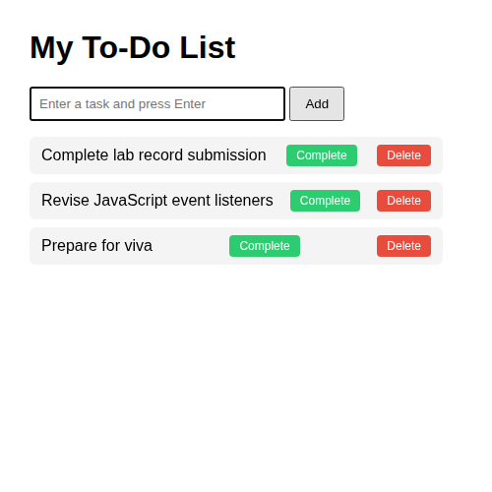
Three tasks added to the list (one via Add button, two via Enter key)
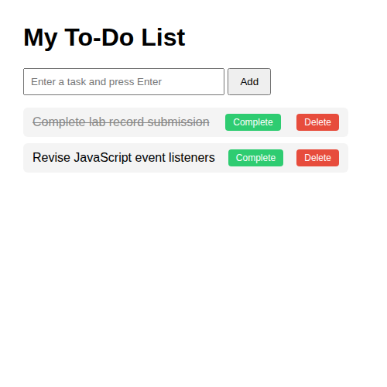
After marking the first task complete and deleting the third task

10. RESULT
Thus, an interactive to-do list was successfully developed using DOM manipulation and JavaScript event listeners, and task addition, completion and deletion were verified in the browser.

