LABORATORY OBSERVATION

Course: Full Stack Web Development
Course Code: 23CM4121
Experiment No.: 8
Student Name: Gorapalli Sravya
Roll No.: A24126552257
Date: 26-08-2026

1. TITLE
Demonstrate HTML5 Graphics and CSS3 Web Styling Techniques

2. AIM
To demonstrate HTML5 graphics using the canvas element and to apply advanced CSS3 styling techniques such as gradients, transitions and animations.

3. OBJECTIVE
The objectives of this experiment are:
- To draw basic shapes using the HTML5 <canvas> element and JavaScript.
- To apply CSS3 gradients, border-radius and box-shadow for styling.
- To apply a CSS3 transition for an interactive hover effect.
- To apply a CSS3 keyframe animation for a continuously animated element.

4. THEORY
The HTML5 <canvas> element provides a drawable region on a webpage that is controlled using JavaScript through the Canvas 2D API, accessed via getContext("2d"). It can be used to draw shapes, lines, text and images programmatically.
CSS3 introduced advanced visual styling features such as linear-gradient() backgrounds for smooth colour transitions, box-shadow for depth, and border-radius for rounded corners.
The CSS3 transition property animates a property change smoothly over a given duration (e.g., on hover), while @keyframes combined with the animation property defines a repeating sequence of style changes, such as a pulsing effect.

5. ALGORITHM / PROCEDURE
1. Create an HTML file with a <canvas> element.
2. Get the 2D drawing context using getContext("2d").
3. Draw a filled rectangle using fillRect().
4. Draw a filled circle using arc() and fill().
5. Draw a line using moveTo(), lineTo() and stroke().
6. Add two styled boxes below the canvas using linear-gradient backgrounds.
7. Apply border-radius and box-shadow to the styled boxes.
8. Add a CSS3 transition so the boxes scale up smoothly on hover.
9. Add a circular element with a @keyframes pulse animation.
10. Save the file and open it in a browser to view the graphics and effects.

6. PROGRAM
index.html
<!DOCTYPE html>
<html>
<head>
<title>HTML5 Graphics &amp; CSS3 Styling</title>
<style>
canvas { background: white; border: 1px solid #ccc; }
.box-row { display: flex; justify-content: center; gap: 24px; margin-top: 30px; }
.box {
width: 120px; height: 120px; border-radius: 16px;
box-shadow: 0 4px 10px rgba(0,0,0,0.25);
transition: transform 0.3s ease;
}
.box:hover { transform: scale(1.12); }
.gradient1 { background: linear-gradient(135deg, #667eea, #764ba2); }
.gradient2 { background: linear-gradient(135deg, #f6d365, #fda085); }
.pulse {
width: 60px; height: 60px; border-radius: 50%;
background: #e74c3c; margin: 40px auto 0;
animation: pulse 1.5s infinite;
}
@keyframes pulse {
0% { transform: scale(1); opacity: 1; }
50% { transform: scale(1.35); opacity: 0.55; }
100% { transform: scale(1); opacity: 1; }
}
</style>
</head>
<body>
<h1>HTML5 Graphics &amp; CSS3 Styling Demo</h1>

<canvas id="myCanvas" width="300" height="200"></canvas>

<div class="box-row">
<div class="box gradient1"></div>
<div class="box gradient2"></div>
</div>

<div class="pulse"></div>

<script>
const canvas = document.getElementById("myCanvas");
const ctx = canvas.getContext("2d");

ctx.fillStyle = "#3498db";
ctx.fillRect(20, 20, 100, 60);

ctx.beginPath();
ctx.arc(220, 50, 40, 0, Math.PI * 2);
ctx.fillStyle = "#2ecc71";
ctx.fill();

ctx.beginPath();
ctx.moveTo(20, 150);
ctx.lineTo(280, 150);
ctx.strokeStyle = "#e74c3c";
ctx.lineWidth = 4;
ctx.stroke();
</script>
</body>
</html>

7. CODE EXPLANATION
Tag / Code | Explanation
<canvas id=""> | Creates a drawable canvas area on the page
getContext("2d") | Returns the 2D drawing context used to draw on the canvas
fillRect() / arc() / stroke() | Canvas methods used to draw a rectangle, a circle and a line
linear-gradient() | CSS3 function that creates a smooth colour gradient background
border-radius / box-shadow | CSS3 properties that round corners and add a shadow to an element
transition: transform 0.3s | Smoothly animates the scale change when the box is hovered
@keyframes pulse / animation | Defines and applies a repeating scale + opacity animation

8. TEST CASES AND EXECUTION DATA
The page was opened in a browser and each graphic and styling effect was verified.
Test Case | Description | Expected Result | Actual Result | Status
TC-01 | Open index.html in a browser | Canvas shows a rectangle, circle and line | Shapes displayed correctly | Pass
TC-02 | Hover over a gradient box | Box scales up smoothly | Box scaled up smoothly | Pass
TC-03 | Observe the pulse circle | Circle continuously pulses in size and opacity | Circle pulsed continuously | Pass
TC-04 | Check gradient boxes | Boxes display smooth diagonal colour gradients | Gradients displayed correctly | Pass
TC-05 | Check box shadow and corners | Boxes show rounded corners and a soft shadow | Rounded corners and shadow visible | Pass

9. OUTPUT
Output: Canvas Graphics and CSS3 Styling in Browser
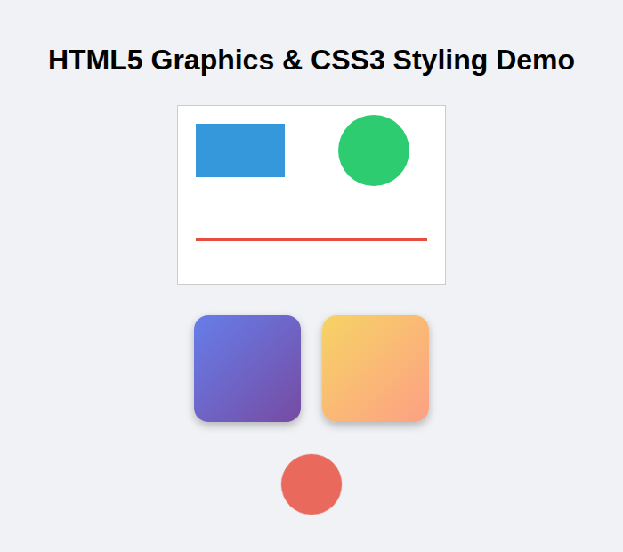
Canvas shapes, gradient boxes and pulsing circle in their default state
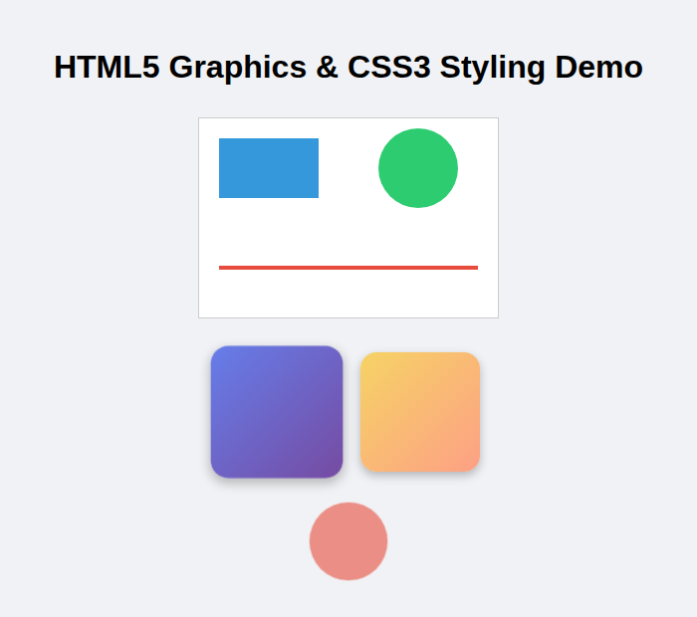
Gradient box scaled up on hover, showing the CSS3 transition effect

10. RESULT
Thus, HTML5 canvas graphics were successfully drawn and CSS3 styling techniques such as gradients, transitions and animations were successfully applied, and the output was verified in a web browser.

