LABORATORY OBSERVATION

Course: Full Stack Web Development
Course Code: 23CM4121
Experiment No.: 9
Student Name: Gorapalli Sravya
Roll No.: A24126552257
Date: 26-08-2026

1. TITLE
Develop a Student Profile Manager Using JavaScript Class and DOM

2. AIM
To develop a Student Profile Manager web application using a JavaScript class to model student data, and DOM manipulation to add, display and delete student profiles dynamically.

3. OBJECTIVE
The objectives of this experiment are:
- To define a JavaScript class (Student) with properties and a method.
- To create multiple objects (instances) of the class from form input.
- To dynamically render a list of objects onto the page using the DOM.
- To remove an object from the underlying array and re-render the list.

4. THEORY
JavaScript ES6 introduced the class syntax as a cleaner way to implement object-oriented concepts. A class is defined using the class keyword, with a constructor() method that initializes an object's properties, and additional methods that define its behaviour.
Objects (instances) of a class are created using the new keyword, for example new Student(...). Each instance has its own copy of the properties defined in the constructor and can call the methods defined on the class.
Combined with DOM methods such as createElement() and appendChild(), classes can be used to model structured data (such as a student) and dynamically render a list of such objects on a webpage, updating the list whenever the underlying array changes.

5. ALGORITHM / PROCEDURE
1. Create an HTML file with input fields for name, roll number and branch, an Add button, and a container for the profile list.
2. Define a Student class with a constructor that accepts name, rollNo and branch.
3. Add a getSummary() method to the class that returns a formatted string.
4. Create an array, students, to hold Student objects.
5. Write an addStudent() function that reads the input fields, creates a new Student object using new, and pushes it into the array.
6. Write a renderStudents() function that clears and rebuilds the profile list from the students array using the DOM.
7. Add a Delete button to each rendered profile that removes that student from the array (using splice) and re-renders the list.
8. Attach addStudent() to the Add button using addEventListener().
9. Save the file and test adding and deleting multiple student profiles in the browser.

6. PROGRAM
index.html
<!DOCTYPE html>
<html>
<head>
<title>Student Profile Manager</title>
</head>
<body>
<h1>Student Profile Manager</h1>

<input type="text" id="nameInput" placeholder="Name">
<input type="text" id="rollInput" placeholder="Roll No">
<input type="text" id="branchInput" placeholder="Branch">
<button id="addBtn">Add Student</button>

<div id="profileList"></div>

<script src="script.js"></script>
</body>
</html>
script.js
class Student {
constructor(name, rollNo, branch) {
this.name = name;
this.rollNo = rollNo;
this.branch = branch;
}

getSummary() {
return `${this.name} (${this.rollNo}) - ${this.branch}`;
}
}

const students = [];

function renderStudents() {
const listDiv = document.getElementById("profileList");
listDiv.innerHTML = "";

students.forEach((student, index) => {
const card = document.createElement("div");
card.className = "profile-card";

const text = document.createElement("span");
text.textContent = student.getSummary();

const deleteBtn = document.createElement("button");
deleteBtn.textContent = "Delete";
deleteBtn.onclick = () => {
students.splice(index, 1);
renderStudents();
};

card.appendChild(text);
card.appendChild(deleteBtn);
listDiv.appendChild(card);
});
}

function addStudent() {
const nameField = document.getElementById("nameInput");
const rollField = document.getElementById("rollInput");
const branchField = document.getElementById("branchInput");

const name = nameField.value.trim();
const rollNo = rollField.value.trim();
const branch = branchField.value.trim();

if (name && rollNo && branch) {
const student = new Student(name, rollNo, branch);
students.push(student);
renderStudents();

nameField.value = "";
rollField.value = "";
branchField.value = "";
}
}

document.getElementById("addBtn").addEventListener("click", addStudent);

7. CODE EXPLANATION
Tag / Code | Explanation
class Student { ... } | Defines a blueprint for a student object with properties and a method
constructor(name, rollNo, branch) | Initializes a new Student object's properties
getSummary() | Instance method that returns a formatted summary string
new Student(...) | Creates a new instance (object) of the Student class
students.push() / splice() | Adds a student to, or removes a student from, the array
document.createElement() | Dynamically creates a new profile card / button element
renderStudents() | Rebuilds the visible profile list from the current students array

8. TEST CASES AND EXECUTION DATA
The application was tested in the browser by adding and deleting several student profiles.
Test Case | Description | Expected Result | Actual Result | Status
TC-01 | Add a student with valid details | A new profile card appears in the list | Profile card appeared correctly | Pass
TC-02 | Add a student with an empty field | No profile is added | No profile added | Pass
TC-03 | Add three students | All three profiles are listed correctly | All profiles listed correctly | Pass
TC-04 | Click Delete on the middle profile | That profile is removed; the others remain | Correct profile removed | Pass
TC-05 | Check getSummary() output | Displays name, roll number and branch in the expected format | Correct format displayed | Pass

9. OUTPUT
Output: Student Profiles Added and Removed
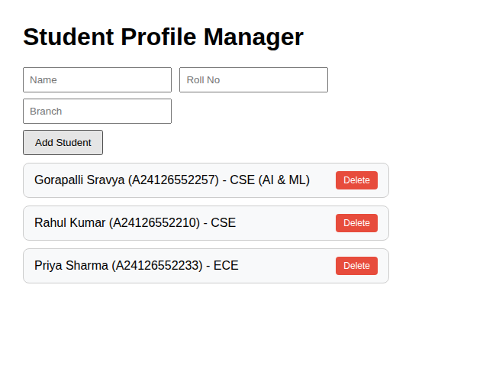
Three student profiles added using the Student class
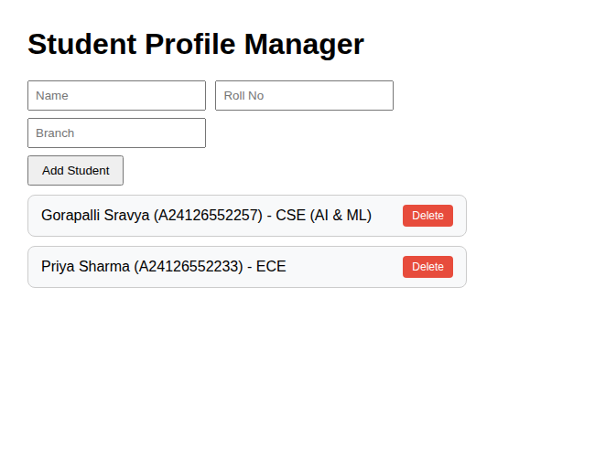
Profile list after deleting the second student (Rahul Kumar)

10. RESULT
Thus, a Student Profile Manager was successfully developed using a JavaScript class to model student data, and DOM manipulation was used to dynamically add, display and delete student profiles.

