school of intelligent engineering (former school of mechanical and electrical engineering), Shaoxing university
AI-Powered Sentiment Analysis and Recommendation System for E-Commerce Reviews
Project Training Course Final Project
GORASH PLATON
Student ID: 22605107

abstract goes here

Introduction
Customer reviews are the lifeblood of modern e-commerce, shaping buyer decisions, surfacing product problems, and powering personalization. However, most platforms still rely on rudimentary signals-star ratings or keyword counts-that miss nuance, misread sarcasm/irony/idioms, and fail to connect opinion to product features. This project report describes the development of an AI-Powered Sentiment Analysis and Recommendation System for E-Commerce Reviews that turns raw review text into actionable insights: accurate sentiment labels, such as positive, negative, and neutral; extracted product aspects, e.g. quality and shipping; and personalized product suggestions powered by user sentiment and behavior.
Using the public Amazon Reviews dataset and a Django web interface backed by MySQL, we will implement a complete end-to-end application suitable for a course project. Baseline classifiers (TF-IDF + Logistic Regression / LinearSVC or Multinomial Naive Bayes) provide robust and interpretable sentiment detection; optional LSTM experiments investigate gains from sequence models. Aspect extraction relies on targeted NLP, namely noun-phrase extraction and keyword matching, so the system links sentiment to product features without heavyweight models. Recommendations combine simple collaborative-filtering or content-based approaches with sentiment signals to produce more relevant suggestions.
The project follows standard project management phases: Initiation, Planning, Execution, Monitoring & Control, and Closing. Scope control, mitigation of risk, and reproducibility are checked. We also provide multilingual support for both English and Spanish through light translation or dual pipelines, and explicit fairness checks that detect performance disparities across languages or categories.
The pragmatic ML choices, disciplined development, and straightforward NLP techniques demonstrated in this project significantly enhance review understanding and recommendation quality. This report discusses the design, implementation plan, evaluation strategy, and ethical safeguards for guiding the team from prototype to tested, maintainable application.

Methodology
- Initiation: Define the project’s goal, success metrics, scope, and constraints. Confirm the dataset and resource needs. Create an initial risk log covering data quality, model accuracy, and schedule concerns. Deliverables: project charter, risk log, timeline.
- Planning: Break the work into tasks and create a sprint plan. Select the technology stack (Python, scikit-learn/TensorFlow, Pandas, NumPy, Django, MySQL, SQLAlchemy). Design the data schema and prepare UML diagrams. Outline the ML approach, including baseline models, optional LSTM testing, and multilingual handling. Set evaluation criteria. Deliverables: task list, UML/schema, environment checklist.
- Execution: Build the data pipeline to load and clean the Kaggle dataset and detect languages. Implement text preprocessing (tokenization, stop-word removal, TF-IDF). Train baseline models (NB, Logistic/LinearSVC) and run LSTM tests if needed, handling class imbalance. Implement aspect extraction using noun phrases and keywords. Build a simple recommender using collaborative or content-based filtering. Develop the Django web app and connect it to MySQL. Add unit and integration tests. Deliverables: trained models, endpoints, Django prototype, tests, and a demo.
- Monitoring: Track progress with status reports and sprint reviews. Use continuous integration to ensure code quality and testing. Log model runs and metrics. Monitor model performance across languages and categories. Address risks as they arise. Deliverables: status updates, logs, performance metrics, an updated risk log.
- Closing: Run final evaluations and summarize results. Package the codebase, setup instructions, and database scripts. Conduct a project review and outline future improvements. Deliverables: final code, documentation, trained models, project review, slides.

Data
This project relies on the Amazon Review Full Score Dataset Version 3 (September 2015), adapted from a large corpus of Amazon product reviews originally collected by McAuley & Leskovec (2013). The larger Amazon dataset covers an 18-year timespan and includes roughly 35 million reviews submitted through March 2013, each with product information, user ID, star rating, and free-text review. Based on this massive repository, Xiang Zhang et al. built a standardized text-classification benchmark for machine-learning research (Zhang et al., 2015).
Reviews were sampled to ensure a balanced representation throughout the full 1-to-5 rating scale. For each of the five rating categories, specifically, 600,000 training examples and 130,000 testing examples were randomly selected, resulting in total of 3 million training samples and 650,000 testing samples. Each instance in the dataset includes three fields:
- numerical rating label (1–5, where 1 is negative and 5 is positive);
- review title;
- review body.
Text fields are quoted and follow standard CSV escaping conventions, such as internal quotation marks doubled and line breaks encoded as “\”.
The dataset contains millions of customer reviews over various product types and different writing styles. Most are in English, but several others are in other languages, including Spanish. It is designed in such a way that it is suited for simple sentiment classification but can also be used to study multilingual processing and model consistency across languages. It forms a good middle ground between simple examples and large, complex datasets.
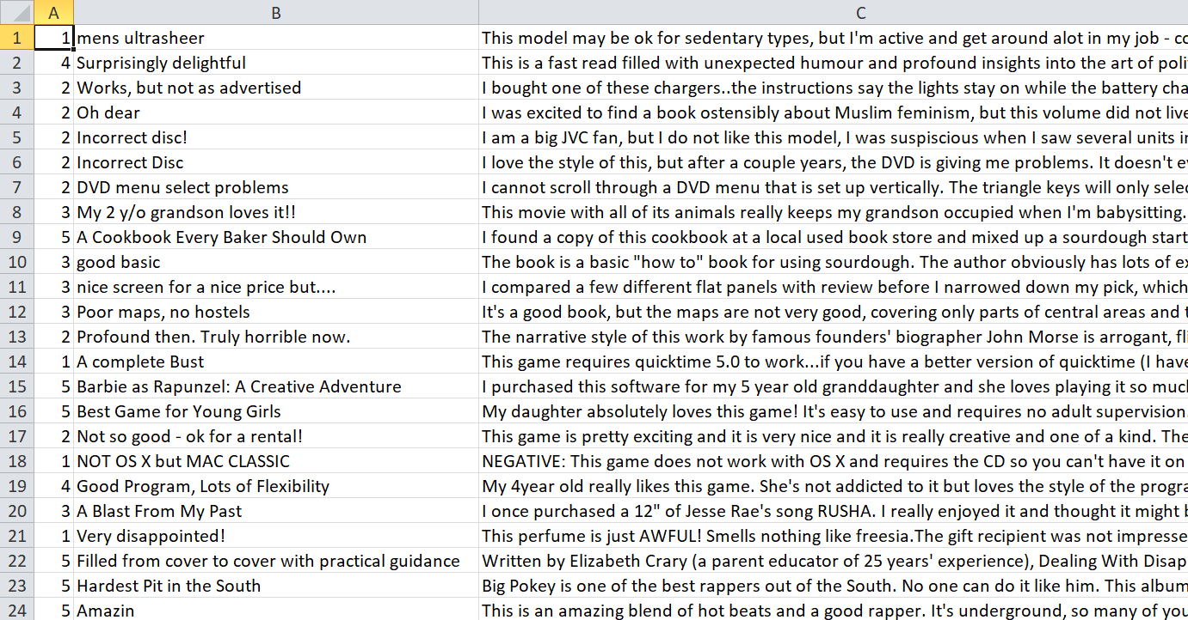
Figure 1: Preview of the dataset (CSV table format)

Initiation
Risk Description | Impact | Likelihood | Mitigation / Action
Noisy or incomplete review data | Medium | Low | Apply cleaning, deduplication, and validation checks
Imbalanced sentiment classes | High | High | Use class weighting, oversampling, and monitor per-class metrics
Lower accuracy on Spanish reviews | Medium | Medium | Use language detection; separate or translation-based pipeline
Model underperforms or overfits | High | Medium | Use cross-validation, simpler models first, track validation metrics
Weak recommendation quality | Medium | Medium | Tune similarity scoring; use popularity fallback
Django app slow due to model size or queries | Medium | Low | Cache model, optimize DB, add indexes
Time/resources insufficient for advanced features | High | High | Prioritize core tasks; freeze scope early
Fairness issues across languages or categories | High | Medium | Evaluate fairness; retrain if disparities exceed threshold
Library or version conflicts | Medium | Medium | Pin versions (pip freeze)
Database integration errors or migration | Medium | Medium | Test schema early; validate migrations
Figure 2: Risk Register Table
 | WEEK 1 | WEEK 2 | WEEK 3 | WEEK 4 | WEEK 5
INITIATION
Project setup & charter
Dataset acquisition
Risk register
PLANNING
Requirements & scope
ML/DB/Django design
UML + architecture
ML
Data preprocessing
Language detection (EN/ES)
TF-IDF baseline models
Model tuning & evaluation
WEB + DB
MySQL integration
Web UI (review + results)
Recommendation engine
Integration of ML → Django
TESTING
Unit tests
Performance checks
MONITORING
Experiment tracking
Fairness checks (EN/ES)
Issue triage & revisions
CLOSING
Final documentation
Demo & presentation
Figure 3: Gantt Chart Timeline
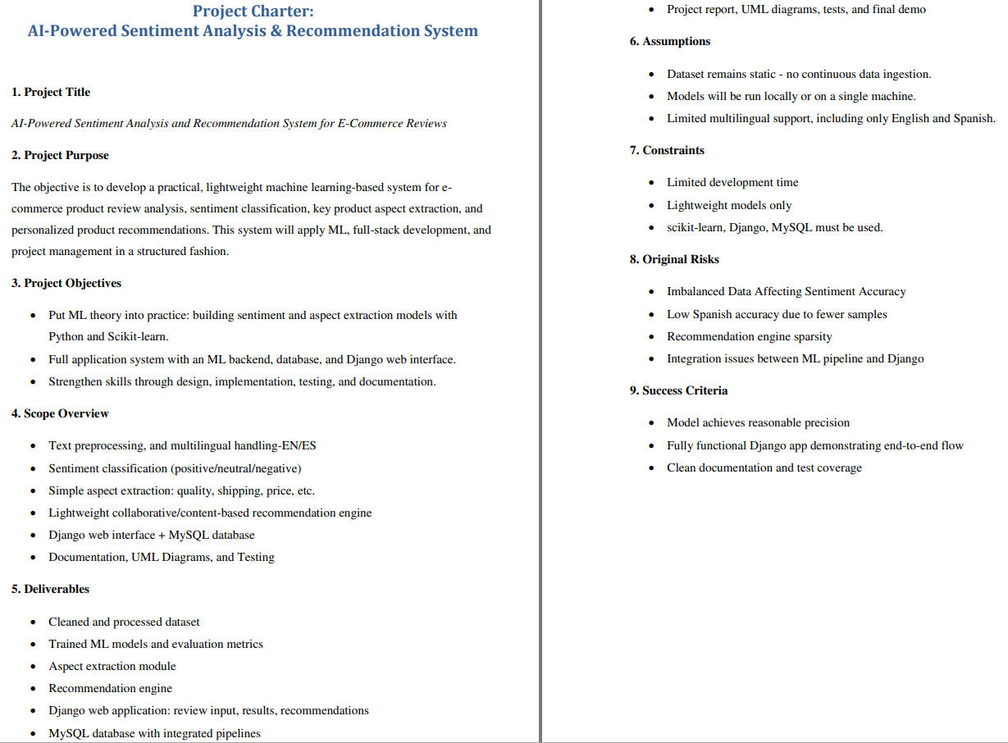
Figure 4: Project Charter Overview

Planning
Planning | - Define the system requirements and features  - Design ML pipeline and multilingual strategy  - Design database schema and Django architecture  - Create UML diagrams and sprint plan.
Data Processing | - Load and inspect dataset  - Clean data: remove duplicates, fix missing values  - Detect language, preprocess text - EN/ES  - Create train/validation/test splits
Machine Learning | - Implement TF-IDF + baseline models (NB, Logistic/LinearSVC)  - Model evaluation and hyperparameter tuning  - Build optional LSTM experiment - if time allows  - Implement aspect extraction module  - Save trained models and vectorizers
Recommendation System | - Build user–product interaction matrix  - Implement collaborative or content-based filtering  - Precision@K evaluation and parameter tuning
Web & Database Development | - Django project setup and apps  - Create MySQL database and integrate with Django ORM  - Build review submission page and sentiment result page  - Integrate ML pipeline into Django backend  - Add recommendations view and basic UI templates
Testing | - Write unit tests for preprocessing, models and recommender  - Write integration tests for Django endpoints  - Perform simple performance testing
Monitoring & Control | - Track model experiments and metrics  - Run fairness checks - English vs Spanish  - Fix issues and update risk
Conclusion | - Finalize documentation and UML  - Prepare final demo and presentation  - Conduct project retrospective and sign-off

Results
a

Results
a

Results
a

Results
a

Results
a

Results
a

Contribution
a

Conclusion
a

References
- Cortez, P. (2008). Student Performance [Dataset]. UCI Machine Learning Repository. Available at: https://doi.org/10.24432/C5TG7T.
- Cortez, P., & Silva, A.M. (2008). Using data mining to predict secondary school student performance. Proceedings of 5th Annual Future Business Technology Conference
- Wakelam, Ed et al. (2019). The potential for student performance prediction in small cohorts with minimal available attributes. British Journal of Educational Technology. 51.
- Abu Zohair, L.M. (2019). Prediction of Student’s performance by modelling small dataset size. International Journal of Educational Technology in Higher Education. 16, 27.
- Chen, J. et. al. (2025), Application of machine learning in higher education to predict students’ performance, learning engagement and self-efficacy: a systematic literature review. Asian Education and Development Studies. 14, 2, 205-240
- Costa-Mendes et. al. (2021). A machine learning approximation of the 2015 Portuguese high school student grades: A hybrid approach. Education and Information Technologies. 26. 1-21.
- Schneider, A., Hommel, G., & Blettner, M. (2010). Linear regression analysis: part 14 of a series on evaluation of scientific publications. Deutsches Arzteblatt international, 107(44), 776–782.
- Breiman, L. (2001). Random Forests. Machine Learning 45, 5–32.
- Jena, M., & Dehuri, S. (2015). Decision tree for classification and regression: A state‑of‑the‑art review. Informatica, 44 (4).
- Chicco, D., Warrens, M. J., & Jurman, G. (2021). The coefficient of determination R‑squared is more informative than SMAPE, MAE, MAPE, MSE and RMSE in regression analysis evaluation. PeerJ Computer Science, 7, e623.

