EMPATHOME LEARNING FOUNDATION
HYBRID LAN DOCUMENT - Trevor Ian Flickinger

Table of Contents:
1) Internal router configuration
2) DMZ router configuration
3) VPN configuration
4) Azure Resources
5) Access Control Lists
6) LAN Topology / DHCP
7) Wazuh Installation (SIEM)

I. INTERNAL ROUTER CONFIGURATION

// router syntax //

> enable
# configure terminal
# interface GigabitEthernet0 0

# hostname INTERNAL_RTR
# interface GigabitEthernet0 0
# description LAN_INTERFACE
# ip address 192.168.1.1 255.255.255.0
# no shutdown
# exit

# interface GigabitEthernet0 1
# description CONNECT_TO_DMZ_ROUTER
# ip address 192.168.2.1 255.255.255.252
# no shutdown

# router ospf 1
# network 192.168.1.0 0.0.0.255 area 0
# network 192.168.2.0 0.0.0.3 area 0

// end router syntax //

II. DMZ ROUTER CONFIGURATION

// router syntax //

> enable
# configure Terminal
# hostname DMZ_RTR
# interface GigabitEthernet0 0
# description OUTSIDE_INTERNET
# ip address [Public_IP] [Subnet_Mask]
# no shutdown

# interface GigabitEthernet0 1
# description DMZ_SERVER_ZONE
# ip address 192.168.10.1 255.255.255.0
# no shutdown

# interface GigabitEthernet0 2
# description CONNECT_TO_INTERNAL
# ip address 192.168.2.2 255.255.255.252
# no shutdown

// end router syntax //

III. VPN Configuration

VNET 10.0.0.0/16
GatewaySubnet
Azure object which represents the on-prem Cisco router and office subnet (192.168.1.0/24).
Connection: The resource that links the two gateways and holds the Shared Key

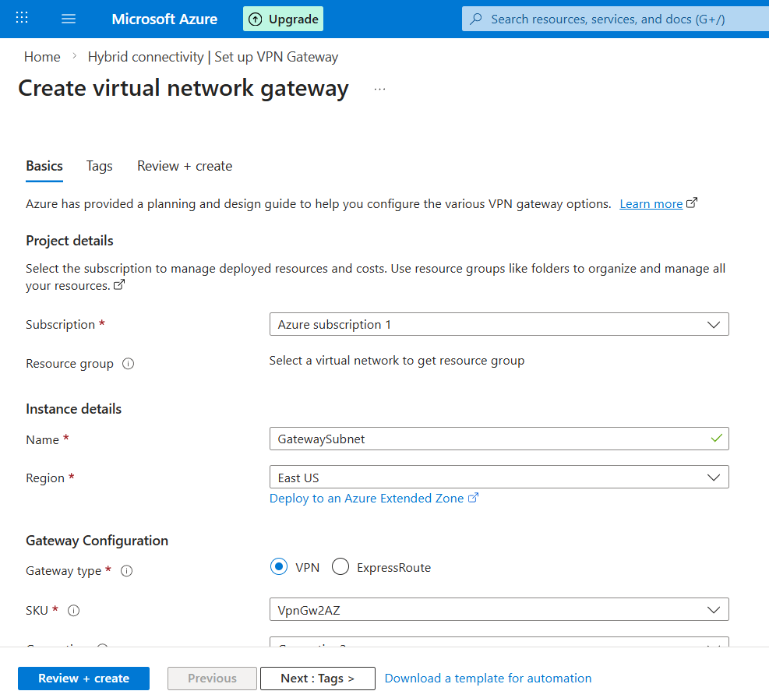

VPN Handshake

// router syntax //

# crypto ikev2 proposal AZURE-PROP
# encryption aes-cbc-256
# integrity sha256
# group 14

# crypto ikev2 policy AZURE-POL
# proposal AZURE-PROP

# crypto ikev2 keyring AZURE-KEY
# peer AZURE-GW
# address [Azure_Gateway_Public_IP]
# pre-shared-key Your_Strong_Secret_Key

// end router syntax //

Virtual Tunnel VTI

# interface Tunnel1
# ip address 169.254.0.1 255.255.255.252
# tunnel source [Your_Outside_Interface]
# tunnel mode ipsec ipv4
# tunnel destination [Azure_Gateway_Public_IP]
# tunnel protection ipsec profile AZURE-IPSEC-PRO
# ip tcp adjust-mss 1350

IV. Azure Resources
Resource Groups:

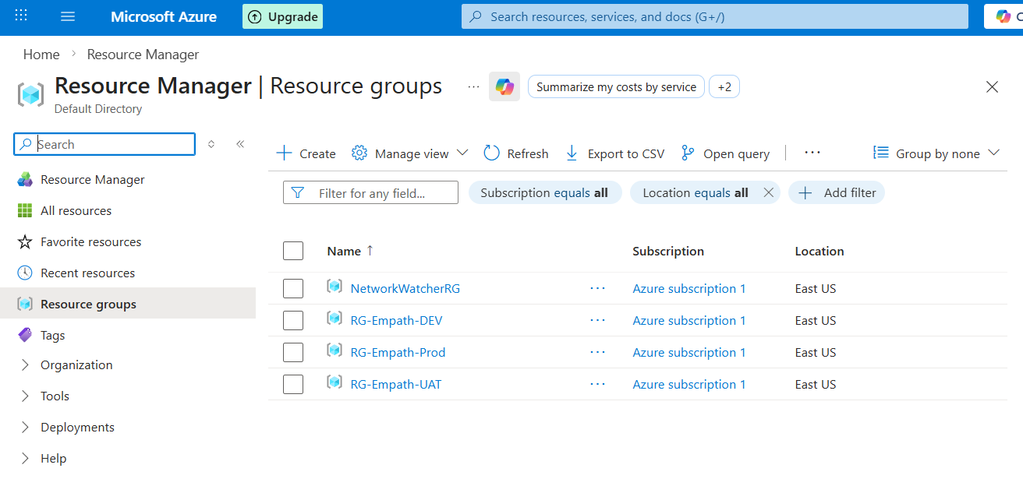

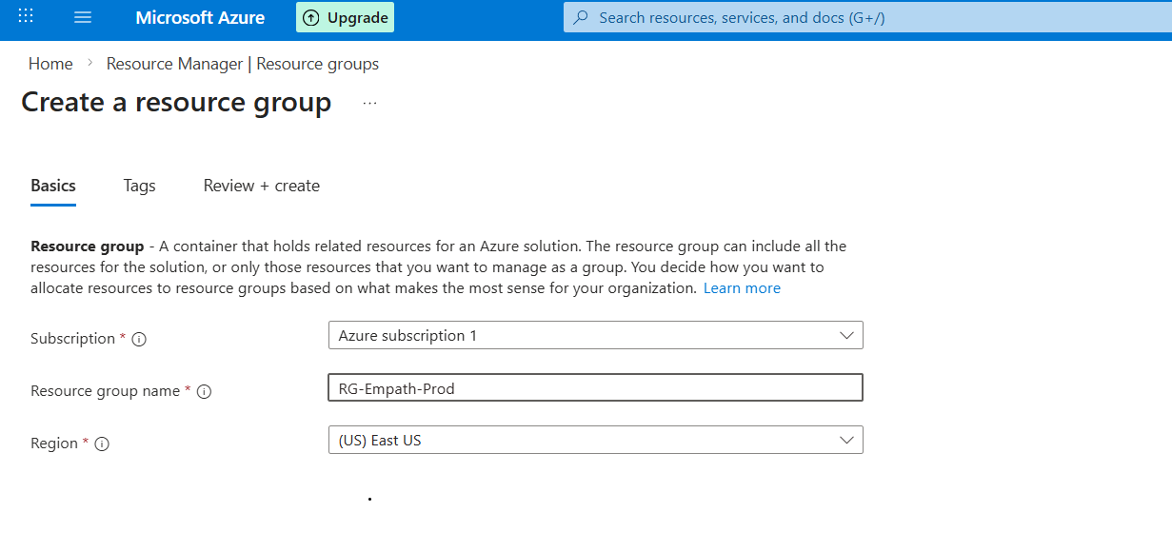

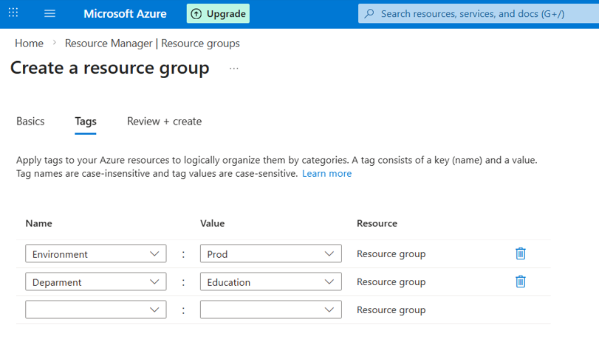

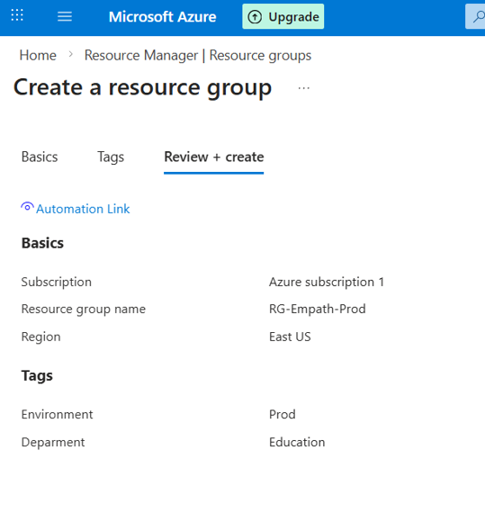

Storage
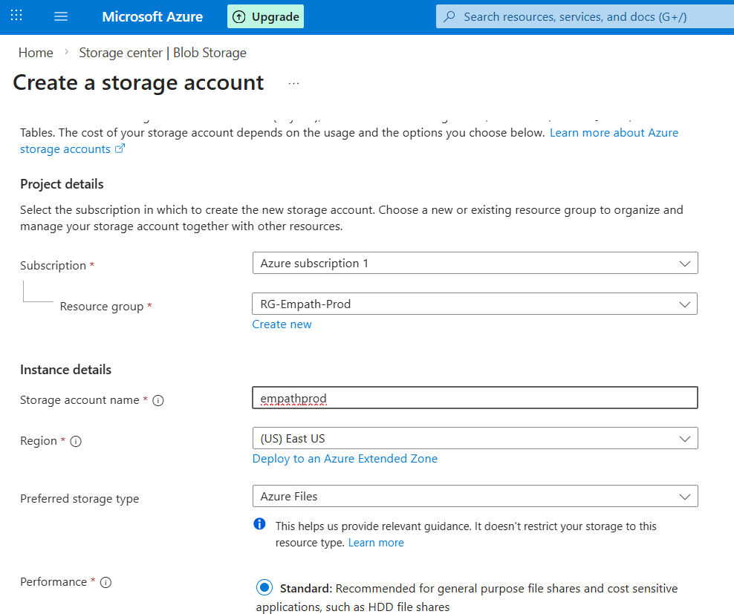

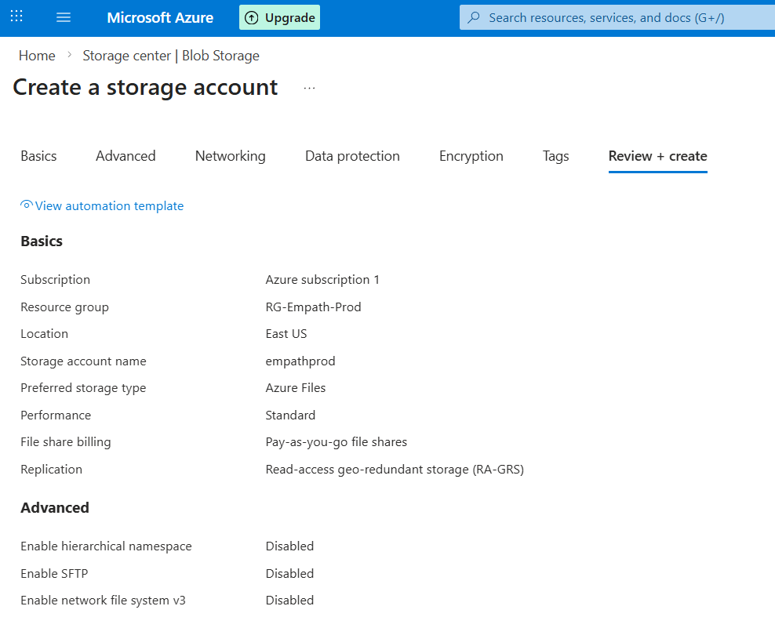

VMs:
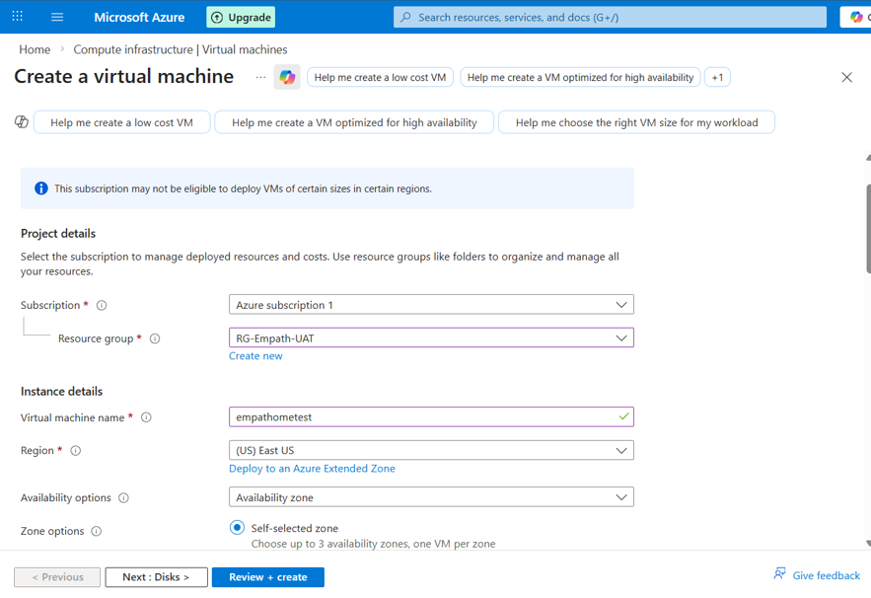

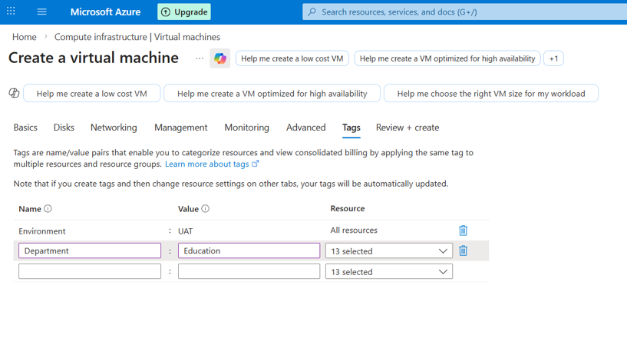

Web server

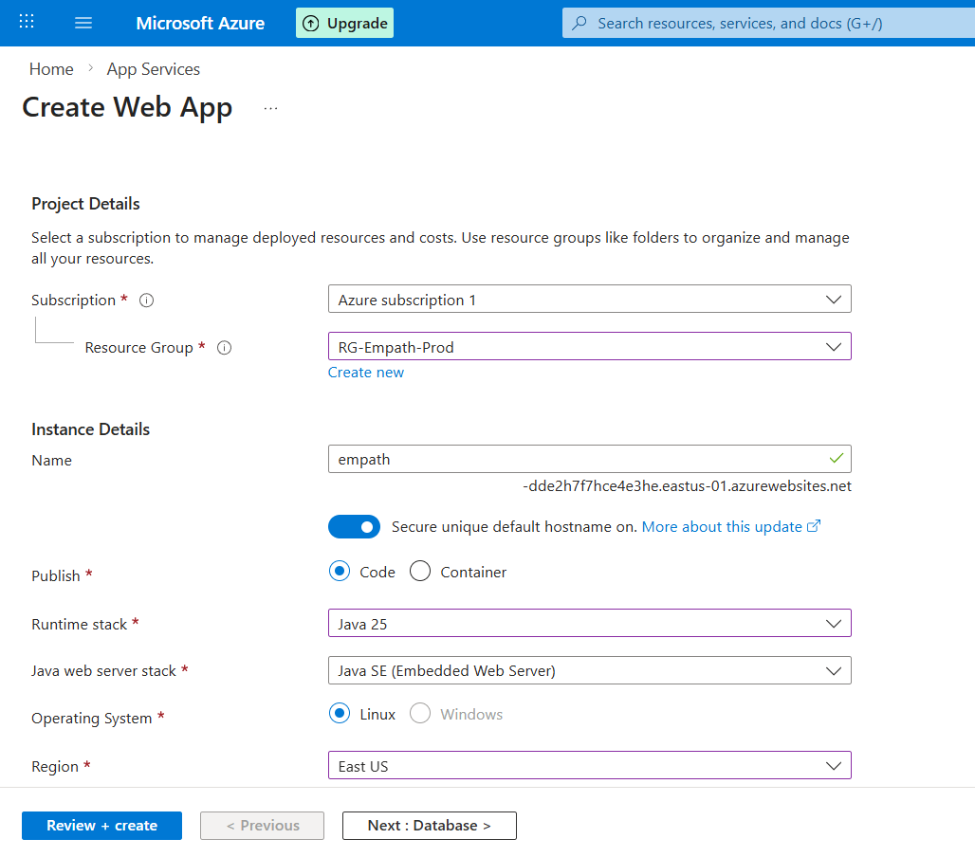

Database

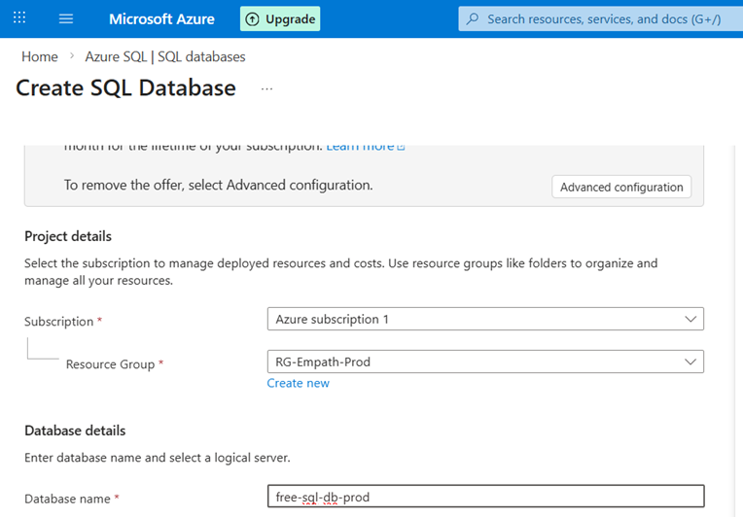

VNET / NSG

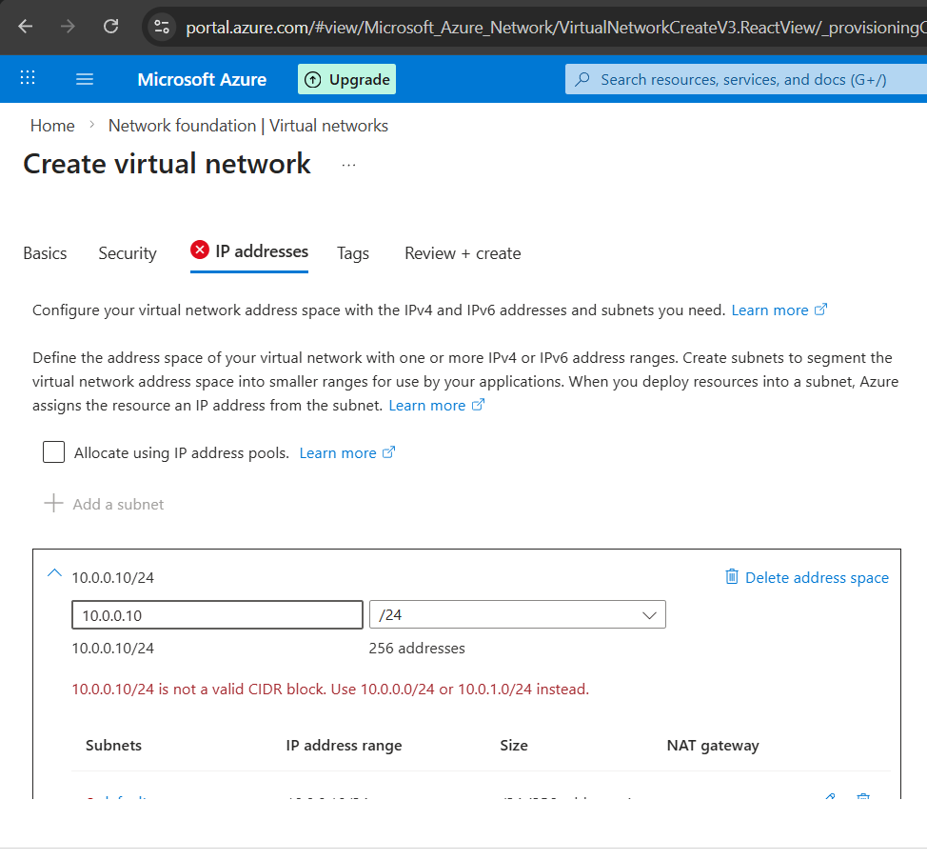

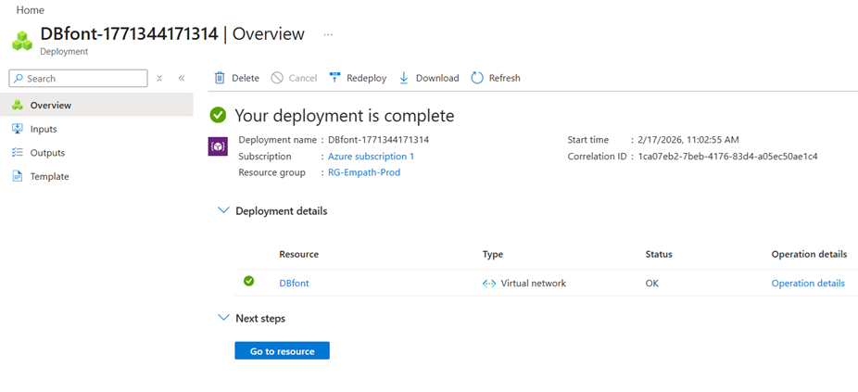

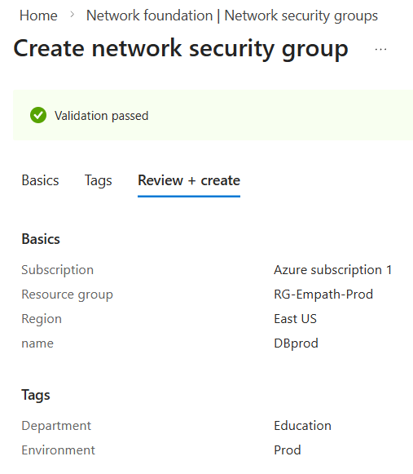

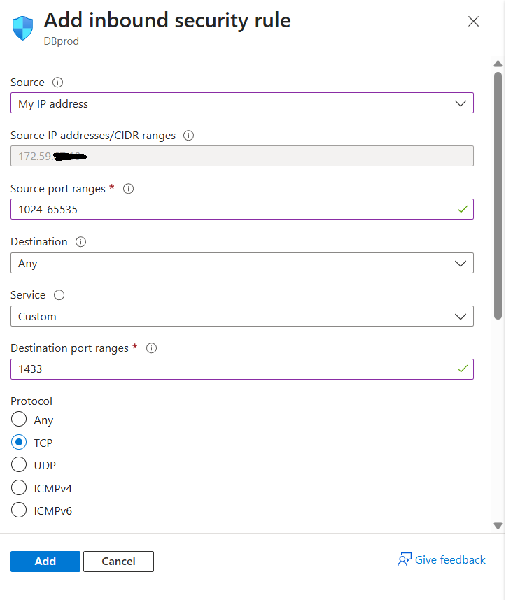

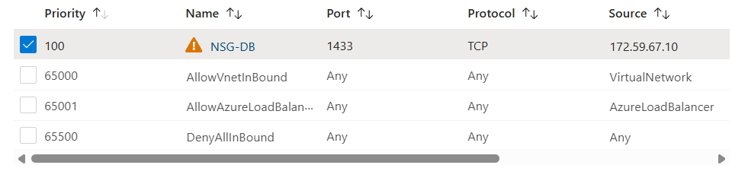

V. Access Control Lists

ACL Configuration inbound

// router syntax //

ip access-list extended OUTSIDE_INBOUND
remark Allow Azure VPN Gateway inbound
permit ip host 10.0.0.1 any

remark Allow established return traffic
permit tcp any any established

ACL Configuration outbound

ip access-list extended OUTSIDE_OUTBOUND
remark Allow outbound HTTP/HTTPS
permit tcp any any eq 80
permit tcp any any eq 443

remark Allow outbound to Azure Gateway
permit ip any host 10.0.0.1

remark Deny all other outbound traffic
deny ip any any

interface GigabitEthernet0/0
description OUTSIDE_INTERNET
ip address 172.59.x.x 255.255.0.0

interface GigabitEthernet0/0
ip access-group OUTSIDE_INBOUND in
ip access-group OUTSIDE_OUTBOUND out

// end router syntax //

VI. LAN Topology + DHCP Configuration

// router syntax //

# ip dhcp excluded-address 192.168.1.1 192.168.1.20
# !
# ip dhcp pool OFFICE_LAN
# network 192.168.1.0 255.255.255.0
# default-router 192.168.1.1
# dns-server 8.8.8.8 1.1.1.1
# lease 8

# ip dhcp pool PRINTER_1
# host 192.168.1.15 255.255.255.0
# client-identifier 01aa.bbcc.ddee.ff

# ip dhcp pool PRINTER_1
# host 192.168.1.16 255.255.255.0
# client-identifier 01bb.ccdd.eeff.11

# show ip dhcp binding

// end router syntax //

Dotted Decimal CIDR Total Host IPs
255.255.255.0 /24 254
255.255.255.252 /30 2 (router-to-router link)

Standard issue workstations: 50
Higher end workstations: 2
machine learning workstations: 2
Network printers: 2
Total connections: 56
Maximum supported connections for the LAN (future expansion): 254

Standard config:
AMD Ryzen 5 9600X
24 GB DDR5-5600 CL28
1 TB SSD
NVIDIA RTX 5070
Dual Boot: Windows 11 Pro + Fedora

High End Config:
AMD Ryzen 7 9700X
32 GB DDR-5600 CL28
2 TB SSD
NVIDIA RTX 5070 Ti
Dual Boot: Windows 11 Pro + Fedora

Machine Learning Config:
Intel Core Ultra 9 285K
64 GB DDR-6000 CL30
4 TB SSD
NVIDIA RTX 5090
Ubuntu LTS

VII. Installing Wazuh (SIEM)

Via Ubuntu WSL:

curl -sL https://packages.wazuh.com/4.14/wazuh-install.sh -o wazuh-install.sh

wazuh-install.sh -a
ATTN: Make sure to save admin password (printed to the terminal) after installation completes so you can login to the web interface.

