FastAPI Setup and Validation

Analyze an API using Fast API (assuming Windows with admin access, PowerShell and Python)

In powershell, go to your project directory (e.g. cd c:\users\myuser\myproject)

Set your Python virtualized environment:

python -m venv .venv

.\.venv\Scripts\Activate.ps1

Install uvicron and fastapi with pip

pip install uvicorn

pip install "uvicorn[standard]"

pip install fastapi uvicorn

Create an __init__.py file
touch app/__init__.py

Check if FastAPI is installed properly

python -c "import fastapi; print('FastAPI OK')"
Will return ‘FastAPI OK’ if installed correctly

Start the API:
uvicorn app.main:app –reload

Should see a return saying application startup complete:

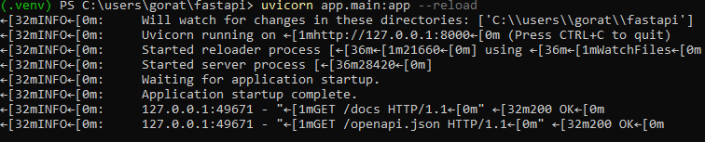

And you should also see a web page on your local host in a web browser:
