DEPLOYING KUBERNETES IN WSL (Ubuntu)

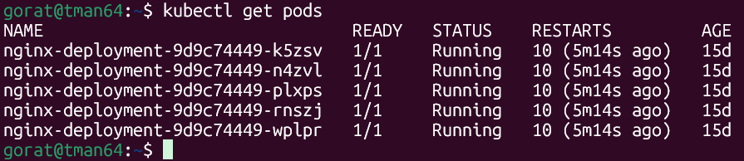

curl -LO "https://dl.k8s.io/release/$(curl -L -s https://dl.k8s.io/release/stable.txt)/bin/linux/amd64/kubectl"
sudo install -o root -g root -m 0755 kubectl /usr/local/bin/kubectl
kubectl version --client
cd ./kube
kubectl get nodes
kubectl apply -f pod.yaml
kubectl get pods
kubectl port-forward nginx-pod 8080:80
kubectl cluster-info
kubectl get nodes
sudo kubectl get nodes
kubectl apply -f deployment.yaml
kubectl get pods -l app=web-cluster
kubectl get pods
kubectl delete pod nginx-deployment-fc8b4869d-4585m
kube get pods
kubectl get pods
kubectl apply -f service.yaml
kubectl get svc
kubectl port-forward svc/nginx-service 8080:80 &
kubectl get endpoints nginx-service
kubectl get deployments
kubectl port-forward svc/nginx-service 8080:80 > /dev/null 2>&1 &
kubectl port-forward svc/nginx-service 8080:80 &
kubectl get pods
kubectl apply -f deployment.yaml
kubectl get pods --watch
kubectl get pods
kubectl rollout history deployment/nginx-deployment
kubectl rollout undo deployment/nginx-deployment
kubectl get pods
kubectl get replicasets
kubectl apply -f configmap.yaml
kubectl apply -f secret.yaml
kubectl apply -f deployment.yaml
kubectl get pods
kubectl exec -it nginx-deployment-784889d8f7-hl85j -- printenv | grep -E "UI_COLOR|DATABASE_PWD"
kubectl get pods
kubectl exec nginx-deployment-784889d8f7-hl85j -- printenv | grep -E "UI_COLOR|DATABASE_PWD"
kubectl get configmap app-config -o yaml
kubectl get secret app-secret -o yaml
kubectl apply -f pv.yaml
kubectl apply -f pvc.yaml
kubectl apply -f deployment.yaml
kubectl get pods
kubectl apply -f configmap.yaml
kubectl apply -f secret.yaml
kubectl apply -f pv.yaml
kubectl apply -f pvc.yaml
kubectl apply -f deployment.yaml
kubectl apply -f
kubectl apply -f https://raw.githubusercontent.com/kubernetes/ingress-nginx/main/deploy/static/provider/kind/deploy.yaml
kubectl get pods
kubectl get pods -n ingress-nginx
kubectl apply -f ingress.yaml
kubectl get pods
kubectl apply -f
kubectl apply --help
kubectl apply -f configmap.yaml
kubectl apply -f secret.yaml
kubectl apply -f pv.yaml
kubectl apply -f pvc.yaml
kubectl apply -f ingress.yaml
kubectl get ingress
kubectl apply -f configmap.yaml
kubectl apply -f secret.yaml
kubectl apply -f configmap.yaml
kubectl apply -f secret.yaml
kubectl apply -f configmap.yaml
kubectl apply -f pv.yaml
kubectl apply -f pvc.yaml
kubectl apply -f ingress.yaml
kubectl get ingress
kubectl get pods -n ingress-nginx
kubectl delete -f ingress.yaml
kubectl apply -f ingress.yaml
kubectl get pods -n ingress-nginx
POD_NAME=$(kubectl get pods -n ingress-nginx -l app.kubernetes.io/component=controller -o jsonpath='{.items[0].metadata.name}')
kubectl logs -n ingress-nginx $POD_NAME | tail -n 20
kubectl get ns
kubectl apply -f https://raw.githubusercontent.com/kubernetes/ingress-nginx/main/deploy/static/provider/kind/deploy.yaml
kubectl get pods -n ingress-nginx
kubectl get endpoints nginx-service
kubectl apply -f service.yaml
kubectl get pods -l app=web-cluster
kubectl get svc nginx-service
kubectl get endpoints nginx-service
kubectl apply -f .
kubectl get pvc
kubectl get pods
kubectl get svc,endpoints nginx-service
kubectl get pods
kubectl top pods
kubectl get pods -n kube-system -l k8s-app=metrics-server
kubectl apply -f https://github.com/kubernetes-sigs/metrics-server/releases/latest/download/components.yaml
kubectl get pods -n kube-system -l k8s-app=metrics-server
kubectl top pods
kubectl patch deployment metrics-server -n kube-system --type='json' -p='[{"op": "add", "path": "/spec/template/spec/containers/0/args/-", "value": "--kubelet-insecure-tls"}]'
kubectl get apiservice v1beta1.metrics.k8s.io
kubectl get pods
history|grep -i kubectl
kubectl get pods
history|grep kube

