ttps://www.youtube.com/watch?v=WD5PgDgF5ec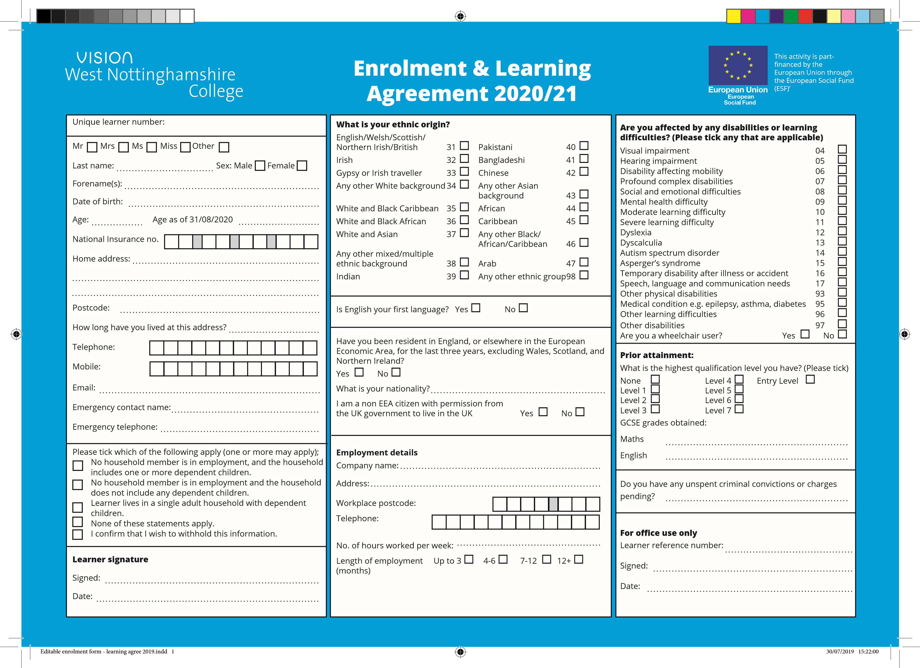

[n]

CV

[y]

CV

[96]

CV

[14]

CV

[97]

CV

[95]

CV

[93]

CV

[17]

CV

[16]

CV

[15]

CV

[13]

CV

[12]

CV

[11]

CV

[10]

CV

[09]

CV

[08]

CV

[07]

CV

[06]

CV

[05]

CV

[04]

CV

[E12]

CV

[HomeAddress]

[DateOfBirth]

[AgeAsOff]

[ForeName]

[LastName]

[Q9]]]

[Q8]]]

[Q6]]]

[Q7]]]

[Q5]]]

[Q4]]]

[Q2]]]

[Q3]]]

[Q1]]

[Crime]

[English]

[Maths]

[WorkTel]

[HoursWorked]

[CompanyName]

[AddressEmploy]

[N2]

[N1]

[Nationality]

[R2]

[R1]

[L2]

[L1]

[E17]

CV

[E18]

CV

[E16]

CV

[E15]

CV

[E14]

CV

[E13]

CV

[E11]

CV

[E9]

CV

[E8]

CV

[E6]

CV

[E7]

CV

[E5]

CV

[E4]

CV

[E2]

CV

[E3]CV

[E1]

CV

[E10]

CV

[EmerCN]

[EmerTel]

[Email]

[Mobile]

[Telephone]

[AddL]

[PostCode]

[NatInsuranceNo]

[G2]

[G1]

[T4]

[T3]

[T2]

[T1]

[T5]

[WorkPC]

[Age]

**Prior attainment levels**

The information shown in the table below provides a guide to the overall attainment level of learners that have achieved various combinations of qualifications. The levels shown do not necessarily coincide with the level at which individual qualifications are set. For example, GCSEs are at Level 1/2, but the level of attainment achieved by a learner is dependent on the grade they achieve. Where a learner attains a grade D-G this would be considered a Level 1.

|  |  |
| --- | --- |
| **Prior attainment level descriptors** | **Qualification equivalent (incorporating NQF and QCF)** |
| **Entry level (code 7, 9)** | QCF Award at Entry Level  QCF Certificate at Entry Level  Certificate in Adult Literacy, Numeracy, ESOL at Entry Level |
| **Level 1 (code 1)** | GCSE/O Level (5 or more at grades D-G or fewer than 5 at grades A-C)  CSE below grade 1  1 AS Level  QCF Diploma Level 1  QCF Certificate Level 1  QCF Award Level 1  Foundation 14-19 Diploma  Functional Skills  Certificate in Adult Literacy, Numeracy, ESOL at Level 1  Level 1 Key Skills  Level 1 Principal Learning  Introductory Diploma  Introductory Certificate  GNVQ Foundation  NVQ Level 1 |
| **Full Level 2 (code 2)** | GCSE/O Level (5 or more GCSEs grades A-C)  GCSE (9-1) (5 or more GCSEs grade 4 or above)  GCSE (9-1) (5 or more GCSEs grade 4 or above) 2 or 3 AS Levels  CSE Grade 1 (5 or more)  1 A Level  Higher 14-19 Diploma  QCF Diploma level 2 QCF Certificate level 2 at 13 or 14 credits undertaken before 2014/15 Level 2 Principal Learning  NVQ Level 2  GNVQ Intermediate Substantial Level 2 vocational qualifications in the 16-19 performance tables QCF Certificate Level 2 at 15 credits and above |
| **Full Level 3 (code 3)** | A Levels (2 or more advanced level passes)  4 or more AS Levels  QCF Diploma Level 3  QAA Access to HE  Advanced 14-19 Diploma |

For learners who started on or after 1 August 2013, the prior attainment must be recorded using the current Ofqual Regulated Qualifications Framework for levels 4 and above. Learners whose prior attainment was recorded prior to 1st August 2013 can continue to use the National Qualification Framework codes for levels 4 and 5+.

|  |  |
| --- | --- |
| **Prior attainment level descriptors** | **Qualification equivalent (incorporating NQF and QCF)** |
|  | GNVQ Advanced  NVQ Level 3  AVCE double award Tech Levels which are in the 16-19 Performance Tables Early Years Educator qualifications which are 30 credits or more or 300 guided learning hours or more.  QCF Certificate at Level 3 which is 30 to 36 credits |

The guidance has been updated to reflect the introduction of the Regulated Qualification Framework (RQF) from the 1 October 2015 and the decoupling of AS Levels from A Levels from September 2015.

|  |  |  |  |
| --- | --- | --- | --- |
| **Prior attainment level descriptors** | **Current Ofqual Regulated Framework (incorporating NQF and QCF)** | **National Qualification framework (used in ILR prior to 2013/14, valid for continuing learners**  **only)** | **Framework for Higher Education Qualifications** |
| **Level 4**  **(code 10)** | QCF Award Level 4  QCF Certificate Level 4  QCF Diploma Level 4  HNC | Level 4 (code 4)  NVQ Level 4  Level 4 Professional  Certificate  Level 4 Professional  Diploma | Certificates of  Higher Education |
| **Level 5**  **(code 11)** | QCF Award Level 5  QCF Certificate Level 5  QCF Diploma Level 5  HND | Foundation degrees |
| **Level 6**  **(code 12)** | QCF Award Level 6  QCF Certificate Level 6  QCF Diploma Level 6 | Bachelor’s degrees graduate certificates and diplomas |
| **Level 7+ (code 13)** | QCF Award Level 7  QCF Certificate Level 7  QCF Diploma Level 7  QCF Award Level 8  QCF Certificate Level 8  QCF Diploma Level 8 | Level 5+ (code 5)  Continuing Education  Diploma  NVQ Level 5  Level 5 Professional  Certificate | Master’s degrees Postgraduate certificates and diplomas |

Editable enrolment form - learning agree 2019.indd 2 30/07/2019 15:22:00