Bradley Boutcher

P6: Proposal

Bon Appetit Menu App

**Target Audience**: Gordon College Faculty, Staff, and Students

**Problem**: Exit 17 Live is a rapidly expanding entertainment platform for the campus community, but there is no singular way to enjoy all of the quality content. Some is available on facebook, and other content is available on youtube.

**Goal**: My goal is to provide a content hub for exit 17, displaying their most recent videos, news, and updates so the college community can stay up-to-date.

**Primary Features:**

* Log in with your Google / Youtube Account
* List their most recent videos in decending order
* Re-arrange the videos by most popular
* Check a schedule for the upcoming E17 Shows

**UI Sketch:**

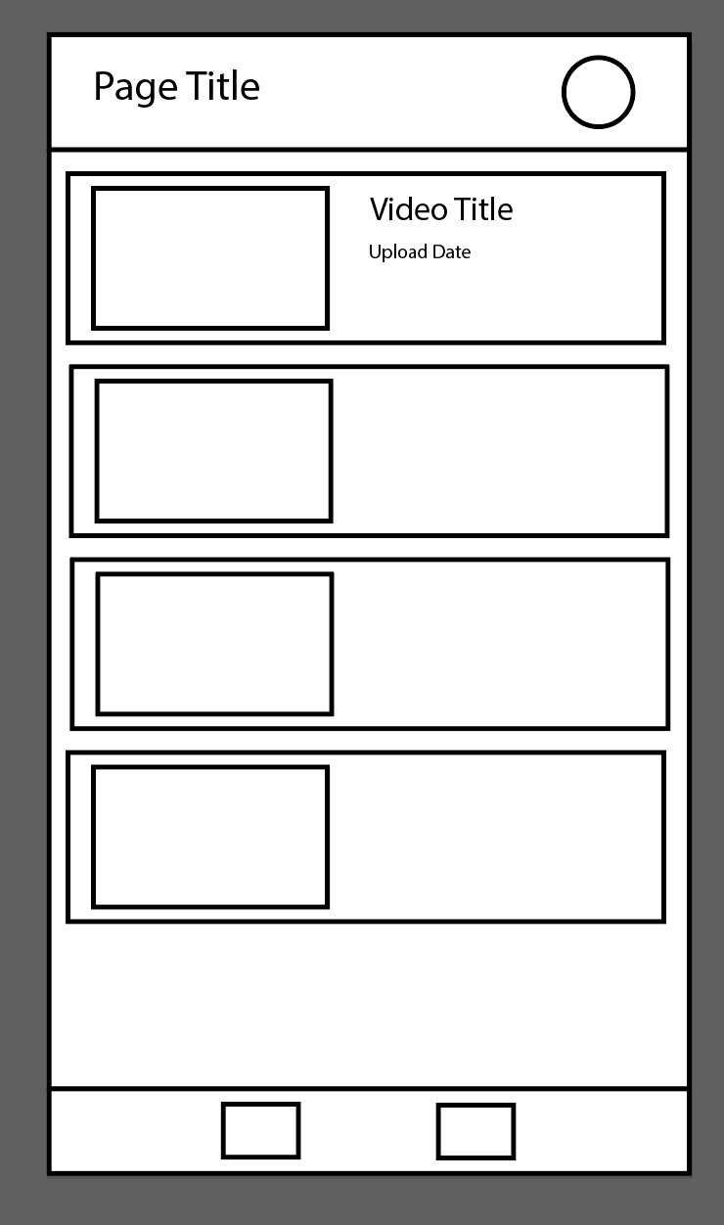

**Prototype:**

It will display a list of most recent videos in decending order

**APIs**:

Firebase Authentication API – Allow users to log-in to their Youtube account to subscribe or like videos

Youtube’s Content API – For the main aggregation and display of youtube videos