CCT385H5, Fall 2015

CCT385 Team 9 Final Report:

Creating Project UTM 3D and Its Immersive Effects

December 10th, 2015

Gordon Monk | 1000407151 | gordon.monk@mail.utoronto.ca

Martin Roger Nkpwang Ze | 1000925396 | martinroger.nkpwang.ze@mail.utoronto.ca

Danny Soufi | 999241128 | danny.soufi@mail.utoronto.ca

**Table of Contents**

1. ***Introduction* . . . . . . . . . . . . . . . . . . . . . . . . . . . . . . . . . . . . . . . . . . 2**
2. ***Project Preparation* . . . . . . . . . . . . . . . . . . . . . . . . . . . . . . . . . . . . 3**
3. ***Scholarly Research* . . . . . . . . . . . . . . . . . . . . . . . . . . . . . . . . . . . . . 4**
4. ***Technical Implementation* . . . . . . . . . . . . . . . . . . . . . . . . . . . . . . . 7**
5. ***Field Research* . . . . . . . . . . . . . . . . . . . . . . . . . . . . . . . . . . . . . . . . 10**
6. ***Conclusions* . . . . . . . . . . . . . . . . . . . . . . . . . . . . . . . . . . . . . . . . . . 12**
7. ***References . .* . . . . . . . . . . . . . . . . . . . . . . . . . . . . . . . . . . . . . . . . . 13**
8. ***Introduction***

It is completely natural for one to be unfamiliar with places and not being able to navigate new places when they’re first exposed to them/visit them. Being unfamiliar with a new environment is one issue but another issue is anxiety. People get anxious when they are unfamiliar with anything new to them. At times they also feel lost. Anxiety issues arise especially when it comes to new places and/or buildings. When people are unfamiliar with a place they get anxious because they don’t know where they are or how to travel through the new environment. Navigating virtual reality worlds assists people in remembering the place and in becoming more familiar with it, which in turn helps them when they’re exposed to the real world environment.

Navigating an unfamiliar university campus environment has been an issue for both local and international students alike and with the University of Toronto Mississauga’s large campus it does not make it any easier. University freshmen and international student are more susceptible to experiencing anxiety because of the unfamiliarity with the environment they are in. Usually the buildings around campus are filled with students that they don’t know, making it hard for them to truly integrate themselves. Although the university has tried to provide immersive experiences to the users by introducing Rez360, an application which enables students to have a closer view to the residences the students will be staying in, the application is very limited in features and only pertains to residence students. Indeed, there have been very few effective measures taken to assist with finding their way around campus quickly and in a timely manner. Our goal was then to create an interactive game which allows the user to navigate through campus, greatly assisting him in navigating and remembering the campus. They found that having previous experience in a 3D rendition of a real world location they were able to navigate the environment with confidence and a sense of familiarity. We believe that replicating this system of virtual-world to real-world association will provide students with a mental map of the environment they wish to explore.

1. ***Project Preparation***

Time and time again first-year students have wandered through the halls of their new campus hoping to find the right room for their class, only to embarrassingly step into a biology class instead of their theatre course. The goal of Operation: UTM 3D is to produce a fully-interactive 3D map of Deerfield Hall (since mapping out the entirety of the UTM campus would take months) in which players can navigate freely throughout the map to get a better idea of the campus in which they’ll be pursuing their educational career. For many students, scoping out prospective campuses for their post-secondary education isn’t an option for them due to geographical limitations, or for more sensitive reasons, like social anxiety. This project’s behavioral-changing intent is to help students with social anxiety, or other behavioral problems, feel a little less intimidated the first time they step on campus.

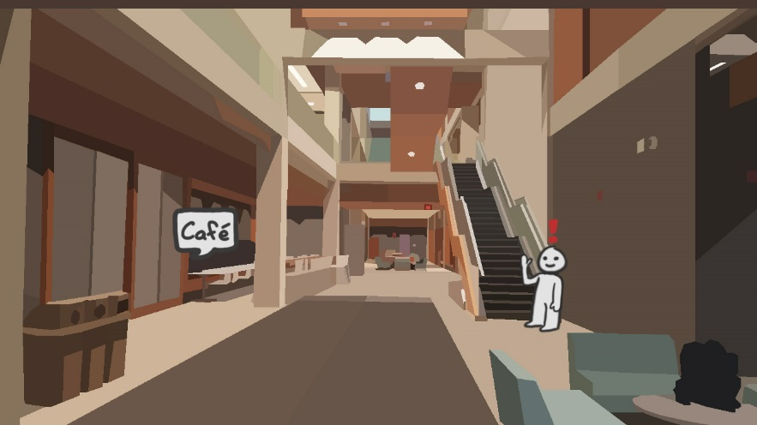For Milestone One, we planned to learn what was required to know about 3D texturing in Unity. Unity is a game engine used to create 2D and 3D games and virtual reality experiences. We researched therapeutic elements that can be implemented in the fame. This was supplemented by reading *Treatment of Social Anxiety Disorder Using Online Virtual Environments in Second Life* by Erica K. Yuen. We also designed concept art **(fig 0)** to visualize different game features. We then took all necessary measurements of Deerfield Hall in order to begin designing/creating the game. For Milestone Two, we completed a raw 3D map of Deerfield Hall. We also planned to complete all texture assets needed for the map of Deerfield Hall. This was all supplemented by reading *The digital transformation of human identity towards a conceptual model of virtual identity in virtual worlds*. Finally, for Milestone Three, we planned to add all the textures to all surfaces in the raw 3D map. At this point we concluded all the needed design for the game.

***Figure 0***

In order to create a 3D re-creation of Deerfield Hall, there were a few new skills that had to be learned. For starters, we needed to learn how to use Blender, the 3D modeling software, to produce a large scale map. Luckily, the members of our team are registered students at Sheridan College which permits them passage to the hundreds of educational video tutorials found on the online learning company, <http://www.lynda.com/>. George Maestri’s *Blender Essential Training* offers an in-depth look on a variety of skills ranging from learning the user interface to manipulating objects, textures and lighting in a 3D space. This part of the technical training gave us the skills to create the map, but not the skills to use the map in a game engine. Our team agreed on using the Unity 5 Personal Edition video game engine with which to import and use all assets, so the team needed to learn Unity starting with the basics. Lynda.com has many different courses teaching skills in Unity, although since the scope of this project only required the skills to import the map, create a first-person controller, and create text that appeared upon approach of the first-person controller, Adam Crespi’s *Unity 5: 3D Essential Training* provided most of this knowledge. The only other required training after that was learning how to make an in-game line of text appear when the first-person controller approaches it, which was described most succinctly by YouTube user “JediNikola” in their video *Basic Speech Bubbles - Unity Tutorial*. Upon learning that, all of the necessary training was completed and the scholarly research began.

1. ***Scholarly Research***

Sara de Freitas touches upon the subject of educational games that use virtual reality. In her article titled “Learning as immersive experiences: Using the four dimensional framework for designing and evaluating immersive learning experiences in a virtual world,” she proposes a framework which she deems useful when thinking about designing a VR educational game. This four dimensional framework is divided into four sections: Learner Specifics (profile, role, competencies of the player), Representation (Fidelity, Interactivity, and Immersion), Pedagogy and Context.

Virtual worlds are extremely useful and can help those with anxiety come together to help each other and be relieved of their anxiety. This way, they can all help each other navigate a certain place together and become familiar with it. This assists them when they’re exposed to the real world environment because they will remember the virtual world environment and be able to navigate the place with ease. “Virtual worlds also support peer collaboration and may be used for collaborative assignments in-world with particular outputs (de Freitas, 2009[1]).” virtual worlds enable the user to remember the environment they’re in such that they are familiar with and recognize is once they’re exposed to it in real life.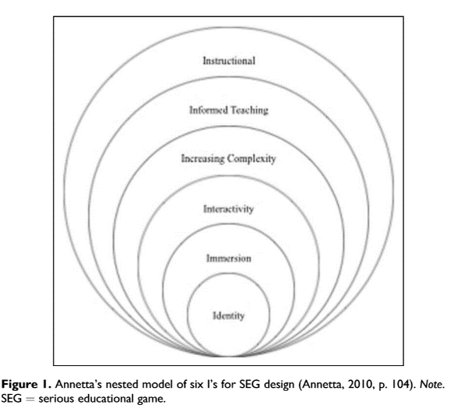 To create this game, we have decided to follow the model of an educational one. Indeed, we want our user to gain knowledge and information about a specific building, and identify the different places. Our initial plan was to create a game in which the user interacted with several NPCs. We thought that it would help them familiarise with the environment (as they would be more likely to remember the place they interacted with a specific NPC) and increase their social skills.

Creating an educational game means that we need to both design the platform in which the user can navigate, and also to implement some educational principles. Indeed, in “Equipping the Designers of the Future: Best Practices in Epistemic Video Game Design”, Strobel and Boots are discussing the complexity behind the creation of an educational game. Leonard Annetta’s six “I’s” **(fig 1)** are mentioned when talking about serious educational game design: identity, immersion, interactivity, increasing complexity, informed teaching and instructional. When designing Deerfield Hall, we have to take these elements into account. The component we are mostly concerned with is identity, as it is the building block for the other ones. Having an Identity in the game is crucial for the player for many reasons. The first one is that it tricks the player into making them believe that he/she is in a unique being within the environment[2]. This way, the player feels like they are in control of the game. Secondly, it gives purpose to the participant: by having an identity, he has a specific role; goal to accomplish. For Annetta, the option of customizing your character proves to be essential, as it gives players the illusion of ownership of that specific virtual environment.

Immersion is also part of the framework, giving a “heightened sense of presence through individual identity”, helping the player to familiarize more easily with the environment. Interactivity would correspond to the communication between a player and a computerized agent (NPC). That would include any objects within that virtual environment. This goes back to our idea of trying to implement NPCs into our game. The fourth component, which builds upon the third one is increased complexity. According to Boots and Strobel, it deals with “the increasing difficulty of the challenges within the game as the abilities of the player should improve’.” Informed Teaching is a way to measure a student’s understanding (activities, login times, and length of play…). The Instructional component would correspond to the result of having all the above elements incorporated into the game to give that a genre (educational).

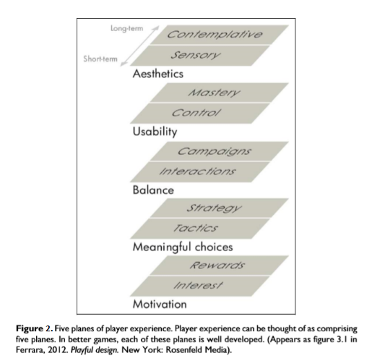We also needed to think from the player’s perspective when designing the game. This means that we had to emphasise on the player’s experience. In his research paper, Ferrara presents us with five different planes of the user experience **(fig 2)** we need to consider when thinking about serious gaming. One of his main criticisms was the fact that designers only focused on the motivation aspect of the game (which includes rewards and interest)[3]. UTM 3D wants the user to feel like being immersed in that specific environment is a reward itself. This means that we can easily incorporate the other planes, as they are an incentive for providing that immersive experience. For example, we would need to take in account the Aesthetics or the Usability aspects, since these two elements are essential for the design of the game.

Even if we are creating an educational game, UTM 3D is qualified as being more of a simulation, as we were replicating Deerfield Hall. Simulations are part of what Charsky would call serious games, which are games that “use the characteristics to provide learners with an authentic learning experience where the entertainment and learning are seamlessly integrated” (Gee, 2003, 2005; Prensky, 2001)[4]. Our objective is for users to identify the different areas of Deerfield Hall so they can navigate without problem in real life, even if they have never been to the building before.

One of our concerns was to know whether or not an individual can feel anxiety in a virtually constructed environment. A study involving people with snake phobia was done to see how they would react to these creatures in a virtual setting. Participants were divided into three categories: the first group was immersed in a baseline neutral/ irrelevant control environment, the second one were in a virtual desert-like space where anxiety was strongly induced, while the third group was just placed in a desert-like environment but with no induced anxiety. The research also shows that depending on the virtual environment the player is in the degree of presence will vary. The research confirmed their hypothesis; “The experimental induction of anxiety led to a stronger feeling of presence during VR immersions. State anxiety therefore appears to have a direct impact on the subjective feeling of presence”.

To test the effectiveness of the game, we will employ the Media Comparison Approach, a methodology used by Richard E. Mayer (‘’Three Genres of Game Research’’). This method allows us to compare two groups that have different learning methods. The first group will get to experience being in Deerfield with the use of Virtual Reality, while the other one will use conventional means to acquire information about the building (photos, Google Maps, narrated explanation…). After they have completed their task, the two groups will head to the real building. We can then measure the level of familiarity and anxiety the group members are feeling. This will be done via surveys and questionnaires.

The desire to create highly immersive experiences in which individuals can identify places they’ve already been is a not a recent. Indeed, VR has been around since the mid 80’s, mainly used for simulations (for military purposes). In their research paper, Hendrik A.H.C. van Veen *, Hartwig K. Distler, Stephan J. Braun, Heinrich H. Biilthoff argue that virtual reality can help understanding the very nature of human perception and behaviour. One of their main concerns was to know whether or not the human action and perception the individual feels could be transferred to natural environments.

Their experiment revolved around people using virtual reality to point out invisible landmarks of a known virtually constructed city. The experiment involved subjects who have lived in the city of Tubingen for at least two years. These people were therefore expected to have a detailed mental representation of the city. The goal of this experiment was to know whether or not these participants could identify the different landmarks of the city such as churches and the city hall. The experiment was successful, as the participants had no trouble pointing out the buildings and did not get disoriented when navigating in virtual Tubingen.

1. ***Technical Implementation***

With both the scholarly research and the technical training out of the way, the technical implementation of the 3D Deerfield Hall began by first mapping out the floor plan of the real Deerfield Hall with pencil and grid paper by using the uniformly spaced structural columns for scale. This took close to three hours total to complete, followed up by another two hours of listing the locations of all numbered doors in the building as well as recording all relevant information on each door; such as professor names, student names, hours of operation, and room purposes. Once the blueprints were completed, the actual 3D implementation in Blender could finally begin. For use as points of reference, the first things to be built were the structural 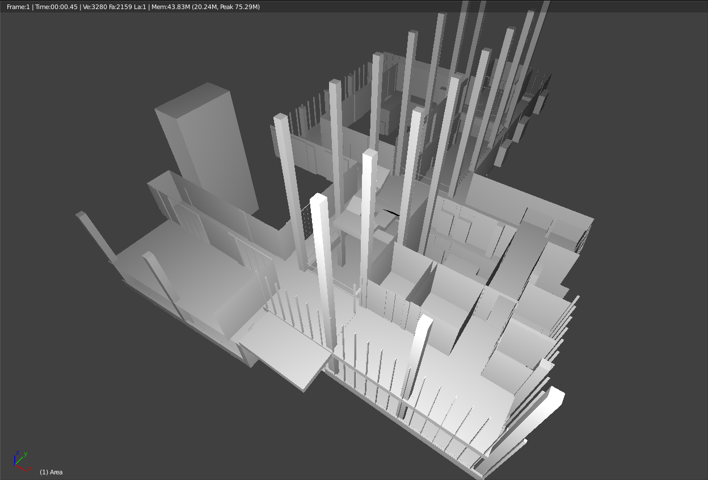columns, followed by the elevators, and then the staircases **(fig 3)**. Then the floors and walls were put in place and adjusted to fit the scaled down measurements of the 3D map. In order to maintain easy access to views of individual levels, each level’s floors and walls were kept in its own layer, along with another linked layer for that level’s ceiling. In the end, there were eight layers: one for each of the four levels, and one for each level’s ceiling.

***Figure 3***

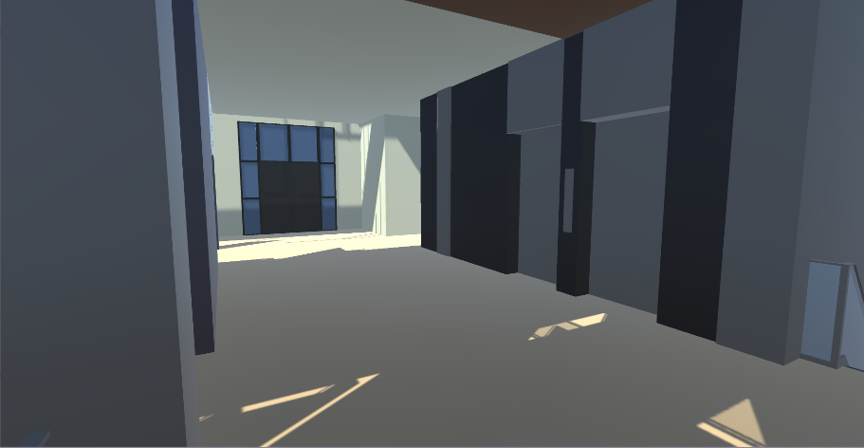Once the basic shape had been made, the map then had a basis on which to display the most recognizable details of Deerfield Hall. Starting from the first floor front entrance, the first details to take shape were the window linings; followed by the window panes; the café seating area; the café doors; the elevator doors **(fig 4)**, which were copied for all four floors; the recessed window seats in the main hall; and then all the doors. For the second, third and fourth floors, the formula remained the same: windows, then elevators, and then doors. After the 3D layout took shape, the colouring layout required scrubbing through all the recorded video resources and manually creating a colour palette that resembled the one in the real Deerfield Hall. Once it was coloured, all that was left was to import the map into Unity, ensure that all 2D planes faced inward, and then create the first-person controller and pop-up text system for the doors. A few planes had to be adjusted so that the player would not fall through the map, but this was a quick fix, and luckily, the standard assets included with Unity 5 provided a first-person controller that could be edited to fit the scale of the map. With the knowledge gained from “JediNikola’s” *Basic Speech Bubbles - Unity Tutorial*, the pop-up text system worked just as anticipated, and also marked the completion of UTM 3D: Deerfield Hall.

***Figure 4***

1. ***Field Research***

To test the effectiveness of the game, we employed the Media Comparison Approach, a methodology used by Richard E. Mayer (‘’Three Genres of Game Research’’). This method allowed us to compare two groups that have different learning methods. The first group will get to experience being in Deerfield with the use of Virtual Reality, while the other one will use conventional online means to acquire information about the building (photos, Google Maps, narrated explanation…). After they have completed their task, the two groups headed to the real building. We then measured the level of familiarity and anxiety the group members were feeling. The results were recorded via surveys and questionnaires.

The first group to search for the five rooms was the control group; the group that was only allowed access to the online resources that they could find when left to their own devices. Interestingly, the control group opted to race to the fourth floor to begin searching; this was confirmed to be because of their belief that finding the final room on the first floor would have let them reach the finish line sooner, but was ultimately voided due to the time it took them to reach the fourth floor in the beginning. The control group reported some struggle in finding the assigned rooms on the third floor and fourth floor due to the small amount of online resources that displayed any meaningful landmarks or maps for those floors; this is one of the main concerns that this project addresses and is further evidenced by the control groups reports. The control group finished with an average time of 4 minutes, 31 seconds and with minor struggles in locating rooms on the third and fourth floors.

Next up was the test group; the group that was given a chance to play Team 9’s UTM 3D: Deerfield Hall. Unlike the control group, the test group did not opt to begin with the top floors, but instead started on the first floor and worked their way up. The test group performed much more fluidly than the control group by quickly finding the rooms on the first and second floors, and just as promptly finding the ones on the third and fourth floors with which the control group had such difficulty locating. One of the subjects in the test group noted that “finding the psychology office was way easier because of how much it stood out in the game”; just as hypothesized. The test group finished with an average time of 3 minutes, 9 seconds and with no reported struggles in locating any of the rooms.

The results of the testing session clearly indicate that the test group had a much easier experience than the control group when locating five specific rooms on all four floors of Deerfield Hall. This is evidenced by the 1 minute, 22 second difference between the two groups where the test group had the faster average time, as well as by one of the test group subject’s remark explaining how much easier it was for them to find the rooms because of how the game emphasized its presence. The only possible discrepancy in these results is the potential lost time from the control group’s testing session when they chose to explore the topmost floor of Deerfield Hall first instead of the main floor like the test group, however it is definitely not a determining factor in the confirmation of the hypothesis since the time it took the control group to reach the fourth floor did not exceed 1 minute, 22 seconds. All in all, the results of the testing session combined with the feedback from the control and test groups lead to the conclusion that presenting students to UTM 3D: Deerfield Hall does, in fact, both motivate them to visit Deerfield Hall out of curiosity inspired by the 3D rendition, and increase their confidence in navigating the building.

1. ***Conclusions***

When we first set out to create this project, the goal was to help people change one of their behaviours for the better in some way. We knew that many students and prospective campus visitors would naturally have a hard time navigating such a large campus and we realized that video game environments provided a method that was conducive to spatial recognition and recall. To emulate this, we created UTM 3D: Deerfield Hall; an interactive 3D map of the real Deerfield Hall that emphasizes the most prominent features of the building so that players could recognize them upon visiting it. We hypothesized that creating a 3D rendition of a real world environment would provide a much more in-depth look at the important details of it and would help ease the campus visitors into the unfamiliar environment. This idea was backed by the research on anxiety relief through virtual worlds, forming an identity in a virtual environment and immersion through four-dimensional entertainment, and how they confirm that a virtual environment can change the player’s outlook on visiting a new place. These topics were tested in the field research portion of the project, and in the end ultimately led to the confirmation that playing a video game that emulates a real world environment did, in fact, make the players more familiar with the real Deerfield Hall.

1. ***References***

Boots, N., & Strobel, J. (2014). Equipping the Designers of the Future: Best Practices of

Epistemic Video Game Design. Games and Culture.

Ferrara, J. (2013). Games for Persuasion: Argumentation, Procedurality, and the Lie of

Gamification. Games and Culture, 289-304

Charsky, D. (2010). From Edutainment to Serious Games: A Change in the Use of Game

Characteristics. Games and Culture, 177-198.

Freitas, S., Rebolledo-Mendez, G., Liarokapis, F., Magoulas, G., & Poulovassilis, A. (2010). *Learning as immersive experiences: Using the four-dimensional framework for designing and evaluating immersive learning experiences in a virtual world*. British Journal of Educational Technology, 69-85.

Bouchard, Stéphane, Julie St-Jacques, Geneviève Robillard, and Patrice Renaud. "MIT Press Journals - Presence: Teleoperators and Virtual Environments - Abstract." *MIT Press Journals - Presence: Teleoperators and Virtual Environments - Abstract*. Massachusetts Institute of Technology, Aug. 2008. Web. 17 Nov. 2015.

Van Veen, H., Distler, H., Braun, S., & Bülthoff, H. (1998). Navigating Through A Virtual City: Using Virtual Reality Technology To Study Human Action And Perception⋆. *Future Generation Computer Systems,* 231-242.

1. Freitas, S., Rebolledo-Mendez, G., Liarokapis, F., Magoulas, G., & Poulovassilis, A. (2010). *Learning as immersive experiences: Using the four-dimensional framework for designing and evaluating immersive learning experiences in a virtual world*. British Journal of Educational Technology, 69-85.
2. Boots, N., & Strobel, J. (2014). Equipping the Designers of the Future: Best Practices of

   Epistemic Video Game Design. Games and Culture.
3. Ferrara, J. (2013). Games for Persuasion: Argumentation, Procedurality, and the Lie of

   Gamification. Games and Culture, 289-304
4. Charsky, D. (2010). From Edutainment to Serious Games: A Change in the Use of Game

   Characteristics. Games and Culture, 177-198.