Use Case Document
  - Comprehensive Guide to System Use Cases

1. Introduction
This Use Case Document outlines the functional requirements and interactions for the proposed system. It serves as a reference for developers, stakeholders, and testers to understand the intended behavior and user interactions with the system.

2. Purpose
The purpose of this document is to define and describe the key use cases that capture the main functionalities and user scenarios for the application. It ensures that all user requirements are addressed and provides a foundation for system development and validation.

3. Scope
This document covers the primary use cases for the system, focusing on core user interactions and system responses. It does not include detailed technical specifications or low-level implementation details.

4. Actors
- Primary User: The main individual interacting with the system to achieve specific goals.
- Administrator: Responsible for managing user accounts and system configurations.
- External System: Any third-party service or application that interfaces with the system.

5. Use Case Diagrams
A visual representation of the system's use cases and actors can be included here. (Insert diagram if available.)

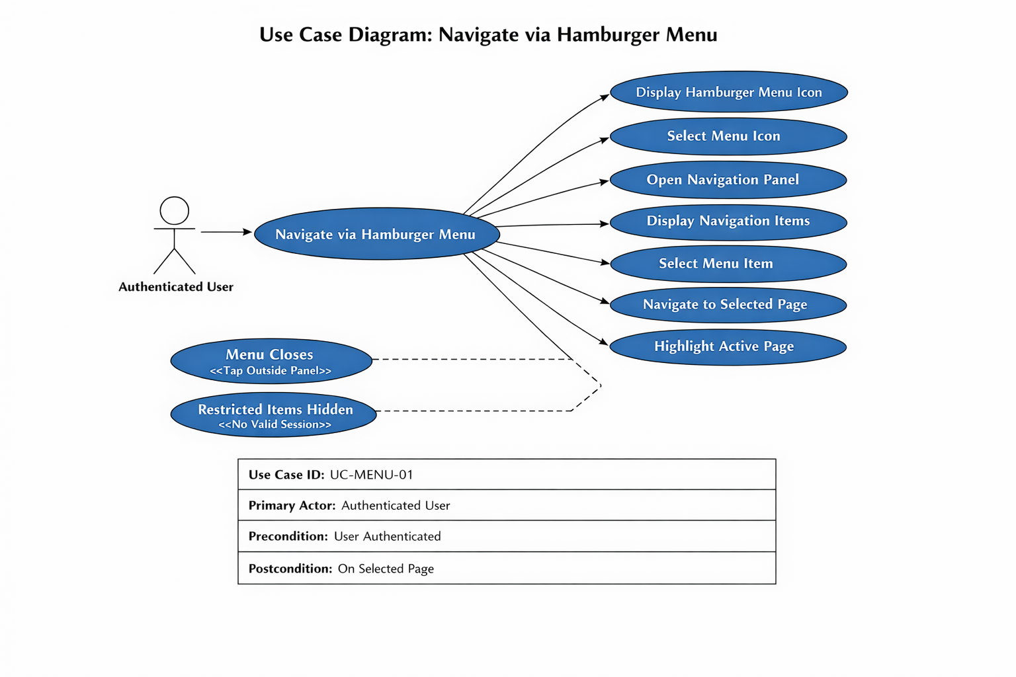

6. Use Case Description

6.1 Use Case: Dashboard
Primary Actor: Authenticated User
Goal:
Access application pages through the navigation menu.
Preconditions
User is authenticated.
Trigger
User taps the hamburger menu icon.
Main Success Scenario
- System displays hamburger menu icon on all authenticated pages.
“The system shall display a hamburger menu icon in the top navigation bar…”
- User selects the icon.
- System opens navigation panel.
- System displays primary and secondary navigation items.
- User selects a menu item.
- System navigates to selected page.
- System highlights active page.
Alternate / Exception Flows
- User taps outside panel → menu closes.
- No valid session → restricted items hidden.
Postconditions
User is on selected page.
Traceability
BR-MENU-01 through BR-MENU-10.

7. Assumptions and Constraints
- Users must have valid credentials to access the system.
- All data entries are subject to validation rules.
- The system will be accessible via standard web browsers.

8. References
Include any relevant documents, standards, or external resources referenced in the development of this use case document.

10. Revision History
Version | Date | Description | Author
1.0 | 04/14/2026 | Initial draft | Gordon Neuls

