Use Case Document
  - Comprehensive Guide to System Use Cases

1. Introduction
This Use Case Document outlines the functional requirements and interactions for the proposed system. It serves as a reference for developers, stakeholders, and testers to understand the intended behavior and user interactions with the system.

2. Purpose
The purpose of this document is to define and describe the key use cases that capture the main functionalities and user scenarios for the application. It ensures that all user requirements are addressed and provides a foundation for system development and validation.

3. Scope
This document covers the primary use cases for the system, focusing on core user interactions and system responses. It does not include detailed technical specifications or low-level implementation details.

4. Actors
- Primary User: The main individual interacting with the system to achieve specific goals.
- Administrator: Responsible for managing user accounts and system configurations.
- External System: Any third-party service or application that interfaces with the system.

5. Use Case Diagrams
A visual representation of the system's use cases and actors can be included here. (Insert diagram if available.)

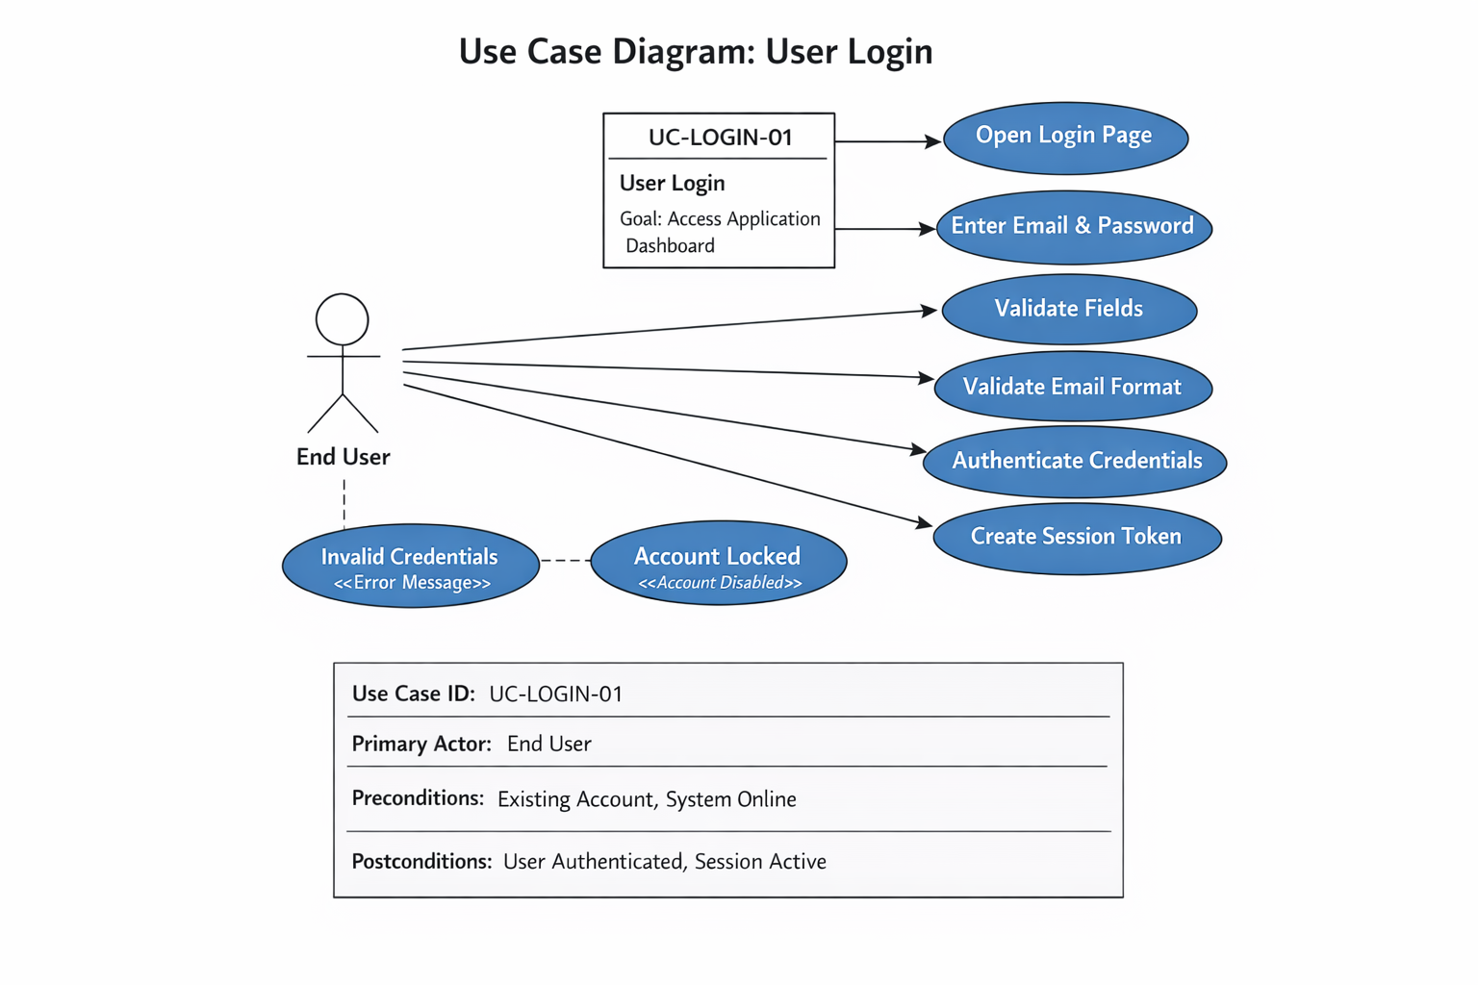

6. Use Case Description

6.1 Use Case: User Login
Primary Actor: End User
Goal:
Authenticate and access the application dashboard.
Preconditions
- User has an existing account.
- System is online and accessible.
Trigger
• User navigates to the login page.
Main Success Scenario
- User opens the login page.
Cited BRD line: “The system shall display a login page that includes fields for entering a valid email address and password.”
- User enters email and password.
- System validates required fields.
“The system shall validate that both the email and password fields are populated…”
- System validates email format.
- System authenticates credentials against stored values.
- System creates a secure session token and stores it in an HTTP-only cookie.
- System redirects user to the dashboard.
“The system shall redirect authenticated users to the application's home/dashboard page.”
Alternate / Exception Flows
- Invalid credentials: System displays authentication error.
“The system shall display an error message when authentication fails…”
- Locked/disabled account: System displays specific error.
- Too many failed attempts: System locks account temporarily.
Postconditions
- User is authenticated.
- Active session token exists.
Traceability
BR-Login-01 through BR-Login-15.

7. Assumptions and Constraints
- Users must have valid credentials to access the system.
- All data entries are subject to validation rules.
- The system will be accessible via standard web browsers.

8. References
Include any relevant documents, standards, or external resources referenced in the development of this use case document.

10. Revision History
Version | Date | Description | Author
1.0 | 04/14/2026 | Initial draft | Gordon Neuls

