Use Case Document
  - Comprehensive Guide to System Use Cases

1. Introduction
This Use Case Document outlines the functional requirements and interactions for the proposed system. It serves as a reference for developers, stakeholders, and testers to understand the intended behavior and user interactions with the system.

2. Purpose
The purpose of this document is to define and describe the key use cases that capture the main functionalities and user scenarios for the application. It ensures that all user requirements are addressed and provides a foundation for system development and validation.

3. Scope
This document covers the primary use cases for the system, focusing on core user interactions and system responses. It does not include detailed technical specifications or low-level implementation details.

4. Actors
- Primary User: The main individual interacting with the system to achieve specific goals.
- Administrator: Responsible for managing user accounts and system configurations.
- External System: Any third-party service or application that interfaces with the system.

5. Use Case Diagrams
A visual representation of the system's use cases and actors can be included here. (Insert diagram if available.)

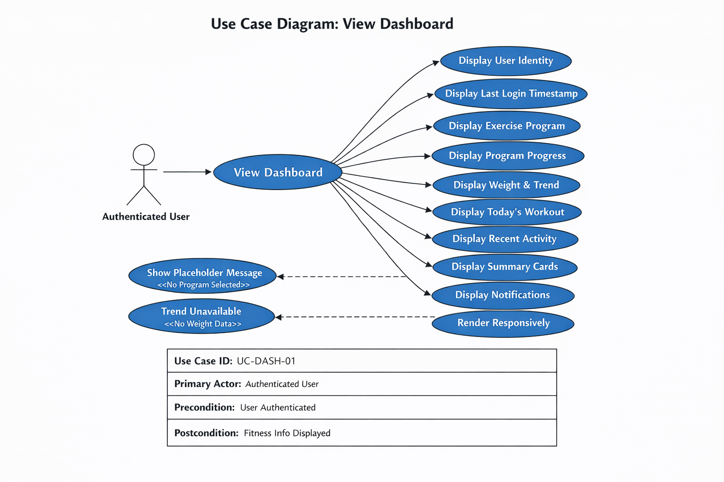

6. Use Case Description

6.1 Use Case: Dashboard
Primary Actor: Authenticator User
Goal:
View personalized fitness summary.
Preconditions
- User is authenticated.
Trigger
• Successful login or user navigates to Dashboard.
Main Success Scenario
- System displays dashboard.
“The system shall display a dashboard page immediately after successful user authentication.”
- System displays user identity (email).
- System displays last login timestamp.
- System displays selected exercise program.
- System displays program progress.
- System displays current weight and weight trend.
- System displays today's workout summary.
- System displays recent activity (3–5 workouts).
- System displays progress summary cards.
- System displays notifications.
- Dashboard renders responsively.
- Dashboard refreshes data on load.
Alternate / Exception Flows
- No selected program → show placeholder message.
- No weight entries → trend unavailable.
Postconditions
• User sees up-to-date fitness information.
Traceability
BR-DASH-01 through BR-DASH-15.

7. Assumptions and Constraints
- Users must have valid credentials to access the system.
- All data entries are subject to validation rules.
- The system will be accessible via standard web browsers.

8. References
Include any relevant documents, standards, or external resources referenced in the development of this use case document.

10. Revision History
Version | Date | Description | Author
1.0 | 04/14/2026 | Initial draft | Gordon Neuls

