UI Specification
Contents
2. Purpose 1
3. Scope 1
4. UI Design Principles 1
Responsive rules 1
Platform guidelines 1
5. Screen Inventory 3
6. Navigation Model 3
7. Screen Specifications 4
7.1 WF-01 Login 4
7.2 WF-02 Create Account 4
7.3 WF-03 Reset Password 5
7.4 WF-04 Dashboard 6
7.5 WF-05 Exercise Program List 6
7.6 WF-06 Workout Detail 7
7.7 WF-07 Log Workout 7
7.8 WF-08 Help 8
7.9 WF-10 Notification List 9
7.10 WF-11 Reports 9
7.11 WF-12 User Profile 10
7.11 WF-13 Weight Tracking 10
8. References 11
9. Revision History 12
10. Approval 12
11. Glossary of Terms 12
12. Appendix B: Document Cross Reference 12

1. Introduction
This Use Case Document outlines the functional requirements and interactions for the proposed system. It serves as a reference for developers, stakeholders, and testers to understand the intended behavior and user interactions with the system.

2. Purpose
The purpose of this document is to define and describe the key use cases that capture the main functionalities and user scenarios for the application. It ensures that all user requirements are addressed and provides a foundation for system development and validation.

3. Scope
This document covers the primary use cases for the system, focusing on core user interactions and system responses. It does not include detailed technical specifications or low-level implementation details.

4. UI Design Principles
Responsive rules
The User Interface will respond to input in a reasonable time (under a few seconds)
Platform guidelines
These principles ensure the NeuByte Fitness App behaves consistently with modern mobile platform standards, providing users with predictable, intuitive interactions regardless of device.
1. Follow Native Navigation Conventions
The app adheres to platform‑standard navigation patterns to reduce cognitive load and ensure familiarity.
- Primary navigation uses a hamburger menu consistent with Android/iOS mobile norms.
- Back navigation uses the OS‑native gesture or back button.
- Screen transitions follow platform‑appropriate motion (slide-in, fade, etc.).
2. Respect System-Level UI Components
The app uses native controls where possible to ensure accessibility, performance, and user trust.
- Native pickers for date, time, and numeric inputs.
- Native keyboard types (numeric for weight, email keyboard for login).
- Native modal sheets for confirmations and destructive actions.
3. Optimize for Mobile-First Interaction
The UI is designed for thumb‑reachable zones and small-screen ergonomics.
- Primary actions placed in lower-third of the screen.
- Tap targets meet minimum 44–48 px guidelines.
- Layouts adapt to portrait-first usage, with responsive behavior for foldables.
4. Honor System Accessibility Settings
The app respects OS-level accessibility preferences to ensure inclusive use.
- Dynamic Type scaling for text.
- High-contrast mode support.
- Reduced motion settings for animations.
- Voice Over/Talk Back compatibility for all interactive elements.
5. Support Platform Security Expectations
The app aligns with mobile security norms to protect user data.
- Use secure OS-level authentication (biometrics, passcode).
- Prevents screenshots on sensitive screens (optional for portfolio).
- Follows platform guidelines for secure storage of tokens and credentials.
6. Leverage Platform Feedback Patterns
The app uses platform-native feedback mechanisms to communicate state.
- Haptic feedback for key actions (save, delete, complete).
- Toast/snack bar notifications for non-blocking messages.
- System vibration patterns for errors or invalid inputs.
7. Ensure Performance and Responsiveness
The app meets platform expectations for smooth, fluid interaction.
- 60fps target for animations and transitions.
- Lazy-loading for workout history lists.
- Local caching for offline-first behavior where appropriate.
NeuByte color palette
- Typography
In Order to Match closely Eras Family, the Web page will use ManRope
- Iconography
Font Awesome collection for Hamburger menu and Arrows used to indicate expansion and close

5. Screen Inventory
Screen ID | Screen Name | Module | Status | Use Case(s) | Requirement(s)
WF-01 | Login | Authentication
WF-02 | Create Account | Authentication
WF-03 | Reset Password | Authentication
WF-04 | Dashboard | Dashboard
WF-05 | Exercise Program List | Program
WF-06 | Workout Detail | Program
WF-07 | Log Workout | Program
WF-08 | Help | Help
WF-09 | Navigation | Framework No Module
WF-10 | Notification List | Dashboard
WF-11 | Reports | Dashboard
WF-12 | User Profile | Profile
WF-13 | Weight Tracking | Profile

6. Navigation Model
The Fitness App navigation is based on the idea of mobile phone access so the menu will be closed as a hamburger menu icon then expanded to a simple one layer drop down menu to include:
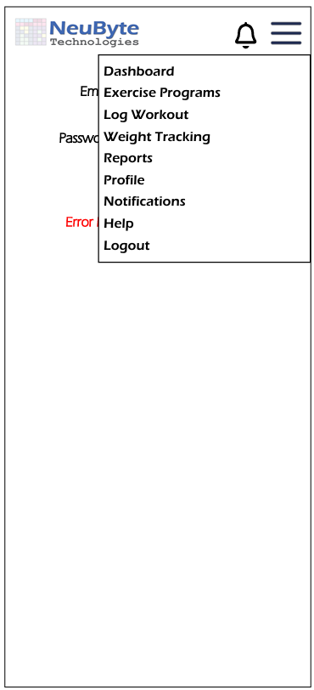
- Dashboard
- Exercise Programs
- Log Workout
- Weight Tracking
- Reports
- Profile
- Notifications
- Help
- Logout

The application will start with the Login UI as the initial landing page with no other options. After successful login the main UI will be the Dashboard.
6.1Related Requirements
BR‑MENU‑01, BR‑MENU‑02, BR‑MENU‑03, BR‑MENU‑04, BR-MENU-06

7. Screen Specifications
Users must have valid credentials to access the system.
All data entries are subject to validation rules.
The system will be accessible via standard web browsers, including mobile devices.

7.1 UIS-LOGIN-01 Login Page
7.1.1 Purpose
Allows the user to authenticate for the use of the application. Link to Create a new Account if the user needs one.
7.1.2 Related Requirements
BR‑Login-01, BR‑Login-02, BR‑Login-03, BR‑Login-06, BR‑Login-07, BR‑Login-13
7.1.3 User Interface Design
7.1.3.1 Login UI
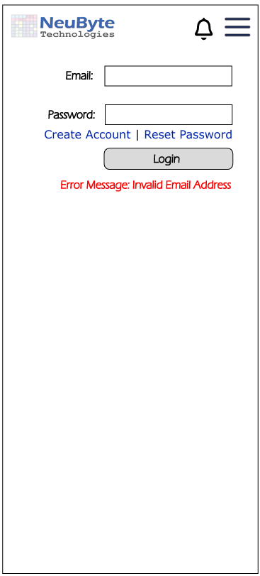
Header contains the NeuByte Logo as well as a Notification Icon and Hamburger Menu. See the Navigation Specification later in this document.
The Form will contain labels for the users’ Email and Password. Next to the Labels are Text Boxes for user input. Between Password row and Login are Links to Create an Account or Reset Password. The Login button to start the authorization process. The Error Label will show errors as generated by user input being incorrect to authenticate a user.

7.2 UIS-CA-01 Create Account Page
7.2.1 Purpose
Allow the user to create a new account for the use of the application.
7.2.2 Related Requirements
BR‑CREATE-01, BR-CREATE-02, BR-CREATE-03, BR-CREATE-04, BR-CREATE-05, BR-CREATE-06, BR-CREATE-07,
BR-CREATE-11, BR-CREATE-12

7.2.3 User Interface Design
7.2.3.1 Create Account UI
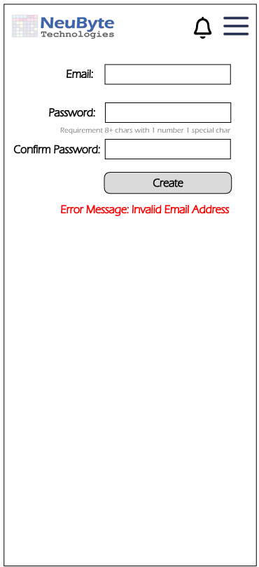
Header contains the NeuByte Logo as well as a Notification Icon and Hamburger Menu. See the Navigation Specification later in this document.
The Form will contain labels for the users’ Email, Password. And Confirm Password Next to the Labels are Text Boxes for user input. Between Password row and Confirm Password is a text explaining minimum password requirements. The Create button to start the process to add a new account. The Error Label will show errors generated by user input (e.g. Email Address already used).

7.3 UIS-RP-01 Reset Password Page
7.3.1 Purpose
Allow the user to reset existing account password.
7.3.2 Related Requirements
BR‑RESET‑01, BR‑RESET‑02, BR-RESET‑03, BR‑RESET‑04, BR‑RESET‑05, BR-RESET-06, BR-RESET-07,
BR-RESET-12, BR-RESET-14, BR-RESET-16, BR-RESET-17
7.2.3 User Interface Design
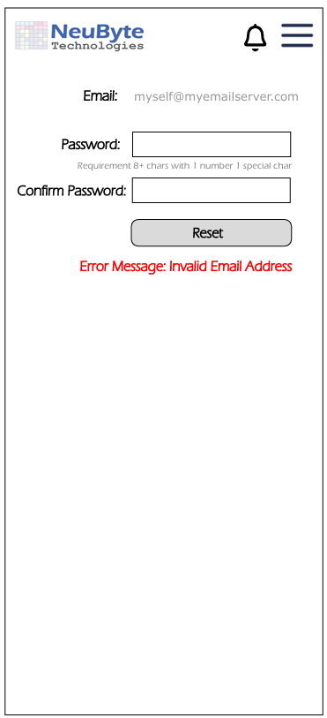
7.3.3.1 Reset Password
Header contains the NeuByte Logo as well as a Notification Icon and Hamburger Menu. See the Navigation Specification later in this document.
The Form will contain labels for email and the users’ actual email address. Next to the Password and Confirm Password Labels are Text Boxes for user input. Between Password row and Confirm Password is a text explaining minimum password requirements. The Create button to start the process to add a new account. The Error Label will show errors generated by user input (e.g. Email Address already used).

7.4 UIS-DASH-01 Dashboard Layout
7.4.1 Purpose
The main application page from where the bulk of the interactions with the Application contents are initiated.
7.4.2 Related Requirements
BR‑DASH-01, BR‑DASH-02, BR‑DASH-03, BR‑DASH-04, BR-DASH-05, BR-DASH-06, BR-DASH=07, BR-DASH-08,
BR‑DASH-09, BR‑DASH-10, BR‑DASH-11, BR‑DASH-12, BR-DASH-13, BR-DASH-14, BR-DASH=15, BR-DASH-16,
BR‑DASH-17, BR‑DASH-18, BR‑DASH-19, BR‑DASH-20, BR-DASH-21, BR-DASH-22, BR-DASH=23, BR‑DASH-24, BR‑DASH-25, BR‑DASH-26
7.4.3 User Interface Design
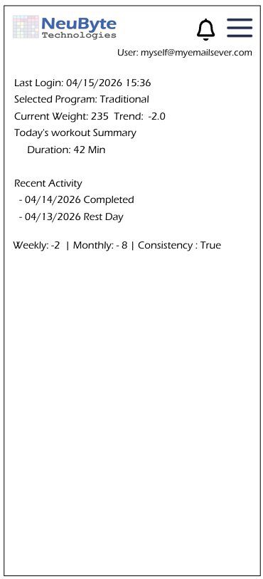
7.4.3.1 Dashboard
Header contains the NeuByte Logo as well as a Notification Icon and Hamburger Menu. See the Navigation Specification later in this document.
The page will display the logged in User in the upper right with the associated email address.
The main part of the page will display the Last Login Date, The Selected Program, The User’s current weight and the weight trend
Today’s workout summary shows the workout duration logged
Recent Activity shows the past few days activity to assist in the user’s ability to build on the past.
The bottom of the page will show the weight trend for the week, the month and the user’s consistency trend.

7.5 UIS-EP-01 Program List Page
7.5.1 Purpose
The Exercise list shows a variety of exercise programs the user can choose from to select in support of their fitness journey.
7.5.2 Related Requirements
BR‑EP‑01, BR‑EP‑02, BR‑EP‑03, BR‑EP‑04, BR‑EP‑05
7.5.3 User Interface Design
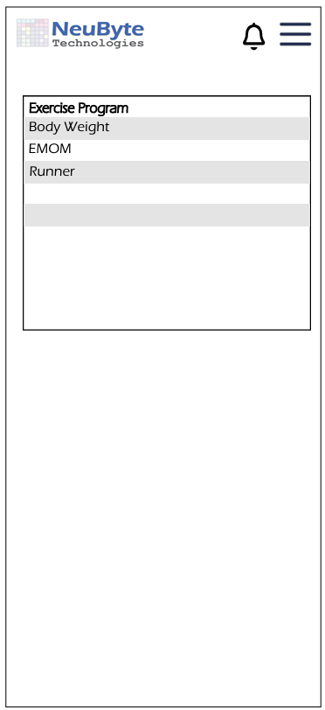
7.5.3.1 Exercise Program List
Header contains the NeuByte Logo as well as a Notification Icon and Hamburger Menu. See the Navigation Specification later in this document.
The page will display the list of Exercise Program(s) the user can select from Double-click the row to view the Workout

7.6 UIS-PROG-01 Program Detail Page
7.6.1 Purpose
Show a Selected Exercise Program Detail so the user can understand what is being asked for in the program.
7.6.2 Related Requirements
BR‑PROG‑01, BR‑PROG‑02, BR‑PROG‑03, BR‑PROG‑04, BR‑PROG‑05, BR‑PROG‑06, BR‑PROG‑07, BR‑PROG‑08,
BR‑PROG‑09, BR‑PROG‑10, BR‑PROG‑11, BR‑PROG‑12, BR‑PROG‑13, BR‑PROG‑14, BR‑PROG‑15, BR‑PROG‑16, BR‑PROG‑17, BR‑PROG‑18, BR‑PROG‑19, BR‑PROG‑20, BR‑PROG‑21, BR‑PROG‑22, BR‑PROG‑23
7.6.3 User Interface Design
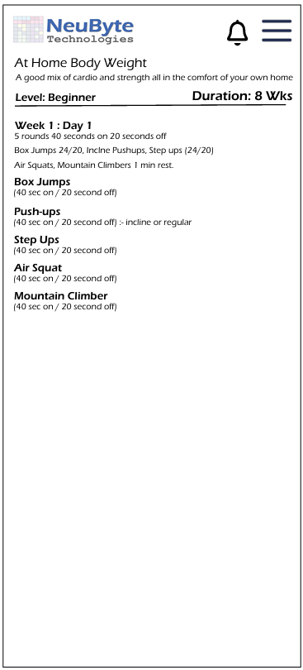
7.6.3.1 Workout Detail
Header contains the NeuByte Logo as well as a Notification Icon and Hamburger Menu. See the Navigation Specification later in this document.
The page will display the details of a Workout Program Day By Day

7.7 UIS-LW-01 Log Workout Page
7.7.1 Purpose
Show a Selected Exercise Program Detail so the user can understand what is being asked for in the program.
7.7.2 Related Requirements
BR‑LW‑01, BR‑LW‑02, BR‑LW‑03, BR‑LW‑04, BR‑LW‑05, BR‑LW‑06, BR‑LW‑07, BR‑LW‑08, BR‑LW‑09, BR‑LW‑10, BR‑LW‑11, BR‑LW‑12, BR‑LW‑13, BR‑LW‑14, BR‑LW‑15, BR‑LW‑16, BR‑LW‑17, BR‑LW‑18, BR‑LW‑19, BR‑LW‑20, BR‑LW‑21, BR‑LW‑22, BR‑LW‑23, BR‑LW‑24
7.7.3 User Interface Design
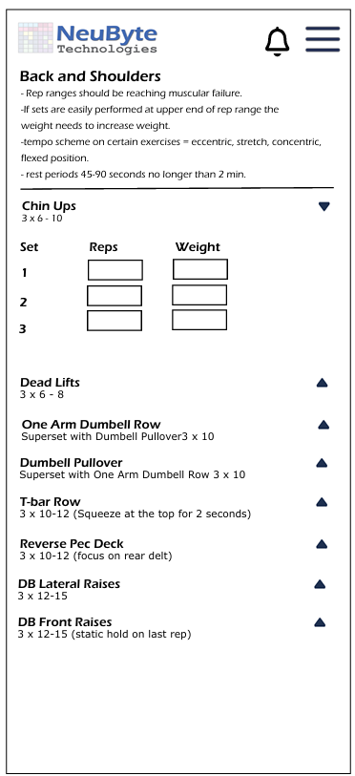
7.7.3.1 Log Workout
Header contains the NeuByte Logo as well as a Notification Icon and Hamburger Menu. See the Navigation Specification later in this document.
The page will display the details of a Workout Program for the day and provide text boxes for each set to indicate the reps executed and another for the weight moved. For cardio these would instead be a duration / distance and rest period. This allows for both lifting and cardio workout records.

7.8 UIS-HELP-01 Help Page Layout
7.8.1 Purpose
The main application page to provide help to the user.
7.8.2 Related Requirements
BR‑HELP‑01, BR‑HELP‑02, BR‑HELP‑03, BR‑HELP‑04, BR‑HELP‑05, BR‑HELP‑06, BR‑HELP‑07, BR‑HELP‑08, BR‑HELP‑09, BR‑HELP‑10, BR‑HELP‑11, BR‑HELP‑12, BR‑HELP‑13, BR‑HELP‑14, BR‑HELP‑15

7.8.3 User Interface Design
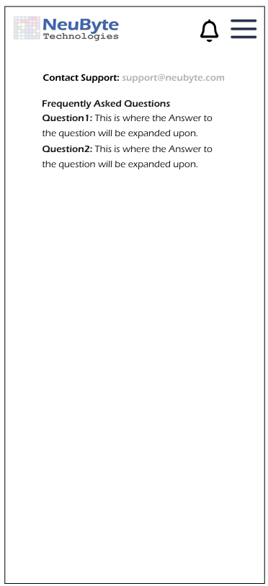
7.8.3.1 Help
Header contains the NeuByte Logo as well as a Notification Icon and Hamburger Menu. See the Navigation Specification later in this document.
The page will display Contact Support: support@neubyte.com.
The page will display a Frequently Asked Question list of questions and answers.

7.9 UIS-NOTE-01 Notification Center
7.9.1 Purpose
Show a central List of application Notifications for a user.
7.9.2 Related Requirements
BR-NOTE-01, BR-NOTE-02, BR-NOTE-03, BR-NOTE-04, BR-NOTE-05, BR-NOTE-06, BR-NOTE-07, BR-NOTE-08, BR-NOTE-09, BR-NOTE-10, BR-NOTE-11, BR-NOTE-12, BR-NOTE-13, BR-NOTE-14, BR-NOTE-15, BR-NOTE-16
7.9.3 User Interface Design
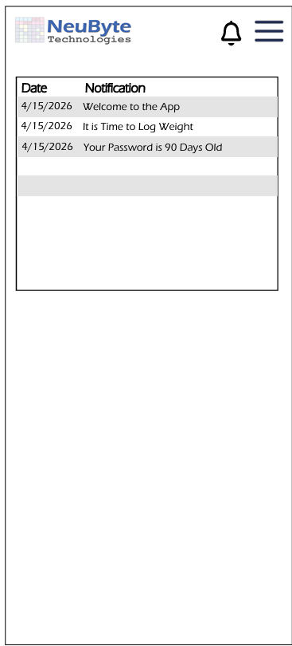
7.9.3.1 Notification List
Header contains the NeuByte Logo as well as a Notification Icon and Hamburger Menu. See the Navigation Specification later in this document.
The page shall display the List of Notifications for the User. The Notification will link to the appropriate app location (e.g. a pop up for a welcome message or the Weight Tracking page for a Time to Log Weight notification). After a notification is clicked on it will not stay in the list because it was read.

7.10 UIS-RPT-01 Report List Page
7.10.1 Purpose
Provide a central location for Application Reports.
7.10.2 Related Requirements
BR‑RPT‑01, BR‑RPT‑02, BR‑RPT‑03, BR‑RPT‑04, BR‑RPT‑05, BR‑RPT‑06, BR‑RPT‑07, BR‑RPT‑08, BR‑RPT‑09, BR‑RPT‑10, BR‑RPT‑11, BR‑RPT‑12, BR‑RPT‑13

7.10.3 User Interface Design
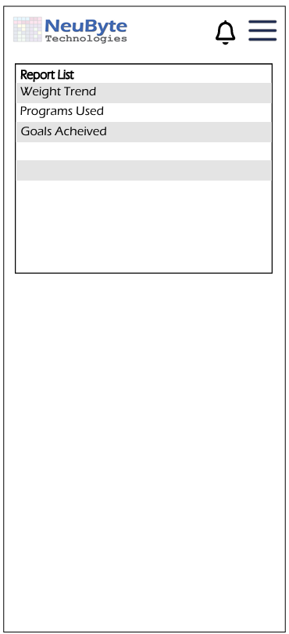
7.10.3.1 Report List
Header contains the NeuByte Logo as well as a Notification Icon and Hamburger Menu. See the Navigation Specification later in this document.
The page shall display the List of Notifications for the User. The Notification will link to the appropriate app location (e.g. a pop up for a welcome message or the Weight Tracking page for a Time to Log Weight notification). After a notification is clicked on it will not stay in the list because it was read.

7.11 UIS-UP-01 User Profile
7.11.1 Purpose
A central location for managing a user’s profile.
7.11.2 Related Requirements
BR‑PROF‑01, BR‑PROF‑02, BR‑PROF‑03, BR‑PROF‑04, BR‑PROF‑05, BR‑PROF‑06, BR‑PROF‑07, BR‑PROF‑08, BR‑PROF‑09, BR‑PROF‑10, BR‑PROF‑11
7.11.3 User Interface Design
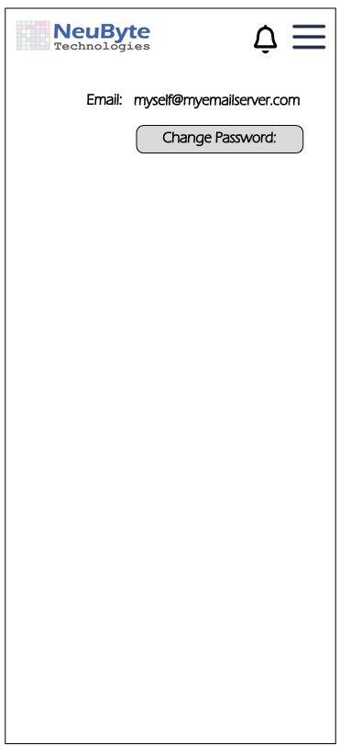
7.11.3.1 Notification List
Header contains the NeuByte Logo as well as a Notification Icon and Hamburger Menu. See the Navigation Specification later in this document.
The page shall display Email for the user and a button to allow for password change.

7.11 UIS-WT-01 Weight Tracking Page
7.11.1 Purpose
Provide a method to track a user’s weight over time to assist in meeting fitness goals.
7.11.2 Related Requirements
BR-WT-01, BR-WT-02, BR-WT-03, BR-WT-04, BR-WT-05, BR-WT-06, BR-WT-07, BR-WT-08, BR-WT-09, BR-WT-10, BR-WT-11, BR-WT-12, BR-WT-13, BR-WT-14, BR-WT-15, BR-WT-16, BR-WT-17, BR-WT-18, BR-WT-19, BR-WT-20, BR-WT-21, BR-WT-22, BR-WT-23, BR-WT-24, BR-WT-25, BR-WT-26

7.11.3 User Interface Design
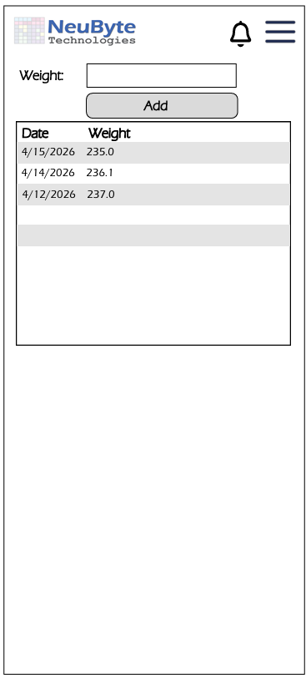
7.11.3.1 Notification List
Header contains the NeuByte Logo as well as a Notification Icon and Hamburger Menu. See the Navigation Specification later in this document.
The page shall display a label Weight with a text box to allow the user to enter a new weight.
If user input generates an error, it will be displayed above the text box.
There will be a list of user’s weight entries to show the trend.

8. References
Include any relevant documents, standards, or external resources referenced in the development of this use case document.

9. Revision History
Version | Date | Description | Author
1.0 | 04/10/2026 | Initial draft | Gordon Neuls
1.1 | 04/17/2026 | Update Specs with RTM Naming | Gordon Neuls

10. Approval
Date | Role | Author
04/17/2026 | Business System Analyst | Gordon Neuls
04/17/2026 | Principle Software Engineer | Gordon Neuls

11. Glossary of Terms
Term | Definition
Account Lockout | A security control that temporarily disables a user account after repeated failed login attempts.  Referenced in: “The system shall track failed login attempts and temporarily lock the account…” (BR‑Login‑14).

12. Appendix B: Document Cross Reference
Artifact Type | Identifier | Document Name / Section | Linked To | Notes
Business Requirement | BR‑Login-01

