06. Imaging
Overview. Every control on this screen has detailed built-in help: hover it, press F1, or click the ? beside the title. See Built-in Help.
The Imaging screen is the live capture and preview screen. Use it for manual exposures, exploring exposure settings, and monitoring a target in real time.
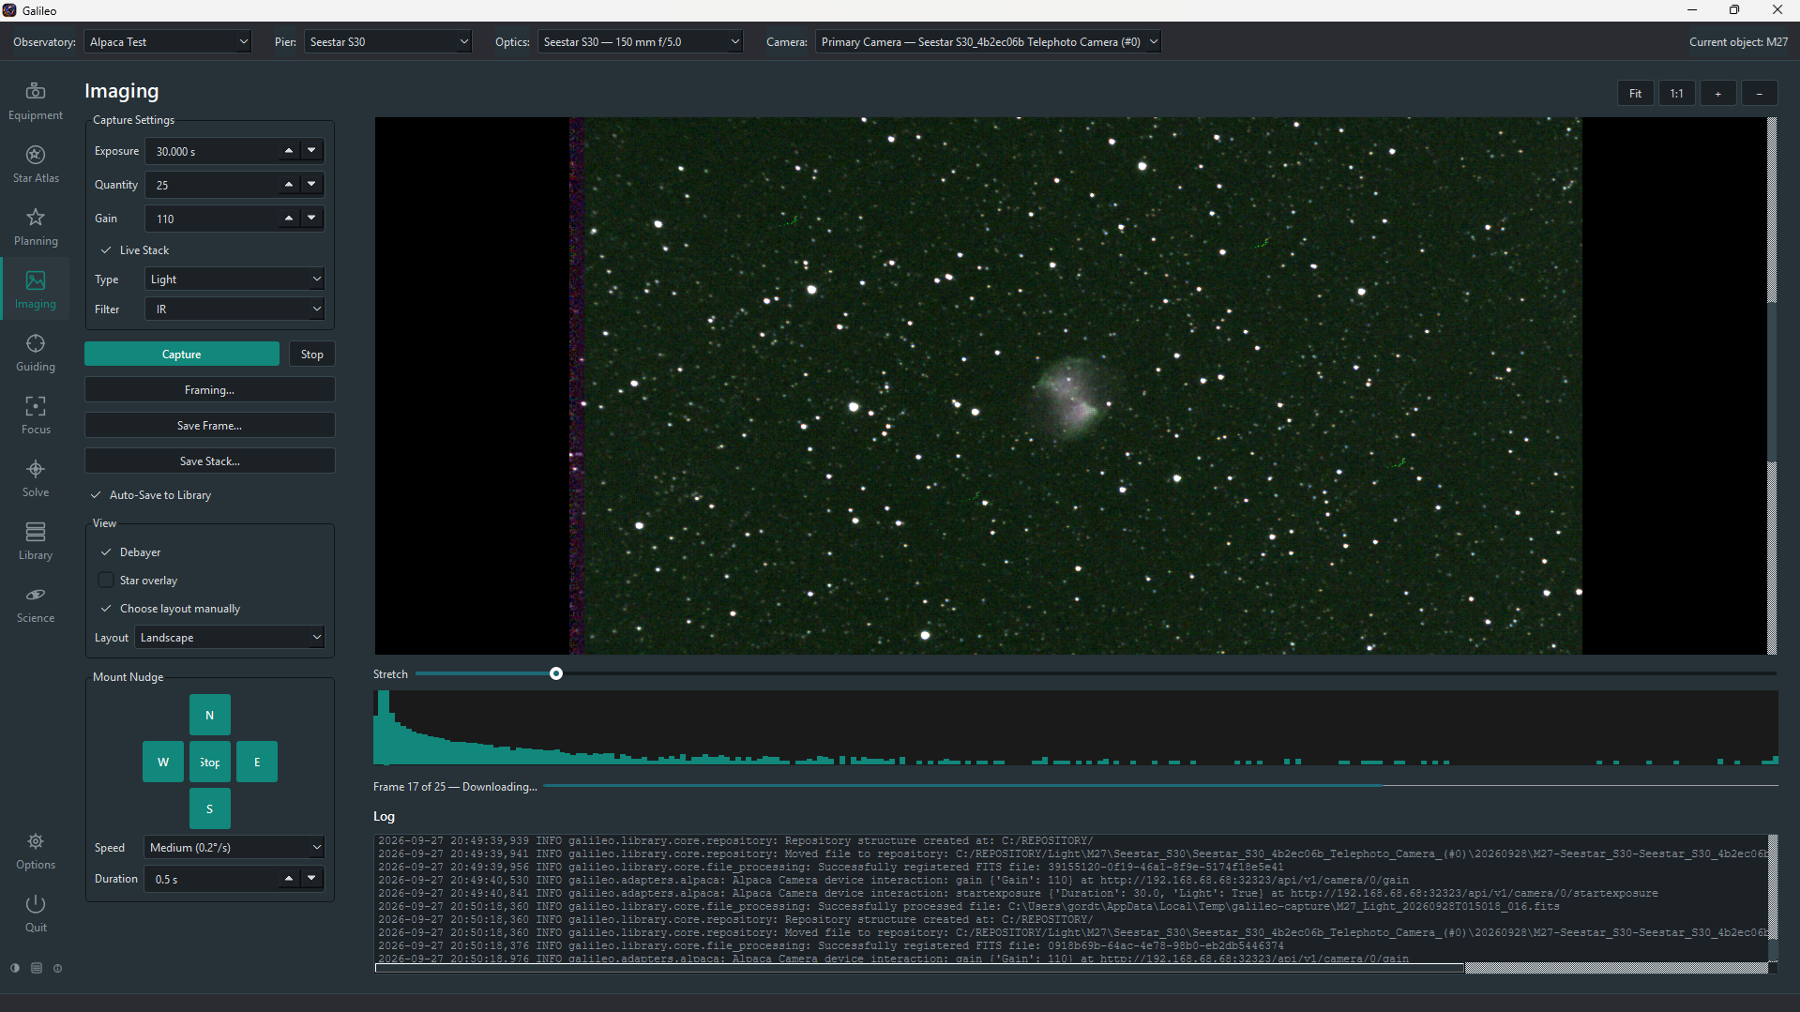
Imaging screen
For portrait-oriented sensors the layout rearranges automatically:
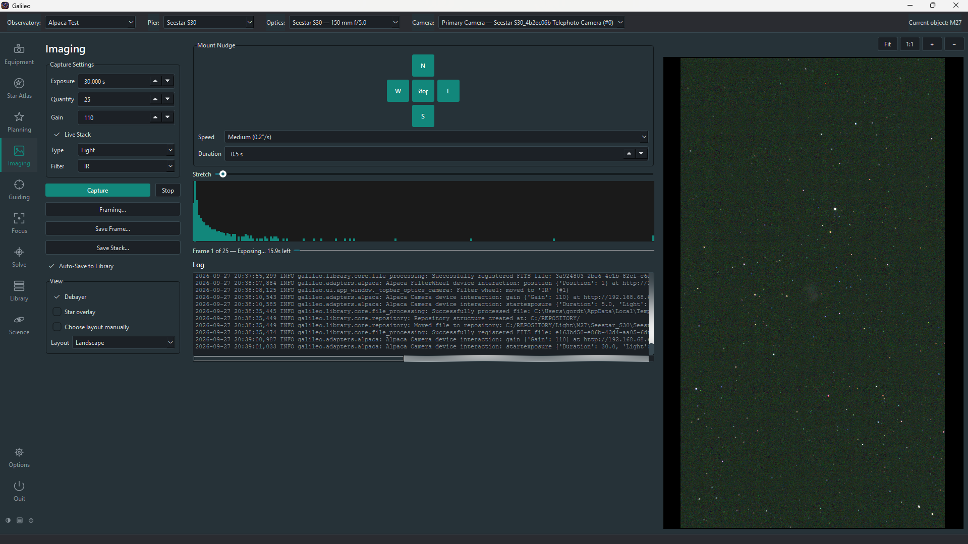
Imaging screen — portrait layout

Prerequisites
- A camera must be saved and connected under Equipment > Camera. The status bar shows "Connected to primary camera '…'" when it is ready. If it shows "No camera connected", go to Equipment > Camera, pick the device, click Save, and then re-select the Pier to trigger auto-connect.
- Optional: a filter wheel for multi-filter work, a mount for nudging, and optics configured under Equipment > Optics.

Capture settings
The settings panel on the left contains:
Setting | Notes
Type | Light, Dark, Flat or Bias. Dark, Flat and Bias are used to build calibration frames for the Library.
Exposure | Exposure time in seconds (0.001 s – 3600 s).
Quantity | How many frames to take in succession. Default 1.
Gain | Sensor gain in the camera's native units.
Offset | Sensor offset (bias pedestal).
Filter | Appears when a filter wheel is associated with the selected optics. Choosing a filter moves the wheel before the capture starts; the status bar confirms the move.
Bin | Pixel binning (1×1, 2×2, etc.) if the camera supports it.

Taking an exposure
- Set Type, Exposure, Quantity and Filter as needed.
- Click Capture (or Loop to keep repeating the run until you press Stop). A progress bar and countdown show while the camera exposes and downloads; the window stays responsive throughout.
- The frame appears in the preview area as soon as it downloads. With Quantity > 1, frames appear one after another; click Stop to end the run after the current exposure finishes (the exposure already in progress is never aborted mid-frame). While a session is running on the Pier, the status line under the preview shows the session's progress (block, frame and current activity) instead of Idle.

Preview and histogram
The preview panel on the right shows the most recent frame with an auto-stretch applied. Controls along the top of the preview:
Control | Effect
Pan / zoom | Drag to pan; scroll wheel or toolbar buttons to zoom
Stretch level | Slider to adjust the auto-stretch strength
Annotate | Overlay plate-solve annotation (object names, star IDs) on the preview (requires a solve first)
Crosshair | Overlay a diagonal crosshair with a target circle marking the centre of the frame (display only)
The histogram below the settings panel shows the pixel-value distribution of the last frame. A summary line above it gives: mean, median, min, max, star count and HFR (half-flux radius — lower is sharper).

Mount Nudge
The Mount Nudge panel lets you jog the connected mount without leaving the Imaging screen — useful for centring a target between exposures.
Control | Effect
N / S / E / W and diagonal (NW, NE, SW, SE) buttons | Hold to move the mount in that direction; release to stop
Speed | Level 1 (slowest) to 9 (fastest), the same as the Mount page's Rate
Stop | Halt both axes immediately

Rotator
The Rotator panel has a Rotation field (degrees) and a Set button that turns the rotator connected under Equipment > Rotator to that angle — handy for setting framing rotation between exposures.

Live Stack
Live Stack registers and co-adds incoming frames in real time into one improving composite image. Toggle it with the Live Stack checkbox.
- Requires at least 3 frames before a stack is shown (fewer frames cannot be usefully registered).
- Uses astroalign for star-pattern registration where installed.
- The stack image is not saved automatically. Use Save Stack… to save it:
  - Save to Library: registers it in the catalog like a normal frame.
  - Save to File…: writes it to a path you choose.
- The stack resets when a new run starts or when Galileo exits. Save it before starting a new run if you want to keep it.

Flat frames
Click Flats… on the preview toolbar to open the Flats Assistant, which takes a set of flat frames for you:
Method | How it works
Sky Flats | Waits for twilight, points the mount at a star-poor patch of sky and adjusts each exposure to the right brightness. Needs a mount and the Observatory's latitude/longitude.
Flat Panel | Drives a connected flat panel (Equipment > Flat Panel) — cover closed, light on.
Observatory Panel | A fixed, light-only panel in the observatory.
Leave the exposure on Calculate to have Galileo work it out from the camera's Max well depth (Equipment > Camera), or set it yourself. Filter: All repeats the run for every filter in the wheel. Each frame is saved to the Library.
The Flats and Darks assistants don't lock the rest of Galileo, so you can work on another Pier while one runs. While a run is going, Hide puts the dialog away without stopping it; the toolbar button then reads Flats… (running) (or Darks… (running)) — press it to bring the dialog back with its live progress. Switching Pier hides a running assistant, and a failed run brings it back with the reason.

Dark frames
Click Darks… to open the Darks Assistant: list the exposure lengths (for example 10,20,30,60), cover the telescope, and press Start — one dark is captured at each length and saved to the Library. Each dark is shown in the Imaging preview as it arrives, so you can check it is really dark.

Power and dew controls
The More button on the preview toolbar opens the power and dew channels you ticked Show on imaging on Equipment > Switches (for example a WandererBox's dew heaters): an On / Off button for each and, for a dew heater, a percentage you set with Set. The web and mobile Imaging screens show the same channels, and on the phone the flat panel's controls sit on the same screen, so you never leave the picture to warm a lens. Switching a channel off while a session is running asks you to confirm. Every control has built-in help.

Framing and mosaics
Click Framing… to open the Framing Assistant: your camera and telescope's field of view drawn on a real sky survey picture, so you can compose before you shoot. Set the target and rotation, and optionally a mosaic grid (columns, rows and overlap); rotation turns the whole mosaic grid about its centre, and with a rotator connected OK also turns the rotator to that angle. A mosaic can be captured directly from the Imaging screen or from a session's Image block. After each move to a new pane Galileo waits a settle time (Options > Imaging > Mosaic settle time, 5 seconds by default) so the mount has stopped ringing before the exposure starts. With Live Stack on, the mosaic builds up on screen as it goes, each pane placed where it really is on the sky (north up, east left): Galileo plate-solves the first frame of each pane with your Pier's solver, so a pane the mount pointed a little off, or that a meridian flip turned upside down, still lines up with its neighbours; overlaps are blended and their brightness matched, and when the run ends the picture is trimmed to the panes captured. Without a working solver the panes go where the plan put them. Annotate labels the stars and deep-sky objects in the current frame.

Saving frames
Galileo has two independent save mechanisms — use either, both, or neither for any given run:
 | Save Frame… | Auto-Save to Library
Trigger | Manual button click after capture | Automatic — every frame in the run
What it writes | One FITS file to a path you choose | Writes to a scratch folder, then the Library indexes and moves it
Tracking | None — Galileo forgets the file | Appears on Library > Images, filed by object and session
Requires | Nothing extra | A repository folder set under Options > Library
Leave Auto-Save to Library ticked (the default) for a normal session so every frame lands in the catalog without extra clicks.

Frame format (BITPIX)
Under Options > Imaging you can choose the pixel format (BITPIX) of saved frames. Leave it on Auto unless other software needs one fixed format. This setting applies to all of Galileo.

Layout modes
The layout adjusts automatically to the shape of the captured frame:
- Landscape / square frame (the default): preview on the right, settings and histogram on the left.
- Portrait frame (taller than wide): preview becomes a full-height left column; histogram, progress bar and log move into a centre column.
To keep the layout fixed regardless of frame shape, use View > Choose layout manually, which reveals a Portrait / Landscape toggle. Unticking it restores automatic switching.

Customizing panels
Every control has built-in help.

