07. Using the Focus Screen
Overview. Every control on this screen has detailed built-in help: hover it, press F1, or click the ? beside the title. See Built-in Help.
The Focus screen runs and displays an autofocus sequence using the connected camera and focuser. It is separate from the Imaging screen so you can focus without disrupting a capture run.
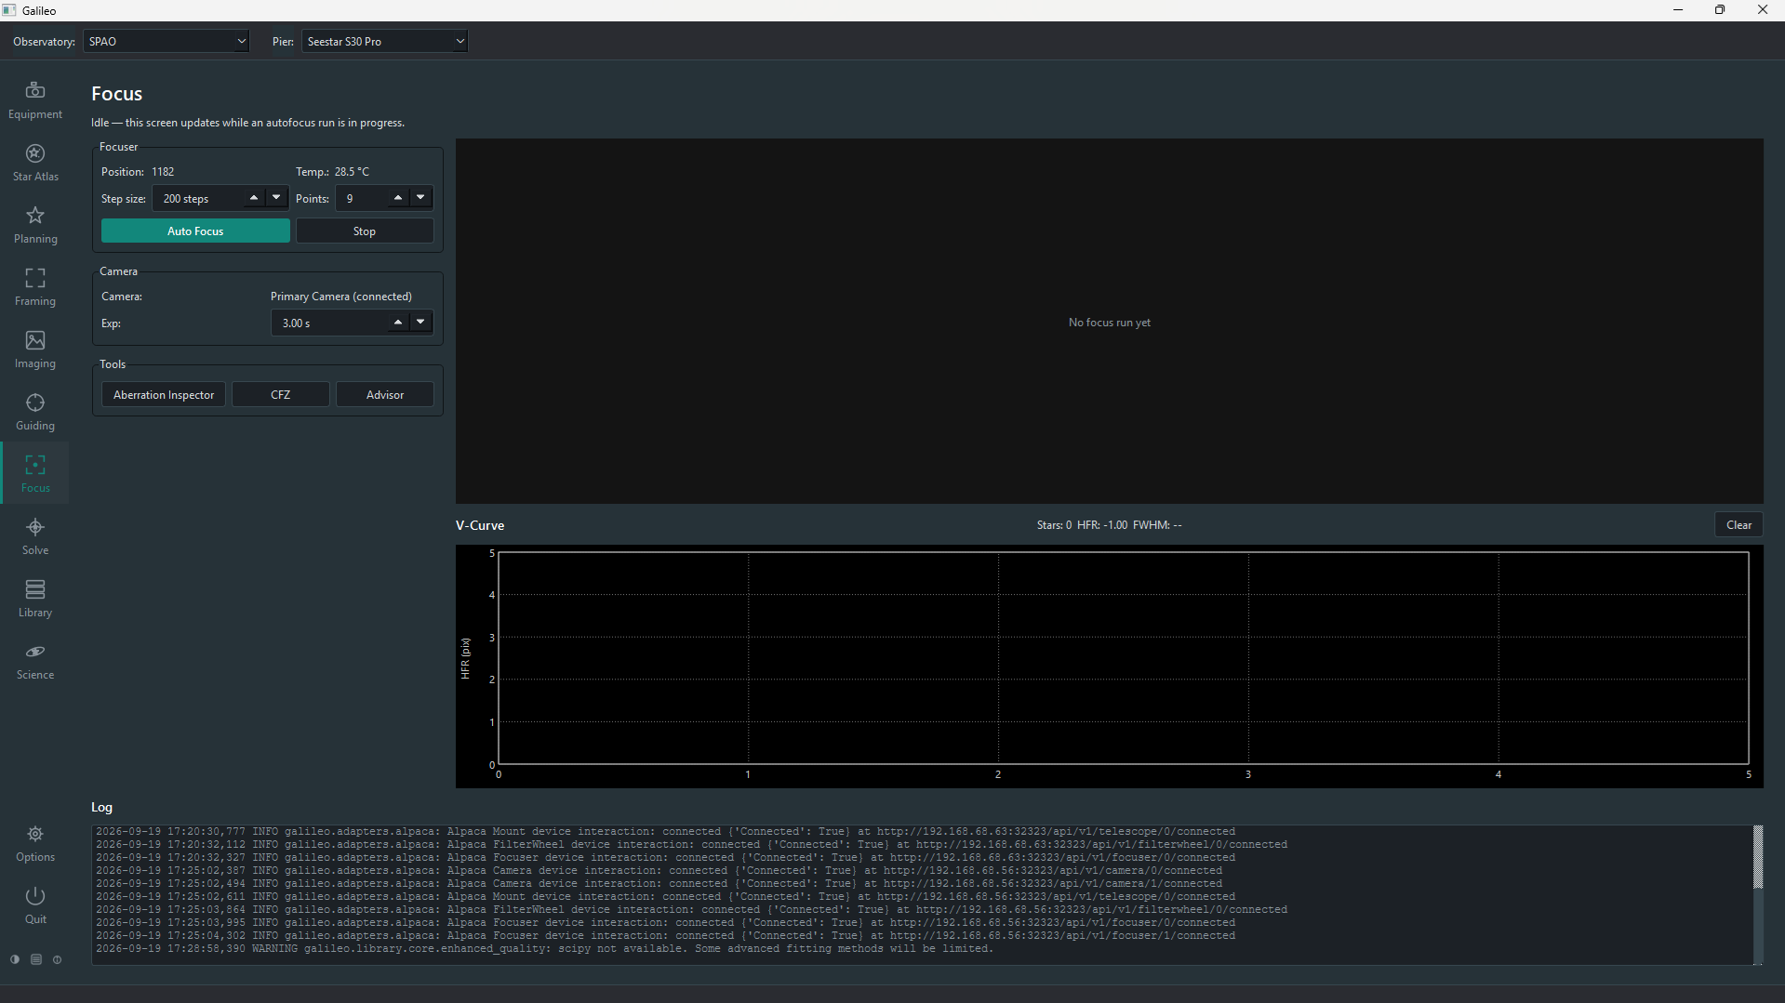
Focus screen

Prerequisites
- A camera connected under Equipment > Camera.
- A focuser connected under Equipment > Focuser.
- The focuser and camera should be associated with the same optical tube under Equipment > Optics.

Running autofocus
- Open Focus in the sidebar. Choose the Optics and Camera in the top bar: the screen shows the camera by name and the focuser associated with those Optics, and starts Gain and Offset at the camera's defaults from Equipment > Camera (you can change them for focusing).
- Set the step size (focuser steps per measurement position) and the number of steps (how many positions to sample on each side of the current position).
- Click Auto Focus. Galileo moves the focuser through the measurement range, taking a short exposure at each position, detecting stars and computing the HFR (half-flux radius). Lower HFR means sharper stars.
- When the sequence finishes, the focuser moves to the position that minimises HFR — the fitted minimum of the V-curve.
Click Stop at any time to halt the sequence after the current exposure. The focuser stays at whatever position it reached.

The HFR V-curve
As the focuser moves through its range the HFR values trace a V shape: high and blurry far from focus, dropping to a sharp minimum at the best focus position, then rising again as the focuser moves past it. The chart shows:
- Blue dots: measured HFR at each focuser step
- Red curve: the parabola fit through the measurements
- Vertical line: the fitted minimum (the position the focuser moves to)
- Star count: shown alongside each measurement point — a sudden drop in star count at an extreme position can indicate the frame is too blurred to detect stars reliably
The current frame is shown above the V-curve chart in real time as each exposure arrives.

Focus controls
Control | Effect
Step size | Focuser steps between exposures in the sweep
Points | How many exposures the sweep takes, centred on the current position
Backlash | Overshoot-and-return steps before each move so gear slack is taken up consistently (0 = off)
Exp | Exposure time of each measurement frame — long enough for several stars, short enough not to saturate
Auto Focus | Start the automatic sweep: the focuser moves to the best position, or returns to where it began if no sensible focus is found
Stop | End the run; the focuser goes back where it started
The same defaults can be set per Pier; see Autofocus defaults. Sessions and triggers use them.

Portrait and landscape layout
Like the Imaging screen, this screen arranges itself to suit the frame: a portrait frame (taller than wide) gets a full-height column on the right, a third of the screen wide, with the other panels beside it. Tick View > Choose layout manually to pick Portrait or Landscape yourself. A one-shot-colour camera's frames are shown in colour automatically.

Manual focuser control
The Manual Focus box on the left lets you focus by hand without a full sweep: type a Position and press Move, Capture one exposure to measure its HFR, or Loop repeated exposures while you adjust and watch the HFR fall; Stop ends the loop.

Filter offsets
Different filters focus at slightly different positions. Filter Offsets… measures each filter's best focus relative to a Primary filter once; afterwards, changing filter in a session shifts the focuser by that offset instead of running a full autofocus.

Autofocus defaults
Options > Focus holds the default autofocus settings for the Pier: step size, number of points, exposure and backlash compensation. They seed the Focus screen and are used by autofocus blocks in sessions. They are saved per Pier, so each telescope keeps its own defaults — choose the Pier in the top bar first.

