Que 1)
clc;
clear;

% Define transfer functions (example values)
G = tf(4,1); % 4
H1 = tf(2,1); % 2
H2 = tf(3,1); % 3

% Step 1: Inner feedback loop
F = feedback(G, H2); % G/(1 + G*H2)

% Step 2: Compute H1 path effect correctly
H1_equiv = H1/(1 + G*H2); % because same denominator

% Step 3: Add parallel paths
TF = parallel(F, H1_equiv);
[num, den] = tfdata(TF,'v');

fprintf('\nTransfer Function C(s)/R(s) = %g / %g\n', num, den);
fprintf('Numerical Value = %.4f\n\n', num/den);

output:
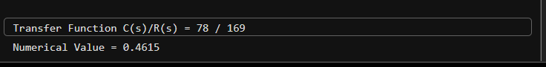

Que 2)

clc;
clear;

G1 = tf(2,1);
G2 = tf(3,1);

Forward1 = parallel(G1, 1); % G1 + 1
Forward2 = series(Forward1, G2); % (G1 + 1)*G2
TF = parallel(Forward2, 1); % (G1 + 1)*G2 + 1

[num, den] = tfdata(TF,'v');

fprintf('\nC(s)/R(s) = %g\n\n', num/den);

output:
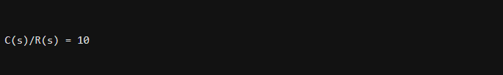

Que 3)
clc;
clear;

% Example numerical values
G1 = tf(2,1);
G2 = tf(3,1);
G3 = tf(4,1);
H1 = tf(5,1);
H2 = tf(6,1);

% ----- Step 1: Inner feedback around G1 with H1 -----
G1_closed = feedback(G1, H1);

% ----- Step 2: Series with G2 -----
Path1 = series(G1_closed, G2);

% ----- Step 3: Parallel with G3 path -----
X = parallel(Path1, G3);

% ----- Step 4: Outer feedback with H2 -----
TF = feedback(X, H2);

% -------- Clean Final Output --------
[num, den] = tfdata(TF,'v');

fprintf('\nFinal Transfer Function C(s)/R(s) = \n');
fprintf('-----------------------------------\n');
fprintf('Numerator : ');
disp(num)
fprintf('Denominator : ');
disp(den)

fprintf('Numerical Value (DC Gain) = %.4f\n\n', dcgain(TF));
output :
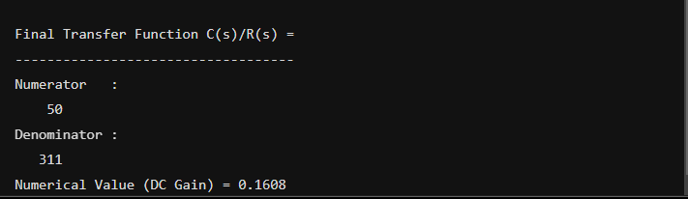

Que 4)
clc;
clear;

% Example numerical values
G1 = tf(2,1);
G2 = tf(3,1);
G3 = tf(4,1);
G4 = tf(5,1);
H1 = tf(6,1);
H2 = tf(7,1);

% ----- Step 1: Combine G1 and G4 (parallel) -----
G14 = parallel(G1, G4); % G1 + G4

% ----- Step 2: Inner feedback around G2 with H1 -----
G2_closed = feedback(G2, H1); % G2/(1 + G2*H1)

% ----- Step 3: Series with G3 -----
Forward_path = series(G14, G2_closed);
Forward_path = series(Forward_path, G3);

% ----- Step 4: Outer feedback with H2 -----
TF = feedback(Forward_path, H2);

% -------- Clean Final Output --------
[num, den] = tfdata(TF,'v');

fprintf('\nFinal Transfer Function C(s)/R(s):\n');
fprintf('-----------------------------------\n');
fprintf('Numerator : ');
disp(num)
fprintf('Denominator : ');
disp(den)

fprintf('Numerical Value (DC Gain) = %.4f\n\n', dcgain(TF));

output :
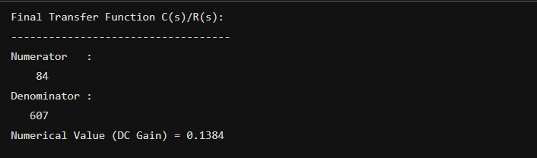

Que 5)
clc;
clear;

% Example numerical values
G1 = tf(2,1);
G2 = tf(3,1);
G3 = tf(4,1);
G4 = tf(5,1);
G5 = tf(6,1);
G6 = tf(7,1);
G7 = tf(8,1);

%% ----- Step 1: Combine G2 and G3 (parallel) -----
G23 = parallel(G2, G3); % (G2 + G3)

%% ----- Step 2: Close inner feedback with G1 -----
Inner1 = feedback(G23, G1);
% (G2+G3)/(1 + G1(G2+G3))

%% ----- Step 3: Series with G5 -----
PathA = series(Inner1, G5);

%% ----- Step 4: Add G4 (parallel) -----
X = parallel(PathA, G4);
% G5(G2+G3)/(1+G1(G2+G3)) + G4

%% ----- Step 5: Series with G6 -----
Forward = series(X, G6);

%% ----- Step 6: Outer feedback with G7 -----
TF = feedback(Forward, G7);

%% ----- Clean Final Output -----
[num, den] = tfdata(TF,'v');

fprintf('\nFinal Transfer Function C(s)/R(s):\n');
fprintf('-----------------------------------\n');
fprintf('Numerator : ');
disp(num)
fprintf('Denominator : ');
disp(den)

fprintf('Numerical Value (DC Gain) = %.4f\n\n', dcgain(TF));

output :
