1. a)MSAL-404-C03

IPv6 Address. . . . . . . . . . . : 2001:b30:1802:6:d8f6:c341:9b88:9ffd(Preferred)

IPv6 Address. . . . . . . . . . . : 2001:b30:5000:6:d8f6:c341:9b88:9ffd(Preferred)

IPv4 Address. . . . . . . . . . . : 10.150.1.204(Preferred)

b)&&

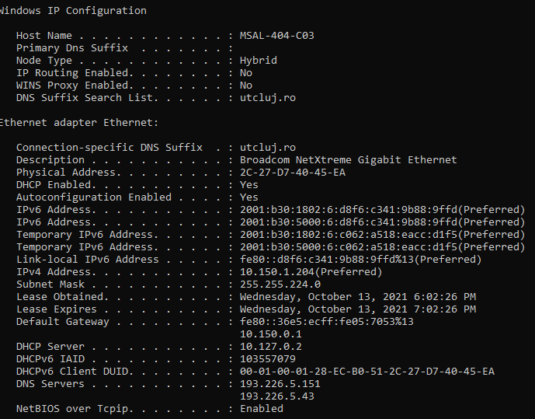

c)

d) 10.150.1.204:65392 proxy:3128 ESTABLISHED

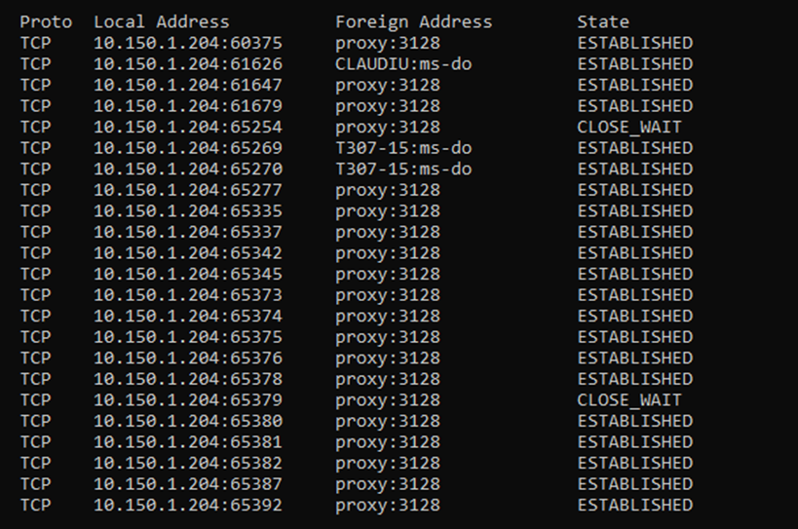

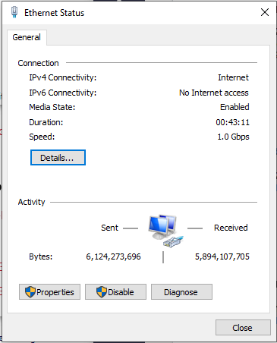

e)

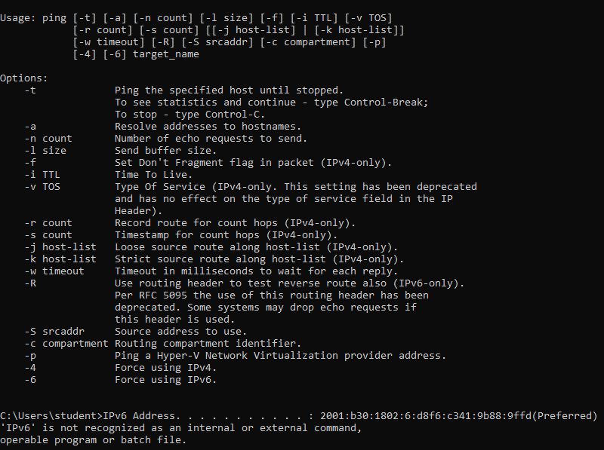

2)