### Diagram Kelas

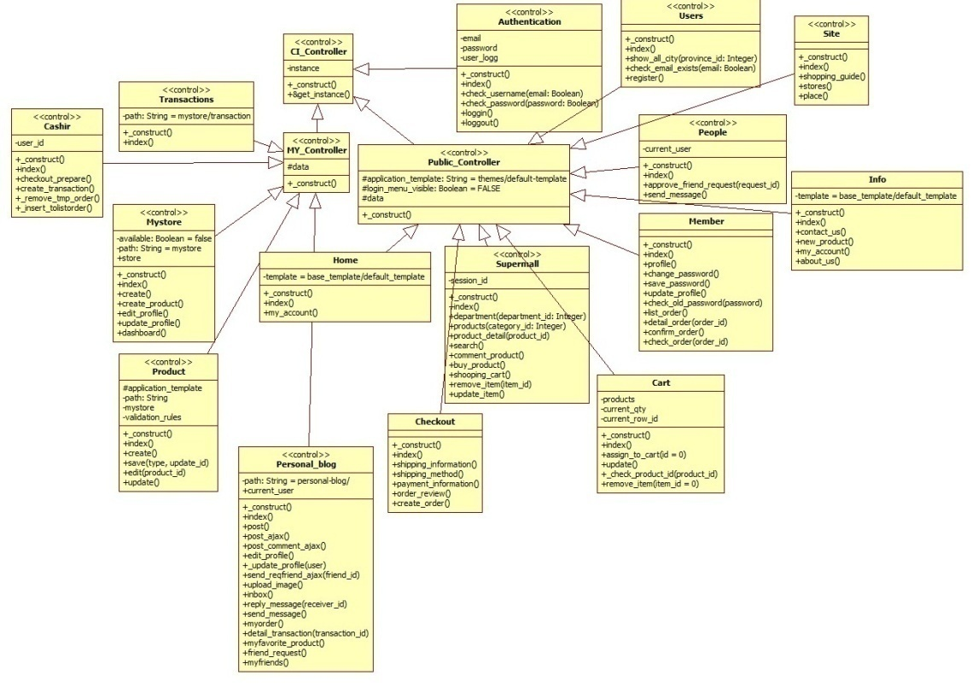

Gambar 14. Diagram Kelas Controller

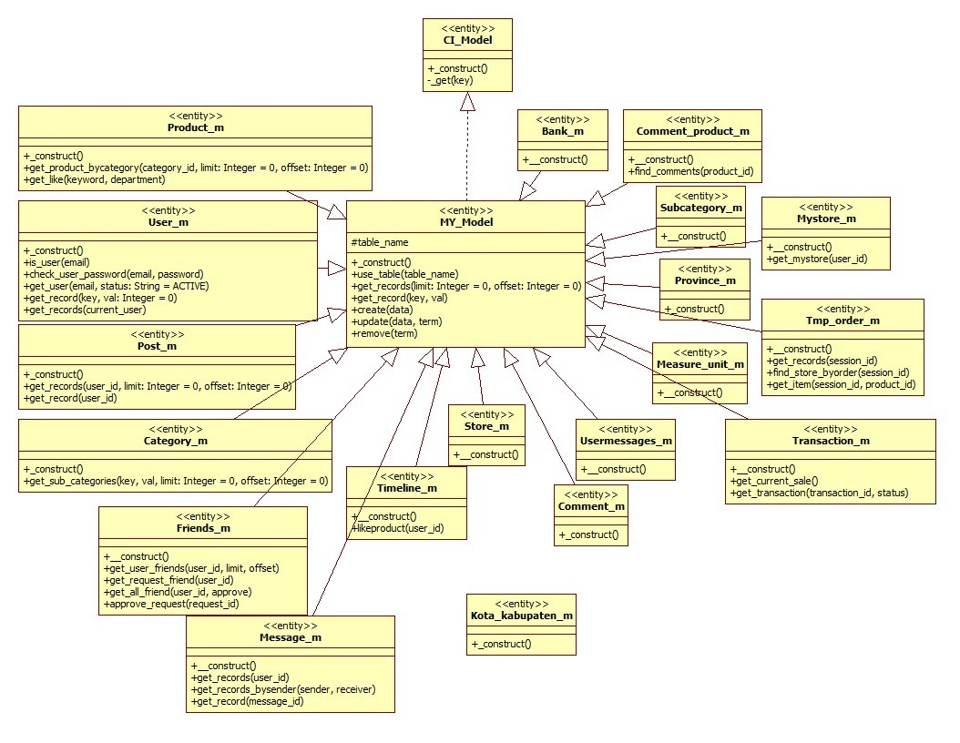

Gambar 15. Diagram Kelas Model

### Diagram *Sequence*

#### Sequence Register

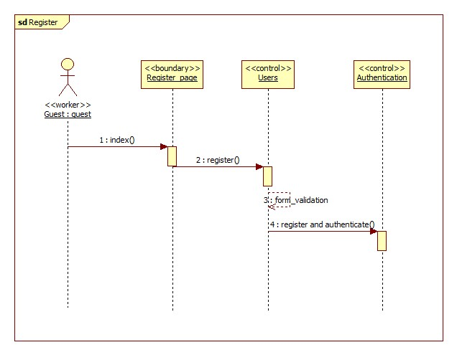

Gambar 16 Register Sequence

#### Sequence Login

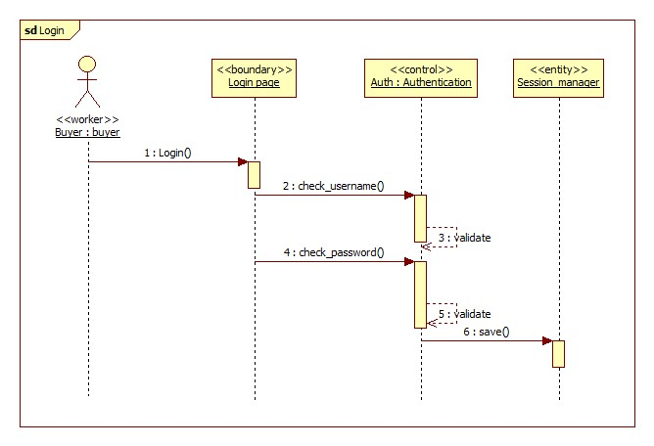

Gambar 17. Login Sequence

CATATAN: login sequence salahnya di object session manager, harusnya diganti user_m karena ikut ke kelas diagram MY MODEL