Title: Improvement of Protein Expression Efficiency Using Machine Learning

Partners: Trenzyme GmbH, Stemick GmbH
Last Update: 15. 9. 2024

Background
Protein expression at Trenzyme harnesses a variety of expression systems in mammalian, insect, yeast, and bacterial cell cultures. The typical process starts with a given amino acid sequence. This sequence is analyzed by experienced scientists at Trenzyme for important features like for example the presence of signaling peptides, transmembrane domains, or protease cleavage sites using bioinformatics tools. The results of this analysis feeds into the choice of the expression system and the design of the expression construct. Target proteins that might be difficult be expressed can be identified and the expression system optimized leveraging the deep understanding of key features of the biological systems and creative approach to maximize yield and activity. In addition, Trenzyme’s high-throughput protein expression optimization method can be applied for an efficient combinatorial testing of different expression strains/cell lines and culture conditions such as growth media and additives, temperatures, induction conditions, extraction methods and other parameters.
Identifying the optimal expression conditions for successful expression of active protein in sufficient quantity is challenging to predict and depends on a large variety of factors including characteristics of the protein sequence, of the expression system and of the expression construct.
Trenzyme and Stemick believe that a systematic analysis of available protein expression data in combination with expert knowledge using modern machine learning tools provides a promising opportunity to support and streamline Trenzyme’s workflow and ultimately achieve higher success rates for target protein expression.
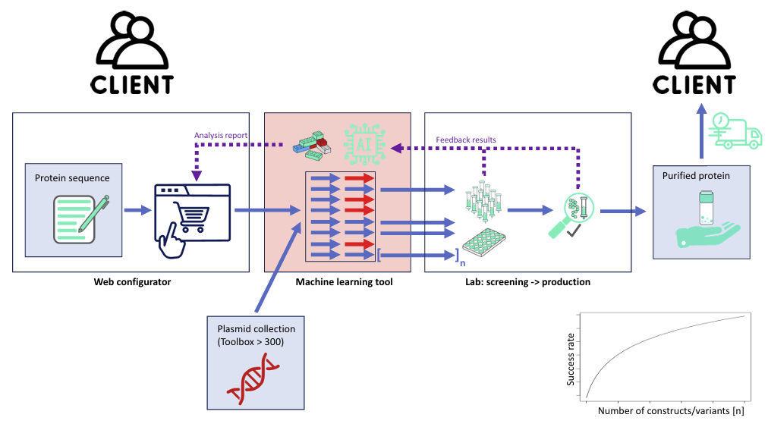
Figure 1. Schema of Trenzyme's Web Configurator

Objectives
- Protein sequence analysis (locally and over the internet) creating semi-automated reports supporting the scientist;
- Data collection of expression systems, target protein and “success” (activity and yield), preparation for analysis;
- Training of a machine learning algorithm to identify success factors and to support optimization of expression systems for future protein expression tasks (data analysis and prediction).
- Marketing tool (accessible online) that can attract new potential costumers

Tasks
- Protein sequence analysis
  - Process map for project-specific sequence analysis and information collection at Trenzyme that covers the variety of target proteins
  - Data collection at Trenzyme and in the public domain (see attached table template), includes data dictionary and coding, categorizing and classification of data (sorting and grouping), estimation of data availability and effort
  - Building of an inhouse protein expression database including sequence and meta data, and sett up of analysis tools: collection of expression information (meta data) and sequence data, data formatting, software installation, back-up solution
- Data collection
  - Data collection at Trenzyme and in the public domain (Table 1), includes the extraction and creation of a data dictionary, categorization, and classification of data (sorting and grouping), estimation of data availability and effort
  - Preparation of analysis data sets: data management and programming, estimating the size of the available data sets
  - Definition of analysis goals based on the available data
  - Definition of data items (data dictionary) that are to be collected in the future
- Machine learning
  - Setup of machine learning environment tailored for the available data and analysis goals.
  - Training and evaluation of classifier/regressor (primary analysis)
  - Implementation for inhouse use and/or as service for clients

Table 1. Items that are (will be) collected for each expression construct
Item | Description | Valuetype | Examples
UniprotNo
Target Name
Size [kDa] |  | numeric
Sequence (?)
hydrophobic regions (ja/nein) |  | yes/no
+- HisTag
domain of multimer
Truncation
"mature"
Propeptide removed?
DiS bond req
N-Glyc-Sites
"class"
"receptor-interaction"
Promoter
Signal Peptide
+/- Protease Site
+/- TEV site
Chaperone / bdg Partner
Vector (?!)
Vektor Size
Cell Line (?)
TFX efficiency
Viability (3d expr)
Viab (5d expr)
pH @ harvest
Est Expr yield
Soluble target
"ER Stress"
"Golgi Stress"
Protease Cleavage" (Yes / No / %)
"TEV cleavage" (Yes / No / %)
POC yield (mg/ml sn)
rel. Yield ctrls ??

Material
- Overview of competitor (KEMP): "C:\Users\stefa\Documents\Business\stemick\Projects\Trenzyme-Collaboration\KempProteins_Capability_Presentation_24JUL2024.pdf"
- Potential resources or partner: MPI in Göttingen: https://www.mpinat.mpg.de/soeding
- Potential resources or partner: https://toolkit.tuebingen.mpg.de/tools/quick2d
- EXCEL file with plasmid information Armins Email, 21.8.2024, Anhang: Plasmid_f_Stefan "C:\Users\stefa\Documents\Business\stemick\Projects\Trenzyme-Collaboration\Plasmide_f_Stefan.xlsx"

