**HTML, CSS, BOOTSTRAP, JQUERY, JAVASCRIPT**

**HTML**( Hyper text markup language ) and is the most basic building block of a web application.

HTML page has 2 sections: **Head and Body**

**Head contains** metadatalike title, keywords, author, css files, js information etc

**Body** has the actual content.

<!-- Anything here is considered as Comment -->

HTML has 6 types of heading ( h1, h2… )

Different ways of writing body.

<body>

<p>This is my laptop,

And this is my finger.

Keep on fingering.</p>

</body>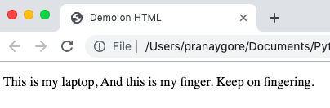

<body>

<p>This is my laptop,</p>

<p>And this is my finger.</p>

<p>Keep on fingering.</p>

</body>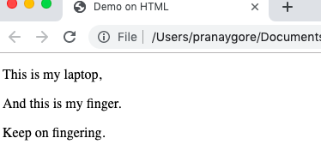

Indentation is not important but tags.

**<b> - BOLD**

**<i> - ITALIC**

There are 2 types list in HTML:

1. **Ordered list**
2. **Un-ordered list**

<ol>

<li>Liverpool</li>

<li>London</li>

<li>Cardiff</li>

</ol>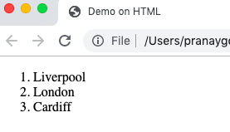

<ul>

<li>Liverpool</li>

<li>London</li>

<li>Cardiff</li>

</ul>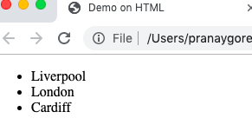

We can have nested ordered/unordered list in one another.

**Div and Span tags**

We can use Div and Span tags to group related tags into a single unit.

Normally, we use these in CSS.

<div> is nothing but division.

It is effective or will be working when we use CSS , else it will not work.

Span tag is similar to div tag, but span is inline.

Basically, **div** will work for group of lines, **span** will work for single line.

HTML sheet

*HEAD>*

*<TITLE>Basic HTML Sample Page</TITLE>*

*</HEAD>*

*<link rel="stylesheet" type="text/css" href="style1.css">*

*<BODY>*

*<div>*

*<H1>This is <span>a size</span> "1" heading</H1>*

*<H2>This is a size "2" heading</H2>*

*<H3>This is a size "3" heading</H3>*

*</div> </BODY>*

CSS sheet

*h1{color:red;}*

*div{color: green;}*

*Span{color: yellow;}*

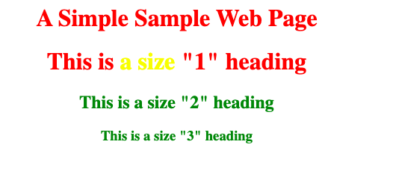

**Tables:**

**<table>** to create table

**<thead>** to specify head row

**<th>** to specify column data in head row(column name)

**<tr>** to insert row in the table

**<td>** to specify column data in the row/record.

*<table border="1">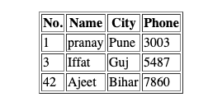*

*<thead>*

*<th>No.</th>*

*<th>Name</th>*

*<th>City</th>*

*<th>Phone</th>*

*</thead>*

*<tr>*

*<td>1</td>*

*<td>pranay</td>*

*<td>Pune</td>*

*<td>3003</td>*

*</tr>*

*<tr>*

*<td>3</td>*

*<td>Iffat</td>*

*<td>Guj</td>*

*<td>5487</td>*

*</tr>*

*<tr>*

*<td>42</td>*

*<td>Ajeet</td>*

*<td>Bihar</td>*

*<td>7860</td>*

*</tr>*

*</body>*

**HTML Forms**

We can create form by using <form> tag.

There are some pre-defined inputs like, text, email , password etc.

<input type="text" name="username" value="Enter User Name"/>

<input type="email" name="mailid" value=""/>

<input type="password" name="pwd" value=""/>

<input type="checkbox" name="course" value=""/>

<input type="radio" name="married" value=""/>

**CSS**

We can have css tags integrated inside a THML file instead of separate CSS file but it will be applicable to only that same HTML file.

If we have separate CSS file, it can be used with multiple files.

**The Box model**

In a document, each element is represented in a rectangular box.In CSS, each of these rectangular boxes is described by using a standard box model.

Box has 4 edges:

**-Content Edge.**

**-Border Edge.**

**-Padding Edge.**

**-Margin Edge.**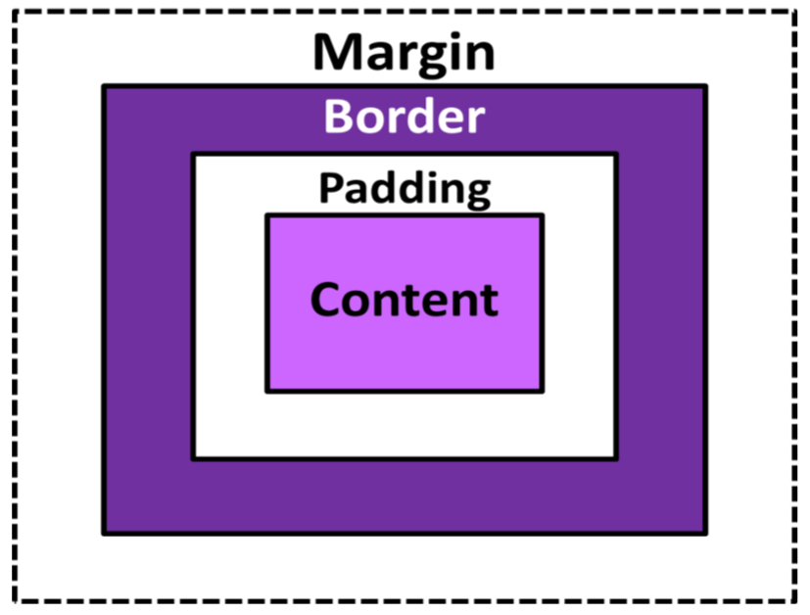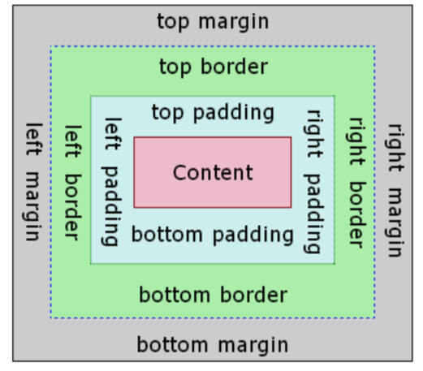

Space between two borders of HTML elements is **MARGIN**.

Space between content and the border is **PADDING**.

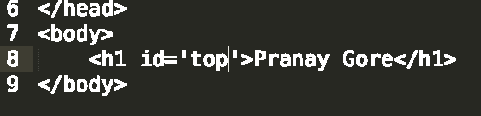

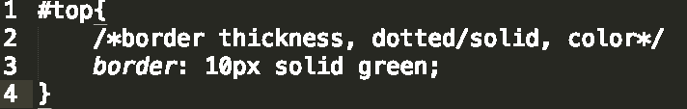

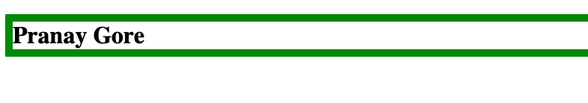

This border (green) is going on complete page.

So I will provide the width.

