AI Automated Test Report
Generated: 2026-09-15 15:15:19
Application: Hotel Booking System
Automation Framework: Playwright + Python
AI Verification: Google Gemini

Summary
Metric | Result
Total Tests | 15
Passed | 15
Failed | 0
Pass Rate | 100.0%
AI PASS Checkpoints | 1
AI FAIL Checkpoints | 0
AI UNCERTAIN Checkpoints | 14

Test Results Overview
Test ID | Test Name | Category | Status
TC-001 | Complete valid booking flow | Happy Path | PASS
TC-002 | Search for available rooms | Happy Path | PASS
TC-003 | View room details | Happy Path | PASS
TC-004 | View my bookings | Happy Path | PASS
TC-005 | Empty first name | Validation | PASS
TC-006 | Empty last name | Validation | PASS
TC-007 | Invalid email format | Validation | PASS
TC-008 | Invalid phone (letters) | Validation | PASS
TC-009 | Phone less than 10 digits | Validation | PASS
TC-010 | Check-out before check-in | Validation | PASS
TC-011 | Guests = 0 | Validation | PASS
TC-012 | Guests > 10 | Validation | PASS
TC-013 | Invalid card number | Validation | PASS
TC-014 | Expired card date | Validation | PASS
TC-015 | Invalid CVV | Validation | PASS

Detailed Test Results

TC-001 — Complete valid booking flow
Test ID: TC-001
Test Name: Complete valid booking flow
Category: Happy Path
Status: PASS

Expected Result
Booking confirmation displayed

Actual Result
The expected workflow completed successfully, all deterministic Playwright checks passed, and AI visual verification confirmed the expected state.

AI Verification
AI Status: PASS
AI Observation: All 1 AI visual checkpoint(s) passed.
Per-step AI observations:
- Step 27 — SCREENSHOT: TC-001_step-26_success [PASS, 100%] The booking confirmation is clearly displayed with a booking reference (BK-420405) and summary details.

Steps
Step | Action | Status | AI Status | Confidence
1 | OPEN: / | PASS | NOT RUN | N/A
2 | FILL: city-input = New York | PASS | NOT RUN | N/A
3 | FILL: checkin-input = 2026-09-20 | PASS | NOT RUN | N/A
4 | FILL: checkout-input = 2026-09-23 | PASS | NOT RUN | N/A
5 | FILL: guests-input = 2 | PASS | NOT RUN | N/A
6 | CLICK: search-button | PASS | NOT RUN | N/A
7 | WAIT_FOR: room-card-1 | PASS | NOT RUN | N/A
8 | CLICK: view-details-1 | PASS | NOT RUN | N/A
9 | WAIT_FOR: room-name | PASS | NOT RUN | N/A
10 | CLICK: book-now-button | PASS | NOT RUN | N/A
11 | WAIT_FOR: first-name-input | PASS | NOT RUN | N/A
12 | FILL: first-name-input = John | PASS | NOT RUN | N/A
13 | FILL: last-name-input = Doe | PASS | NOT RUN | N/A
14 | FILL: email-input = john@example.com | PASS | NOT RUN | N/A
15 | FILL: phone-input = 9876543210 | PASS | NOT RUN | N/A
16 | FILL: booking-checkin-input = 2026-09-20 | PASS | NOT RUN | N/A
17 | FILL: booking-checkout-input = 2026-09-23 | PASS | NOT RUN | N/A
18 | FILL: booking-guests-input = 2 | PASS | NOT RUN | N/A
19 | FILL: special-requests-input = No special requests | PASS | NOT RUN | N/A
20 | FILL: card-number-input = 4111111111111111 | PASS | NOT RUN | N/A
21 | FILL: expiry-input = 12/30 | PASS | NOT RUN | N/A
22 | FILL: cvv-input = 123 | PASS | NOT RUN | N/A
23 | CLICK: confirm-booking-button | PASS | NOT RUN | N/A
24 | WAIT_FOR: booking-confirmation | PASS | NOT RUN | N/A
25 | ASSERT_VISIBLE: booking-confirmation | PASS | NOT RUN | N/A
26 | ASSERT_TEXT: booking-reference CONTAINS BK- | PASS | NOT RUN | N/A
27 | SCREENSHOT: TC-001_step-26_success | PASS | PASS | 100%

Screenshots
Step 1 — OPEN: /
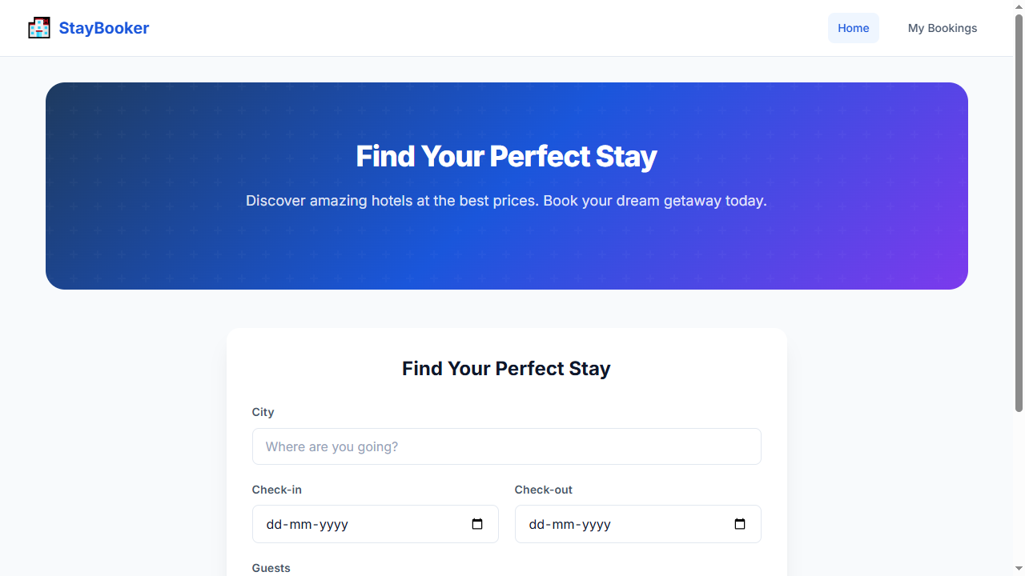
Step 2 — FILL: city-input = New York
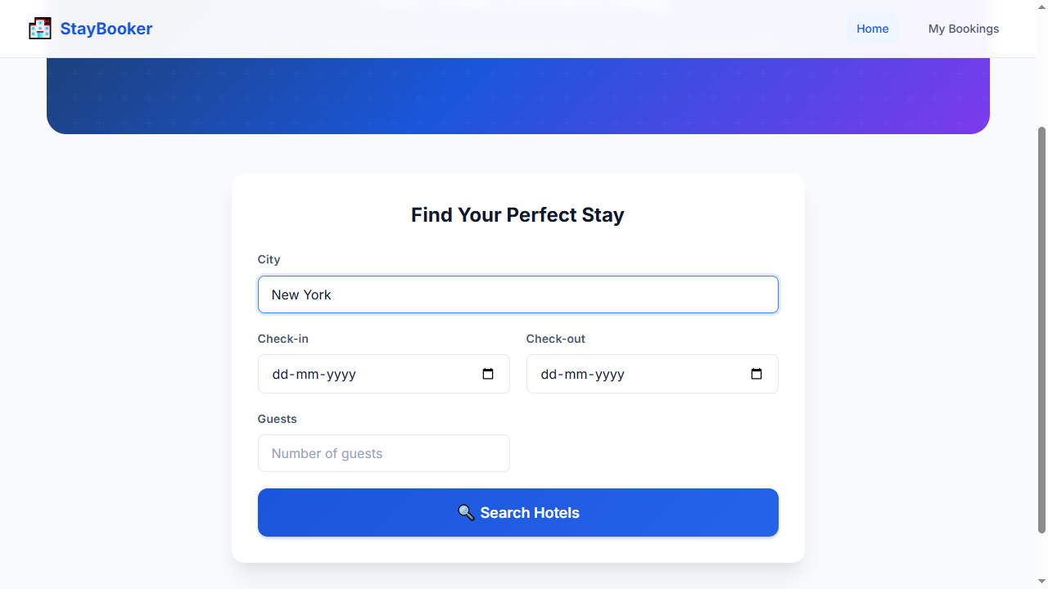
Step 3 — FILL: checkin-input = 2026-09-20
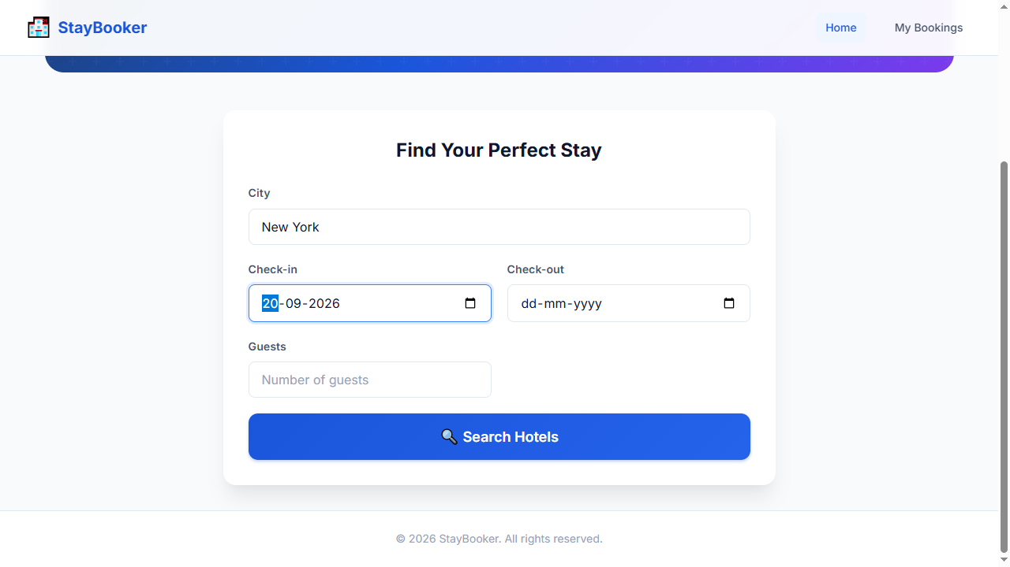
Step 4 — FILL: checkout-input = 2026-09-23
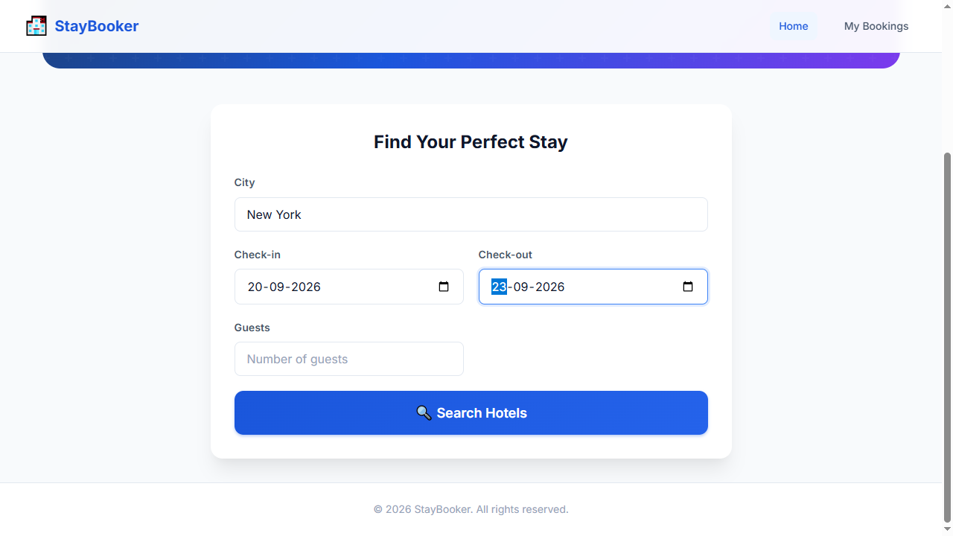
Step 5 — FILL: guests-input = 2
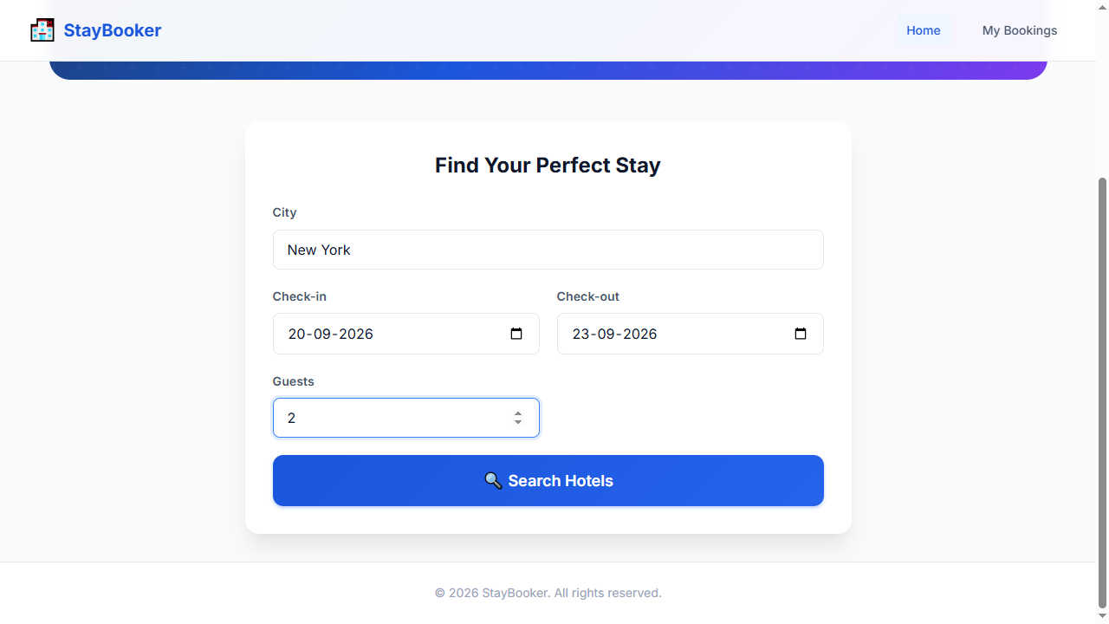
Step 6 — CLICK: search-button
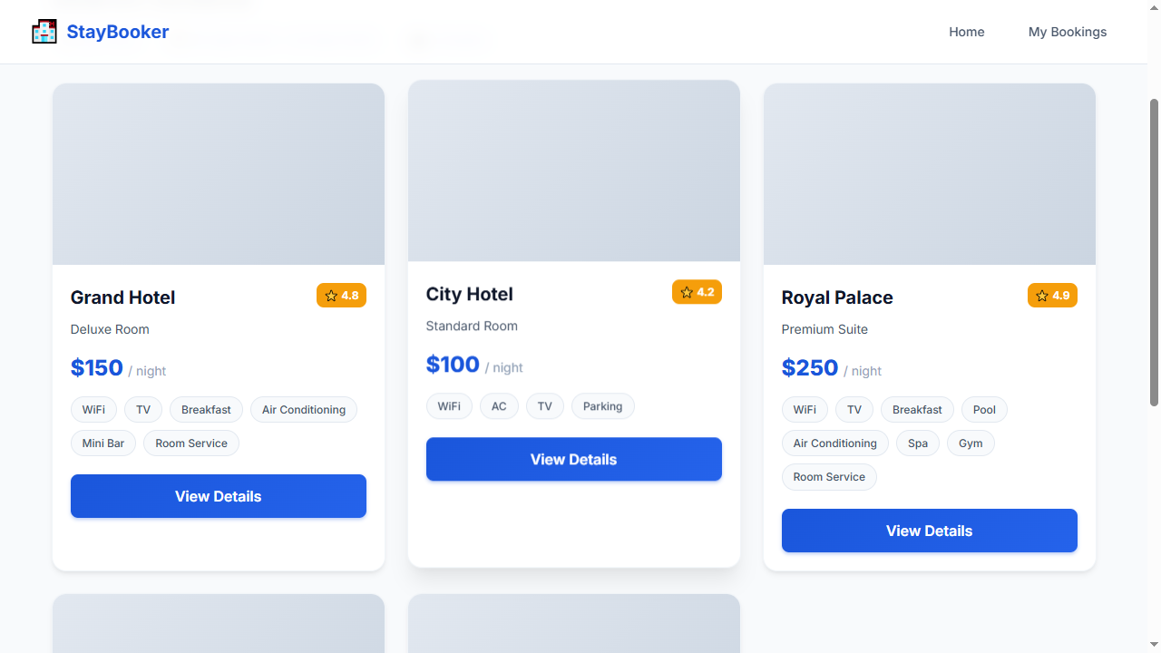
Step 7 — WAIT_FOR: room-card-1
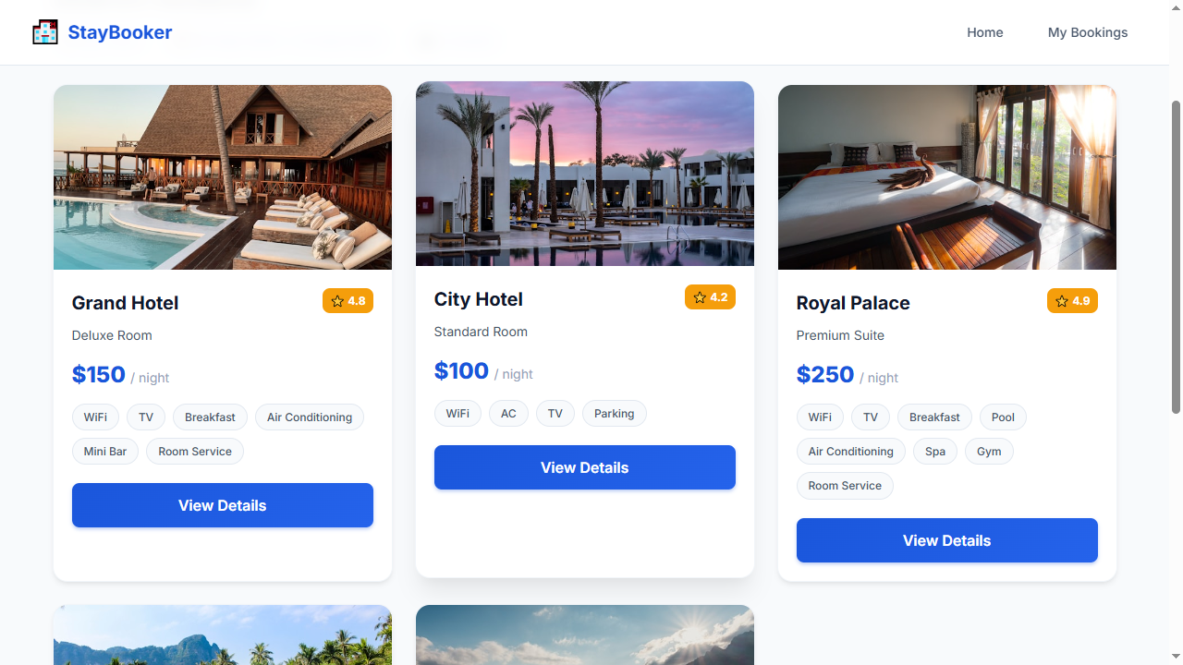
Step 8 — CLICK: view-details-1
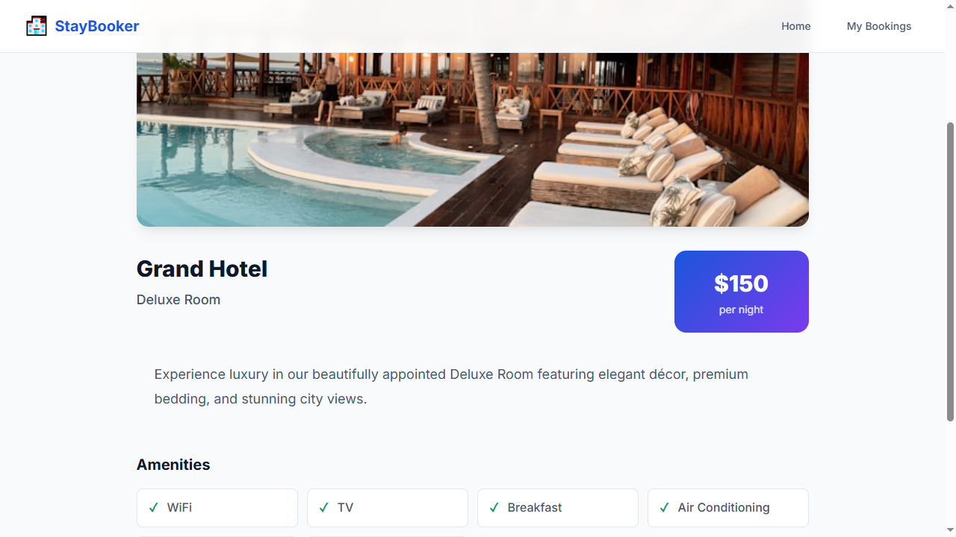
Step 9 — WAIT_FOR: room-name
Step 10 — CLICK: book-now-button
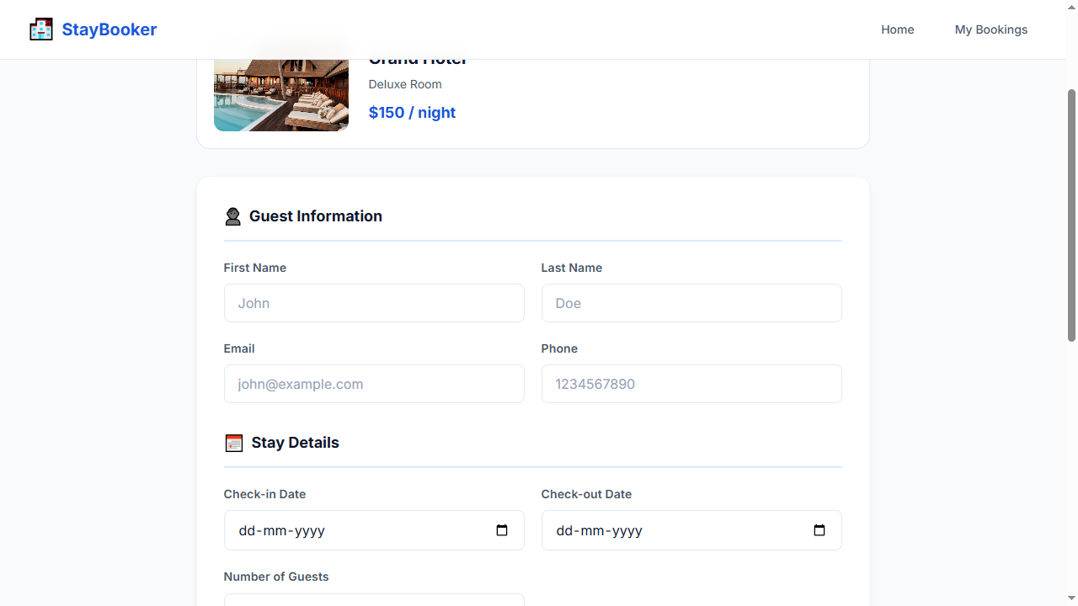
Step 11 — WAIT_FOR: first-name-input
Step 12 — FILL: first-name-input = John
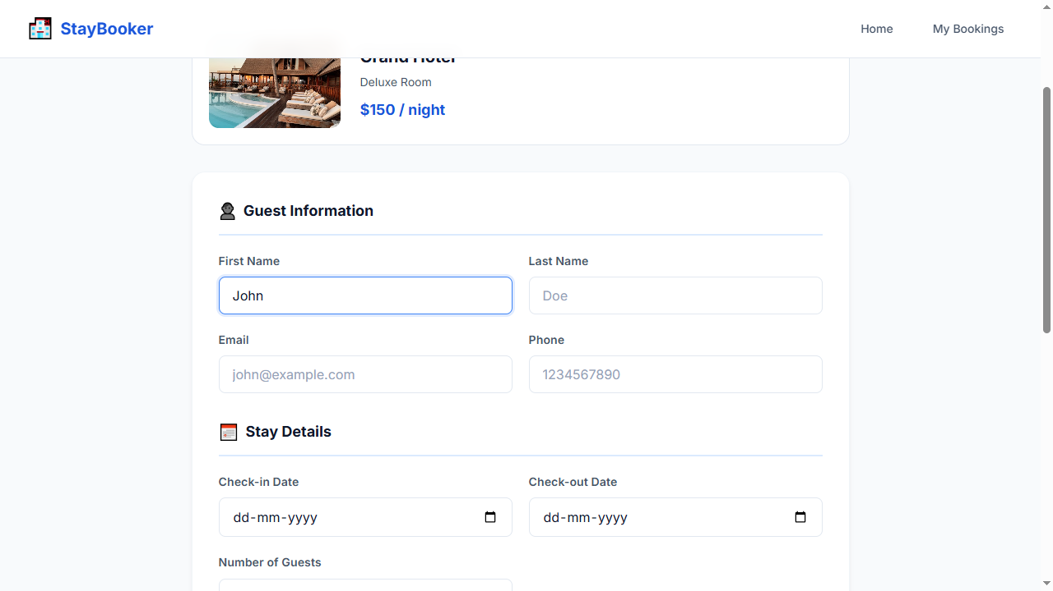
Step 13 — FILL: last-name-input = Doe
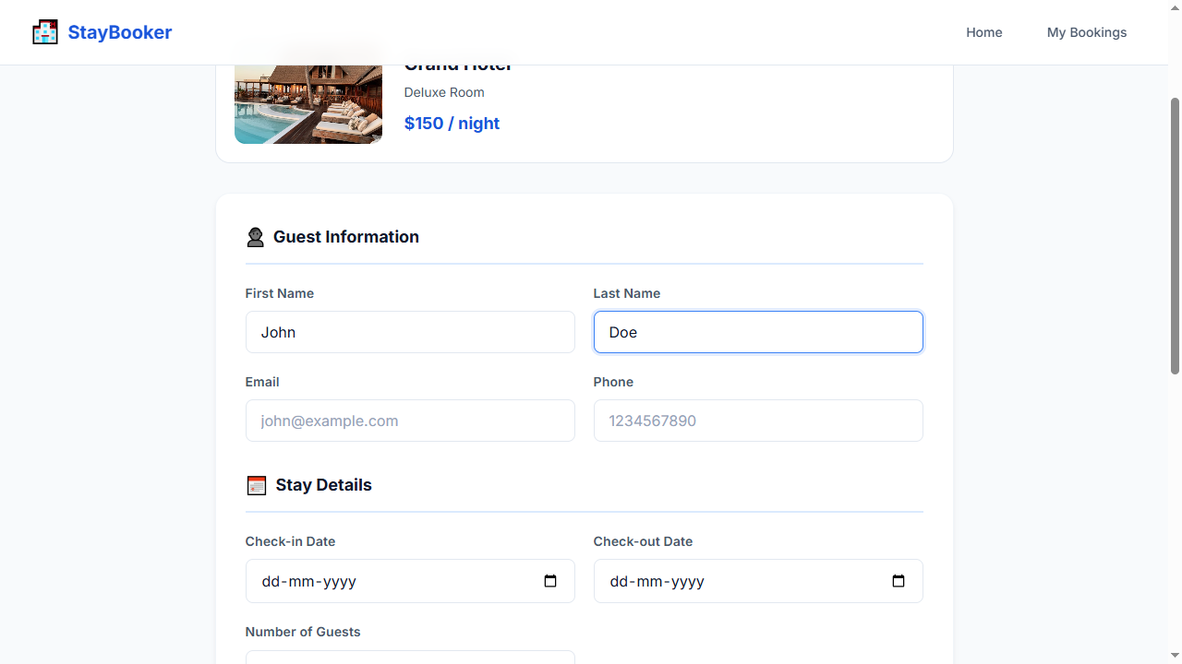
Step 14 — FILL: email-input = john@example.com
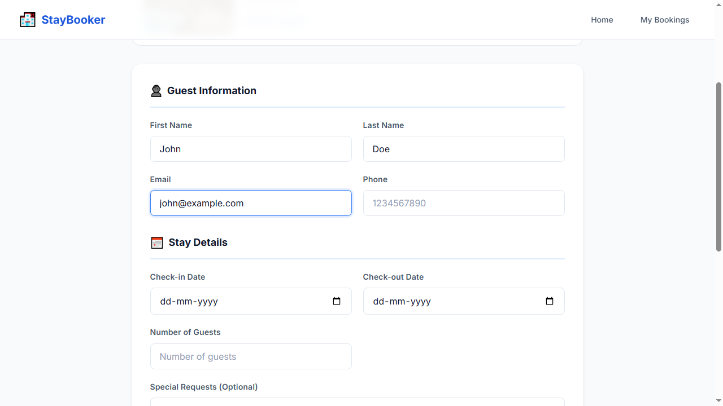
Step 15 — FILL: phone-input = 9876543210
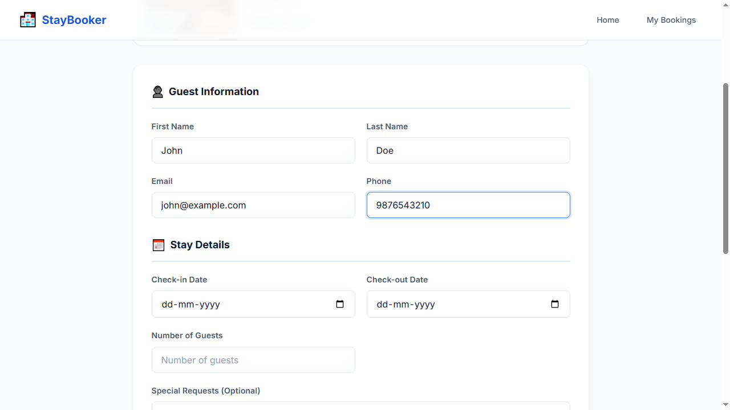
Step 16 — FILL: booking-checkin-input = 2026-09-20
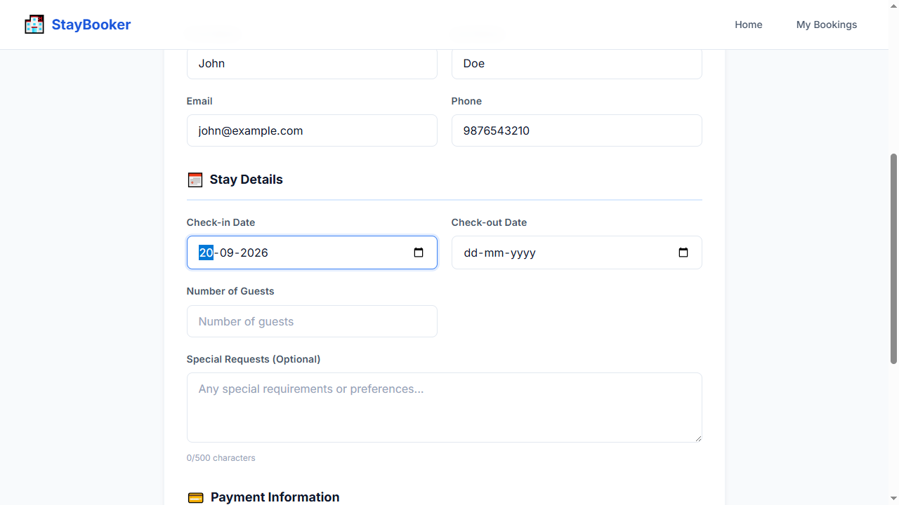
Step 17 — FILL: booking-checkout-input = 2026-09-23
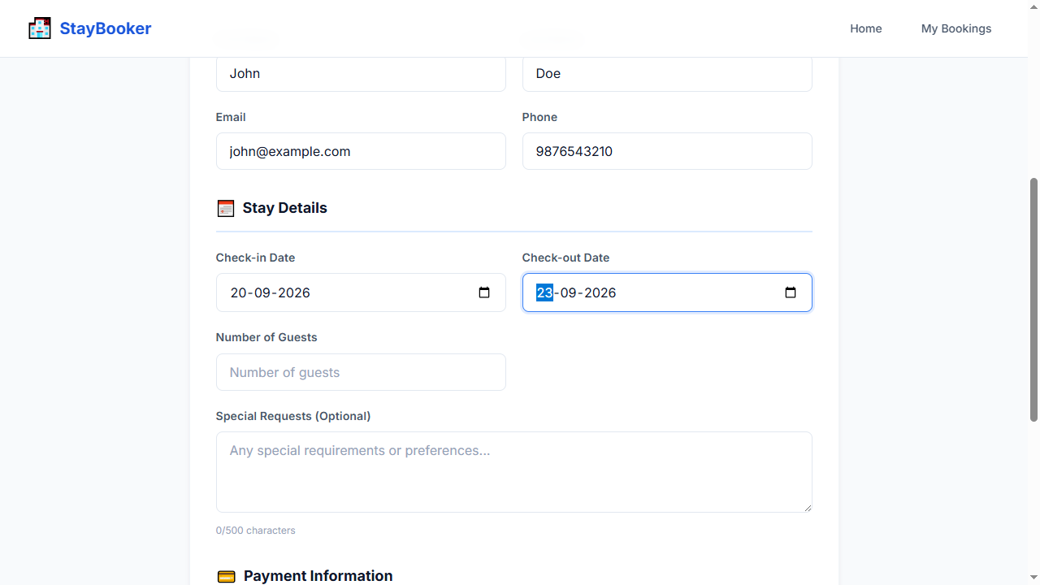
Step 18 — FILL: booking-guests-input = 2
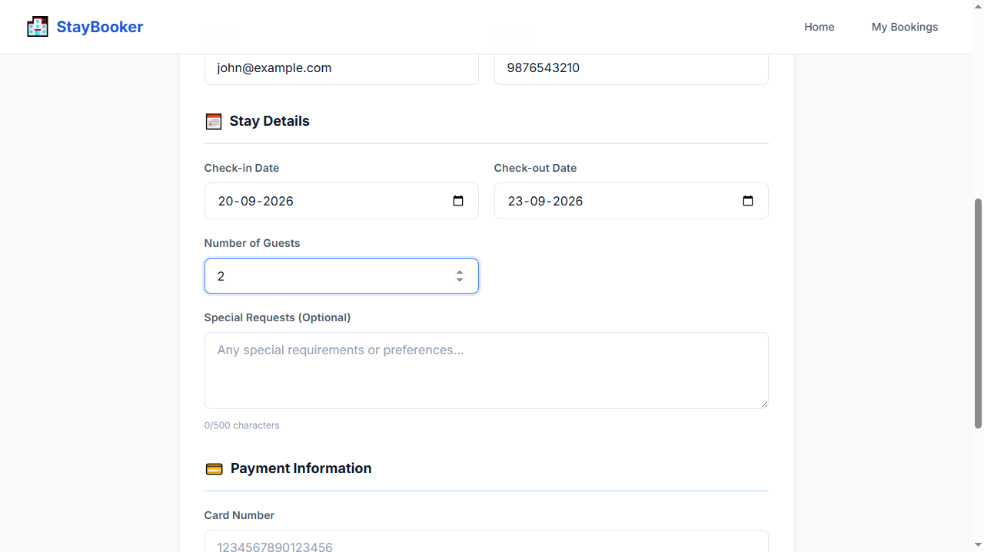
Step 19 — FILL: special-requests-input = No special requests
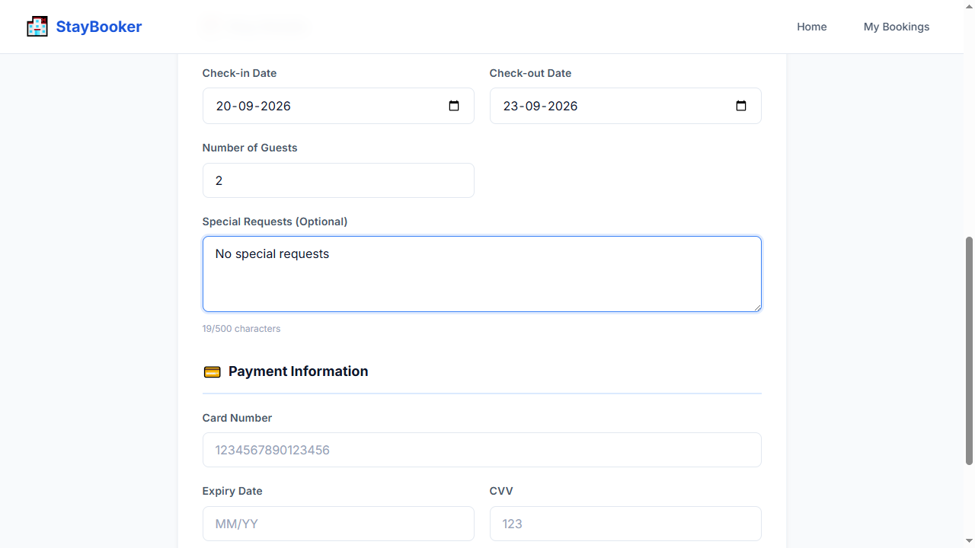
Step 20 — FILL: card-number-input = 4111111111111111
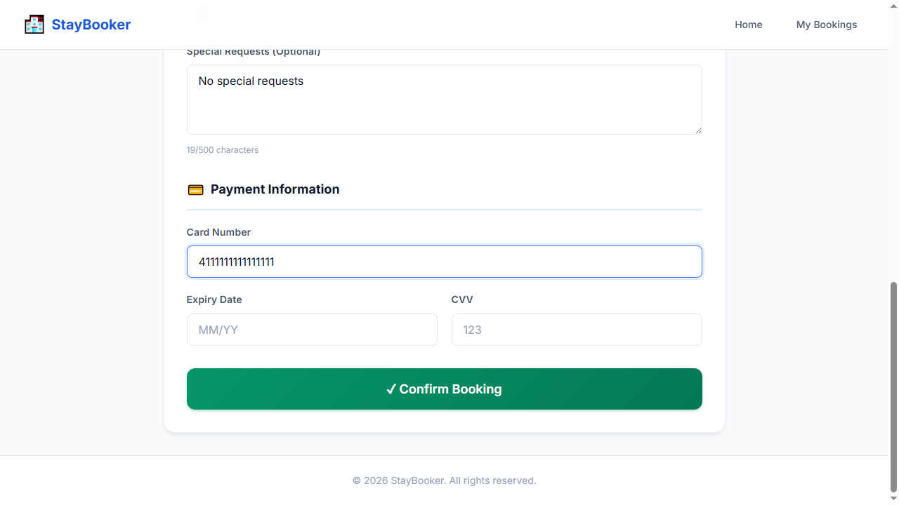
Step 21 — FILL: expiry-input = 12/30
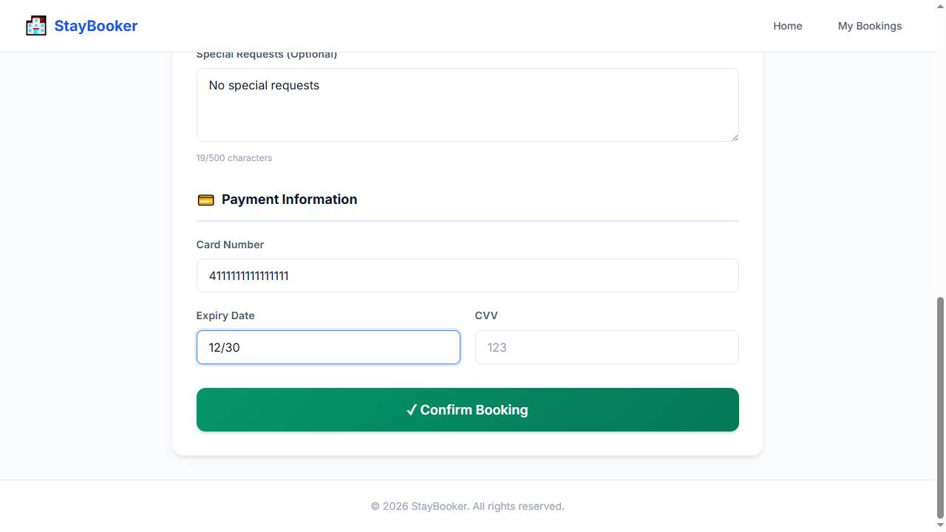
Step 22 — FILL: cvv-input = 123
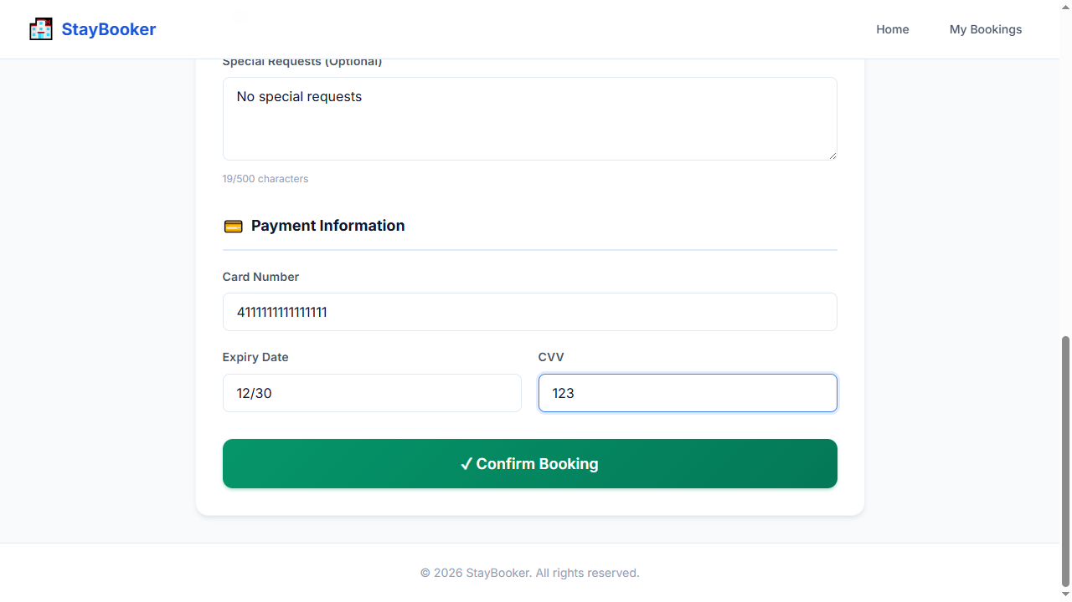
Step 23 — CLICK: confirm-booking-button
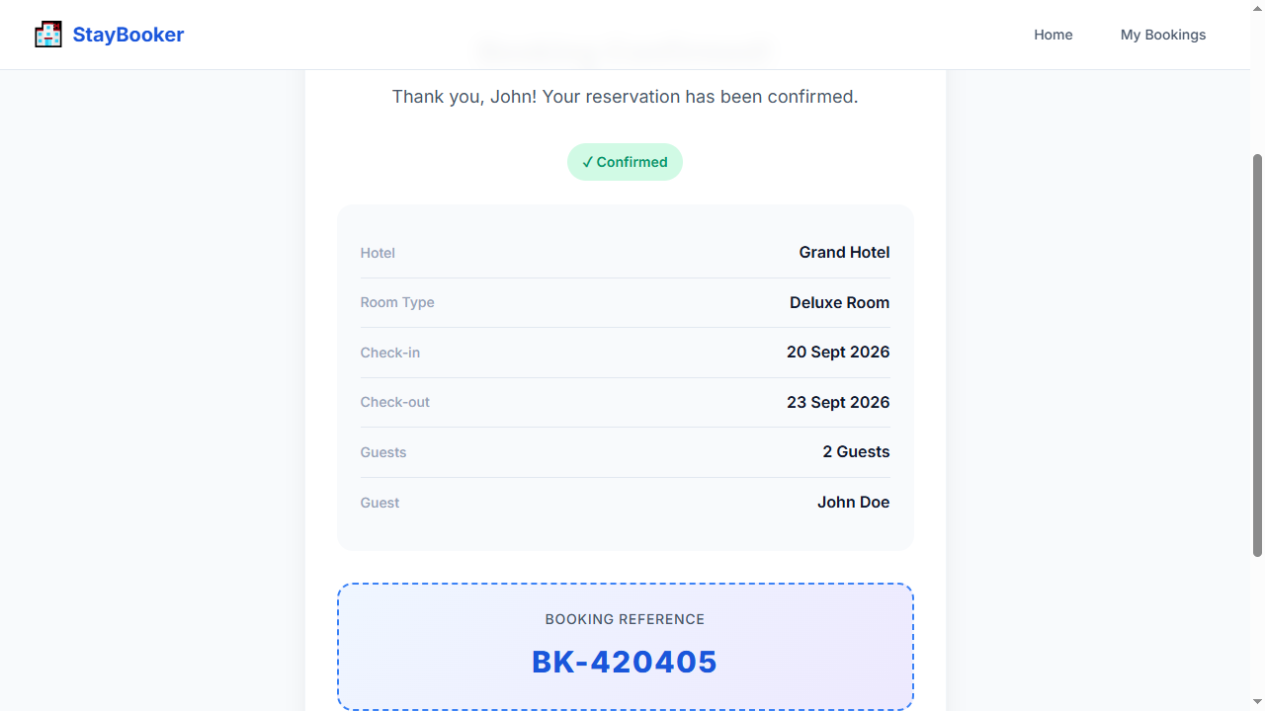
Step 24 — WAIT_FOR: booking-confirmation
Step 25 — ASSERT_VISIBLE: booking-confirmation
Step 26 — ASSERT_TEXT: booking-reference CONTAINS BK-
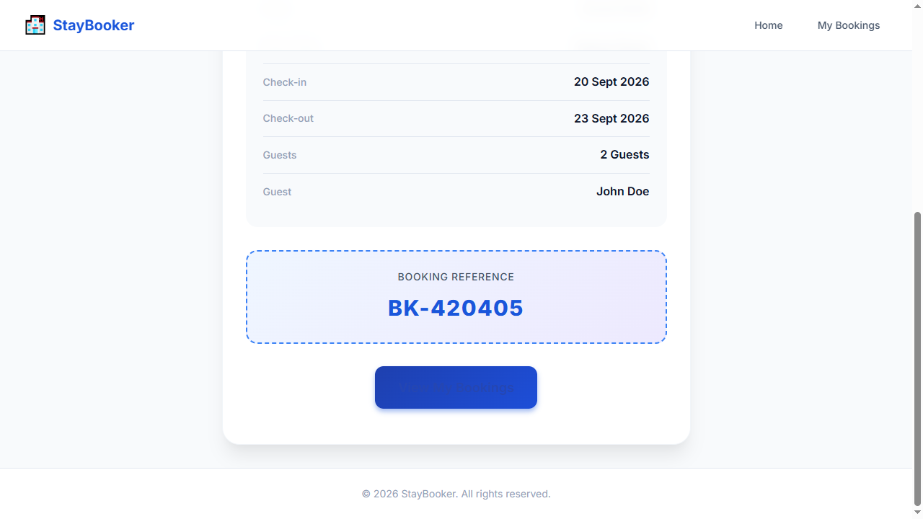
Step 27 — SCREENSHOT: TC-001_step-26_success
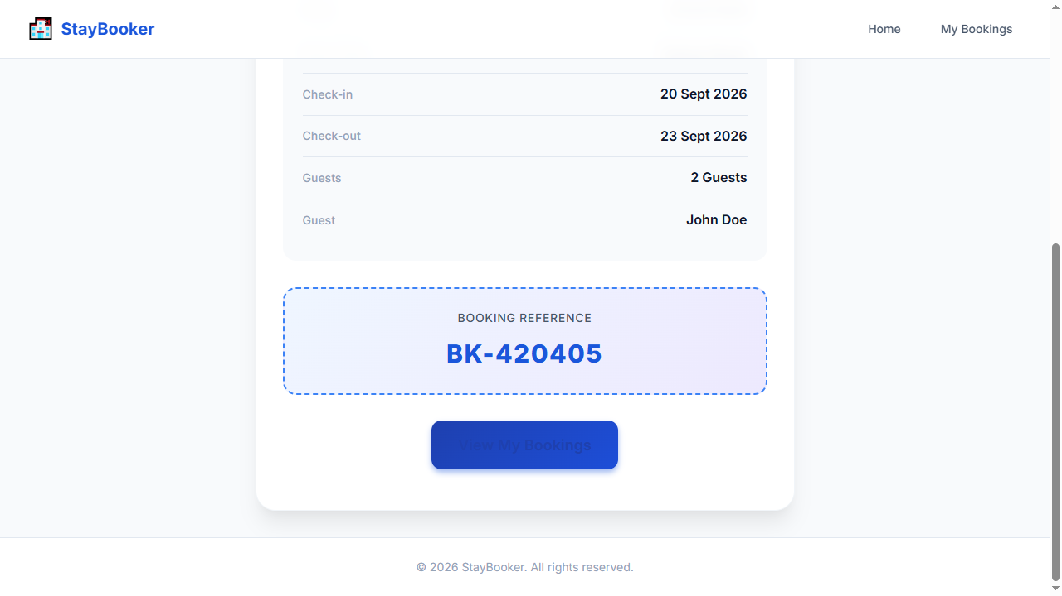

TC-002 — Search for available rooms
Test ID: TC-002
Test Name: Search for available rooms
Category: Happy Path
Status: PASS

Expected Result
Available rooms are displayed

Actual Result
The expected workflow completed successfully and all deterministic Playwright checks passed. AI visual verification was UNCERTAIN: Deterministic checks passed; AI was UNCERTAIN on 1 checkpoint(s).

AI Verification
AI Status: UNCERTAIN
AI Observation: Deterministic checks passed; AI was UNCERTAIN on 1 checkpoint(s).
Per-step AI observations:
- Step 9 — SCREENSHOT: TC-002_step-08_success [UNCERTAIN, N/A] AI quota exhausted (429). Reduce AI_VERIFY_EVERY_SCREENSHOT or wait for quota reset. model gemini-3-flash-preview: ClientError: 429 RESOURCE_EXHAUSTED. {'error': {'code': 429, 'message': 'You exceeded your current quota, please check your plan and billing details. For more information on this error, head to: https://ai.google.dev/gemini-api/docs/rate-limits. To m...

Steps
Step | Action | Status | AI Status | Confidence
1 | OPEN: / | PASS | NOT RUN | N/A
2 | FILL: city-input = New York | PASS | NOT RUN | N/A
3 | FILL: checkin-input = 2026-09-20 | PASS | NOT RUN | N/A
4 | FILL: checkout-input = 2026-09-23 | PASS | NOT RUN | N/A
5 | FILL: guests-input = 2 | PASS | NOT RUN | N/A
6 | CLICK: search-button | PASS | NOT RUN | N/A
7 | WAIT_FOR: room-card-1 | PASS | NOT RUN | N/A
8 | ASSERT_VISIBLE: room-card-1 | PASS | NOT RUN | N/A
9 | SCREENSHOT: TC-002_step-08_success | PASS | UNCERTAIN | N/A

Screenshots
Step 1 — OPEN: /
Step 2 — FILL: city-input = New York
Step 3 — FILL: checkin-input = 2026-09-20
Step 4 — FILL: checkout-input = 2026-09-23
Step 5 — FILL: guests-input = 2
Step 6 — CLICK: search-button
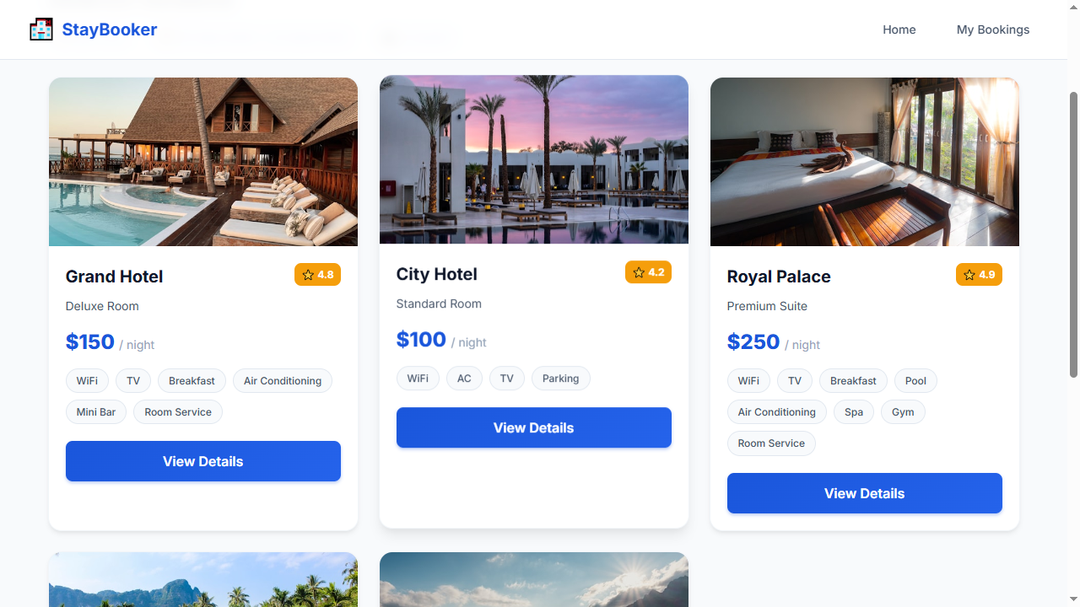
Step 7 — WAIT_FOR: room-card-1
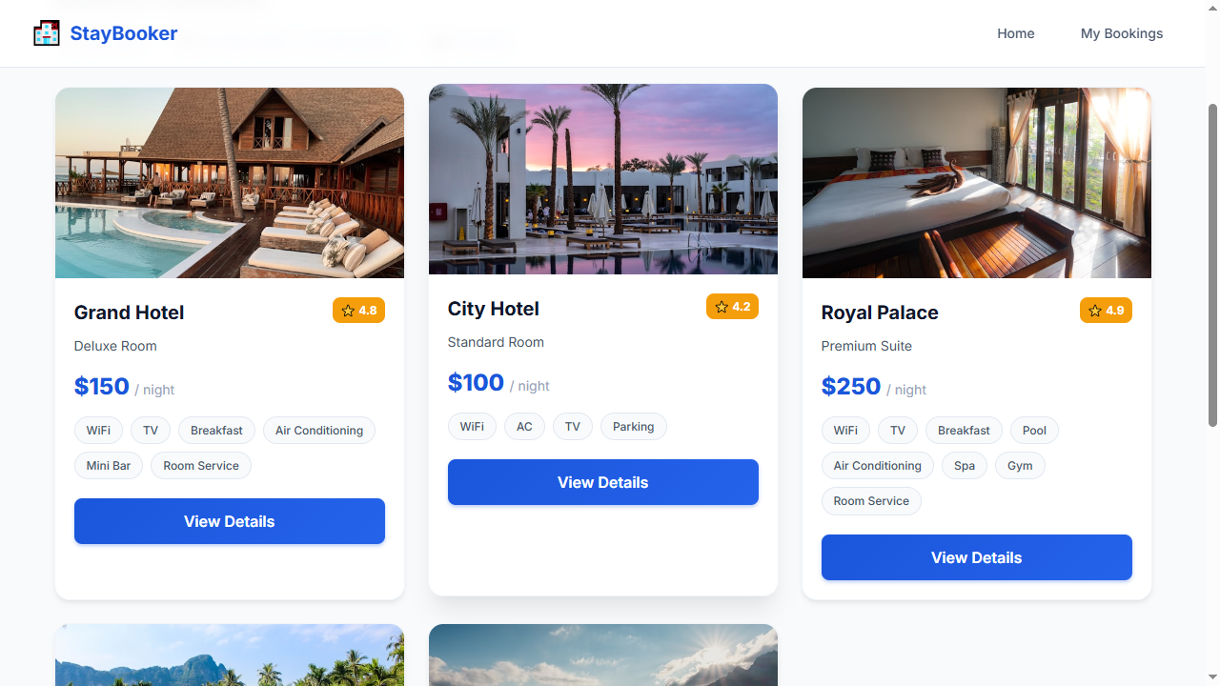
Step 8 — ASSERT_VISIBLE: room-card-1
Step 9 — SCREENSHOT: TC-002_step-08_success

TC-003 — View room details
Test ID: TC-003
Test Name: View room details
Category: Happy Path
Status: PASS

Expected Result
Room details are displayed

Actual Result
The expected workflow completed successfully and all deterministic Playwright checks passed. AI visual verification was UNCERTAIN: Deterministic checks passed; AI was UNCERTAIN on 1 checkpoint(s).

AI Verification
AI Status: UNCERTAIN
AI Observation: Deterministic checks passed; AI was UNCERTAIN on 1 checkpoint(s).
Per-step AI observations:
- Step 13 — SCREENSHOT: TC-003_step-12_success [UNCERTAIN, N/A] AI quota exhausted (429). Reduce AI_VERIFY_EVERY_SCREENSHOT or wait for quota reset. model gemini-3-flash-preview: ClientError: 429 RESOURCE_EXHAUSTED. {'error': {'code': 429, 'message': 'You exceeded your current quota, please check your plan and billing details. For more information on this error, head to: https://ai.google.dev/gemini-api/docs/rate-limits. To m...

Steps
Step | Action | Status | AI Status | Confidence
1 | OPEN: / | PASS | NOT RUN | N/A
2 | FILL: city-input = New York | PASS | NOT RUN | N/A
3 | FILL: checkin-input = 2026-09-20 | PASS | NOT RUN | N/A
4 | FILL: checkout-input = 2026-09-23 | PASS | NOT RUN | N/A
5 | FILL: guests-input = 2 | PASS | NOT RUN | N/A
6 | CLICK: search-button | PASS | NOT RUN | N/A
7 | WAIT_FOR: room-card-1 | PASS | NOT RUN | N/A
8 | CLICK: view-details-1 | PASS | NOT RUN | N/A
9 | WAIT_FOR: room-name | PASS | NOT RUN | N/A
10 | ASSERT_VISIBLE: room-name | PASS | NOT RUN | N/A
11 | ASSERT_VISIBLE: room-type | PASS | NOT RUN | N/A
12 | ASSERT_VISIBLE: room-price | PASS | NOT RUN | N/A
13 | SCREENSHOT: TC-003_step-12_success | PASS | UNCERTAIN | N/A

Screenshots
Step 1 — OPEN: /
Step 2 — FILL: city-input = New York
Step 3 — FILL: checkin-input = 2026-09-20
Step 4 — FILL: checkout-input = 2026-09-23
Step 5 — FILL: guests-input = 2
Step 6 — CLICK: search-button
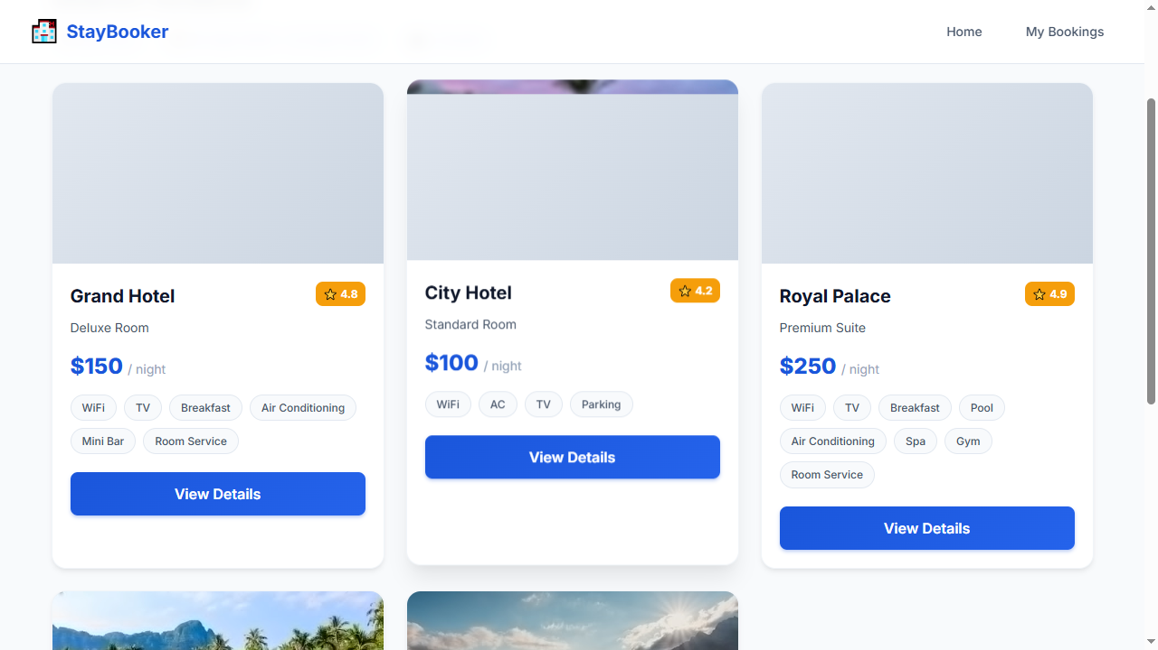
Step 7 — WAIT_FOR: room-card-1
Step 8 — CLICK: view-details-1
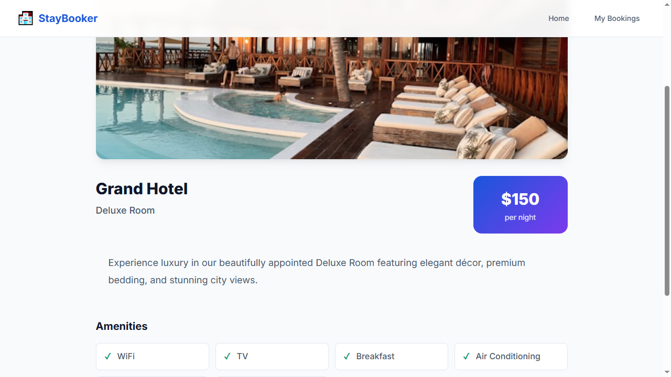
Step 9 — WAIT_FOR: room-name
Step 10 — ASSERT_VISIBLE: room-name
Step 11 — ASSERT_VISIBLE: room-type
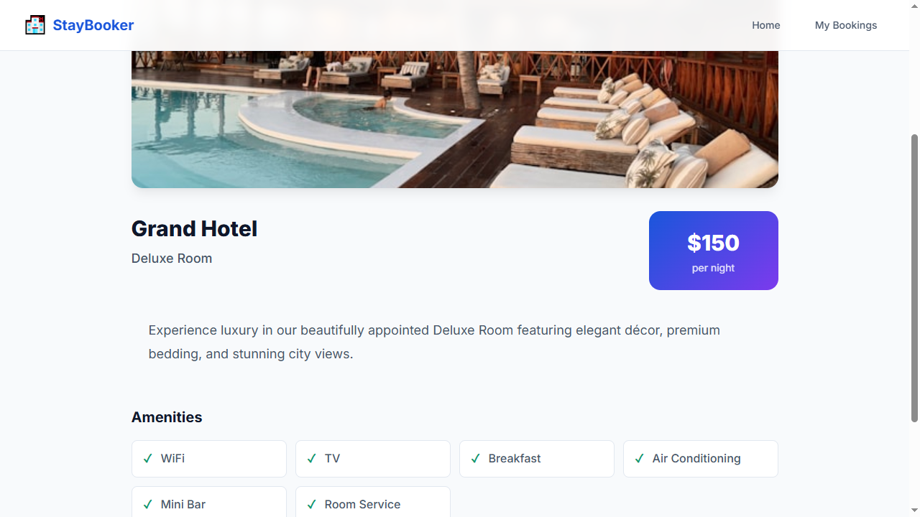
Step 12 — ASSERT_VISIBLE: room-price
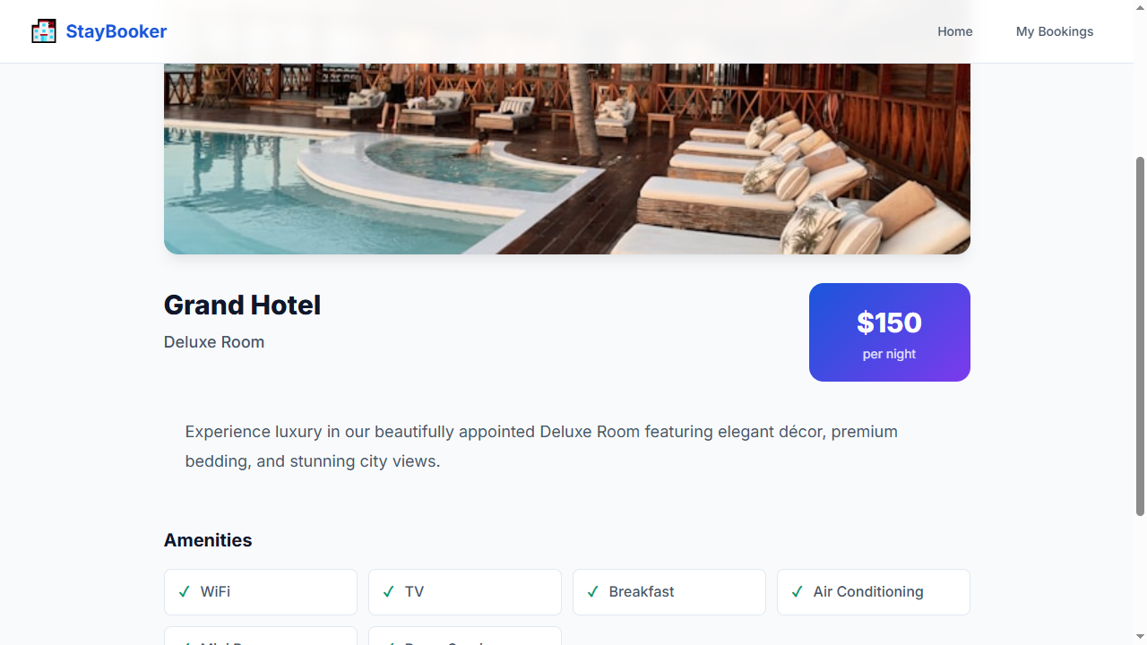
Step 13 — SCREENSHOT: TC-003_step-12_success

TC-004 — View my bookings
Test ID: TC-004
Test Name: View my bookings
Category: Happy Path
Status: PASS

Expected Result
User bookings are displayed

Actual Result
The expected workflow completed successfully and all deterministic Playwright checks passed. AI visual verification was UNCERTAIN: Deterministic checks passed; AI was UNCERTAIN on 1 checkpoint(s).

AI Verification
AI Status: UNCERTAIN
AI Observation: Deterministic checks passed; AI was UNCERTAIN on 1 checkpoint(s).
Per-step AI observations:
- Step 27 — SCREENSHOT: TC-004_step-26_success [UNCERTAIN, N/A] AI quota exhausted (429). Reduce AI_VERIFY_EVERY_SCREENSHOT or wait for quota reset. model gemini-3-flash-preview: ClientError: 429 RESOURCE_EXHAUSTED. {'error': {'code': 429, 'message': 'You exceeded your current quota, please check your plan and billing details. For more information on this error, head to: https://ai.google.dev/gemini-api/docs/rate-limits. To m...

Steps
Step | Action | Status | AI Status | Confidence
1 | OPEN: / | PASS | NOT RUN | N/A
2 | FILL: city-input = New York | PASS | NOT RUN | N/A
3 | FILL: checkin-input = 2026-09-20 | PASS | NOT RUN | N/A
4 | FILL: checkout-input = 2026-09-23 | PASS | NOT RUN | N/A
5 | FILL: guests-input = 2 | PASS | NOT RUN | N/A
6 | CLICK: search-button | PASS | NOT RUN | N/A
7 | WAIT_FOR: room-card-1 | PASS | NOT RUN | N/A
8 | CLICK: view-details-1 | PASS | NOT RUN | N/A
9 | WAIT_FOR: room-name | PASS | NOT RUN | N/A
10 | CLICK: book-now-button | PASS | NOT RUN | N/A
11 | WAIT_FOR: first-name-input | PASS | NOT RUN | N/A
12 | FILL: first-name-input = John | PASS | NOT RUN | N/A
13 | FILL: last-name-input = Doe | PASS | NOT RUN | N/A
14 | FILL: email-input = john@example.com | PASS | NOT RUN | N/A
15 | FILL: phone-input = 9876543210 | PASS | NOT RUN | N/A
16 | FILL: booking-checkin-input = 2026-09-20 | PASS | NOT RUN | N/A
17 | FILL: booking-checkout-input = 2026-09-23 | PASS | NOT RUN | N/A
18 | FILL: booking-guests-input = 2 | PASS | NOT RUN | N/A
19 | FILL: card-number-input = 4111111111111111 | PASS | NOT RUN | N/A
20 | FILL: expiry-input = 12/30 | PASS | NOT RUN | N/A
21 | FILL: cvv-input = 123 | PASS | NOT RUN | N/A
22 | CLICK: confirm-booking-button | PASS | NOT RUN | N/A
23 | WAIT_FOR: booking-confirmation | PASS | NOT RUN | N/A
24 | OPEN: /bookings | PASS | NOT RUN | N/A
25 | WAIT_FOR: bookings-page | PASS | NOT RUN | N/A
26 | ASSERT_VISIBLE: bookings-page | PASS | NOT RUN | N/A
27 | SCREENSHOT: TC-004_step-26_success | PASS | UNCERTAIN | N/A

Screenshots
Step 1 — OPEN: /
Step 2 — FILL: city-input = New York
Step 3 — FILL: checkin-input = 2026-09-20
Step 4 — FILL: checkout-input = 2026-09-23
Step 5 — FILL: guests-input = 2
Step 6 — CLICK: search-button
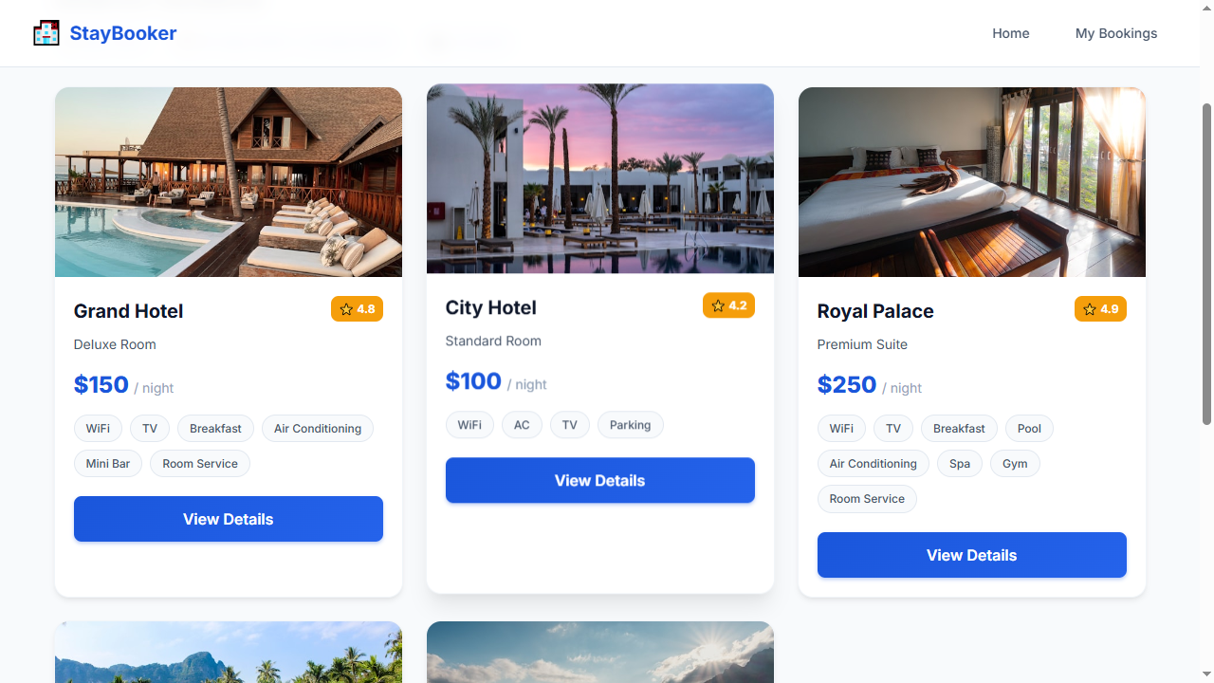
Step 7 — WAIT_FOR: room-card-1
Step 8 — CLICK: view-details-1
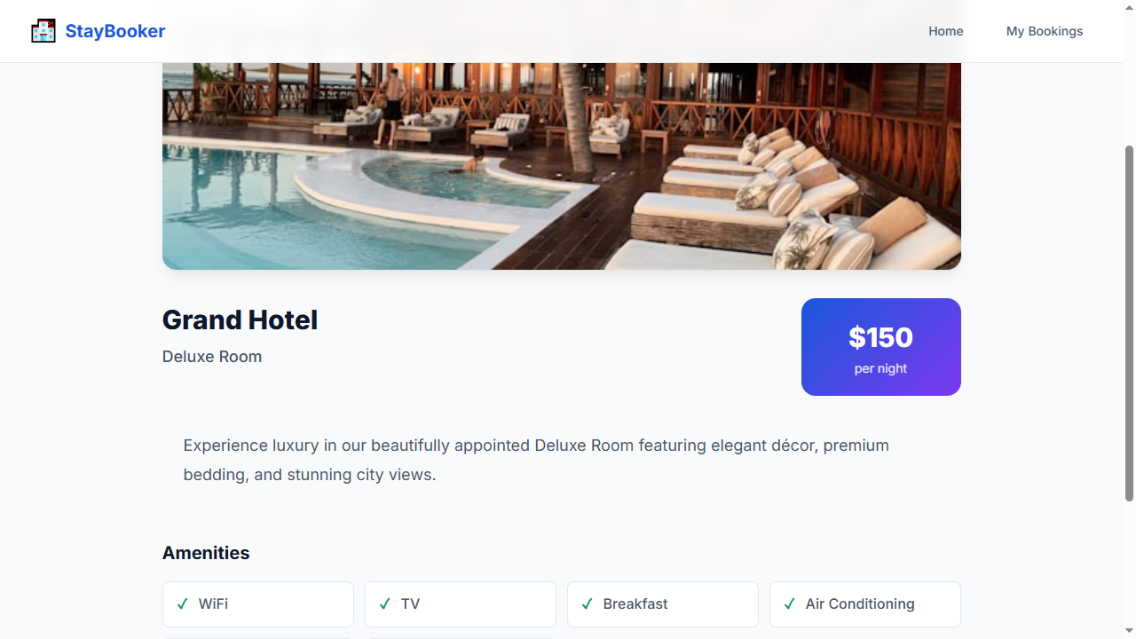
Step 9 — WAIT_FOR: room-name
Step 10 — CLICK: book-now-button
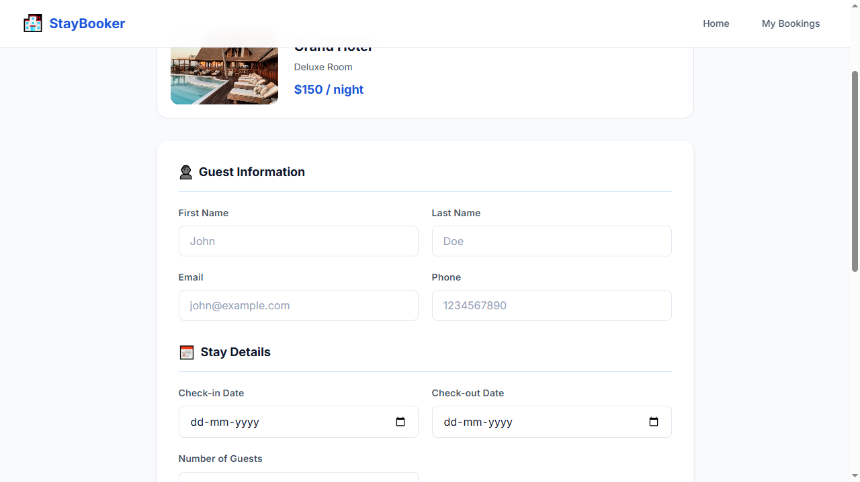
Step 11 — WAIT_FOR: first-name-input
Step 12 — FILL: first-name-input = John
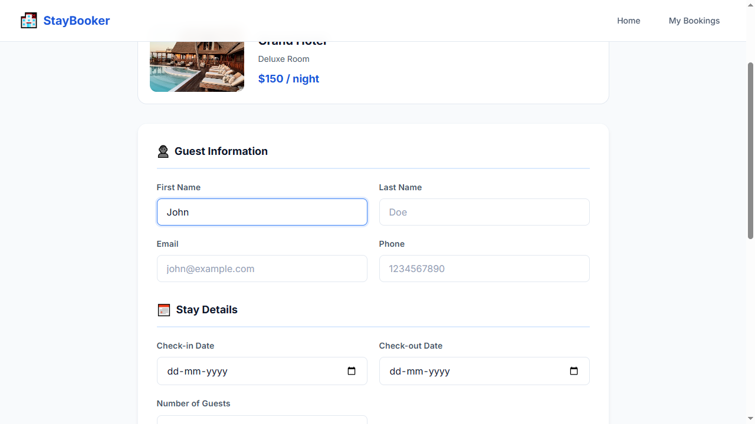
Step 13 — FILL: last-name-input = Doe
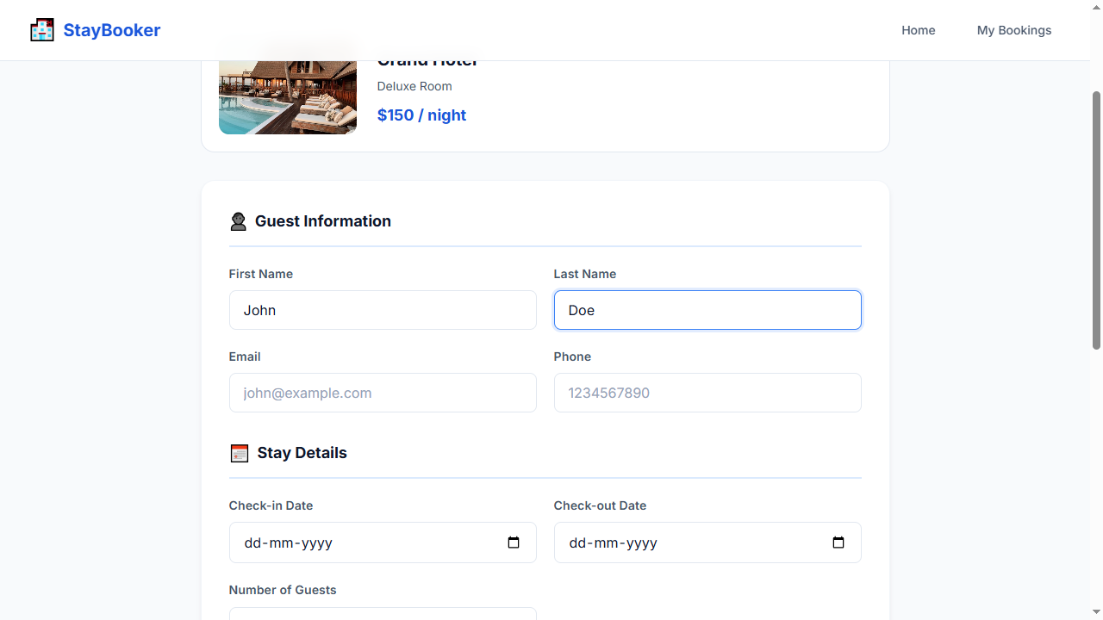
Step 14 — FILL: email-input = john@example.com
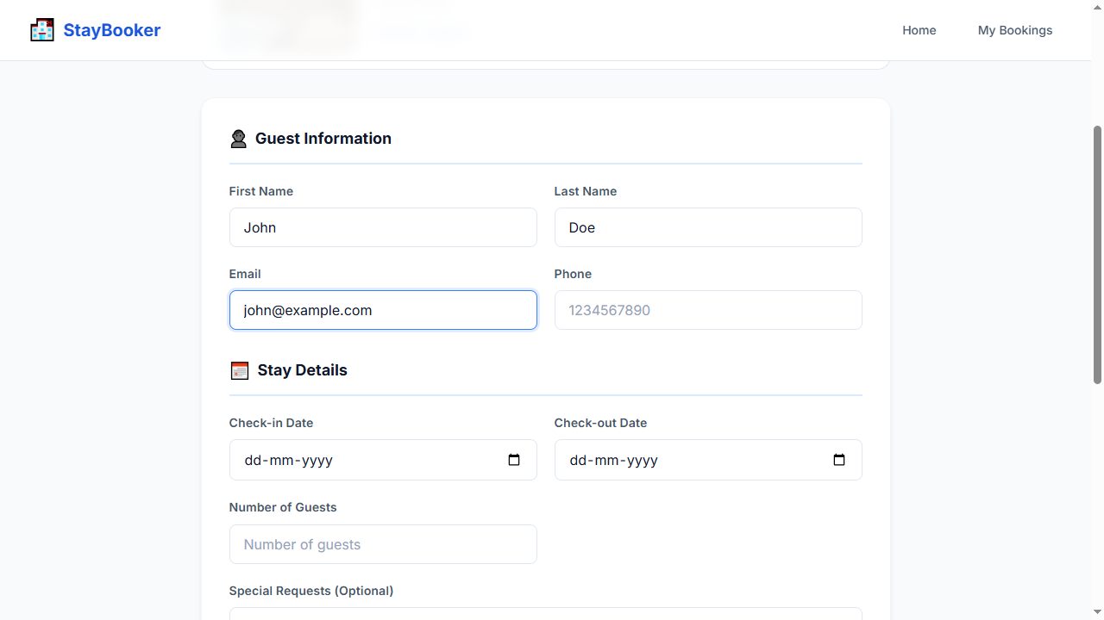
Step 15 — FILL: phone-input = 9876543210
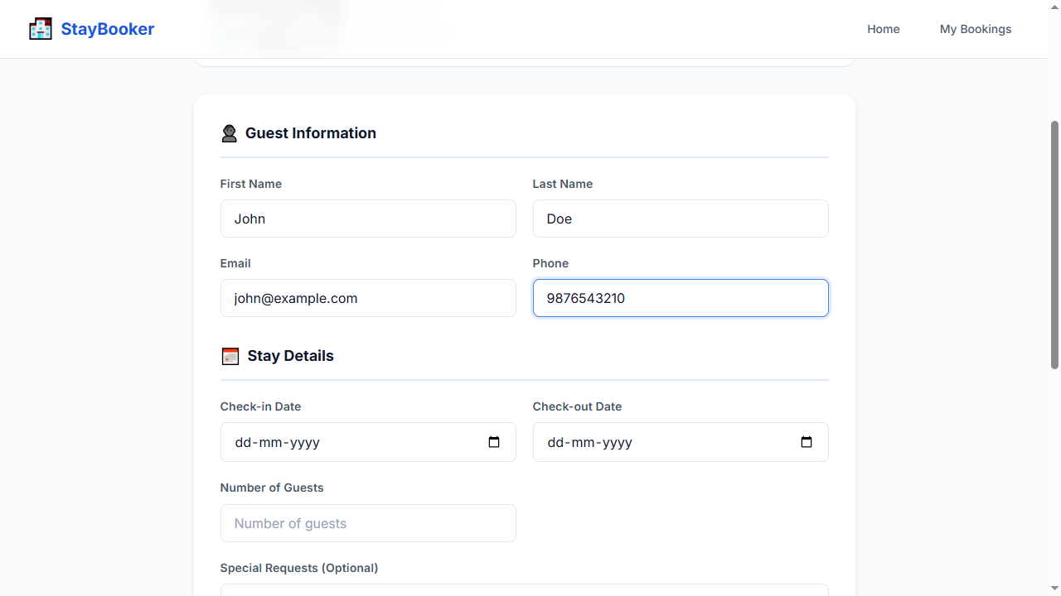
Step 16 — FILL: booking-checkin-input = 2026-09-20
Step 17 — FILL: booking-checkout-input = 2026-09-23
Step 18 — FILL: booking-guests-input = 2
Step 19 — FILL: card-number-input = 4111111111111111
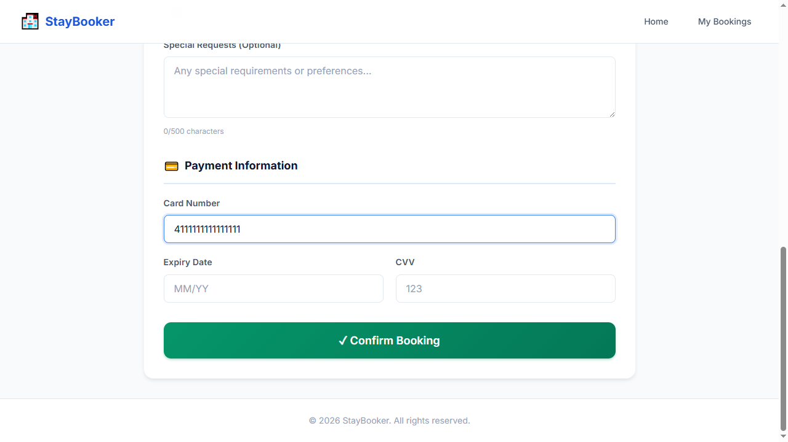
Step 20 — FILL: expiry-input = 12/30
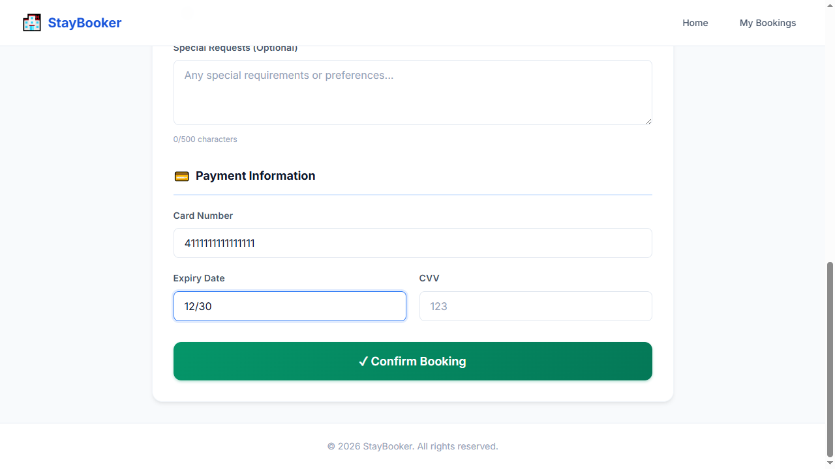
Step 21 — FILL: cvv-input = 123
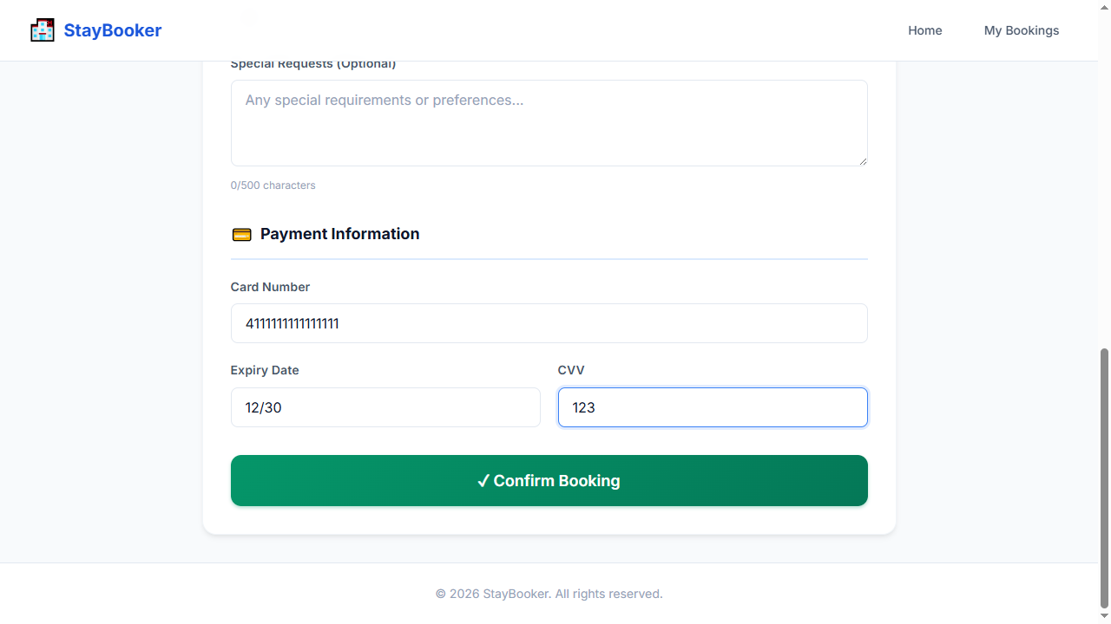
Step 22 — CLICK: confirm-booking-button
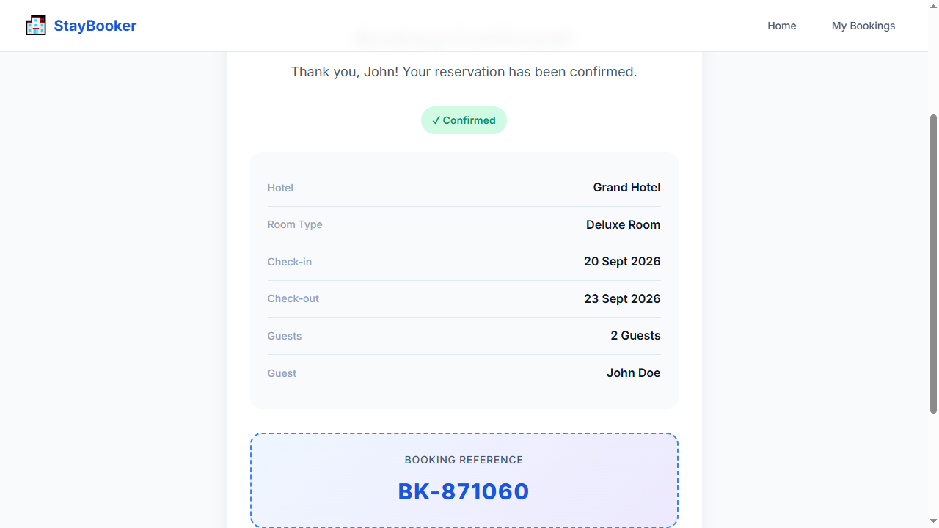
Step 23 — WAIT_FOR: booking-confirmation
Step 24 — OPEN: /bookings
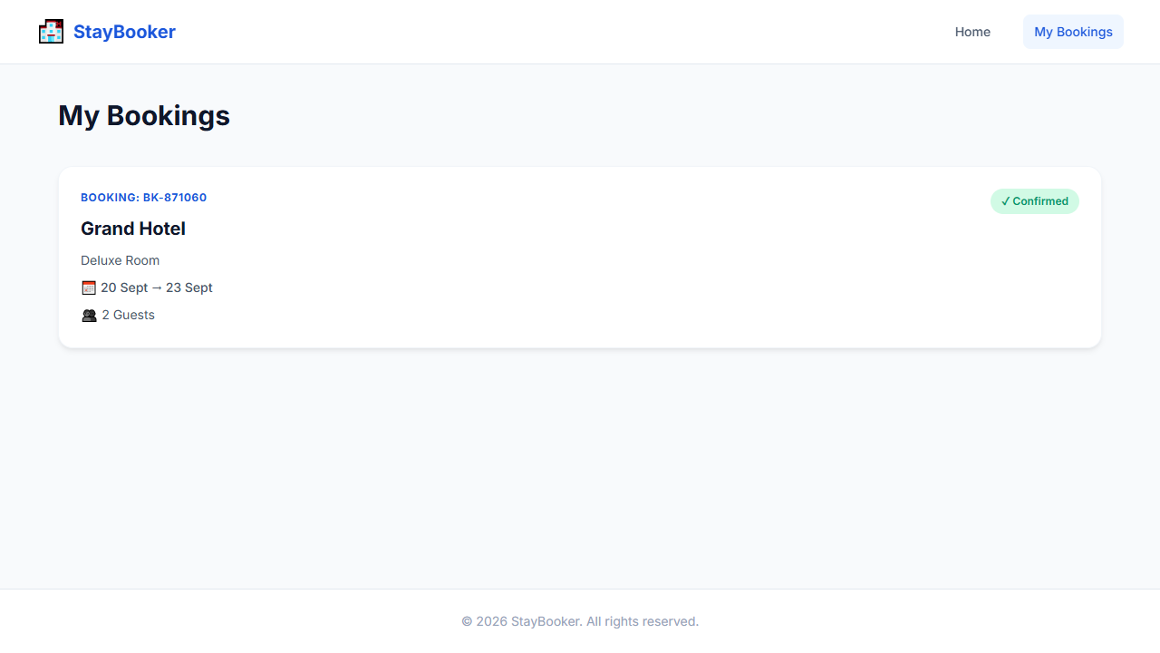
Step 25 — WAIT_FOR: bookings-page
Step 26 — ASSERT_VISIBLE: bookings-page
Step 27 — SCREENSHOT: TC-004_step-26_success

TC-005 — Empty first name
Test ID: TC-005
Test Name: Empty first name
Category: Validation
Status: PASS

Expected Result
First name validation error is displayed

Actual Result
The expected workflow completed successfully and all deterministic Playwright checks passed. AI visual verification was UNCERTAIN: Deterministic checks passed; AI was UNCERTAIN on 1 checkpoint(s).

AI Verification
AI Status: UNCERTAIN
AI Observation: Deterministic checks passed; AI was UNCERTAIN on 1 checkpoint(s).
Per-step AI observations:
- Step 25 — SCREENSHOT: validation_error [UNCERTAIN, N/A] AI quota exhausted (429). Reduce AI_VERIFY_EVERY_SCREENSHOT or wait for quota reset. model gemini-3-flash-preview: ClientError: 429 RESOURCE_EXHAUSTED. {'error': {'code': 429, 'message': 'You exceeded your current quota, please check your plan and billing details. For more information on this error, head to: https://ai.google.dev/gemini-api/docs/rate-limits. To m...

Steps
Step | Action | Status | AI Status | Confidence
1 | OPEN: / | PASS | NOT RUN | N/A
2 | FILL: city-input = New York | PASS | NOT RUN | N/A
3 | FILL: checkin-input = 2026-09-20 | PASS | NOT RUN | N/A
4 | FILL: checkout-input = 2026-09-23 | PASS | NOT RUN | N/A
5 | FILL: guests-input = 2 | PASS | NOT RUN | N/A
6 | CLICK: search-button | PASS | NOT RUN | N/A
7 | WAIT_FOR: room-card-1 | PASS | NOT RUN | N/A
8 | CLICK: view-details-1 | PASS | NOT RUN | N/A
9 | WAIT_FOR: room-name | PASS | NOT RUN | N/A
10 | CLICK: book-now-button | PASS | NOT RUN | N/A
11 | WAIT_FOR: first-name-input | PASS | NOT RUN | N/A
12 | FILL: first-name-input = | PASS | NOT RUN | N/A
13 | FILL: last-name-input = Doe | PASS | NOT RUN | N/A
14 | FILL: email-input = john@example.com | PASS | NOT RUN | N/A
15 | FILL: phone-input = 9876543210 | PASS | NOT RUN | N/A
16 | FILL: booking-checkin-input = 2026-09-20 | PASS | NOT RUN | N/A
17 | FILL: booking-checkout-input = 2026-09-23 | PASS | NOT RUN | N/A
18 | FILL: booking-guests-input = 2 | PASS | NOT RUN | N/A
19 | FILL: card-number-input = 4111111111111111 | PASS | NOT RUN | N/A
20 | FILL: expiry-input = 12/30 | PASS | NOT RUN | N/A
21 | FILL: cvv-input = 123 | PASS | NOT RUN | N/A
22 | CLICK: confirm-booking-button | PASS | NOT RUN | N/A
23 | WAIT_FOR: first-name-error | PASS | NOT RUN | N/A
24 | ASSERT_VISIBLE: first-name-error | PASS | NOT RUN | N/A
25 | SCREENSHOT: validation_error | PASS | UNCERTAIN | N/A

Screenshots
Step 1 — OPEN: /
Step 2 — FILL: city-input = New York
Step 3 — FILL: checkin-input = 2026-09-20
Step 4 — FILL: checkout-input = 2026-09-23
Step 5 — FILL: guests-input = 2
Step 6 — CLICK: search-button
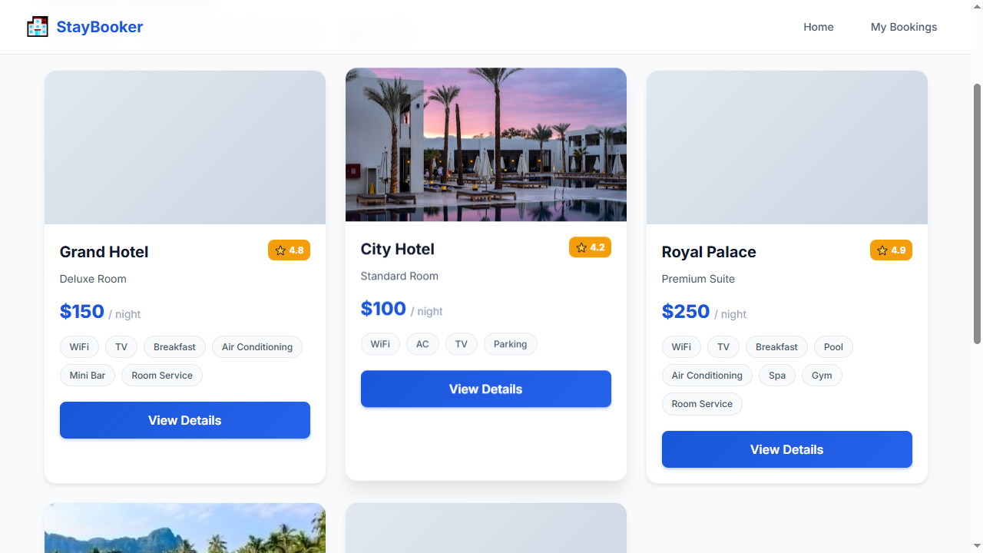
Step 7 — WAIT_FOR: room-card-1
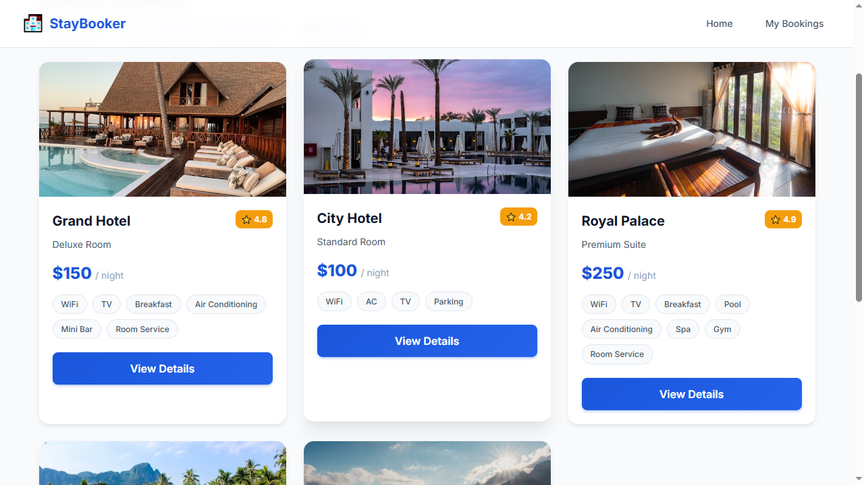
Step 8 — CLICK: view-details-1
Step 9 — WAIT_FOR: room-name
Step 10 — CLICK: book-now-button
Step 11 — WAIT_FOR: first-name-input
Step 12 — FILL: first-name-input =
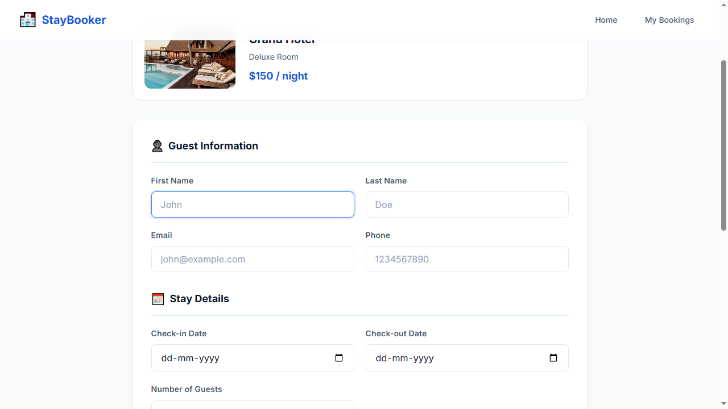
Step 13 — FILL: last-name-input = Doe
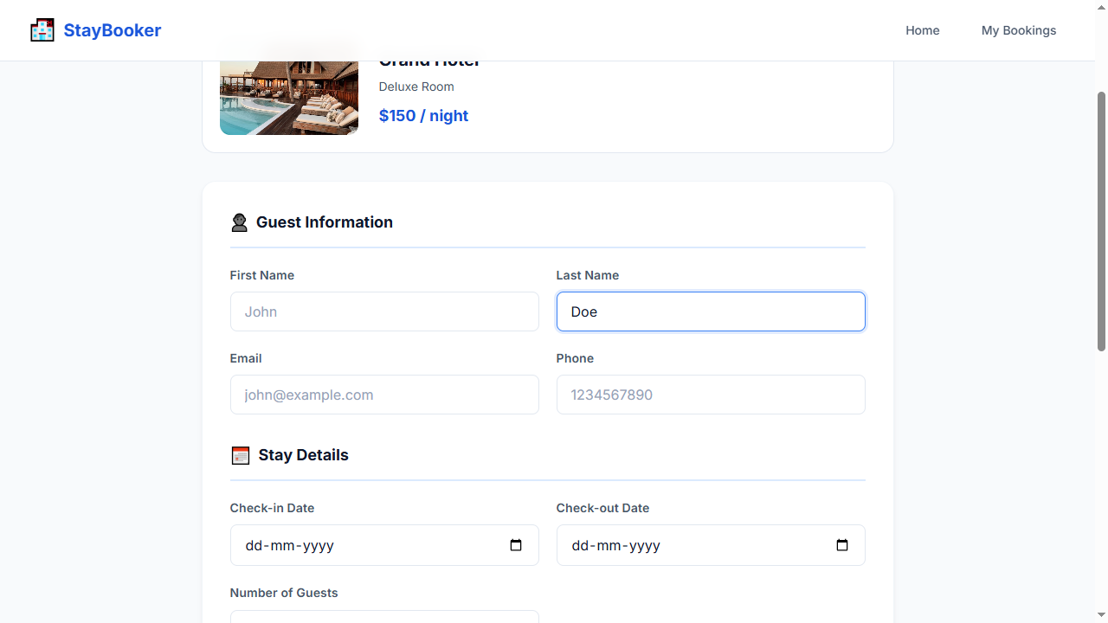
Step 14 — FILL: email-input = john@example.com
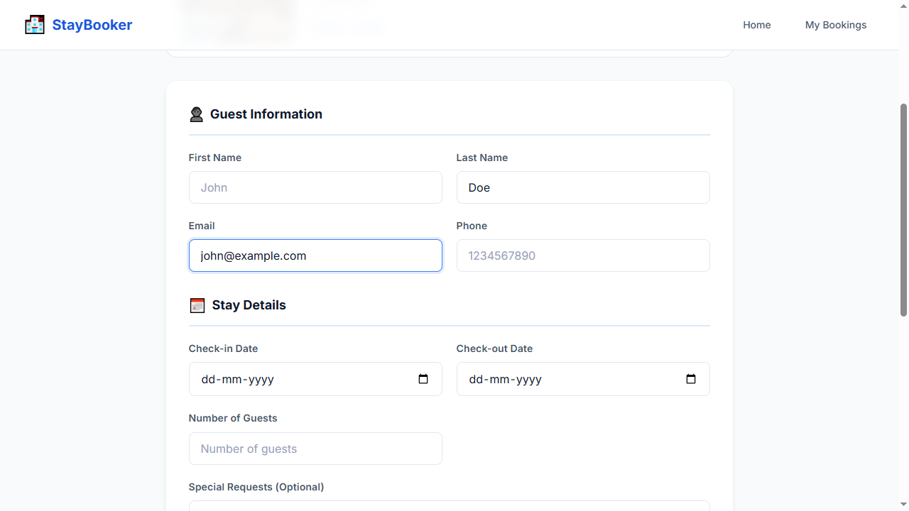
Step 15 — FILL: phone-input = 9876543210
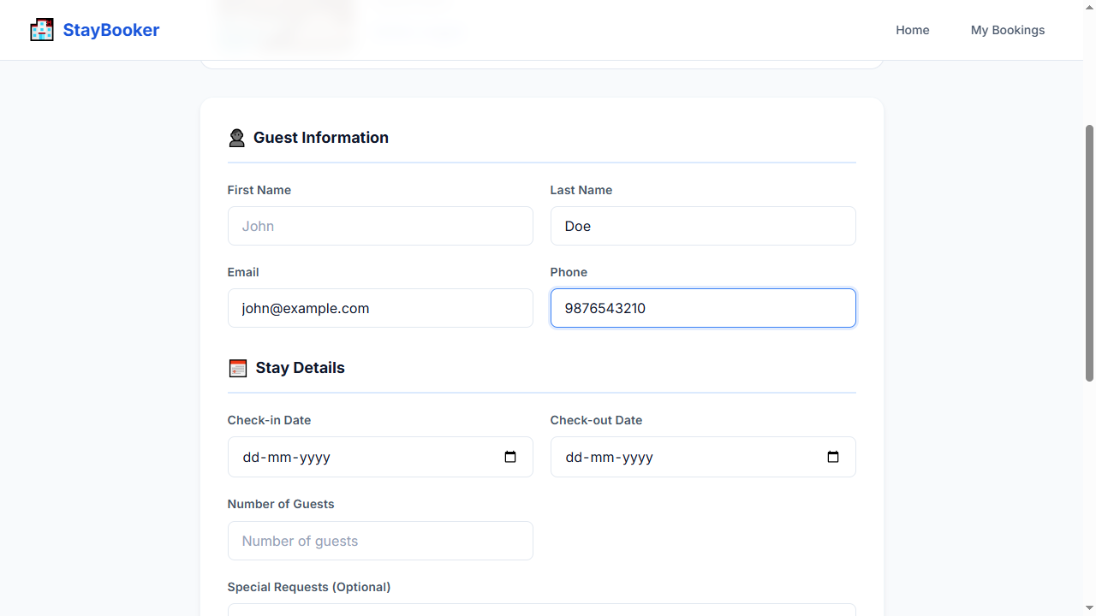
Step 16 — FILL: booking-checkin-input = 2026-09-20
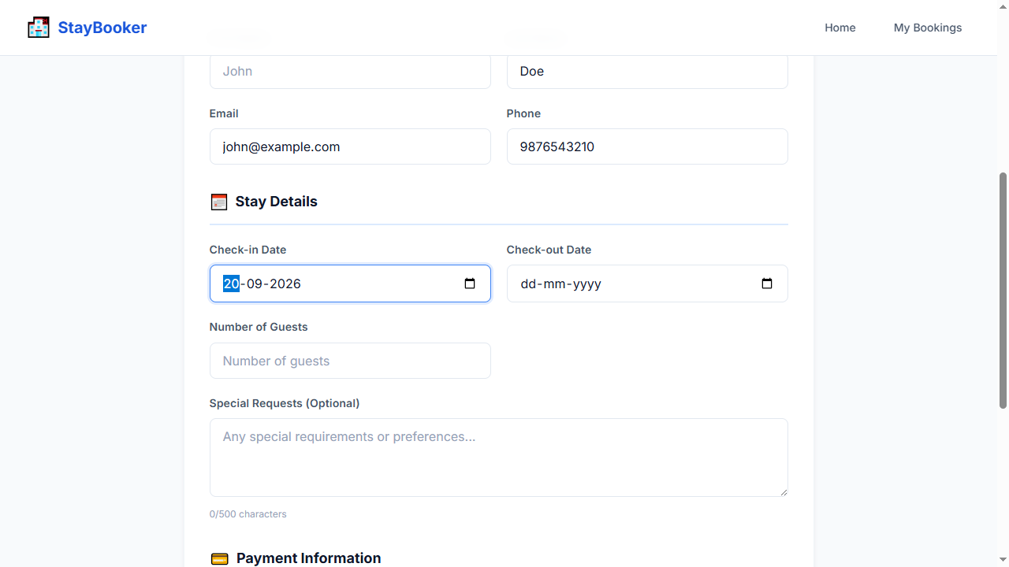
Step 17 — FILL: booking-checkout-input = 2026-09-23
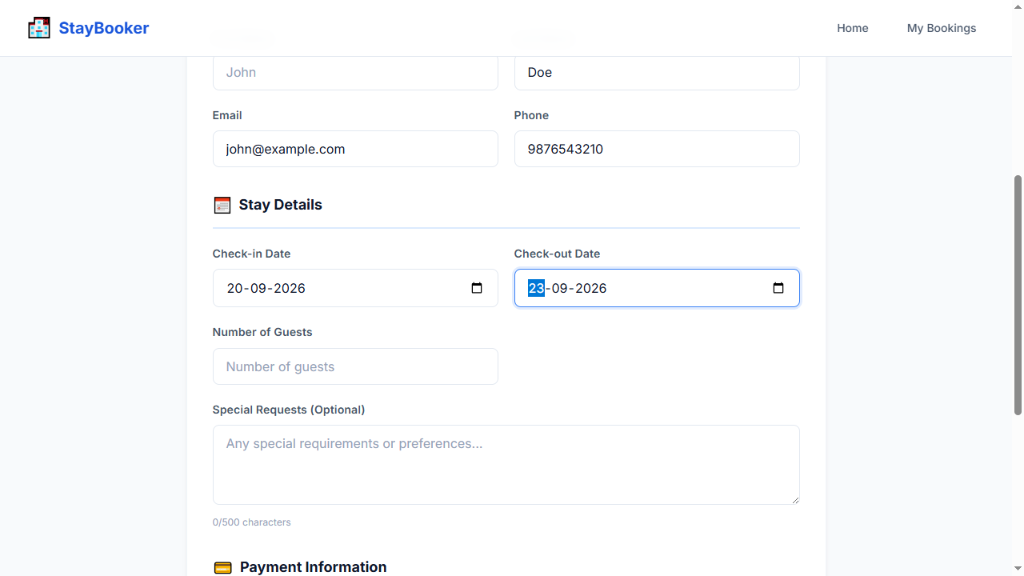
Step 18 — FILL: booking-guests-input = 2
Step 19 — FILL: card-number-input = 4111111111111111
Step 20 — FILL: expiry-input = 12/30
Step 21 — FILL: cvv-input = 123
Step 22 — CLICK: confirm-booking-button
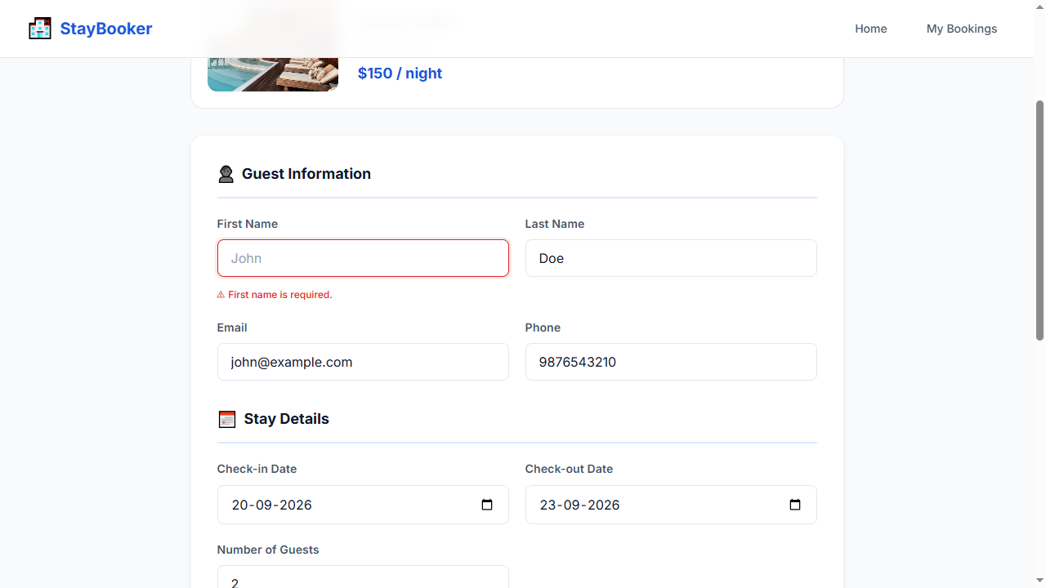
Step 23 — WAIT_FOR: first-name-error
Step 24 — ASSERT_VISIBLE: first-name-error
Step 25 — SCREENSHOT: validation_error

TC-006 — Empty last name
Test ID: TC-006
Test Name: Empty last name
Category: Validation
Status: PASS

Expected Result
Last name validation error is displayed

Actual Result
The expected workflow completed successfully and all deterministic Playwright checks passed. AI visual verification was UNCERTAIN: Deterministic checks passed; AI was UNCERTAIN on 1 checkpoint(s).

AI Verification
AI Status: UNCERTAIN
AI Observation: Deterministic checks passed; AI was UNCERTAIN on 1 checkpoint(s).
Per-step AI observations:
- Step 25 — SCREENSHOT: validation_error [UNCERTAIN, N/A] AI quota exhausted (429). Reduce AI_VERIFY_EVERY_SCREENSHOT or wait for quota reset. model gemini-3-flash-preview: ClientError: 429 RESOURCE_EXHAUSTED. {'error': {'code': 429, 'message': 'You exceeded your current quota, please check your plan and billing details. For more information on this error, head to: https://ai.google.dev/gemini-api/docs/rate-limits. To m...

Steps
Step | Action | Status | AI Status | Confidence
1 | OPEN: / | PASS | NOT RUN | N/A
2 | FILL: city-input = New York | PASS | NOT RUN | N/A
3 | FILL: checkin-input = 2026-09-20 | PASS | NOT RUN | N/A
4 | FILL: checkout-input = 2026-09-23 | PASS | NOT RUN | N/A
5 | FILL: guests-input = 2 | PASS | NOT RUN | N/A
6 | CLICK: search-button | PASS | NOT RUN | N/A
7 | WAIT_FOR: room-card-1 | PASS | NOT RUN | N/A
8 | CLICK: view-details-1 | PASS | NOT RUN | N/A
9 | WAIT_FOR: room-name | PASS | NOT RUN | N/A
10 | CLICK: book-now-button | PASS | NOT RUN | N/A
11 | WAIT_FOR: first-name-input | PASS | NOT RUN | N/A
12 | FILL: first-name-input = John | PASS | NOT RUN | N/A
13 | FILL: last-name-input = | PASS | NOT RUN | N/A
14 | FILL: email-input = john@example.com | PASS | NOT RUN | N/A
15 | FILL: phone-input = 9876543210 | PASS | NOT RUN | N/A
16 | FILL: booking-checkin-input = 2026-09-20 | PASS | NOT RUN | N/A
17 | FILL: booking-checkout-input = 2026-09-23 | PASS | NOT RUN | N/A
18 | FILL: booking-guests-input = 2 | PASS | NOT RUN | N/A
19 | FILL: card-number-input = 4111111111111111 | PASS | NOT RUN | N/A
20 | FILL: expiry-input = 12/30 | PASS | NOT RUN | N/A
21 | FILL: cvv-input = 123 | PASS | NOT RUN | N/A
22 | CLICK: confirm-booking-button | PASS | NOT RUN | N/A
23 | WAIT_FOR: last-name-error | PASS | NOT RUN | N/A
24 | ASSERT_VISIBLE: last-name-error | PASS | NOT RUN | N/A
25 | SCREENSHOT: validation_error | PASS | UNCERTAIN | N/A

Screenshots
Step 1 — OPEN: /
Step 2 — FILL: city-input = New York
Step 3 — FILL: checkin-input = 2026-09-20
Step 4 — FILL: checkout-input = 2026-09-23
Step 5 — FILL: guests-input = 2
Step 6 — CLICK: search-button
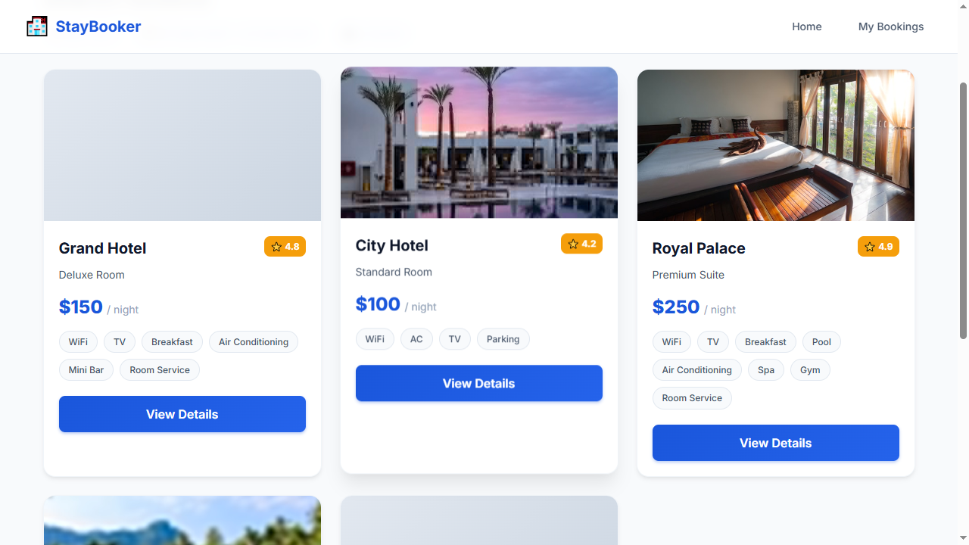
Step 7 — WAIT_FOR: room-card-1
Step 8 — CLICK: view-details-1
Step 9 — WAIT_FOR: room-name
Step 10 — CLICK: book-now-button
Step 11 — WAIT_FOR: first-name-input
Step 12 — FILL: first-name-input = John
Step 13 — FILL: last-name-input =
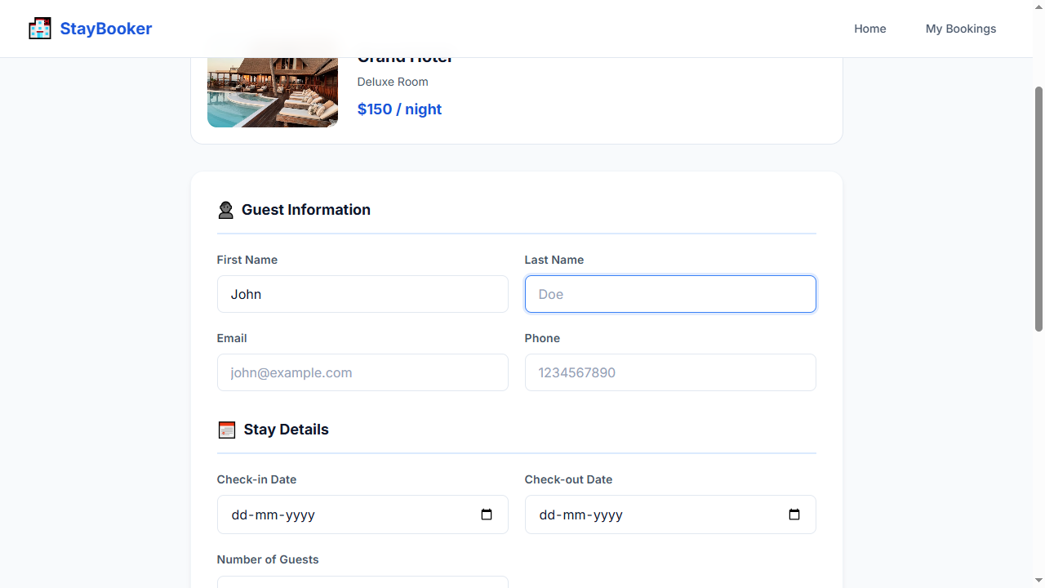
Step 14 — FILL: email-input = john@example.com
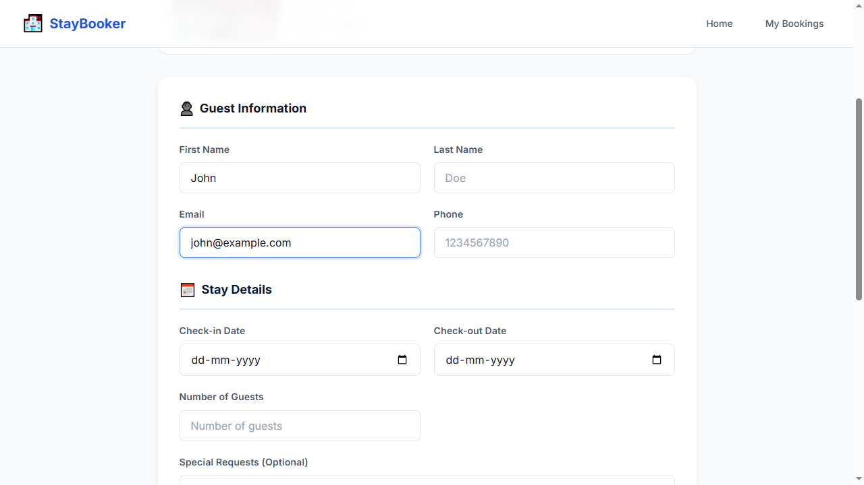
Step 15 — FILL: phone-input = 9876543210
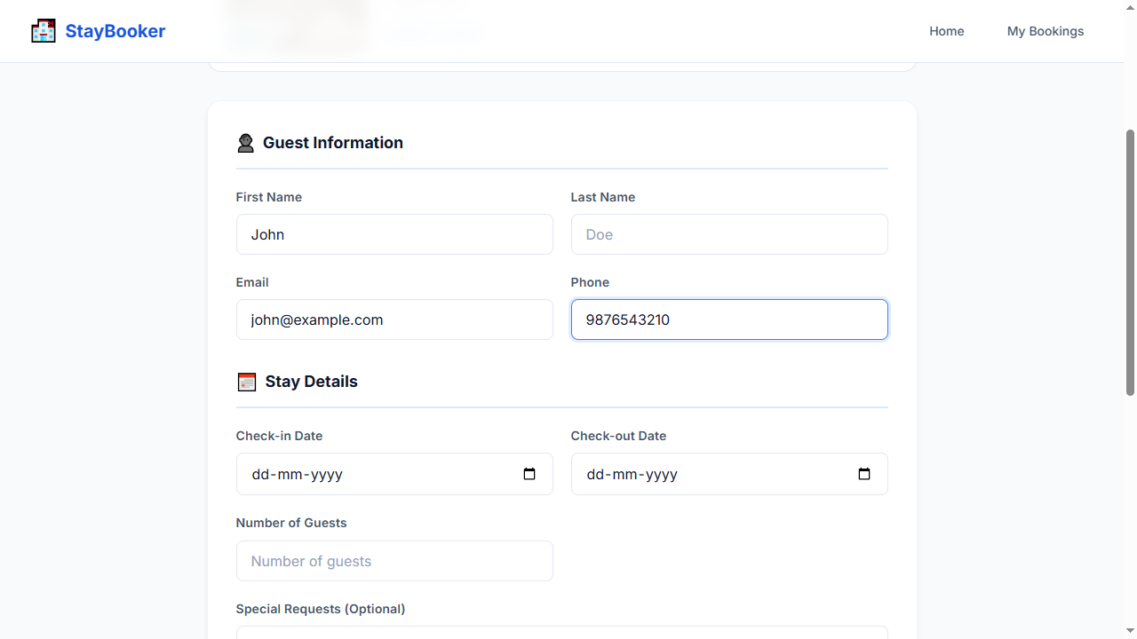
Step 16 — FILL: booking-checkin-input = 2026-09-20
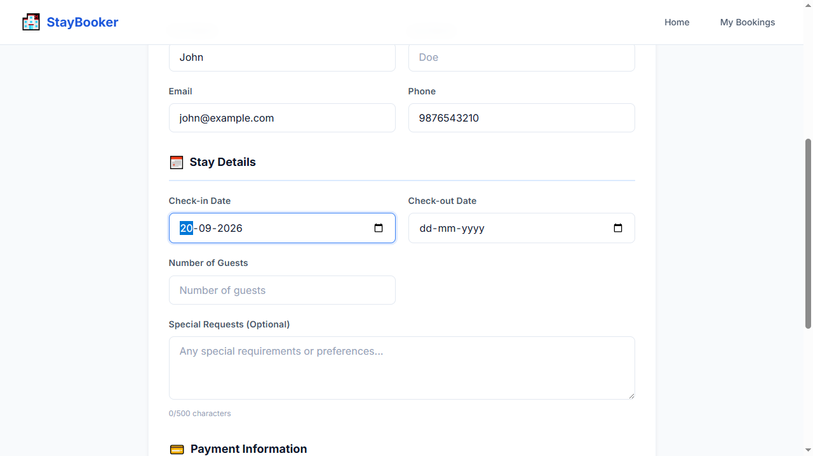
Step 17 — FILL: booking-checkout-input = 2026-09-23
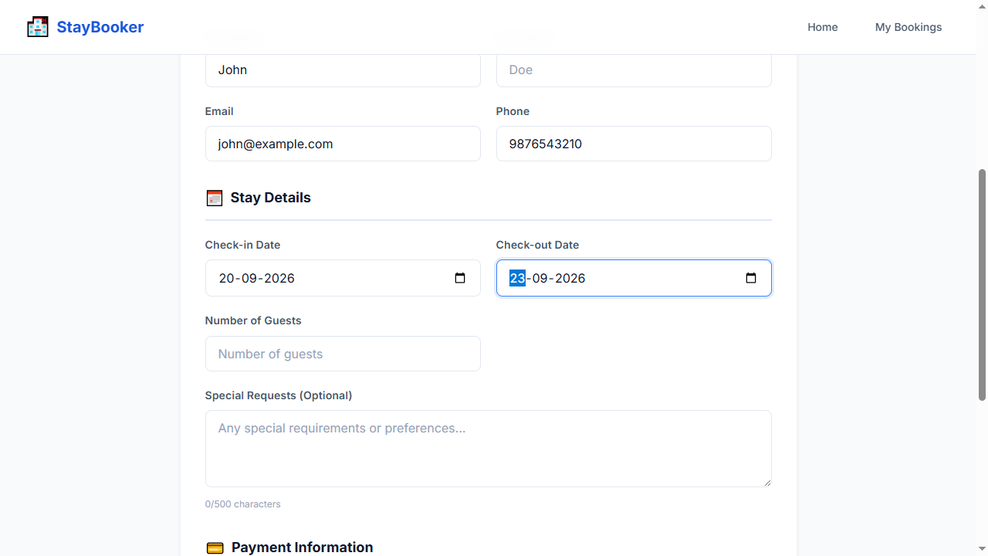
Step 18 — FILL: booking-guests-input = 2
Step 19 — FILL: card-number-input = 4111111111111111
Step 20 — FILL: expiry-input = 12/30
Step 21 — FILL: cvv-input = 123
Step 22 — CLICK: confirm-booking-button
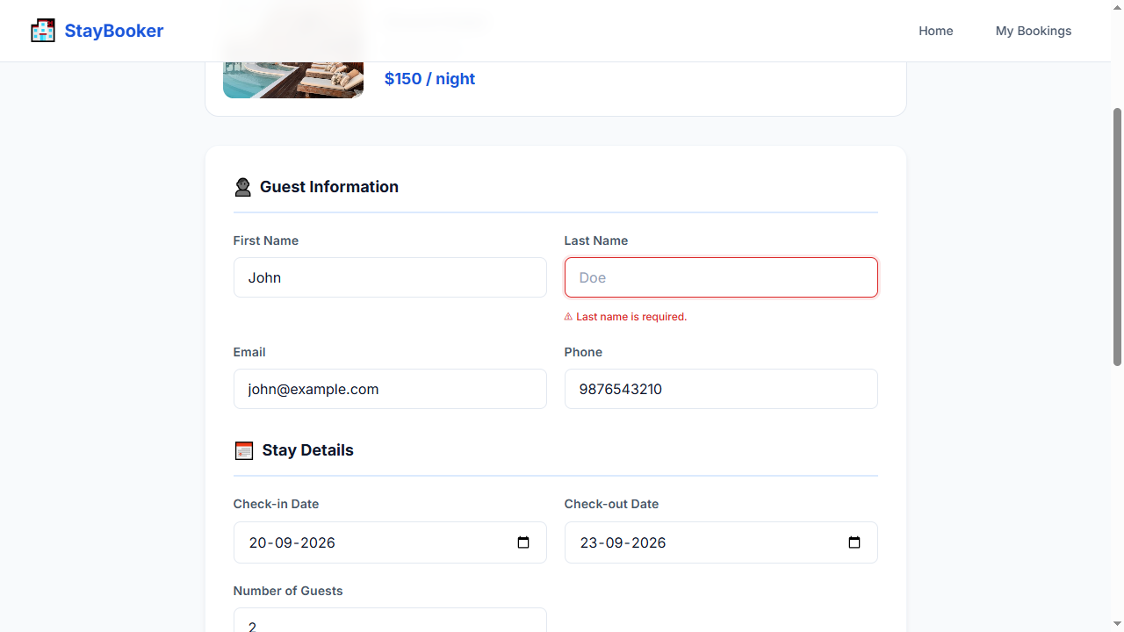
Step 23 — WAIT_FOR: last-name-error
Step 24 — ASSERT_VISIBLE: last-name-error
Step 25 — SCREENSHOT: validation_error

TC-007 — Invalid email format
Test ID: TC-007
Test Name: Invalid email format
Category: Validation
Status: PASS

Expected Result
Email validation error is displayed

Actual Result
The expected workflow completed successfully and all deterministic Playwright checks passed. AI visual verification was UNCERTAIN: Deterministic checks passed; AI was UNCERTAIN on 1 checkpoint(s).

AI Verification
AI Status: UNCERTAIN
AI Observation: Deterministic checks passed; AI was UNCERTAIN on 1 checkpoint(s).
Per-step AI observations:
- Step 25 — SCREENSHOT: validation_error [UNCERTAIN, N/A] AI quota exhausted (429). Reduce AI_VERIFY_EVERY_SCREENSHOT or wait for quota reset. model gemini-3-flash-preview: ClientError: 429 RESOURCE_EXHAUSTED. {'error': {'code': 429, 'message': 'You exceeded your current quota, please check your plan and billing details. For more information on this error, head to: https://ai.google.dev/gemini-api/docs/rate-limits. To m...

Steps
Step | Action | Status | AI Status | Confidence
1 | OPEN: / | PASS | NOT RUN | N/A
2 | FILL: city-input = New York | PASS | NOT RUN | N/A
3 | FILL: checkin-input = 2026-09-20 | PASS | NOT RUN | N/A
4 | FILL: checkout-input = 2026-09-23 | PASS | NOT RUN | N/A
5 | FILL: guests-input = 2 | PASS | NOT RUN | N/A
6 | CLICK: search-button | PASS | NOT RUN | N/A
7 | WAIT_FOR: room-card-1 | PASS | NOT RUN | N/A
8 | CLICK: view-details-1 | PASS | NOT RUN | N/A
9 | WAIT_FOR: room-name | PASS | NOT RUN | N/A
10 | CLICK: book-now-button | PASS | NOT RUN | N/A
11 | WAIT_FOR: first-name-input | PASS | NOT RUN | N/A
12 | FILL: first-name-input = John | PASS | NOT RUN | N/A
13 | FILL: last-name-input = Doe | PASS | NOT RUN | N/A
14 | FILL: email-input = invalid-email | PASS | NOT RUN | N/A
15 | FILL: phone-input = 9876543210 | PASS | NOT RUN | N/A
16 | FILL: booking-checkin-input = 2026-09-20 | PASS | NOT RUN | N/A
17 | FILL: booking-checkout-input = 2026-09-23 | PASS | NOT RUN | N/A
18 | FILL: booking-guests-input = 2 | PASS | NOT RUN | N/A
19 | FILL: card-number-input = 4111111111111111 | PASS | NOT RUN | N/A
20 | FILL: expiry-input = 12/30 | PASS | NOT RUN | N/A
21 | FILL: cvv-input = 123 | PASS | NOT RUN | N/A
22 | CLICK: confirm-booking-button | PASS | NOT RUN | N/A
23 | WAIT_FOR: email-error | PASS | NOT RUN | N/A
24 | ASSERT_VISIBLE: email-error | PASS | NOT RUN | N/A
25 | SCREENSHOT: validation_error | PASS | UNCERTAIN | N/A

Screenshots
Step 1 — OPEN: /
Step 2 — FILL: city-input = New York
Step 3 — FILL: checkin-input = 2026-09-20
Step 4 — FILL: checkout-input = 2026-09-23
Step 5 — FILL: guests-input = 2
Step 6 — CLICK: search-button
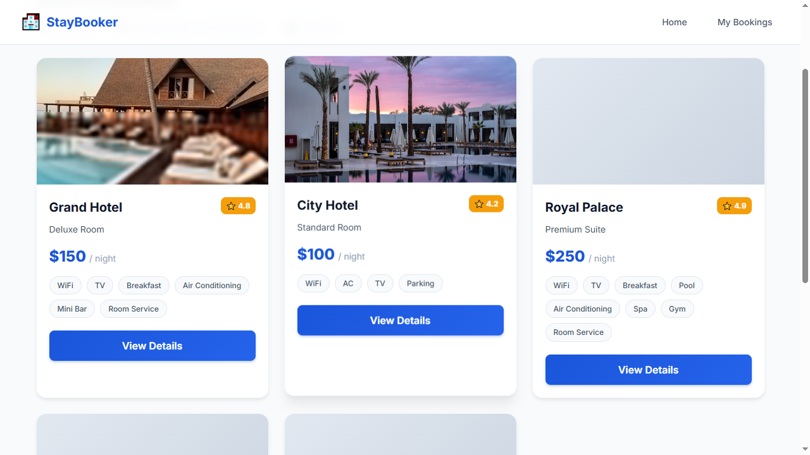
Step 7 — WAIT_FOR: room-card-1
Step 8 — CLICK: view-details-1
Step 9 — WAIT_FOR: room-name
Step 10 — CLICK: book-now-button
Step 11 — WAIT_FOR: first-name-input
Step 12 — FILL: first-name-input = John
Step 13 — FILL: last-name-input = Doe
Step 14 — FILL: email-input = invalid-email
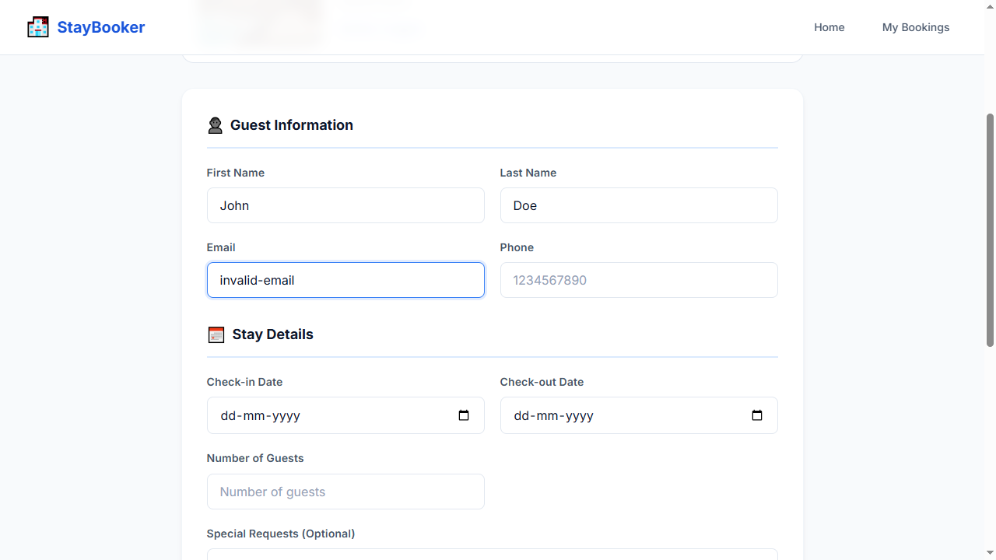
Step 15 — FILL: phone-input = 9876543210
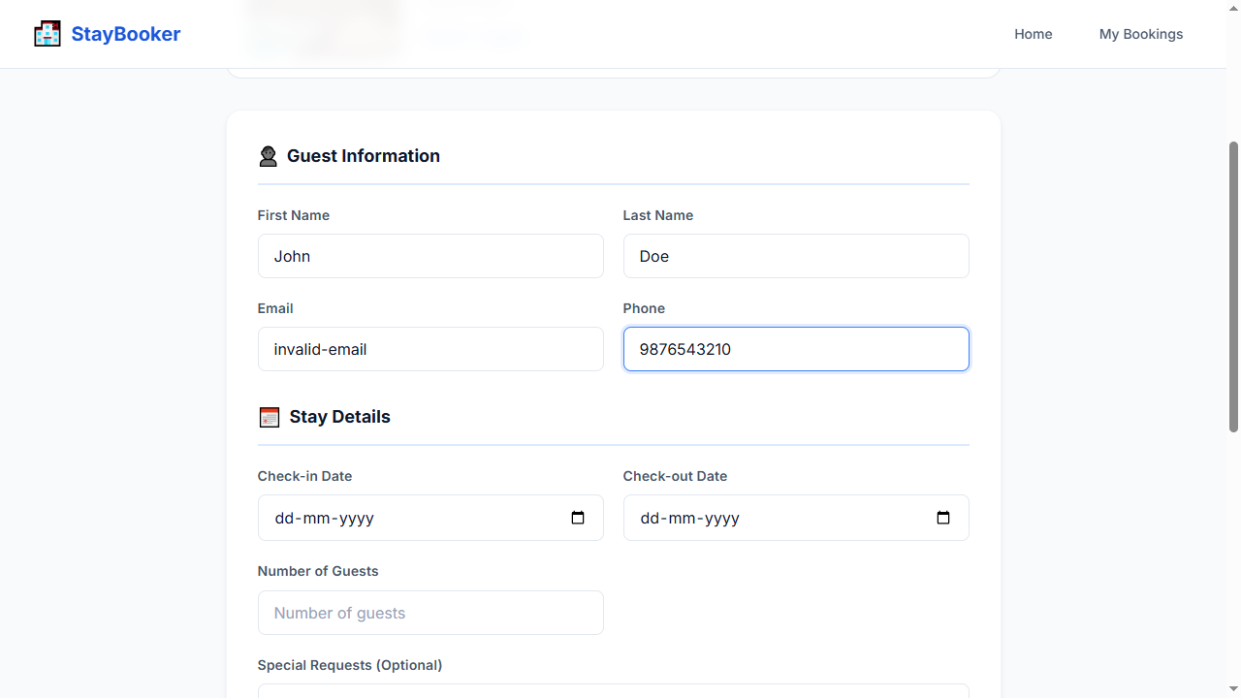
Step 16 — FILL: booking-checkin-input = 2026-09-20
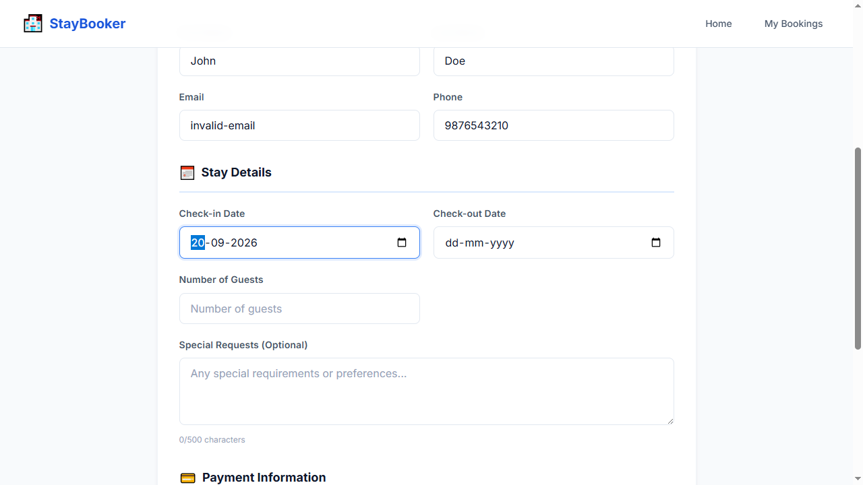
Step 17 — FILL: booking-checkout-input = 2026-09-23
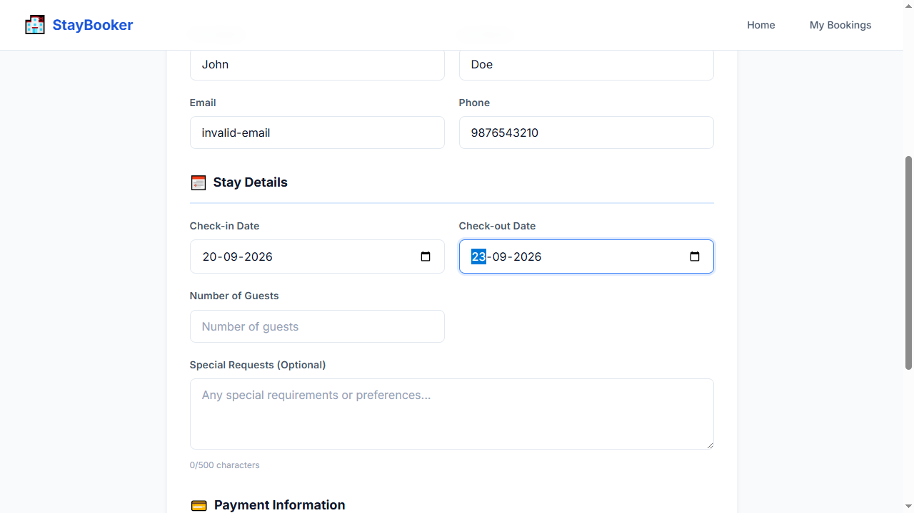
Step 18 — FILL: booking-guests-input = 2
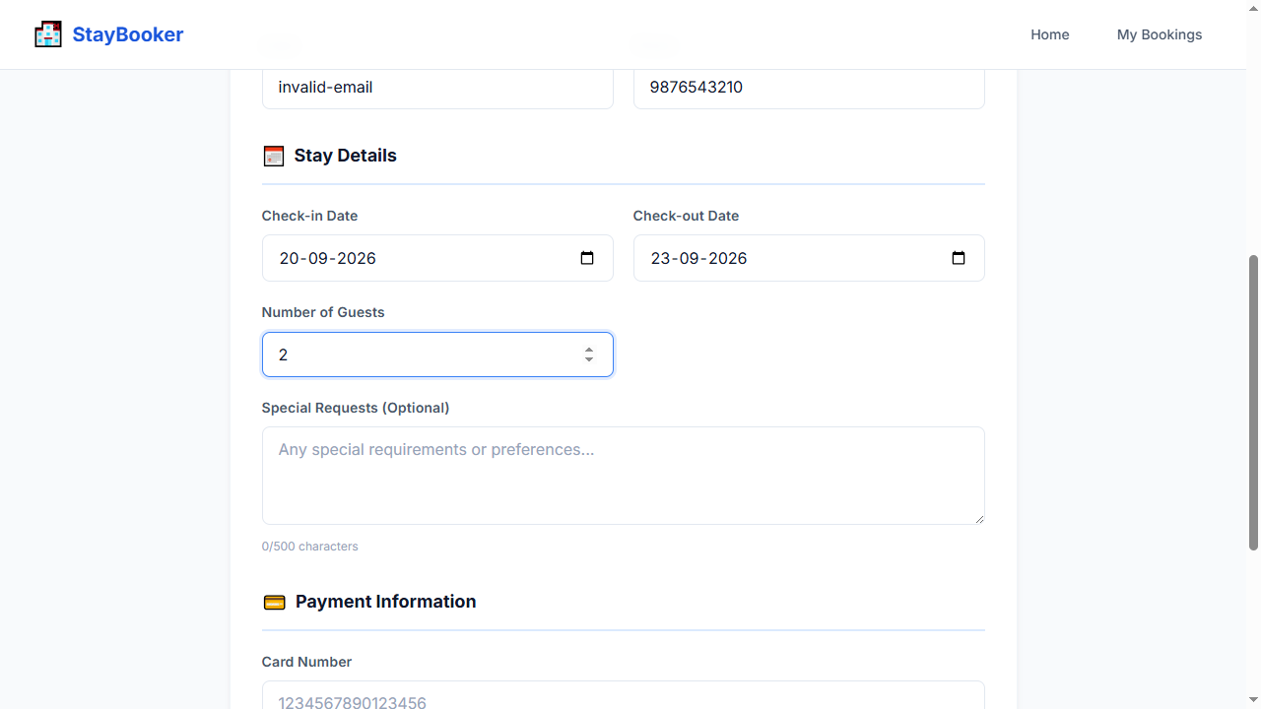
Step 19 — FILL: card-number-input = 4111111111111111
Step 20 — FILL: expiry-input = 12/30
Step 21 — FILL: cvv-input = 123
Step 22 — CLICK: confirm-booking-button
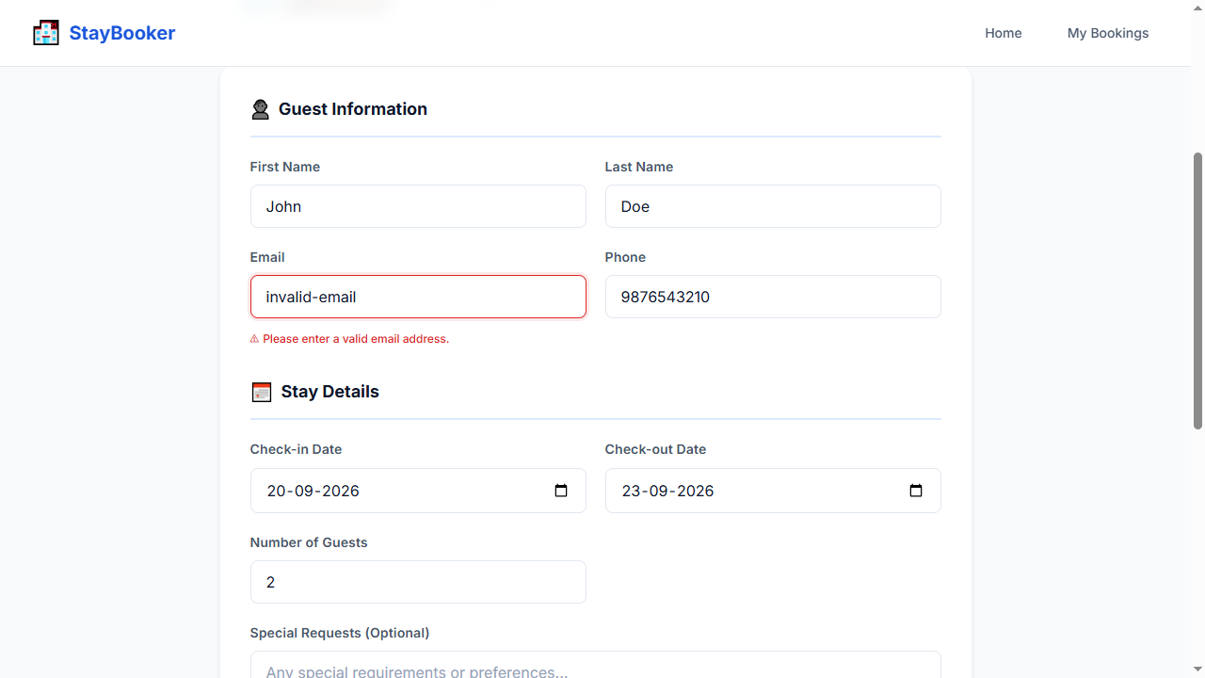
Step 23 — WAIT_FOR: email-error
Step 24 — ASSERT_VISIBLE: email-error
Step 25 — SCREENSHOT: validation_error

TC-008 — Invalid phone (letters)
Test ID: TC-008
Test Name: Invalid phone (letters)
Category: Validation
Status: PASS

Expected Result
Phone validation error is displayed

Actual Result
The expected workflow completed successfully and all deterministic Playwright checks passed. AI visual verification was UNCERTAIN: Deterministic checks passed; AI was UNCERTAIN on 1 checkpoint(s).

AI Verification
AI Status: UNCERTAIN
AI Observation: Deterministic checks passed; AI was UNCERTAIN on 1 checkpoint(s).
Per-step AI observations:
- Step 25 — SCREENSHOT: validation_error [UNCERTAIN, N/A] AI quota exhausted (429). Reduce AI_VERIFY_EVERY_SCREENSHOT or wait for quota reset. model gemini-3-flash-preview: ClientError: 429 RESOURCE_EXHAUSTED. {'error': {'code': 429, 'message': 'You exceeded your current quota, please check your plan and billing details. For more information on this error, head to: https://ai.google.dev/gemini-api/docs/rate-limits. To m...

Steps
Step | Action | Status | AI Status | Confidence
1 | OPEN: / | PASS | NOT RUN | N/A
2 | FILL: city-input = New York | PASS | NOT RUN | N/A
3 | FILL: checkin-input = 2026-09-20 | PASS | NOT RUN | N/A
4 | FILL: checkout-input = 2026-09-23 | PASS | NOT RUN | N/A
5 | FILL: guests-input = 2 | PASS | NOT RUN | N/A
6 | CLICK: search-button | PASS | NOT RUN | N/A
7 | WAIT_FOR: room-card-1 | PASS | NOT RUN | N/A
8 | CLICK: view-details-1 | PASS | NOT RUN | N/A
9 | WAIT_FOR: room-name | PASS | NOT RUN | N/A
10 | CLICK: book-now-button | PASS | NOT RUN | N/A
11 | WAIT_FOR: first-name-input | PASS | NOT RUN | N/A
12 | FILL: first-name-input = John | PASS | NOT RUN | N/A
13 | FILL: last-name-input = Doe | PASS | NOT RUN | N/A
14 | FILL: email-input = john@example.com | PASS | NOT RUN | N/A
15 | FILL: phone-input = abcdefghij | PASS | NOT RUN | N/A
16 | FILL: booking-checkin-input = 2026-09-20 | PASS | NOT RUN | N/A
17 | FILL: booking-checkout-input = 2026-09-23 | PASS | NOT RUN | N/A
18 | FILL: booking-guests-input = 2 | PASS | NOT RUN | N/A
19 | FILL: card-number-input = 4111111111111111 | PASS | NOT RUN | N/A
20 | FILL: expiry-input = 12/30 | PASS | NOT RUN | N/A
21 | FILL: cvv-input = 123 | PASS | NOT RUN | N/A
22 | CLICK: confirm-booking-button | PASS | NOT RUN | N/A
23 | WAIT_FOR: phone-error | PASS | NOT RUN | N/A
24 | ASSERT_VISIBLE: phone-error | PASS | NOT RUN | N/A
25 | SCREENSHOT: validation_error | PASS | UNCERTAIN | N/A

Screenshots
Step 1 — OPEN: /
Step 2 — FILL: city-input = New York
Step 3 — FILL: checkin-input = 2026-09-20
Step 4 — FILL: checkout-input = 2026-09-23
Step 5 — FILL: guests-input = 2
Step 6 — CLICK: search-button
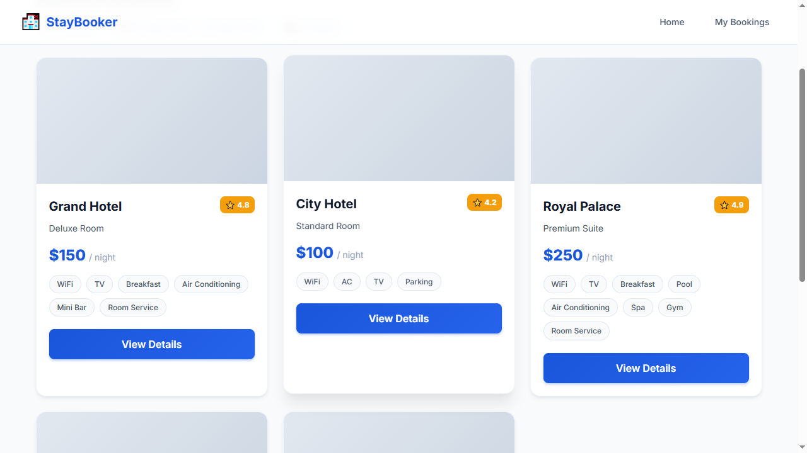
Step 7 — WAIT_FOR: room-card-1
Step 8 — CLICK: view-details-1
Step 9 — WAIT_FOR: room-name
Step 10 — CLICK: book-now-button
Step 11 — WAIT_FOR: first-name-input
Step 12 — FILL: first-name-input = John
Step 13 — FILL: last-name-input = Doe
Step 14 — FILL: email-input = john@example.com
Step 15 — FILL: phone-input = abcdefghij
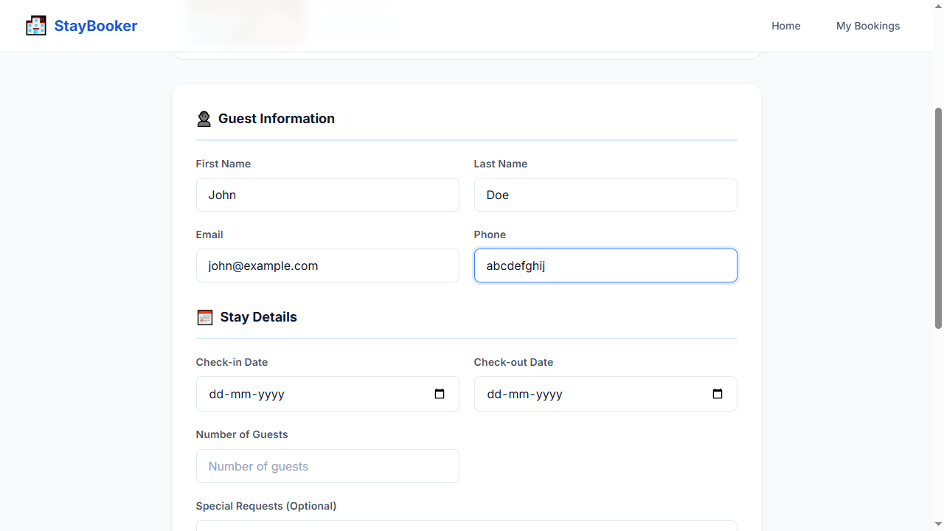
Step 16 — FILL: booking-checkin-input = 2026-09-20
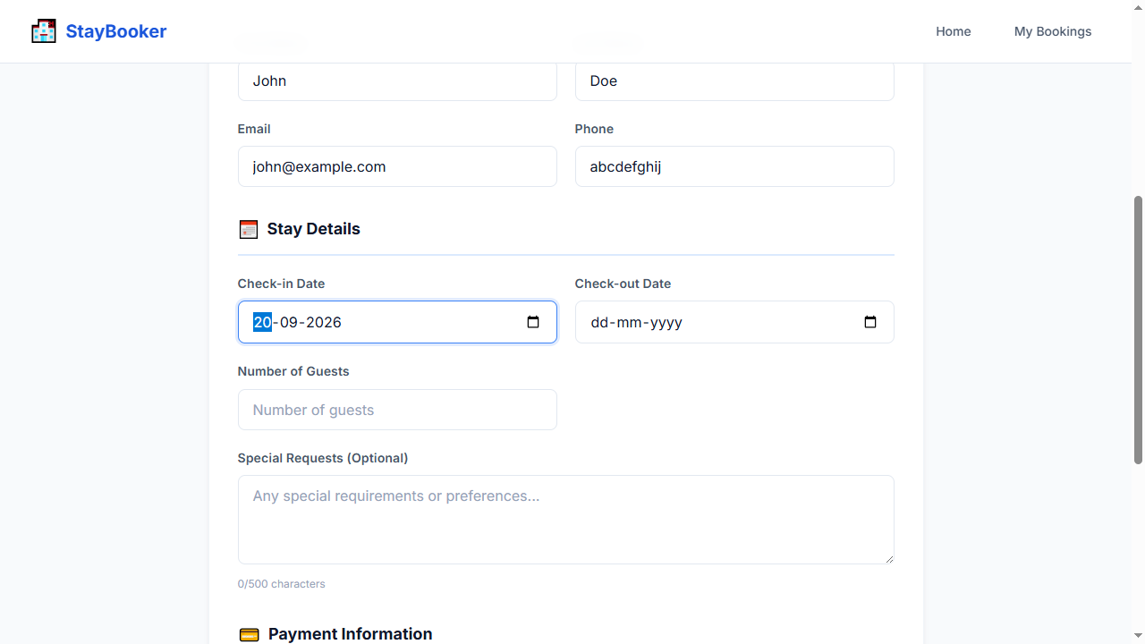
Step 17 — FILL: booking-checkout-input = 2026-09-23
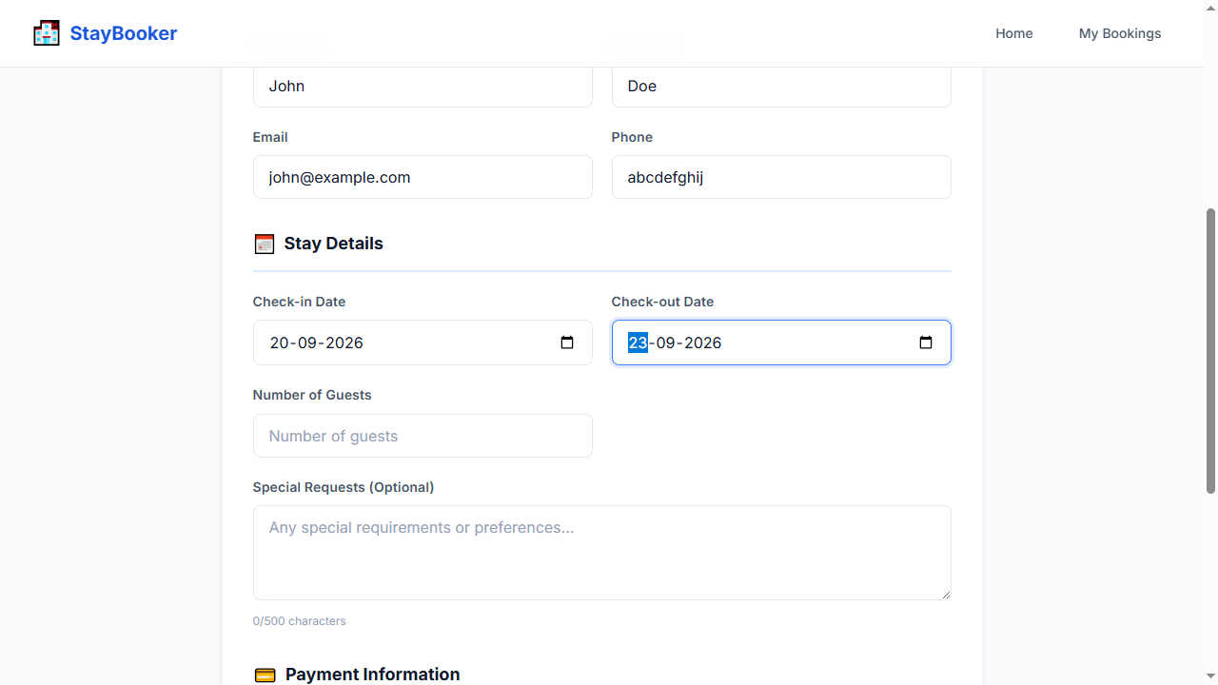
Step 18 — FILL: booking-guests-input = 2
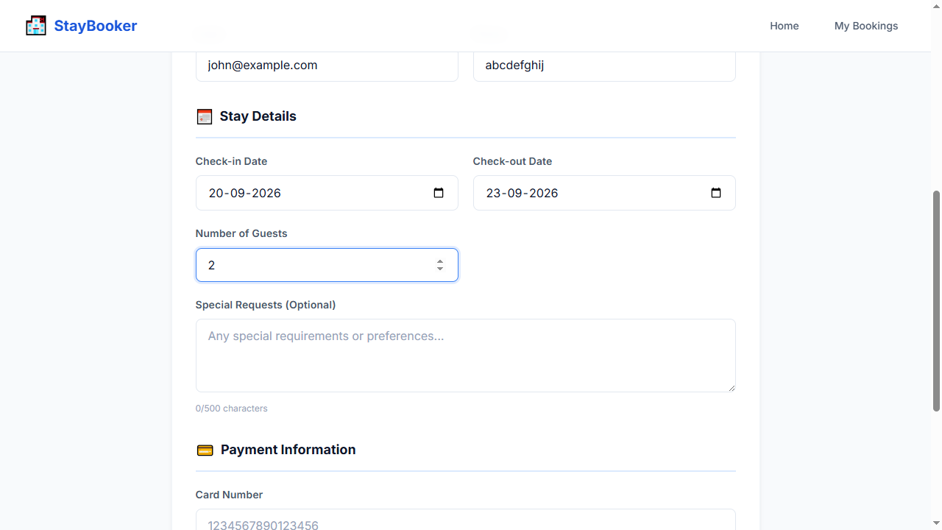
Step 19 — FILL: card-number-input = 4111111111111111
Step 20 — FILL: expiry-input = 12/30
Step 21 — FILL: cvv-input = 123
Step 22 — CLICK: confirm-booking-button
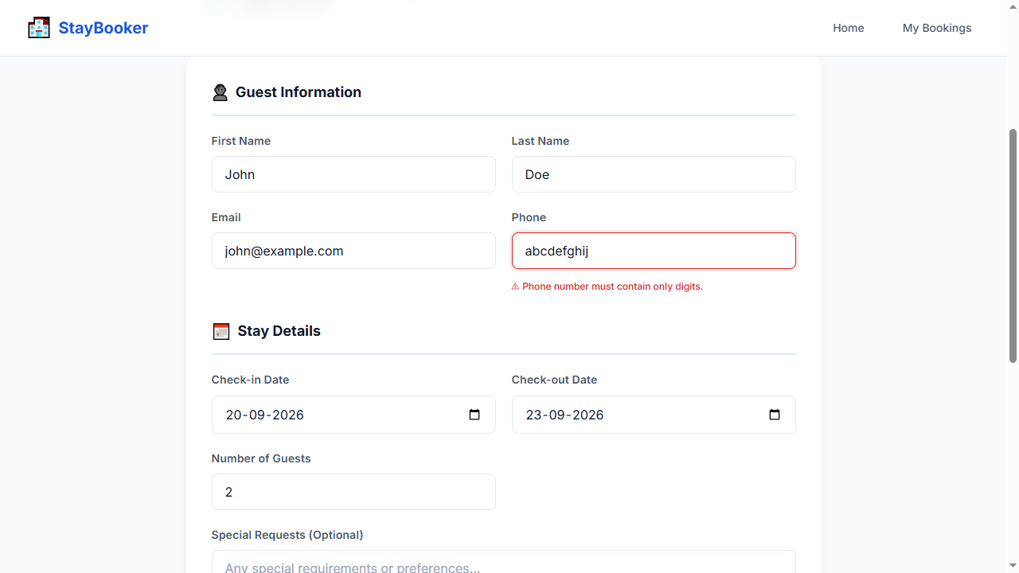
Step 23 — WAIT_FOR: phone-error
Step 24 — ASSERT_VISIBLE: phone-error
Step 25 — SCREENSHOT: validation_error

TC-009 — Phone less than 10 digits
Test ID: TC-009
Test Name: Phone less than 10 digits
Category: Validation
Status: PASS

Expected Result
Phone length validation error is displayed

Actual Result
The expected workflow completed successfully and all deterministic Playwright checks passed. AI visual verification was UNCERTAIN: Deterministic checks passed; AI was UNCERTAIN on 1 checkpoint(s).

AI Verification
AI Status: UNCERTAIN
AI Observation: Deterministic checks passed; AI was UNCERTAIN on 1 checkpoint(s).
Per-step AI observations:
- Step 25 — SCREENSHOT: validation_error [UNCERTAIN, N/A] AI quota exhausted (429). Reduce AI_VERIFY_EVERY_SCREENSHOT or wait for quota reset. model gemini-3-flash-preview: ClientError: 429 RESOURCE_EXHAUSTED. {'error': {'code': 429, 'message': 'You exceeded your current quota, please check your plan and billing details. For more information on this error, head to: https://ai.google.dev/gemini-api/docs/rate-limits. To m...

Steps
Step | Action | Status | AI Status | Confidence
1 | OPEN: / | PASS | NOT RUN | N/A
2 | FILL: city-input = New York | PASS | NOT RUN | N/A
3 | FILL: checkin-input = 2026-09-20 | PASS | NOT RUN | N/A
4 | FILL: checkout-input = 2026-09-23 | PASS | NOT RUN | N/A
5 | FILL: guests-input = 2 | PASS | NOT RUN | N/A
6 | CLICK: search-button | PASS | NOT RUN | N/A
7 | WAIT_FOR: room-card-1 | PASS | NOT RUN | N/A
8 | CLICK: view-details-1 | PASS | NOT RUN | N/A
9 | WAIT_FOR: room-name | PASS | NOT RUN | N/A
10 | CLICK: book-now-button | PASS | NOT RUN | N/A
11 | WAIT_FOR: first-name-input | PASS | NOT RUN | N/A
12 | FILL: first-name-input = John | PASS | NOT RUN | N/A
13 | FILL: last-name-input = Doe | PASS | NOT RUN | N/A
14 | FILL: email-input = john@example.com | PASS | NOT RUN | N/A
15 | FILL: phone-input = 12345 | PASS | NOT RUN | N/A
16 | FILL: booking-checkin-input = 2026-09-20 | PASS | NOT RUN | N/A
17 | FILL: booking-checkout-input = 2026-09-23 | PASS | NOT RUN | N/A
18 | FILL: booking-guests-input = 2 | PASS | NOT RUN | N/A
19 | FILL: card-number-input = 4111111111111111 | PASS | NOT RUN | N/A
20 | FILL: expiry-input = 12/30 | PASS | NOT RUN | N/A
21 | FILL: cvv-input = 123 | PASS | NOT RUN | N/A
22 | CLICK: confirm-booking-button | PASS | NOT RUN | N/A
23 | WAIT_FOR: phone-error | PASS | NOT RUN | N/A
24 | ASSERT_VISIBLE: phone-error | PASS | NOT RUN | N/A
25 | SCREENSHOT: validation_error | PASS | UNCERTAIN | N/A

Screenshots
Step 1 — OPEN: /
Step 2 — FILL: city-input = New York
Step 3 — FILL: checkin-input = 2026-09-20
Step 4 — FILL: checkout-input = 2026-09-23
Step 5 — FILL: guests-input = 2
Step 6 — CLICK: search-button
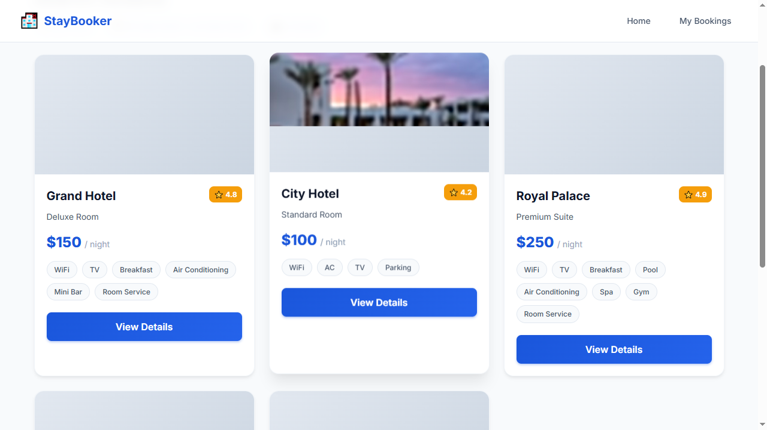
Step 7 — WAIT_FOR: room-card-1
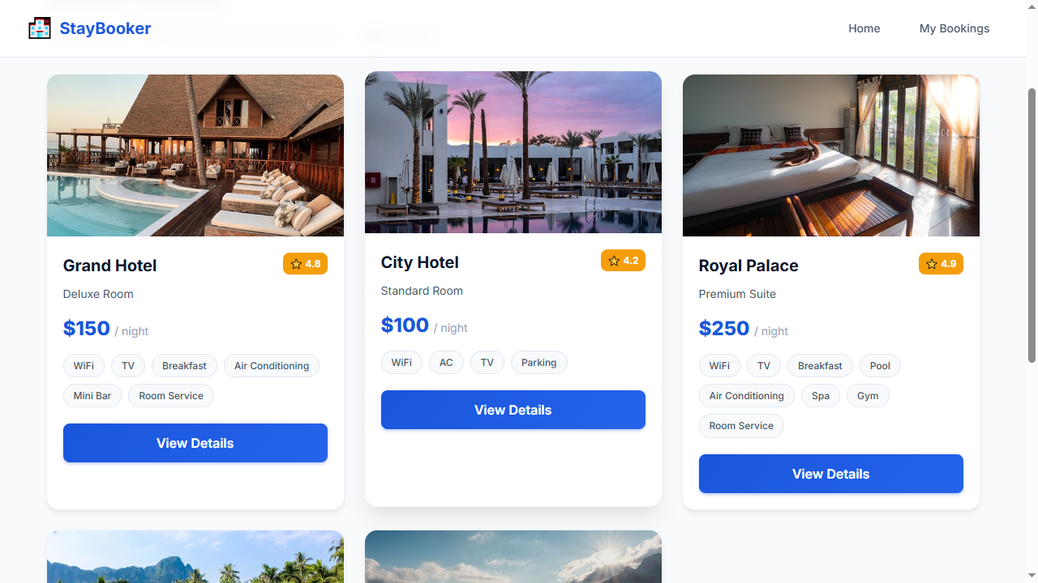
Step 8 — CLICK: view-details-1
Step 9 — WAIT_FOR: room-name
Step 10 — CLICK: book-now-button
Step 11 — WAIT_FOR: first-name-input
Step 12 — FILL: first-name-input = John
Step 13 — FILL: last-name-input = Doe
Step 14 — FILL: email-input = john@example.com
Step 15 — FILL: phone-input = 12345
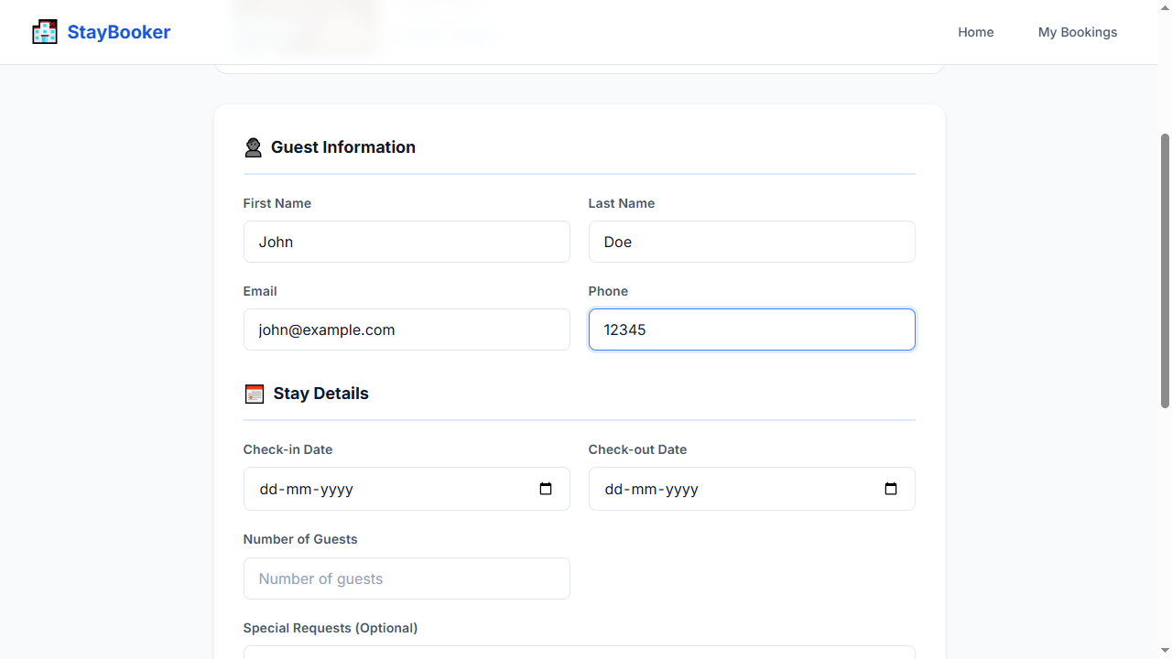
Step 16 — FILL: booking-checkin-input = 2026-09-20
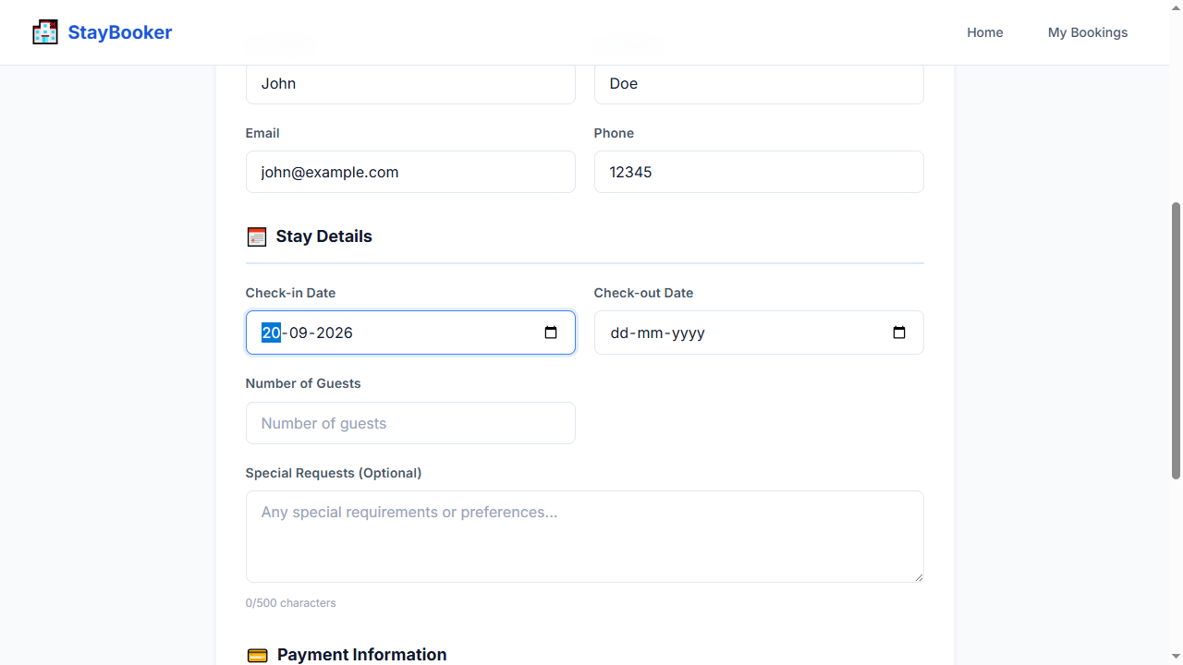
Step 17 — FILL: booking-checkout-input = 2026-09-23
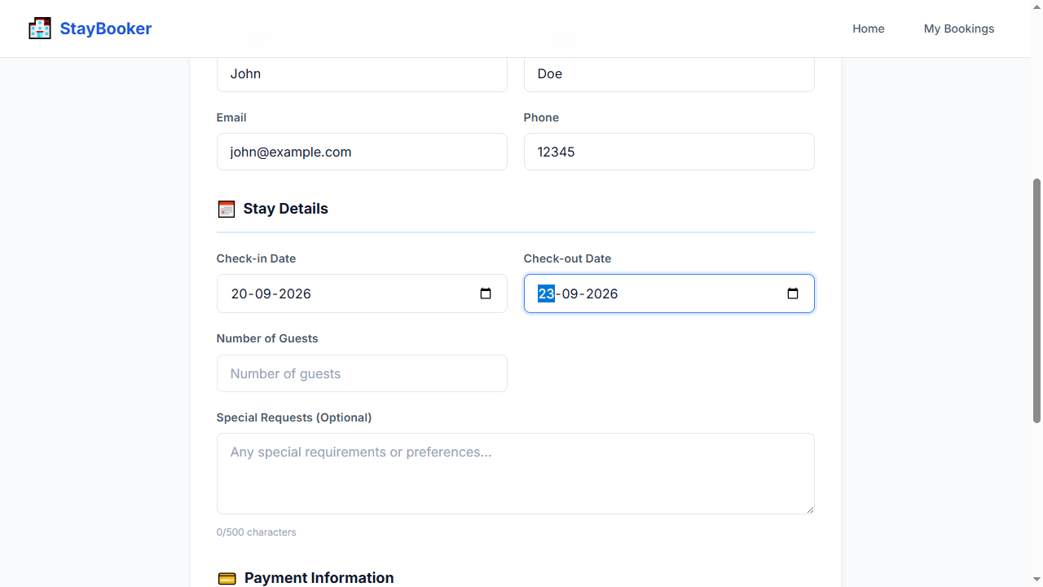
Step 18 — FILL: booking-guests-input = 2
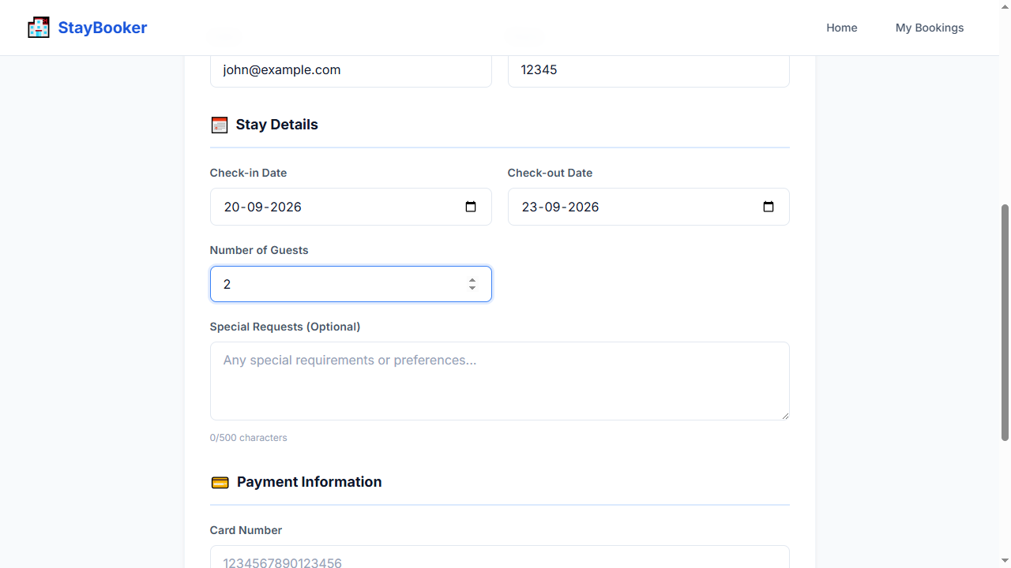
Step 19 — FILL: card-number-input = 4111111111111111
Step 20 — FILL: expiry-input = 12/30
Step 21 — FILL: cvv-input = 123
Step 22 — CLICK: confirm-booking-button
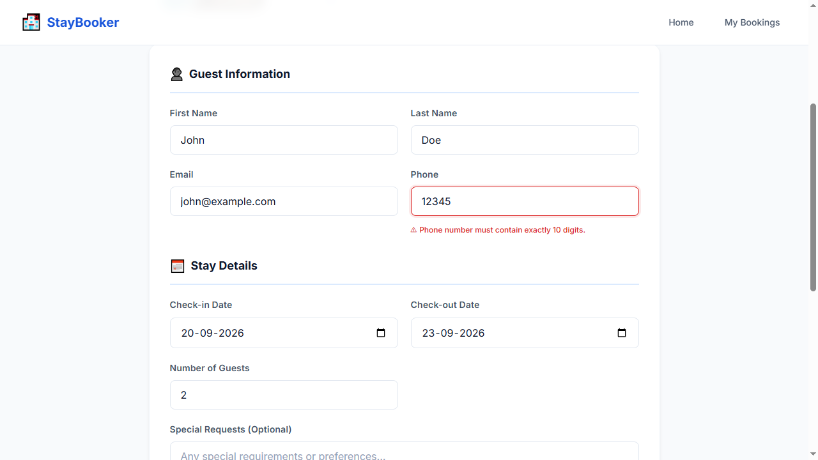
Step 23 — WAIT_FOR: phone-error
Step 24 — ASSERT_VISIBLE: phone-error
Step 25 — SCREENSHOT: validation_error

TC-010 — Check-out before check-in
Test ID: TC-010
Test Name: Check-out before check-in
Category: Validation
Status: PASS

Expected Result
Check-out validation error is displayed

Actual Result
The expected workflow completed successfully and all deterministic Playwright checks passed. AI visual verification was UNCERTAIN: Deterministic checks passed; AI was UNCERTAIN on 1 checkpoint(s).

AI Verification
AI Status: UNCERTAIN
AI Observation: Deterministic checks passed; AI was UNCERTAIN on 1 checkpoint(s).
Per-step AI observations:
- Step 25 — SCREENSHOT: validation_error [UNCERTAIN, N/A] AI quota exhausted (429). Reduce AI_VERIFY_EVERY_SCREENSHOT or wait for quota reset. model gemini-3-flash-preview: ClientError: 429 RESOURCE_EXHAUSTED. {'error': {'code': 429, 'message': 'You exceeded your current quota, please check your plan and billing details. For more information on this error, head to: https://ai.google.dev/gemini-api/docs/rate-limits. To m...

Steps
Step | Action | Status | AI Status | Confidence
1 | OPEN: / | PASS | NOT RUN | N/A
2 | FILL: city-input = New York | PASS | NOT RUN | N/A
3 | FILL: checkin-input = 2026-09-20 | PASS | NOT RUN | N/A
4 | FILL: checkout-input = 2026-09-23 | PASS | NOT RUN | N/A
5 | FILL: guests-input = 2 | PASS | NOT RUN | N/A
6 | CLICK: search-button | PASS | NOT RUN | N/A
7 | WAIT_FOR: room-card-1 | PASS | NOT RUN | N/A
8 | CLICK: view-details-1 | PASS | NOT RUN | N/A
9 | WAIT_FOR: room-name | PASS | NOT RUN | N/A
10 | CLICK: book-now-button | PASS | NOT RUN | N/A
11 | WAIT_FOR: first-name-input | PASS | NOT RUN | N/A
12 | FILL: first-name-input = John | PASS | NOT RUN | N/A
13 | FILL: last-name-input = Doe | PASS | NOT RUN | N/A
14 | FILL: email-input = john@example.com | PASS | NOT RUN | N/A
15 | FILL: phone-input = 9876543210 | PASS | NOT RUN | N/A
16 | FILL: booking-checkin-input = 2026-09-20 | PASS | NOT RUN | N/A
17 | FILL: booking-checkout-input = 2026-09-18 | PASS | NOT RUN | N/A
18 | FILL: booking-guests-input = 2 | PASS | NOT RUN | N/A
19 | FILL: card-number-input = 4111111111111111 | PASS | NOT RUN | N/A
20 | FILL: expiry-input = 12/30 | PASS | NOT RUN | N/A
21 | FILL: cvv-input = 123 | PASS | NOT RUN | N/A
22 | CLICK: confirm-booking-button | PASS | NOT RUN | N/A
23 | WAIT_FOR: booking-checkout-error | PASS | NOT RUN | N/A
24 | ASSERT_VISIBLE: booking-checkout-error | PASS | NOT RUN | N/A
25 | SCREENSHOT: validation_error | PASS | UNCERTAIN | N/A

Screenshots
Step 1 — OPEN: /
Step 2 — FILL: city-input = New York
Step 3 — FILL: checkin-input = 2026-09-20
Step 4 — FILL: checkout-input = 2026-09-23
Step 5 — FILL: guests-input = 2
Step 6 — CLICK: search-button
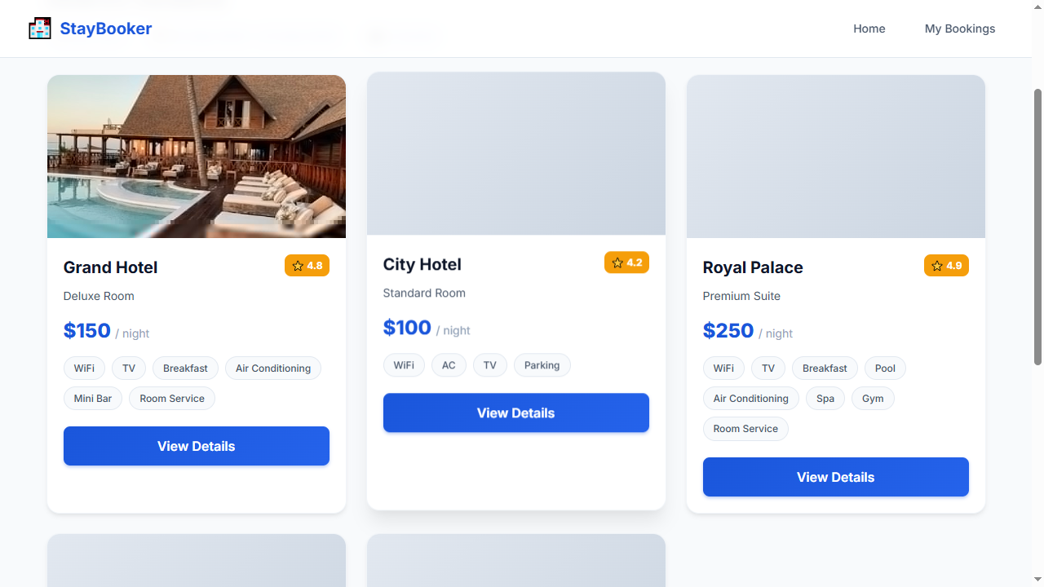
Step 7 — WAIT_FOR: room-card-1
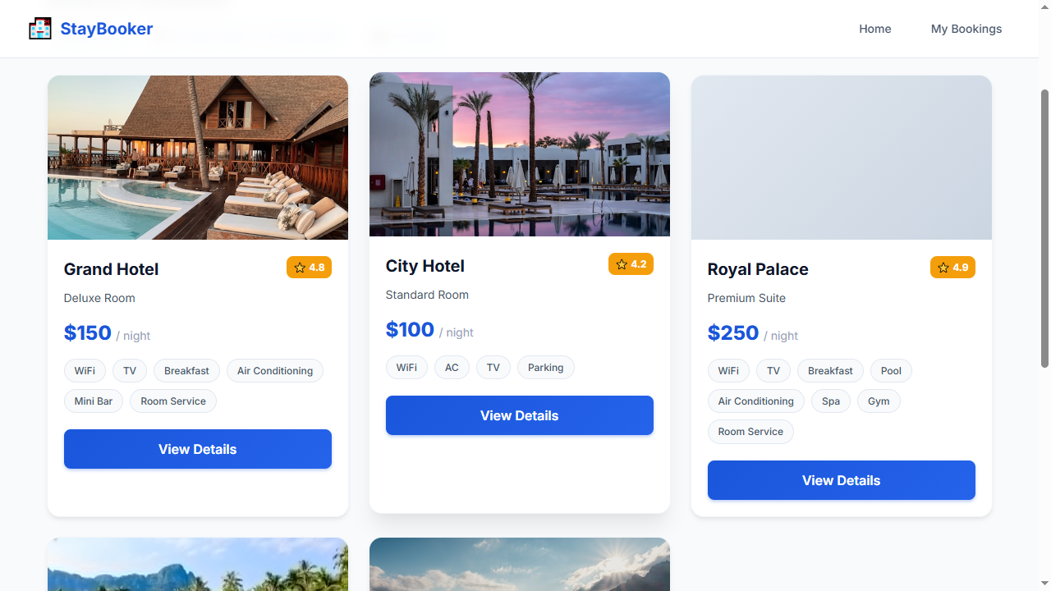
Step 8 — CLICK: view-details-1
Step 9 — WAIT_FOR: room-name
Step 10 — CLICK: book-now-button
Step 11 — WAIT_FOR: first-name-input
Step 12 — FILL: first-name-input = John
Step 13 — FILL: last-name-input = Doe
Step 14 — FILL: email-input = john@example.com
Step 15 — FILL: phone-input = 9876543210
Step 16 — FILL: booking-checkin-input = 2026-09-20
Step 17 — FILL: booking-checkout-input = 2026-09-18
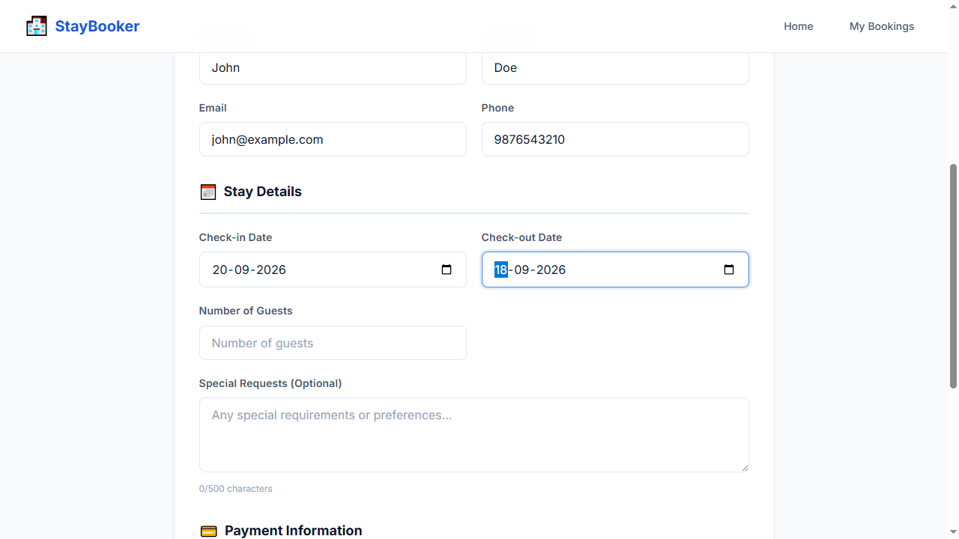
Step 18 — FILL: booking-guests-input = 2
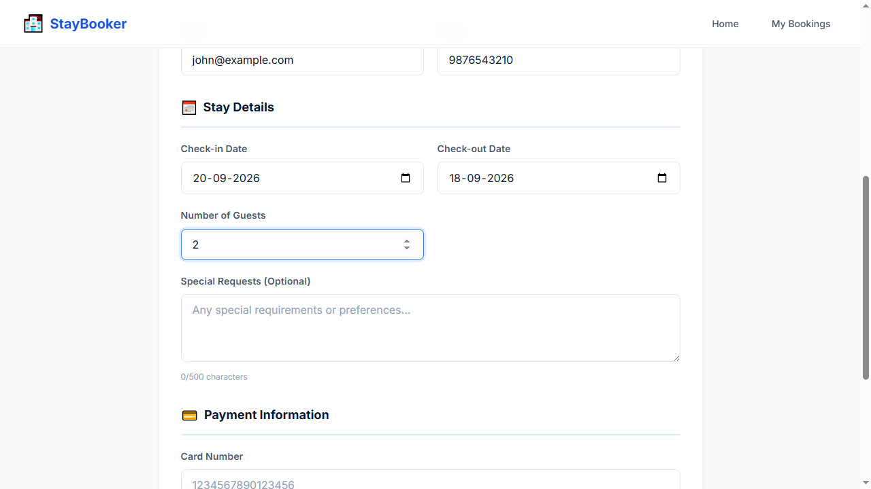
Step 19 — FILL: card-number-input = 4111111111111111
Step 20 — FILL: expiry-input = 12/30
Step 21 — FILL: cvv-input = 123
Step 22 — CLICK: confirm-booking-button
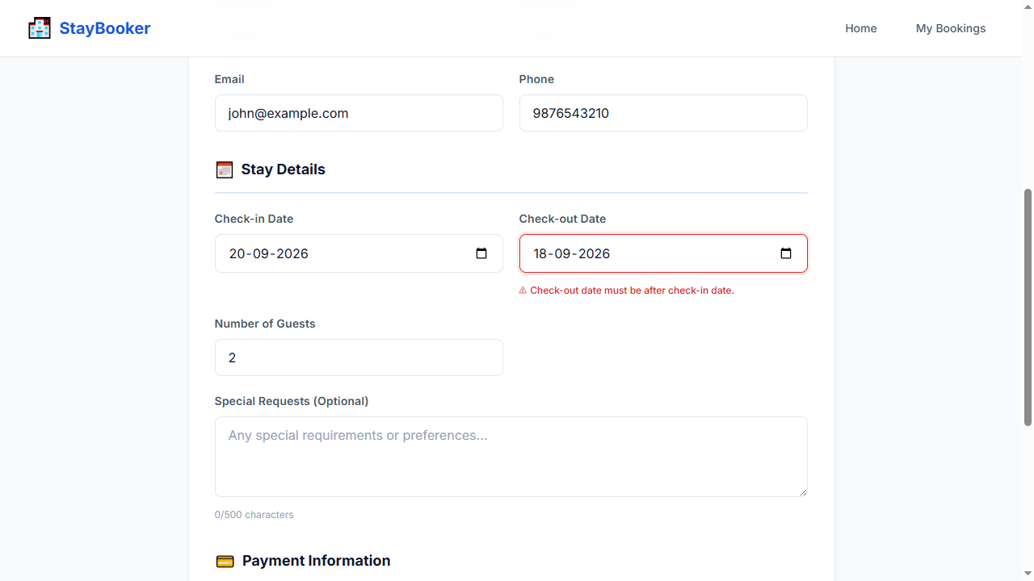
Step 23 — WAIT_FOR: booking-checkout-error
Step 24 — ASSERT_VISIBLE: booking-checkout-error
Step 25 — SCREENSHOT: validation_error

TC-011 — Guests = 0
Test ID: TC-011
Test Name: Guests = 0
Category: Validation
Status: PASS

Expected Result
Guests min validation error is displayed

Actual Result
The expected workflow completed successfully and all deterministic Playwright checks passed. AI visual verification was UNCERTAIN: Deterministic checks passed; AI was UNCERTAIN on 1 checkpoint(s).

AI Verification
AI Status: UNCERTAIN
AI Observation: Deterministic checks passed; AI was UNCERTAIN on 1 checkpoint(s).
Per-step AI observations:
- Step 25 — SCREENSHOT: validation_error [UNCERTAIN, N/A] AI quota exhausted (429). Reduce AI_VERIFY_EVERY_SCREENSHOT or wait for quota reset. model gemini-3-flash-preview: ClientError: 429 RESOURCE_EXHAUSTED. {'error': {'code': 429, 'message': 'You exceeded your current quota, please check your plan and billing details. For more information on this error, head to: https://ai.google.dev/gemini-api/docs/rate-limits. To m...

Steps
Step | Action | Status | AI Status | Confidence
1 | OPEN: / | PASS | NOT RUN | N/A
2 | FILL: city-input = New York | PASS | NOT RUN | N/A
3 | FILL: checkin-input = 2026-09-20 | PASS | NOT RUN | N/A
4 | FILL: checkout-input = 2026-09-23 | PASS | NOT RUN | N/A
5 | FILL: guests-input = 2 | PASS | NOT RUN | N/A
6 | CLICK: search-button | PASS | NOT RUN | N/A
7 | WAIT_FOR: room-card-1 | PASS | NOT RUN | N/A
8 | CLICK: view-details-1 | PASS | NOT RUN | N/A
9 | WAIT_FOR: room-name | PASS | NOT RUN | N/A
10 | CLICK: book-now-button | PASS | NOT RUN | N/A
11 | WAIT_FOR: first-name-input | PASS | NOT RUN | N/A
12 | FILL: first-name-input = John | PASS | NOT RUN | N/A
13 | FILL: last-name-input = Doe | PASS | NOT RUN | N/A
14 | FILL: email-input = john@example.com | PASS | NOT RUN | N/A
15 | FILL: phone-input = 9876543210 | PASS | NOT RUN | N/A
16 | FILL: booking-checkin-input = 2026-09-20 | PASS | NOT RUN | N/A
17 | FILL: booking-checkout-input = 2026-09-23 | PASS | NOT RUN | N/A
18 | FILL: booking-guests-input = 0 | PASS | NOT RUN | N/A
19 | FILL: card-number-input = 4111111111111111 | PASS | NOT RUN | N/A
20 | FILL: expiry-input = 12/30 | PASS | NOT RUN | N/A
21 | FILL: cvv-input = 123 | PASS | NOT RUN | N/A
22 | CLICK: confirm-booking-button | PASS | NOT RUN | N/A
23 | WAIT_FOR: booking-guests-error | PASS | NOT RUN | N/A
24 | ASSERT_VISIBLE: booking-guests-error | PASS | NOT RUN | N/A
25 | SCREENSHOT: validation_error | PASS | UNCERTAIN | N/A

Screenshots
Step 1 — OPEN: /
Step 2 — FILL: city-input = New York
Step 3 — FILL: checkin-input = 2026-09-20
Step 4 — FILL: checkout-input = 2026-09-23
Step 5 — FILL: guests-input = 2
Step 6 — CLICK: search-button
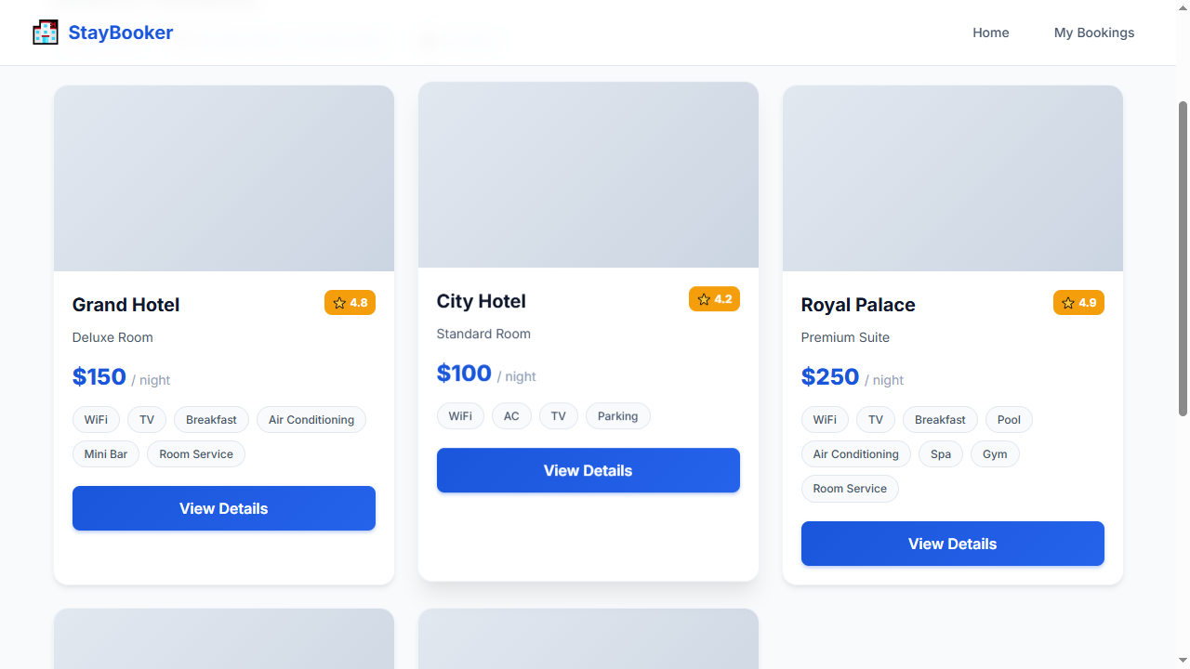
Step 7 — WAIT_FOR: room-card-1
Step 8 — CLICK: view-details-1
Step 9 — WAIT_FOR: room-name
Step 10 — CLICK: book-now-button
Step 11 — WAIT_FOR: first-name-input
Step 12 — FILL: first-name-input = John
Step 13 — FILL: last-name-input = Doe
Step 14 — FILL: email-input = john@example.com
Step 15 — FILL: phone-input = 9876543210
Step 16 — FILL: booking-checkin-input = 2026-09-20
Step 17 — FILL: booking-checkout-input = 2026-09-23
Step 18 — FILL: booking-guests-input = 0
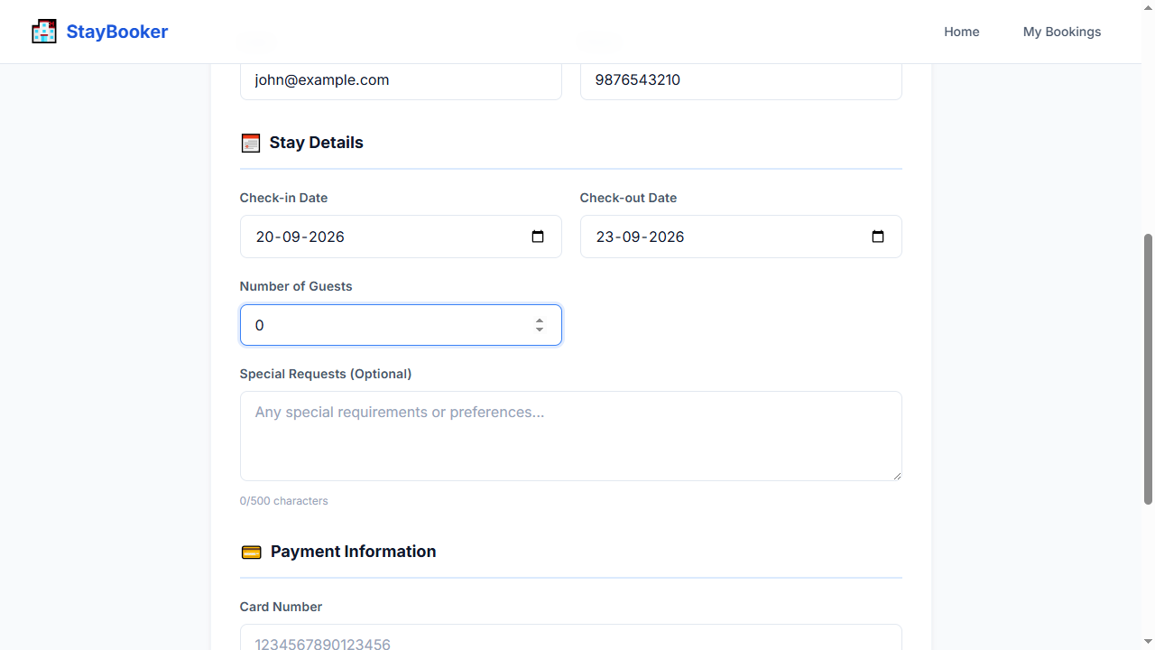
Step 19 — FILL: card-number-input = 4111111111111111
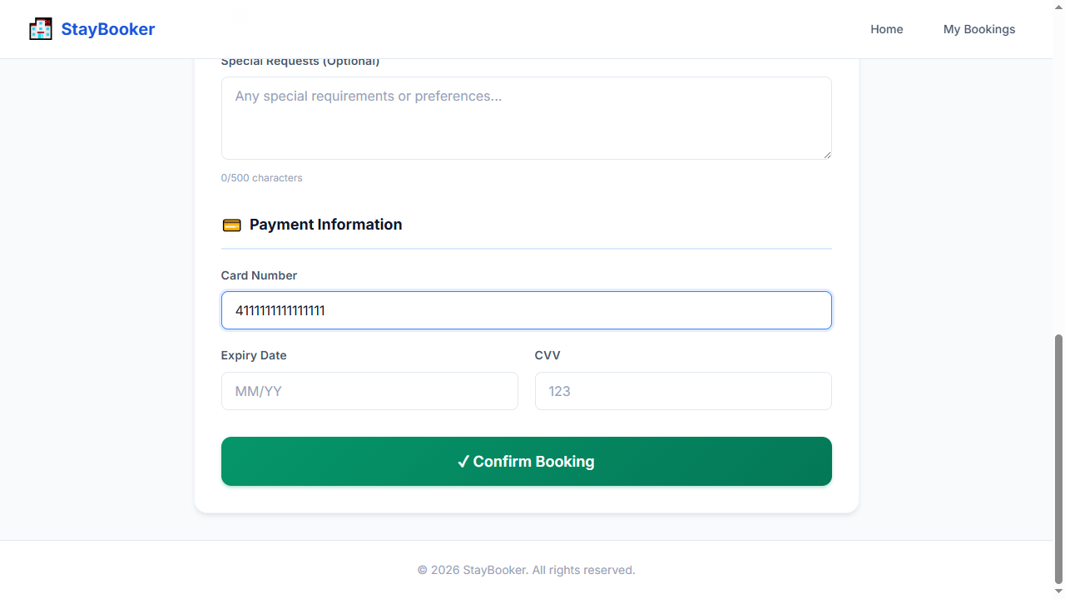
Step 20 — FILL: expiry-input = 12/30
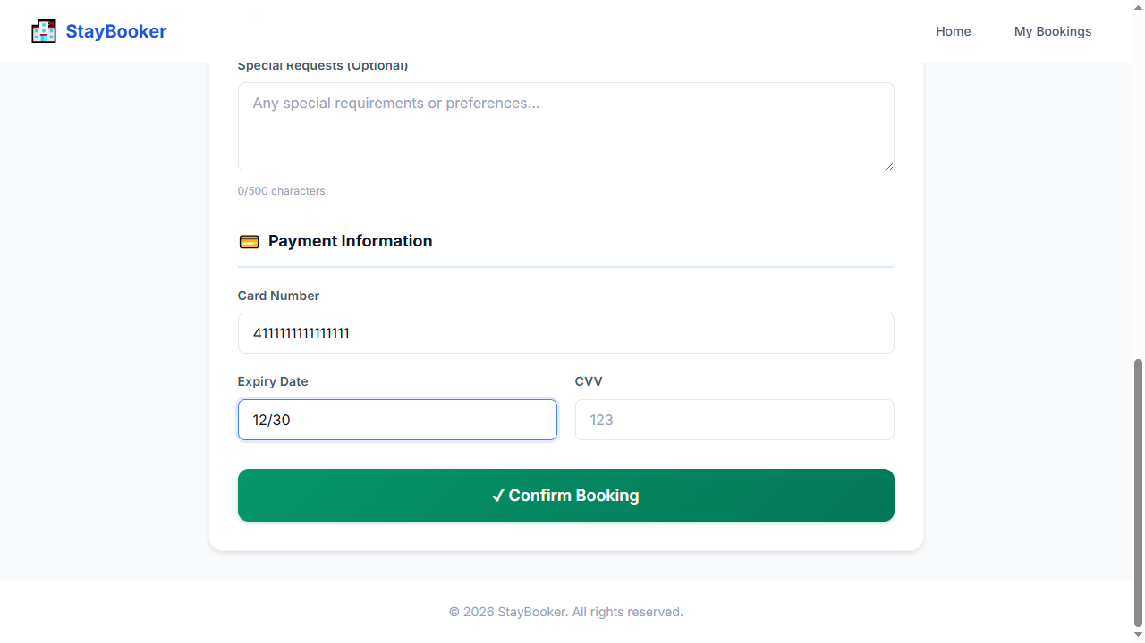
Step 21 — FILL: cvv-input = 123
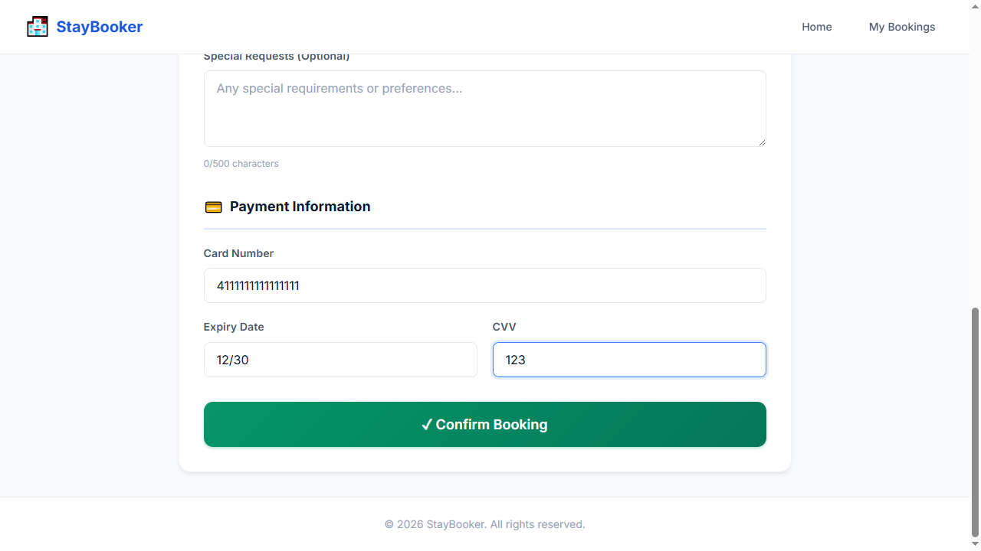
Step 22 — CLICK: confirm-booking-button
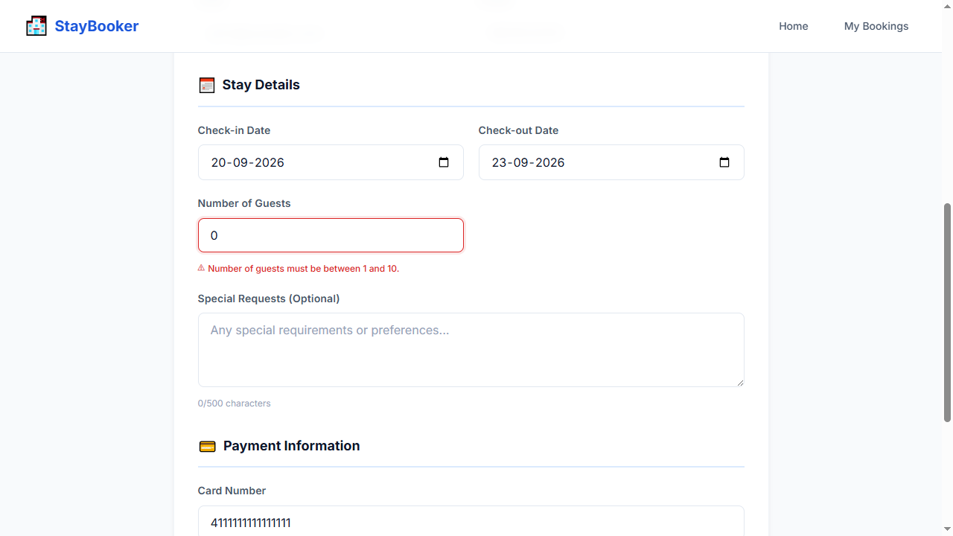
Step 23 — WAIT_FOR: booking-guests-error
Step 24 — ASSERT_VISIBLE: booking-guests-error
Step 25 — SCREENSHOT: validation_error

TC-012 — Guests > 10
Test ID: TC-012
Test Name: Guests > 10
Category: Validation
Status: PASS

Expected Result
Guests max validation error is displayed

Actual Result
The expected workflow completed successfully and all deterministic Playwright checks passed. AI visual verification was UNCERTAIN: Deterministic checks passed; AI was UNCERTAIN on 1 checkpoint(s).

AI Verification
AI Status: UNCERTAIN
AI Observation: Deterministic checks passed; AI was UNCERTAIN on 1 checkpoint(s).
Per-step AI observations:
- Step 25 — SCREENSHOT: validation_error [UNCERTAIN, N/A] AI quota exhausted (429). Reduce AI_VERIFY_EVERY_SCREENSHOT or wait for quota reset. model gemini-3-flash-preview: ClientError: 429 RESOURCE_EXHAUSTED. {'error': {'code': 429, 'message': 'You exceeded your current quota, please check your plan and billing details. For more information on this error, head to: https://ai.google.dev/gemini-api/docs/rate-limits. To m...

Steps
Step | Action | Status | AI Status | Confidence
1 | OPEN: / | PASS | NOT RUN | N/A
2 | FILL: city-input = New York | PASS | NOT RUN | N/A
3 | FILL: checkin-input = 2026-09-20 | PASS | NOT RUN | N/A
4 | FILL: checkout-input = 2026-09-23 | PASS | NOT RUN | N/A
5 | FILL: guests-input = 2 | PASS | NOT RUN | N/A
6 | CLICK: search-button | PASS | NOT RUN | N/A
7 | WAIT_FOR: room-card-1 | PASS | NOT RUN | N/A
8 | CLICK: view-details-1 | PASS | NOT RUN | N/A
9 | WAIT_FOR: room-name | PASS | NOT RUN | N/A
10 | CLICK: book-now-button | PASS | NOT RUN | N/A
11 | WAIT_FOR: first-name-input | PASS | NOT RUN | N/A
12 | FILL: first-name-input = John | PASS | NOT RUN | N/A
13 | FILL: last-name-input = Doe | PASS | NOT RUN | N/A
14 | FILL: email-input = john@example.com | PASS | NOT RUN | N/A
15 | FILL: phone-input = 9876543210 | PASS | NOT RUN | N/A
16 | FILL: booking-checkin-input = 2026-09-20 | PASS | NOT RUN | N/A
17 | FILL: booking-checkout-input = 2026-09-23 | PASS | NOT RUN | N/A
18 | FILL: booking-guests-input = 11 | PASS | NOT RUN | N/A
19 | FILL: card-number-input = 4111111111111111 | PASS | NOT RUN | N/A
20 | FILL: expiry-input = 12/30 | PASS | NOT RUN | N/A
21 | FILL: cvv-input = 123 | PASS | NOT RUN | N/A
22 | CLICK: confirm-booking-button | PASS | NOT RUN | N/A
23 | WAIT_FOR: booking-guests-error | PASS | NOT RUN | N/A
24 | ASSERT_VISIBLE: booking-guests-error | PASS | NOT RUN | N/A
25 | SCREENSHOT: validation_error | PASS | UNCERTAIN | N/A

Screenshots
Step 1 — OPEN: /
Step 2 — FILL: city-input = New York
Step 3 — FILL: checkin-input = 2026-09-20
Step 4 — FILL: checkout-input = 2026-09-23
Step 5 — FILL: guests-input = 2
Step 6 — CLICK: search-button
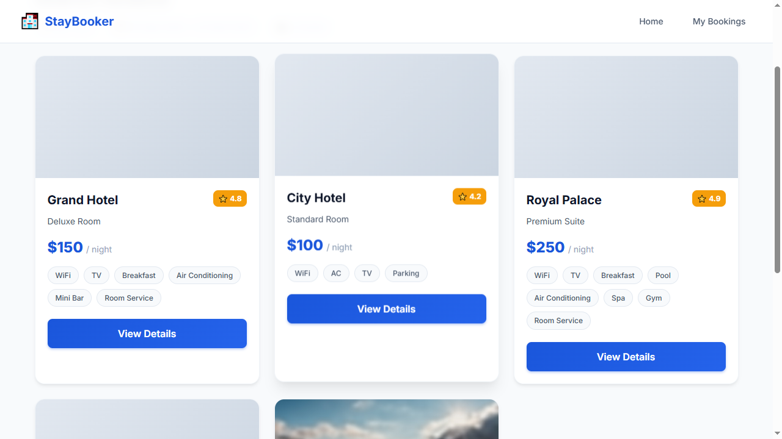
Step 7 — WAIT_FOR: room-card-1
Step 8 — CLICK: view-details-1
Step 9 — WAIT_FOR: room-name
Step 10 — CLICK: book-now-button
Step 11 — WAIT_FOR: first-name-input
Step 12 — FILL: first-name-input = John
Step 13 — FILL: last-name-input = Doe
Step 14 — FILL: email-input = john@example.com
Step 15 — FILL: phone-input = 9876543210
Step 16 — FILL: booking-checkin-input = 2026-09-20
Step 17 — FILL: booking-checkout-input = 2026-09-23
Step 18 — FILL: booking-guests-input = 11
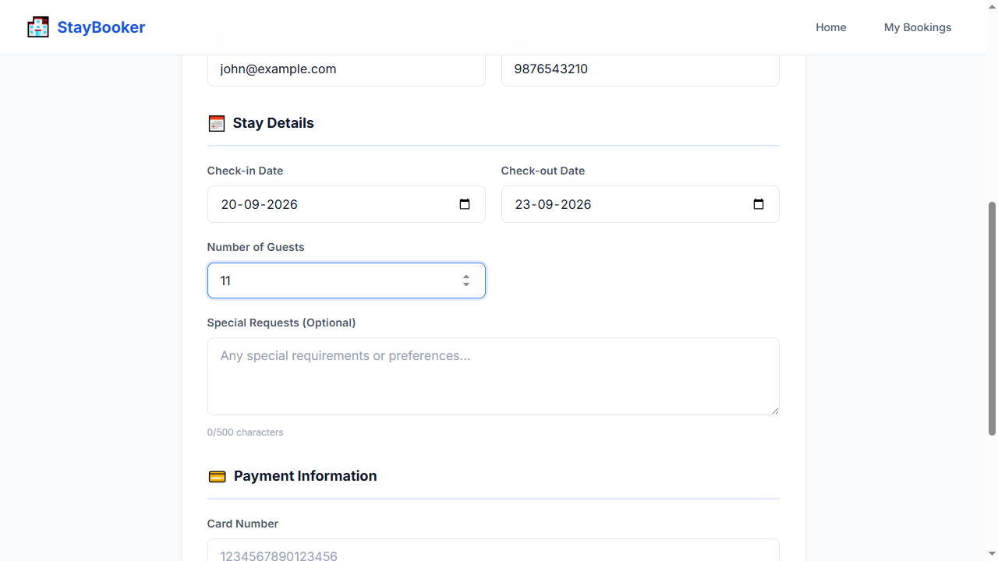
Step 19 — FILL: card-number-input = 4111111111111111
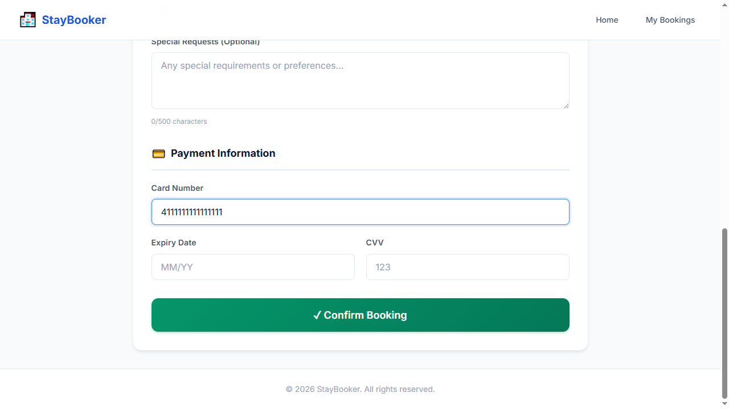
Step 20 — FILL: expiry-input = 12/30
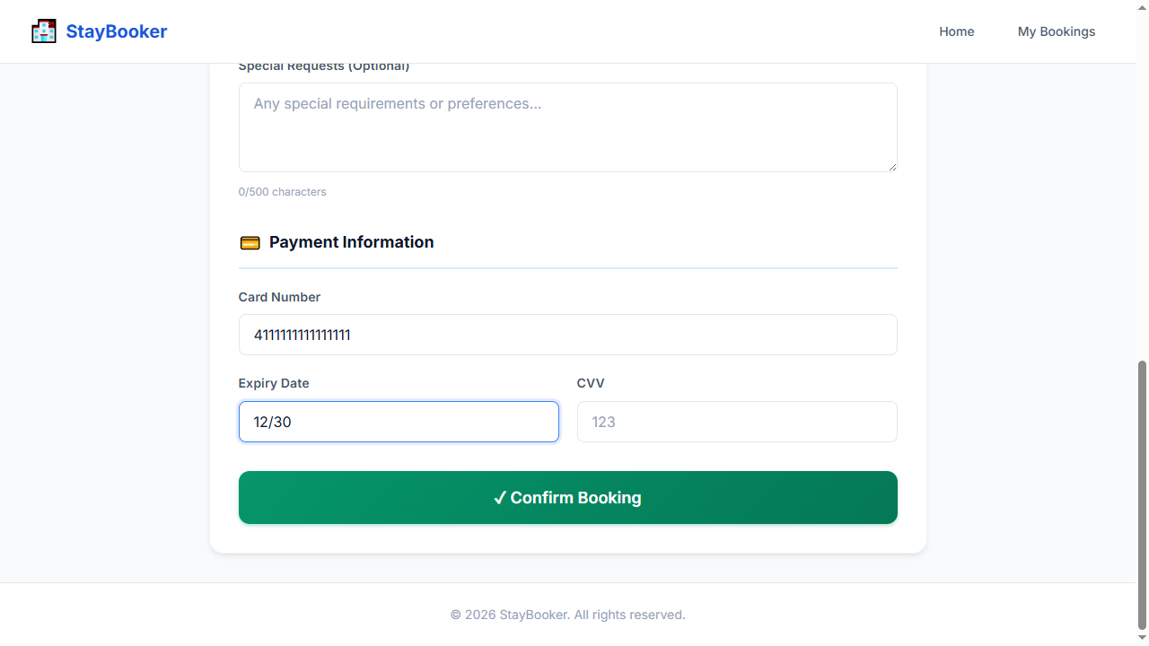
Step 21 — FILL: cvv-input = 123
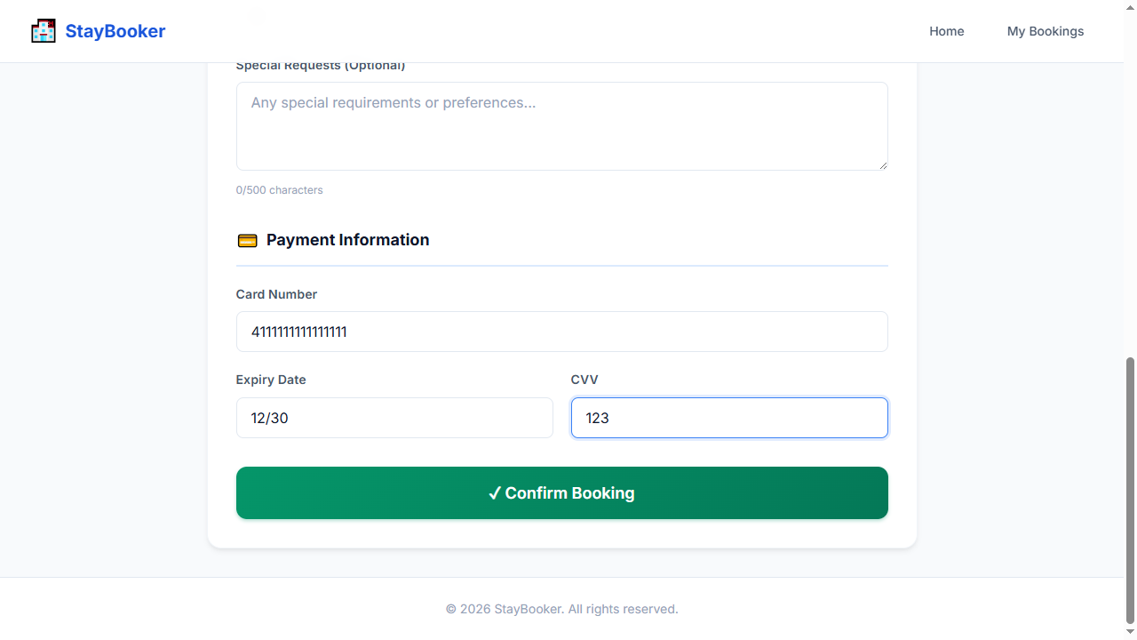
Step 22 — CLICK: confirm-booking-button
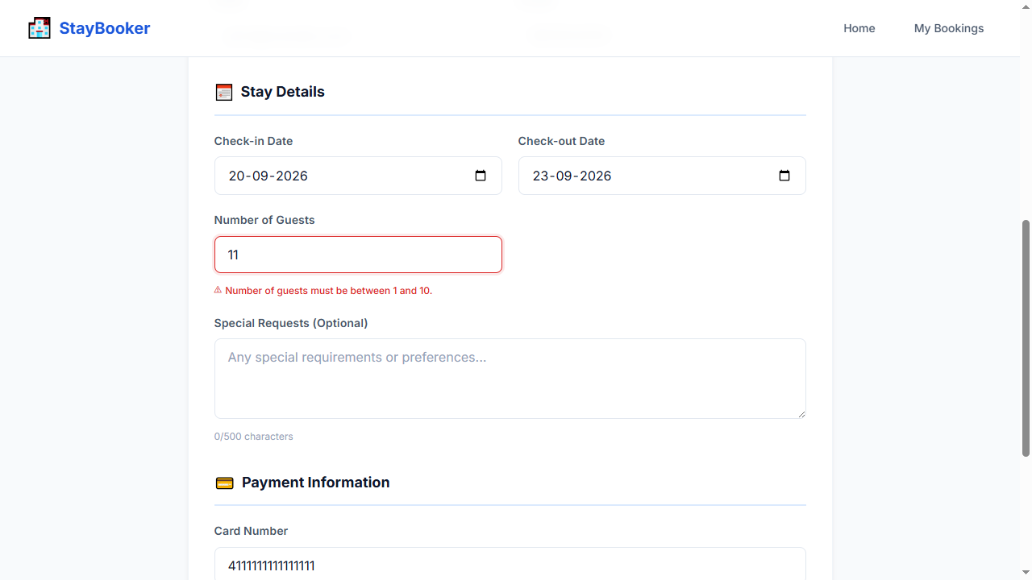
Step 23 — WAIT_FOR: booking-guests-error
Step 24 — ASSERT_VISIBLE: booking-guests-error
Step 25 — SCREENSHOT: validation_error

TC-013 — Invalid card number
Test ID: TC-013
Test Name: Invalid card number
Category: Validation
Status: PASS

Expected Result
Card length validation error is displayed

Actual Result
The expected workflow completed successfully and all deterministic Playwright checks passed. AI visual verification was UNCERTAIN: Deterministic checks passed; AI was UNCERTAIN on 1 checkpoint(s).

AI Verification
AI Status: UNCERTAIN
AI Observation: Deterministic checks passed; AI was UNCERTAIN on 1 checkpoint(s).
Per-step AI observations:
- Step 25 — SCREENSHOT: validation_error [UNCERTAIN, N/A] AI quota exhausted (429). Reduce AI_VERIFY_EVERY_SCREENSHOT or wait for quota reset. model gemini-3-flash-preview: ClientError: 429 RESOURCE_EXHAUSTED. {'error': {'code': 429, 'message': 'You exceeded your current quota, please check your plan and billing details. For more information on this error, head to: https://ai.google.dev/gemini-api/docs/rate-limits. To m...

Steps
Step | Action | Status | AI Status | Confidence
1 | OPEN: / | PASS | NOT RUN | N/A
2 | FILL: city-input = New York | PASS | NOT RUN | N/A
3 | FILL: checkin-input = 2026-09-20 | PASS | NOT RUN | N/A
4 | FILL: checkout-input = 2026-09-23 | PASS | NOT RUN | N/A
5 | FILL: guests-input = 2 | PASS | NOT RUN | N/A
6 | CLICK: search-button | PASS | NOT RUN | N/A
7 | WAIT_FOR: room-card-1 | PASS | NOT RUN | N/A
8 | CLICK: view-details-1 | PASS | NOT RUN | N/A
9 | WAIT_FOR: room-name | PASS | NOT RUN | N/A
10 | CLICK: book-now-button | PASS | NOT RUN | N/A
11 | WAIT_FOR: first-name-input | PASS | NOT RUN | N/A
12 | FILL: first-name-input = John | PASS | NOT RUN | N/A
13 | FILL: last-name-input = Doe | PASS | NOT RUN | N/A
14 | FILL: email-input = john@example.com | PASS | NOT RUN | N/A
15 | FILL: phone-input = 9876543210 | PASS | NOT RUN | N/A
16 | FILL: booking-checkin-input = 2026-09-20 | PASS | NOT RUN | N/A
17 | FILL: booking-checkout-input = 2026-09-23 | PASS | NOT RUN | N/A
18 | FILL: booking-guests-input = 2 | PASS | NOT RUN | N/A
19 | FILL: card-number-input = 1234 | PASS | NOT RUN | N/A
20 | FILL: expiry-input = 12/30 | PASS | NOT RUN | N/A
21 | FILL: cvv-input = 123 | PASS | NOT RUN | N/A
22 | CLICK: confirm-booking-button | PASS | NOT RUN | N/A
23 | WAIT_FOR: card-error | PASS | NOT RUN | N/A
24 | ASSERT_VISIBLE: card-error | PASS | NOT RUN | N/A
25 | SCREENSHOT: validation_error | PASS | UNCERTAIN | N/A

Screenshots
Step 1 — OPEN: /
Step 2 — FILL: city-input = New York
Step 3 — FILL: checkin-input = 2026-09-20
Step 4 — FILL: checkout-input = 2026-09-23
Step 5 — FILL: guests-input = 2
Step 6 — CLICK: search-button
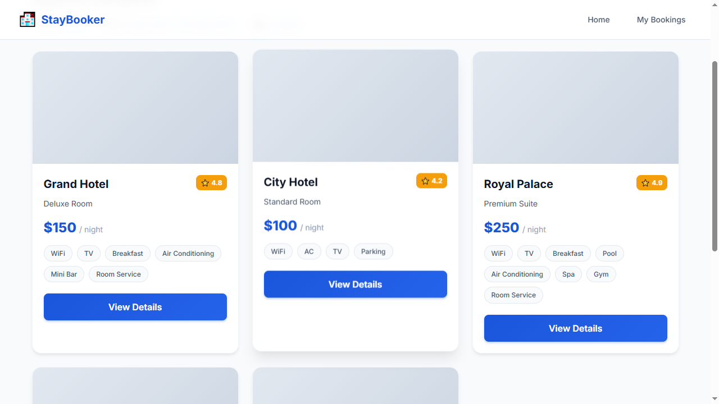
Step 7 — WAIT_FOR: room-card-1
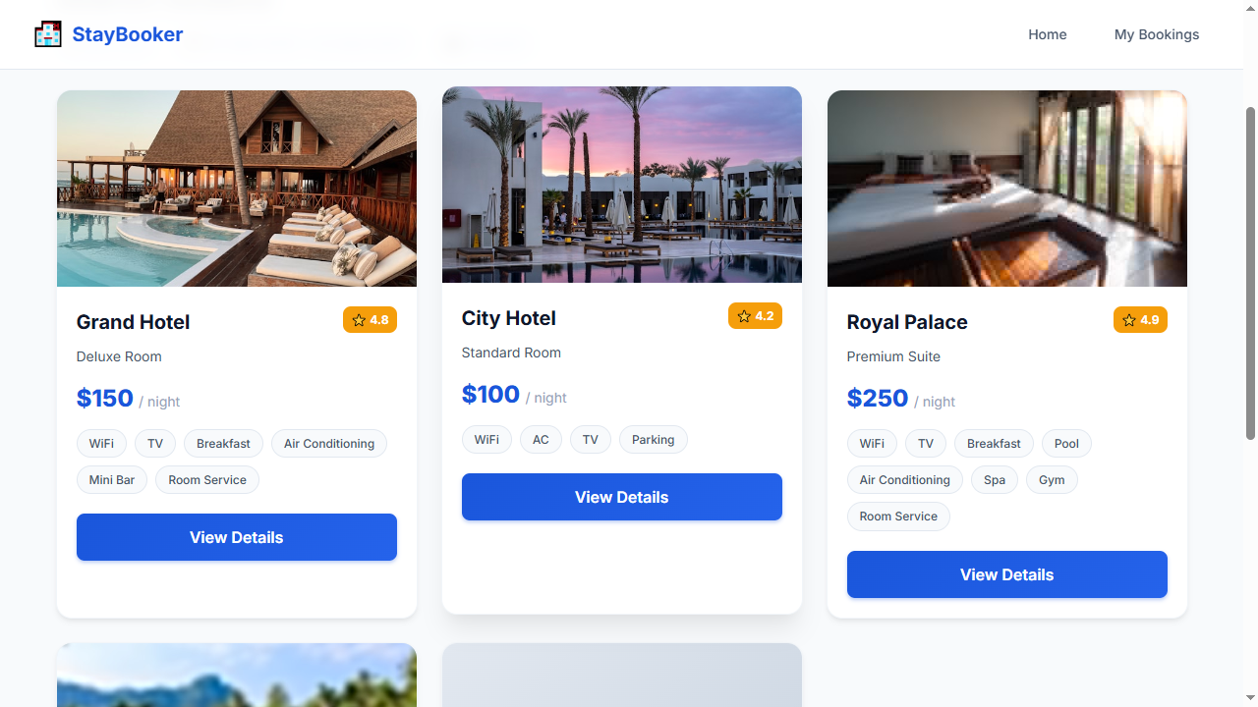
Step 8 — CLICK: view-details-1
Step 9 — WAIT_FOR: room-name
Step 10 — CLICK: book-now-button
Step 11 — WAIT_FOR: first-name-input
Step 12 — FILL: first-name-input = John
Step 13 — FILL: last-name-input = Doe
Step 14 — FILL: email-input = john@example.com
Step 15 — FILL: phone-input = 9876543210
Step 16 — FILL: booking-checkin-input = 2026-09-20
Step 17 — FILL: booking-checkout-input = 2026-09-23
Step 18 — FILL: booking-guests-input = 2
Step 19 — FILL: card-number-input = 1234
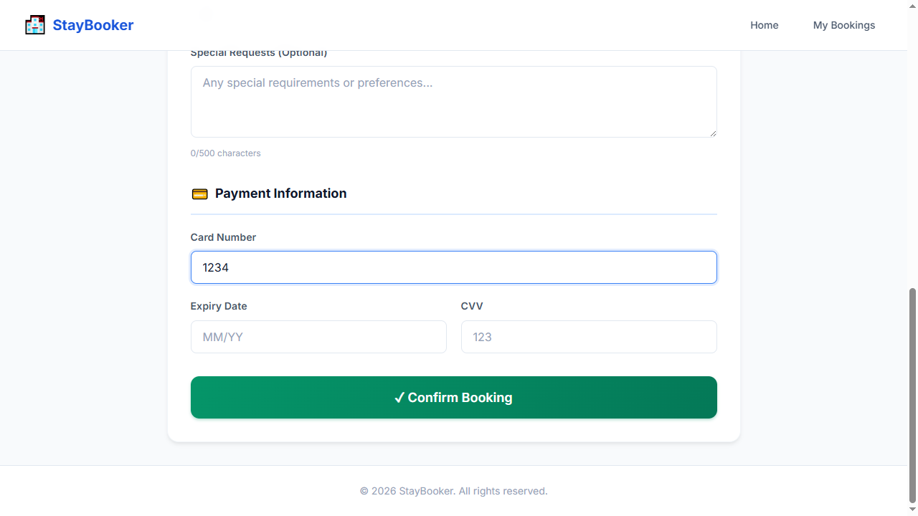
Step 20 — FILL: expiry-input = 12/30
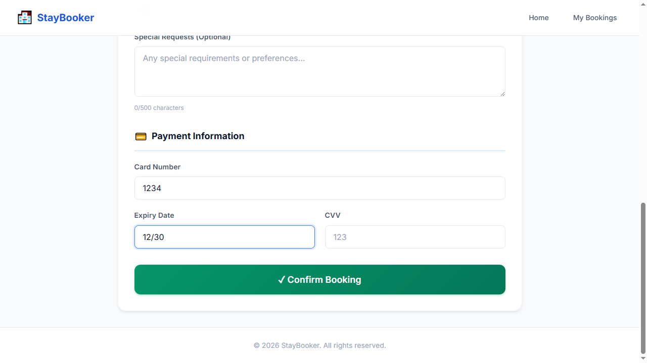
Step 21 — FILL: cvv-input = 123
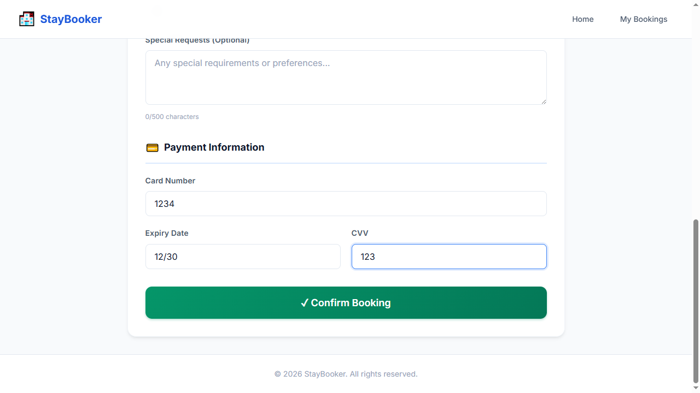
Step 22 — CLICK: confirm-booking-button
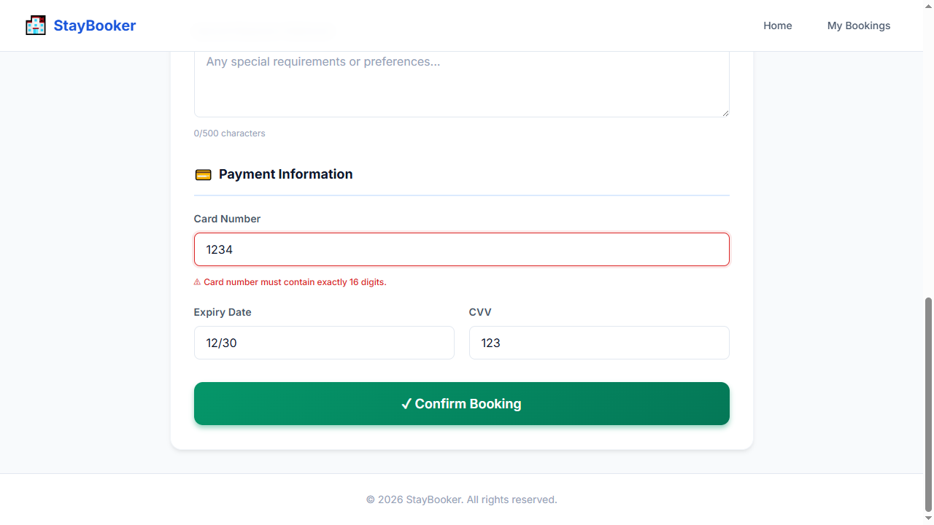
Step 23 — WAIT_FOR: card-error
Step 24 — ASSERT_VISIBLE: card-error
Step 25 — SCREENSHOT: validation_error

TC-014 — Expired card date
Test ID: TC-014
Test Name: Expired card date
Category: Validation
Status: PASS

Expected Result
Expiry validation error is displayed

Actual Result
The expected workflow completed successfully and all deterministic Playwright checks passed. AI visual verification was UNCERTAIN: Deterministic checks passed; AI was UNCERTAIN on 1 checkpoint(s).

AI Verification
AI Status: UNCERTAIN
AI Observation: Deterministic checks passed; AI was UNCERTAIN on 1 checkpoint(s).
Per-step AI observations:
- Step 25 — SCREENSHOT: validation_error [UNCERTAIN, N/A] AI quota exhausted (429). Reduce AI_VERIFY_EVERY_SCREENSHOT or wait for quota reset. model gemini-3-flash-preview: ClientError: 429 RESOURCE_EXHAUSTED. {'error': {'code': 429, 'message': 'You exceeded your current quota, please check your plan and billing details. For more information on this error, head to: https://ai.google.dev/gemini-api/docs/rate-limits. To m...

Steps
Step | Action | Status | AI Status | Confidence
1 | OPEN: / | PASS | NOT RUN | N/A
2 | FILL: city-input = New York | PASS | NOT RUN | N/A
3 | FILL: checkin-input = 2026-09-20 | PASS | NOT RUN | N/A
4 | FILL: checkout-input = 2026-09-23 | PASS | NOT RUN | N/A
5 | FILL: guests-input = 2 | PASS | NOT RUN | N/A
6 | CLICK: search-button | PASS | NOT RUN | N/A
7 | WAIT_FOR: room-card-1 | PASS | NOT RUN | N/A
8 | CLICK: view-details-1 | PASS | NOT RUN | N/A
9 | WAIT_FOR: room-name | PASS | NOT RUN | N/A
10 | CLICK: book-now-button | PASS | NOT RUN | N/A
11 | WAIT_FOR: first-name-input | PASS | NOT RUN | N/A
12 | FILL: first-name-input = John | PASS | NOT RUN | N/A
13 | FILL: last-name-input = Doe | PASS | NOT RUN | N/A
14 | FILL: email-input = john@example.com | PASS | NOT RUN | N/A
15 | FILL: phone-input = 9876543210 | PASS | NOT RUN | N/A
16 | FILL: booking-checkin-input = 2026-09-20 | PASS | NOT RUN | N/A
17 | FILL: booking-checkout-input = 2026-09-23 | PASS | NOT RUN | N/A
18 | FILL: booking-guests-input = 2 | PASS | NOT RUN | N/A
19 | FILL: card-number-input = 4111111111111111 | PASS | NOT RUN | N/A
20 | FILL: expiry-input = 10/20 | PASS | NOT RUN | N/A
21 | FILL: cvv-input = 123 | PASS | NOT RUN | N/A
22 | CLICK: confirm-booking-button | PASS | NOT RUN | N/A
23 | WAIT_FOR: expiry-error | PASS | NOT RUN | N/A
24 | ASSERT_VISIBLE: expiry-error | PASS | NOT RUN | N/A
25 | SCREENSHOT: validation_error | PASS | UNCERTAIN | N/A

Screenshots
Step 1 — OPEN: /
Step 2 — FILL: city-input = New York
Step 3 — FILL: checkin-input = 2026-09-20
Step 4 — FILL: checkout-input = 2026-09-23
Step 5 — FILL: guests-input = 2
Step 6 — CLICK: search-button
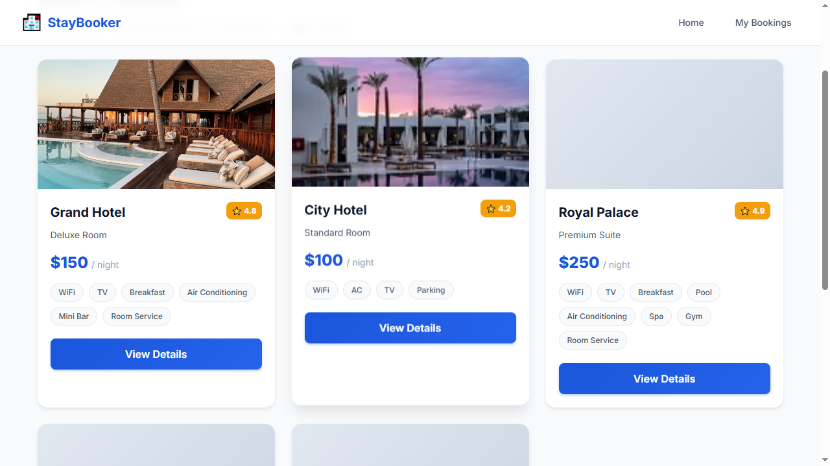
Step 7 — WAIT_FOR: room-card-1
Step 8 — CLICK: view-details-1
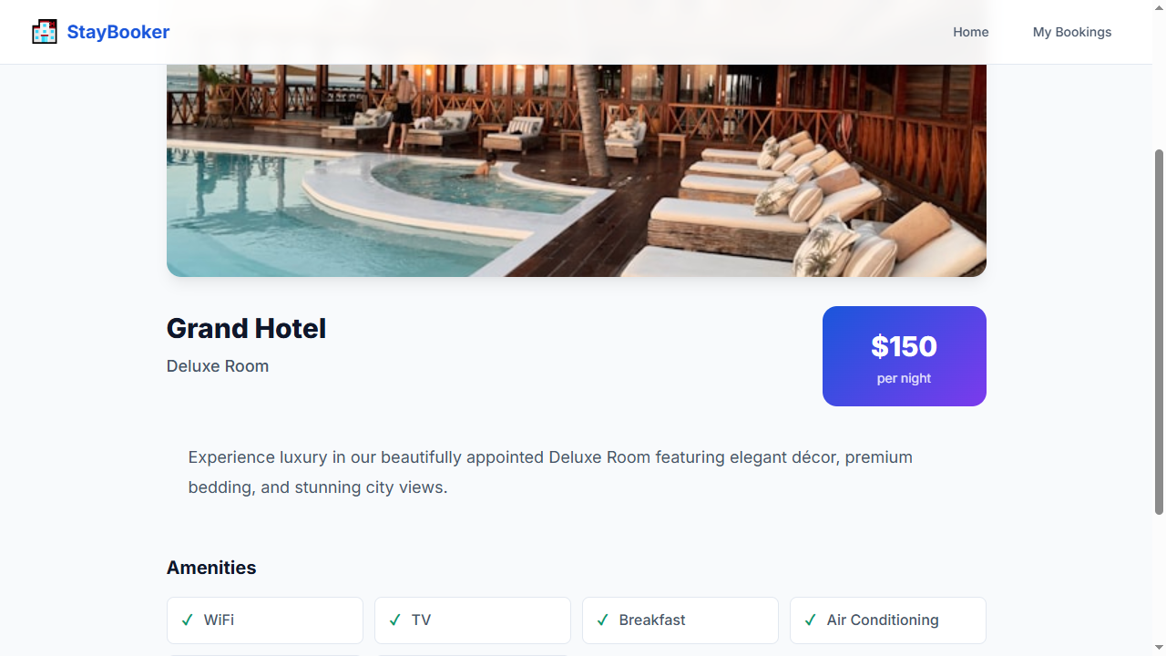
Step 9 — WAIT_FOR: room-name
Step 10 — CLICK: book-now-button
Step 11 — WAIT_FOR: first-name-input
Step 12 — FILL: first-name-input = John
Step 13 — FILL: last-name-input = Doe
Step 14 — FILL: email-input = john@example.com
Step 15 — FILL: phone-input = 9876543210
Step 16 — FILL: booking-checkin-input = 2026-09-20
Step 17 — FILL: booking-checkout-input = 2026-09-23
Step 18 — FILL: booking-guests-input = 2
Step 19 — FILL: card-number-input = 4111111111111111
Step 20 — FILL: expiry-input = 10/20
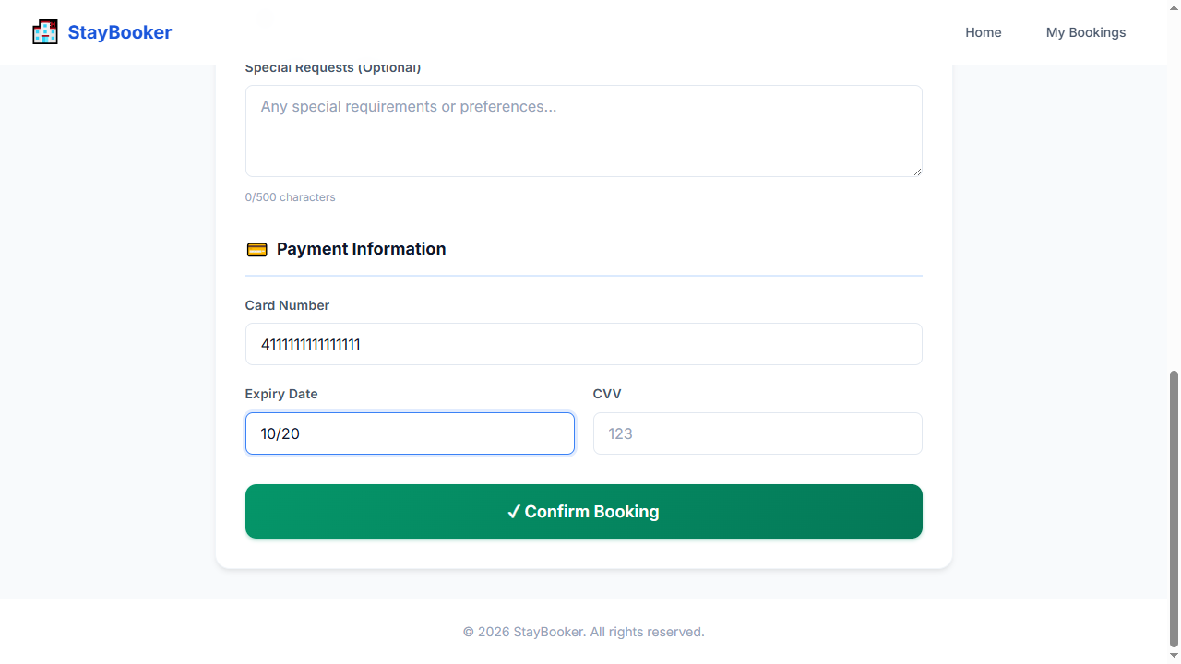
Step 21 — FILL: cvv-input = 123
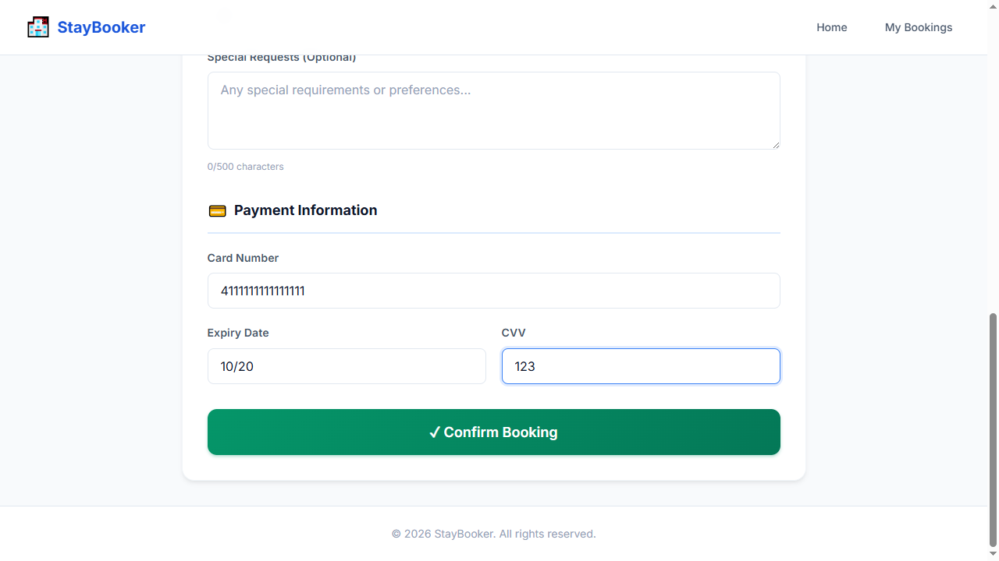
Step 22 — CLICK: confirm-booking-button
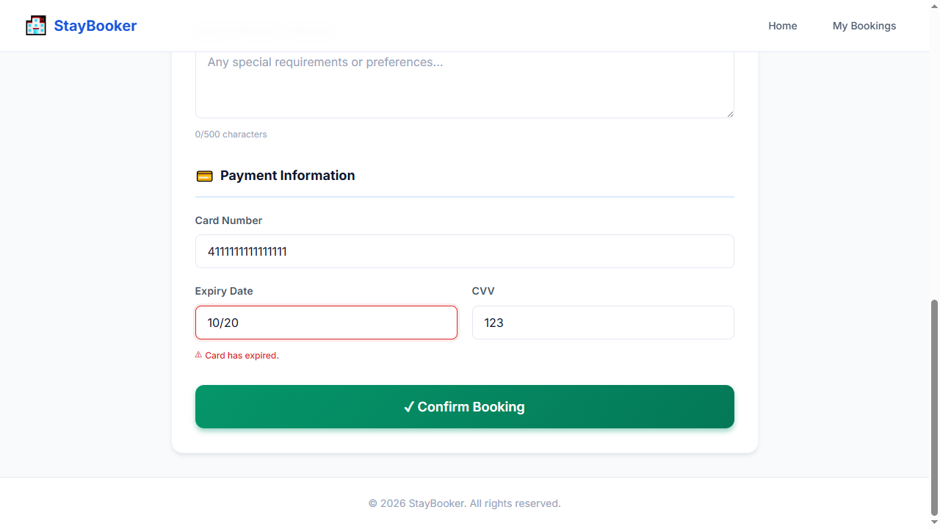
Step 23 — WAIT_FOR: expiry-error
Step 24 — ASSERT_VISIBLE: expiry-error
Step 25 — SCREENSHOT: validation_error

TC-015 — Invalid CVV
Test ID: TC-015
Test Name: Invalid CVV
Category: Validation
Status: PASS

Expected Result
CVV validation error is displayed

Actual Result
The expected workflow completed successfully and all deterministic Playwright checks passed. AI visual verification was UNCERTAIN: Deterministic checks passed; AI was UNCERTAIN on 1 checkpoint(s).

AI Verification
AI Status: UNCERTAIN
AI Observation: Deterministic checks passed; AI was UNCERTAIN on 1 checkpoint(s).
Per-step AI observations:
- Step 25 — SCREENSHOT: validation_error [UNCERTAIN, N/A] AI quota exhausted (429). Reduce AI_VERIFY_EVERY_SCREENSHOT or wait for quota reset. model gemini-3-flash-preview: ClientError: 429 RESOURCE_EXHAUSTED. {'error': {'code': 429, 'message': 'You exceeded your current quota, please check your plan and billing details. For more information on this error, head to: https://ai.google.dev/gemini-api/docs/rate-limits. To m...

Steps
Step | Action | Status | AI Status | Confidence
1 | OPEN: / | PASS | NOT RUN | N/A
2 | FILL: city-input = New York | PASS | NOT RUN | N/A
3 | FILL: checkin-input = 2026-09-20 | PASS | NOT RUN | N/A
4 | FILL: checkout-input = 2026-09-23 | PASS | NOT RUN | N/A
5 | FILL: guests-input = 2 | PASS | NOT RUN | N/A
6 | CLICK: search-button | PASS | NOT RUN | N/A
7 | WAIT_FOR: room-card-1 | PASS | NOT RUN | N/A
8 | CLICK: view-details-1 | PASS | NOT RUN | N/A
9 | WAIT_FOR: room-name | PASS | NOT RUN | N/A
10 | CLICK: book-now-button | PASS | NOT RUN | N/A
11 | WAIT_FOR: first-name-input | PASS | NOT RUN | N/A
12 | FILL: first-name-input = John | PASS | NOT RUN | N/A
13 | FILL: last-name-input = Doe | PASS | NOT RUN | N/A
14 | FILL: email-input = john@example.com | PASS | NOT RUN | N/A
15 | FILL: phone-input = 9876543210 | PASS | NOT RUN | N/A
16 | FILL: booking-checkin-input = 2026-09-20 | PASS | NOT RUN | N/A
17 | FILL: booking-checkout-input = 2026-09-23 | PASS | NOT RUN | N/A
18 | FILL: booking-guests-input = 2 | PASS | NOT RUN | N/A
19 | FILL: card-number-input = 4111111111111111 | PASS | NOT RUN | N/A
20 | FILL: expiry-input = 12/30 | PASS | NOT RUN | N/A
21 | FILL: cvv-input = 12 | PASS | NOT RUN | N/A
22 | CLICK: confirm-booking-button | PASS | NOT RUN | N/A
23 | WAIT_FOR: cvv-error | PASS | NOT RUN | N/A
24 | ASSERT_VISIBLE: cvv-error | PASS | NOT RUN | N/A
25 | SCREENSHOT: validation_error | PASS | UNCERTAIN | N/A

Screenshots
Step 1 — OPEN: /
Step 2 — FILL: city-input = New York
Step 3 — FILL: checkin-input = 2026-09-20
Step 4 — FILL: checkout-input = 2026-09-23
Step 5 — FILL: guests-input = 2
Step 6 — CLICK: search-button
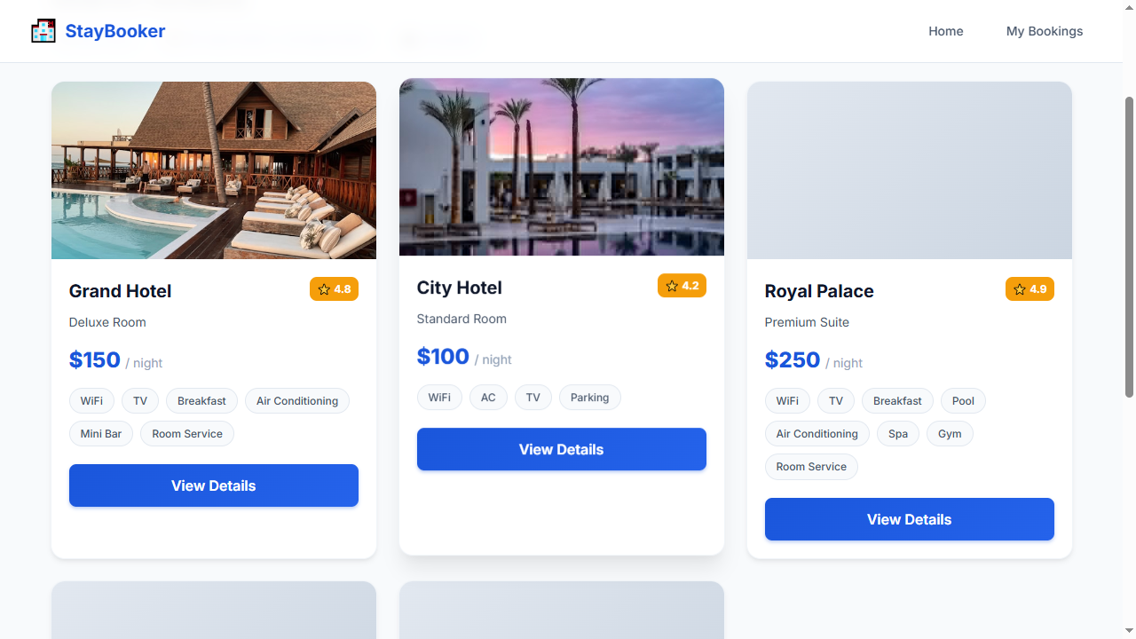
Step 7 — WAIT_FOR: room-card-1
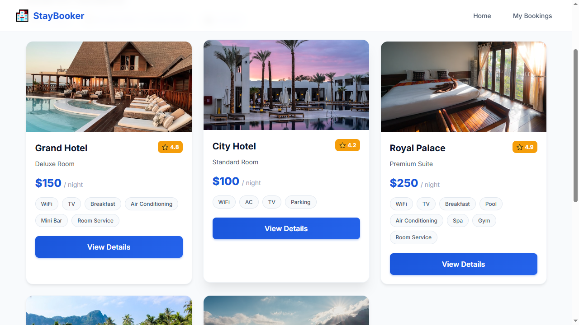
Step 8 — CLICK: view-details-1
Step 9 — WAIT_FOR: room-name
Step 10 — CLICK: book-now-button
Step 11 — WAIT_FOR: first-name-input
Step 12 — FILL: first-name-input = John
Step 13 — FILL: last-name-input = Doe
Step 14 — FILL: email-input = john@example.com
Step 15 — FILL: phone-input = 9876543210
Step 16 — FILL: booking-checkin-input = 2026-09-20
Step 17 — FILL: booking-checkout-input = 2026-09-23
Step 18 — FILL: booking-guests-input = 2
Step 19 — FILL: card-number-input = 4111111111111111
Step 20 — FILL: expiry-input = 12/30
Step 21 — FILL: cvv-input = 12
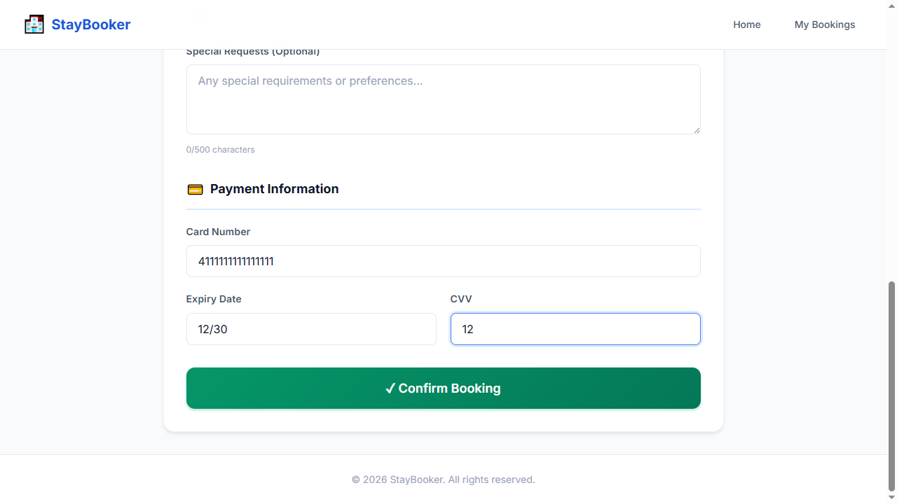
Step 22 — CLICK: confirm-booking-button
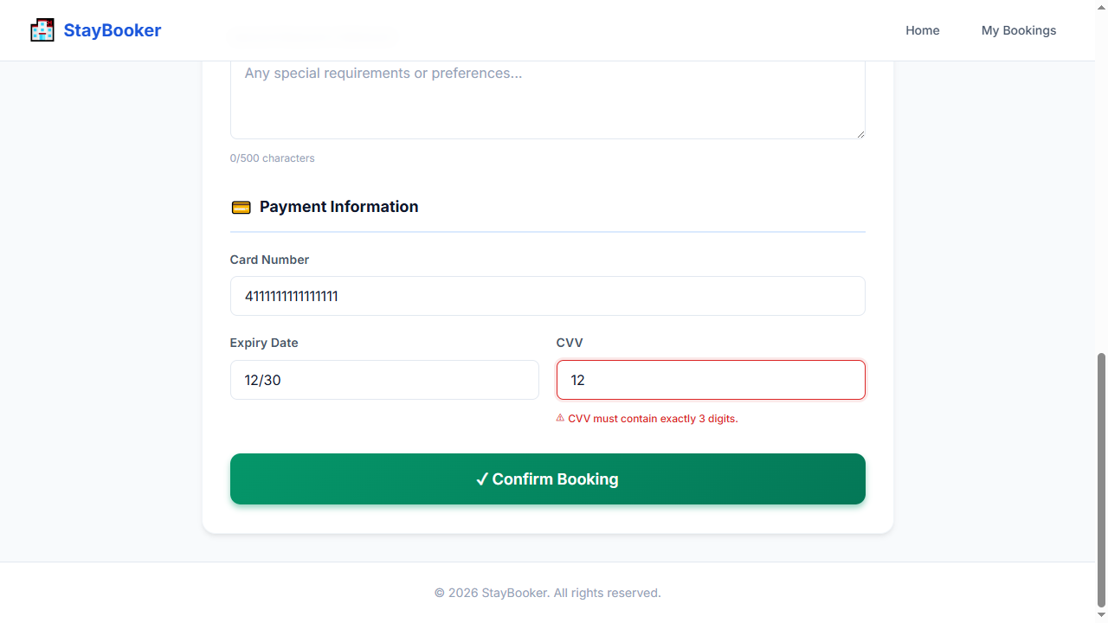
Step 23 — WAIT_FOR: cvv-error
Step 24 — ASSERT_VISIBLE: cvv-error
Step 25 — SCREENSHOT: validation_error

