PA8

CSE 8A Spring 2021 PA 8
Due date: Wednesday, June 2 @ 11:59PM PST
(Thursday, June 3 @ 11:59PM PST w/ slip day)

Provided Files
- CSE8AImage.py (DO NOT EDIT)
- CSE8ACSV.py (DO NOT EDIT)

File(s) to Edit and Submit
- crop.py
- pa8_csv.py
Please note, in PA8, there are hidden test cases, which will not appear in your submission results. Therefore, the test case result you see when you submit your code is NOT final.

Part 1: Implementation

Overview
In this assignment, we will continue our focus on working with 2D lists that represent images. You will perform some interesting transformations using images and get more practice iterating through 2D lists. In the second part, we will work with dictionaries and CSV files. You will perform some data analysis on the given dataset.

Part 1.1: More image filters

Step A: Reviewing CSE8AImage Documentation
Inside crop.py you will find an import statement. That is the library you will be using to do some operations like loading images, saving images, creating images, or finding out the image properties like height and width. The documentation for the most relevant methods in the CSE8AImage library are provided below.
NOTE: You do NOT need to completely understand how these functions are implemented to use them. Just like we don't know how sum, len, and other built-in Python functions are implemented, but we use them! So you're free to look at the code in CSE8AImage.py, but not responsible for understanding it.
Here is some documentation for the functions you will be working with.
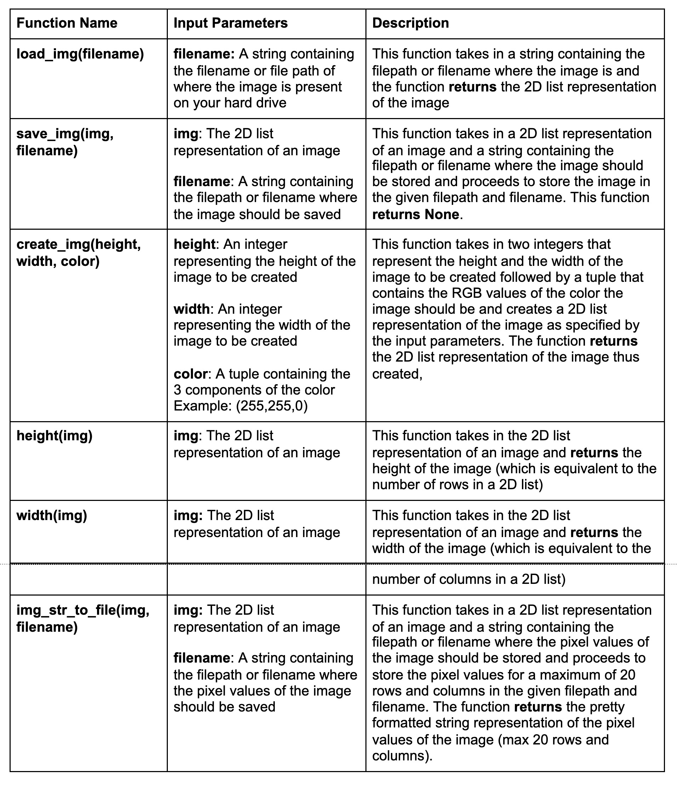

Step B: Start Coding!
Crop
In crop.py, implement the following functions:
def crop(img, region_width, region_height)
- Parameters:
  - Img - The 2D list representation of an image
  - region_width - An integer representing the width of an image
  - region_height - An integer representing the height of an image
- Return:
  - If the parameters are valid, return a cropped version of the given image to the given height and width values.
  - If the parameters are invalid, return the original image without any changes.
- Description:
  - This filter takes in an image and two integers, region_width and region_height, and returns a new image that contains the cropped version of the input image to given width (number of columns) and the given height (the number of rows). The cropped version always starts at the top left corner of img.
- Examples:
  - The image below was created by calling crop(img, 350, 350), where img = load_img('cat.jpg').
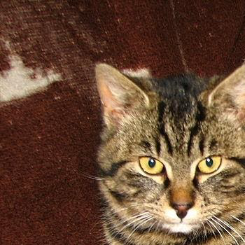

  - crop([[(0, 0, 0), (128, 128, 128)], [(64, 128, 255), (255, 255, 255)]], 1, 2) should return [[(0, 0, 0)], [(64, 128, 255)]]
- You can run your code on one of the given images such as cat.jpg or jacko_lantern.jpg. To visualize the result, save the result image as <original image name>-crop.jpg. Here you probably want to use load_image and save_image functions to convert images to 2D lists and vice versa.
def check_validity(img, region_width, region_height)
You would implement another function to check if input parameters are valid. Input parameters are the same as above, and you need to return True if parameters are valid, and False otherwise. You can assume img is always a valid 2D list of tuples. Rules for valid parameters are as follow:
- region_width and region_height should be greater than 0.
- region_width should be less than or equal to the width of img
- region_height should be less than or equal to the height of img
Examples:
- check_validity([[(1,1,1)]], 2, 1) should return False because the region_width is larger than the width of the image.
- check_validity([[(0, 0, 0), (128, 128, 128)], [(64, 128, 255), (255, 255, 255)]], 1, 2) should return True because all conditions for valid parameters are met.

Part 1.2: Working with csv files and dictionaries
Step A: Overview of CSE8ACSV documentation
In pa8_csv.py, you will implement a function that calculates the total number of Black Lives Matter protests among a certain group of states and protest attendance. You are provided a few functions that help with loading data from CSV (Comma Separated Values) files in CSE8ACSV.py. Take a look at blm_state.csv to get an idea of the data and the format. You will not have to call any of these functions, as they are already implemented in the starter code provided in pa8_csv.py. Below are the functions provided.
def get_blm_data(filename)
You are given a function that will convert a CSV file (Comma Separated Values) containing data related to Black Lives Matter protests by state into a list of dictionaries, formatted as following:
[{State: String, TotalProtests: float, ...},
{State: String, TotalProtests: float, ...},
... more states ...
]
This function is already present in the starter code to load the data into the variable blm_protest_data. Each dictionary in the list contains the following information:
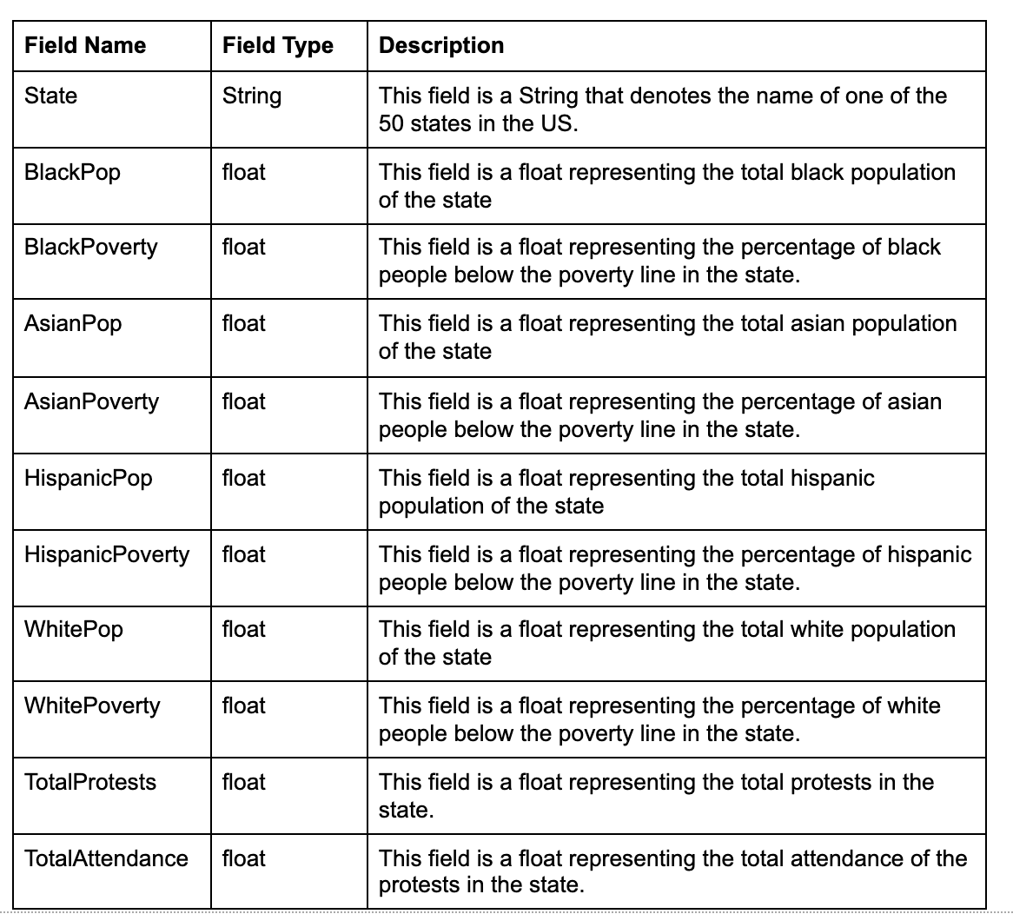
def get_state_pops()
This function simply returns a dictionary formatted as following:
{'Alabama': 1359025, 'Alaska': 382768, ..., 'Wyoming': 147609}
The returned dictionary contains the population of each state. The function is already present in the starter code to load the data into the variable state_populations.
Step B: Start Coding!
Total BLM Protests
We are interested in calculating the total number of Black Lives Matter protests among a certain group of states. The data is already present in the starter code as a list of dictionaries, named blm_protest_data. Write a function in pa8_csv.py that returns the total number of protests that took place in the list of states provided as the input parameter.
def total_blm_protests(states)
- Parameter:
  - states - A list of strings denoting state names
- Return:
  - Returns an int representing the total number of protests in the list of state names (note that all values in the dictionaries are floats)
- Description:
  - This function uses the list of dictionaries blm_protest_data to obtain the total number of protests in the list of states.
- Examples:
>>> states = ["California", "Texas"]
>>> total_blm_protests(states)
110

>>> states = []
>>> total_blm_protests(states)
0

>>> states = ["Alaska", "New Mexico", "Arkansas", "New York"]
>>> total_blm_protests(states)
72
Protest attendance
Write a function to determine which states had a percentage of the population attend protests higher than a given threshold. Specifically, if 500 people attended protests in a state, and there were a total of 50000 people in the state, then the percentage of attendance for the state would be 1%. The same list of dictionaries, blm_protest_data, will be used for this problem. You may also find the variable state_populations useful.
def protest_attendance(threshold)
- Parameter:
  - threshold - a float that represents the minimum threshold for the percentage of the state's population that attended Black Lives Matter protests. threshold can be a value between 0 to 100 (both inclusive), but will only have realistic values between 0 and 10 (both inclusive), since in every state only less than 10% of the population attended the protests.
- Return:
  - The function should return a list of states that had a higher percentage of its population attend protests than the given threshold.
- Description:
  - This function calculates the percentage of people in each state that attended the Black Lives Matter protests, and returns a list of all states with a percentage attendance above the threshold
- Examples:
>>> threshold = 0.3 # 0.3% of population attendance
>>> protest_attendance(threshold)
['District of Columbia', 'Maryland', 'Minnesota', 'Missouri', 'New York']

Part 2: Style
Coding style is an important part of ensuring readability and maintainability of your code. Starting from this assignment on, we will grade your coding style in all submitted code files according to the style guidelines. You can keep these guidelines in mind as you write your code or go back and fix your code at the end. If you fix your code at the end, be sure to click the "Mark" button to submit your code. We will grade the last submission, not your workspace. For now, we will mainly be focusing on the following:
- Use of descriptive variable names: The names of your variables should describe the data they hold. Your variable names should be words (or abbreviations), not single letters.
  - e.g. a --> index_of_apple; letter1 and letter2 --> lower_case_letter and upper_case_letter
  - Exception: If it is a loop index like i, j, k, one char is OK and sometimes preferred.
- Inline Comments: If there is a length of code that is left unexplained, take the time to type a non-redundant line summarizing this length of code (e.g. #initialize an int is redundant, vs. #set initial length to 10 inches ). It will let others who look at your code understand what's going on without having to spend time understanding your logic first. But don't be too descriptive, as too many comments reduces readability.

CSE8ACSV.py

import csv

def get_blm_data(filename):
data = []
with open(filename) as f:
for row in csv.DictReader(f):
row_dict = {k: float(v) for k, v in row.items() if k != 'State'}
row_dict['State'] = row['State']
data.append(row_dict)
return data

def get_csv(filename):
data = []
with open(filename) as file_object:
for row in csv.DictReader(file_object, delimiter=','):
data.append(row)
return data

def get_state_pops():
return {'Alabama': 1359025,
'Alaska': 382768,
'Arizona': 4816902,
'Arkansas': 816032,
'California': 29044234,
'Colorado': 3226330,
'Connecticut': 1522919,
'Delaware': 101276,
'District of Columbia': 599620,
'Florida': 9497148,
'Georgia': 2423899,
'Hawaii': 582887,
'Idaho': 648635,
'Illinois': 6289798,
'Indiana': 2508905,
'Iowa': 1057373,
'Kansas': 1349359,
'Kentucky': 1094053,
'Louisiana': 1423072,
'Maine': 129851,
'Maryland': 2401948,
'Massachusetts': 3199551,
'Michigan': 3004677,
'Minnesota': 2181353,
'Mississippi': 510952,
'Missouri': 1942357,
'Montana': 295249,
'Nebraska': 778507,
'Nevada': 2234496,
'New Hampshire': 232417,
'New Jersey': 2110494,
'New Mexico': 1040982,
'New York': 10612671,
'North Carolina': 3351401,
'North Dakota': 262802,
'Ohio': 3887738,
'Oklahoma': 1662991,
'Oregon': 1774109,
'Pennsylvania': 2599981,
'Rhode Island': 479649,
'South Carolina': 743429,
'South Dakota': 224005,
'Tennessee': 2515486,
'Texas': 14999365,
'Utah': 1648183,
'Vermont': 35859,
'Virginia': 3021985,
'Washington': 3180145,
'West Virginia': 125905,
'Wisconsin': 2033230,
'Wyoming': 147609}

CSE8AImage.py

# DO NOT EDIT THIS FILE

# Code from Sorin Lerner and Gerald Soosai Raj

import numpy as np
from PIL import Image

def load_img(filename):
img = Image.open(filename)
pil_img = img.convert('RGB')
arr = np.array(pil_img.getdata(), dtype=np.uint8).reshape(pil_img.height, pil_img.width, 3)
img = [ [ (int(p[0]),int(p[1]),int(p[2])) for p in row ] for row in arr ]
return img

def save_img(img, filename):
# Checks for empty image
if len(img) == 0:
raise RuntimeError("Cannot save empty image")
# Checks if first row is empty
if len(img[0]) == 0:
raise RuntimeError("Cannot save image where rows have length 0")
# Checks if all rows have the same length
for i in range(1, len(img)):
if len(img[i]) != len(img[i - 1]):
raise RuntimeError("Cannot save image where not all rows have the same length")
arr = np.asarray(img, dtype=np.uint8)
pil_img = Image.fromarray(arr)
pil_img.save(filename, format='png')

def save_img_big(img, filename, scale = 20):
if len(img) == 0:
raise RuntimeError("Cannot save empty image")
# Checks if first row is empty
if len(img[0]) == 0:
raise RuntimeError("Cannot save image where rows have length 0")
# Checks if all rows have the same length
for i in range(1, len(img)):
if len(img[i]) != len(img[i - 1]):
raise RuntimeError("Cannot save image where not all rows have the same length")
# Check for valid scale
if (scale < 1):
raise RuntimeError("Cannot save scale < 1")
arr = np.asarray(img, dtype=np.uint8)
pil_img = Image.fromarray(arr)
pil_img = pil_img.resize((pil_img.width*scale, pil_img.height*scale), resample = Image.BOX)
pil_img.save(filename, format='png')

def create_img(height, width, color):
result = [None] * height
for i in range(len(result)):
result[i] = [color] * width
return result

def height(img):
return len(img)

def width(img):
return len(img[0])

def summarize(img):
return "Image[width=%s,height=%s]" % (width(img), height(img))

def img_str_to_file(img, filename):
# Converting to integer pixel values
img = np.asarray(img, dtype=np.uint8)

# Calculating max length
max_length = len(str((255,255,255)))

# Limiting the number of rows and columns to be printed
r_limit = min(20, height(img))
c_limit = min(20, width(img))

with open(filename, 'w') as file:
pix_str = ""
for y in range(r_limit):
for x in range(c_limit):
# Creating the string representation
temp_str = ("(" + str(img[y][x][0])
+ "," + str(img[y][x][1])
+ "," + str(img[y][x][2]) + ")")
pix_str += temp_str
# Added appropriate number of spaces to make it visually clear
pix_str += " " * (max_length-len(temp_str))
pix_str += "\n"
file.write(pix_str)

return pix_str

crop.py

from CSE8AImage import *

def check_validity(img, region_width, region_height):
# TODO

def crop(img, region_width, region_height):
# TODO

pa8_csv.py

from CSE8ACSV import *

#############################
blm_protest_data = get_blm_data("blm_state.csv")
state_populations = get_state_pops()
##############################
#DO NOT MODIFY CODE BLOCK ABOVE

def total_blm_protests(states):
# TODO

def protest_attendance(threshold):
# TODO

