4ThePlot
Software Engineering Documentation
Subject Course: Software Engineering

Group Members
Angjelina Zenunaj
Briana Llapaj
Gëzime Mirku
Ilion Elezi
Klaus Saliaj
Revi Beja
Ronald Lamani
Generated: 2026-05-22

Table of Contents
Right-click and choose Update Field to refresh the table of contents.

1. Introduction
This document describes the implemented 4ThePlot Flutter frontend. The source of truth is the Dart source code under frontend_lib. Backend behavior is included only where the frontend calls it through DatabaseHelper. Every local diagram image is included later with an explanation so the Word document can be read without needing to inspect the folder tree separately.

2. Program Structure and Implemented Parts
Program Part | Explanation
Application entrypoint | main.dart initializes the Flutter application, loads the configured backend server IP, and opens LandingPage.
Authenticated shell | MainWrapper is the central logged-in container. It switches the bottom navigation layout according to the active UserRole.
API integration | DatabaseHelper builds URLs, attaches headers/tokens, sends HTTP requests, decodes responses, normalizes failures, and converts responses into frontend models.
Domain models | The models folder defines the client-side shape of users, events, comments, registrations, business profiles, preferences, and host credibility.
Page workflows | The pages folder contains full UI workflows such as login, signup, discovery, add event, edit event, details, calendar, map, profile, settings, business hosting, and admin screens.
Reusable widgets | The widgets folder contains repeated interface pieces used across screens, including event cards, comment cards, buttons, information cards, tags, and visual styling wrappers.
Common utilities | The common folder stores color constants and credit-card input formatters used in the promotion/payment-style flow.

3. Role-Based Navigation
The frontend defines three roles: Goer, Business, and Admin. The active role controls what the user sees after authentication.
Role | Tabs | Explanation
Goer | Home, Calendar, Add, Map, Profile | Goers start from discovery, can join events, create events, view map/calendar data, and manage their profile.
Business | Hosted, Calendar, Add, Map, Profile | Business users start from hosted events, can create/edit hosted events, view hosted calendars, use maps, and promote events.
Admin | Admin, Events, Map, Profile | Admins receive an operational shell for dashboard access, event administration, map visibility, and profile/settings behavior.

4. Implemented Workflows

Startup and session recovery
The application loads the saved server IP, opens the landing screen, and attempts to restore a previously saved user session.

Login
The login form calls DatabaseHelper.login. On success, the access token is saved in secure storage, user data is saved in shared preferences, and MainWrapper becomes active.

Signup
The signup screen sends a create-user payload through DatabaseHelper.createUser and then routes the user toward login.

Event discovery
The discovery workflow uses event list methods in DatabaseHelper, displays event cards, and routes selected events into EventDetailsPage.

Event details and comments
EventDetailsPage shows event data, checks registration state, loads comments, creates comments, deletes comments, and exposes role-specific actions.

Event creation
The add-event flow stores form state in AddEventDraft, collects event details, location, and images, then submits the final payload.

Event editing
The edit-event flow initializes from an existing event, stores changes in EditEventDraft, and submits an update payload.

Calendar and map
CalendarPage and MapPage load role-specific event lists. The map screens use OpenStreetMap tiles and event coordinates.

Business promotion
TrendingPaymentPage collects payment-style fields and updates the selected event as trending.

Admin features
Admin pages implement dashboard navigation, event administration, and host verification screens. Some dashboard options are placeholders.

5. Screen and Module Explanations
Frontend Page | Explanation
frontend_lib/pages/add_event/add_event_details_page.dart | Multi-step creation workflow. It stores a draft, collects details/location/photos, and submits the final event.
frontend_lib/pages/add_event/add_event_draft.dart | Multi-step creation workflow. It stores a draft, collects details/location/photos, and submits the final event.
frontend_lib/pages/add_event/add_event_flow_root.dart | Multi-step creation workflow. It stores a draft, collects details/location/photos, and submits the final event.
frontend_lib/pages/add_event/add_event_photos_page.dart | Multi-step creation workflow. It stores a draft, collects details/location/photos, and submits the final event.
frontend_lib/pages/add_event/add_event_summary.dart | Multi-step creation workflow. It stores a draft, collects details/location/photos, and submits the final event.
frontend_lib/pages/admin/admin_dashboard_page.dart | Admin frontend area. It includes dashboard navigation, event administration, and host verification screens.
frontend_lib/pages/admin/admin_events_page.dart | Admin frontend area. It includes dashboard navigation, event administration, and host verification screens.
frontend_lib/pages/admin/admin_host_verification_page.dart | Admin frontend area. It includes dashboard navigation, event administration, and host verification screens.
frontend_lib/pages/calendar/calendar_page.dart | Calendar-oriented event view. It displays joined events for Goers and hosted events for Business users.
frontend_lib/pages/discover/discover_page.dart | Main event browsing surface for Goers. It loads events, displays them, and routes users into event details.
frontend_lib/pages/edit_event/edit_event_details_page.dart | Multi-step editing workflow. It initializes from an existing event and submits updated event data.
frontend_lib/pages/edit_event/edit_event_draft.dart | Multi-step editing workflow. It initializes from an existing event and submits updated event data.
frontend_lib/pages/edit_event/edit_event_page.dart | Multi-step editing workflow. It initializes from an existing event and submits updated event data.
frontend_lib/pages/edit_event/edit_event_photos_page.dart | Multi-step editing workflow. It initializes from an existing event and submits updated event data.
frontend_lib/pages/edit_event/edit_event_summary.dart | Multi-step editing workflow. It initializes from an existing event and submits updated event data.
frontend_lib/pages/event_details/event_details_page.dart | Detailed event page. It combines event information, registration state, comments, host controls, admin controls, and business promotion entry.
frontend_lib/pages/hosted_business_events/hosted_business_events_page.dart | Business landing area. It lists events hosted by the logged-in business user.
frontend_lib/pages/join_event/join_event_page.dart | Join confirmation page. It creates a Registration payload for the active user and selected event.
frontend_lib/pages/landing/landing_page.dart | Initial entry screen. It decides whether to restore an existing session or route users toward login/signup.
frontend_lib/pages/login/login_page.dart | Authentication screen. It gathers email/password credentials and delegates login, token storage, and user persistence to DatabaseHelper.
frontend_lib/pages/main_wrapper.dart | Implemented Flutter page module for main_wrapper.
frontend_lib/pages/map/map_page.dart | Map-oriented event view. It uses OpenStreetMap tiles and event coordinates to show events geographically.
frontend_lib/pages/profile/profile_page.dart | Role-aware profile screen. It displays user identity, business or credibility information, and related events.
frontend_lib/pages/settings/settings_page.dart | Settings and session management screen. It lets users change the backend server IP and clear the session.
frontend_lib/pages/signup/signup_page.dart | Registration screen. It gathers new account details and sends them through the frontend API helper.
frontend_lib/pages/trending_payment/trending_payment_page.dart | Business promotion screen. It collects payment-style input and updates an event as trending.

6. Data Model Explanations
Model File | Classes / Enums | Main Fields | Explanation
frontend_lib/models/business_profile_summary.dart | BusinessProfileSummary | name, description, websiteUrl, logoUrl, isPublished | Represents business profile data attached to a user.
frontend_lib/models/comment.dart | Comment | id, userId, eventId, text, createdAt, author, event | Represents comments displayed and managed on event detail screens.
frontend_lib/models/event.dart | EventLocation, EventCapacity, RecurrenceRule, Event, EventStatus | address, venueName, latitude, longitude, city, maxAttendees, confirmedAttendees, waitlistEnabled, frequency, interval, endDate, count ... | Represents the event object consumed across discovery, details, map, calendar, creation, editing, and promotion flows.
frontend_lib/models/goer_preferences.dart | GoerPreferences | categories, updatedAt | Represents preference categories associated with a Goer.
frontend_lib/models/host_credibility_summary.dart | HostCredibilitySummary | rating, reviewCount, trusted | Represents host trust signals such as rating, review count, and trusted state.
frontend_lib/models/registration.dart | Registration | id, userId, eventId, registeredAt, user, event | Represents a user's join relationship with an event.
frontend_lib/models/user.dart | User, UserRole, UserStatus | id, displayName, email, phone, avatarUrl, role, status, goerPreferences, businessProfile, hostCredibility, createdAt, updatedAt | Represents authenticated users and their role/status, which drive navigation and screen permissions.

7. API Method Explanations
Frontend Method | Endpoint Used | Explanation
_request |  | Frontend API operation.
_multipartRequest |  | Frontend API operation.
login | POST login/ | Authenticates credentials, saves the token in secure storage, saves the returned user, and activates MainWrapper.
getUser | GET user/$userId | Fetches a single user profile and converts it into the frontend User model.
createUser | POST user/ | Sends signup/account creation data to the backend.
updateUser | PUT user/$userId | Sends profile, role, or host credibility changes for a user.
getNotTrustedUsers | GET user/not-trusted | Loads users whose host credibility is not trusted, used by admin verification UI.
markUserAsTrusted |  | Updates host credibility data so an admin can mark a host as trusted.
deleteUser | DELETE user/$userId | Deletes a user account through the frontend API helper.
getAllEvents | GET events/ | Loads the main event feed and can fall back to cached events after a network failure.
getTrendingEvents | GET events/trending/ | Loads promoted events and can fall back to cached events after a network failure.
getEvent | GET events/$eventId | Loads one event and converts it into the frontend Event model.
createEvent | POST events/ | Submits the event payload produced by the add-event summary screen.
uploadCoverImage | POST events/photos | Uploads a selected event image as multipart data and returns the cover image URL.
updateEvent | PUT events/$eventId | Submits the event payload produced by the edit-event summary or promotion screen.
deleteEvent | DELETE events/$eventId | Deletes an event, used from host/admin event actions.
getNearbyEvents | GET events/nearby/search | Loads events near a selected map coordinate.
getSearchedEvents | GET events/search | Loads events matching a text search query.
getCityEvents | GET events/city/$city | Loads events filtered by city.
getCityHostEvents | GET events/host/$hostId/city/$city | Loads one host's events filtered by city.
getRegisteredEvents | GET events/registered/$userId | Loads events joined by a specific user, used by calendar/profile workflows.
getEventsByHostId | GET events/host/$hostId | Loads events hosted by a specific user, used by Business and host views.
getComment | GET comments/$commentId | Loads one comment by identifier.
getCommentsByEvent | GET comments/event/$eventId | Loads comments for an event and sorts them newest first.
createComment | POST comments/ | Submits a new comment for an event.
deleteComment | DELETE comments/$commentId | Deletes a comment.
createRegistration | POST registration/ | Creates a user-event registration, implementing the join event action.
getRegistrationsByUser | GET registration/user/$userId | Loads raw registration records for a user.
getRegistrationForUserEvent | GET registration/user/$userId/event/$eventId | Checks whether a user is already registered for a specific event.
deleteRegistration | DELETE registration/$registrationId | Cancels or removes a registration.

8. UI Component Explanations
File | Component | Explanation
frontend_lib/widgets/comment_card.dart | CommentCard | Displays one event comment with author, timestamp, text, and optional delete state.
frontend_lib/widgets/glassmorphism.dart | Glassmorphism | Provides a reusable translucent container style used for polished UI panels.
frontend_lib/widgets/gradient_button.dart | GradientButton | Provides a reusable gradient-styled action button.
frontend_lib/widgets/gradient_text.dart | GradientText | Renders text with a gradient shader.
frontend_lib/widgets/info_card.dart | InfoCard | Displays a compact icon, label, and value pair for event/profile details.
frontend_lib/widgets/quantity_button.dart | QuantityButton | Displays an enabled/disabled icon button for numeric adjustments.
frontend_lib/widgets/tag_chip.dart | TagChip | Displays event category or tag labels as compact chips.
frontend_lib/widgets/trending_event.dart | TrendingEvent | Displays a promoted event card and navigates to the event detail screen.
frontend_lib/common/colors.dart | Utility | Shared utility used by multiple frontend screens.
frontend_lib/common/credit_card_expiry_formatter.dart | CreditCardExpiryFormatter | Shared utility used by multiple frontend screens.
frontend_lib/common/credit_card_number_formatter.dart | CreditCardNumberFormatter | Shared utility used by multiple frontend screens.

9. Testing Focus
- Verify that each role receives the correct MainWrapper tabs after login.
- Verify login, signup, token storage, user storage, logout, and 401 token clearing.
- Verify discovery, event detail loading, joining, comment creation/deletion, and event list cache behavior.
- Verify add-event and edit-event flows including map selection, photo upload, summary payload, and refresh behavior.
- Verify Business hosted-event and trending promotion flows.
- Verify Admin event and host verification screens.

10. Diagram and Image Appendices
Each image below comes from an existing local project folder. The explanation below each image describes what the diagram contributes to the documentation. The written implementation sections remain based on the frontend source code.
Image Group | Count
ERD | 1
Use Case Diagrams | 4
Admin Activity Diagrams | 2
Business Activity Diagrams | 7
Goer Activity Diagrams | 14
Admin Sequence Diagrams | 2
Business Sequence Diagrams | 9
Goer Sequence Diagrams | 15
Admin State Diagrams | 5
Business State Diagrams | 4
Goer State Diagrams | 8
Total | 71

ERD

4The Plot ERD
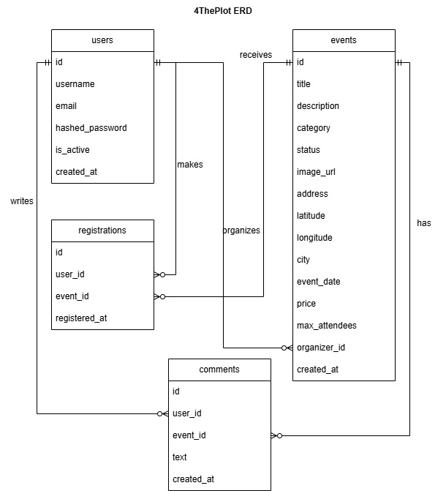
Figure 1: 4The Plot ERD. Source: ERD/4ThePlot ERD.jpg
Explanation: This diagram explains the database-side structure expected by the application: users, events, registrations, comments, categories, locations, capacity, recurrence, and administrative records. In this frontend-based document, it is included as a visual reference for the data objects consumed by the Flutter models.

Use Case Diagrams

Use Case Diagram
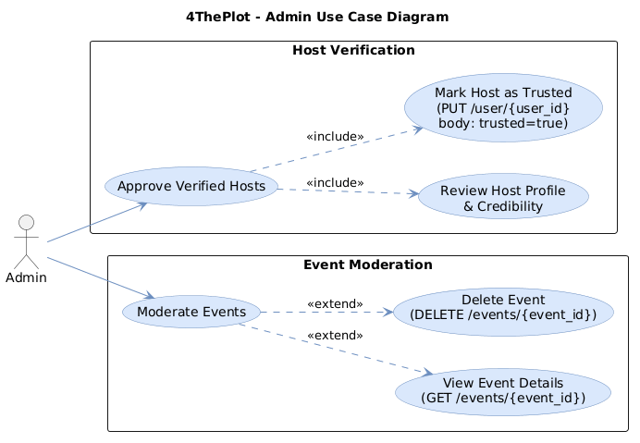
Figure 2: Use Case Diagram. Source: User Cases/User Case Diagrams/UC_ADM_UseCaseDiagram.png
Explanation: This use case diagram summarizes the visible capabilities for the general role. It should be read as a high-level visual companion to the implemented screens and API calls documented earlier.

Use Case Diagram
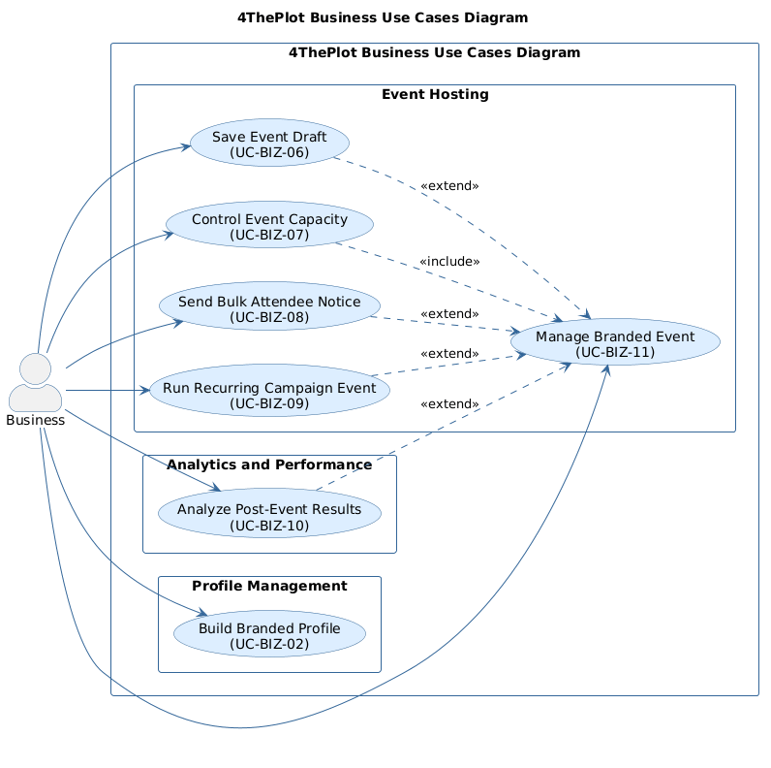
Figure 3: Use Case Diagram. Source: User Cases/User Case Diagrams/UC_BUS_UseCaseDiagram.png
Explanation: This use case diagram summarizes the visible capabilities for the general role. It should be read as a high-level visual companion to the implemented screens and API calls documented earlier.

Use Case Diagram
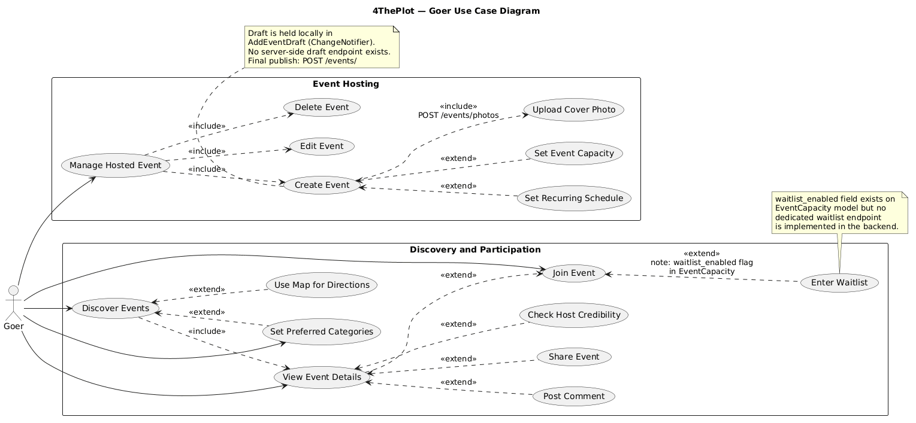
Figure 4: Use Case Diagram. Source: User Cases/User Case Diagrams/UC_GO_UseCaseDiagram.png
Explanation: This use case diagram summarizes the visible capabilities for the general role. It should be read as a high-level visual companion to the implemented screens and API calls documented earlier.

Use Case Diagram General
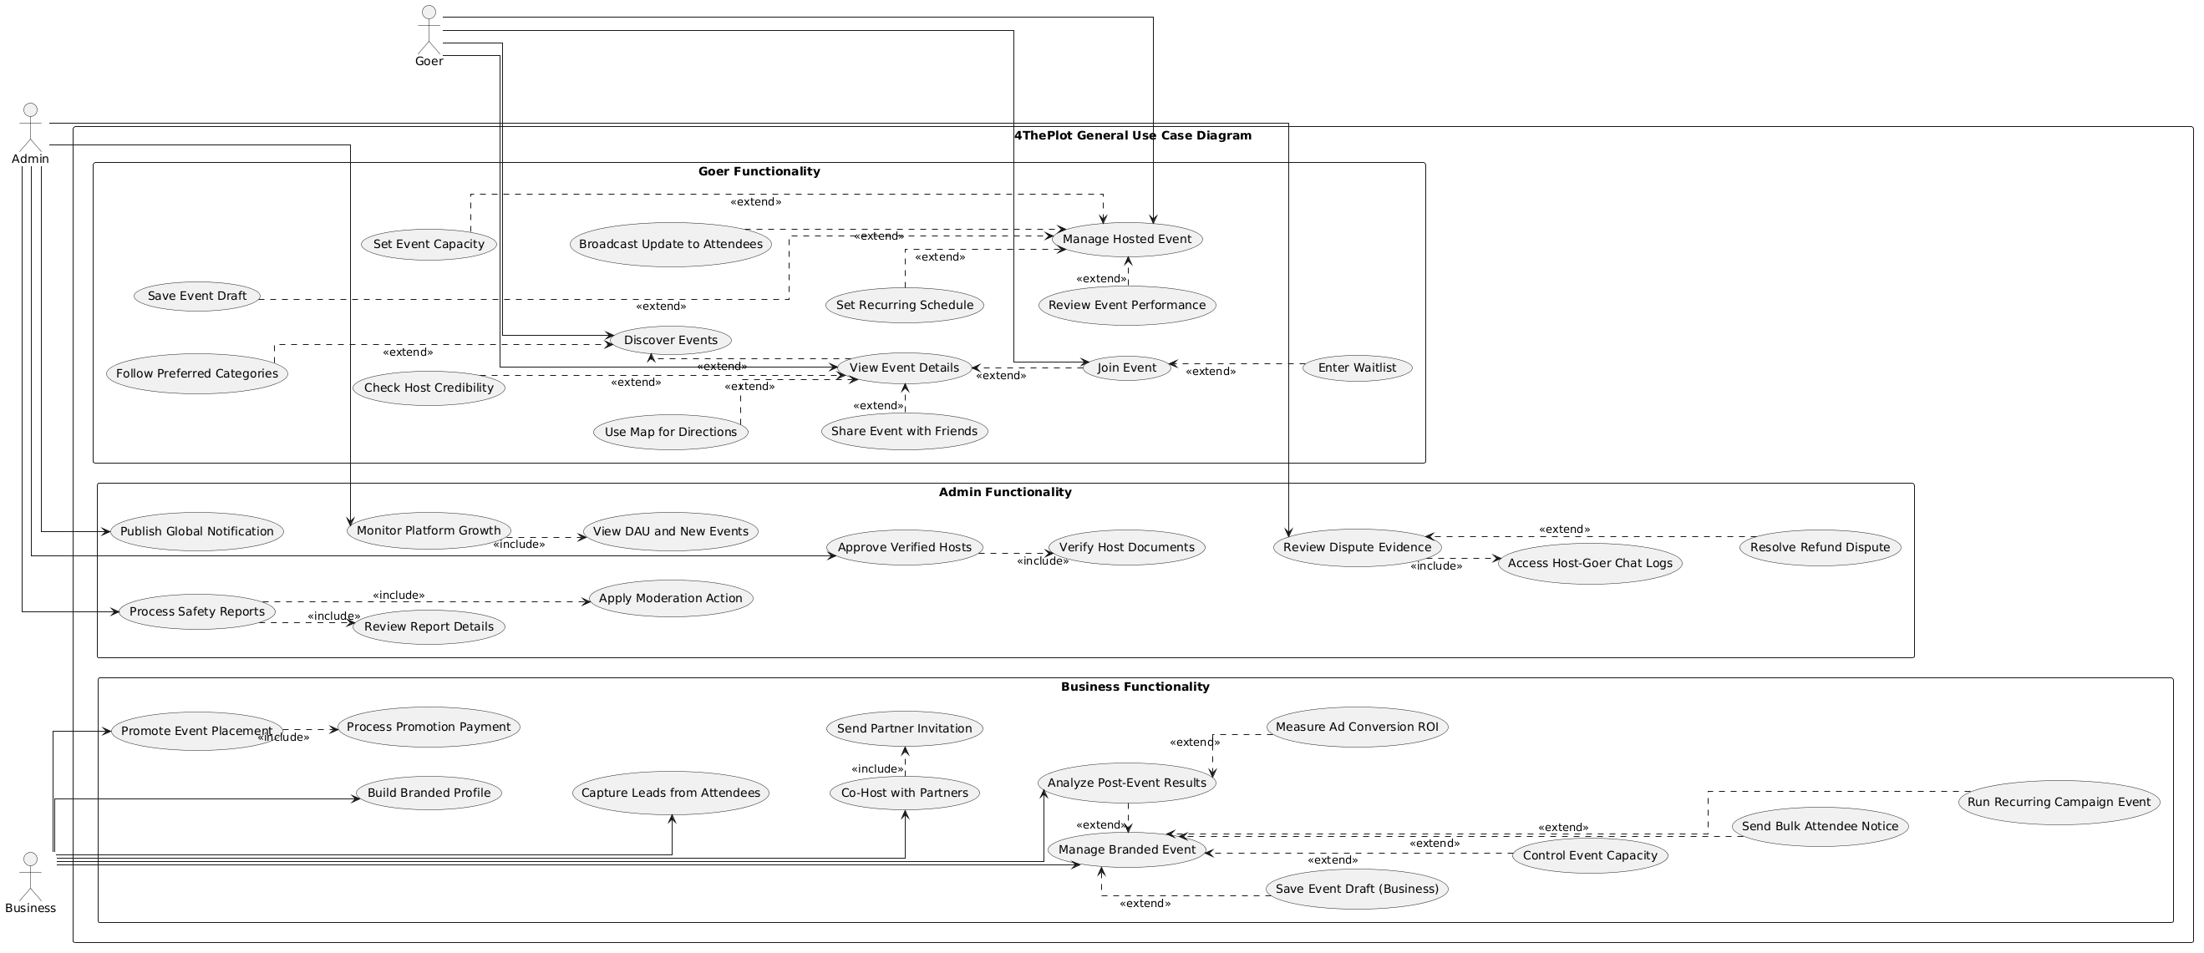
Figure 5: Use Case Diagram General. Source: User Cases/User Case Diagrams/UseCaseDiagram - General.png
Explanation: This use case diagram summarizes the visible capabilities for the general role. It should be read as a high-level visual companion to the implemented screens and API calls documented earlier.

Admin Activity Diagrams

01 Approve Verified Hosts
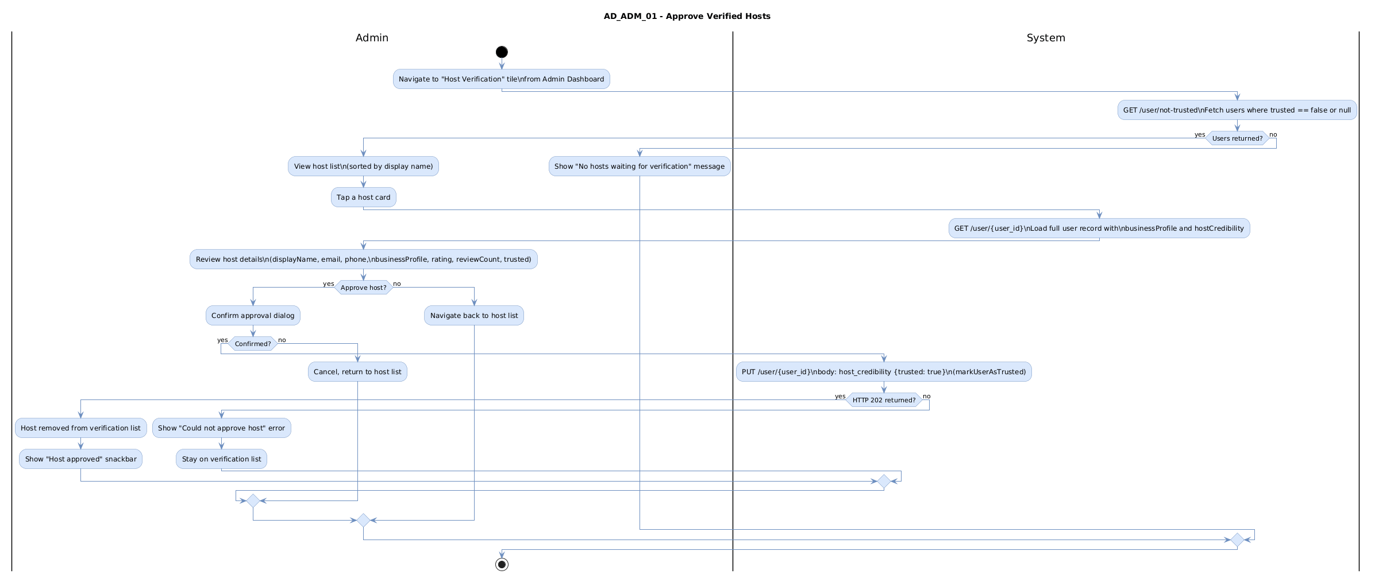
Figure 6: 01 Approve Verified Hosts. Source: User Cases/Activity Diagrams/AdminRole/AD_ADM_01_ApproveVerifiedHosts.png
Explanation: This activity diagram illustrates the process flow for 01 Approve Verified Hosts. It shows the order of user decisions and system responses for the admin workflow, which helps explain how the corresponding frontend screens guide the user through the task.

02 Moderate Events
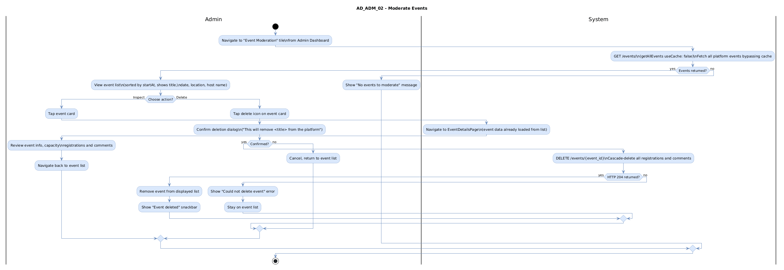
Figure 7: 02 Moderate Events. Source: User Cases/Activity Diagrams/AdminRole/AD_ADM_02_ModerateEvents.png
Explanation: This activity diagram illustrates the process flow for 02 Moderate Events. It shows the order of user decisions and system responses for the admin workflow, which helps explain how the corresponding frontend screens guide the user through the task.

Business Activity Diagrams

Analyze Post Event Results
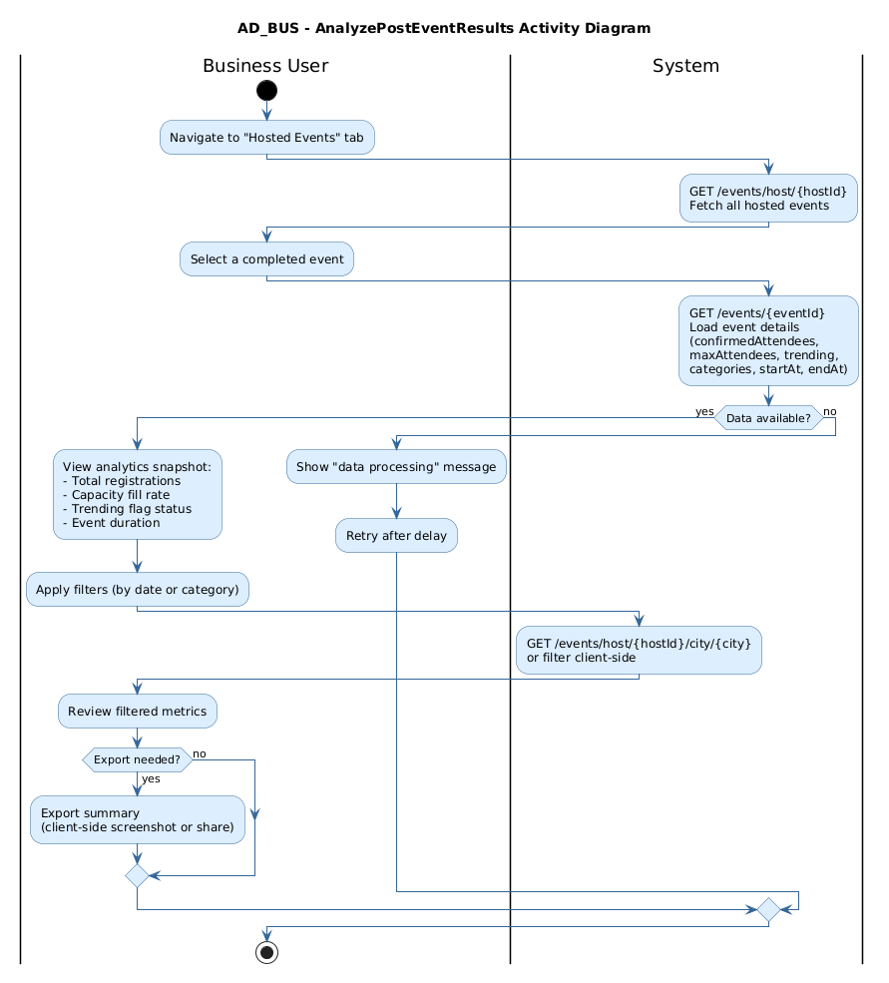
Figure 8: Analyze Post Event Results. Source: User Cases/Activity Diagrams/BusinessRole/AD_BUS_AnalyzePostEventResults.png
Explanation: This activity diagram illustrates the process flow for Analyze Post Event Results. It shows the order of user decisions and system responses for the business workflow, which helps explain how the corresponding frontend screens guide the user through the task.

Build Branded Profile
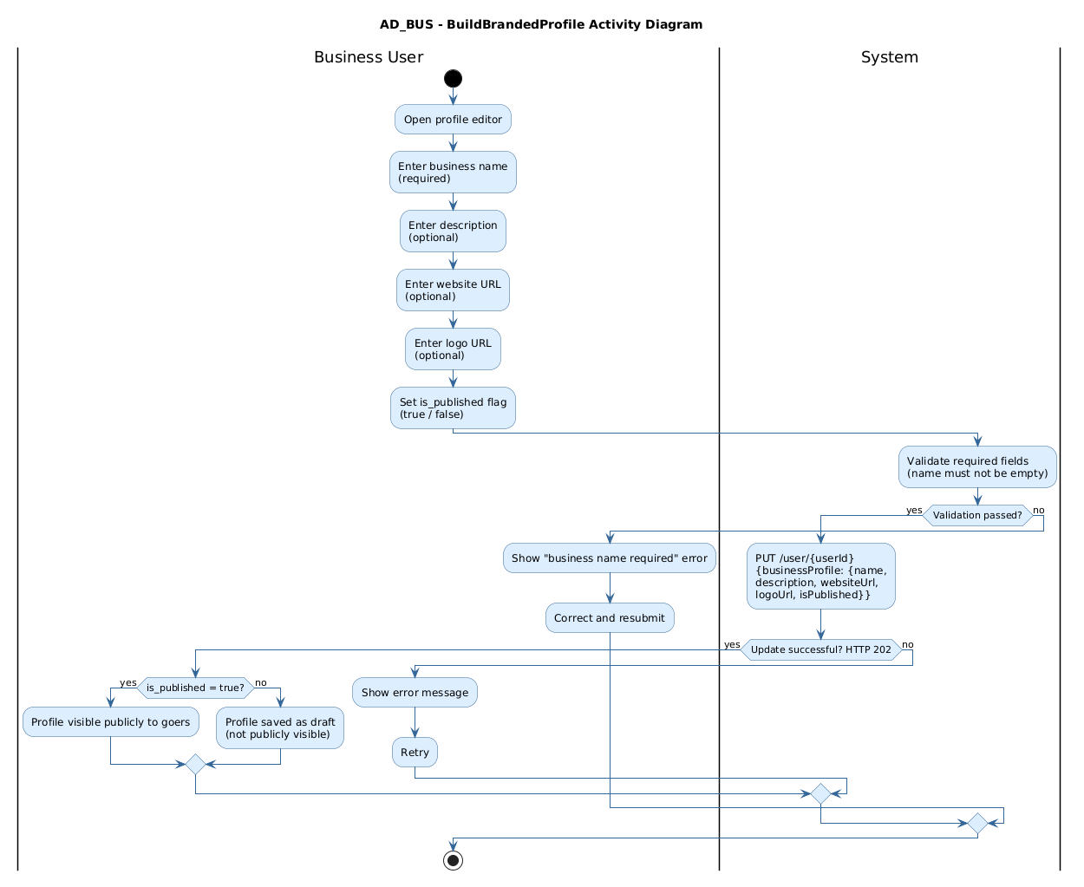
Figure 9: Build Branded Profile. Source: User Cases/Activity Diagrams/BusinessRole/AD_BUS_BuildBrandedProfile.png
Explanation: This activity diagram illustrates the process flow for Build Branded Profile. It shows the order of user decisions and system responses for the business workflow, which helps explain how the corresponding frontend screens guide the user through the task.

CE Create Event
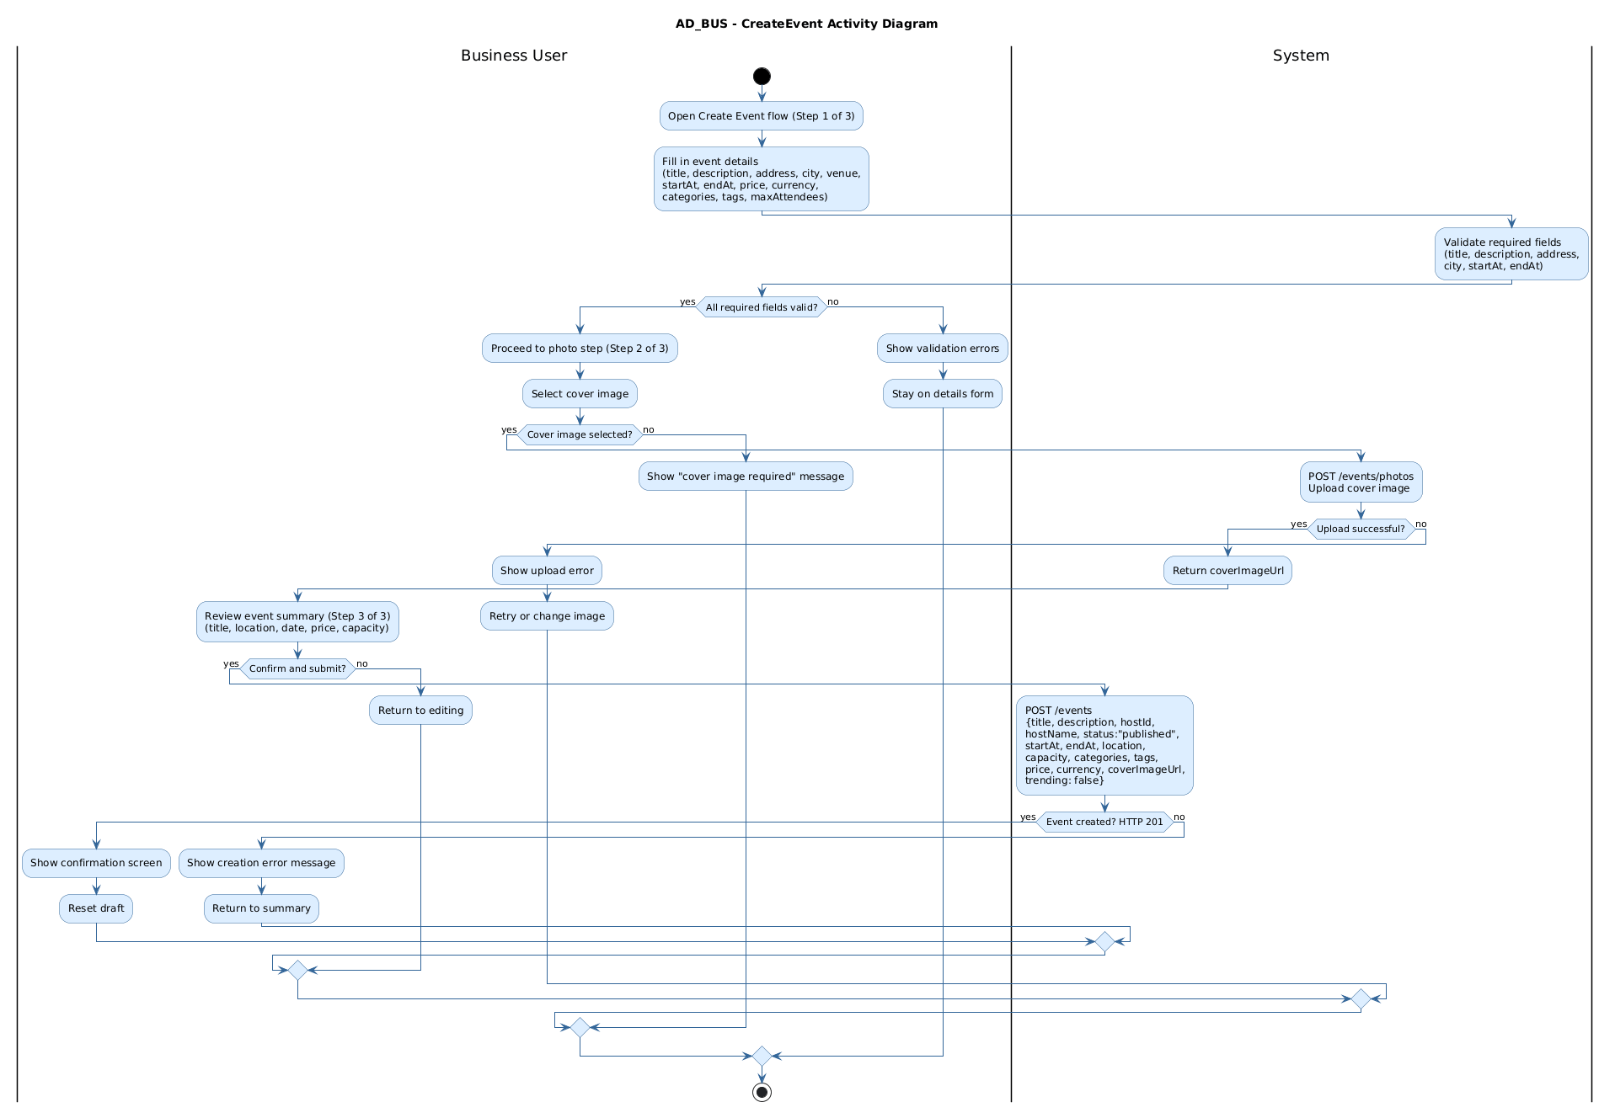
Figure 10: CE Create Event. Source: User Cases/Activity Diagrams/BusinessRole/AD_BUS_CE_CreateEvent.png
Explanation: This activity diagram illustrates the process flow for CE Create Event. It shows the order of user decisions and system responses for the business workflow, which helps explain how the corresponding frontend screens guide the user through the task.

Control Event Capacity
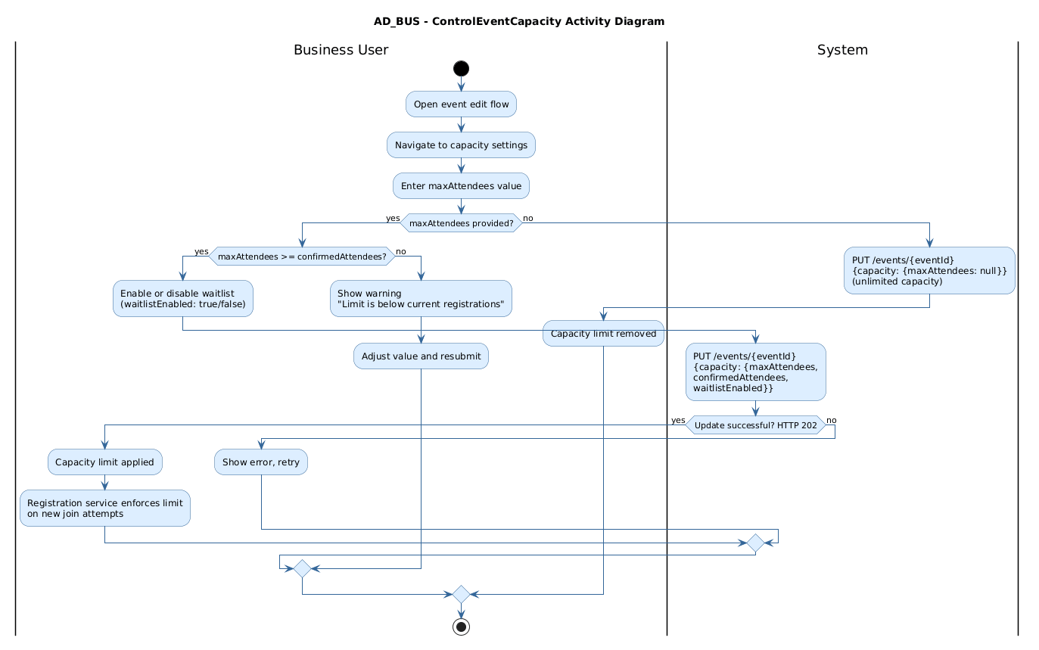
Figure 11: Control Event Capacity. Source: User Cases/Activity Diagrams/BusinessRole/AD_BUS_ControlEventCapacity.png
Explanation: This activity diagram illustrates the process flow for Control Event Capacity. It shows the order of user decisions and system responses for the business workflow, which helps explain how the corresponding frontend screens guide the user through the task.

Manage Hosted Events
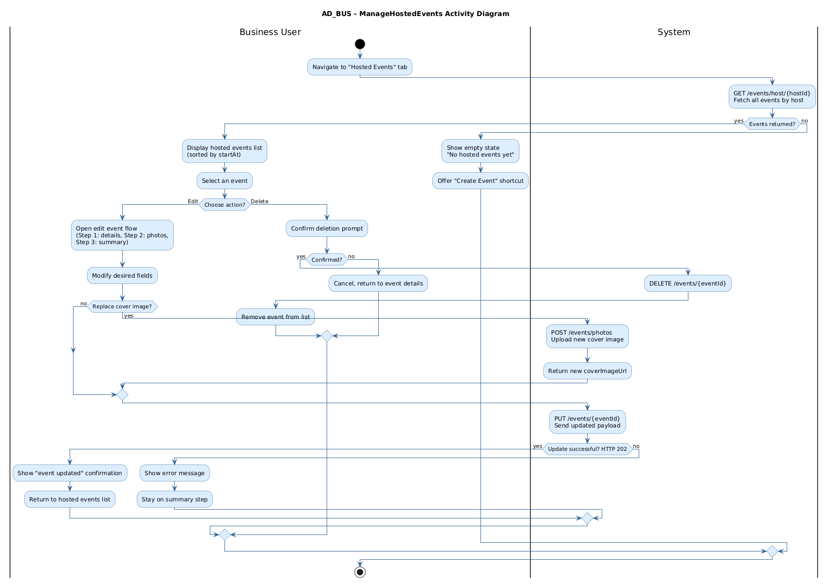
Figure 12: Manage Hosted Events. Source: User Cases/Activity Diagrams/BusinessRole/AD_BUS_ManageHostedEvents.png
Explanation: This activity diagram illustrates the process flow for Manage Hosted Events. It shows the order of user decisions and system responses for the business workflow, which helps explain how the corresponding frontend screens guide the user through the task.

Run Recurring Campaign Event
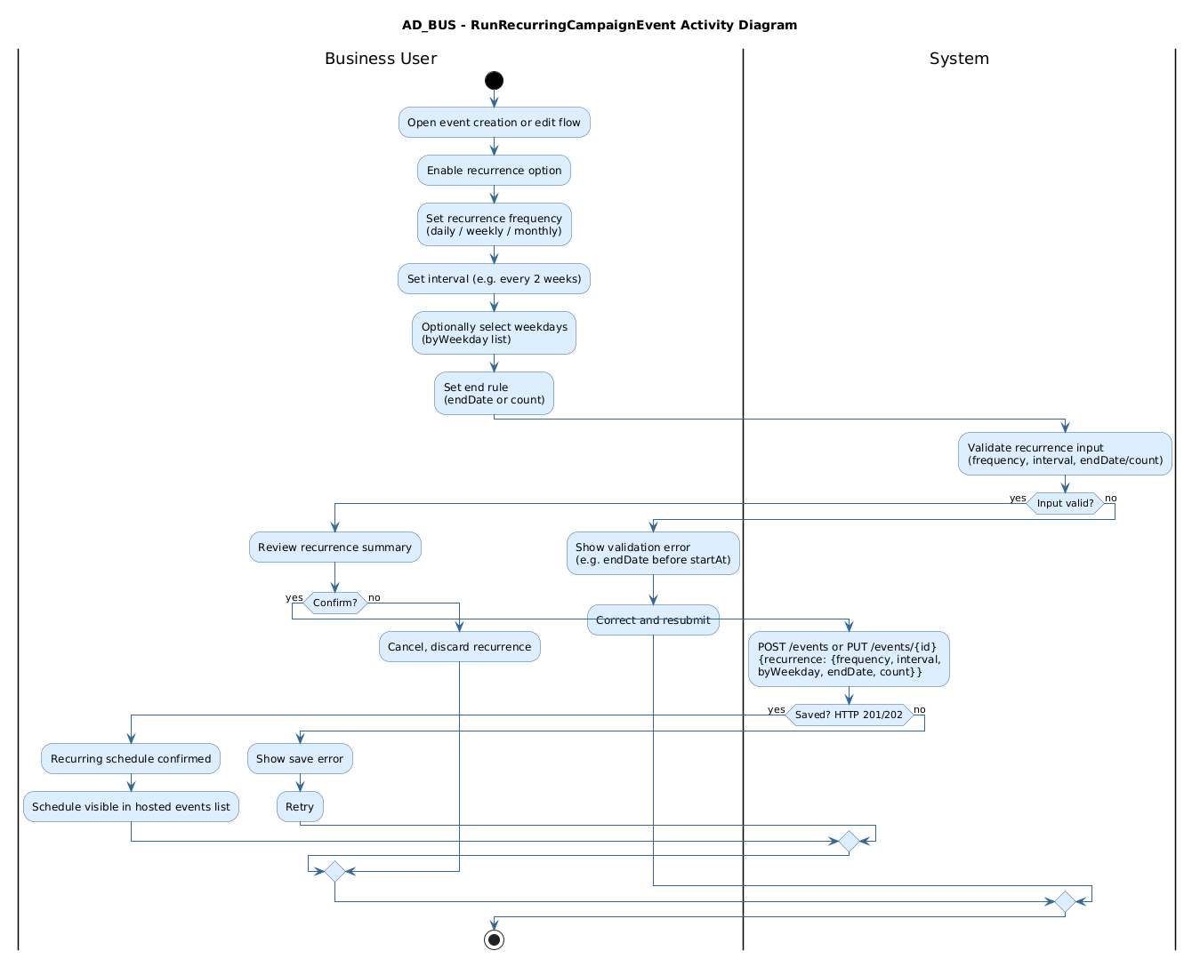
Figure 13: Run Recurring Campaign Event. Source: User Cases/Activity Diagrams/BusinessRole/AD_BUS_RunRecurringCampaignEvent.png
Explanation: This activity diagram illustrates the process flow for Run Recurring Campaign Event. It shows the order of user decisions and system responses for the business workflow, which helps explain how the corresponding frontend screens guide the user through the task.

Send Bulk Attendee Notice
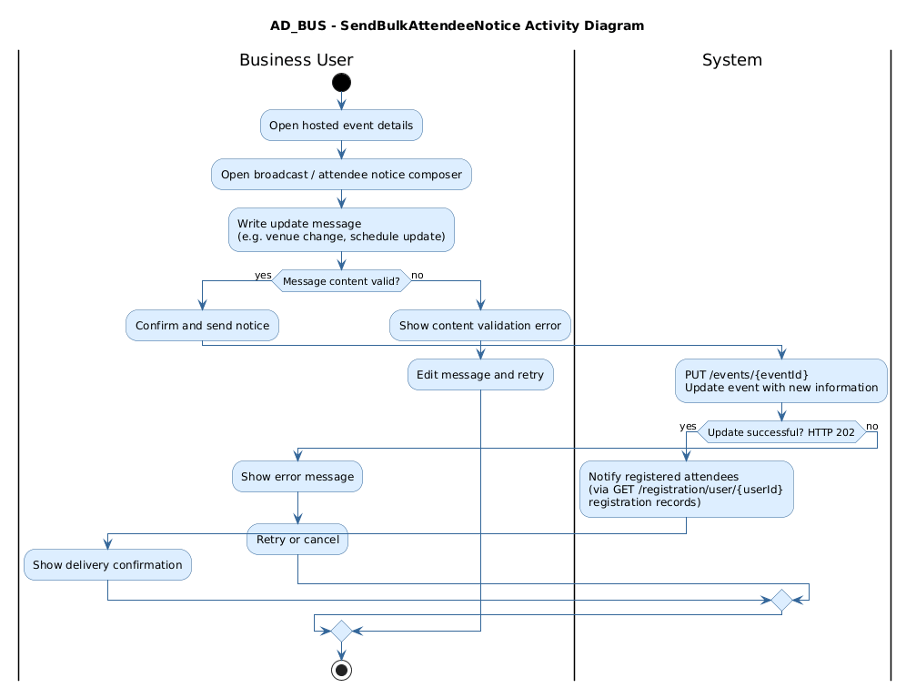
Figure 14: Send Bulk Attendee Notice. Source: User Cases/Activity Diagrams/BusinessRole/AD_BUS_SendBulkAttendeeNotice.png
Explanation: This activity diagram illustrates the process flow for Send Bulk Attendee Notice. It shows the order of user decisions and system responses for the business workflow, which helps explain how the corresponding frontend screens guide the user through the task.

Goer Activity Diagrams

11 Discover Events
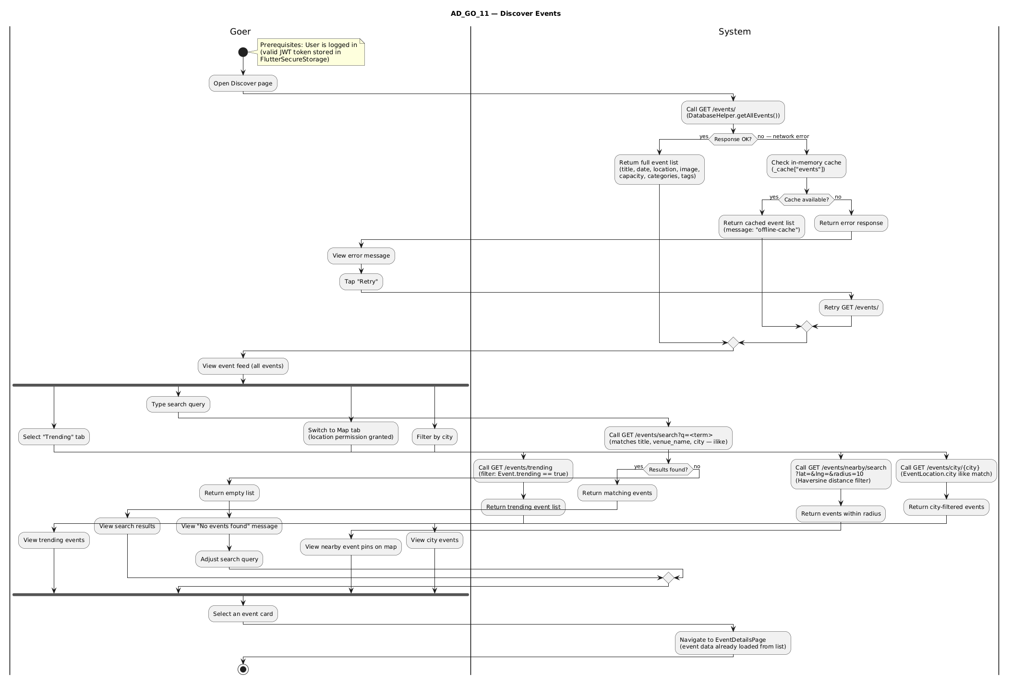
Figure 15: 11 Discover Events. Source: User Cases/Activity Diagrams/GoerRole/AD_GO_11_DiscoverEvents.png
Explanation: This activity diagram illustrates the process flow for 11 Discover Events. It shows the order of user decisions and system responses for the goer workflow, which helps explain how the corresponding frontend screens guide the user through the task.

12 View Event Details
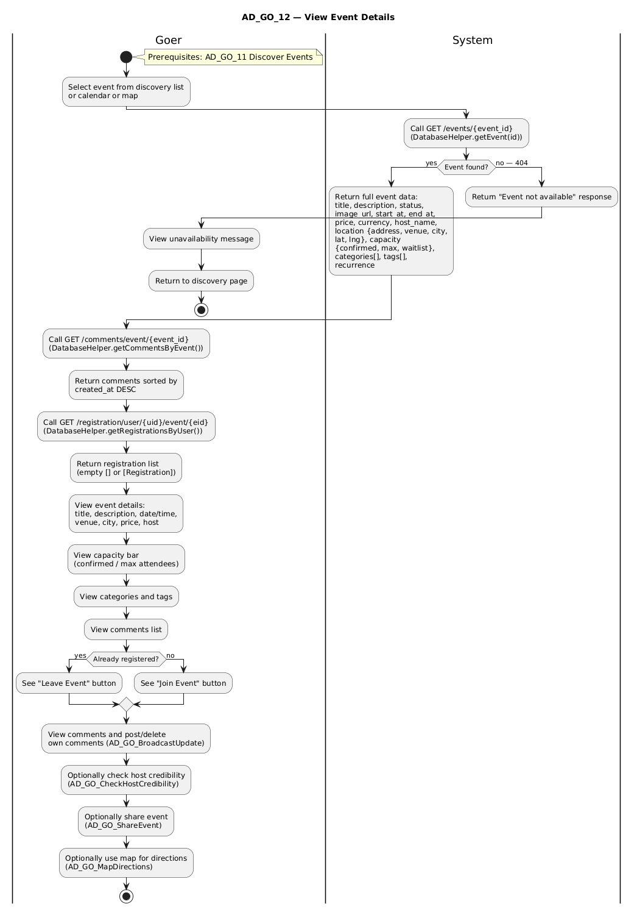
Figure 16: 12 View Event Details. Source: User Cases/Activity Diagrams/GoerRole/AD_GO_12_ViewEventDetails.png
Explanation: This activity diagram illustrates the process flow for 12 View Event Details. It shows the order of user decisions and system responses for the goer workflow, which helps explain how the corresponding frontend screens guide the user through the task.

13 Join Event
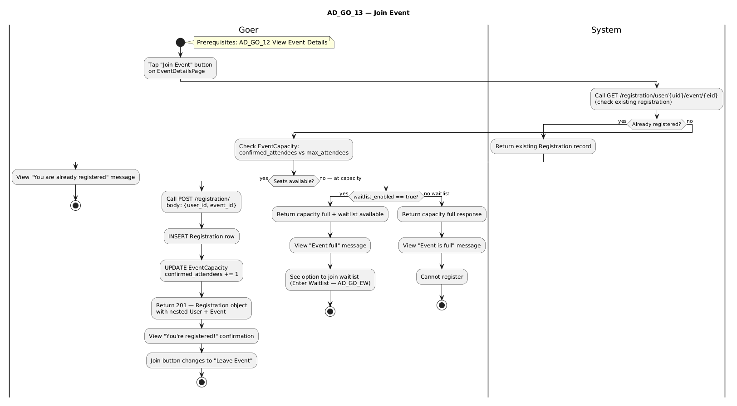
Figure 17: 13 Join Event. Source: User Cases/Activity Diagrams/GoerRole/AD_GO_13_JoinEvent.png
Explanation: This activity diagram illustrates the process flow for 13 Join Event. It shows the order of user decisions and system responses for the goer workflow, which helps explain how the corresponding frontend screens guide the user through the task.

14 Manage Hosted Events
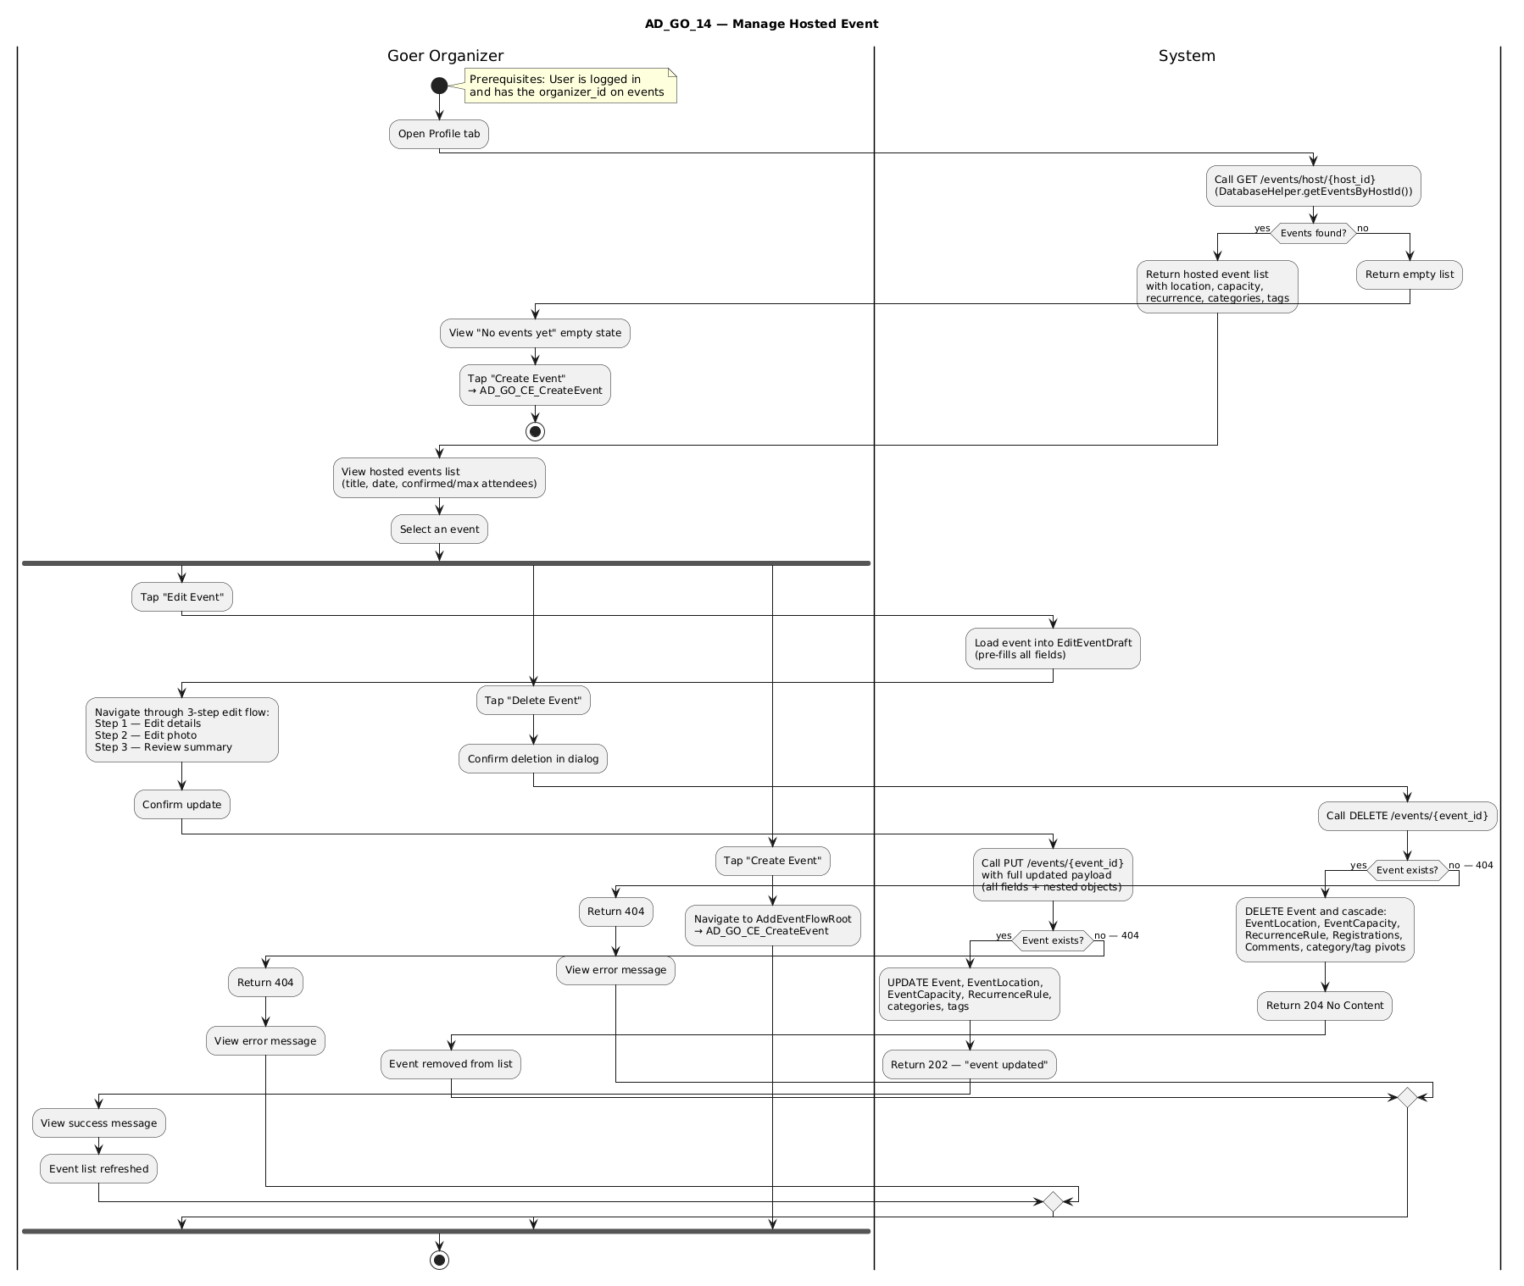
Figure 18: 14 Manage Hosted Events. Source: User Cases/Activity Diagrams/GoerRole/AD_GO_14_ManageHostedEvents.png
Explanation: This activity diagram illustrates the process flow for 14 Manage Hosted Events. It shows the order of user decisions and system responses for the goer workflow, which helps explain how the corresponding frontend screens guide the user through the task.

Broadcast Update
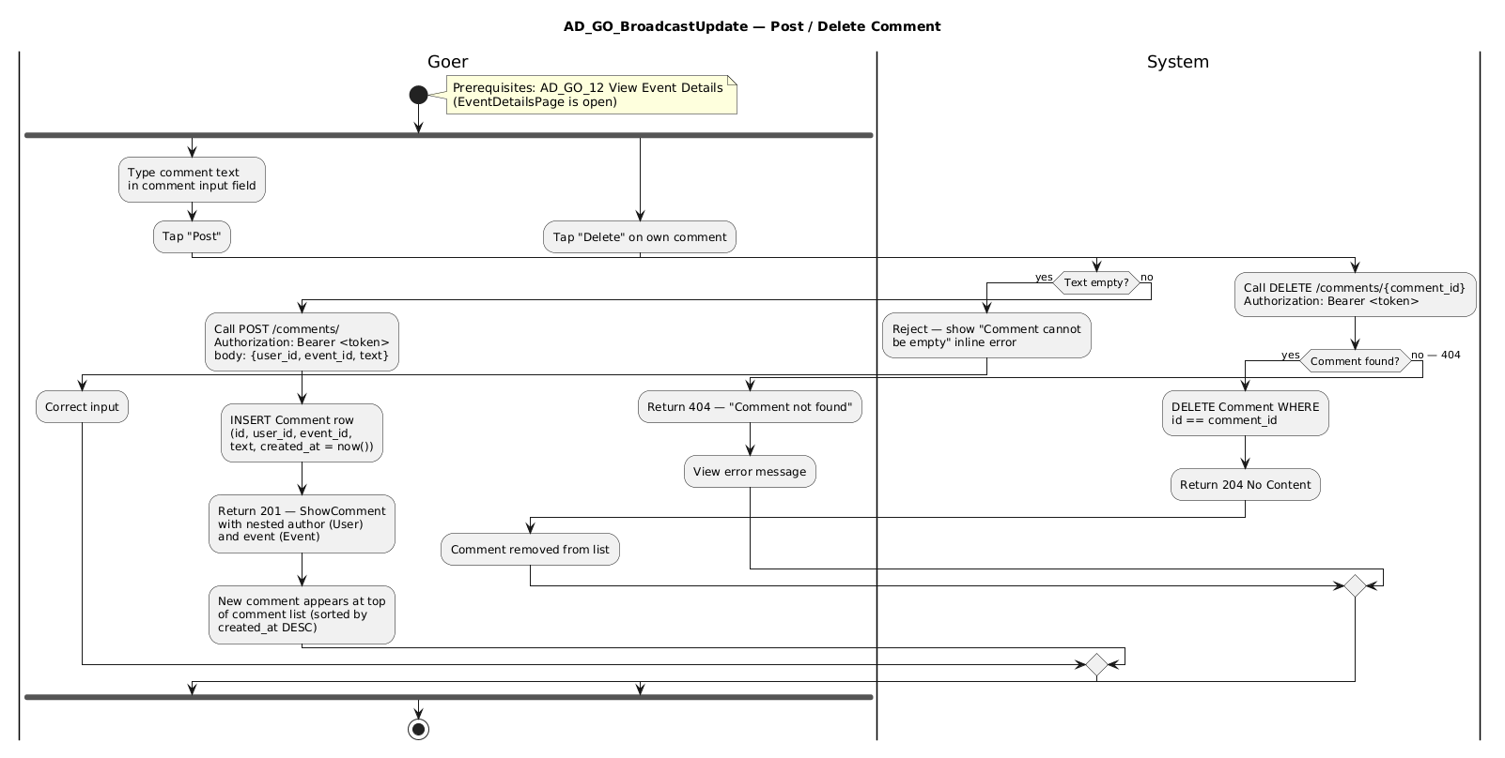
Figure 19: Broadcast Update. Source: User Cases/Activity Diagrams/GoerRole/AD_GO_BroadcastUpdate.png
Explanation: This activity diagram illustrates the process flow for Broadcast Update. It shows the order of user decisions and system responses for the goer workflow, which helps explain how the corresponding frontend screens guide the user through the task.

CE Create Event
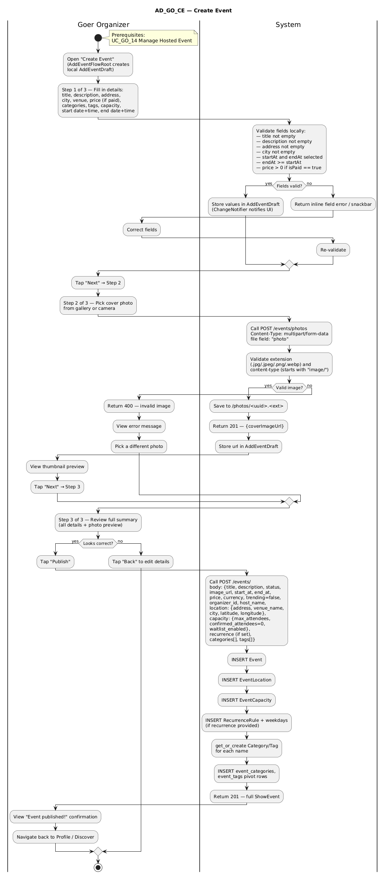
Figure 20: CE Create Event. Source: User Cases/Activity Diagrams/GoerRole/AD_GO_CE_CreateEvent.png
Explanation: This activity diagram illustrates the process flow for CE Create Event. It shows the order of user decisions and system responses for the goer workflow, which helps explain how the corresponding frontend screens guide the user through the task.

Check Host Credibility
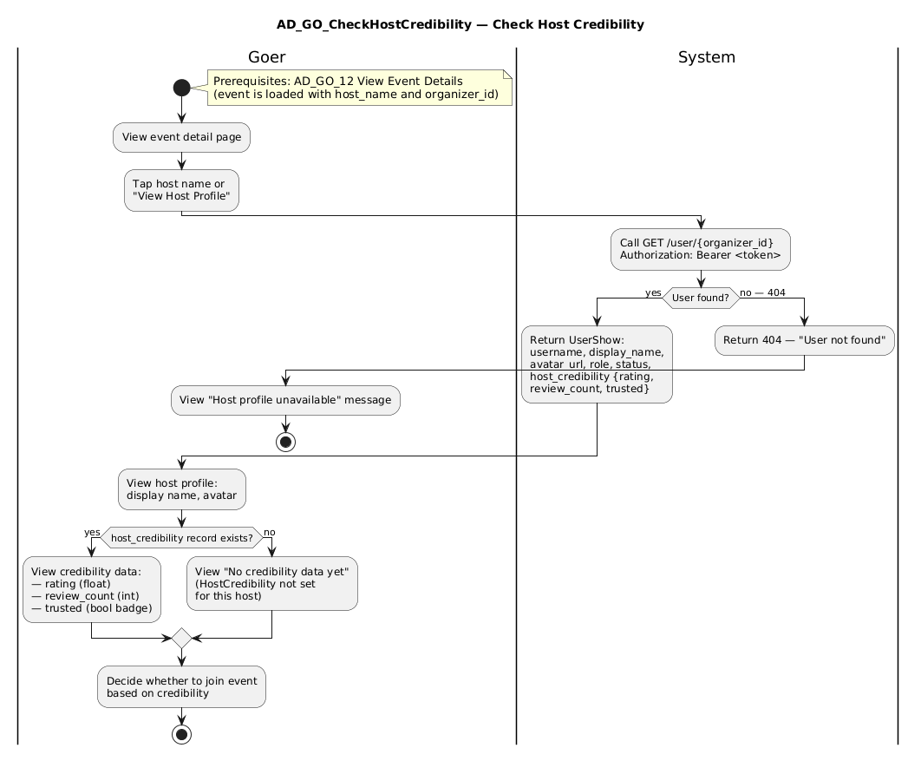
Figure 21: Check Host Credibility. Source: User Cases/Activity Diagrams/GoerRole/AD_GO_CheckHostCredibility.png
Explanation: This activity diagram illustrates the process flow for Check Host Credibility. It shows the order of user decisions and system responses for the goer workflow, which helps explain how the corresponding frontend screens guide the user through the task.

Enter Waitlist
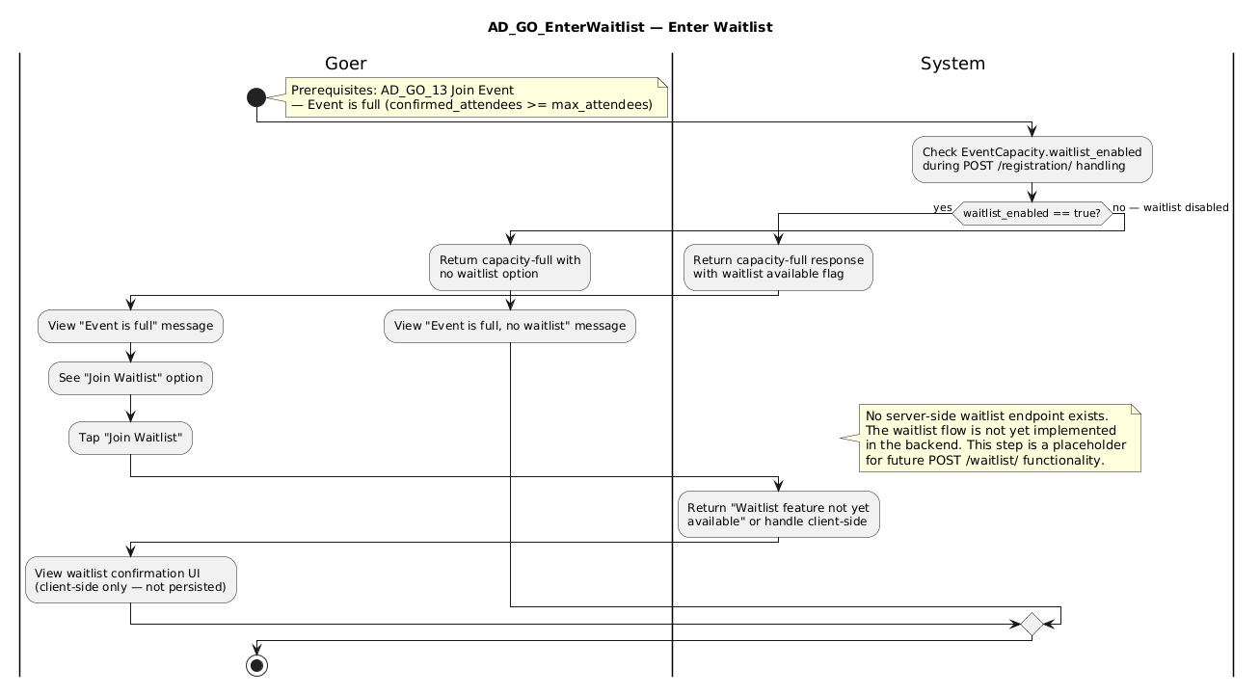
Figure 22: Enter Waitlist. Source: User Cases/Activity Diagrams/GoerRole/AD_GO_EnterWaitlist.png
Explanation: This activity diagram illustrates the process flow for Enter Waitlist. It shows the order of user decisions and system responses for the goer workflow, which helps explain how the corresponding frontend screens guide the user through the task.

Limit Event Capacity
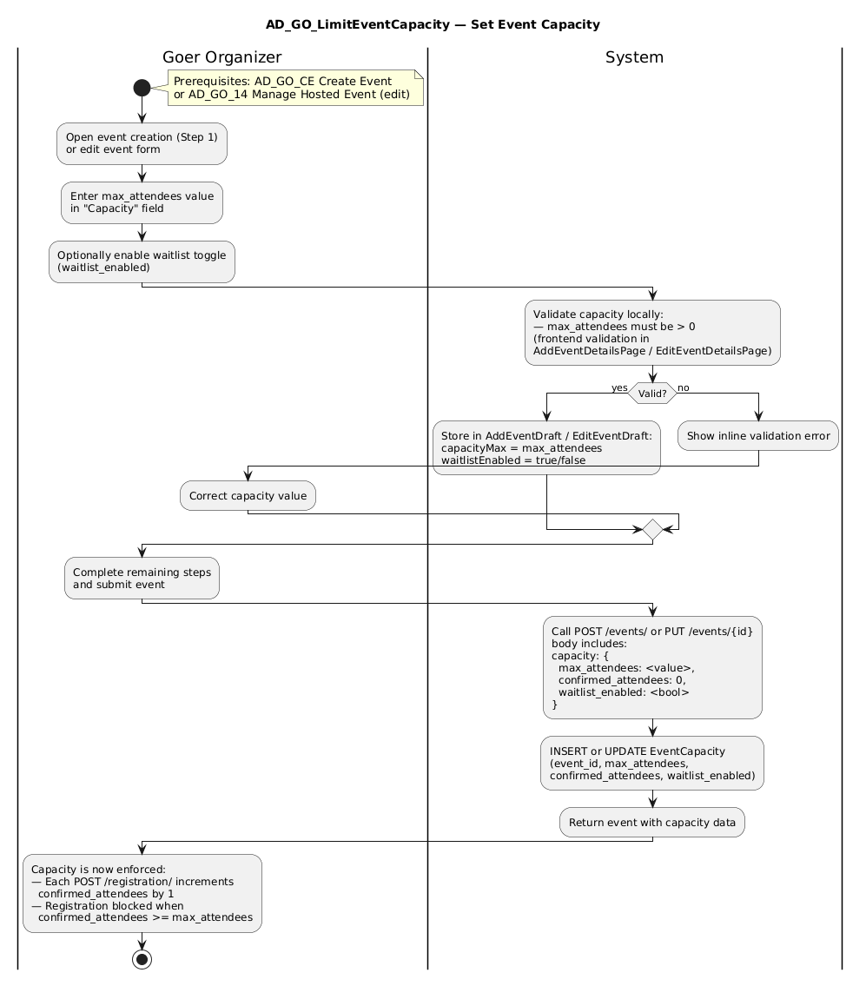
Figure 23: Limit Event Capacity. Source: User Cases/Activity Diagrams/GoerRole/AD_GO_LimitEventCapacity.png
Explanation: This activity diagram illustrates the process flow for Limit Event Capacity. It shows the order of user decisions and system responses for the goer workflow, which helps explain how the corresponding frontend screens guide the user through the task.

Map Directions
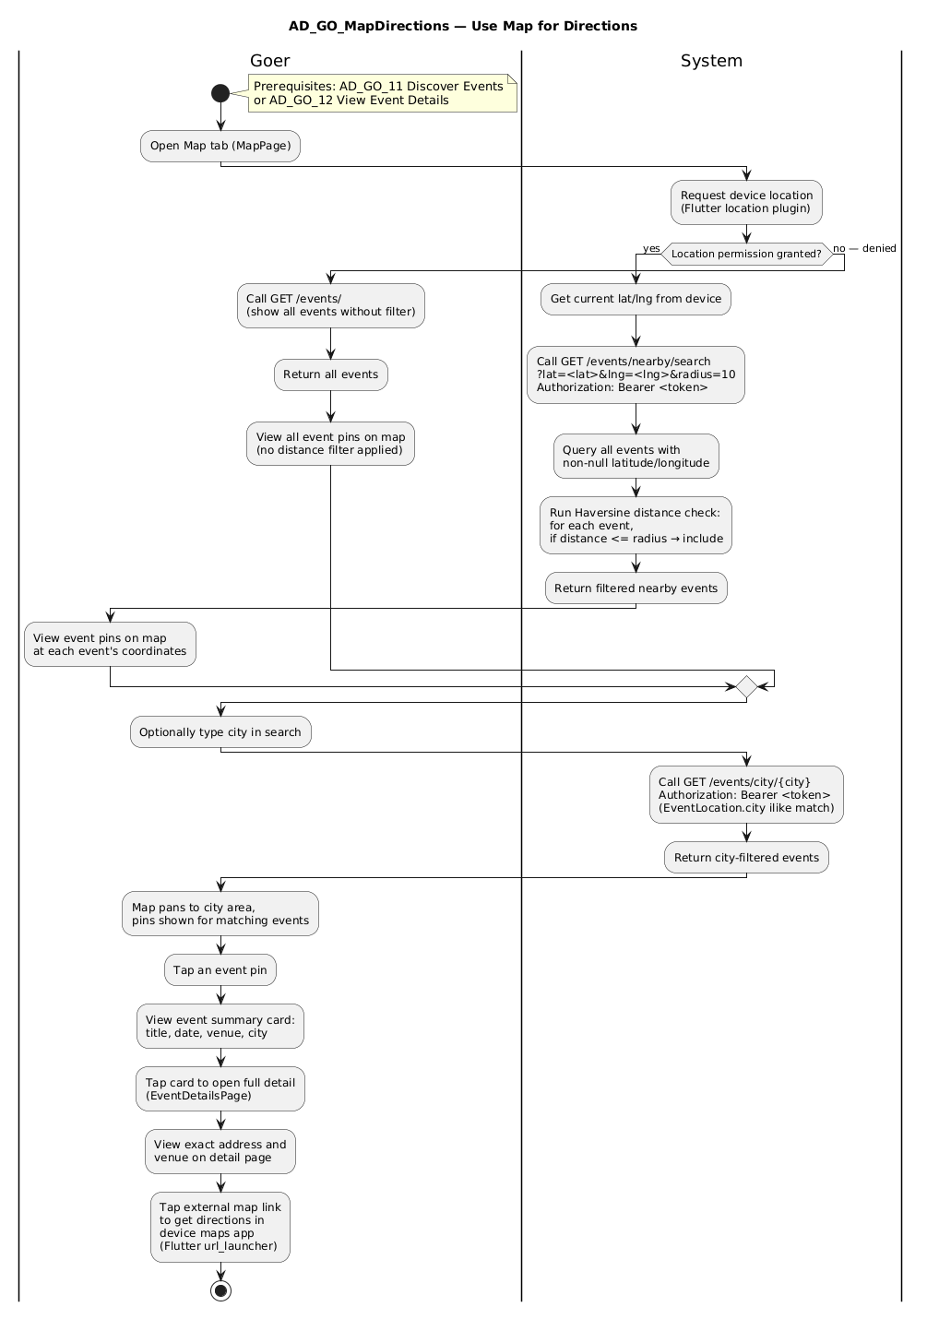
Figure 24: Map Directions. Source: User Cases/Activity Diagrams/GoerRole/AD_GO_MapDirections.png
Explanation: This activity diagram illustrates the process flow for Map Directions. It shows the order of user decisions and system responses for the goer workflow, which helps explain how the corresponding frontend screens guide the user through the task.

Pref Categories
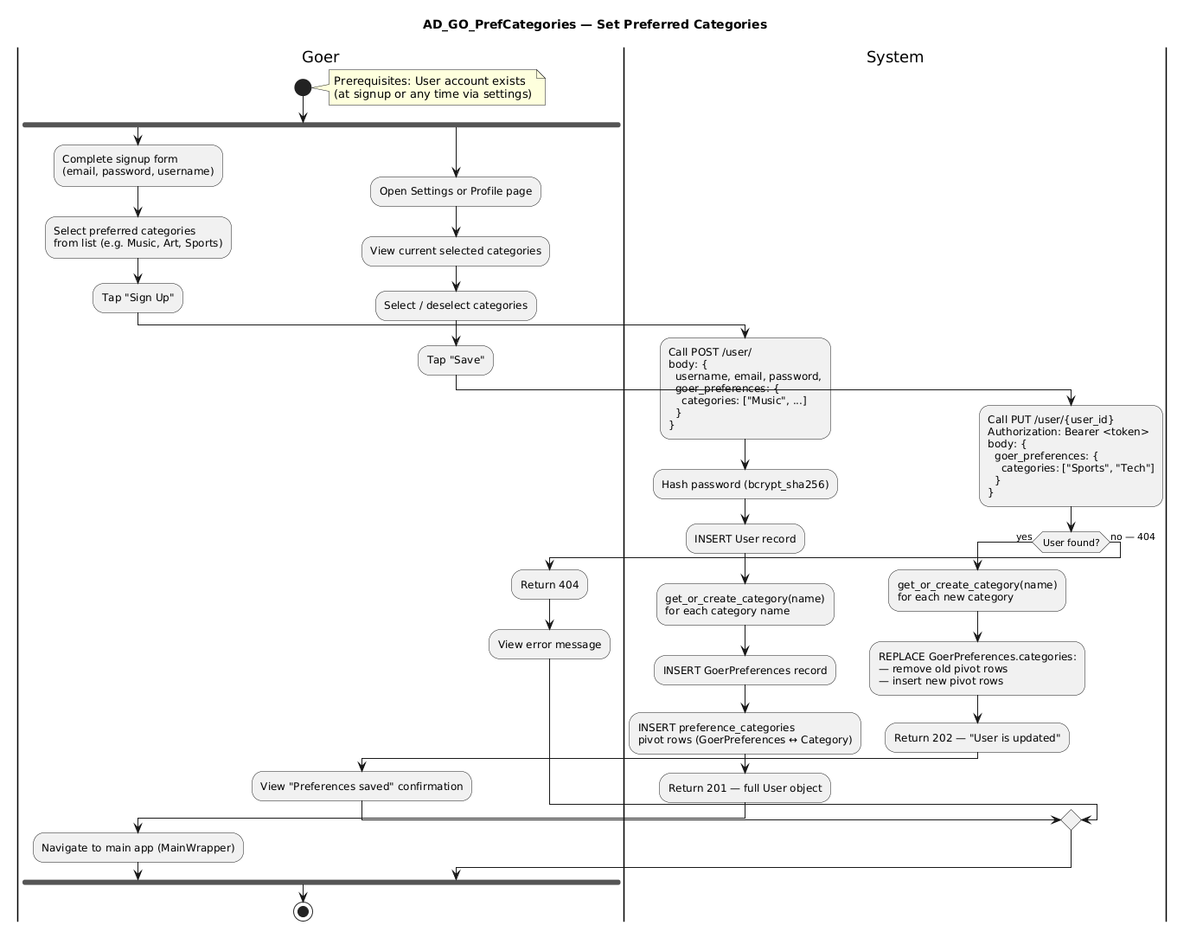
Figure 25: Pref Categories. Source: User Cases/Activity Diagrams/GoerRole/AD_GO_PrefCategories.png
Explanation: This activity diagram illustrates the process flow for Pref Categories. It shows the order of user decisions and system responses for the goer workflow, which helps explain how the corresponding frontend screens guide the user through the task.

Review Event Performance
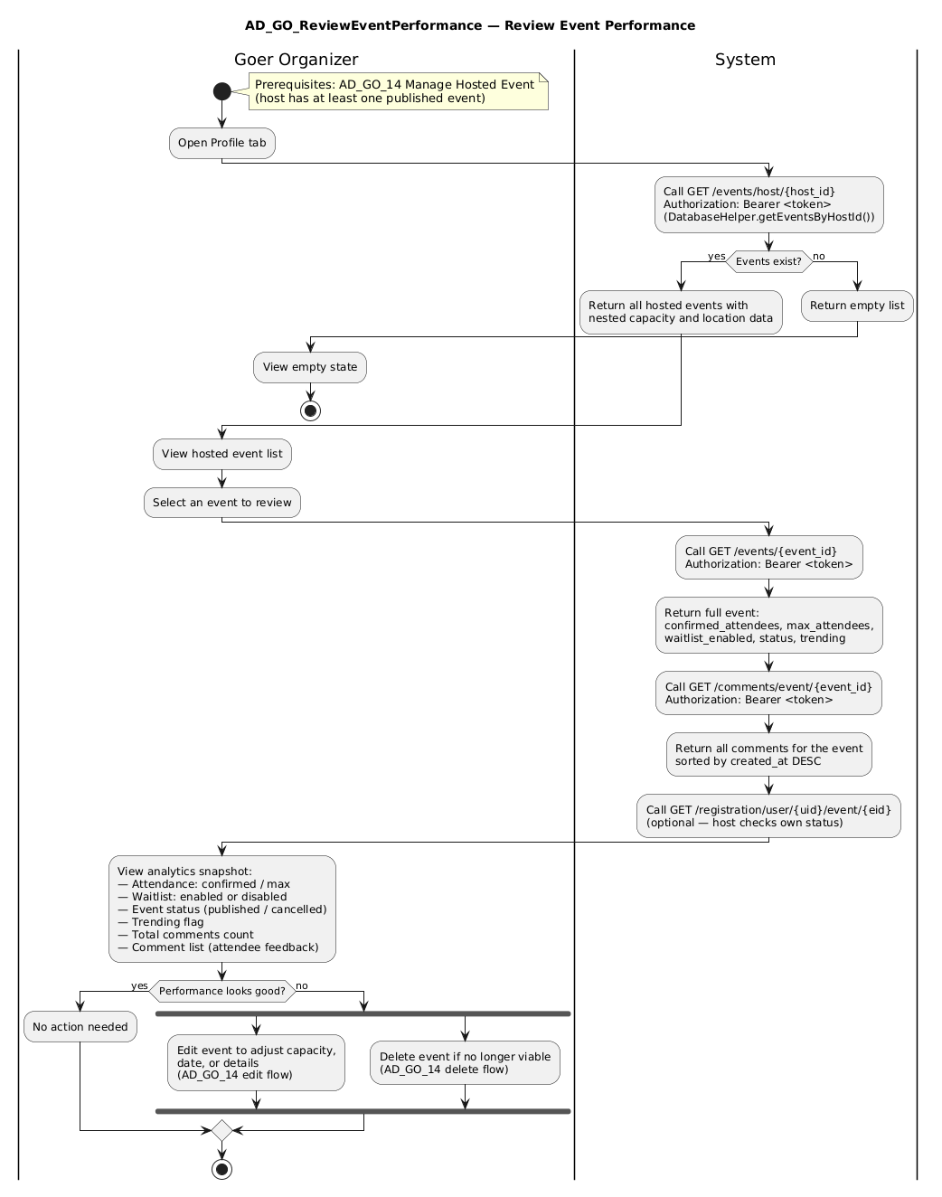
Figure 26: Review Event Performance. Source: User Cases/Activity Diagrams/GoerRole/AD_GO_ReviewEventPerformance.png
Explanation: This activity diagram illustrates the process flow for Review Event Performance. It shows the order of user decisions and system responses for the goer workflow, which helps explain how the corresponding frontend screens guide the user through the task.

Set Rec Schedule
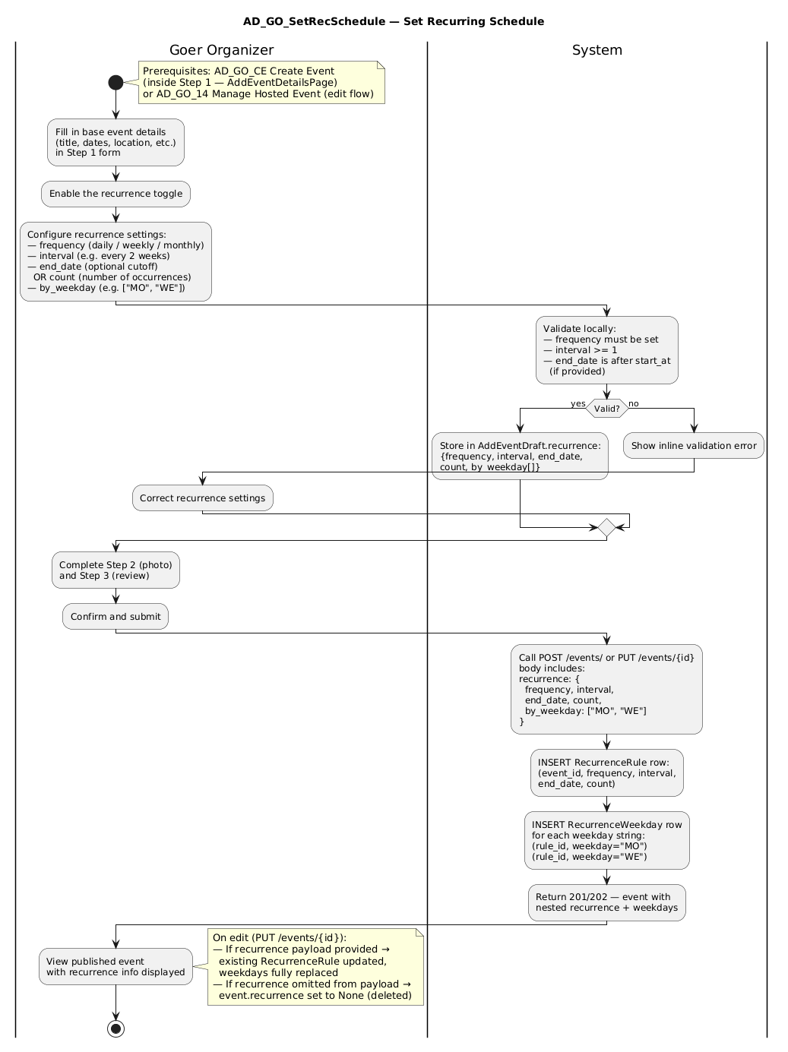
Figure 27: Set Rec Schedule. Source: User Cases/Activity Diagrams/GoerRole/AD_GO_SetRecSchedule.png
Explanation: This activity diagram illustrates the process flow for Set Rec Schedule. It shows the order of user decisions and system responses for the goer workflow, which helps explain how the corresponding frontend screens guide the user through the task.

Share Event
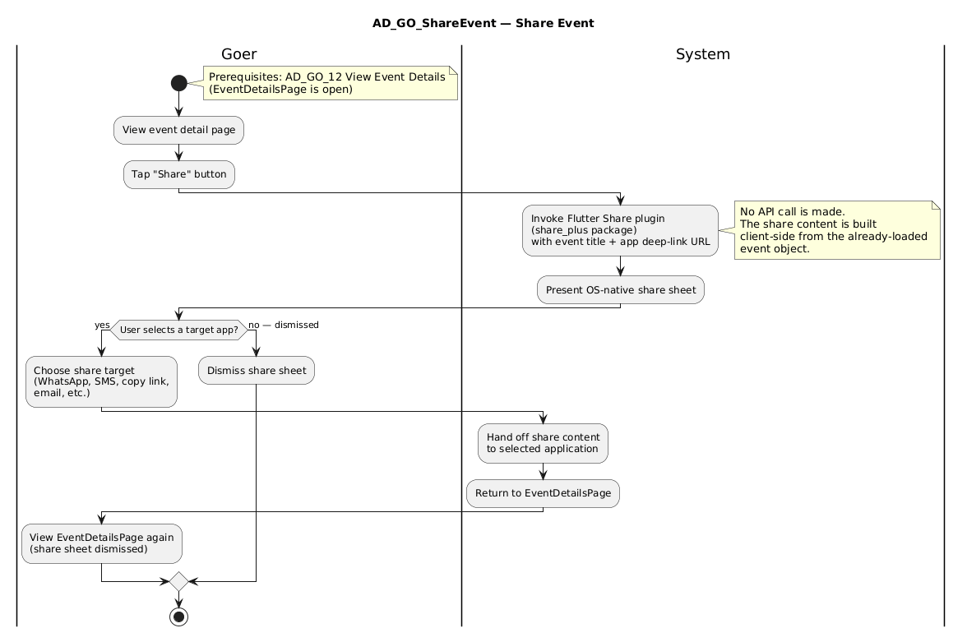
Figure 28: Share Event. Source: User Cases/Activity Diagrams/GoerRole/AD_GO_ShareEvent.png
Explanation: This activity diagram illustrates the process flow for Share Event. It shows the order of user decisions and system responses for the goer workflow, which helps explain how the corresponding frontend screens guide the user through the task.

Admin Sequence Diagrams

01 Approve Verified Hosts
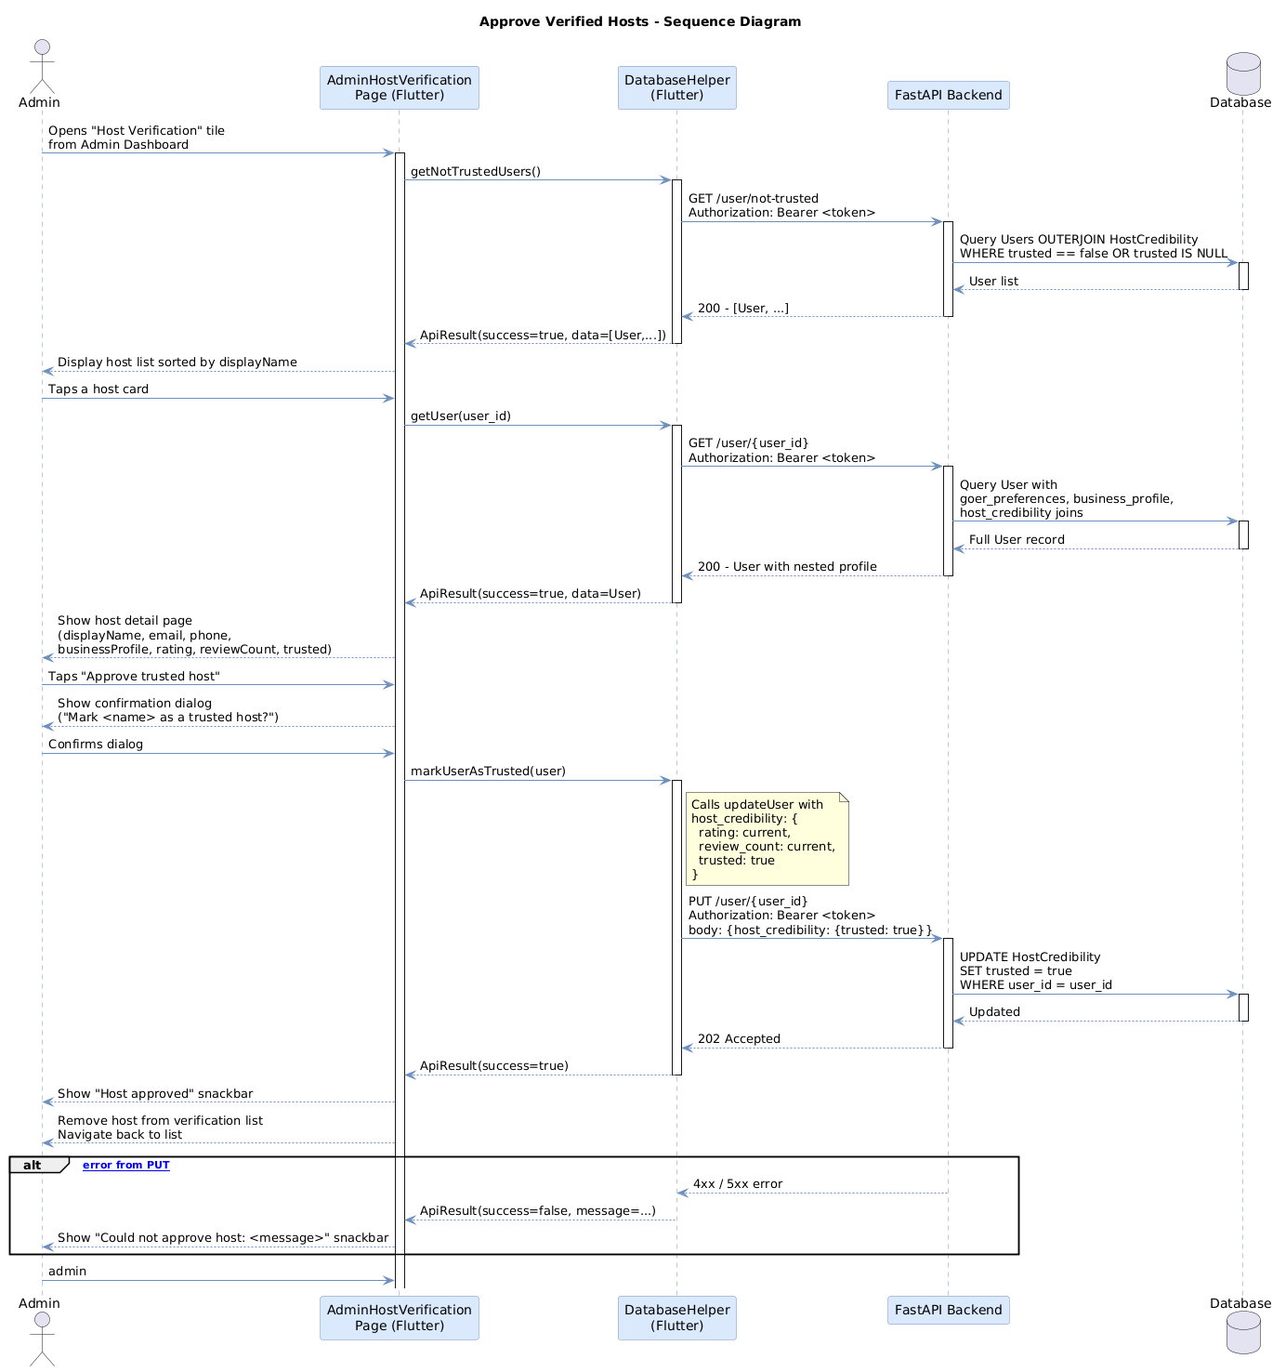
Figure 29: 01 Approve Verified Hosts. Source: User Cases/Sequence Diagrams/AdminRole/SEQ_ADM_01_ApproveVerifiedHosts.png
Explanation: This sequence diagram explains the runtime interaction for 01 Approve Verified Hosts. It is useful for understanding how the user interface, frontend logic, and backend API contract are expected to collaborate during this workflow.

02 Moderate Events
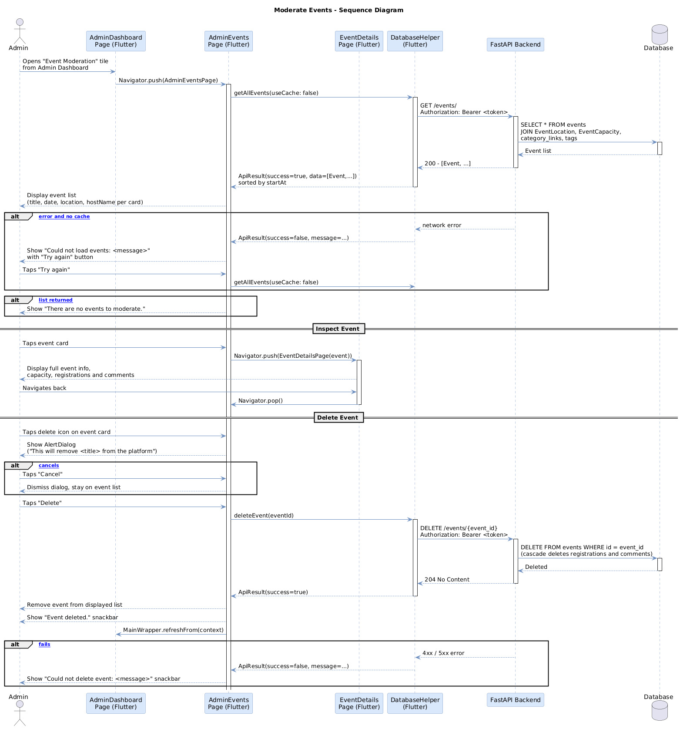
Figure 30: 02 Moderate Events. Source: User Cases/Sequence Diagrams/AdminRole/SEQ_ADM_02_ModerateEvents.png
Explanation: This sequence diagram explains the runtime interaction for 02 Moderate Events. It is useful for understanding how the user interface, frontend logic, and backend API contract are expected to collaborate during this workflow.

Business Sequence Diagrams

06 Broadcast Notice
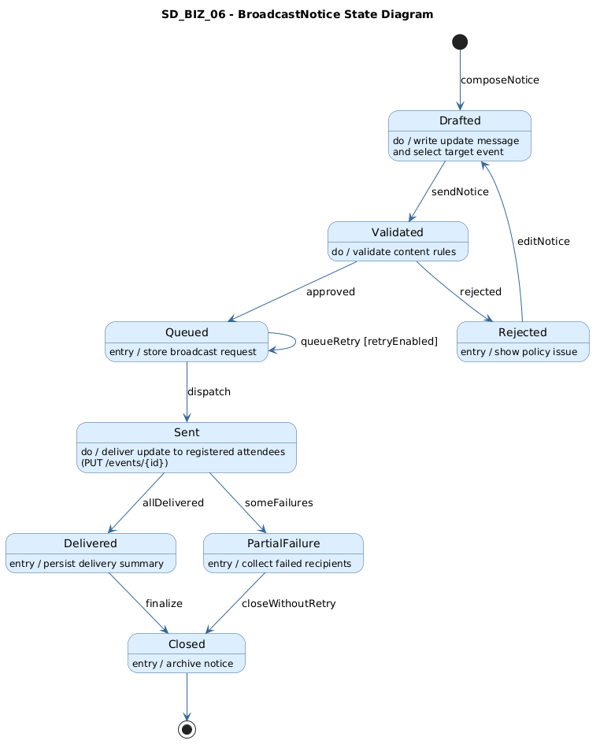
Figure 31: 06 Broadcast Notice. Source: User Cases/Sequence Diagrams/BusinessRole/SD_BIZ_06_BroadcastNotice.png
Explanation: This sequence diagram explains the runtime interaction for 06 Broadcast Notice. It is useful for understanding how the user interface, frontend logic, and backend API contract are expected to collaborate during this workflow.

Analyze Post Event Results
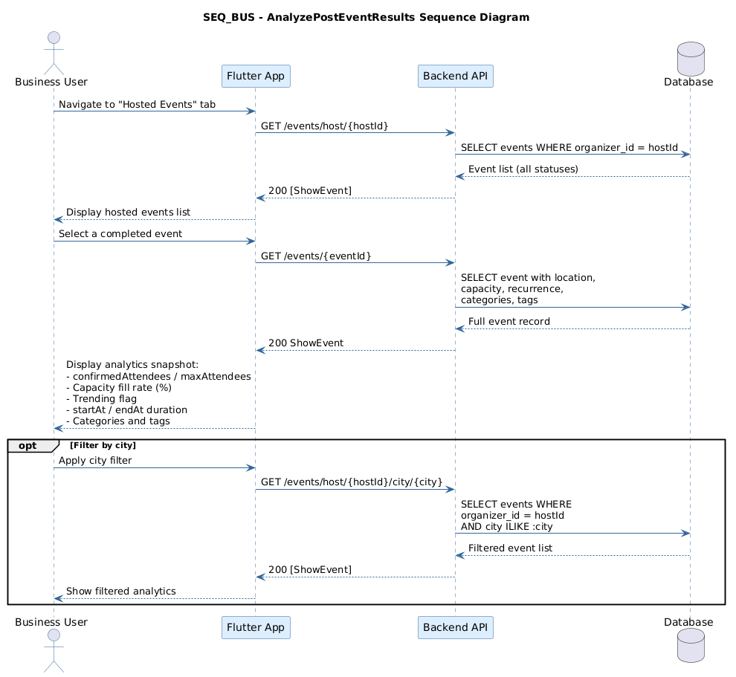
Figure 32: Analyze Post Event Results. Source: User Cases/Sequence Diagrams/BusinessRole/SEQ_BUS_AnalyzePostEventResults.png
Explanation: This sequence diagram explains the runtime interaction for Analyze Post Event Results. It is useful for understanding how the user interface, frontend logic, and backend API contract are expected to collaborate during this workflow.

Build Branded Profile
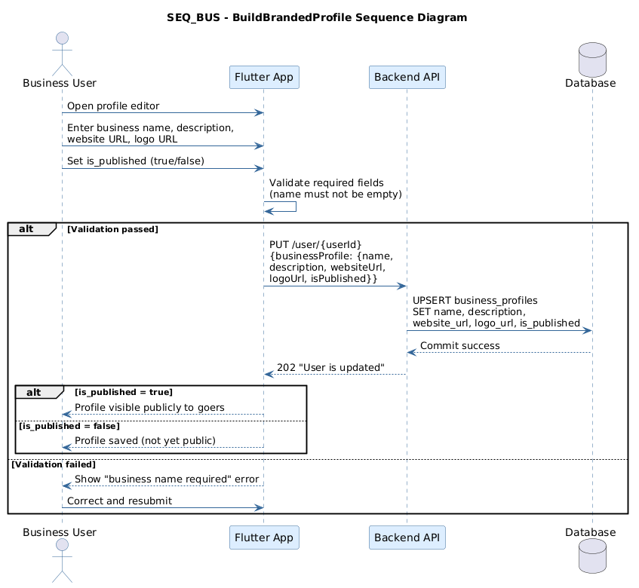
Figure 33: Build Branded Profile. Source: User Cases/Sequence Diagrams/BusinessRole/SEQ_BUS_BuildBrandedProfile.png
Explanation: This sequence diagram explains the runtime interaction for Build Branded Profile. It is useful for understanding how the user interface, frontend logic, and backend API contract are expected to collaborate during this workflow.

Control Event Capacity
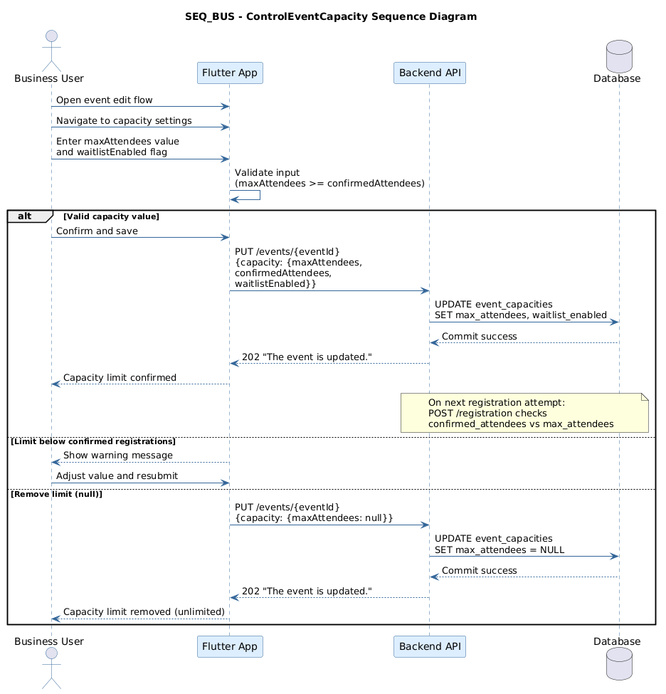
Figure 34: Control Event Capacity. Source: User Cases/Sequence Diagrams/BusinessRole/SEQ_BUS_ControlEventCapacity.png
Explanation: This sequence diagram explains the runtime interaction for Control Event Capacity. It is useful for understanding how the user interface, frontend logic, and backend API contract are expected to collaborate during this workflow.

Create Event
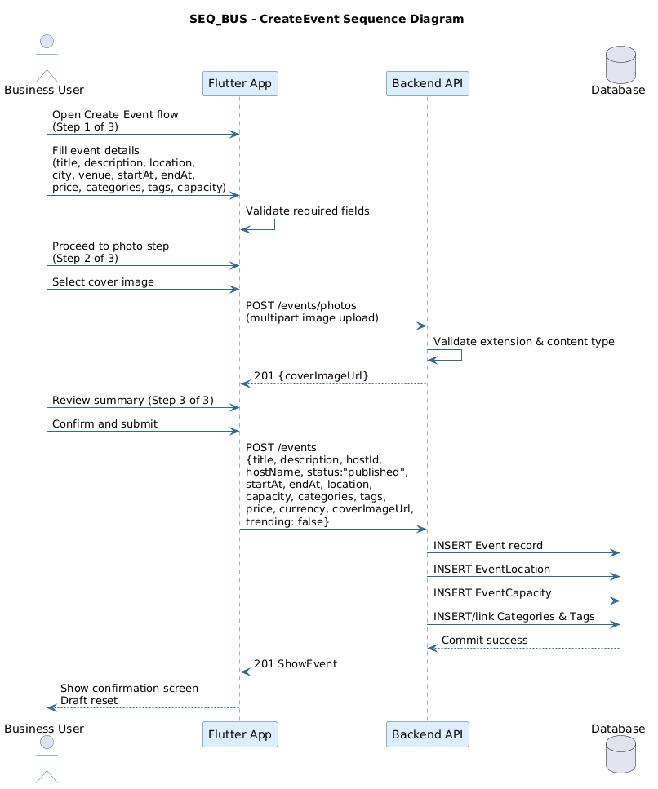
Figure 35: Create Event. Source: User Cases/Sequence Diagrams/BusinessRole/SEQ_BUS_CreateEvent.png
Explanation: This sequence diagram explains the runtime interaction for Create Event. It is useful for understanding how the user interface, frontend logic, and backend API contract are expected to collaborate during this workflow.

Manage Hosted Events
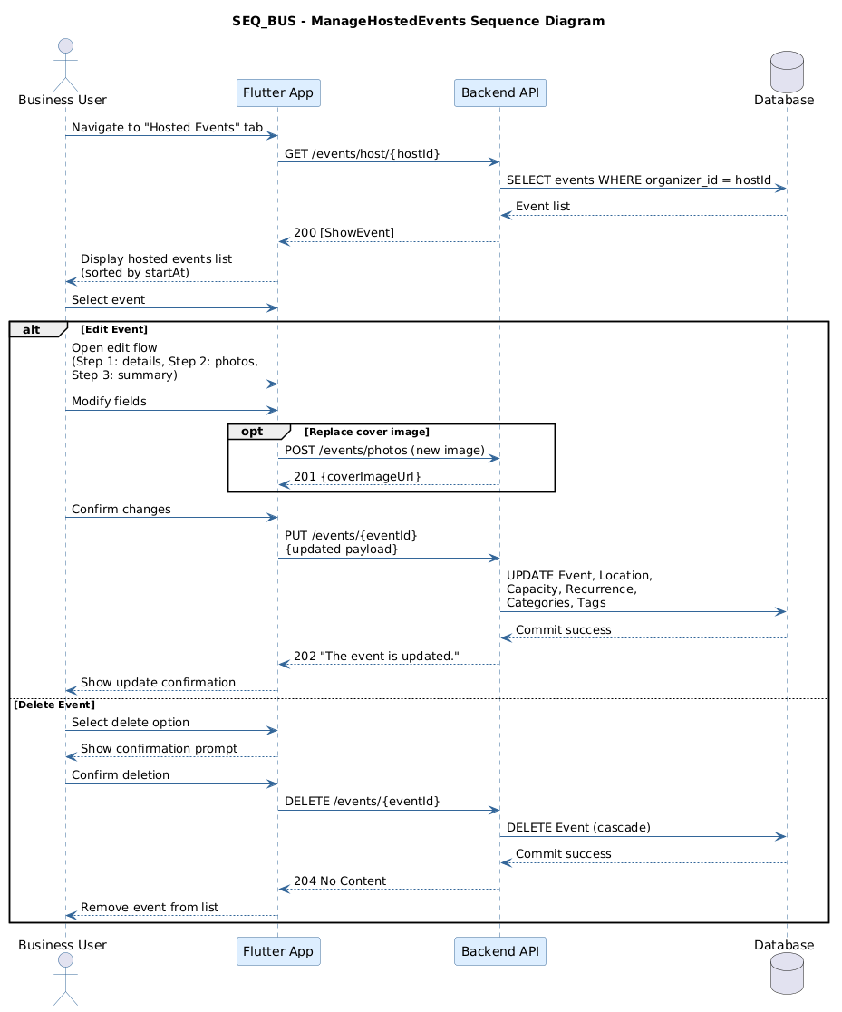
Figure 36: Manage Hosted Events. Source: User Cases/Sequence Diagrams/BusinessRole/SEQ_BUS_ManageHostedEvents.png
Explanation: This sequence diagram explains the runtime interaction for Manage Hosted Events. It is useful for understanding how the user interface, frontend logic, and backend API contract are expected to collaborate during this workflow.

Run Recurring Campaign Event
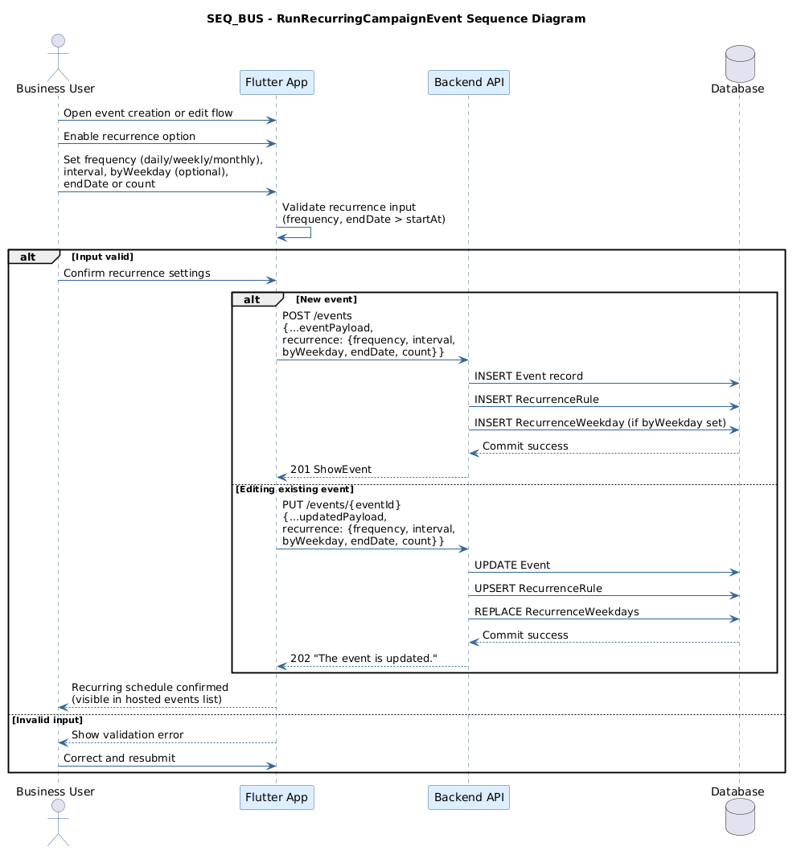
Figure 37: Run Recurring Campaign Event. Source: User Cases/Sequence Diagrams/BusinessRole/SEQ_BUS_RunRecurringCampaignEvent.png
Explanation: This sequence diagram explains the runtime interaction for Run Recurring Campaign Event. It is useful for understanding how the user interface, frontend logic, and backend API contract are expected to collaborate during this workflow.

Save Event Draft
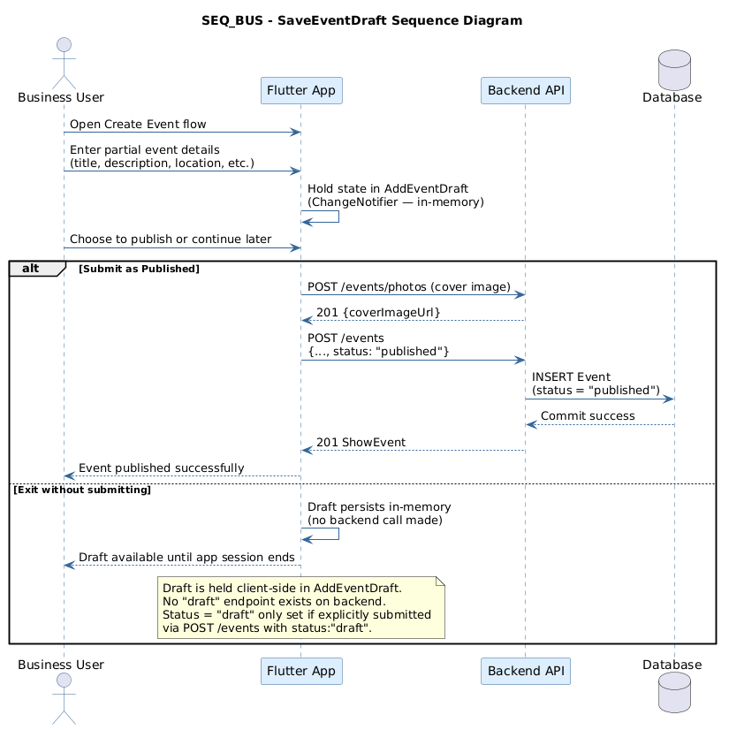
Figure 38: Save Event Draft. Source: User Cases/Sequence Diagrams/BusinessRole/SEQ_BUS_SaveEventDraft.png
Explanation: This sequence diagram explains the runtime interaction for Save Event Draft. It is useful for understanding how the user interface, frontend logic, and backend API contract are expected to collaborate during this workflow.

Send Bulk Attendee Notice
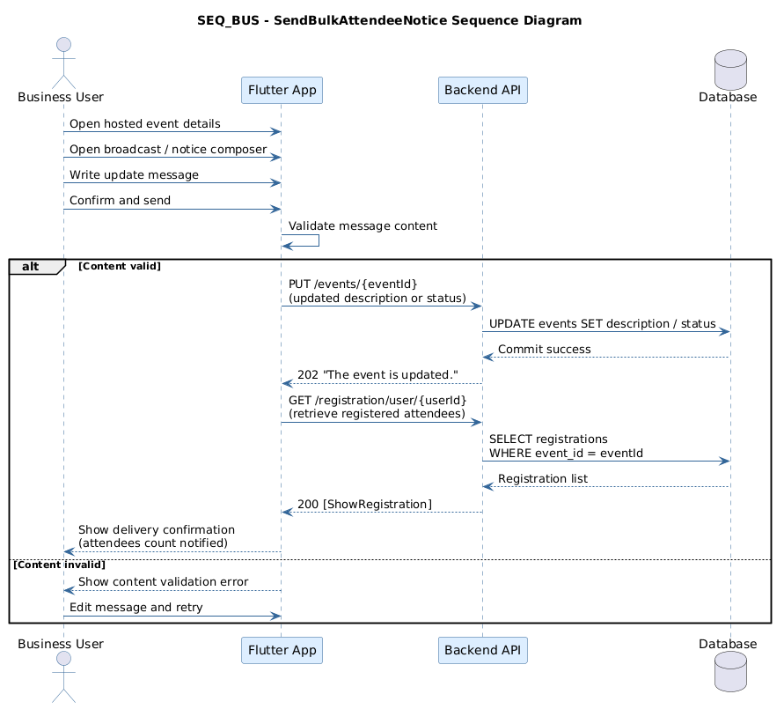
Figure 39: Send Bulk Attendee Notice. Source: User Cases/Sequence Diagrams/BusinessRole/SEQ_BUS_SendBulkAttendeeNotice.png
Explanation: This sequence diagram explains the runtime interaction for Send Bulk Attendee Notice. It is useful for understanding how the user interface, frontend logic, and backend API contract are expected to collaborate during this workflow.

Goer Sequence Diagrams

Broadcast Update
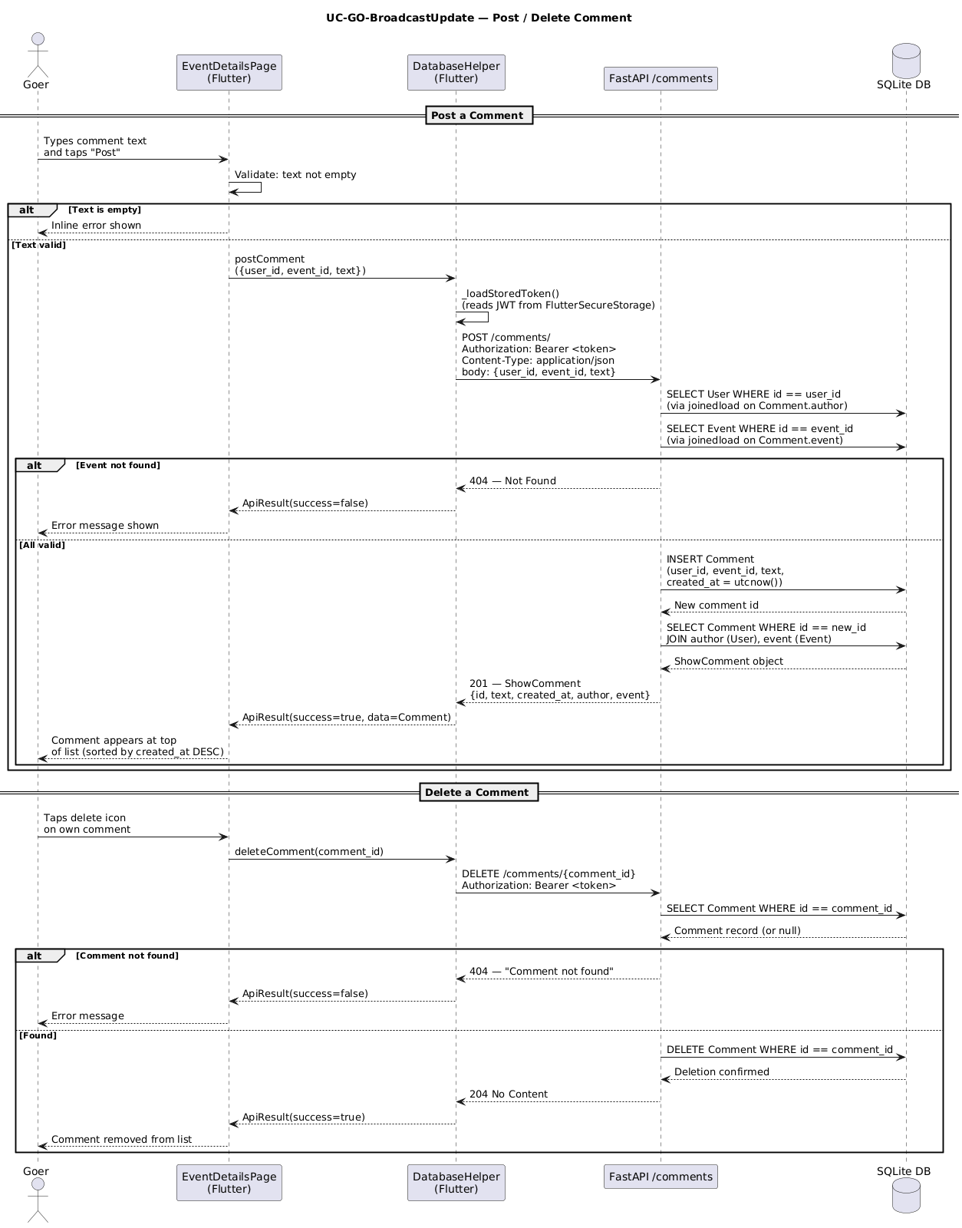
Figure 40: Broadcast Update. Source: User Cases/Sequence Diagrams/GoerRole/SEQ_GO_BroadcastUpdate.png
Explanation: This sequence diagram explains the runtime interaction for Broadcast Update. It is useful for understanding how the user interface, frontend logic, and backend API contract are expected to collaborate during this workflow.

Check Host Credibility
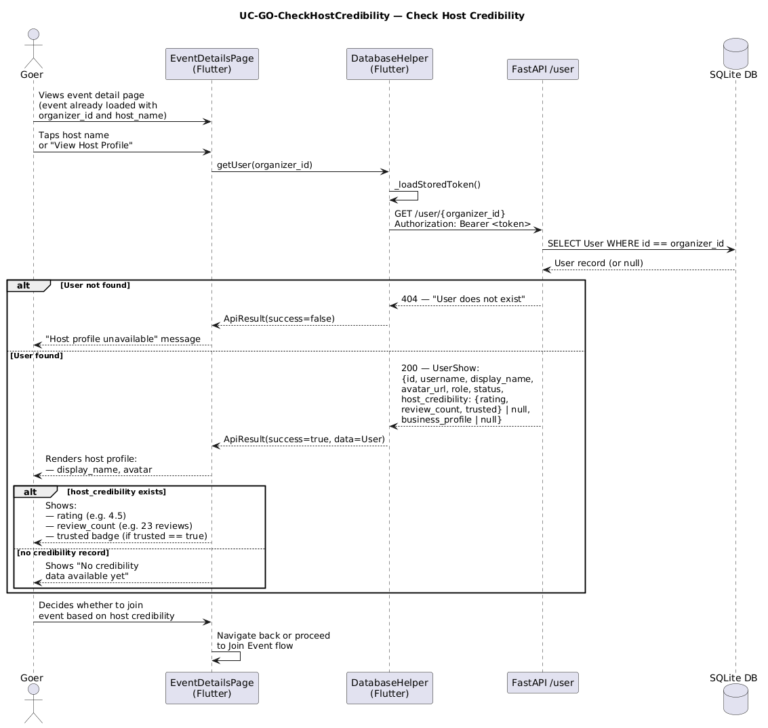
Figure 41: Check Host Credibility. Source: User Cases/Sequence Diagrams/GoerRole/SEQ_GO_CheckHostCredibility.png
Explanation: This sequence diagram explains the runtime interaction for Check Host Credibility. It is useful for understanding how the user interface, frontend logic, and backend API contract are expected to collaborate during this workflow.

Discover Events
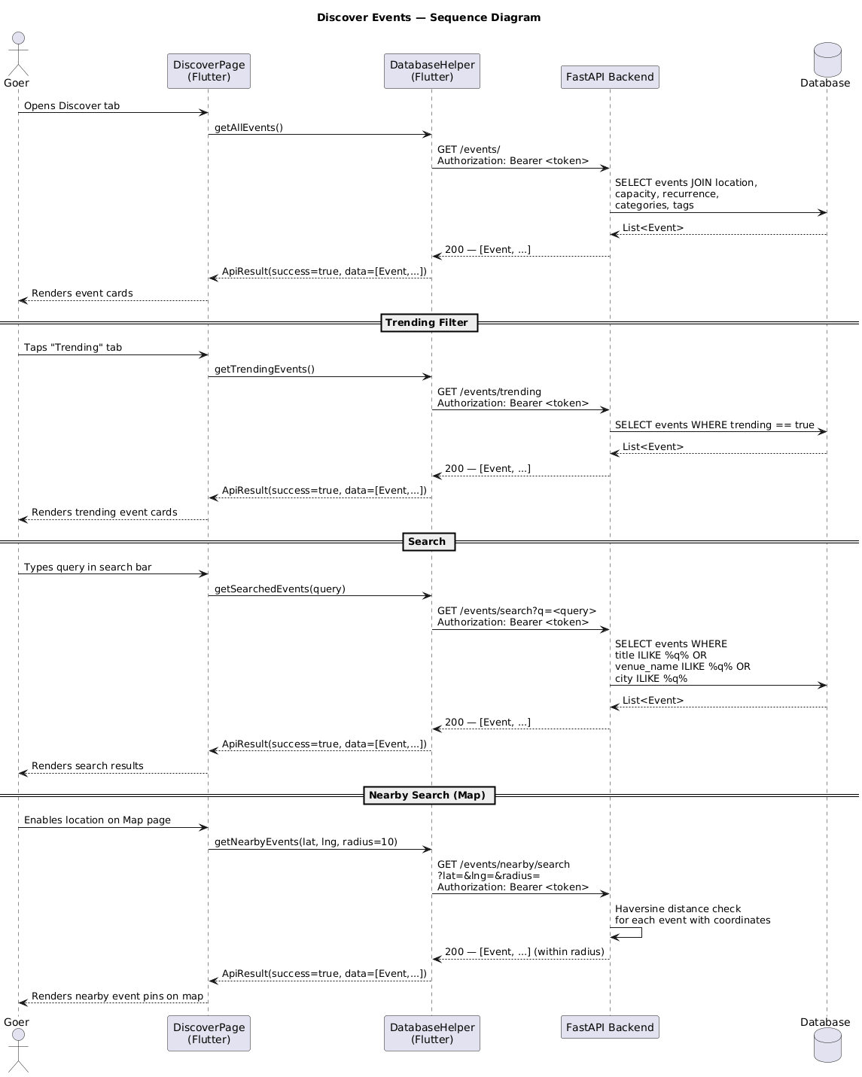
Figure 42: Discover Events. Source: User Cases/Sequence Diagrams/GoerRole/SEQ_GO_DiscoverEvents.png
Explanation: This sequence diagram explains the runtime interaction for Discover Events. It is useful for understanding how the user interface, frontend logic, and backend API contract are expected to collaborate during this workflow.

Enter Waitlist
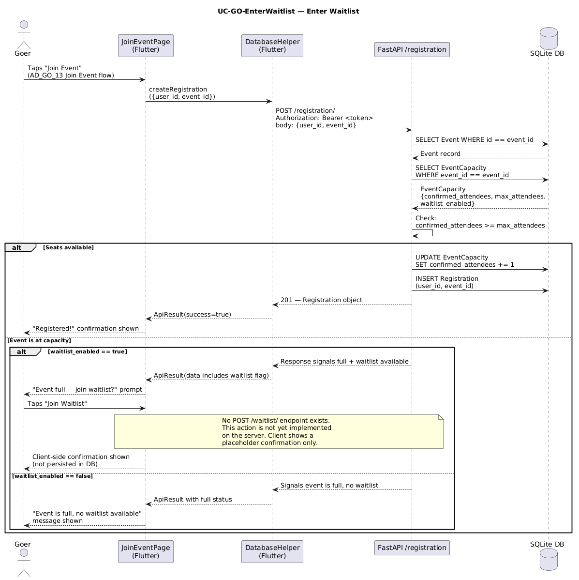
Figure 43: Enter Waitlist. Source: User Cases/Sequence Diagrams/GoerRole/SEQ_GO_EnterWaitlist.png
Explanation: This sequence diagram explains the runtime interaction for Enter Waitlist. It is useful for understanding how the user interface, frontend logic, and backend API contract are expected to collaborate during this workflow.

Event Capacity
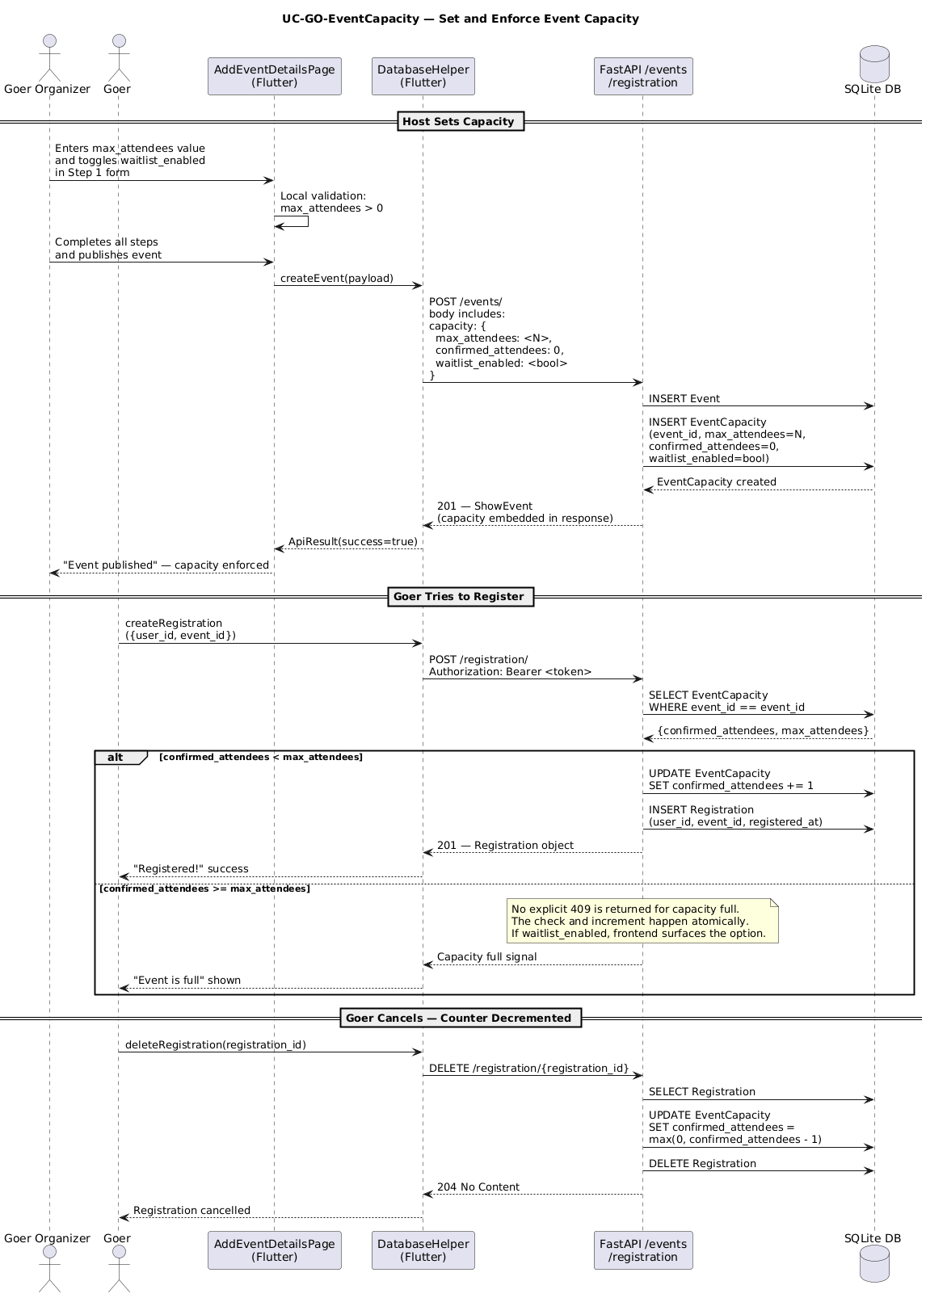
Figure 44: Event Capacity. Source: User Cases/Sequence Diagrams/GoerRole/SEQ_GO_EventCapacity.png
Explanation: This sequence diagram explains the runtime interaction for Event Capacity. It is useful for understanding how the user interface, frontend logic, and backend API contract are expected to collaborate during this workflow.

Join Event
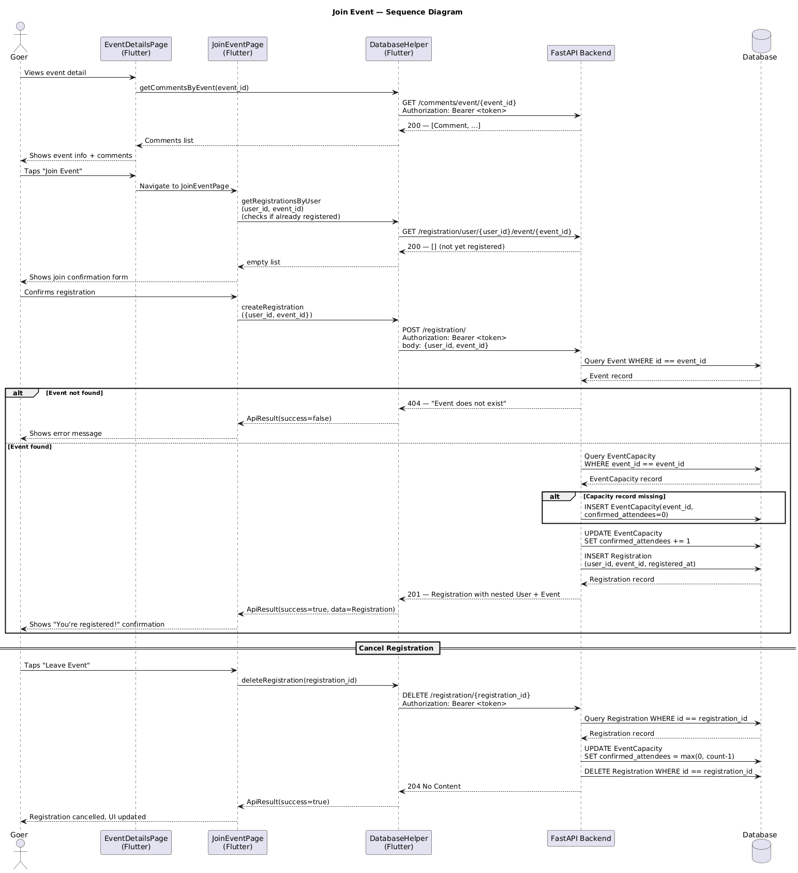
Figure 45: Join Event. Source: User Cases/Sequence Diagrams/GoerRole/SEQ_GO_JoinEvent.png
Explanation: This sequence diagram explains the runtime interaction for Join Event. It is useful for understanding how the user interface, frontend logic, and backend API contract are expected to collaborate during this workflow.

Login
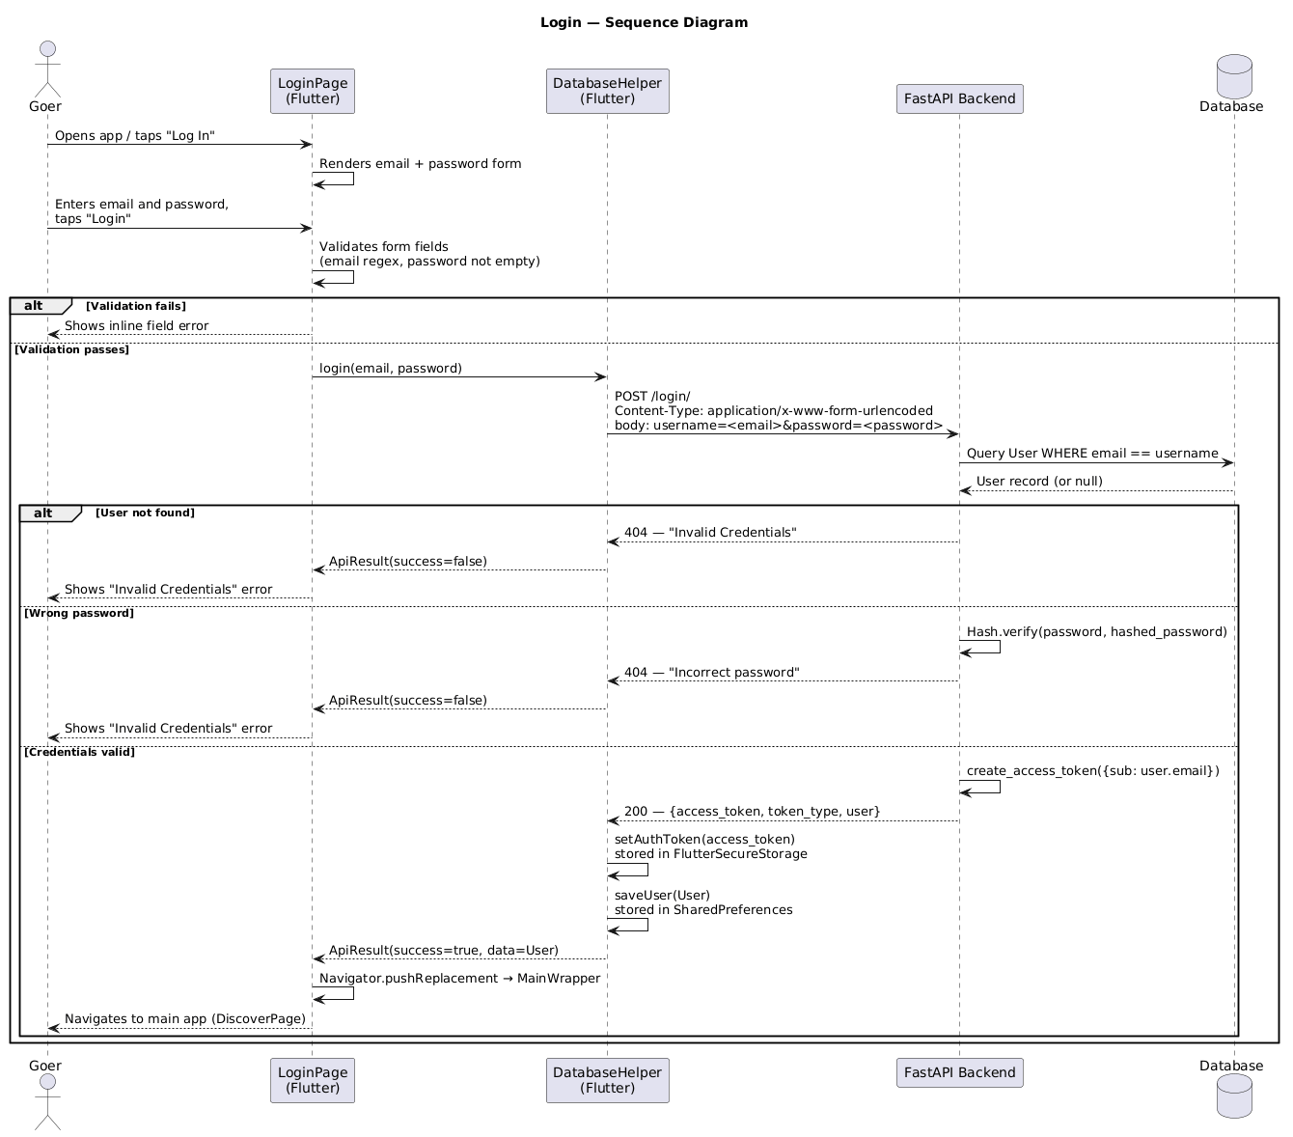
Figure 46: Login. Source: User Cases/Sequence Diagrams/GoerRole/SEQ_GO_Login.png
Explanation: This sequence diagram explains the runtime interaction for Login. It is useful for understanding how the user interface, frontend logic, and backend API contract are expected to collaborate during this workflow.

Manage Hosted Events
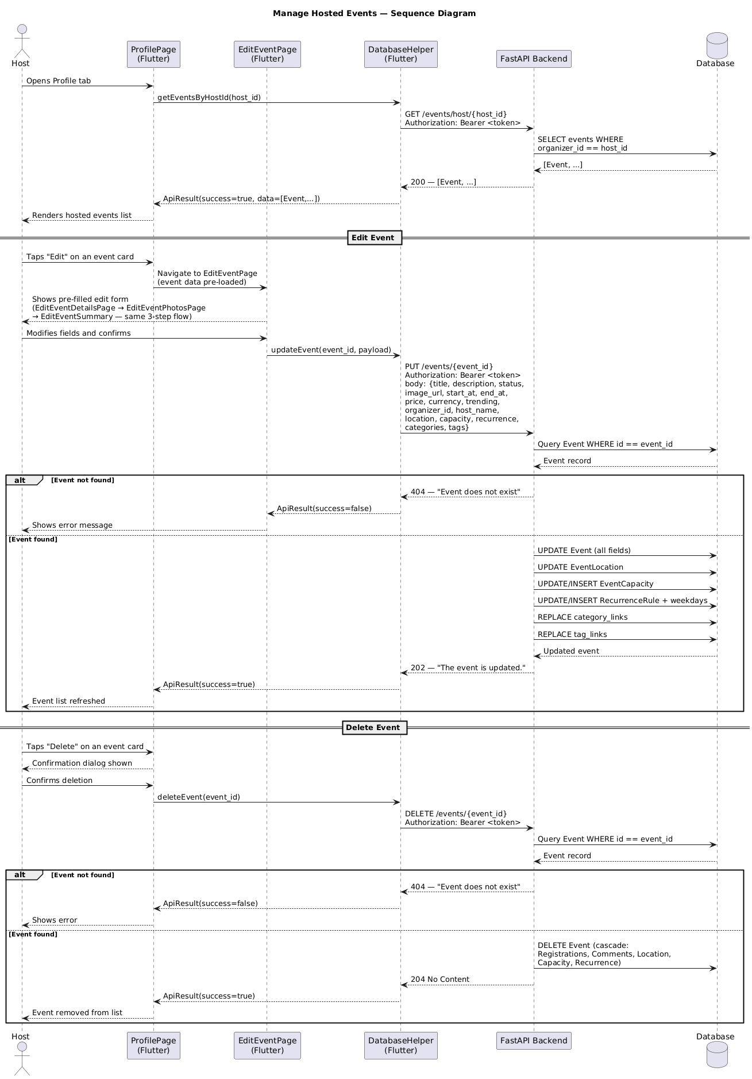
Figure 47: Manage Hosted Events. Source: User Cases/Sequence Diagrams/GoerRole/SEQ_GO_ManageHostedEvents.png
Explanation: This sequence diagram explains the runtime interaction for Manage Hosted Events. It is useful for understanding how the user interface, frontend logic, and backend API contract are expected to collaborate during this workflow.

Pref Categories
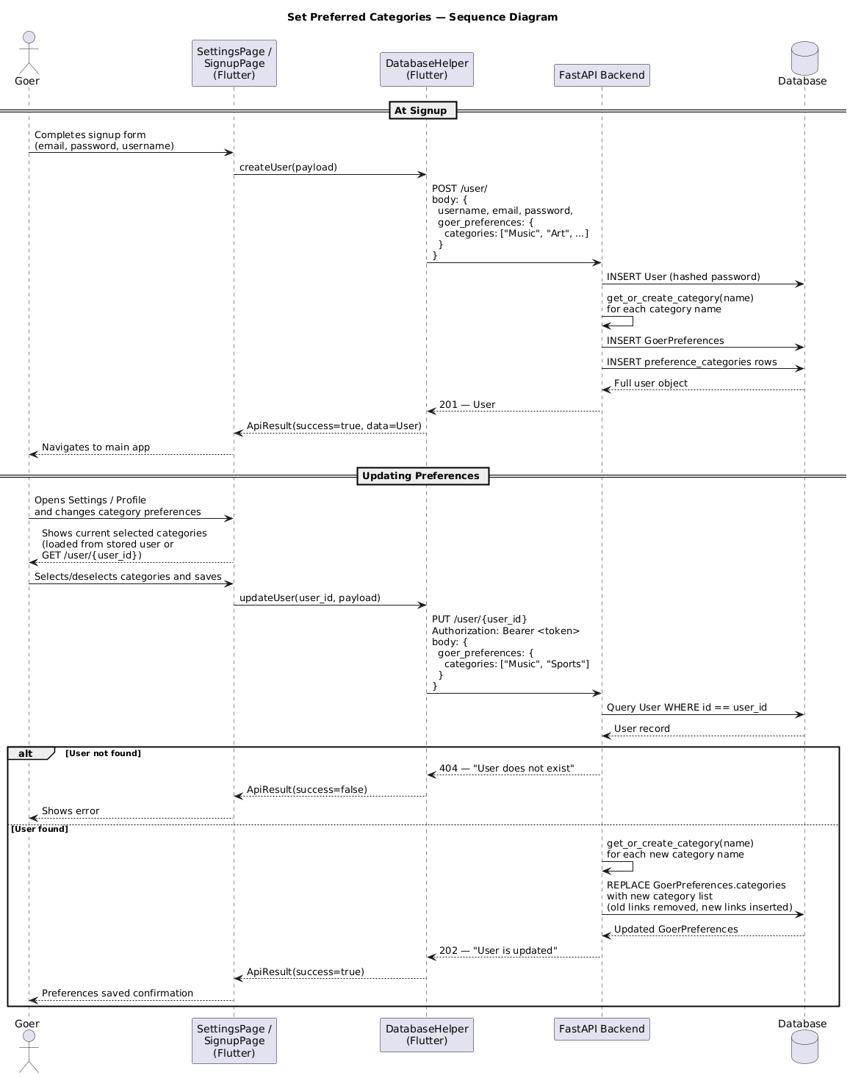
Figure 48: Pref Categories. Source: User Cases/Sequence Diagrams/GoerRole/SEQ_GO_PrefCategories.png
Explanation: This sequence diagram explains the runtime interaction for Pref Categories. It is useful for understanding how the user interface, frontend logic, and backend API contract are expected to collaborate during this workflow.

Rec Schedule
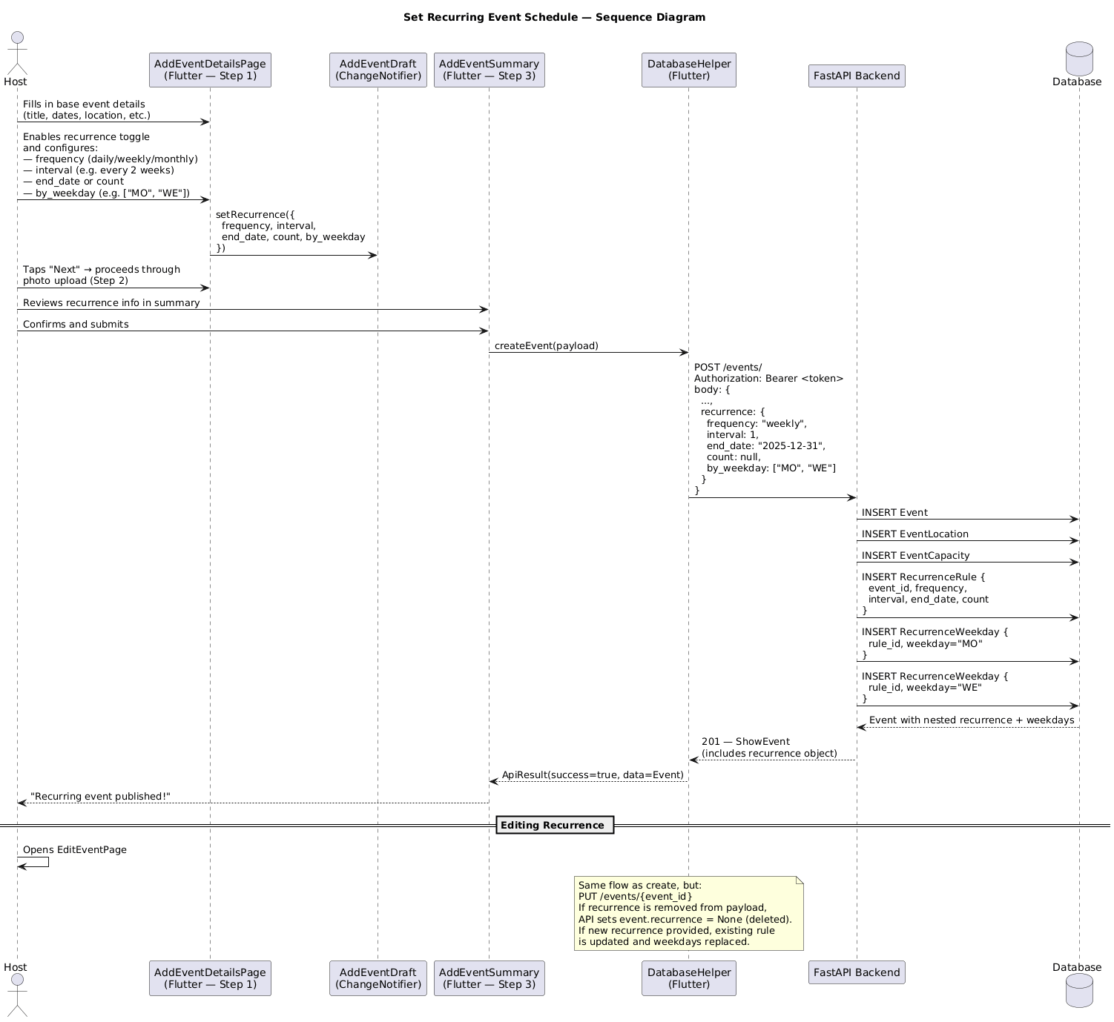
Figure 49: Rec Schedule. Source: User Cases/Sequence Diagrams/GoerRole/SEQ_GO_RecSchedule.png
Explanation: This sequence diagram explains the runtime interaction for Rec Schedule. It is useful for understanding how the user interface, frontend logic, and backend API contract are expected to collaborate during this workflow.

Review Event Perf
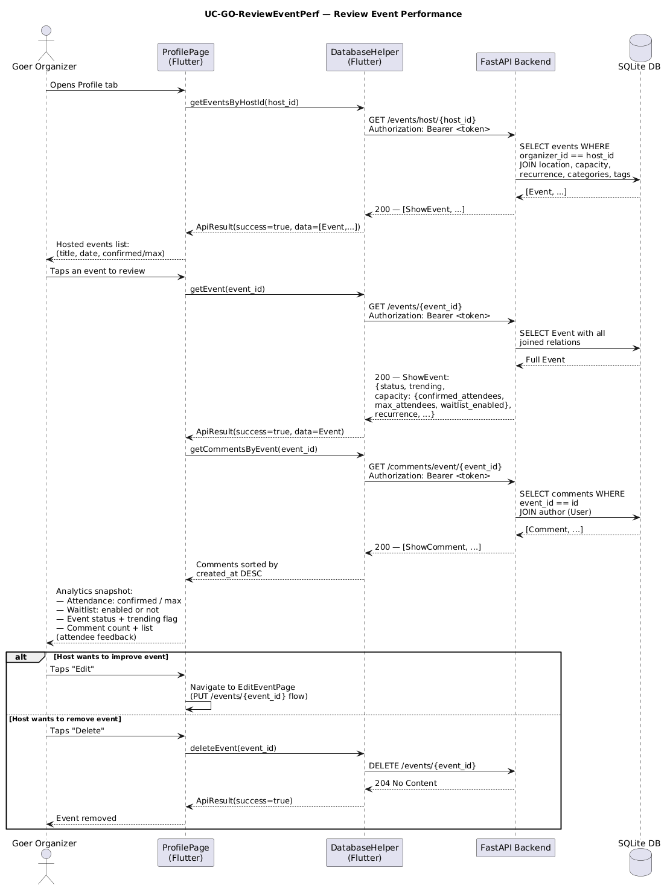
Figure 50: Review Event Perf. Source: User Cases/Sequence Diagrams/GoerRole/SEQ_GO_ReviewEventPerf.png
Explanation: This sequence diagram explains the runtime interaction for Review Event Perf. It is useful for understanding how the user interface, frontend logic, and backend API contract are expected to collaborate during this workflow.

Save Event Draft
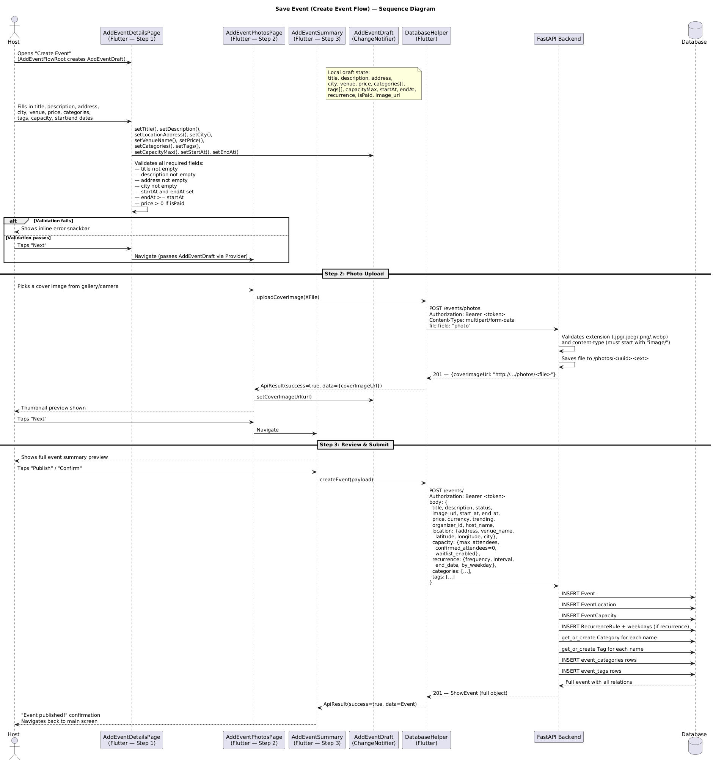
Figure 51: Save Event Draft. Source: User Cases/Sequence Diagrams/GoerRole/SEQ_GO_SaveEventDraft.png
Explanation: This sequence diagram explains the runtime interaction for Save Event Draft. It is useful for understanding how the user interface, frontend logic, and backend API contract are expected to collaborate during this workflow.

Share Event
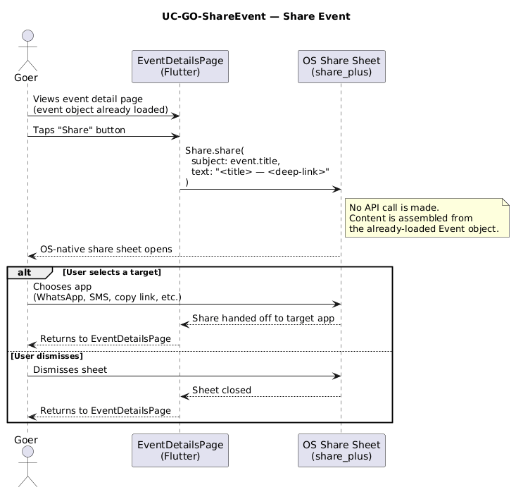
Figure 52: Share Event. Source: User Cases/Sequence Diagrams/GoerRole/SEQ_GO_ShareEvent.png
Explanation: This sequence diagram explains the runtime interaction for Share Event. It is useful for understanding how the user interface, frontend logic, and backend API contract are expected to collaborate during this workflow.

Use Map For Directions
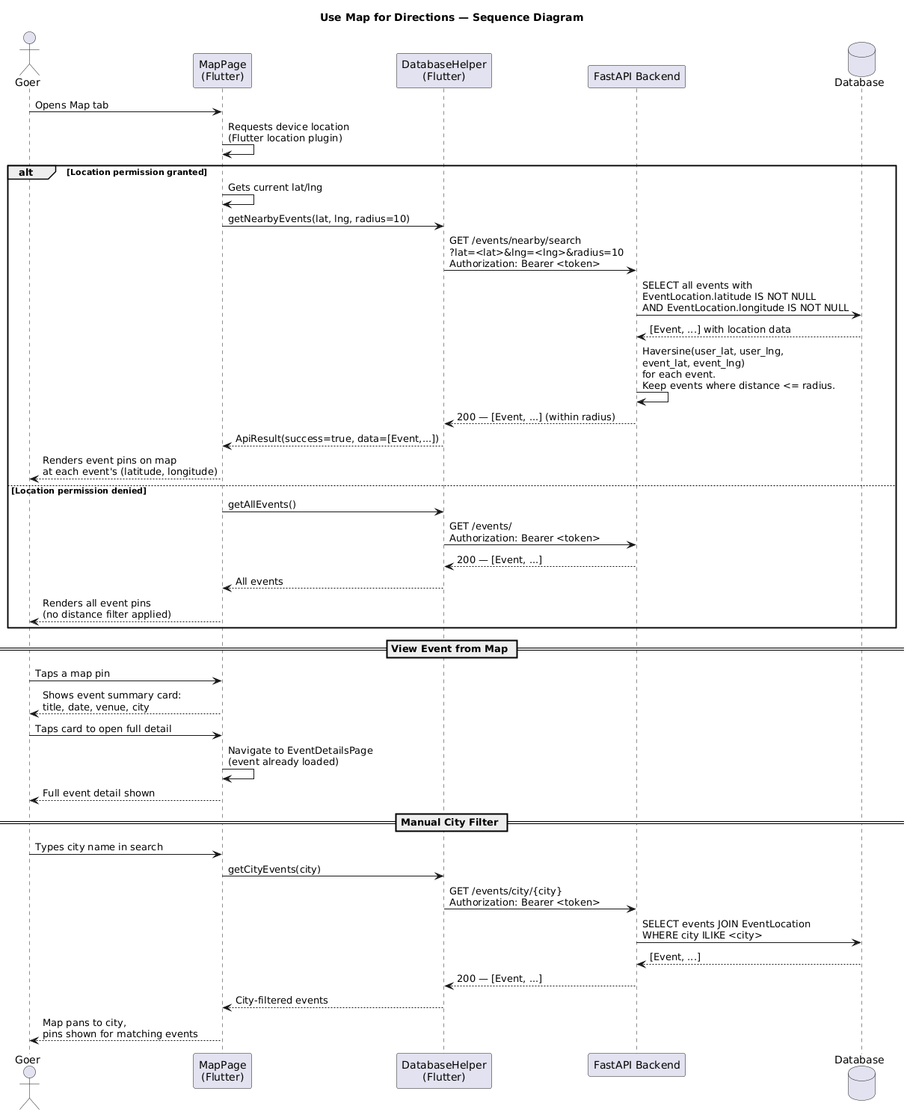
Figure 53: Use Map For Directions. Source: User Cases/Sequence Diagrams/GoerRole/SEQ_GO_UseMapForDirections.png
Explanation: This sequence diagram explains the runtime interaction for Use Map For Directions. It is useful for understanding how the user interface, frontend logic, and backend API contract are expected to collaborate during this workflow.

View Event Details
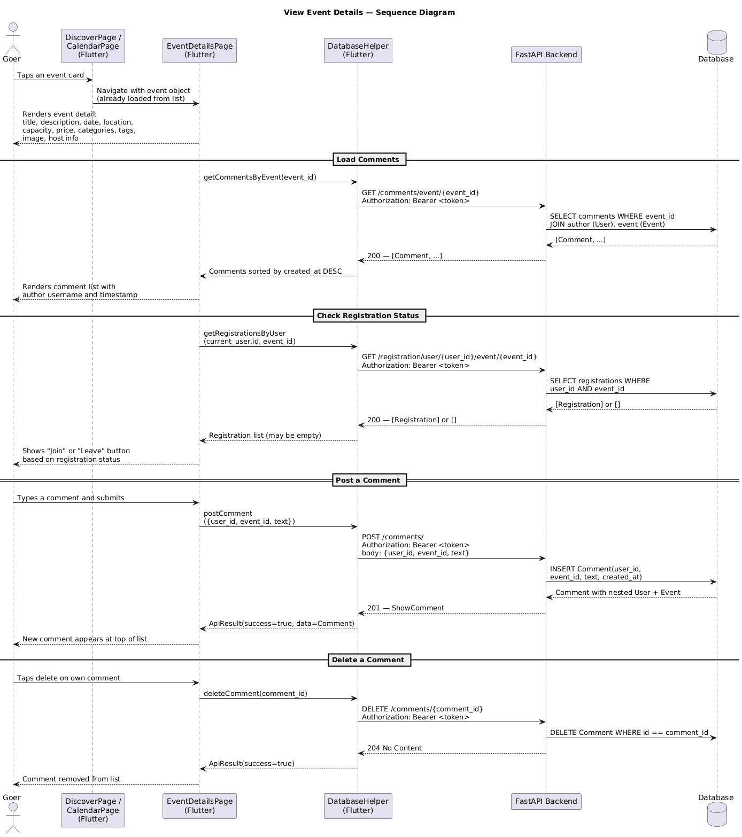
Figure 54: View Event Details. Source: User Cases/Sequence Diagrams/GoerRole/SEQ_GO_ViewEventDetails.png
Explanation: This sequence diagram explains the runtime interaction for View Event Details. It is useful for understanding how the user interface, frontend logic, and backend API contract are expected to collaborate during this workflow.

Admin State Diagrams

01 Event Lifecycle
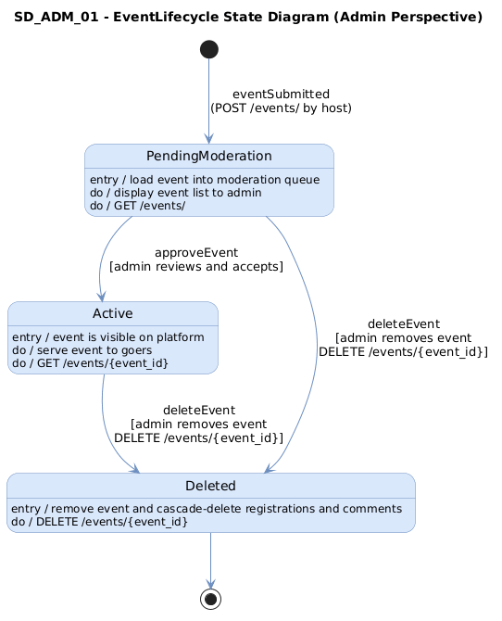
Figure 55: 01 Event Lifecycle. Source: State Diagrams/AdminRole/SD_ADM_01_EventLifecycle.png
Explanation: This state diagram describes the lifecycle of the event-related object represented by 01 Event Lifecycle. It helps identify valid transitions and statuses that the frontend should display or react to.

02 Host Verification
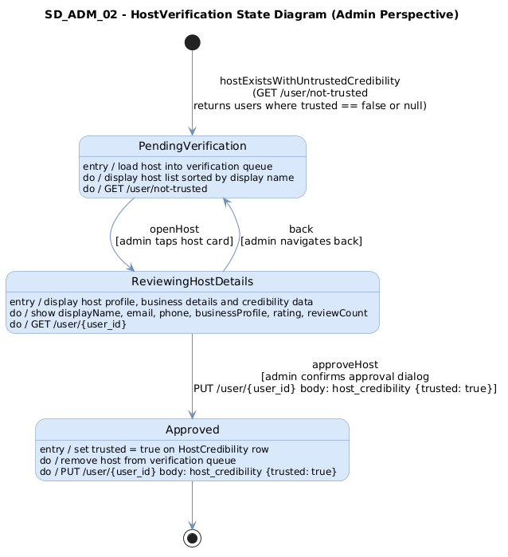
Figure 56: 02 Host Verification. Source: State Diagrams/AdminRole/SD_ADM_02_HostVerification.png
Explanation: This state diagram describes the lifecycle of the trust or verification object represented by 02 Host Verification. It helps identify valid transitions and statuses that the frontend should display or react to.

03 Event Moderation
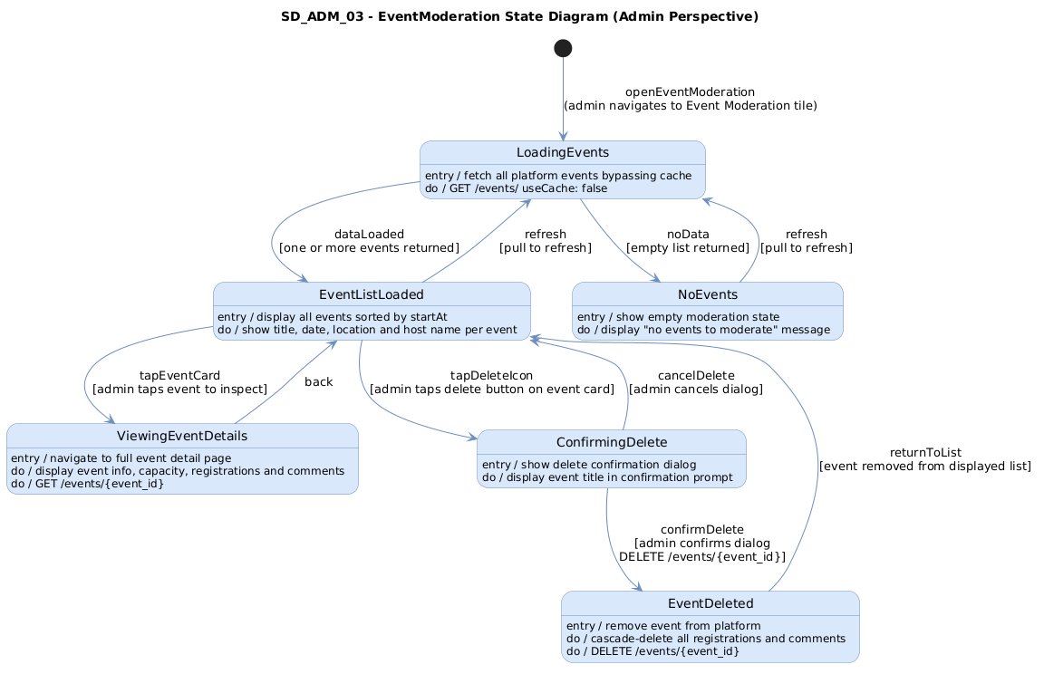
Figure 57: 03 Event Moderation. Source: State Diagrams/AdminRole/SD_ADM_03_EventModeration.png
Explanation: This state diagram describes the lifecycle of the event-related object represented by 03 Event Moderation. It helps identify valid transitions and statuses that the frontend should display or react to.

04 Suspension Appeal
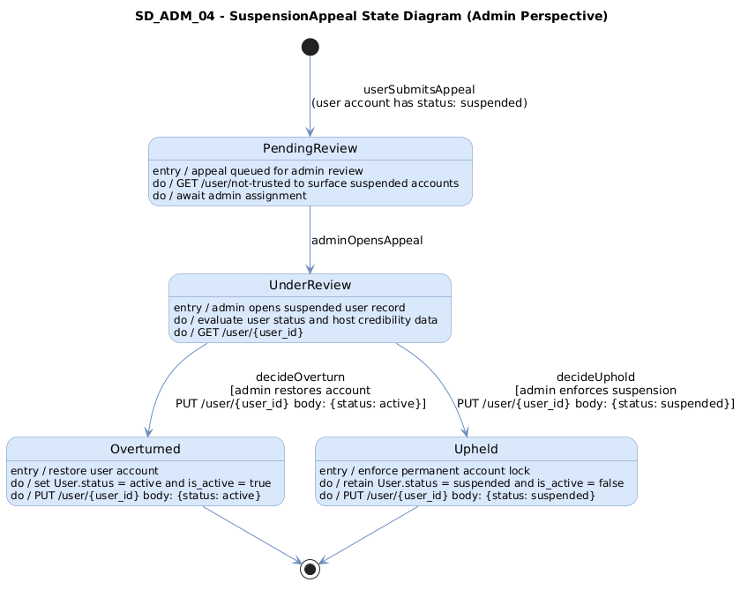
Figure 58: 04 Suspension Appeal. Source: State Diagrams/AdminRole/SD_ADM_04_SuspensionAppeal.png
Explanation: This state diagram describes the lifecycle of the application object represented by 04 Suspension Appeal. It helps identify valid transitions and statuses that the frontend should display or react to.

05 Event Category Management
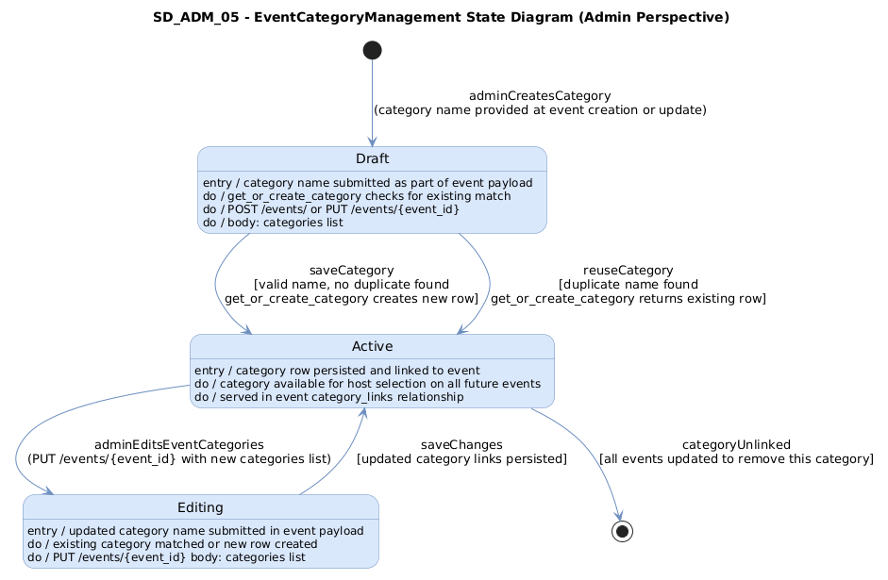
Figure 59: 05 Event Category Management. Source: State Diagrams/AdminRole/SD_ADM_05_EventCategoryManagement.png
Explanation: This state diagram describes the lifecycle of the event-related object represented by 05 Event Category Management. It helps identify valid transitions and statuses that the frontend should display or react to.

Business State Diagrams

02 Business Event
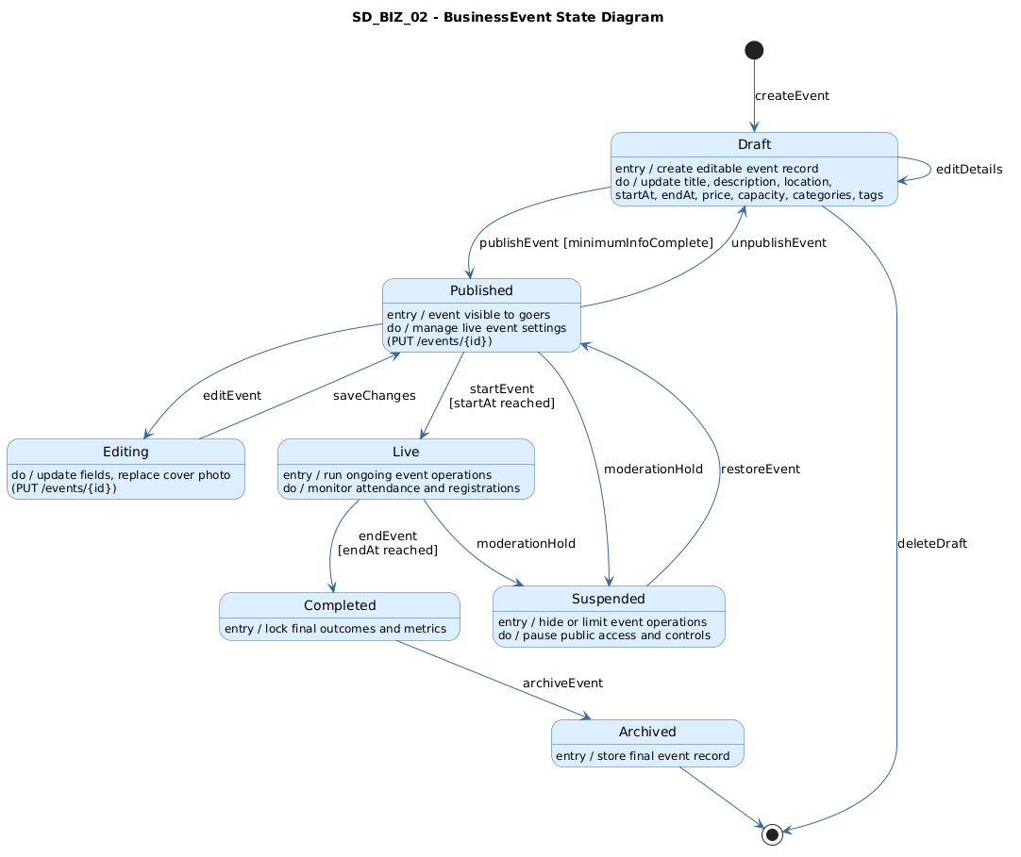
Figure 60: 02 Business Event. Source: State Diagrams/BusinessRole/SD_BIZ_02_BusinessEvent.png
Explanation: This state diagram describes the lifecycle of the event-related object represented by 02 Business Event. It helps identify valid transitions and statuses that the frontend should display or react to.

03 Business Profile
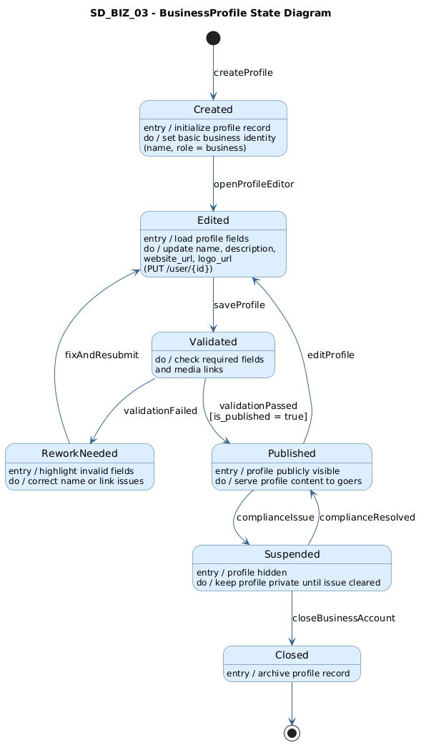
Figure 61: 03 Business Profile. Source: State Diagrams/BusinessRole/SD_BIZ_03_BusinessProfile.png
Explanation: This state diagram describes the lifecycle of the profile object represented by 03 Business Profile. It helps identify valid transitions and statuses that the frontend should display or react to.

06 Broadcast Notice

Figure 62: 06 Broadcast Notice. Source: State Diagrams/BusinessRole/SD_BIZ_06_BroadcastNotice.png
Explanation: This state diagram describes the lifecycle of the application object represented by 06 Broadcast Notice. It helps identify valid transitions and statuses that the frontend should display or react to.

08 Analytics Report Snapshot
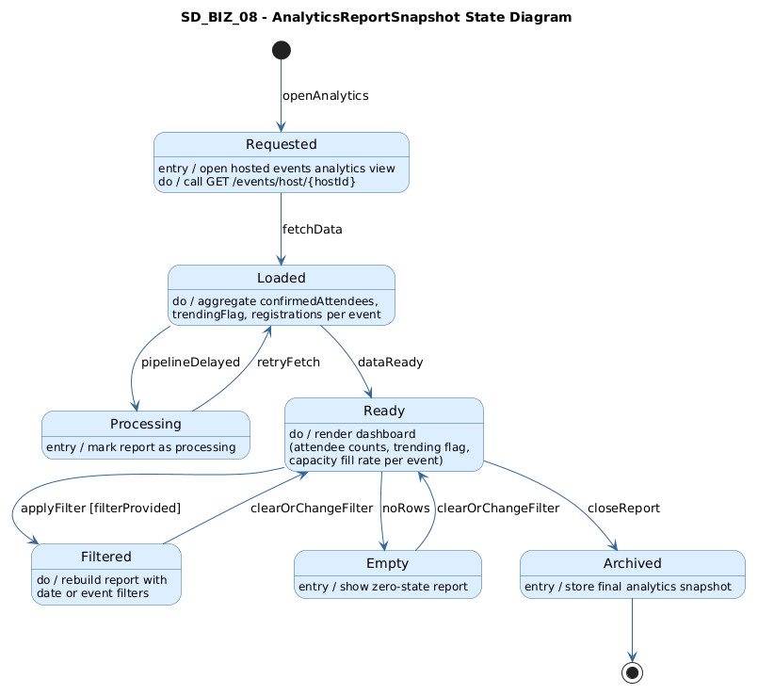
Figure 63: 08 Analytics Report Snapshot. Source: State Diagrams/BusinessRole/SD_BIZ_08_AnalyticsReportSnapshot.png
Explanation: This state diagram describes the lifecycle of the analytics snapshot represented by 08 Analytics Report Snapshot. It helps identify valid transitions and statuses that the frontend should display or react to.

Goer State Diagrams

01 Goer Preference Profile
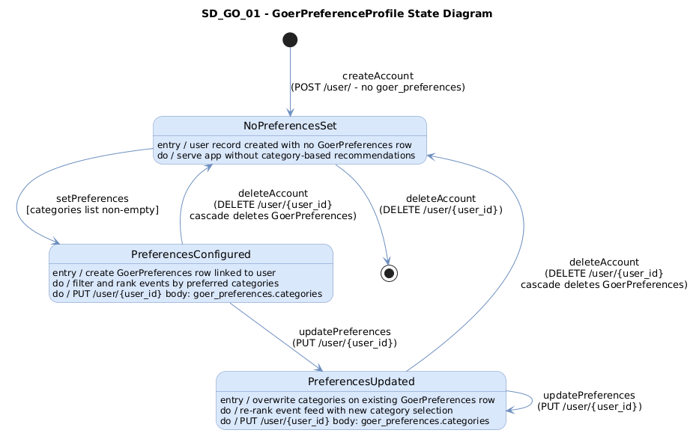
Figure 64: 01 Goer Preference Profile. Source: State Diagrams/GoerRole/SD_GO_01_GoerPreferenceProfile.png
Explanation: This state diagram describes the lifecycle of the profile object represented by 01 Goer Preference Profile. It helps identify valid transitions and statuses that the frontend should display or react to.

02 Event Discovery View
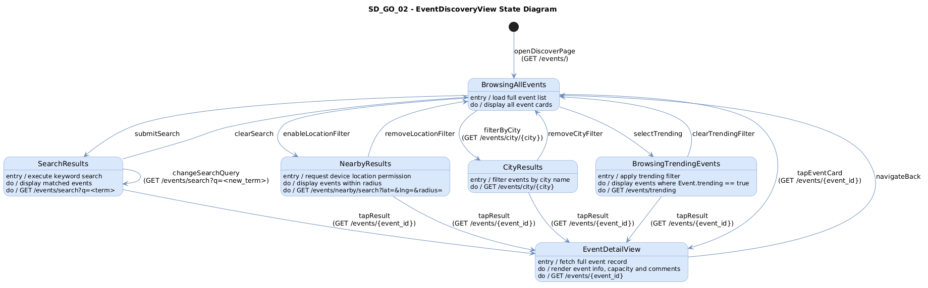
Figure 65: 02 Event Discovery View. Source: State Diagrams/GoerRole/SD_GO_02_EventDiscoveryView.png
Explanation: This state diagram describes the lifecycle of the event-related object represented by 02 Event Discovery View. It helps identify valid transitions and statuses that the frontend should display or react to.

03 Event Enrollment Record
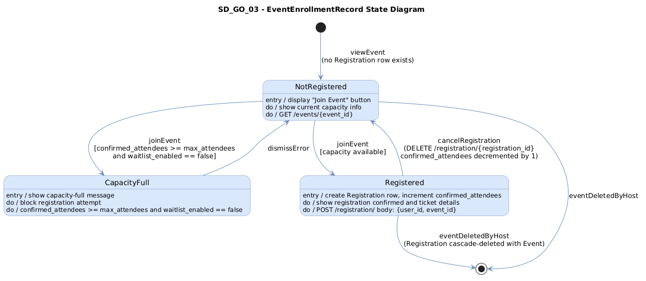
Figure 66: 03 Event Enrollment Record. Source: State Diagrams/GoerRole/SD_GO_03_EventEnrollmentRecord.png
Explanation: This state diagram describes the lifecycle of the event-related object represented by 03 Event Enrollment Record. It helps identify valid transitions and statuses that the frontend should display or react to.

04 Host Credibility Record
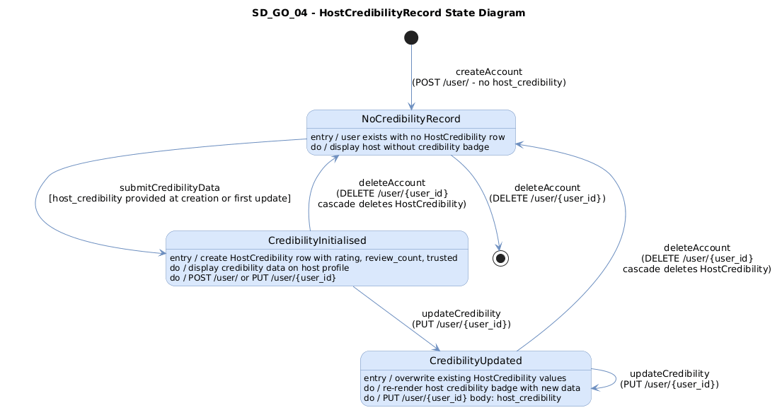
Figure 67: 04 Host Credibility Record. Source: State Diagrams/GoerRole/SD_GO_04_HostCredibilityRecord.png
Explanation: This state diagram describes the lifecycle of the trust or verification object represented by 04 Host Credibility Record. It helps identify valid transitions and statuses that the frontend should display or react to.

05 Event Share Request
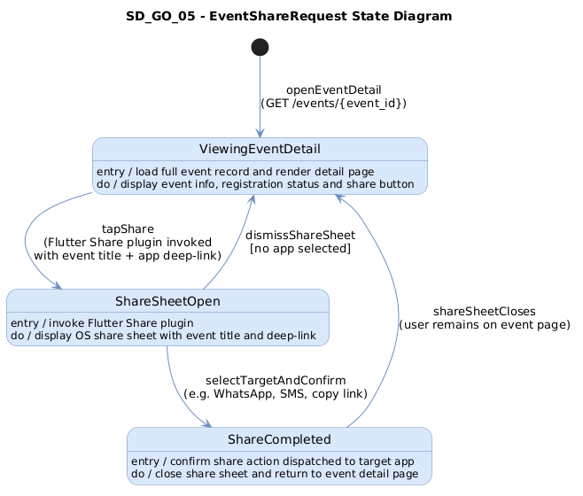
Figure 68: 05 Event Share Request. Source: State Diagrams/GoerRole/SD_GO_05_EventShareRequest.png
Explanation: This state diagram describes the lifecycle of the event-related object represented by 05 Event Share Request. It helps identify valid transitions and statuses that the frontend should display or react to.

06 Hosted Event Plan
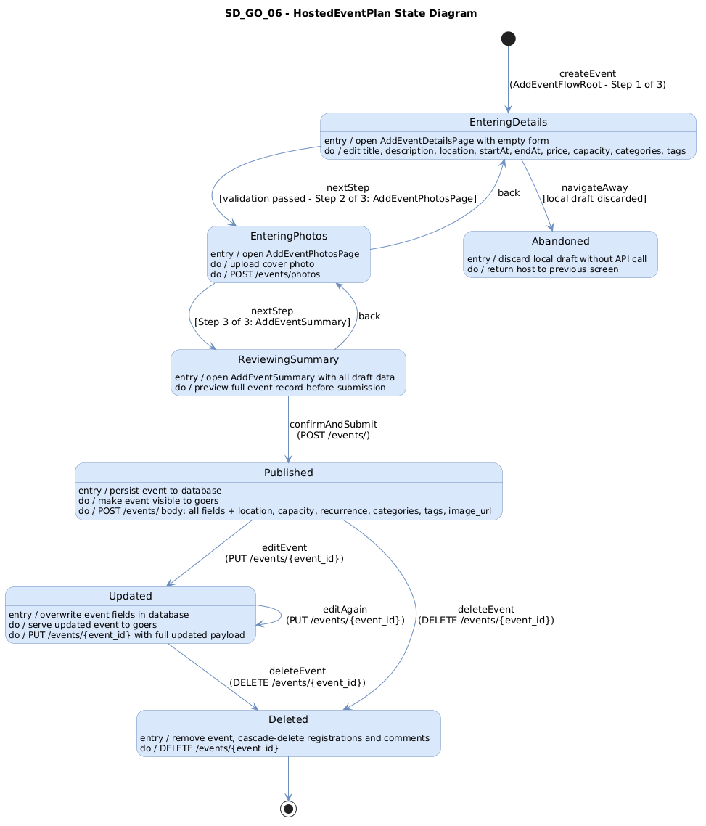
Figure 69: 06 Hosted Event Plan. Source: State Diagrams/GoerRole/SD_GO_06_HostedEventPlan.png
Explanation: This state diagram describes the lifecycle of the event-related object represented by 06 Hosted Event Plan. It helps identify valid transitions and statuses that the frontend should display or react to.

07 Hosted Event Notice
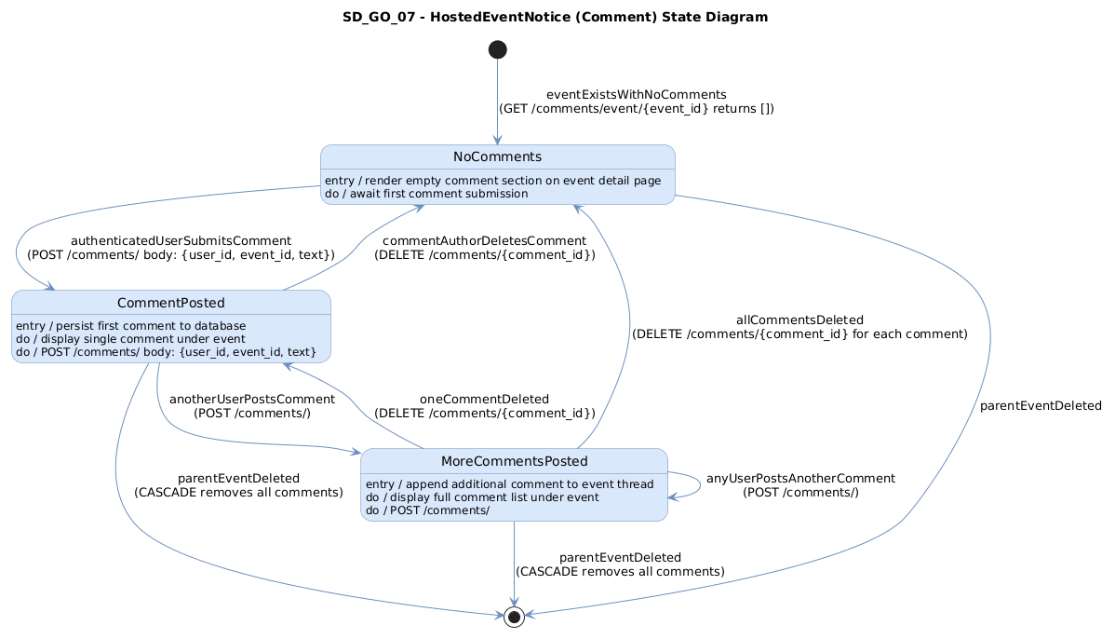
Figure 70: 07 Hosted Event Notice. Source: State Diagrams/GoerRole/SD_GO_07_HostedEventNotice.png
Explanation: This state diagram describes the lifecycle of the event-related object represented by 07 Hosted Event Notice. It helps identify valid transitions and statuses that the frontend should display or react to.

08 Goer Analytics Snapshot
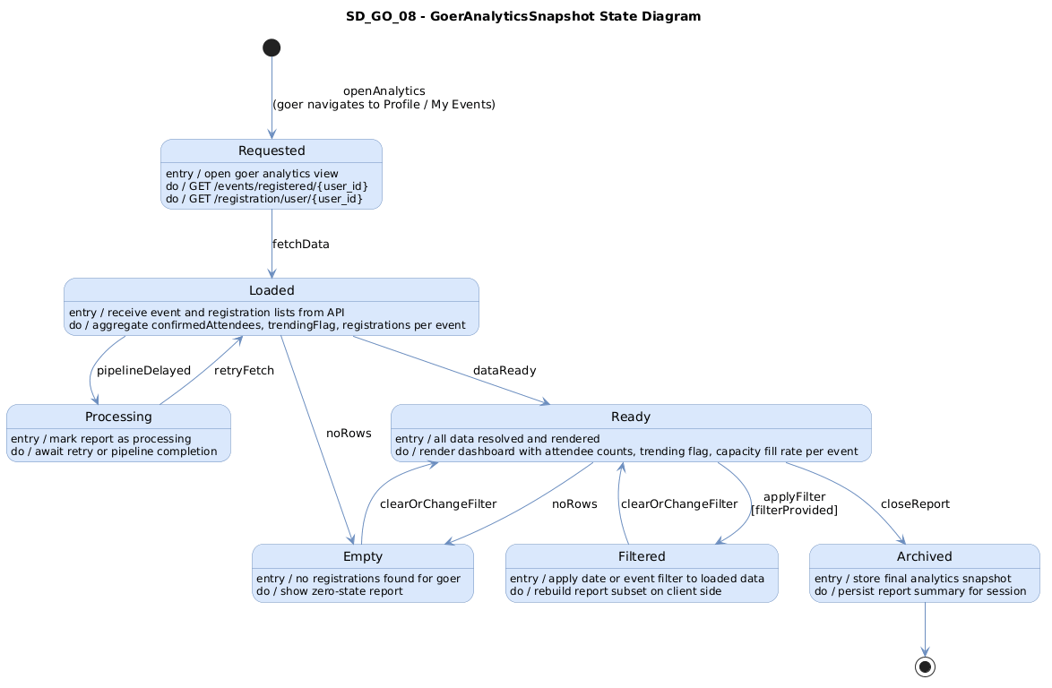
Figure 71: 08 Goer Analytics Snapshot. Source: State Diagrams/GoerRole/SD_GO_08_GoerAnalyticsSnapshot.png
Explanation: This state diagram describes the lifecycle of the analytics snapshot represented by 08 Goer Analytics Snapshot. It helps identify valid transitions and statuses that the frontend should display or react to.

