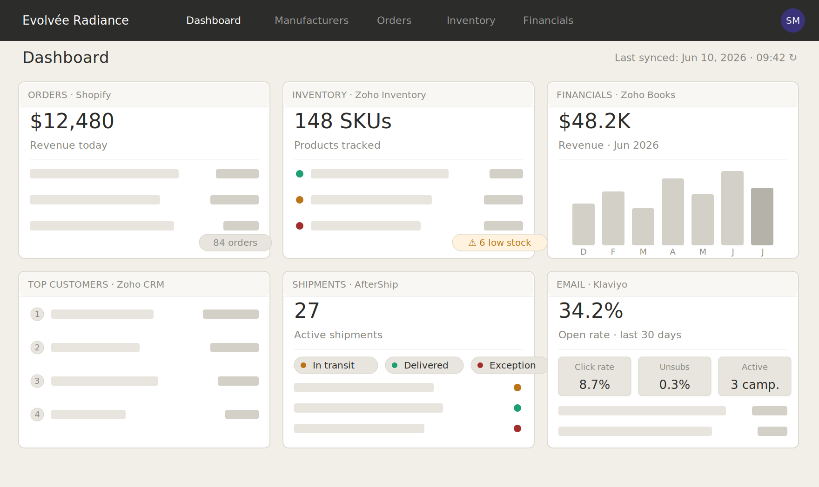
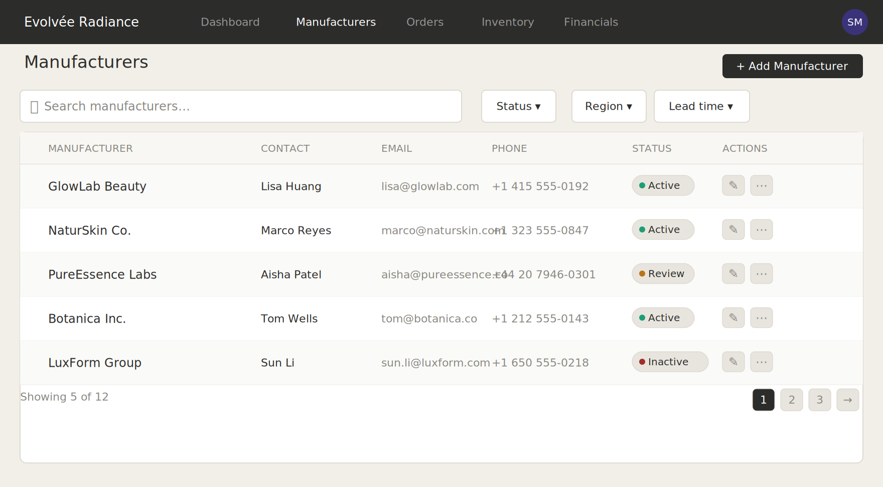

Example manufacturers generated; not affiliated with the existing Evolvee products.
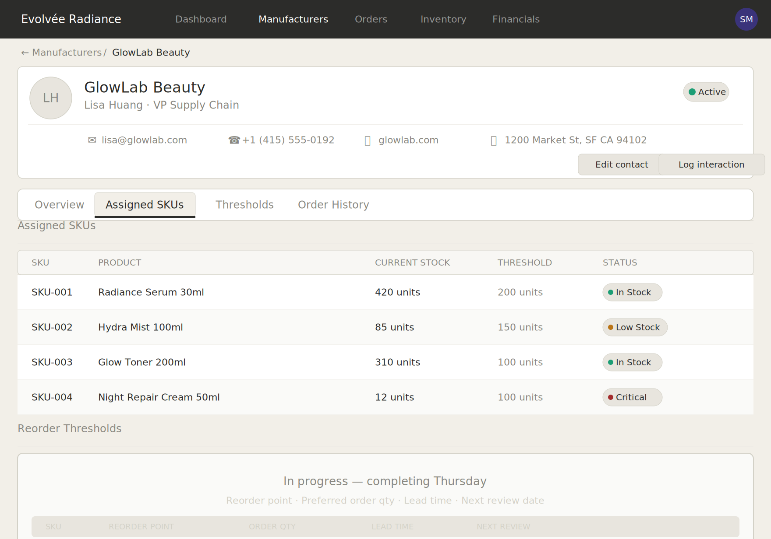

Example products generated; not affiliated with the existing Evolvee products.

