Evolvée Radiance Operations Hub
UI Wireframe Documentation

Version 1 · June 2026 · Internship Build
All wireframes are greyscale and contain placeholder data only.
Manufacturer names, SKUs, contacts, and figures are illustrative and not affiliated with existing Evolvée Radiance products.

1 Operations Dashboard
The dashboard is the primary landing view for all roles. It presents a 3×2 tile grid surfacing the six core V1 data modules: Inventory, Sales, Top Customers, Revenue, Shipping, and Reorder Alerts. Each tile links to a dedicated detail view or the Manufacturer Tool as appropriate.
Nav bar shows Dashboard active, with Manufacturer Tool and User Management as inactive links.

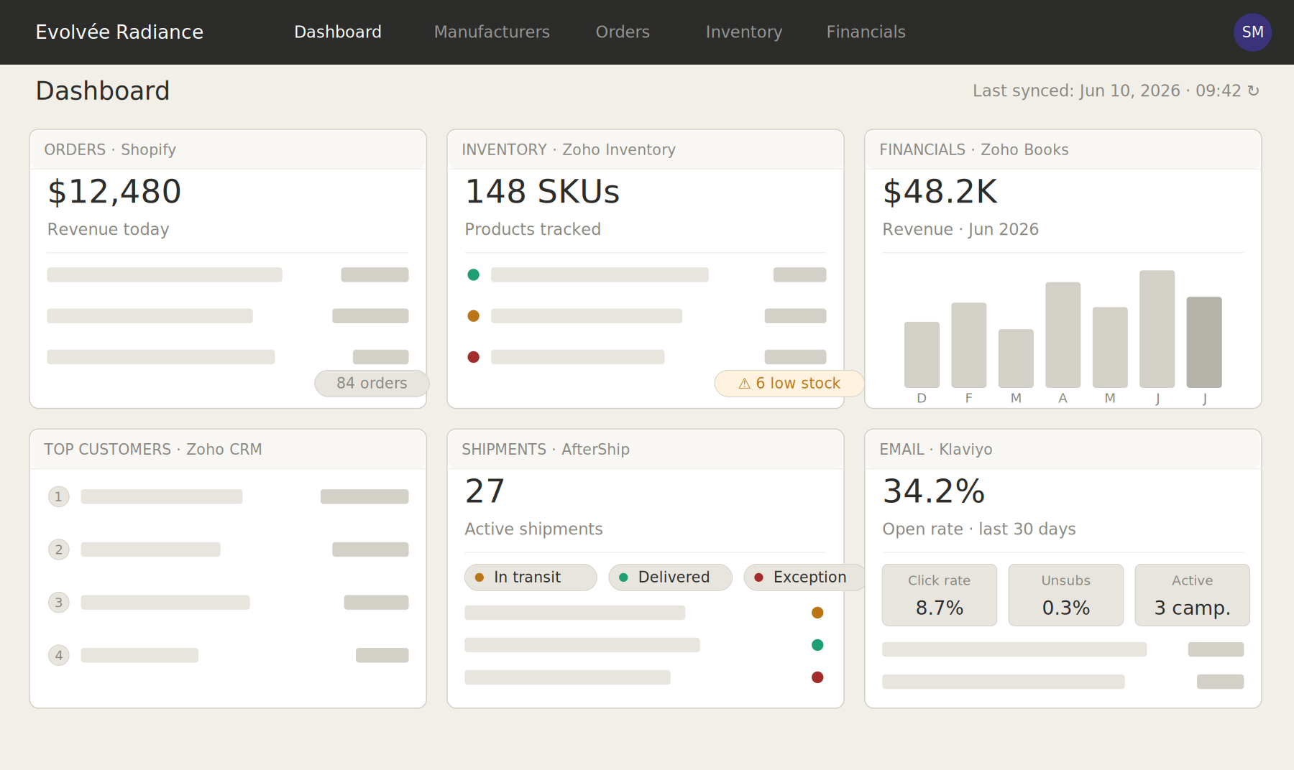
Fig 1 — Operations Dashboard wireframe · greyscale · placeholder data

2 Manufacturer POC & Reorder Management Tool
The Manufacturer Tool is a master–detail CRUD interface for managing supplier relationships, reorder thresholds, and production tracking. It is the second primary system in the Operations Hub.
2.1 Manufacturer List
The left panel presents a searchable list of all manufacturers. Each row shows the manufacturer name, assigned SKU count, and number of active production runs. Selecting a row loads the full detail panel on the right. The list also carries a summary reorder-alert banner at the top, surfacing open threshold breaches without navigating away.

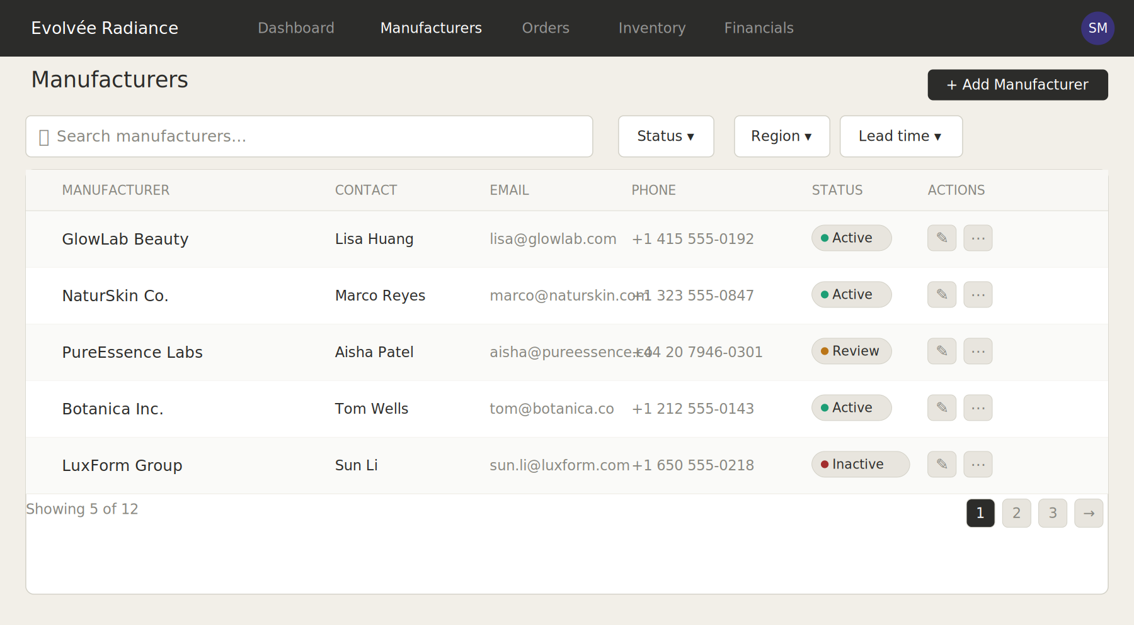
Fig 2 — Manufacturer list panel · greyscale · placeholder data · example manufacturers not affiliated with existing Evolvée Radiance products

2.2 Manufacturer Detail
The detail panel covers all V1 sections for the selected manufacturer: contact/POC records, product-to-SKU assignments with editable reorder thresholds and live stock-vs-threshold status badges, reorder history log, communication log, and production run status cards.

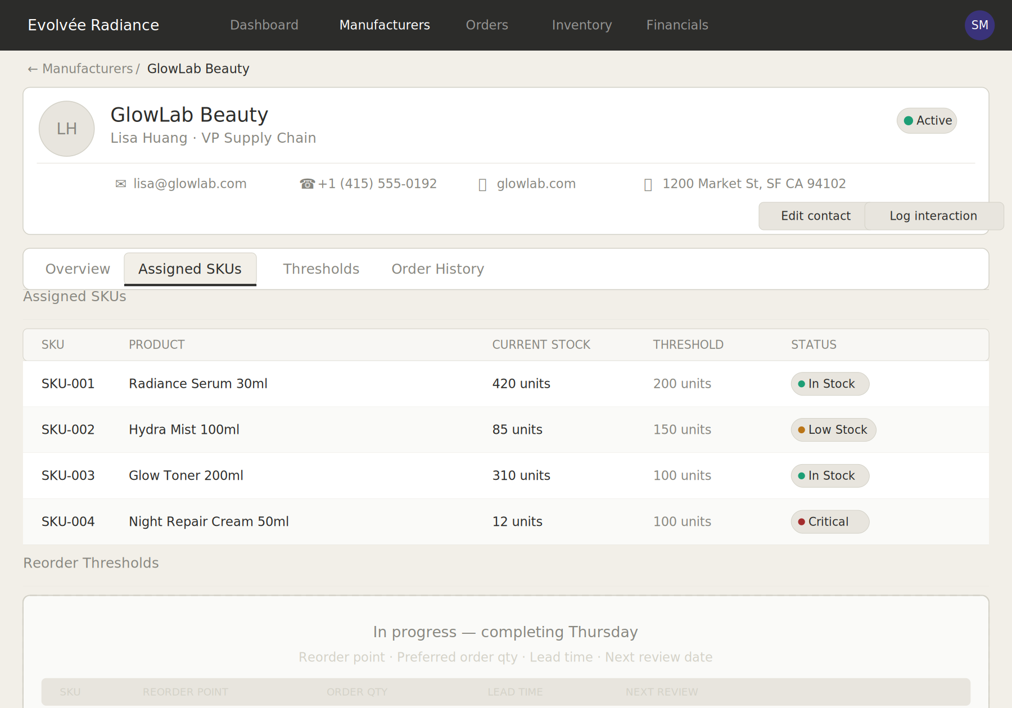
Fig 3 — Manufacturer detail panel · greyscale · placeholder data · example products not affiliated with existing Evolvée Radiance products

2.3 Full Tool View (List + Detail)
Combined view showing the list panel and detail panel side by side as they appear in the live application. Lumière Labs is shown in the selected state, with all detail sections populated. This is the default viewport at 1200px wide.

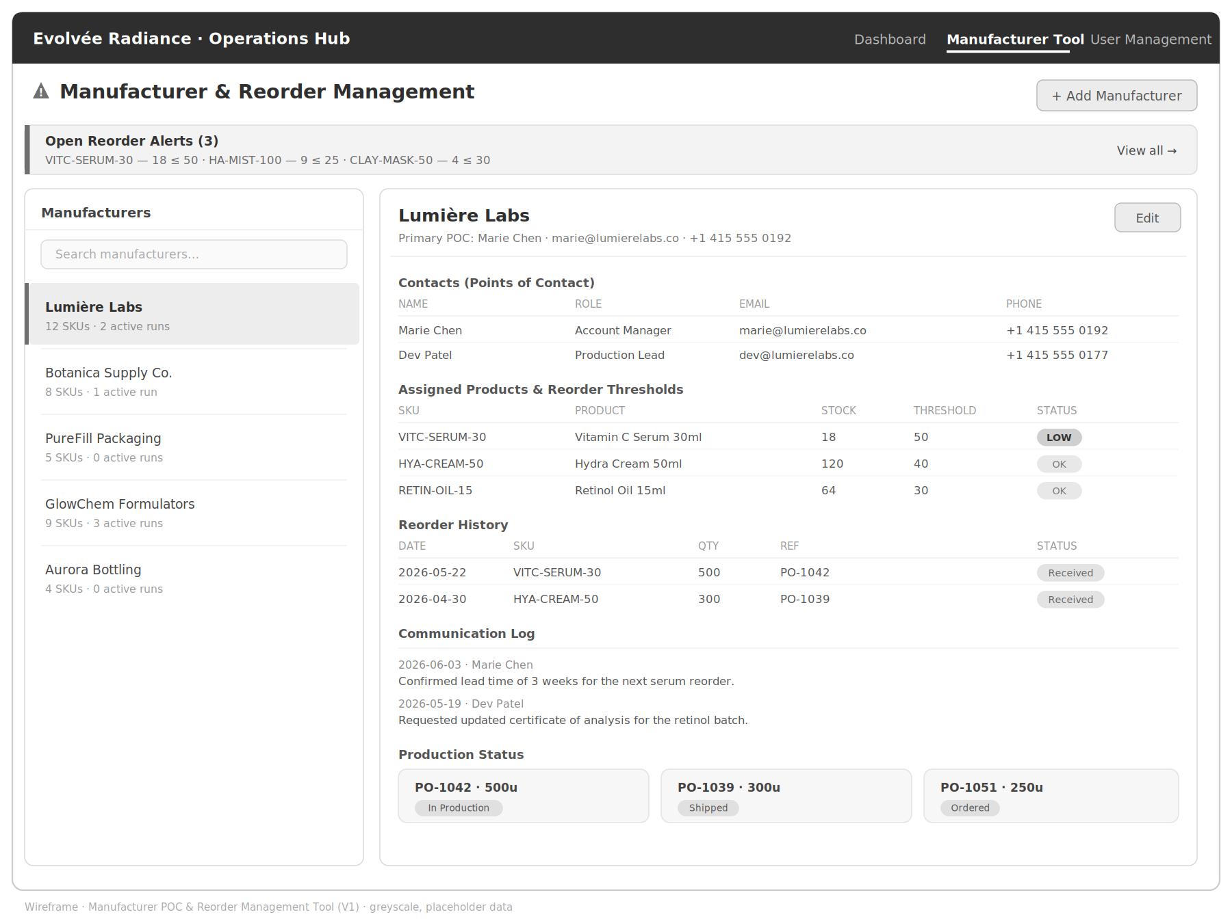
Fig 4 — Full Manufacturer Tool view · greyscale · placeholder data · example manufacturers/products not affiliated with existing Evolvée Radiance products

3 Notes & Scope
Coverage
These wireframes cover V1 scope only. V2 modules (ambassador performance, commission tracking, returns, marketing performance, expense summary) are not wireframed here and will be scoped if time allows after V1 delivery.
Pending: QR Partner Dashboard
The QR Partner Dashboard module is marked TBC in the architecture diagram pending API access confirmation from the QR platform. It is not wireframed in this document. A placeholder tile appears in the dashboard grid; it will be replaced with live content or removed at implementation time.
Role-based Visibility
Not all tiles or sections are visible to all roles. The Manufacturer Tool is restricted to Admin and Operations Manager roles. Financial data (Revenue tile, Reorder cost fields) is hidden from the Marketing role. The Partner/Ambassador role uses row-level scoping rather than module-level access, which is a more complex RBAC implementation and will be addressed separately.
Data
All manufacturer names, contact details, SKUs, product names, quantities, PO references, and dates shown in these wireframes are illustrative placeholder data. They are not affiliated with any existing Evolvée Radiance products, suppliers, or customers.
Tech Stack Reference
Frontend: React · Backend: Node.js / Express · Database: PostgreSQL · Auth: JWT · Hosting: Netlify (frontend), Railway (backend) · External APIs: Shopify, Zoho Inventory, Zoho Books, Zoho CRM, AfterShip, Klaviyo

