a. send notification: ( 2 to 3 hours)

1 . "Send" Button does not become active always in "Sending" mode after sending notification , Please have a look at the screenshot.

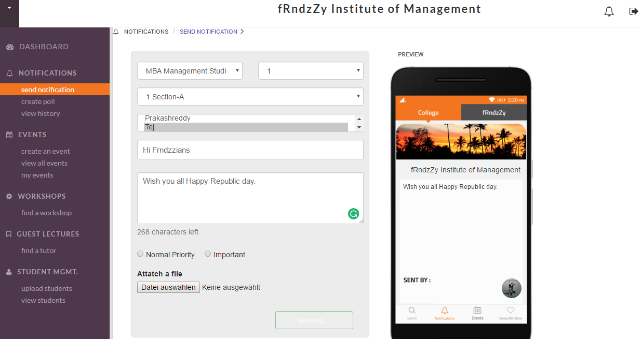

2. Filter the sections in the client end based on the selected year.

3. Change the Notify Students API call body format:

Ex: {"send_option":1,"account_id":243,"role_id":4,"dept_id":601,"section_id":20,"student_data":[{"student_id":"243","department_id":"601","college_id":"55"}],"year":1,"college_id":55,"title":"Not for Umesh","message":"Lorem Ipsum is simply dummy text of the printing and typesetting industry. Check Check","file_url":"","priority":0,"action_required":0,"action_question":"","action_choices":[]}

**b. Polling Module:( 6 hours)**

4. Change the send polling API body to this format:

Ex: {"send_option":1,"account_id":243,"role_id":4,"year":1,"college_id":55,"dept_id":601,"section_id":20,"title":"Test Notification 123","message":"","file_url":"","priority":0,"action_required":1,"action_question":"Will Dhoni and Co repeat the same Magic?","action_choices":["YES","NO","NO COMMENTS","MAY BE"]}

5. Filter the sections in the client end based on the selected year.

6. Polling History :

https://api.frndzzy.com/webservices_cubix/college_portal_api.php?action=read_polling_history

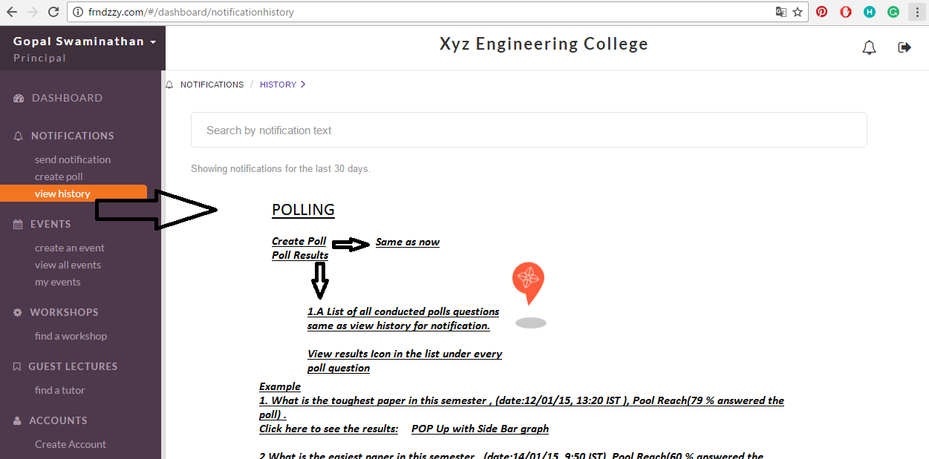

Display of polling results:

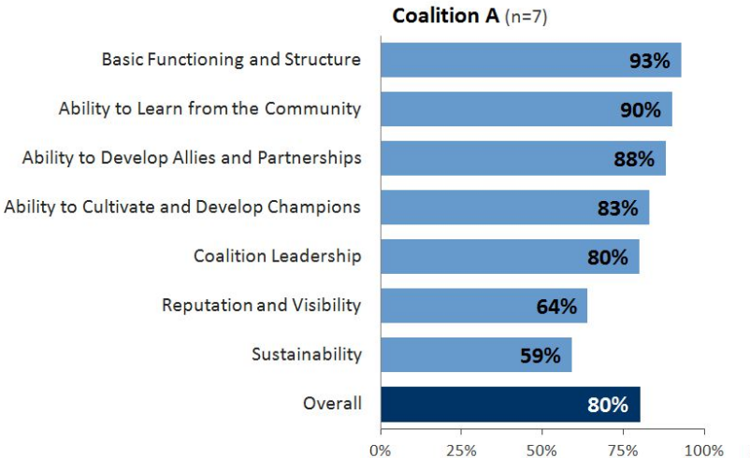

https://api.frndzzy.com/webservices_cubix/college_portal_api.php?action=read_polling_history

**c. Account Management ( Settings) (2 hours).**

7. Edit Account details according to the privileges:

"is_ambassador": 1 , Can't able to edit the account details. Others can edit the account.

