A REAL TIME PROJECT REPORT
on

EXPLORING INDIA’S CULTURE AND HERITAGE: MUSICAL INSTRUMENTS OF INDIA

Submitted for partial fulfillment of the requirements for the award of the degree of

BACHELOR OF TECHNOLOGY

In
CSE (Artificial Intelligence & Machine Learning)
Submitted by
G. Yashaswini(23UP1A6618)
G. Shivani(23UP1A6621)
B. Nishitha Reddy(23UP1A6610)
K. Mounika(23UP1A6628)
Under the GUIDANCE OF
Mrs. Dr. M. Thejovathi
Associate-Professor



DEPARTMENT OF CSE (ARTIFICIAL INTELLIGENCE & MACHINE LEARNING)
VIGNAN’S INSTITUTE OF MANAGEMENTANDTECHNOLOGY
FOR WOMEN (An Autonomous Institution)
Approved by AICTE and Affiliated to JNTUH
Accredited to NBA NAAC A+(CSE&ECE)
(Affiliated to Jawaharlal Nehru Technological University Hyderabad)
Kondapur (Village), Ghatkesar (Mandal), Medchal (Dist.), Telangana, Pincode-501301

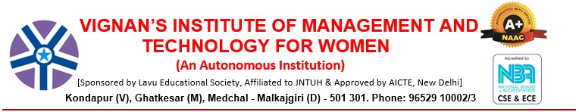

DEPARTMENT OF CSE(AI&ML)

CERTIFICATE

This is to certify that project work entitled “EXPLORING INDIA’S CULTURE AND HERITAGE: MUSICAL INSTRUMENTS OF INDIA”submitted by G.Yashaswini, (23UP1A6618), G. Shivani (23UP1A6621), B. Nishitha Reddy (23UP1A6610), K. Mounika, (23UP1A6628), in the partial fulfilment of the requirements for the award of the degree of Bachelor of Technology in CSE(AI&ML) VIGNAN’S INSTITUTE OF MANAGEMENT AND TECHNOLOGY FOR WOMEN is a record of Bonafide work carried by them under my guidance and supervision. The results embodied in this Project report have not been submitted to any other University or institute for the award of any degree.

Project Guide RTP Coordinator: Head of Department:
MRS. DR. M. THEJOVATHI D. BIKSHALU Dr. D. SHANTHI
Associate-Professor Assistant Professor M. Tech., Ph. D



DEPARTMENT OF CSE(AI&ML)

DECLARATION

We hereby declare that the work reported in the present project entitled “EXPLORING MUSICAL INSTRUMENTS OF INDIA” is a record of bonafide work duly completed by us in the Department of CSE (AI&ML) from Vignan’s Institute of Management and Technology for Women, affiliated to JNTU, Hyderabad. The reports are based on the summer internship work done entirely by us and not copied from any other source. All such materials that have been obtained from other sources have been duly acknowledged.
The results embodied in this Project report have not been submitted to any other University or Institute for the award of any degree to the best of our knowledge and belief.

G. Yashaswini (23UP1A6618)
G. Shivani(23UP1A6621)
B. Nishitha Reddy (23UP1A6610)
K. Mounika (23UP1A6628)

ACKOWLEDGEMENT

We would like to express our sincere gratitude and indebtedness to our project guide MRS. DR. M. THEJOVATHI Associate- Professor for her valuable suggestions and interest throughout the course of this project.

We would like to extend our gratitude to ‘D. BIKSHALU’, Real Time Project Coordinator, Department of CSE- Artificial Intelligence and Machine Learning (AI&ML) from Vignan's Institute of Management and Technology for Women, for his valuable suggestions and timely help while the project.

We are also thankful to Dr. D. SHANTHI, Head of the Department of CSE- Artificial Intelligence and Machine Learning from Vignan's Institute of Management and Technology for Women, Hyderabad for providing excellent infrastructure and a nice atmosphere for completing this project successfully as a part of our B.Tech. Degree (CSM).

We convey our heartfelt thanks to the lab staff for allowing us to use the required equipment whenever needed.

Finally, we would like to take this opportunity to thank our family for their support through the work. We sincerely acknowledge and thank all those who gave directly or indirectly their support in the completion of this work.

G. Yashaswini (23UP1A6618)
G. Shivani(23UP1A6621)
B. Nishitha Reddy (23UP1A6610)
K. Mounika (23UP1A6628)

ABSTRACT

India is a land of rich culture, and music is an important part of it. Indian music has a long history and is deeply connected to traditions and emotions. This project explores the musical instruments that are a part of India’s cultural heritage. Indian music is mainly divided into Hindustani and Carnatic styles. Each style uses unique instruments that have been passed down for generations. The sitar, tabla, and sarod are popular in North India. In South India, the veena, mridangam, and ghatam are widely used. Apart from classical music, India has a wide variety of folk music. Each region has its own special instruments made with local materials. Instruments like dhol, ektara, and shehnai are played during festivals and celebrations. Many instruments are handmade, showing the skill of local craftsmen. They are often decorated and have beautiful designs. These instruments are not just tools for music; they carry stories and traditions. Music brings people together during weddings, temple festivals, and community events. It is used to express joy, devotion, and even sorrow. Learning about these instruments helps us understand Indian life better. From the deserts of Rajasthan to the hills of the Northeast, each area has its own sound. The project also looks at how modern musicians keep these instruments alive. Today, some artists mix traditional instruments with modern music. This helps younger people connect with their roots. Music education and performances help preserve these traditions. Schools and cultural centers play a big role. Overall, musical instruments are a window into India’s soul. They show the beauty of India’s unity in diversity. Through this project, we celebrate the sound and spirit of India.

S.NO | Figure Name | Page no
 | Use Case Diagram | 21
 | Class Diagram | 22
 | Sequence Diagram | 23
 | Activity Diagram | 25
 | Deployment Diagram | 26

LIST OF FIGURES

LIST OF TABLES:

S.NO | Name of tables | Pg.no
1 | literature survey | 10

TABLE OF CONTENTS

Chapter No. Title page.no.

Abstract v

List of Figures vi

List of Tables vii

1. INTRODUCTION 1

1.1 Problem Statement 3

1.2 Objective 4

1.3 Motivation 5

1.4 Existing System 6

1.5 Proposed system 7

1.6 Scope and Purpose 8

2. LITERATURY REVIEW 10

3. SYSTEM REQUIREMENTS AND 12

SPECIFICATIONS

3.1 SOFTWARE AND HARDWARE 13

REQUIREMENTS

4. SYSTEM DESIGN 17

4.1 System Architecture or block diagram 18

4.2 UML Diagrams 21

4.2.1 Use case Diagram 21

4.2.2 Class Diagram 22

4.2.3 Sequence Diagram 23

4.2.4 Activity Diagram 25

4.2.5 Deployment Diagram 2

5. IMPLEMENTATION 28

5.1 Module Split up 28

5.2 Proposed Algorithm 29

6. RESULTS 34

7. TESTING 38

8. CONCLUSION 41

9. FUTURE ENHANCEMENT 42

10. REFERENCES 43
SAMPLE CODE 45

CHAPTER-1
INTRODUCTION

India is known all over the world for its rich culture and long history. One of the most beautiful parts of this culture is music, which has been a part of Indian life for thousands of years. It is used in temples, during festivals, at weddings, and even in daily life. Indian music is not just a form of entertainment but a way to express emotions, beliefs, and stories. Musical instruments play an important role in Indian music and are used in both classical and folk traditions. India has many different types of instruments that come from different regions, each with its own sound, style, and cultural meaning. These instruments are made from natural materials like wood, clay, metal, leather, and bamboo. Many are handcrafted by skilled artisans who pass down their knowledge through generations. In this project, we will explore these wonderful instruments, how they are made, how they sound, and how they are used in performances. We will also study the role of music in Indian traditions and how it changes from region to region. Every state in India has its own unique musical style, rhythm, and instruments. Instruments like the sitar and tabla are well known around the world, while others like the pungi, ektara, and khartal are deeply rooted in local traditions and used in folk music. All of them are important parts of India’s musical and cultural identity. By learning about them, we show respect to our cultural roots and help keep these traditions alive for future generations. This project will also help us understand how music brings people together and creates a sense of unity in diversity. Music in India brings joy, peace, devotion, and connection among people, regardless of language or background. It is a powerful way to share feelings, tell stories, and celebrate life. We will collect information from books, interviews, documentaries, and online sources to learn more. Through this project, we hope to appreciate the beauty of Indian music and share it with others in a meaningful way. Let us begin our journey into the rich, colorful, and soulful world of Indian musical instruments.

1.1PROBLEM STATEMENT

This website offers an engaging and educational journey into the diverse world of Indian musical instruments, blending interactivity with cultural depth to promote understanding, appreciation, and preservation of India’s rich musical heritage. A visually interactive map of India allows users to explore instruments region by region, revealing traditional instruments native to each state along with cultural and historical context. Clicking on an instrument leads to a dedicated page with in-depth details such as its origin, construction, playing technique, usage in classical or folk traditions, and symbolic significance. To enhance user experience, the site includes hover-based popups that display quick previews—concise descriptions and thumbnail images—for efficient browsing. Each instrument page features multimedia content, including audio samples and performance videos, and highlights notable musicians who have mastered it. The platform is designed to serve as a cultural and educational resource for students, teachers, music lovers, and researchers, with content structured for potential inclusion in school curricula. Language is tailored to suit a wide age group, and future updates may introduce quizzes, timelines, and interactive learning modules to deepen engagement and make learning more fun. A clean, user-friendly interface ensures easy navigation across desktops, tablets, and smartphones, while accessibility guidelines are followed to accommodate users with disabilities. The site’s design emphasizes inclusivity, with plans for multilingual support to broaden reach and allow users to explore content in various Indian languages. Additionally, a glossary of musical terms and a section on related instruments will help users expand their knowledge and draw connections across different traditions. More than just a website, this platform is a digital archive and learning space—preserving traditional knowledge, encouraging discovery, and celebrating the unity in diversity of India’s musical landscape. Through this immersive experience, users from all backgrounds can connect with the soulful rhythms and stories that make Indian music a living legacy. By bringing together technology, education, and tradition, the website aims to inspire pride in India’s cultural roots and ensure that its musical treasures are passed on to future generations
1.2 OBJECTIVES

Indian classical music is one of the oldest musical traditions in the world, rooted deeply in India’s spiritual, cultural, and artistic history. The instruments used in this genre are not only tools for producing sound but are also vessels of rich tradition, craftsmanship, and expression. These instruments have evolved over centuries and are deeply tied to regional styles, religious practices, and philosophical ideas. This project aims to explore the classical instruments of India, focusing on both the Hindustani (North Indian) and Carnatic (South Indian) traditions. Instruments like the sitar, tabla, veena, mridangam, sarod, and bansuri form the core of classical music and are revered for their expressive capabilities and unique sound textures. Each instrument carries a story of invention, evolution, and performance, shaped by the hands of master musicians and artisans. By studying these instruments, we aim to gain a better understanding of how music reflects India's cultural values and diverse heritage. This project also focuses on the importance of preserving these instruments through education, documentation, and modern technology. The goal is to help students, educators, and music enthusiasts appreciate the intricate beauty and significance of classical music. Alongside this narrative, we have outlined specific objectives that will guide our research and presentation of this topic.

Specific Objectives:
- To trace the historical development of Indian classical musical instruments.
- To classify the instruments based on their type: string (tata), wind (sushira), percussion (avanaddha), and solid (ghana).
- To study the construction, materials, and traditional craftsmanship involved in making these instruments.
- To understand the role of each instrument in classical music compositions and performances.
- To examine the regional variations in instrument use between Hindustani and Carnatic traditions.
- To analyze the cultural, religious, and symbolic meanings associated with classical instruments.
- To highlight the contributions of famous Indian classical musicians and their association with specific instruments.
- To evaluate the current challenges facing traditional instrument makers and classical musicians.
- To encourage the preservation and promotion of classical instruments through educational platforms.
- To develop audio-visual and digital resources that make learning about these instruments engaging and accessible.

1.3 Motivation
India's classical musical instruments are deeply intertwined with the nation's cultural and historical identity, reflecting centuries of tradition, craftsmanship, and artistic expression. However, despite their significance, awareness and appreciation of these instruments have declined in the digital age, with younger generations often disconnected from this rich heritage.
This project seeks to bridge this gap by developing an interactive website that brings India's classical musical instruments to life through immersive, user-friendly digital experiences. The core feature—a dynamic map of India—enables users to explore musical instruments region-wise, discovering their unique characteristics, origins, historical evolution, and cultural importance.
By incorporating engaging multimedia elements such as audio samples, images, and descriptive narratives, the website aims to provide a multi-sensory learning experience that enhances understanding and fosters appreciation. Leveraging modern web technologies, the project emphasizes interactivity, accessibility, and education, allowing users to actively engage with content rather than passively consume information.
Beyond individual exploration, the initiative aspires to be a valuable resource for musicians, researchers, educators, and cultural enthusiasts, promoting India's rich musical legacy on both national and global platforms. By creating a digital space where tradition meets technology, the project encourages users to rediscover the timeless beauty of India's classical music and ensure that these art forms remain vibrant for generations to come.
1.4 Existing System
In the current digital landscape, information about India's classical musical instruments is scattered across various sources, but lacks a unified, interactive, and engaging platform. Existing resources include:
Wikipedia & Online Articles – These provide textual descriptions of classical instruments but often lack interactive features or immersive multimedia
Music Blogs & Forums – Some platforms discuss Indian classical music, but they are often informal and not well-structured for comprehensive learning.
YouTube Videos & Documentaries – These provide rich audiovisual content but do not offer an organized or structured exploration of instruments by region.
Museum Websites & Cultural Archives – Certain institutions showcase musical heritage, but their information is often limited, non-interactive, or text-heavy.
Here are some websites that provide information about India's classical musical instruments:
Despite these available resources, they come with several limitations:
- Lack of Centralization – No single platform allows users to explore India's musical instruments state-wise in a structured manner.
- Minimal Interactivity – Most sources provide only static content, making user engagement limited.
- Limited Multimedia Elements – Few platforms offer an immersive experience with audio samples, interactive visuals, or dynamic educational tools.
- Absence of Visual Mapping – No existing system provides an interactive map to explore instruments based on Indian states.
- Restricted Accessibility – Content is often not mobile-friendly or personalized for different user needs.
Thus, the existing systems fail to provide an immersive, informative, and engaging way for users to explore and appreciate India's classical musical heritage. project aims to address these gaps by offering a structured, interactive, and user-friendly experience that seamlessly blends cultural storytelling with modern web technologies.
1.5 Proposed System
The proposed system aims to create an interactive web-based platform dedicated to showcasing India's classical musical instruments through an engaging, visually appealing, and user-friendly interface. Unlike existing fragmented sources, this system will provide a centralized, immersive experience by integrating interactive mapping, multimedia elements, and structured information to enhance user engagement.
Key Features:
- Clickable India Map – The platform will feature an interactive map where users can explore musical instruments state by state, gaining insights into their historical origins, cultural significance, and distinctive characteristics.
- Hover-Based Popups – Users will see brief descriptions and images of instruments when hovering over a state, offering quick access to fundamental details. Clicking on them will provide in-depth historical narratives.
- Dedicated Pages for Instruments – Each instrument will have a unique page showcasing its history, usage, craftsmanship, regional variations, and famous musicians associated with it.
- Audio Integration – The website will incorporate audio samples, allowing users to listen to the authentic sounds of each classical instrument, enriching their understanding of its tonal qualities.
- Educational Tool for Schools and Researchers – The platform will serve as a valuable resource for students, educators, and researchers, helping them explore India's musical heritage in an interactive and structured manner.
- User-Friendly Interface – Designed to be accessible to people of all ages, ensuring seamless navigation, readability, and mobile compatibility for widespread engagement.
Impact and Significance:
By merging technology with tradition, this proposed system offers a modern approach to preserving and promoting India’s classical musical instruments. It fosters a deep appreciation for indigenous music traditions, making knowledge interactive, engaging, and widely accessible to musicians, cultural enthusiasts, educators, and general users alike.
1.6 Scope and Purpose
Scope:
The scope of this project includes the development of an interactive web platform that provides a comprehensive and engaging way to explore India's classical musical instruments. The system will feature:
- Scroll-Interactive India Map – Each state will display its unique classical musical instruments through a hover-based popup containing brief descriptions and images.
- Detailed Instrument Pages – Each musical instrument will have a dedicated page containing its history, cultural significance, images, and embedded audio samples for a richer understanding.
- Responsive Web Design – The platform will be accessible across desktops, tablets, and smartphones, ensuring a seamless user experience.
- Content Management System (CMS) – Administrators will have the ability to update instrument details, images, and audio samples dynamically.
- Backend Database Support – A database will store instrument information, facilitating efficient data retrieval and updates.
- Educational and Cultural Enrichment – The platform will serve as a learning tool for students, educators, musicians, and cultural enthusiasts, making traditional knowledge interactive and accessible.
Purpose:
The primary purpose of this project is to design and develop an interactive website that acts as a digital guide to India’s classical musical instruments, making exploration engaging, informative, and immersive. Through historical content, cultural narratives, state-wise mapping, and multimedia integration, the platform aims to preserve and promote India’s rich musical heritage while ensuring accessibility across diverse audiences.
The system is designed for:
- Music Enthusiasts and Researchers – Individuals interested in studying the origins, characteristics, and evolution of classical Indian instruments.
- Educators and Students – Academic institutions can use the platform as an interactive resource for cultural and music studies.
- General Public – Anyone curious about India’s musical traditions can explore instruments effortlessly through a visually appealing, interactive interface.
By delivering a centralized, multimedia-rich, and user-friendly platform, this project bridges the gap between traditional music heritage and modern digital experiences, ensuring that India's classical musical legacy remains alive, accessible, and appreciated by future generations.

CHAPTER 2
LITERATURE SURVEY

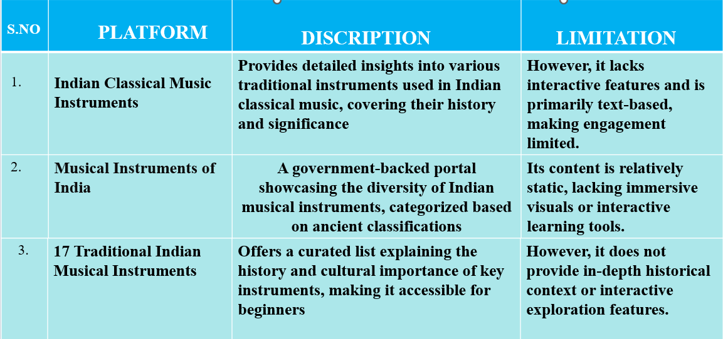

Table2.1: literature survey

• Alastair Dick (2020) - The Grove Dictionary of Musical Instruments
Key Findings:
Provides detailed descriptions and historical backgrounds of traditional Indian instruments like sitar, tabla, veena, and shehnai.
Relevance to Project:
Supports accurate representation of instruments and their roles in ceremonial and cultural settings.
• SwarGanga.org (2023) - Indian Classical Instruments Database
Key Findings:
Categorizes instruments by type (string, percussion, wind) and offers sound samples and playing techniques.
Relevance to Project:
Useful for illustrating the diversity and sonic identity of instruments used in various rituals or events.

• Ministry of Culture, Government of India (2024) - Traditional Performing Arts Archive
Key Findings:
Highlights the cultural significance and regional use of instruments in dance, theater, and folk traditions.
Relevance to Project:
Helps enrich narrative or visual storytelling with culturally accurate musical elements.
• Rajiv Menon (2015) - Soundscapes of India: A Journey Through Music
Key Findings:
Explores the emotional and spiritual role of music and instruments in Indian life, including religious ceremonies.
Relevance to Project:
Provides thematic depth and emotional realism to scenes involving music or rituals.
• NaadSadhana.com (2023) - Beginner’s Guide to Indian Musical Instruments
Key Findings:
Simplifies learning about key instruments, their use in contemporary and traditional settings.
Relevance to Project:
Makes it easier to describe instrument function and presence in everyday or festive scenarios.

CHAPTER 3
SYSTEM ANALYSIS

System analysis is a foundational process in the development of any information system, aimed at thoroughly examining existing operations, identifying gaps, and formulating detailed requirements for an improved solution. It involves studying the current system’s structure—whether manual or automated—to understand how data flows, how users interact with the system, and where inefficiencies or redundancies exist. Analysts collect information through methods such as interviews, surveys, observations, and document reviews to capture the real-world functioning of the system from multiple perspectives. This data is then organized into structured models like data flow diagrams, entity-relationship diagrams, and system flowcharts, providing a visual and logical representation of the system. The objective is not only to understand what the system does but also to uncover what it fails to do, what users need, and how it can be improved in terms of speed, accuracy, and functionality. System analysis is both a technical and interpersonal discipline—it requires attention to detail, critical thinking, and strong communication skills to bridge the gap between stakeholders and developers. By translating user needs into functional requirements, analysts ensure that the system will meet business goals, regulatory standards, and user expectations. This phase also includes feasibility studies—technical, operational, and economic—that help determine whether the project is viable and worth investing in. It addresses potential risks, constraints, and integration challenges early, preventing costly errors during later stages of development. Additionally, system analysis sets performance benchmarks, defines data relationships, and identifies the necessary hardware, software, and human resources. It also evaluates the scalability and maintainability of proposed systems, ensuring that solutions remain effective as organizations grow and evolve. Whether it’s designing a hospital information system, an educational portal, or an e-commerce platform, system analysis guarantees that the development is grounded in a clear understanding of needs, workflows, and expectations. In essence, it forms the blueprint of the entire system, guiding designers and developers toward creating solutions that are reliable, efficient, user-friendly, and sustainable over time.

3.1 SOFTWARE AND HARDWARE REQUIREMENTS

Hardware requirements

1. Processor:
- Minimum: Intel Core i3 processor or an equivalent processor from AMD. This ensures sufficient processing power to run the application and testing tools smoothly.
- Recommendation: Intel Core i5 or higher, or an equivalent AMD Ryzen processor, is recommended for optimal performance, especially when running multiple tests or resource-intensive scenarios.

2. Random Access Memory (RAM):
- Minimum: 4 GB of RAM is the absolute minimum required to run the application and basic testing processes. However, performance may be significantly impacted with limited RAM.
- Recommendation: 8 GB of RAM is strongly recommended. This allows for smoother multitasking, running multiple applications concurrently (e.g., the application under test, testing frameworks, bug reporting tools), and handling larger datasets or more complex test scenarios without significant performance degradation.
3. Storage:
- Minimum: At least 500 MB of free disk space is necessary to accommodate the application installation, test data, and any temporary files generated during the testing process.
- Recommendation: While 500 MB is the minimum, having several gigabytes of free space is advisable to avoid performance bottlenecks and to accommodate potential growth in application size or test data. A Solid State Drive (SSD) is also highly recommended over a traditional Hard Disk Drive (HDD) for significantly faster read and write speeds, leading to quicker test execution and overall better responsiveness.
4. Display:
- Minimum: A display with a screen size of 13 inches or larger is required. This ensures sufficient screen real estate for viewing the application interface, test results, and testing tools comfortably.
- Rationale: A larger screen facilitates better User Interface (UI) testing by allowing testers to view more elements at once and identify layout issues or inconsistencies more easily. Smaller screens can make comprehensive UI testing challenging and less efficient.
5. Input Devices:
- Required: A standard keyboard and a pointing device (such as a mouse or trackpad) are essential for interacting with the application under test and executing test procedures. The keyboard is crucial for inputting data, navigating the application, and running commands, while the pointing device allows for precise interaction with graphical elements and navigation within the user interface. Ensure both devices are functioning correctly for effective testing.
Software requirements

1. Operating System:
- Supported Platforms: Developers can utilize any of the following operating systems:
  - Windows: Version 10 or later is recommended for optimal compatibility and access to a wide range of development tools.
  - macOS: The latest stable version or the preceding version is recommended, providing a robust Unix-based environment suitable for web development.
  - Linux: Various distributions such as Ubuntu, Fedora, or Debian are supported, offering flexibility and customization for experienced developers.
2. Code Editor:
- Recommended Editor: Visual Studio Code (VS Code) is the preferred code editor for this project.
  - Rationale: VS Code is a free, lightweight, and powerful source code editor with extensive support for various programming languages, including those used in this project (HTML, CSS, JavaScript). It offers features like intelligent code completion (IntelliSense), debugging tools, Git integration, and a vast ecosystem of extensions that enhance productivity and collaboration. Developers are encouraged to familiarize themselves with VS Code's features and install relevant extensions for web development.
3. Web Technologies:
The project leverages the following core web technologies for its front-end development:
- HTML (HyperText Markup Language): The standard markup language for creating web pages and structuring their content. A fundamental understanding of HTML5 is essential for all developers.
- CSS (Cascading Style Sheets): Used for styling the visual presentation of the HTML elements, including layout, colors, fonts, and responsiveness. Familiarity with CSS3 and modern styling techniques is required.
- JavaScript: A dynamic scripting language that enables interactivity and dynamic behavior on the web page. A strong understanding of core JavaScript concepts, including ES6+ syntax, is necessary.
- Bootstrap: A popular CSS framework that provides pre-built components and responsive grid systems, facilitating rapid and consistent UI development. Familiarity with Bootstrap's classes and conventions is expected.
4. Web Browser (for Testing):
- Recommended Browsers: For testing and ensuring cross-browser compatibility, developers should utilize either Google Chrome or Mozilla Firefox.
  - Rationale: These are widely used and actively maintained web browsers with excellent developer tools that aid in debugging, inspecting elements, and profiling performance. Regularly testing the application on both Chrome and Firefox will help identify and resolve any browser-specific issues, ensuring a consistent user experience across different platforms. Developers are encouraged to keep their browser versions up to date to benefit from the latest features and security patches

CHAPTER 4
SYSTEM DESIGN
The system design of this interactive website revolves around creating an engaging and visually intuitive platform for exploring India's classical musical instruments. It follows a structured three-tier architecture, comprising the frontend, backend, and database layers, ensuring seamless functionality and an immersive user experience. The frontend is designed using HTML, CSS, and JavaScript, incorporating an interactive India map where users can hover over states to access previews of classical instruments. Clicking on a state leads to detailed instrument pages, enriched with historical narratives, images, and embedded audio samples, allowing users to explore the instruments' cultural significance. The backend is responsible for managing dynamic content loading, user interactions, and multimedia playback. Technologies like Node.js or Python handle data retrieval and updates efficiently, ensuring smooth navigation and responsiveness. The database layer, implemented using MySQL or Firebase, stores comprehensive information about each instrument, including descriptions, audio samples, and associated artists.
The workflow of the system begins with users accessing the homepage, where they interact with the clickable India map to explore instruments regionally. Hover-based popups provide instant previews, while dedicated pages offer deeper insights, enhancing user engagement through structured storytelling. The system is equipped with a content management feature, allowing administrators to update information dynamically, ensuring that the platform remains relevant and continuously evolving. Additionally, the search and filter functionality aids users in quickly locating instruments based on name, region, or category, improving accessibility. The design is responsive, ensuring compatibility across devices, including desktops, tablets, and smartphones, providing a smooth experience for all users. Performance optimization techniques such as lazy loading ensure faster content delivery and prevent lag, making navigation efficient.
Ultimately, the system design balances functionality, accessibility, and cultural preservation, merging tradition with modern web technology to create an interactive, educational, and immersive resource for music enthusiasts, students, researchers, and the general public. It ensures that India's classical musical heritage is presented in a compelling digital format, fostering awareness and appreciation across generations.

4.1 SYSTEM ARCHITECTURE

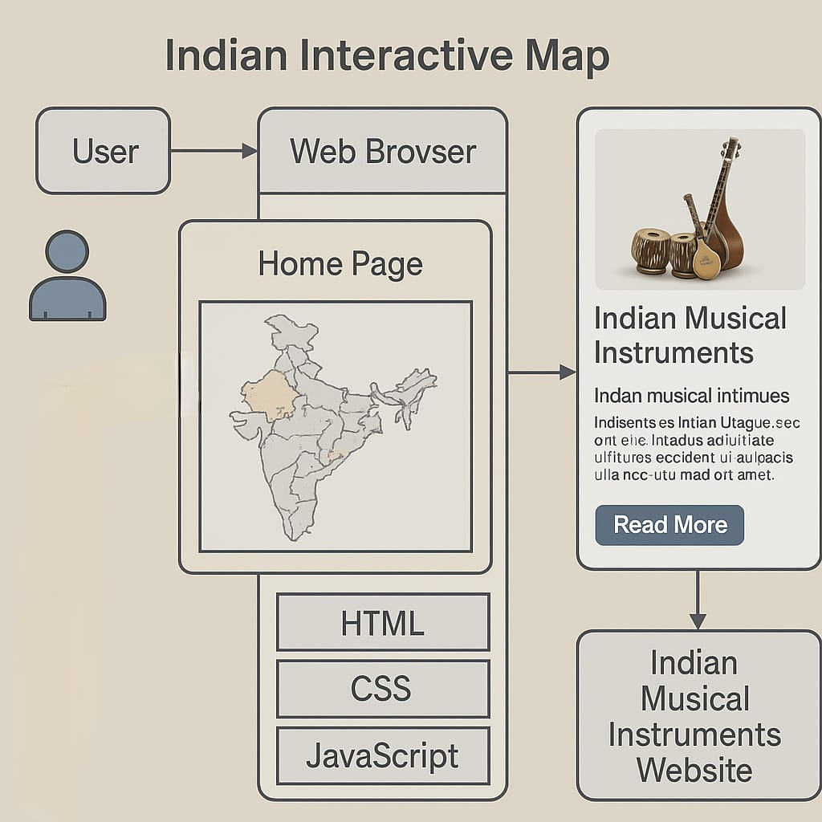
Fig 4.1: system architecture

Indian Interactive Map & Musical Instruments Website: Detailed One-Page Summary
This innovative website provides an engaging and comprehensive platform for exploring the diverse world of Indian musical instruments, leveraging an interactive map as its central navigational element. Upon accessing the Home Page via a Web Browser, users are immediately presented with a visually appealing and interactive map of India. This map, structurally built with HTML, aesthetically styled with CSS, and dynamically enhanced with JavaScript, forms the gateway to discovering the rich musical heritage of different regions.
Users can intuitively interact with this map by clicking on specific states or culturally significant areas. This action triggers JavaScript functionalities that identify the selected region and dynamically retrieve relevant information about the musical instruments traditionally associated

with it. This information is then presented in a designated section, titled "Indian Musical Instruments," often featuring captivating images of the instruments alongside concise introductory text that highlights their key characteristics and regional significance. A prominent "Read More" button accompanies this initial display, serving as a clear call to action for users seeking deeper knowledge.

Upon clicking the "Read More" button, users are seamlessly navigated to the core of the "Indian Musical Instruments Website." This expanded platform houses a wealth of detailed information, organized and presented to facilitate comprehensive learning. Employing hover-based popups, the website allows users to quickly preview essential details and visuals of instruments as they navigate lists or galleries, enhancing browsing efficiency and piquing their interest. Crucially, each instrument featured on the website boasts its own dedicated page. These pages offer an in-depth exploration of the instrument's history, tracing its origins and evolution; its traditional and contemporary usage, detailing playing techniques and musical contexts; its profound cultural significance within its region and beyond; and often, profiles of famous musicians who have mastered and popularized it.

Recognizing its potential as an educational tool, the website is thoughtfully designed to be accessible and informative for a wide range of users, from students and educators to cultural enthusiasts of all ages. The intuitive navigation and visually appealing design ensure a user-friendly experience, encouraging widespread engagement and facilitating the preservation and promotion of traditional knowledge about India's rich musical heritage. The integration of multimedia elements, such as high-quality audio samples and illustrative video clips (though not explicitly shown in this simplified diagram, they are a likely component of a comprehensive musical instrument website), further enriches the learning experience, allowing users to not only read about but also hear and see these instruments in action. In essence, this interactive website transforms the process of learning about Indian musical instruments from a passive reading experience into a dynamic, visually engaging, and geographically contextualized explora

4.2 UML DIAGRAMS
4.2.1 USECASE

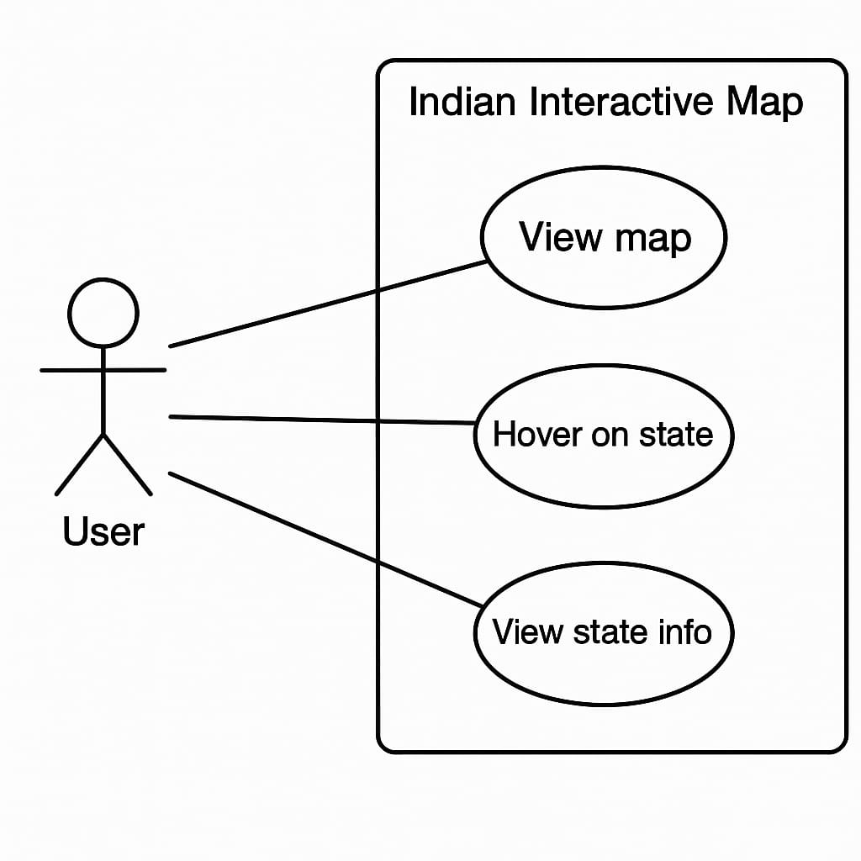

Fig 4.2: use case

The use case diagram depicted in the image represents the interaction between a user and the "Indian Interactive Map" feature of a website focused on Indian musical instruments. In this system, the user can perform three primary actions: View Map, Hover on State, and View State Info. These functionalities allow users to explore different regions of India by visually interacting with a map. Upon hovering over a specific state, the system may highlight it or display a brief overview. Clicking on the state or a particular instrument icon then enables the user to view detailed information about the traditional instruments specific to that region. This interactive approach enhances user engagement while also supporting the educational and cultural preservation goals of the platform.

4.2.2 CLASS DIAGRAM

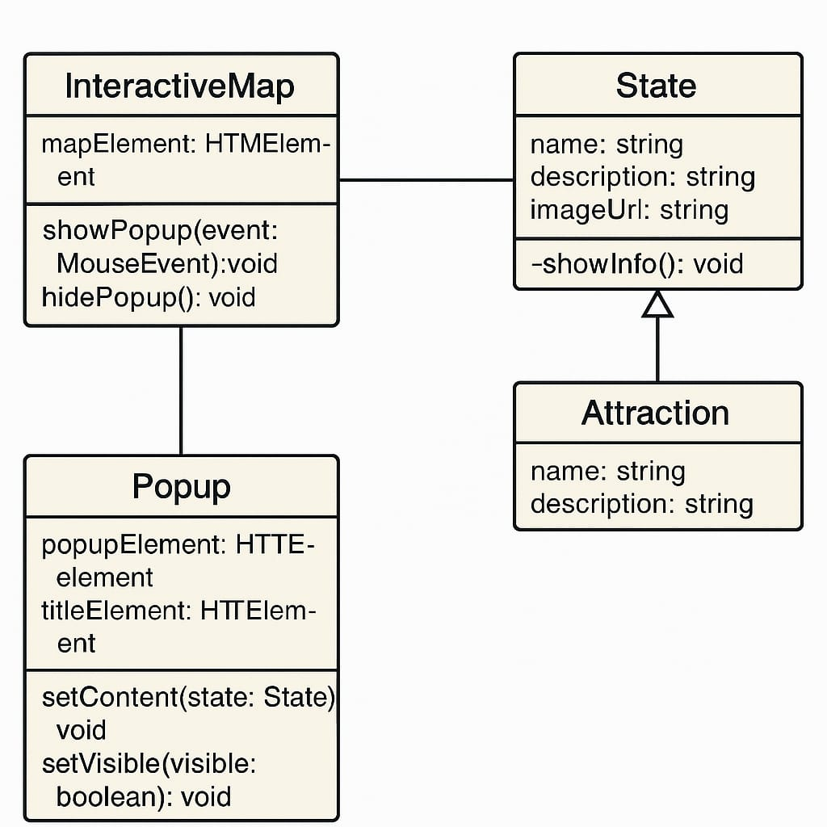

Fig4.3:class diagram

This class diagram models an interactive map application that displays information about various attractions, particularly U.S. states. The InteractiveMap class manages the map's HTML interface and handles user interactions, such as showing or hiding popups based on mouse events. The Popup class is responsible for displaying additional information, such as state details, in a popup window. It includes HTML elements for the popup itself and its title, and provides methods to set its content and control visibility. These two classes work together to respond to user input and visually present data.

On the data side, the State class represents a specific location with attributes like name, description, and an image URL. It extends the Attraction class, inheriting its name and description properties, which means that a state is considered a specialized form of attraction with additional information. The State class also includes a private method, showInfo, likely used to present state-specific content. This structure supports object-oriented principles by separating concerns between UI management (handled by InteractiveMap and Popup) and data representation (handled by State and Attraction).

4.2.3 SEQUENCE DIAGRAM

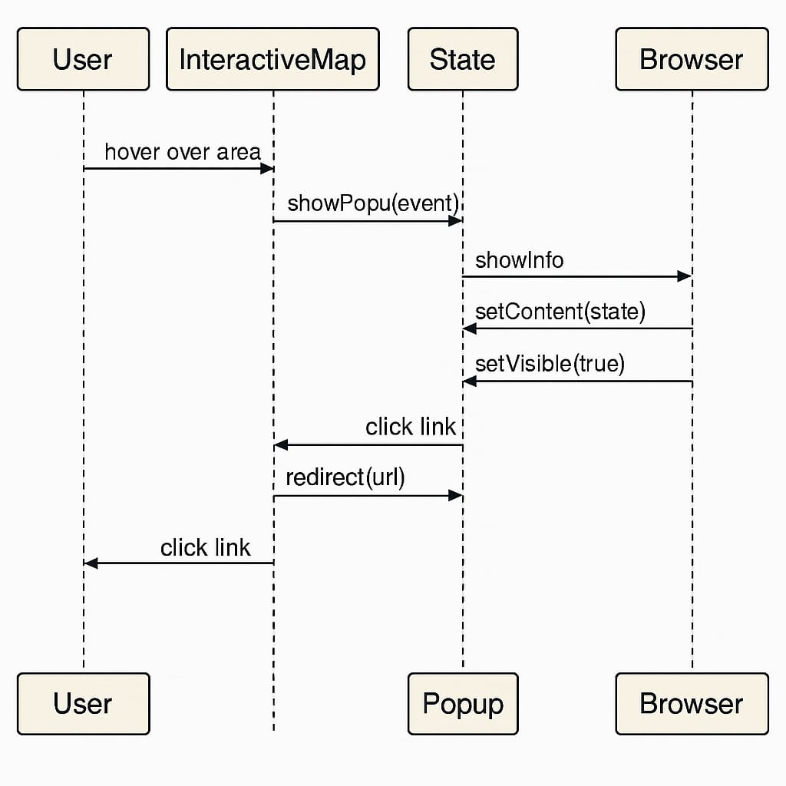

Fig4.4: sequence diagram

A sequence diagram is a type of interaction diagram in Unified Modeling Language (UML) that shows how objects operate with one another and in what order. The provided sequence diagram depicts the interaction between a user, an interactive map, a state component, a popup, and a browser. It begins with the user hovering over an area on the interactive map, prompting the map to call the showPopup(event) function in the state object. This triggers a chain of functions: showInfo, setContent(state), and setVisible(true) which sends content to the browser to display the popup containing information about the hovered state.

Subsequently, the user clicks on a link within the popup, initiating a redirect through the state to a specific URL. This results in a final user interaction where the browser opens the new page. The diagram effectively illustrates the flow of data and control between components in a dynamic web application, showcasing how user interactions are handled in real time with responsive UI feedback and navigation. It highlights the importance of well-defined communication between front-end components and the underlying logic that manages content visibility and redirection.

4.2.4 ACTIVITY DIAGRAM

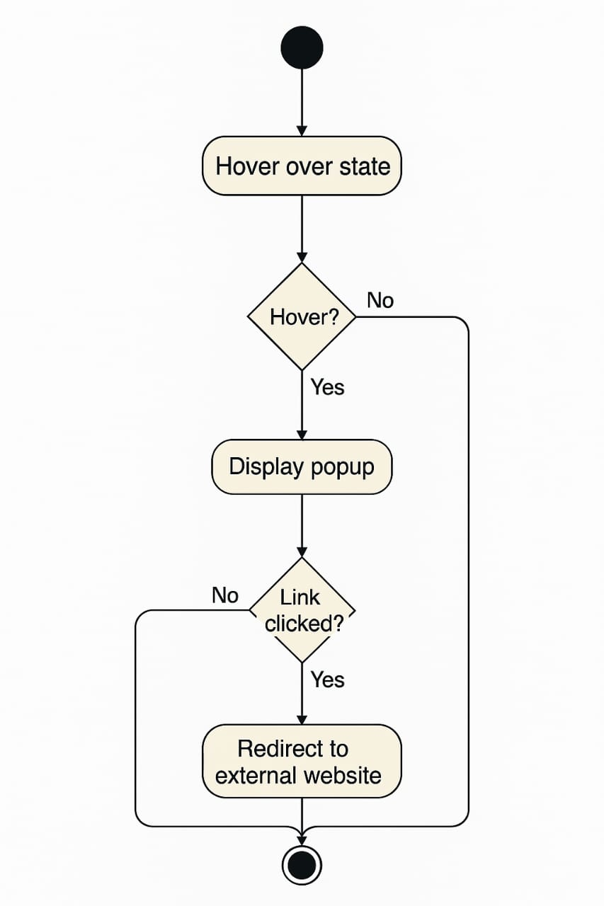
Fig4.5 activity diagram

The image is an activity diagram, which models the workflow of a user interacting with an interactive web map. It begins with the user action "Hover over state," which triggers the start of the activity flow. A decision node immediately checks whether the user is actually hovering over a state. If not, the process terminates or loops back. If the user is indeed hovering, the system proceeds to the next activity displaying a popup that contains relevant state information.

Another decision node follows to determine whether the user clicks a link in the popup. If no link is clicked, the system awaits further user interaction. If the link is clicked, the system carries out the final activity: redirecting the user to an external website. This activity diagram effectively visualizes conditional logic and user-driven navigation in a web application, making it easier to understand and communicate user interaction flows during the design and development stages.
4.2.5 DEPLOYMENT DIAGRAM

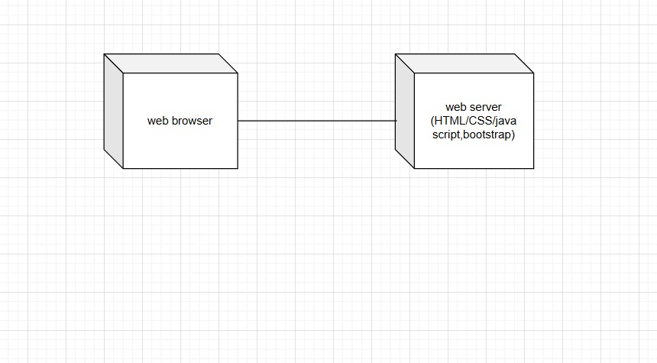
Fig4.6: deployment diagram

The development diagram illustrates a basic client-server architecture typically used in web development. It consists of two main components: a web browser (client side) and a web server (server side). The web browser represents the user's interface where requests are made to the web server for various resources. These resources can include web pages, styles, scripts, or other data. The interaction between the browser and the server usually happens over HTTP or HTTPS, where the browser sends requests, and the server responds with the appropriate content.

On the server side, the diagram specifies technologies like HTML, CSS, JavaScript, and Bootst
rap. These are standard front-end web development technologies. HTML structures the content of the webpage, CSS styles it, JavaScript adds interactivity, and Bootstrap offers responsive design components. The server hosts and serves these resources when requested by the browser. This architecture is foundational to modern web development and reflects the separation of concerns, where the browser handles user interaction and rendering, while the server delivers content and handles logic.

CHAPTER-5
IMPLEMENTATION
The implementation of the web-based interactive musical heritage system is based on a client-server architecture, ensuring a seamless and engaging user experience. Users access the application through their devices using a web browser, where they interact with an interactive India map designed using HTML, CSS, and JavaScript. The web server hosts the frontend, handling user requests such as selecting a state or exploring an instrument. When a user selects a region, the web server communicates with the main server, which manages the core application logic and backend services. This server processes user interactions and retrieves detailed information about musical instruments, accessing a backend database that stores structured data, including instrument names, descriptions, images, state-wise categorization, and audio samples. The backend is developed using Node.js, ensuring smooth data handling. During deployment testing, functionalities such as interactive popups, instrument selection, multimedia playback, and navigation are verified to ensure accurate content loading and responsiveness. This implementation bridges tradition with modern technology, providing students, researchers, musicians, and cultural enthusiasts an immersive digital experience to explore and appreciate India’s classical musical instruments through a centralized and accessible web platform. Let me know if you'd like adjustments

5.1 MODULE SPLITUP

1. User (Visitors) Module
Functionality:
• Visitors can access detailed information about Indian classical musical instruments, including types (string, wind, percussion), their history, and cultural significance.
• As users scroll through the instrument pages, they will discover associated musical genres, famous artists, and regional influences related to the specific instrument.

2. Admin Module
Functionality:
• The admin has full control over the website’s content and can upload or manage data related to musical instruments, artists, and associated genres.
• The admin can update images, descriptions, and other relevant data for each instrument, artist profile, or music type to keep the content fresh and accurate.
3. Server Module
Functionality:
• The server is responsible for handling all incoming user requests such as loading web pages, responding to scrolling behaviour, and dynamically displaying linked content (artists, genres, sound clips, etc.) as users interact with the site.
• The server ensures smooth navigation and fast page loading times, enabling a seamless user experience.
5.3 ALORITHM

STEP 1: Start
The algorithm begins with the initialization phase.
This is the starting point where the project setup begins, including the creation of a development environment, preparation of design and development tools, and defining the project’s scope and goals.

STEP 2: Define Project Scope
Title: Exploring India’s Culture and Heritage: Musical Instruments of India
Objective:
The goal is to create an interactive website where users can explore traditional Indian musical instruments categorized by region and type (string, wind, percussion). By selecting a region from an interactive India map, users will be directed to region-specific content showcasing local instruments, their historical relevance, and famous musicians.

This website is purely educational and informational, intended to spread awareness and appreciation for India’s rich musical heritage in a visually engaging and user-friendly way,

STEP 3: Load Interactive India Map
Action:
A central feature of the platform will be an interactive India map. Users can select a state or region to explore the unique musical instruments originating from that area.

Display:
The map will be built using an SVG (Scalable Vector Graphics) or a high-resolution, responsive image map, ensuring optimal performance across devices.

Hover and Popup:
Each state/region will be clickable, and hovering over it will trigger a popup showing the name and a brief musical heritage note or fact (e.g., “Kerala – Origin of Chenda”).

STEP 4: State/Region-Specific Instrument Page
Content Layout:
1. Traditional Instruments: Details and images of classical instruments from the selected region, including their origin, classification (string, wind, percussion), and construction.
2. Famous Musicians: Profiles of renowned artists associated with the instruments of that region.
3. Cultural Context: Information about how the instruments are used in classical performances, folk traditions, and regional festivals.

STEP 5: Admin Module
Admin Control:
The Admin Module will allow backend users to manage the site’s content. The CMS (Content Management System) will include:
1. Content Upload: Admins can upload images, audio clips, videos, and descriptions for instruments, artists, and regional stories.
2. Data Management: Easy editing and updating of content for each state/region, allowing the admin to revise artist bios, replace outdated images, or add newly recognized instruments.

STEP 6: Store and Manage Data
Database Design:
A structured relational database will be used to manage and retrieve content effectively.
1. Instrument Table: Stores data on each musical instrument—name, type, region, description, and image/audio links.
2. Artists Table: Contains artist names, bios, instruments played, region, awards, and profile images.
3. Region Table: Maps instruments and artists to specific Indian states or regions for organized retrieval and display.
STEP 7: Test and Launch
Testing:
1. Functionality Testing: Ensure that all clickable regions on the map correctly link to their respective content pages. Test hover/popup functionality.
2. Scroll Behavior: Verify dynamic content loading for instrument details, artist profiles, and cultural context as users scroll.
3. Responsive Design: Test responsiveness across all devices—smartphones, tablets, and desktops.
4. Database Integration: Ensure that queries accurately fetch instrument and artist data based on the selected region.

5.4 TECHNOLOGLES

1. HTML (Hypertext Markup Language)

• Purpose: HTML is the standard markup language used to structure content on the
website. It provides the framework for web pages by defining elements such as
headings, paragraphs, images, and links.
• Usage in Website:

HTML is used for structuring the wedding pages, destinations, and
cuisines. It defines the basic layout and organization of the content, ensuring all
information is correctly displayed.
2. CSS (Cascading Style Sheets)

• Purpose: CSS is used for styling the HTML content, dictating the visual presentation,
layout, and design of web pages.
• Usage in Website: CSS is employed to create a responsive design, making the website
adapt to different screen sizes.
3.JavaScript

• Purpose: JavaScript is a programming language that enables interactive elements and
dynamic content on the website.
• Usage in Website: JavaScript powers the interactive India map, allowing users to click
and hover over states to view wedding traditions, destinations, and cuisines.
1. Visual Studio Code (VS Code)
• Purpose: Visual Studio Code is a powerful source-code editor used for writing and
editing code. It provides an environment with features such as syntax highlighting,
debugging tools.
• Usage in Website: VS Code was used throughout the development process for coding
in HTML, CSS, and JavaScript.

CHAPTER-6
RESULTS

The project titled NADA ANVESHA is an interactive web-based educational tool designed to explore the diverse musical traditions of India, particularly focusing on traditional instruments across various Indian states. The application is structured in a multi-page format that provides a smooth and visually engaging journey for users.
1. Cover Page (Landing Screen)
The first image shows the cover page of the project with the title “NADA ANVESHA” prominently displayed in a stylish gradient font. A subtitle, “A Journey Through India’s Musical Landscape,” introduces the user to the theme of the project. The background is minimalistic with musical notes subtly embedded, adding to the thematic design. A large, vibrant button labeled “BEGIN EXPLORATION” is centrally placed to initiate user interaction. This screen acts as a gateway into the immersive exploration of India’s musical culture.
2. Interactive India Map (Main Page)
The second screen showcases a detailed map of India with each state clearly labeled and color-coded. When a user clicks on a state, an interactive card appears, providing information about the region's musical instruments. For example, in this instance, when Sikkim is selected, a pop-up card appears displaying the traditional instrument Damaru, along with an image and a short description. The text explains the cultural and spiritual importance of the Damaru in Hindu mythology, where it is associated with Lord Shiva. This interactivity makes the learning experience dynamic and intuitive.
3. State-Specific Detail Page
The third screen provides an in-depth view of a specific state's musical instruments—in this case, Sikkim. Titled “Sikkim's Traditional Musical Instruments,” the page elaborates on another traditional instrument called Surna. An image of the instrument is shown along with a detailed description, stating that the Surna is a wind instrument similar to the Shehnai, used in folk music, religious ceremonies, and festivals. Key features of the instrument are also included in a section below, highlighting its design and use.

6.1 SCREENSHOTS

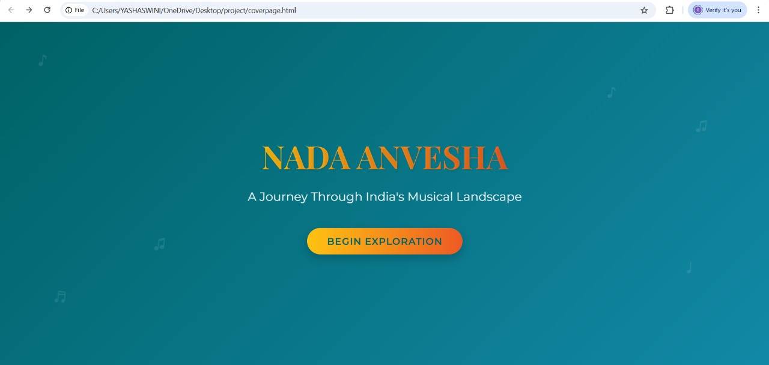

Fig6.1: cover page

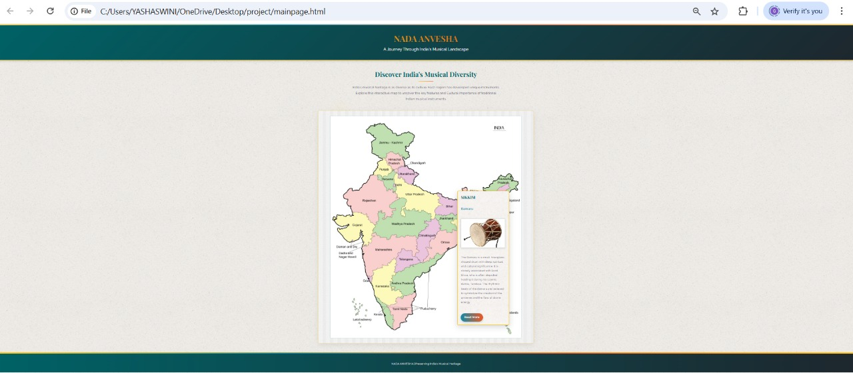

Fig6.2:interactive page

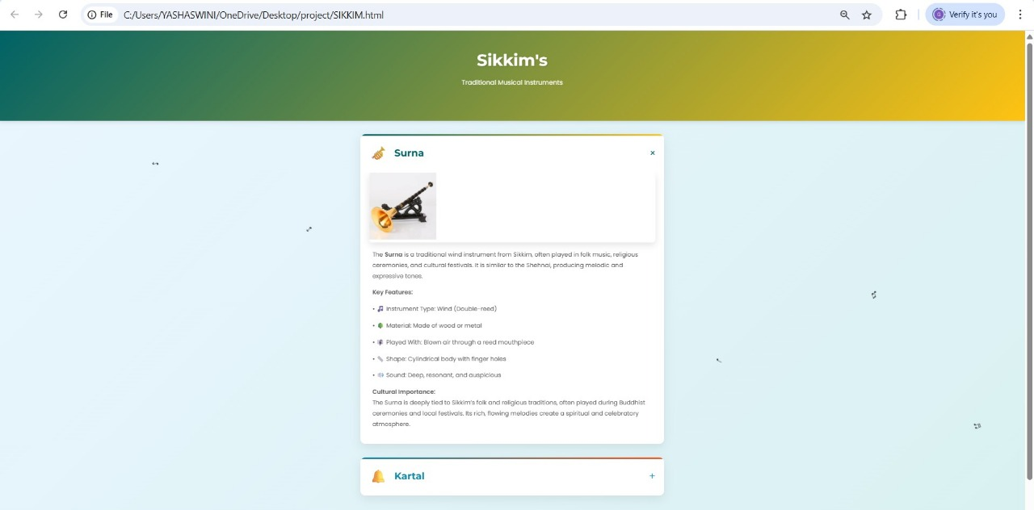
Fig6.3: state page
Chapter-7
TESTING

7.1. Unit Testing

Unit testing ensures individual components work correctly.
• Map Hover Interaction: Verify that hovering over a state displays the correct popup with the region name and a brief musical fact.
• State Click Interaction: Check that clicking a state opens the relevant page with information on regional musical instruments.
• Popup Display: Confirm that the popup accurately displays the state/region name and relevant heritage note.

7.2. Integration Testing

Integration testing ensures that all components work together seamlessly.
• Map Hover and Content Display: Hovering over a region should trigger the correct popup with musical heritage information.
• State Selection and Page Load: Clicking on a region should open the corresponding instrument-focused page with relevant content.
• Database Integration: Ensure that data for instruments and musicians is fetched correctly from the database and displayed on the correct regional page.

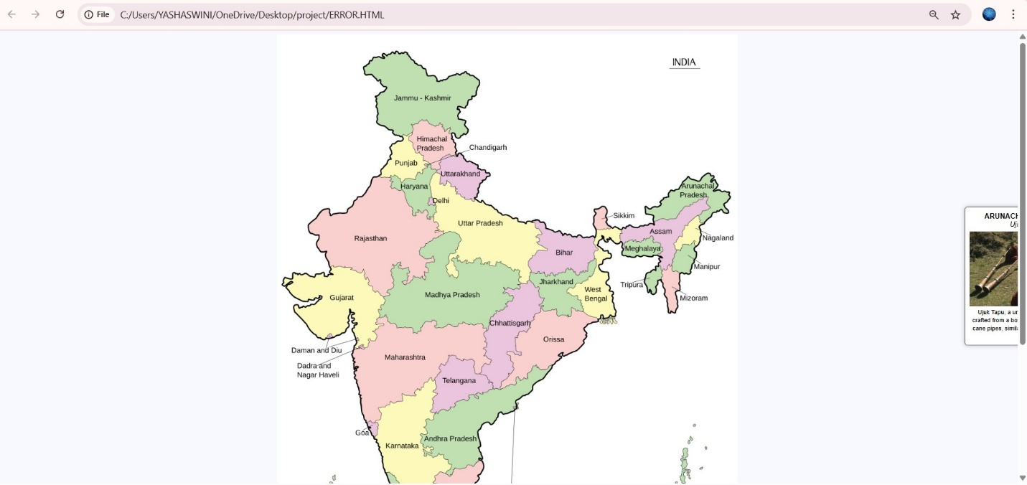

7Fig7.1: error

A test case for the issue where a pop-up appears outside the screen focuses on ensuring proper positioning and accessibility of interactive elements within the user interface. The scenario occurs when a user hovers over or clicks on a region within the interactive India map, triggering a pop-up with information about a musical instrument. However, due to improper alignment or screen limitations, the pop-up extends beyond the visible area, cutting off part of the text and preventing the user from reading the complete details. This issue impacts user experience and content accessibility, making the information difficult to interact with. The expected result is that the pop-up should automatically adjust its position, staying within the visible screen boundaries, regardless of where the interaction occurs. Solutions may involve CSS adjustments, dynamic positioning logic, or boundary detection to reposition the pop-up when near the screen's edges. By resolving this issue, the system ensures seamless navigation, readability, and usability, improving engagement with India's classical musical heritage.

CHAPTER 8
Conclusion
This project represents a significant step toward preserving and promoting India’s classical musical heritage through modern web technologies. By developing an interactive and immersive digital platform, the initiative effectively addresses the fragmentation and inaccessibility of information about classical musical instruments, creating a centralized and engaging learning experience for users. The integration of a scroll-interactive India map, hover-based popups, detailed instrument pages, and multimedia features such as audio samples and images ensures that users can explore India's musical traditions in an intuitive, structured, and visually appealing way.
The client-server architecture enables seamless communication between the frontend, backend, and database layers, ensuring dynamic content loading and responsiveness. Users can explore instruments state-wise, listen to their sounds, and understand their historical and cultural significance without needing to sift through scattered or text-heavy resources. The content management system (CMS) allows administrators to update and expand the database over time, making the platform scalable and adaptable to future developments. The use of responsive web design ensures accessibility across desktop, mobile, and tablet devices, increasing its reach among students, researchers, musicians, and general audiences.
Beyond education, this project serves a cultural preservation role, ensuring that lesser-known classical instruments are documented and promoted to a wider audience. By bridging traditional knowledge with interactive digital learning, this platform fosters appreciation and engagement with India’s rich musical heritage, inspiring future generations to explore, study, and celebrate the artistry of classical music. Ultimately, this initiative contributes to the documentation, promotion, and revitalization of India's musical legacy, ensuring it remains alive, accessible, and widely appreciated in the evolving digital era.

CHAPTER-10
REFERENCES:
- Indian Classical Music Instruments
- Musical Instruments of India
- 17 Traditional Indian Musical Instruments
- Wikipedia

CHAPTER 9
FUTURE ENHANCEMENT

1. User Reviews and Feedback System
One of the potential enhancements for the platform is the integration of a user review and feedback system. This feature would allow musicians, learners, and enthusiasts to rate and review different Indian musical instruments, brands, and local artisans. Such user-generated content would provide valuable insights for others, enhance the credibility of vendors, and create a more engaged community of users.

2. Interactive Learning Tools
To improve user engagement and learning outcomes, the platform could include interactive learning modules. These tools may offer step-by-step tutorials, video lessons, virtual instrument simulators, and real-time feedback systems for instruments like tabla, sitar, veena, mridangam, sarod, and bansuri. Incorporating features like progress tracking and certification could further motivate learners.

3. Integration of Instrument Makers and Sellers
Future iterations of the platform could feature a comprehensive directory of trusted instrument makers, sellers, and repair technicians, organized by region and instrument type. This would facilitate easy access to authentic instruments and promote traditional artisans and regional craftsmanship.

4. Real-Time Updates on Events and Trends
The system could be enhanced with real-time content updates related to Indian classical and folk music events, new music releases, workshops, artist interviews, and regional festivals. Users could subscribe to notifications or newsletters to stay informed about updates in their areas of interest.

5. Multi-Language Support
Given India’s linguistic diversity, offering content in regional languages such as Hindi, Tamil, Telugu, Bengali, Marathi, and Malayalam would significantly broaden the platform’s accessibility. This would allow users from different regions to learn and engage in their native languages, preserving cultural authenticity.

6. Virtual Demonstrations and Sound Libraries
The inclusion of a digital sound library with high-quality audio samples for each instrument would help users explore the unique tonal characteristics of different instruments. Virtual demonstrations by skilled artists could aid in understanding playing techniques and tonal dynamics before making a purchase or starting to learn.

7. Instrument Comparison and Custom Recommendations
An advanced tool that compares features, sound quality, prices, and user ratings of various instruments could guide users in choosing the most suitable instrument based on their skill level, budget, and musical interest. AI-based recommendation systems could suggest instruments and resources tailored to user preferences.

8. Cultural and Historical Archives
To preserve the rich legacy of Indian musical instruments, the platform could host a digital archive that includes the history, evolution, and cultural significance of various instruments across different regions of India. This could include written articles, documentary videos, and interviews with master musicians.

SAMPLE CODE

Html Sample code:
<!DOCTYPE html>
<html lang="en">
<head>
<meta charset="UTF-8">
<meta name="viewport" content="width=device-width, initial-scale=1.0">
<title>NADA ANVESHA - Exploring India's Musical Heritage</title>
<link href="https://fonts.googleapis.com/css2?family=Raleway:wght@400;600;700&family=Playfair+Display:wght@700&display=swap" rel="stylesheet">
<style>
:root {
--color1: #006266; /* Kerala Green */
--color2: #FFC312; /* Kerala Gold */
--color3: #1289A7; /* Kerala Blue */
--color4: #EE5A24; /* Kerala Orange */
--light-color: #f8f5f2;
--dark-color: #1e272e;
--text-color: #2f3640;
--text-light: #57606f;
}

* {
margin: 0;
padding: 0;
box-sizing: border-box;
}

body {
font-family: 'Raleway', sans-serif;
line-height: 1.6;
color: var(--text-color);
background-color: #fafafa;
background-image: url('https://www.transparenttextures.com/patterns/rice-paper.png');
}

header {
background: linear-gradient(135deg, var(--color1), var(--dark-color));
color: var(--light-color);
padding: 2.5rem 0;
text-align: center;
box-shadow: 0 4px 12px rgba(0,0,0,0.15);
border-bottom: 4px solid var(--color2);
position: relative;
overflow: hidden;
}

header::before {
content: "";
position: absolute;
top: 0;
left: 0;
right: 0;
height: 4px;
background: linear-gradient(90deg,
var(--color2),
var(--color3),
var(--color4),
var(--color2));
}

.header-content {
max-width: 1200px;
margin: 0 auto;
padding: 0 20px;
position: relative;
}

h1, h2, h3 {
font-family: 'Playfair Display', serif;
font-weight: 700;
}

h1 {
font-size: 2.8rem;
margin-bottom: 0.5rem;
background: linear-gradient(to right, var(--color2), var(--color4));
-webkit-background-clip: text;
background-clip: text;
color: transparent;
text-shadow: 1px 1px 2px rgba(0,0,0,0.1);
}

.tagline {
font-size: 1.3rem;
color: var(--light-color);
font-weight: 300;
letter-spacing: 0.5px;
}

.wrapper {
max-width: 1200px;
margin: 3rem auto;
padding: 0 20px;
position: relative;
min-height: 70vh;
}

.map-container {
position: relative;
background: white;
border-radius: 8px;
box-shadow: 0 8px 25px rgba(0,0,0,0.08);
padding: 25px;
margin: 30px 0;
border: 1px solid rgba(255, 195, 18, 0.3);
background-image: url('https://www.transparenttextures.com/patterns/crisp-paper-ruffles.png');
}

.map-container img {
display: block;
max-width: 100%;
height: auto;
margin: 0 auto;
position: relative;
z-index: 1;
border-radius: 4px;
border: 1px solid rgba(0, 98, 102, 0.1);
}

.tooltip {
position: absolute;
display: none;
background: white;
border: 2px solid var(--color2);
border-radius: 8px;
padding: 18px;
width: 280px;
box-shadow: 0 10px 30px rgba(0,0,0,0.15);
z-index: 100;
pointer-events: auto;
transition: all 0.3s cubic-bezier(0.175, 0.885, 0.32, 1.275);
background-image: url('https://www.transparenttextures.com/patterns/rice-paper-2.png');
}

.tooltip img {
width: 100%;
height: 160px;
object-fit: cover;
border-radius: 6px;
margin-bottom: 12px;
border: 1px solid rgba(0,0,0,0.1);
box-shadow: 0 3px 10px rgba(0,0,0,0.1);
}

.tooltip strong {
color: var(--color1);
font-size: 1.3rem;
display: block;
margin-bottom: 5px;
font-family: 'Playfair Display', serif;
}

.tooltip em {
color: var(--color3);
font-style: normal;
font-weight: 600;
display: block;
margin-bottom: 12px;
font-size: 1.1rem;
}

.tooltip small {
color: var(--text-light);
font-size: 0.95rem;
display: block;
margin-bottom: 15px;
line-height: 1.6;
}

.tooltip a {
display: inline-block;
margin-top: 8px;
padding: 10px 18px;
background: linear-gradient(to right, var(--color3), var(--color4));
color: white;
text-decoration: none;
border-radius: 30px;
font-size: 0.95rem;
transition: all 0.3s ease;
font-weight: 600;
letter-spacing: 0.5px;
box-shadow: 0 4px 10px rgba(18, 137, 167, 0.3);
}

.tooltip a:hover {
transform: translateY(-2px);
box-shadow: 0 6px 15px rgba(18, 137, 167, 0.4);
}

footer {
background: linear-gradient(to right, var(--color1), var(--dark-color));
color: var(--light-color);
text-align: center;
padding: 2rem 0;
margin-top: 3rem;
border-top: 4px solid var(--color2);
position: relative;
}

footer::before {
content: "";
position: absolute;
top: 0;
left: 0;
right: 0;
height: 4px;
background: linear-gradient(90deg,
var(--color2),
var(--color3),
var(--color4),
var(--color2));
}

.footer-content {
max-width: 1200px;
margin: 0 auto;
padding: 0 20px;
}

.copyright {
color: rgba(255,255,255,0.8);
font-size: 0.95rem;
margin-top: 1rem;
}

.intro-text {
text-align: center;
margin: 3rem 0;
padding: 0 20px;
}

.intro-text h2 {
font-size: 2.2rem;
color: var(--color1);
margin-bottom: 1.5rem;
position: relative;
display: inline-block;
}

.intro-text h2::after {
content: "";
position: absolute;
bottom: -10px;
left: 50%;
transform: translateX(-50%);
width: 80px;
height: 3px;
background: linear-gradient(to right, var(--color2), var(--color4));
border-radius: 3px;
}

.intro-text p {
max-width: 800px;
margin: 0 auto 1.5rem;
color: var(--text-light);
font-size: 1.1rem;
line-height: 1.8;
}

/* Kerala-inspired decorative elements */
.kerala-pattern {
position: absolute;
width: 150px;
height: 150px;
opacity: 0.05;
z-index: 0;
}

.pattern-1 {
top: 10%;
left: 5%;
background: radial-gradient(circle, var(--color2), transparent 70%);
}

.pattern-2 {
bottom: 15%;
right: 5%;
background: radial-gradient(circle, var(--color4), transparent 70%);
}

@media (max-width: 768px) {
h1 {
font-size: 2.2rem;
}

.tagline {
font-size: 1.1rem;
}

.tooltip {
width: 240px;
padding: 15px;
}

.intro-text h2 {
font-size: 1.8rem;
}

.kerala-pattern {
width: 100px;
height: 100px;
}
}
</style>
</head>
<body>

<header>
<div class="header-content">
<h1>NADA ANVESHA</h1>
<p class="tagline">A Journey Through India's Musical Landscape</p>
</div>
</header>

<div class="wrapper">
<!-- Kerala decorative patterns -->
<div class="kerala-pattern pattern-1"></div>
<div class="kerala-pattern pattern-2"></div>

<div class="intro-text">
<h2>Discover India's Musical Diversity</h2>
<p>India's musical heritage is as diverse as its culture. Each region has developed unique instruments. Explore this interactive map to uncover the key features and Cultural Importance of traditional Indian musical instruments.</p>
</div>

<div class="map-container">
<img src="C:\Users\YASHASWINI\OneDrive\Desktop\project\finalmap.jpg" usemap="#india" alt="Indian Map" id="indiamap1">

<map name="india">
<area shape="poly" coords="303,1063,287,1065,291,1073,293,1080,295,1088,295,1096,295,1104,300,1111,303,1118,306,1128,314,1132,319,1136,325,1140,327,1146,333,1146,332,1134,331,1125,332,1114,336,1108,334,1099,334,1088,334,1076,325,1073,320,1066,321,1060,317,1051,315,1040,312,1032,307,1028,303,1019,294,1016,286,1012,282,1005,273,999,263,992,256,984,248,978,243,975,243,983,247,990,251,998,255,1002,261,1009,266,1019,269,1025,271,1032,275,1040,281,1049,284,1062"
alt="KERALA"
data-instrument="Idakka"
data-image="c:\Users\YASHASWINI\OneDrive\Desktop\project\images\kerala.jpg"
data-description="This hourglass-shaped wonder from Kerala's temples produces melodic, voice-like tones by tightening its strings mid-play. Made of jackfruit wood and hide, it's the star of Kathakali and rituals, blending rhythm and melody magically."
data-link="c:\Users\YASHASWINI\OneDrive\Desktop\project\kerala.html" />
<!--2-->
<area shape="poly" coords="338,1102,303,1024,305,1031,311,1037,315,1044,319,1051,323,1056,323,1063,323,1075,328,1076,333,1073,337,1079,336,1088,335,1103,334,1098,341,1107,338,1112,334,1119,336,1130,336,1139,335,1147,342,1151,349,1151,356,1150,359,1149,310,1024,319,1024,326,1018,334,1018,341,1017,347,1014,353,1008,352,999,354,988,362,980,368,982,374,982,379,985,385,986,391,980,394,973,402,967,407,971,414,971,423,964,429,961,435,962,442,959,451,952,459,955,459,963,459,971,455,976,451,980,447,988,446,995,443,1002,436,1009,436,1016,435,1023,434,1028,431,1023,436,1034,437,1044,438,1053,439,1061,433,1070,440,1068,427,1070,419,1074,415,1082,410,1087,407,1093,404,1100,407,1105,402,1109,410,1111,395,1113,390,1115,382,1118,375,1122,375,1128,374,1136,338,1102,374,1137,360,1150,360,1151"
alt="TAMIL NADU"
data-instrument="Nadaswaram"
data-image="c:\Users\YASHASWINI\OneDrive\Desktop\project\images\tamil nadu.jpg"
data-description="Crowned as South India's Shehnai, this 2-foot-long fiery brass horn delivers earth-shaking melodies through its double reed (kendai). Temple processions and weddings tremble to its 120-decibel glory—it's the only instrument that can drown out a roaring crowd!"
data-link="TAMIL NADU.html">
<!--3-->
<area shape="poly" coords="271,924,219,898,221,889,223,878,224,866,226,858,230,849,231,839,239,831,245,830,251,825,258,824,263,821,272,817,279,815,283,808,291,807,297,807,304,805,308,797,310,803,315,794,323,792,328,782,335,778,340,770,346,775,351,778,354,783,354,789,351,798,355,803,351,811,348,817,348,825,344,831,341,838,342,845,349,845,350,851,347,857,339,857,334,861,335,870,331,875,333,882,333,890,325,890,321,895,323,899,321,906,320,914,323,921,328,919,336,919,343,922,345,928,343,933,337,929,327,927,328,932,331,939,337,939,345,942,351,943,356,939,364,937,370,939,374,944,379,949,382,955,386,961,388,967,383,973,378,979,369,979,363,979,358,983,355,987,351,994,348,1001,355,1005,351,1010,348,1014,342,1015,333,1017,324,1019,319,1021,309,1022,300,1018,294,1015,287,1011,279,1003,268,1000,263,991,257,985,249,980,242,972,238,962,235,952,235,943,235,933,227,920,223,911,219,903,229,927,219,899"
alt="KARNATAKA"
data-instrument="Saraswati Veena"
data-image="c:\Users\YASHASWINI\OneDrive\Desktop\project\images\karnataka.jpg"
data-description="Saraswati Veena, Karnataka's divine lute, features 7 strings & pumpkin resonators, delivering rich Carnatic melodies through intricate gamakas. Revered as Goddess Saraswati's instrument, maestros like Emani Sankara Sastry perfected its spiritual resonance."
data-link="KARNATAKA.html">
<!--4-->
<area shape="poly" coords="256,728,175,701,171,706,172,711,168,717,170,722,173,728,173,735,170,740,179,744,180,754,176,760,177,768,180,774,180,781,182,786,184,791,185,799,188,805,188,812,188,819,188,829,191,837,192,844,192,851,197,855,197,863,202,865,208,863,215,867,221,861,226,863,231,857,236,849,231,843,231,835,238,833,246,829,253,823,259,825,265,822,271,820,279,818,281,805,286,810,292,807,298,807,304,807,307,801,312,794,318,794,328,787,328,779,336,778,341,772,334,768,320,761,327,761,311,756,304,750,293,744,285,739,277,737,272,735,346,775,351,771,356,762,361,755,364,747,367,738,372,740,375,735,382,731,383,724,389,717,398,718,400,723,405,727,412,731,420,728,427,729,433,729,441,730,439,738,440,746,440,751,444,755,448,759,455,759,456,750,460,743,465,739,473,739,476,732,474,726,468,719,465,711,464,700,468,692,466,684,465,678,464,666,465,659,460,650,452,648,444,649,434,649,424,649,417,648,409,651,396,655,404,655,389,652,380,651,370,656,361,656,356,651,354,658,355,643,348,643,339,643,330,646,329,652,323,659,323,665,314,667,308,667,304,661,296,656,288,656,280,656,272,659,265,651,259,648,252,643,248,635,240,630,237,635,232,638,224,639,224,646,229,649,236,651,230,655,225,659,221,664,217,669,224,674,221,679,220,684,210,686,217,689,205,685,207,691,203,696,201,701,196,703,189,697,182,699,191,707"
alt="MAHARASHTRA"
data-instrument="Dholki"
data-image="c:\Users\YASHASWINI\OneDrive\Desktop\project\images\Dholki.png"
data-description="This small, mighty barrel drum fuels Lavani dances and powada ballads with its fast, hypnotic rhythms. Stretched leather heads on wooden shell deliver sharp taks (high pitch) and deep dhooms (bass). Played barehanded with lightning-fast rolls, it drives folk celebrations and wedding processions into frenzy."
data-link="MAHARASHTRA.html">
<!--5-->
<area shape="poly" coords="229,438,216,317,221,320,228,315,234,317,239,320,248,320,255,321,255,331,257,341,262,343,269,344,273,350,281,350,285,357,288,362,289,368,290,375,293,381,299,385,301,390,301,395,304,401,309,408,313,401,320,397,326,397,334,393,337,398,337,404,337,411,343,411,352,411,351,417,356,420,362,426,358,429,357,435,353,441,360,443,369,441,368,448,361,451,354,453,349,461,344,462,338,466,333,469,328,473,321,477,320,482,321,489,325,496,331,496,330,501,337,501,348,499,349,504,346,509,339,512,333,515,334,521,337,528,329,528,329,535,330,544,325,541,320,544,313,542,307,542,300,546,293,555,287,555,296,539,297,527,287,518,276,519,276,507,269,510,260,511,257,519,254,524,255,534,255,542,258,547,258,556,254,562,249,566,247,575,244,579,237,583,231,576,225,574,220,571,212,564,205,559,203,547,198,543,197,534,196,526,190,527,179,527,183,531,171,527,166,523,158,516,150,516,141,515,134,512,127,515,121,515,116,508,112,496,108,484,99,483,92,473,91,459,91,448,84,443,75,439,72,430,74,419,81,415,86,406,91,399,99,395,106,391,114,390,115,395,119,404,124,401,131,398,141,396,157,396,159,387,167,383,169,373,175,368,178,363,184,359,191,356,197,352,201,343,206,337,210,325,216,323"
alt="RAJASTHAN"
data-instrument="Ravanhatta"
data-image="c:\Users\YASHASWINI\OneDrive\Desktop\project\images\rajasthan.jpg"
data-description="Born from Ravana's grief (Ramayana's demon king), this ancient bowed instrument dates back over 3,000 years, making it possibly the world's first violin prototype. Rajasthan's Manganiyar and Langa communities have preserved its haunting legacy."
data-link="RAJASTHAN.html">
<!--6-->
<area shape="poly" coords="269,267,283,223,290,223,297,222,293,232,297,237,303,239,303,244,304,251,307,256,308,261,313,264,321,266,324,271,326,276,327,281,335,282,327,287,331,297,324,295,322,301,324,307,316,309,310,314,310,320,301,320,295,320,286,318,283,324,275,324,269,317,263,311,258,316,249,314,240,314,233,314,233,302,239,293,248,280,255,276,257,263,254,254,258,246,263,245,267,239,274,235,276,241,283,232"
alt="PUNJAB"
data-instrument="Tumbi"
data-image="c:\Users\YASHASWINI\OneDrive\Desktop\project\images\punjab.jpg"
data-description="This 8-inch wooden firecracker delivers stadium-level energy with just a single steel string stretched over a goat-skin resonator. Its piercing twang can shatter glass – and eardrums – when played at full throttle during Bhangra performances."
data-link="PUNJAB.html">
<!--7-->
<area shape="poly" coords="141,587,96,581,96,588,91,594,87,600,79,605,72,608,66,609,59,609,53,610,44,606,36,608,37,619,41,624,47,626,52,630,58,634,60,640,67,644,70,652,73,656,79,663,84,669,89,673,95,674,99,678,106,678,111,669,119,666,122,670,127,674,133,669,139,669,143,664,150,662,154,652,158,644,159,636,160,626,163,617,170,619,171,624,170,629,175,636,171,642,180,643,175,647,173,653,170,661,173,666,176,671,179,677,184,681,181,686,179,691,173,695,178,698,185,690,193,690,196,697,202,691,204,681,211,681,220,678,220,666,213,660,220,658,226,652,235,648,220,641,223,632,228,628,227,617,233,614,234,607,238,601,241,592,237,586,231,582,229,575,222,573,214,569,211,563,203,557,203,550,203,543,195,546,195,538,197,530,191,527,187,531,180,529,174,528,167,523,161,520,153,520,145,518,136,514,128,516,123,518,121,525,116,530,123,533,118,538,113,542,106,541,106,534,99,534,93,533,87,537,83,541,78,542,70,539,64,534,57,536,50,534,44,534,37,534,35,542,31,547,23,546,17,546,15,553,11,558,16,561,21,555,27,552,33,554,31,558,25,559,20,565,26,570,28,574,30,580,36,586,41,589,48,591,55,594,62,594,70,593,76,594,79,594,86,590,225,646"
alt="GUJARAT"
data-instrument=" Morchang"
data-image="c:\Users\YASHASWINI\OneDrive\Desktop\project\images\raj.jpg"
data-description="The Morchang, Rajasthan's beloved jaw harp, is a small but mighty instrument that packs a mesmerizing punch. Crafted from iron or brass, this tiny musical gem is held between the teeth while its flexible metal tongue is plucked to produce hypnotic clicks, buzzes, and rhythmic vibrations."
data-link="GUJARAT.html">
<!--8-->
<area shape="poly" coords= "711,578,657,579,652,578,671,561,667,565,659,567,654,570,650,575,691,548,695,542,704,538,707,532,709,526,712,520,715,512,714,504,708,499,709,492,713,486,717,479,712,476,709,470,707,463,711,457,715,448,715,437,720,437,726,436,732,435,741,435,750,433,755,430,762,433,768,440,768,447,767,453,767,462,760,468,755,470,750,463,747,455,743,459,738,456,735,465,730,458,727,448,725,455,720,461,717,466,719,473,724,478,727,482,734,486,742,486,746,492,744,498,740,502,734,502,728,503,727,510,721,514,720,521,723,528,731,532,737,534,739,543,737,549,737,557,742,564,741,570,748,576,751,582,750,589,751,597,751,606,754,614,759,622,756,627,751,633,744,629,740,634,730,635,730,629,725,627,723,633,719,638,715,632,709,633,702,630,695,628,687,624,683,619,684,611,679,603,679,597,675,589,670,582,664,582,657,583,678,558,652,578,659,571,683,553"
alt="WEST BENGAL"
data-instrument="Dotara"
data-image="c:\Users\YASHASWINI\OneDrive\Desktop\project\images\west bengal.jpg"
data-description="A rustic four-stringed lute with a deep wooden belly and a distinctive twang, the Dotara is the heartbeat of Bengal’s wandering minstrels. Its name means two strings (do-tara)"
data-link="WEST BENGAL.html">
<!--9-->
<area shape="poly" coords="636,486,595,482,590,483,579,484,575,489,571,496,566,500,562,509,564,517,567,526,571,534,578,536,583,531,591,535,598,538,604,538,614,534,624,536,632,532,639,531,646,528,650,521,656,522,663,526,667,530,673,535,679,530,687,529,692,526,692,518,696,513,700,507,707,503,711,496,711,489,715,483,714,475,711,470,707,462,709,455,704,451,699,453,691,453,683,451,677,449,671,451,661,451,655,446,646,446,639,449,633,441,626,436,619,440,614,438,606,434,601,429,597,421,590,419,583,415,576,415,569,420,575,422,578,431,584,437,591,439,589,446,583,447,578,451,584,458,581,467,587,471,594,475,601,483"
alt="BIHAR"
data-instrument="Dholak"
data-image="c:\Users\YASHASWINI\OneDrive\Desktop\project\images\bihar.jpg"
data-description="This double-headed barrel drum, with its high-pitched tikka (right side) and bassy dhum (left side), is Bihar’s ultimate rhythm machine. Made of mango wood and goat skin, its versatile beats power everything from wedding processions to folk dances like Jat-Jatin and Jhijhiya."
data-link="BIHAR.html">
<!--10-->
<area shape="poly" coords="468,445,435,368,432,369,425,370,419,368,414,364,408,361,403,356,399,348,395,341,389,338,384,332,380,326,379,336,372,339,366,335,363,327,363,317,357,309,351,312,346,319,343,328,341,336,343,346,343,352,347,361,350,369,351,375,355,383,355,390,355,397,351,403,351,410,352,420,359,422,361,430,359,434,354,440,360,444,367,441,372,445,378,441,386,441,394,441,401,445,407,450,411,457,407,464,404,471,401,476,399,485,395,489,388,489,386,496,384,506,382,514,381,520,381,527,383,534,387,541,394,542,401,542,403,536,403,529,400,525,397,520,395,515,394,509,394,499,402,497,402,504,409,506,417,505,422,506,425,512,434,512,440,503,448,501,455,501,457,509,463,509,471,511,475,515,482,516,487,513,492,507,499,509,504,515,514,517,520,523,528,524,534,524,539,529,539,539,542,546,545,554,552,556,561,553,565,548,566,544,566,533,566,525,562,517,562,510,565,502,568,497,574,492,579,487,585,482,592,480,599,482,593,473,585,471,579,463,585,459,579,452,583,446,591,445,587,437,579,434,578,429,573,423,567,418,560,418,555,421,547,420,541,419,535,413,529,408,521,405,512,401,503,397,493,393,484,389,481,385,474,378,464,377,459,370,452,373,445,369,435,368"
alt="UTTAR PRADESH"
data-instrument="Shehnai"
data-image="c:\Users\YASHASWINI\OneDrive\Desktop\project\images\utterpradesh.jpg"
data-description="Crafted from aged bamboo with a strategic 7-9 finger hole arrangement, capped by a flaring brass bell for resonance. The double reed (kandi), made from palmyra leaves, vibrates to create its piercing yet prayerful sound."
data-link="UTTAR PRADESH.html">
<!--11-->
<area shape="poly" coords= "503,783,510,779,502,774,511,769,519,762,508,789,515,786,525,783,529,778,533,771,538,767,543,774,550,771,555,769,523,733,523,757,527,750,527,743,523,736,510,788,507,787,561,759,567,746,525,718,576,739,587,745,567,750,523,715,515,715,515,707,524,709,531,713,539,713,540,706,535,702,534,691,534,683,539,674,540,666,546,663,552,662,559,662,563,655,568,647,571,639,574,630,581,622,586,624,588,617,597,618,604,619,612,617,623,616,626,623,630,630,636,630,643,631,650,632,655,624,657,614,664,615,668,622,675,620,683,621,689,626,698,629,703,632,712,636,715,641,707,646,699,648,693,649,687,654,686,662,687,668,689,673,687,678,685,685,680,692,674,700,671,704,666,709,661,711,655,712,649,715,644,718,638,712,629,712,629,718,635,722,631,728,623,733,619,735,614,738,607,740,604,745,597,745,528,720,523,724,500,790,531,725,522,784,577,746,528,729,567,746"
alt="ODISHA"
data-instrument="Mardala"
data-image="c:\Users\YASHASWINI\OneDrive\Desktop\project\images\odisa.jpg"
data-description="This double-reed temple trumpet – crafted from seasoned wood with a flaring brass bell – announces divine moments at Puri’s Jagannath Temple with its piercing, celebratory blasts. Its metallic yet melodic voice carries over roaring crowds during the Rath Yatra, guiding lakhs of devotees like a sonic lighthouse."
data-link="ODISHA.html">
<!--12-->
<area shape="poly" coords="411,880,389,833,401,820,396,833,395,826,408,816,417,816,427,815,431,804,438,805,443,810,449,807,453,800,459,800,467,797,477,792,484,789,495,789,503,792,511,787,520,780,529,780,534,774,536,770,542,768,551,766,559,766,562,756,568,748,577,743,584,743,589,748,597,748,604,744,611,740,610,746,604,752,600,757,597,763,592,766,586,770,580,772,575,776,571,780,571,787,571,792,562,803,564,799,552,804,548,809,541,812,535,815,532,821,533,827,533,832,528,836,523,840,515,842,507,844,496,843,491,848,488,854,486,860,482,864,476,869,467,864,459,867,454,872,451,878,449,884,447,892,447,897,451,904,454,910,451,918,450,924,452,932,456,940,456,947,448,948,443,952,440,958,433,961,427,961,420,965,411,968,402,968,395,976,386,982,378,980,383,970,387,964,383,956,384,949,376,944,372,940,367,940,356,940,346,940,339,936,331,938,327,929,335,930,343,930,346,926,339,920,331,920,323,916,321,906,322,896,329,893,337,888,331,880,335,872,333,865,341,860,349,857,351,849,363,843,372,838,383,839,391,837"
alt="ANDHRA PRADESH "
data-instrument="Thalam"
data-image="c:\Users\YASHASWINI\OneDrive\Desktop\project\images\ap.jpg"
data-description="A pair of handheld bronze cymbals (6-8 inches diameter) played by clashing together, producing bright, metallic rhythms that guide Carnatic music and dance."
data-link="ANDHRA PRADESH.html">
<!--13-->
<area shape="poly" coords="376,585,325,548,322,543,315,545,306,542,303,546,306,542,298,553,291,557,282,559,280,554,286,551,289,545,292,536,297,528,291,520,284,523,276,525,273,519,275,513,270,510,264,513,259,518,256,526,255,537,255,544,261,550,258,558,256,566,250,569,247,574,251,578,247,582,238,584,239,593,240,601,235,606,231,615,227,620,227,630,223,637,231,634,237,632,242,630,247,636,250,641,258,646,262,650,269,655,275,657,283,657,292,657,297,657,303,661,309,668,316,666,321,662,323,655,327,652,328,646,335,646,342,643,347,639,355,639,355,645,355,654,361,654,367,654,373,653,379,650,387,650,393,651,399,653,407,648,414,646,424,646,430,650,438,650,443,648,451,647,456,651,462,656,468,658,471,652,472,643,477,634,484,630,488,626,493,621,498,619,505,613,514,610,515,604,520,597,525,593,527,586,520,584,513,579,504,577,505,570,514,568,523,568,531,572,539,570,544,565,538,559,547,557,540,551,540,545,540,539,541,531,536,526,527,525,519,521,511,517,505,514,499,510,491,508,489,514,484,518,478,518,476,510,470,510,463,510,456,510,453,501,444,500,439,509,431,510,426,513,423,506,419,510,415,510,409,506,402,506,404,498,396,500,392,505,395,511,398,521,402,531,402,540,397,542,389,541,385,539,389,541,382,532,381,524,378,519,383,514,385,509,383,498,387,492,395,488,399,484,403,477,405,473,405,464,411,458,410,452,406,450,403,447,398,443,391,443,383,442,375,442,371,450,363,451,357,456,350,458,343,463,337,468,330,474,323,478,319,484,319,493,325,496,332,498,339,500,348,500,351,508,345,510,337,511,331,515,334,525,338,533,332,536,330,550,331,553,331,550"
alt="MADHYA PRADESH"
data-instrument="Dhol"
data-image="c:\Users\YASHASWINI\OneDrive\Desktop\project\images\madhapradesh.webp"
data-description="This large double-headed barrel drum, crafted from mango wood and stretched goat skin, unleashes electrifying rhythms with its deep dhum (bass side) and sharp tak (treble side). Played with curved wooden sticks, its pulsating beats command dancers in Gaur dances, Bhagoria revelry, and Banjara weddings."
data-link="MADHYA PRADESH.html">
<!--14-->
<area shape="poly" coords="863,440,848,423,835,424,827,424,818,425,813,428,806,429,797,430,788,428,782,428,776,432,767,436,767,443,765,451,765,461,770,464,773,472,779,465,784,460,791,460,801,459,811,460,818,460,824,455,831,455,838,455,842,459,844,464,852,464,857,472,861,480,857,488,852,493,859,497,851,500,855,507,851,512,856,517,859,524,867,526,872,520,878,517,883,510,884,502,888,495,891,488,892,481,890,474,887,463,892,457,899,452,905,448,907,439,911,432,916,427,927,412,921,420,935,406,940,403,945,396,955,394,965,388,963,380,960,374,963,364,955,363,952,380,951,367,942,368,935,373,928,380,923,382,917,383,909,388,903,394,900,400,895,404,888,412,882,415,875,412,866,412,859,412,853,416,847,420,843,423"
alt="ASSAM"
data-instrument="Pepa"
data-image="c:\Users\YASHASWINI\OneDrive\Desktop\project\images\asam.jpg"
data-description="The Pepa is a traditional wind instrument from Assam, made from a buffalo horn and played during Bihu celebrations. It is a symbol of Assamese culture, producing vibrant and energetic melodies.
"
data-link="ASSAM.html">
<!--15-->
<area shape="poly" coords="812,478,801,460,794,460,788,462,780,464,776,470,773,477,769,483,769,489,775,494,783,497,789,497,796,498,802,495,811,496,819,492,827,494,835,496,841,494,849,491,858,486,860,482,856,475,856,468,850,465,843,466,841,456,833,453,828,457,821,458,811,460,803,461"
alt="MEGHALAYA"
data-instrument="Bamboo Flute"
data-image="c:\Users\YASHASWINI\OneDrive\Desktop\project\images\megalaya.jpg"
data-description="Handcrafted from mature bamboo harvested in Meghalaya’s forests, this flute’s haunting melodies mimic mountain streams and rustling pines. Played vertically like a recorder, its 5-6 finger holes produce pentatonic scales perfect for Khasi love ballads (phawar) and harvest celebrations."
data-link="MEGHALAYA.html">
<!--16-->
<area shape="poly" coords="907,505,899,483,892,482,888,489,888,498,882,507,881,515,883,523,886,531,895,531,903,532,912,534,919,535,924,531,925,522,926,515,932,510,932,503,935,497,938,490,935,483,934,475,934,466,929,461,923,467,916,470,910,470,904,475,900,485"
alt="MANIPUR"
data-instrument="Pena"
data-image="c:\Users\YASHASWINI\OneDrive\Desktop\project\images\manipir.jpeg"
data-description="This ancient single-stringed instrument, crafted from a bamboo bow and coconut shell resonator, produces hauntingly beautiful melodies that accompany Manipur’s sacred rituals and epic ballads."
data-link="MANIPUR.html">
<!--17-->
<area shape="poly" coords= "920,446,903,451,897,455,891,460,887,469,891,477,897,482,903,476,906,471,913,470,920,470,924,468,928,465,933,462,933,472,939,473,940,466,943,462,945,454,947,447,947,440,943,433,947,428,955,425,949,421,943,415,941,406,935,408,931,413,923,416,919,424,914,430,908,436,907,452,907,448"
alt="NAGALAND"
data-instrument="Tati"
data-image="c:\Users\YASHASWINI\OneDrive\Desktop\project\images\arunachal.p.webp"
data-description="These massive hollowed-out tree trunks (often teak or jackfruit wood) are Naga culture’s ultimate symbol of unity. Carved with tribal motifs, their deep boom-boom echoes can travel 10+ km across valleys to announce festivals, wars, or village meetings."
data-link="NAGALAND.html">
<!--18-->
<area shape="poly" coords="877,561,863,566,858,550,858,542,859,533,863,523,871,523,878,517,883,520,886,528,891,531,899,533,899,540,899,550,897,561,897,572,891,575,891,583,893,592,893,598,895,606,891,614,887,623,879,619,872,622,872,612,871,605,871,595,868,585,864,577,861,557,865,567"
alt="MIZORAM"
data-instrument="Khuang"
data-image="c:\Users\YASHASWINI\OneDrive\Desktop\project\images\mizoram.jpg"
data-description="This hollow log drum, carved from a single piece of Indian laurel or teak wood and topped with stretched animal hide (usually barking deer or goat), is the soul of Mizo festivals. Played with bare hands or bamboo sticks, its deep dhum-dhum rhythms command dancers during Cheraw (Bamboo Dance) and church processions."
data-link="MIZORAM.html">
<!--19-->
<area shape="poly" coords= "925,355,875,351,873,359,867,364,861,367,858,375,854,382,847,383,841,384,835,388,827,387,823,387,823,395,823,402,829,403,836,405,840,411,841,420,849,417,856,415,863,413,871,412,879,412,888,411,895,405,900,398,903,391,911,387,919,383,927,379,934,375,941,368,951,366,960,363,960,371,960,380,965,385,962,391,955,395,949,397,944,400,941,408,943,417,953,419,959,412,965,411,971,408,972,402,978,399,987,393,993,393,999,397,1007,396,1003,387,1002,380,1005,371,1009,365,1011,355,1003,352,995,349,986,347,979,351,979,342,984,335,979,326,976,330,969,327,975,321,971,315,966,310,957,310,953,315,948,319,946,328,940,327,931,325,923,324,918,319,913,323,907,327,902,335,898,339,897,345,892,349,878,351,885,350"
alt="ARUNACHAL PRADESH"
data-instrument="Ujuk Tapu"
data-image="c:\Users\YASHASWINI\OneDrive\Desktop\project\images\Musical-Arunachal-Pradesh.jpg"
data-description="Ujuk Tapu, a unique wind instrument crafted from a bottle gourd with attached cane pipes, similar to a snake charmer's flute."
data-link="ARUNACHAL PRADESH.html">
<!--20-->
<area shape="poly" coords="721,410,707,408,707,416,704,427,710,433,717,435,725,437,732,436,738,435,747,430,740,423,735,420,737,414,736,407,738,399,736,390,733,384,728,386,719,388,711,392,710,401,707,407"
alt="SIKKIM"
data-instrument="Damaru"
data-image="c:\Users\YASHASWINI\OneDrive\Desktop\project\images\sikkim.jpg"
data-description="The Damaru is a small, hourglass-shaped drum with deep spiritual and cultural significance. It is closely associated with Lord Shiva, who is often depicted holding it during his cosmic dance, Tandava. The rhythmic beats of the damaru are believed to symbolize the creation of the universe and the flow of divine energy"
data-link="SIKKIM.html">
<!--21-->
<area shape="poly" coords="212,876,207,885,210,888,212,896,218,900,223,896,224,889,225,880,223,872,221,865,214,867,207,862,198,864,199,872,207,885,203,877"
alt="GOA"
data-instrument="Ghumot"
data-image="c:\Users\YASHASWINI\OneDrive\Desktop\project\images\goa.jpg"
data-description="It is a traditional percussion instrument made from an earthen pot with a drum membrane, originally crafted from monitor lizard skin (though now replaced with other materials). The Ghumot is deeply embedded in Goan folk and temple music and was officially declared Goa’s heritage instrument in 2019"
data-link="GOA.html">
<!--22-->
<area shape="poly" coords="395,716,387,718,383,723,382,730,375,737,368,735,365,742,359,768,352,779,356,791,355,799,347,824,346,839,357,846,374,837,389,833,403,815,423,814,440,805,447,809,455,801,466,794,479,788,479,773,466,760,453,758,445,758,442,748,438,737,436,726,424,726,415,728,408,722,401,722,176,695,183,698,191,697,201,696,208,690,208,686,218,687,226,681,228,674,220,665,229,659,234,656,242,654,241,643,233,642,225,644,228,637,238,636,243,633,250,647,260,651,275,660,284,660,295,659,301,666,310,672,319,669,327,662,326,658,331,651,335,647,343,643,351,643,350,648,361,660,371,659,380,655,387,650,396,658,405,655,410,646,419,646,427,652,435,653,443,654,451,651,456,654,463,658"
alt="TELANGANA"
data-instrument="Tabla"
data-image="c:\Users\YASHASWINI\OneDrive\Desktop\project\images\adharapradesh.webp"
data-description="This circular frame drum – stretched with taut goat skin and mounted on a wooden hoop – unleashes electrifying rhythms with just two bamboo sticks. Its deep, resonant dhum-dhum-tak beats are the driving force behind Bathukamma dances, Bonalu processions and tribal storytelling traditions across Telangana."
data-link="TELANGANA.html">
<!--23-->
<area shape="poly" coords="308,342,339,290,343,294,345,299,351,301,352,306,349,311,345,314,343,319,341,326,340,334,343,342,343,349,343,357,341,362,339,369,337,378,343,378,346,382,351,385,351,392,350,398,346,402,339,403,335,396,329,391,323,396,315,389,311,395,304,401,305,385,299,380,291,375,287,363,284,351,279,347,270,347,263,341,255,341,258,334,255,327,254,316,261,314,272,321,278,323,287,322,293,321,303,321,311,316,316,307,320,310,323,303,329,295,335,284,333,301"
alt="HARYAHNA"
data-instrument="Been"
data-image="c:\Users\YASHASWINI\OneDrive\Desktop\project\images\haryana.jpg"
data-description="The Been, also known as Pungi, is a traditional wind instrument from India, famously associated with snake charmers. It has a distinctive, hypnotic sound and is deeply rooted in folk traditions."
data-link="HARYAHNA.html">
<!--24-->
<area shape="poly" coords="411,313,357,300,361,300,354,305,358,313,364,319,366,329,371,335,378,339,379,331,386,334,391,340,399,343,401,352,407,358,413,361,419,366,427,369,435,372,443,369,446,364,449,358,450,352,452,346,453,337,459,328,463,323,469,319,475,313,470,308,464,301,457,301,448,297,445,291,438,286,430,285,421,280,416,275,413,269,407,265,403,269,395,269,387,268,379,269,371,272,361,289,365,282,357,300,364,301,363,300"
alt="UTTARAKHAND"
data-instrument="Damru"
data-image="c:\Users\YASHASWINI\OneDrive\Desktop\project\images\utter khand 2.jpg"
data-description="The Damru is an hourglass-shaped drum associated with Lord Shiva and spiritual rituals. Played by shaking, creating rhythmic beats with striking beads."
data-link="UTTARAKHAND.html">
<!--25-->
<area shape="poly" coords= "339,142,343,94,351,94,356,98,359,102,366,102,372,101,380,96,384,90,390,88,399,88,407,90,415,89,424,89,435,90,439,94,444,97,447,102,451,106,449,113,445,118,443,124,442,132,435,134,431,139,425,144,425,150,420,154,419,160,407,158,401,161,402,168,407,171,403,174,403,180,403,186,411,190,418,193,418,199,419,205,424,210,423,218,417,221,411,225,404,227,391,217,387,206,380,206,376,211,371,203,368,198,362,194,357,198,349,201,338,195,334,190,326,190,320,191,312,196,303,198,303,207,300,214,298,222,287,220,279,222,273,223,265,222,262,213,251,207,241,202,231,198,223,192,224,186,224,175,225,164,225,155,225,143,230,130,239,123,244,113,231,106,230,95,221,96,215,89,205,84,198,83,196,70,203,59,210,56,215,50,223,49,230,54,238,53,239,44,245,49,248,42,256,41,263,41,270,42,276,44,286,43,295,48,301,57,307,61,314,67,323,70,327,78,331,85,337,89,354,122,341,119,339,90,340,111"
alt="JAMMU AND KASHMIR"
data-instrument="Santoor"
data-image="c:\Users\YASHASWINI\OneDrive\Desktop\project\images\jk.jpg"
data-description="The Santoor is a mesmerizing string instrument, deeply rooted in Kashmiri folk and classical music. It is a trapezoid-shaped hammered dulcimer, played by striking its 100 strings with lightweight wooden mallets called mezrab"
data-link="JAMMU AND KASHMIR.html">
<!--26-->
<area shape="poly" coords="348,239,323,190,330,190,336,194,339,198,345,199,351,201,358,200,364,197,366,202,369,206,372,210,374,214,378,207,383,214,383,220,388,222,389,228,391,234,394,240,399,246,397,251,398,256,396,263,394,270,388,267,382,266,373,266,367,270,364,277,363,282,359,288,363,294,359,298,349,295,343,286,338,282,327,278,325,268,320,262,313,260,306,250,303,240,297,236,299,225,303,219,304,206,311,201,313,201,319,196,325,194"
alt="HIMACHAL PRADESH"
data-instrument=" Ransingha"
data-image="c:\Users\YASHASWINI\OneDrive\Desktop\project\images\hp.jpg"
data-description="The Ransingha is a traditional wind instrument from India and Nepal, known for its distinctive curved shape and powerful, resonant sound. It has been used for centuries in martial music, religious ceremonies, and folk traditions."
data-link="HIMACHAL PRADESH.html">
<!--27-->
<area shape="poly" coords= "512,660,536,672,541,666,532,685,532,693,532,698,536,706,543,713,539,717,532,715,526,712,520,707,514,713,519,717,523,722,522,730,527,738,528,748,526,754,521,758,518,766,511,770,506,773,503,778,505,783,503,789,497,791,490,790,484,791,481,784,480,777,475,778,471,774,468,766,463,763,456,758,458,752,459,745,463,740,470,740,476,733,477,726,471,721,464,718,467,711,463,703,468,698,467,690,467,681,464,675,463,667,468,660,473,650,475,642,477,632,484,629,491,621,499,617,507,614,515,608,512,598,519,598,525,592,527,586,522,583,518,582,511,578,504,577,508,568,514,566,519,569,526,569,533,568,539,567,542,558,549,555,555,555,561,551,567,551,570,556,576,562,583,565,584,573,585,580,587,585,594,590,594,598,590,602,594,607,590,614,587,622,581,626,575,631,573,638,569,645,565,652,563,658,559,662,554,662,547,664,534,680"
alt="CHHATTISGARH"
data-instrument="Nagara"
data-image="c:\Users\YASHASWINI\OneDrive\Desktop\project\images\chattis.jpg"
data-description="The Nagara is a traditional percussion instrument widely used in Indian folk music, temple rituals, and festive celebrations. It is a large kettledrum, played with sticks to produce deep, resonant beats."
data-link="CHHATTISGARH.html">
<!--28-->
<area shape="poly" coords="837,544,850,517,846,522,841,527,833,530,826,532,823,540,819,547,819,553,820,559,824,564,826,572,827,579,832,573,836,579,843,579,847,573,848,565,851,558,853,549,859,543,860,536,859,533,859,528,858,521,854,515"
alt="TRIPURA"
data-instrument="Sarinda"
data-image="c:\Users\YASHASWINI\OneDrive\Desktop\project\images\tripura.jpg"
data-description="The Sarinda is a traditional bowed string instrument, widely used in folk music across North and Eastern India, Pakistan, and Nepal. It has a hollow wooden body, partially covered with animal skin, and produces deep, resonant tones."
data-link="TRIPURA.html">
<!--29-->
<area shape="poly" coords="623,571,564,546,564,539,568,532,575,532,583,532,591,534,595,533,599,538,607,538,616,534,623,538,626,534,635,532,643,529,648,523,657,523,664,529,668,534,675,534,681,530,690,530,692,524,694,515,697,509,703,506,708,500,711,505,713,512,713,518,711,525,707,532,703,537,696,543,692,550,686,553,680,554,674,556,669,558,666,563,662,566,655,566,650,569,647,578,651,581,657,582,663,583,670,584,671,590,678,592,679,599,679,606,683,611,683,618,676,618,671,621,666,614,659,612,655,618,656,626,651,632,644,629,636,630,627,629,623,621,623,613,615,615,607,616,601,618,593,615,595,606,587,603,592,594,595,586,587,584,586,578,585,571,580,565,574,558,566,547,572,550"
alt="JHARKHAND"
data-instrument="Banam"
data-image="c:\Users\YASHASWINI\OneDrive\Desktop\project\images\jharkand.jpg"
data-description=" The Banam is a traditional bowed string instrument, deeply rooted in the Santhal tribal culture of Jharkhand. It is a folk fiddle, meticulously carved from a single piece of wood, often shaped to resemble a human figure."
data-link="JHARKHAND.html">
</map>

<div id="tooltip" class="tooltip"></div>
</div>
</div>

<script>
document.addEventListener('DOMContentLoaded', function () {
const tooltip = document.getElementById('tooltip');
const areas = document.querySelectorAll('area');
let hideTimeout;

areas.forEach(area => {
area.addEventListener('mouseenter', (e) => {
const coords = area.coords.split(',').map(coord => parseInt(coord));
const xs = coords.filter((c, i) => i % 2 === 0);
const ys = coords.filter((c, i) => i % 2 === 1);

const centerX = Math.min(...xs) + (Math.max(...xs) - Math.min(...xs)) / 2;
const centerY = Math.min(...ys) + (Math.max(...ys) - Math.min(...ys)) / 2;

const state = area.alt;
const instrument = area.dataset.instrument;
const image = area.dataset.image;
const description = area.dataset.description;
const link = area.dataset.link || "#";

tooltip.innerHTML = `
<strong>${state}</strong><br>
<em>${instrument}</em><br>
<img src="${image}" alt="${instrument}"><br>
<small>${description}</small><br>
<a href="${link}" target="_blank">Read More</a>
`;

tooltip.style.display = 'block';
tooltip.style.left = (centerX + 20) + 'px';
tooltip.style.top = (centerY + 20) + 'px';

clearTimeout(hideTimeout);
});

area.addEventListener('mouseleave', () => {
hideTimeout = setTimeout(() => {
tooltip.style.display = 'none';
}, 300);
});
});

tooltip.addEventListener('mouseenter', () => {
clearTimeout(hideTimeout);
});

tooltip.addEventListener('mouseleave', () => {
tooltip.style.display = 'none';
});
});
</script>
<footer>
<div class="footer-content">
<p class="copyright"> NADA ANVESHA | Preserving India's Musical Heritage</p>
</div>
</footer>

</body>

