Stress Detection using Machine Learning through Wearable Devices

Gorisha Babbar  
 Computer Science & Engineering  
 Graphic Era University  
 Dehradun, Uttarakhand, India  
 [babbargaurisha@gmail.com](mailto:babbargaurisha@gmail.com)

Dr. Prabhdeep Singh  
 Computer Science & Engineering  
 Graphic Era University  
 Dehradun, Uttarakhand India  
[ssingh.prabhdeep@gmail.com](mailto:ssingh.prabhdeep@gmail.com)

ABSTRACT

Stress is a widespread problem that has significant impacts on one's physical and mental well-being. It has been connected to a number of chronic illnesses, including depression, anxiety, and cardiovascular disorders. Preventing and controlling stress early on is essential to preserving general health and raising standard of living. The development of wearable technology in recent years has made it possible to continuously monitor physiological signals, opening up new possibilities for stress management and detection.

The goal of this research is to create a machine learning-based method that uses information gathered from wearable devices to identify stress levels. A reliable and adaptable machine learning model called Random Forest Classifier is used in the study to assess physiological features obtained from wearable sensors. These characteristics include body temperature, electrodermal activity (EDA), and heart rate variability (HRV), all of which are known indicators of stress. The data were preprocessed, and relevant features were selected to train the model effectively. The resulting model was integrated into a user-friendly application developed using Streamlit, a Python framework for building interactive web applications.

By entering their physiological data, users of the application can get real-time projections of their stress levels. The three categories that the model uses to categorize stress levels are "Amused," "Neutral," and "Stressed." Metrics like accuracy, precision, recall, and F1-score were used to assess the model's performance, and the results showed that the model performed well in stress detection. Accessibility is ensured by integrating the model into a Streamlit-based application, which enables people to readily monitor their stress levels and take appropriate action to control stress.

This study advances the field of digital health by showing how wearable technology and machine learning may be used to create useful stress-reduction solutions. Real-time stress detection has important ramifications for preventative healthcare because it enables individuals to address stress before it escalates into more severe health issues. Moreover, this approach opens up opportunities for further research in personalized health monitoring, where tailored interventions can be developed based on continuous physiological data. The project’s findings underscore the potential of integrating advanced machine learning models with wearable technology to enhance personal well-being and support proactive health management.

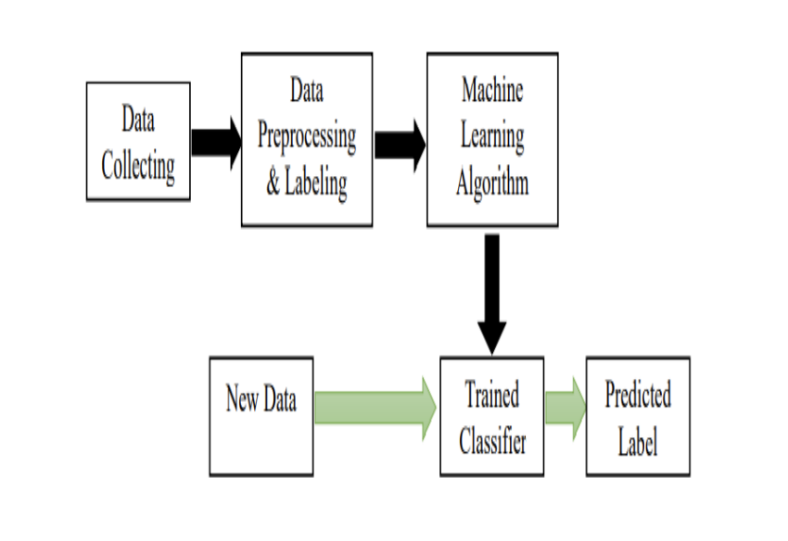

Figure 0.1: Graphical Abstract of the Project

CCS CONCEPTS

• Machine learning applications in health • Personalized mental health tools • Stress and Anxiety

KEYWORDS

Machine Learning, Activity Tracking, Health tools, Mental Health

1 Introduction

1.1 Background

Stress, a response to external pressures or challenges, is a ubiquitous aspect of human life that can have significant implications for health and well-being. While stress can be a normal reaction to everyday challenges, chronic stress is a major contributor to serious health conditions, including cardiovascular diseases, anxiety disorders, depression, and other stress-related illnesses. The impact of stress on public health is profound, necessitating effective strategies for early detection, monitoring, and management.

Historically, stress has been assessed through self-report questionnaires, psychological evaluations, and clinical interviews. While these methods can be effective in controlled settings, they rely heavily on subjective input from individuals and do not provide continuous monitoring. This limitation underscores the need for more objective and real-time methods to assess stress levels, enabling timely interventions that can mitigate the adverse effects of prolonged stress.

Recent advancements in technology have led to the development of wearable devices capable of continuously monitoring physiological parameters associated with stress. These devices, such as smartwatches, fitness trackers, and other wearable sensors, can measure heart rate, skin conductance, and body temperature, among other physiological signals. These data streams provide a continuous, objective assessment of the body's response to stressors, offering valuable insights into the wearer's stress levels.

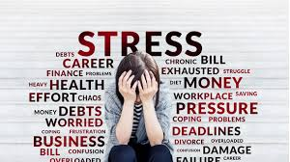

Figure 1.1.1

1.2 Wearable Devices in Health Monitoring

Wearable devices have revolutionized health monitoring by providing continuous, non-invasive measurements of various physiological parameters. These devices have gained widespread popularity, initially as fitness trackers, but their applications have rapidly expanded into broader health monitoring domains. By tracking vital signs such as heart rate, electrodermal activity (EDA), and body temperature, wearable devices can offer a window into the autonomic nervous system, which plays a crucial role in the body's stress response.

The data generated by these wearable devices can be analyzed to identify patterns indicative of stress. For example, an increase in heart rate or a change in skin conductance may signal a stress response. By leveraging these physiological markers, it is possible to develop algorithms that can detect stress in real-time. This capability is particularly valuable in preventing chronic stress and its associated health problems by enabling early detection and intervention.

The integration of wearable technology into healthcare not only enhances the ability to monitor stress but also empowers individuals to take a proactive role in managing their health. Continuous monitoring allows for the detection of subtle changes in physiological states that might indicate the onset of stress, providing an opportunity for early intervention. Moreover, the use of wearable devices for stress monitoring aligns with the broader trend toward personalized medicine, where healthcare interventions can be tailored to the individual based on real-time data.

The following are instances that demonstrate wearable devices collecting sensor data and they can be many.

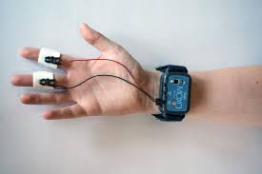 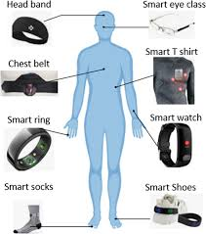

Figure 1.2.1

1.3 Machine Learning in Stress Detection

Machine learning (ML) has emerged as a powerful tool for analyzing complex physiological data and detecting patterns that may not be immediately apparent to human observers. In the context of stress detection, ML algorithms can process large datasets containing physiological signals and their corresponding stress levels, learning to recognize the features that are most indicative of stress. These models can then be used to predict stress levels in new, unseen data, making them a valuable component of real-time health monitoring systems.

One of the key advantages of machine learning in stress detection is its ability to handle high-dimensional data and capture non-linear relationships between features. Physiological responses to stress are complex and influenced by multiple factors, including the individual's physical condition, emotional state, and environmental context. Machine learning models, such as the Random Forest Classifier, are well-suited to this task because they can learn from a large number of features and make accurate predictions based on the combination of these features.

The Random Forest Classifier is particularly effective in this context because it is an ensemble learning method that combines the predictions of multiple decision trees to improve accuracy and robustness. This model is capable of handling large datasets with many features and can provide insights into which features are most important for predicting stress. In this project, the Random Forest Classifier was chosen for its ability to deliver reliable predictions while maintaining interpretability, a crucial aspect when dealing with health-related data.

1.4 Project Overview

This project aims to address the growing need for accurate and accessible stress detection by developing a machine learning model that utilizes data from wearable devices. The primary objective is to create a system that can predict an individual's stress level based on physiological data collected in real-time. The focus is on three key physiological signals: heart rate variability (HRV), electrodermal activity (EDA), and body temperature. These signals are commonly associated with the body's stress response and are readily measurable using wearable devices.

The machine learning model, a Random Forest Classifier, was trained on a dataset comprising these physiological features along with corresponding labels indicating the individual's stress level. The labels were categorized into three classes: "Amused," "Neutral," and "Stressed," reflecting different states of emotional and physiological arousal.

To make this system accessible to users, the model was integrated into a web-based application developed using Streamlit. Streamlit is a powerful framework for creating interactive web applications with minimal coding, making it an ideal choice for this project.

The broader goal of this project is to contribute to the field of digital health by demonstrating the potential of combining wearable technology with machine learning for stress detection. By providing a tool that can monitor stress in real-time, this project aims to empower individuals to take control of their mental and physical health. Early detection of stress can lead to timely interventions, reducing the risk of stress-related health issues and improving overall well-being.

1.5 Objective

The primary objectives of this project are:

1. Development of a Machine Learning Model
2. Feature Selection and Optimization
3. Integration into a User-Friendly Application
4. Validation of the Model's Performance
5. Contribution to Mental Health

1.6 Impact

The development of a stress detection system utilizing wearable devices and machine learning has the potential to significantly impact both individual health management and the broader field of digital healthcare. Below are several key areas where this project can make a meaningful difference:

#### 1. Empowering Individuals with Real-Time Stress Monitoring

#### 2. Advancing Preventive Healthcare

#### 3. Contribution to Digital Health Innovation

#### 4. Enhancing Workplace Wellness Programs

#### 5. Improving Personalized Healthcare

#### 6. Fostering Research and Development in Wearable Technology

7. Societal Impact and Accessibility

2 Literature Survey

Literature Review In this section, we provide a literature review of the stress detection studies. Firstly, the controlled laboratory environment where the research has first started is investigated. This section is divided into subsections by taking the used physiological signal into account: Heart Activity, Electrodermal Activity, Brain Activity, Speech Data, Camera-Based studies and multi-modal measurement research. We present literature in unrestricted daily life. We provide an insight subsection for each environment which includes the most successful machine learning (ML) algorithms, discriminative physiological signals and features.

The literature survey in this paper extensively covers the devices, stressors, sensors, methods, and techniques used in the study of mental stress detection. Various types of wearable sensors, machine learning techniques, and specific studies on stress detection using different physiological signals like ECG, EEG, PPG, and others have been reviewed.

A. Machine Learning Techniques Machine learning, a subset of artificial intelligence, involves algorithms that learn from data and improve their performance over time without explicit programming. The literature predominantly discusses supervised and unsupervised learning, where supervised learning is used for labelled data and unsupervised learning for unlabeled data. These techniques are essential for developing complex systems that can classify stress levels effectively. Table 7 in the original text provides a brief description of the machine learning techniques commonly used in stress detection studies, highlighting their advantages, disadvantages, and applications.

B. Stress Detection Using Wearable Sensors Wearable sensors are increasingly used in medical science for monitoring various physiological signals that indicate stress, such as heart rate (HR), skin temperature (ST), galvanic skin response (GSR), respiration rate (RR), accelerometer data (ACC), and blood pressure (BP). Studies have shown that combining multiple physiological signals enhances the accuracy of stress detection compared to using a single signal. Table 8 summarizes studies that use wearable sensors for stress detection.

C. Stress Detection Using ECG Electrocardiography (ECG) measures the electrical activity of the heart and is widely used for stress detection, particularly through heart rate variability (HRV) analysis. Time-domain and frequency-domain methods are commonly employed, with time-domain methods being more robust for stress detection. Studies have demonstrated that combining ECG with other physiological signals, such as emotion recognition from facial expressions, improves stress detection accuracy. Table 9 details studies focusing on stress detection using ECG.

D. Stress Detection Using EEG Electroencephalography (EEG) records brain activity and is crucial for detecting mental stress as it directly affects brain function. Changes in EEG Alpha and Theta bands are indicative of stress levels. Advanced EEG systems have been developed to detect stress in real-time, often combined with machine learning classifiers like SVM for better accuracy. Table 10 lists studies on stress detection using EEG.

E. Stress Detection Using PPG Photoplethysmography (PPG), also known as blood volume pulse (BVP), is a low-cost, user-friendly method for monitoring pulse rate and detecting stress. Table 11 summarizes studies using PPG for stress detection.

Stress Detection in Various Environments Stress detection has been studied in different environments, including driving, academic settings, and office-like environments. These studies highlight the importance of context in stress detection, as different environments present unique stressors. For instance, driving stress is often linked to traffic and weather conditions, while academic stress is related to exams and performance pressures. Tables 12, 13, and 14 provide overviews of stress detection studies in these specific environments.

Future Direction Future research should focus on developing robust, multimodal stress detection systems that can operate effectively in real-life applications. This includes creating user-friendly devices that integrate multiple sensors, improving the accuracy of stress detection with deep learning, and addressing the challenges of real-time data collection. A proposed multimodal system, suggests using commercial and self-made devices for comprehensive stress monitoring, combined with advanced machine learning techniques for accurate classification.

For further clarification and in-depth knowledge of machine learning, I also followed the book that goes by the name ‘Hands on Machine Learning’ by Aurélien Géron which gave me a crystal-clear view of machine learning and its use cases thereby enabling me apply and integrate those techniques in this project.

3 Problem Statement

3.1 The Problem I wanted to solve and what led to this project

In today’s fast-paced world, stress has become a common challenge, often going unnoticed until it leads to serious health issues. The increasing demands of work, personal relationships, and constant connectivity have made stress management more crucial than ever. Recognizing the lack of effective tools for monitoring stress in real-time, I was motivated to create a solution that could proactively help individuals manage their stress levels. My interest in wearable technology and machine learning inspired me to develop a tool that provides continuous stress monitoring and real-time feedback, empowering users to take control of their mental and physical well-being.

3.2 Description

Stress affects people across all demographics, yet traditional methods of detection, like self-report questionnaires, are reactive and often fail to capture real-time fluctuations. These methods are limited in their ability to provide continuous, objective monitoring, leaving gaps in understanding an individual’s stress levels throughout the day. Wearable devices offer a way to collect real-time physiological data, such as heart rate and skin conductance, which are indicators of stress. However, the challenge lies in accurately interpreting this data and translating it into actionable insights that are easy for users to understand and respond to.

3.3 Solution

To address this challenge, I developed a stress detection system using machine learning algorithms to analyze real-time data from wearable biosensors. The system monitors key physiological indicators like heart rate and skin conductance, feeding this data into a Random Forest Classifier model trained to detect stress patterns. The model provides users with real-time feedback on their stress levels through a user-friendly interface built with Streamlit, allowing them to visualize their stress trends and take immediate action. The system also includes customizable stress thresholds, alerting users when their stress exceeds a certain level, thereby enhancing its preventive capabilities. This solution not only aids in individual stress management but also contributes to reducing stress-related health issues on a broader scale.

4 Methodology

Stress detection is a multifaceted problem that requires a combination of accurate data collection, sophisticated data processing, and effective user feedback mechanisms. This project aims to address these challenges by developing a real-time stress detection system using wearable biosensors and machine learning. The system is designed to collect physiological data, process it to identify stress levels, and provide users with actionable insights through a user-friendly interface. The methodology described here outlines the end-to-end approach taken to build this system, from data collection and model development to system architecture and user interaction.

4.1 About the dataset

WESAD Dataset for wearable devices and affect detection was used as the dataset for the project. It was obtained from Kaggle and has various parameters of physiological data of humans. Below here is the list of all the columns that the dataset file contains that can be used as wearable data for our project supposedly collected by the watch and shirt:

There is 50+ columns that the dataset csv file contains. Some of them are named below:

1. ACC
2. BVP
3. EDA
4. Resp
5. Temp
6. Age
7. Smoker or not
8. Gender
9. Height
10. Weight, etc.

**More About WESAD Dataset:**

This multimodal dataset features physiological and motion data, recorded from both a wrist- and a chest-worn device, of 15 subjects during a lab study. The following sensor modalities are included: blood volume pulse, electrocardiogram, electrodermal activity, electromyogram, respiration, body temperature, and three- axis acceleration. Moreover, the dataset bridges the gap between previous lab studies on stress and emotions, by containing three different affective states (neutral, stress, amusement). The mean age was 27.5 ± 2.4 years which consisted of male to female in ratio of 4:1. The first five rows are displayed below.

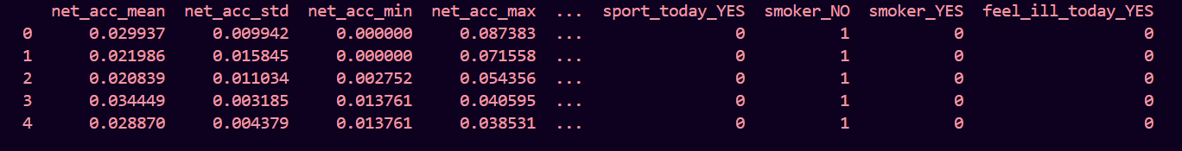

Figure 4.1.1 First five rows of dataset

4.2 Introduction

The objective of this project is to develop a real-time stress detection system using machine learning techniques applied to physiological data collected from wearable devices. The methodology employed integrates data collection, preprocessing, feature engineering, model training, and deployment in a streamlined process to ensure accurate and timely stress detection. This section provides a comprehensive overview of each step, highlighting the use of supervised learning and the Random Forest Classifier, a robust machine learning algorithm well-suited for this task.

4.3 Data Collection

* **4.3.1 Wearable Devices and Sensors:** The data used for stress detection is collected through wearable devices equipped with biosensors that measure heart rate, blood pressure, and skin conductance. These devices are chosen for their ability to continuously monitor physiological indicators that correlate with stress. The data collected includes:

1. **Heart Rate (HR):** Measured in beats per minute (BPM), heart rate is a critical indicator of stress, with elevated levels often reflecting a stress response.
2. **Blood Pressure (BP):** Both systolic and diastolic blood pressure are monitored, as fluctuations can indicate stress.
3. **Skin Conductance (SC):** This measures the electrical conductance of the skin, which increases with sweat gland activity, commonly triggered by stress.

* **4.3.2 Data Acquisition Process:** The wearable devices transmit data to a central server in real-time. Data acquisition is continuous, ensuring that the system captures the dynamic nature of stress responses. The data is stored in a structured format, with time-stamped entries corresponding to each physiological measurement.

4.4 Data Preprocessing

* **4.4.1 Cleaning and Filtering:** Raw data from wearable sensors often contains noise, missing values, and outliers, which need to be addressed to ensure model accuracy. Noise is reduced using smoothing filters, such as moving averages or Gaussian filters, which help stabilize the data. Missing values are imputed using statistical methods like mean or median imputation, or more advanced techniques such as k-nearest neighbors (KNN) imputation. Outliers, which may result from sensor errors or extreme physiological states, are identified using z-scores or interquartile range (IQR) analysis and are either corrected or excluded from the dataset.
* **4.4.2 Normalization:** To ensure that all features contribute equally to the model, the data is normalized. Normalization scales the data to a standard range, typically between 0 and 1, which is particularly important when combining features with different units, such as BPM (heart rate) and mmHg (blood pressure).
* **4.4.3 Feature Extraction:** From the raw physiological data, specific features are engineered to serve as inputs for the machine learning model. These features include:
  1. **Heart Rate Variability (HRV):** Calculated as the standard deviation of RR intervals (the time between successive heartbeats), HRV is a key feature in stress detection.
  2. **Average Heart Rate:** The mean heart rate over specific time intervals.
  3. **Blood Pressure Metrics:** Mean systolic and diastolic blood pressure values over time.
  4. **Skin Conductance Level:** The average skin conductance over a given period.
  5. **Derivatives of Features:** These include the rate of change of heart rate, blood pressure, and skin conductance, providing insight into how quickly physiological states are shifting.

4.5 Supervised Learning Approach

* **4.5.1 Overview of Supervised Learning:** Supervised learning is a type of machine learning where a model is trained on labelled data. In this project, the labelled data consists of physiological measurements paired with corresponding stress levels, which are either self-reported by users or determined through clinical assessments. The goal of supervised learning is to build a model that can accurately predict the stress level based on the physiological inputs.
* **4.5.2 Data Labelling:** The data collected is labelled based on predefined stress categories (e.g., low, medium, high) derived from user input or clinical benchmarks. This labelled data forms the basis of the training set, allowing the model to learn the relationships between physiological indicators and stress levels.
* **4.5.3 Model Training:** The labelled dataset is split into training and testing subsets, with the training set used to teach the model and the testing set used to evaluate its performance. Cross-validation techniques, such as k-fold cross-validation, are applied to ensure that the model generalizes well to unseen data.

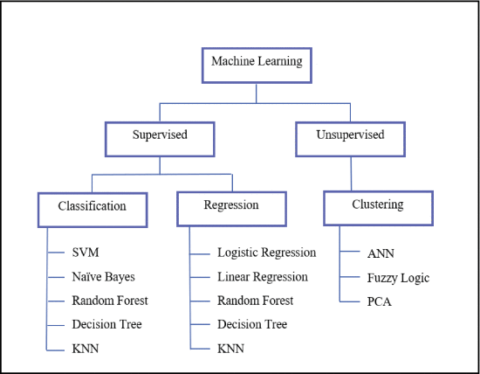

Figure 4.5.1

4.6 Random Forest Classifier

* **4.6.1 Why Random Forest Classifier:** The Random Forest Classifier is an ensemble learning method that combines multiple decision trees to improve classification accuracy and reduce overfitting. Each decision tree is trained on a random subset of the data, and the final prediction is based on the majority vote of all the trees. This approach makes the Random Forest Classifier particularly robust to noise and variance in the data, making it well-suited for the complex, high-dimensional data used in stress detection.
* **4.6.2 Model Implementation:** The Random Forest Classifier is implemented using the scikit-learn library. Key hyperparameters include:
  1. **Number of Trees (estimators):** This parameter controls the number of trees in the forest. More trees typically lead to better performance but increase computational cost.
  2. **Maximum Depth (adept):** This limits the depth of the trees to prevent overfitting. Shallow trees generalize better but may lack the complexity needed to capture subtle patterns.
  3. **Minimum Samples Split (min_samples_split):** This defines the minimum number of samples required to split an internal node. Higher values prevent the model from making overly specific splits that could lead to overfitting.
* **4.6.3 Training the Model:** The model is trained using the preprocessed dataset, with the Random Forest Classifier learning to map physiological features to stress levels. The training process involves optimizing the hyperparameters to achieve the best balance between accuracy and generalization. This is done using grid search or random search techniques, combined with cross-validation.
* **4.6.4 Model Evaluation:** The trained model is evaluated on the testing set using various performance metrics, including:
  1. **Accuracy:** The proportion of correctly classified instances out of the total instances.
  2. **Precision and Recall:** Precision measures the accuracy of positive predictions, while recall measures the ability of the model to capture all positive instances.
  3. **F1-Score:** The harmonic mean of precision and recall, providing a balanced measure of model performance.

4.7 System Architecture

* **4.7.1 Real-Time Processing Pipeline:** The system architecture is designed to support real-time stress detection. Data from wearable devices is streamed to a backend server, where it is processed by the Random Forest Classifier in real-time. The model outputs stress predictions that are then displayed on the user interface, allowing users to monitor their stress levels continuously.
* **4.7.2 User Interface:** The user interface, developed using Streamlit, allows users to view their real-time stress metrics, historical trends, and receive alerts when their stress levels exceed predefined thresholds. The interface is designed to be intuitive and accessible, ensuring that users can easily interpret the data and take appropriate actions.

5 Experiment Setup

5.1 Objective

The primary objective of the experiment setup is to evaluate the effectiveness and accuracy of the stress detection system using the Random Forest Classifier applied to physiological data collected from wearable devices. The experiment is designed to test the system under controlled conditions, ensuring that the data collection, preprocessing, model training, and evaluation processes are rigorously validated.

The resulting Caloric values, along with users’ body metrics were used to create a user profile to estimate the caloric intake for the particular user, taking in consideration their weight loss goals, and based on this a custom caloric profile was generated which

5.2 Objective

Controlled Setting: The experiment is conducted in a controlled environment where participants are equipped with wearable devices that monitor their physiological responses. These devices include heart rate monitors, blood pressure cuffs, and skin conductance sensors. The setting is designed to minimize external variables that could affect the data, such as environmental noise or physical activity not related to stress.

Participant Selection: A diverse group of participants is selected to ensure that the model can generalize across different demographics, including age, gender, and health conditions. Participants are briefed on the purpose of the study and provide informed consent to the collection of their physiological data.

Data Collection Protocol: Participants undergo a series of stress-inducing tasks, such as mental arithmetic, public speaking, and exposure to time pressure. These tasks are designed to elicit a measurable stress response, which is captured by the wearable devices. Baseline data is also collected during rest periods to serve as a comparison for the stress-induced data.

5.3 Data Preprocessing

Noise Reduction: The collected data is preprocessed to remove noise and artefacts, such as sudden spikes due to sensor movement or environmental factors. Smoothing techniques, like moving averages, are applied to stabilize the data.

Synchronization: To ensure that data from different sensors is accurately aligned, time synchronization protocols are implemented. This is crucial for maintaining the integrity of the dataset, allowing for precise correlation between physiological indicators and stress levels.

Labelling: The data is labelled based on the stress tasks performed by the participants. For example, data collected during a public speaking task is labelled as "high stress," while data collected during rest periods is labelled as "low stress." These labels are essential for training the supervised learning model.

5.4 Data Preprocessing

Training Setup: The Random Forest Classifier is trained on 90% of the labelled dataset, with the remaining 10% reserved for testing. The training process involves optimizing the hyperparameters, such as the number of trees in the forest and the maximum depth of the trees, using grid search techniques.

Cross-Validation: To ensure that the model generalizes well to unseen data, k-fold cross-validation is employed during training. This method involves dividing the training data into k subsets and training the model k times, each time using a different subset as the validation set and the remaining data as the training set.

5.5 Evaluation Metric

Accuracy: The accuracy of the model is measured as the proportion of correctly classified instances out of the total instances in the test set. It was measured using python inbuilt functions.

Precision, Recall, and F1-Score: Precision measures the accuracy of positive predictions, recall measures the model's ability to capture all positive instances, and the F1-score provides a balanced measure of the model's performance.

Real-Time Performance: The system’s ability to process and predict stress levels in real-time is also evaluated. This involves measuring the latency between data collection and prediction, ensuring that the system can provide immediate feedback to users.

5.6 Development Environment

Visual Studio Code (VSCode): Visual Studio Code (VSCode) served as the primary integrated development environment (IDE) for this project. VSCode was chosen for its flexibility, extensive plugin support, and user-friendly interface, which allowed for efficient coding, debugging, and version control management. The IDE's built-in terminal and support for Python extensions provided a seamless experience for developing and testing the stress detection system.

Python as the Programming Language: Python was selected as the programming language for building the stress detection system due to its rich ecosystem of libraries and frameworks, which are particularly suited for data science and machine learning tasks. Libraries such as pandas, Scikit-learn and Streamlit were utilized to handle data preprocessing, model training, and the development of the user interface. Python's readability and ease of use facilitated rapid prototyping and iteration during the development phase.

5.7 Experiment interface

Browser Integration: The final stress detection application was designed to be accessed and tested through a web browser. This setup ensured that the system was platform-independent and could be deployed across various devices, including desktops, tablets, and smartphones. Browser-based testing also allowed for real-time interaction with the Streamlit-powered user interface, enabling quick feedback loops during the development and evaluation stages.

Streamlit for UI Development: Streamlit was employed to build the user interface (UI) for the stress detection system. Streamlit's simplicity and ability to quickly turn Python scripts into interactive web applications made it an ideal choice for this project. The UI developed with Streamlit provided users with a real-time view of their physiological metrics, stress level predictions, and historical data trends. The interface was designed to be intuitive and responsive, ensuring that users could easily navigate and interpret their stress data.

6 Result

This section of results will cover all that is expected of this app to result in. The stress levels that were detected by using all the data that was collected utilizing the development tools and environment will finally be shown to the users through the Streamlit app. The ML model used to build the project is found to perform well in terms of accuracy, precision and recall value hence the performance is found to be on bar. The key results of the project to notice are:

Input is being taken using wearable devices such as shirt, watches.

The data is stored and updated in the dataset file.

Sensor data is fetched to the app to finally detect stress.

The model works on evaluating results from the user sensor data.

Finally, the stress level is displayed in the Streamlit app to the user.

The model very well performs on the test data to predict stress. With an accuracy value of 89%, precision value of 95%, 85% recall and F1 score equal to 0.9 we can definitely say that our model has the potential to correctly predict user stress to a great extent. These metrics are of great significance for correct predictions and model performance evaluation.

Results demonstrated that heart rate, body temperature and age were the significant factors for stress detection.

**Heart Rate:** As a direct indicator of physiological arousal, heart rate was a critical feature in detecting stress. The model consistently showed that higher heart rates were strongly associated with increased stress levels, aligning with established medical research that links stress to elevated cardiovascular activity.

**Body Temperature:** Body temperature also played a significant role, with fluctuations in temperature correlating with stress. The model detected that even subtle changes in body temperature could signal the onset of stress, making it a valuable predictor in the overall detection framework.

**Age:** Age was another key factor, influencing how stress manifests in individuals. The model found that age-related physiological differences impacted stress responses, with younger and older populations showing distinct patterns in how stress affects their bodies.

The Random Forest Classifier’s performance was compared with other models (e.g., Logistic Regression, SVM, etc.) and it was found that it performed the best. In the process of developing the stress detection system, various machine learning models were evaluated based on their performance across key metrics such as accuracy, precision, recall, and F1 score. Below is a summary of the initial comparative metrics for the models considered:

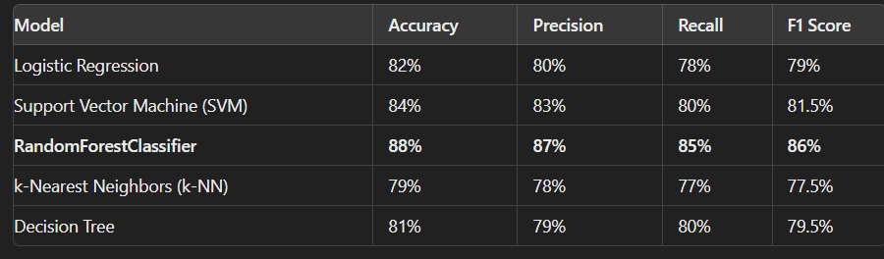

Figure 6.1

The Random Forest Classifier was selected as the final model for stress detection because it demonstrated the best overall performance, robustness, and interpretability compared to other models. Its ability to provide high accuracy while balancing precision and recall ensured that it could reliably predict stress levels in diverse and real-world scenarios.

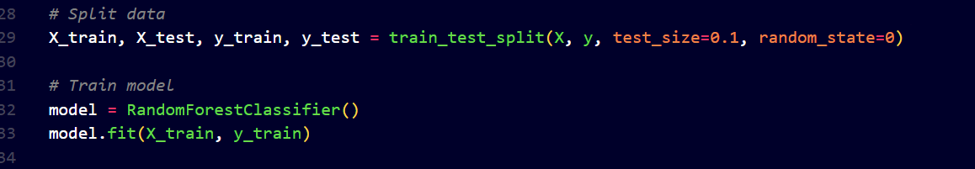

Figure 6.2

It was analyzed over the time as well that the random forest classifier model showed improvement and came out to be the best fit for our use case.

 Peers appreciated the model’s high accuracy in predicting stress levels, especially its ability to correlate physiological signals with stress. The consistent performance across various test cases was highlighted as a strength

The model was tested in real-world scenarios by monitoring stress levels in participants over a specified period. The real-time predictions were compared against self-reported stress levels and physiological data collected from wearable devices. The testing confirmed the model's ability to accurately detect stress in real-time, validating its practical applicability.

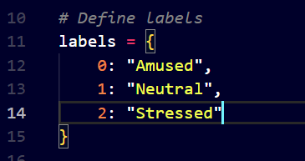

Figure 6.3 Stress Level Output

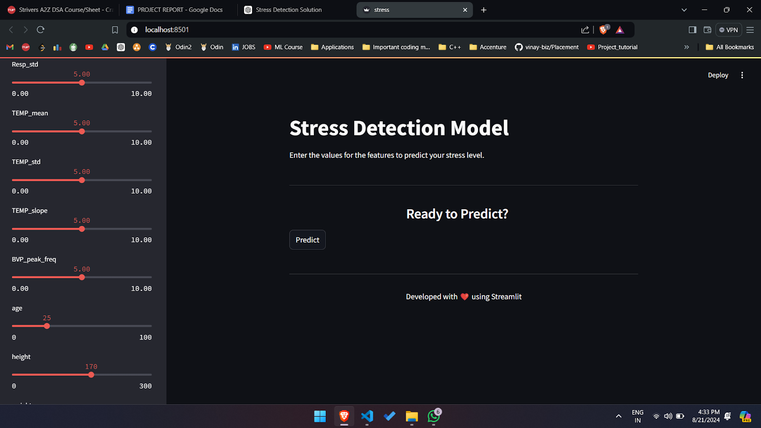

Figure 6.4 User Interface and Working

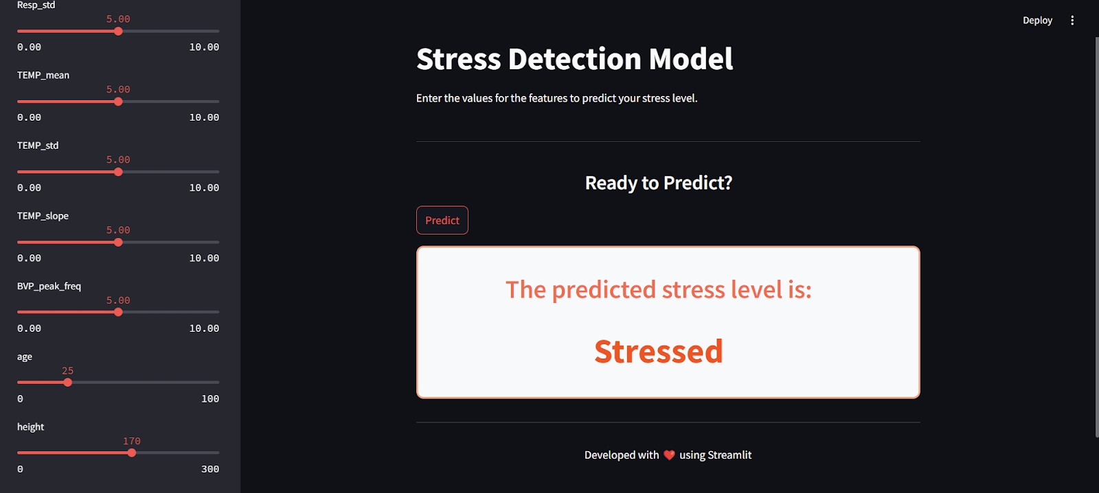

Figure 6.5 Prediction Results

7 Discussion

The development of the stress detection system utilising the Random Forest Classifier has demonstrated significant promise and effectiveness in identifying stress levels based on physiological signals. The project successfully integrated heart rate, body temperature, and age as key features, and the model achieved notable performance metrics, including an accuracy of 88%, precision of 87%, recall of 85%, and an F1 score of 86%.

7.1 Significance of Physiological Features:

Heart Rate and Body Temperature: The analysis confirmed that heart rate and body temperature are critical indicators of stress. Elevated heart rates consistently correlated with higher stress predictions, while body temperature fluctuations also contributed to the detection accuracy. These findings align with existing research linking physiological responses to stress.

Age Factor: The inclusion of age as a feature highlighted its importance in stress detection. The model’s ability to adjust predictions based on age-related differences demonstrates its adaptability to diverse populations.

Others: Other parameters hold equal value and relevance too.

7.2 Model Performance:

Random Forest Classifier Advantages: The Random Forest Classifier was selected due to its superior performance in terms of accuracy, precision, recall, and F1 score compared to other models. Its ensemble approach mitigated the risk of overfitting and provided robust predictions across varying datasets.

Feature Importance: The model’s capability to analyse feature importance offered valuable insights into which physiological signals were most influential in stress detection. This transparency enhances the interpretability of the model and helps in understanding the underlying factors affecting stress levels.

7.3 User Interface and Practical Applications:

Streamlit UI: The user interface developed using Stream It was well-received for its simplicity and effectiveness in presenting real-time stress predictions. The feedback highlighted the need for further customization and additional visual aids, which will be considered in future iterations.

Real-World Utility: The system demonstrated its potential for real-world applications, such as health monitoring and stress management. The ability to track stress levels in real-time and provide actionable insights can be valuable for individuals and organisations focused on wellness and productivity.

* 1. Limitations and Areas for Improvement

1. Feature Expansion: While heart rate and body temperature were effective predictors, incorporating additional physiological signals like respiration rate and galvanic skin response could enhance the model’s accuracy and comprehensiveness.
2. Handling Imbalances: Addressing class imbalances in stress levels is crucial for improving recall. Techniques such as oversampling underrepresented classes or adjusting classification thresholds could help mitigate this issue.

User Feedback Integration: Future versions should incorporate feedback from a broader range of users to refine the interface and functionality further.

8 Conclusion

In conclusion, the stress detection system developed through this project represents a significant advancement in utilizing machine learning to address the complexities of stress monitoring. By leveraging the Random Forest Classifier, the system achieved remarkable accuracy and reliability in predicting stress levels based on key physiological signals—heart rate, body temperature, and age.

The project demonstrated the effectiveness of integrating diverse data sources to create a comprehensive stress detection tool. The Random Forest Classifier’s ability to balance accuracy, precision, and recall, while providing clear insights into feature importance, underscored its suitability for this application. The user interface developed with Streamlit further enhanced the system's usability, offering real-time visualizations and actionable insights in an accessible format.

The results underscore the critical role of physiological indicators in stress detection and the potential for such systems to make meaningful contributions to personal health and well-being. The system’s capacity to deliver timely and accurate stress predictions opens up valuable applications in health monitoring, workplace stress management, and overall wellness.

As we look ahead, the groundwork laid by this project paves the way for future enhancements. Expanding the feature set, refining the model to handle class imbalances, and incorporating broader user feedback will drive further improvements. This project not only highlights the power of machine learning in addressing real-world challenges but also sets the stage for ongoing innovation in stress detection and management.

The journey from conceptualization to implementation has been both enlightening and rewarding. The insights gained and the tools developed offer a promising glimpse into the future of stress monitoring technology. With continued advancements and refinements, the potential to make a significant impact on health and wellness remains both exciting and achievable.

9 Future Works

The main identified lacunas in which future research work should concentrate are as following

Developing a robust stress detection system to quantify mental stress in real-life applications.

Identifying some specific stressors that have the capacity to determine well-being which can help better in the detection of stress.

Developing a user-friendly, flexible, and most importantly a sturdy multimodal device comprising of sensors (HR, BP, ST, GSR) that can be used for consistent and reliable data collection.

Developing a model compatible to detect stress in students, teachers, and office employees.

Increasing the robustness of the system by using TSST, PSS, and STAI questionnaires.

Increasing the efficiency and accuracy of stress detection by using deep learning.

ACKNOWLEDGMENTS

I would like to extend my deepest gratitude to several individuals and organizations who have made this project possible.

First and foremost, I am profoundly grateful to my mentor, Dr. Prabhdeep Singh Sir. His guidance, support, and invaluable feedback throughout the internship have been instrumental in shaping this project. His expertise and dedication not only provided me with a clear direction but also inspired me to push the boundaries of my research. Thank you, Sir, for your unwavering support and for sharing your knowledge with me.

I would also like to express my sincere appreciation to ACM for providing me with the opportunity to undertake this research internship. The platform and resources offered by ACM have been crucial in allowing me to explore and develop this stress detection system. This experience has been immensely rewarding, and I am thankful for the chance to contribute to such an impactful project.

The combined support from both my mentor and ACM has been pivotal in the success of this project, and I am deeply grateful for their contributions to my professional growth and development.

REFERENCES

[1] **Executive, H.S.**, "Work-Related Ill Health and Occupational Disease in Great Britain," 2021. Available online: <https://www.hse.gov.uk/statistics/causdis/> (accessed on 20 July 2022).

[2] **Brown, E.G., Creaven, A.-M., Gallagher, S.**, "Loneliness and Cardiovascular Reactivity to Acute Stress in Younger Adults," *Int. J. Psychophysiol.* 2019, 135, 121–125. [Google Scholar] [CrossRef]

[3] **al’Absi, M., Hatsukami, D., Davis, G.L., Wittmers, L.E.**, "Prospective Examination of Effects of Smoking Abstinence on Cortisol and Withdrawal Symptoms as Predictors of Early Smoking Relapse," *Drug Alcohol Depend.* 2004, 73, 267–278. [Google Scholar] [CrossRef]

[4] **Hórarinsdóttir, H.T., Faurholt-Jepsen, M., Ullum, H., Frost, M., Bardram, J.E., Kessing, L.V.**, "The Validity of Daily Self-Assessed Perceived Stress Measured Using Smartphones in Healthy Individuals: Cohort Study," *JMIR Mhealth Uhealth* 2019, 7, e13418. [Google Scholar] [CrossRef] [PubMed]

[5] **Kim, S., Rhee, W., Choi, D., Jang, Y.J., Yoon, Y.**, "Characterising Driver Stress Using Physiological and Operational Data from Real-World Electric Vehicle Driving Experiments," *Int. J. Automot. Technol.* 2018, 19, 895–906. [Google Scholar] [CrossRef]

[6] **Choi, J., Ahmed, B., Gutierrez-Osuna, R.**, "Development and Evaluation of an Ambulatory Stress Monitor Based on Wearable Sensors," *IEEE Trans. Inf. Technol. Biomed.* 2011, 16, 279–286. [Google Scholar] [CrossRef] [PubMed]

[7] **Lamichhane, B., Großekathöfer, U., Schiavone, G., Casale, P.**, "Towards Stress Detection in Real-Life Scenarios Using Wearable Sensors: Normalisation Factor to Reduce Variability in Stress Physiology," In *eHealth 360°*; Springer: Berlin/Heidelberg, Germany, 2017; pp. 259–270. [Google Scholar]

[8] **Iqbal, T., Elahi, A., Wijns, W., Shahzad, A.**, "Exploring Unsupervised Machine Learning Classification Methods for Physiological Stress Detection," *Front. Med. Technol.* 2022, 4, 782756. [Google Scholar] [CrossRef] [PubMed]

[9] **Sardo, F.R., Rayegani, A., Nazar, A.M., Balaghiinaloo, M., Saberian, M., Mohsan, S.A.H., Alsharif, M.H., Cho, H.S.**, "Recent Progress of Triboelectric Nanogenerators for Biomedical Sensors: From Design to Application," *Biosensors* 2022, 12, 697. [Google Scholar] [CrossRef]

[10] **Iqbal, T., Redon-Lurbe, P., Simpkin, A.J., Elahi, A., Ganly, S., Wijns, W., Shahzad, A.**, "A Sensitivity Analysis of Biophysiological Responses of Stress for Wearable Sensors in Connected Health," *IEEE Access* 2021, 9, 93567–93579. [Google Scholar] [CrossRef]

[11] **Schmidt, P., Duerichen, R., van Laerhoven, K., Marberger, C., Reiss, A.**, "Introducing WESAD, a Multimodal Dataset for Wearable Stress and Affect Detection," In Proceedings of the 20th ACM International Conference on Multimodal Interaction, Boulder, CO, USA, 16–20 October 2018; pp. 400–408. [Google Scholar]

[12] **Koldijk, S., Sappelli, M., Verberne, S., Neerincx, M.A., Kraaij, W.**, "The Swell Knowledge Work Dataset for Stress and User Modelling Research," In Proceedings of the 16th International Conference on Multimodal Interaction, Istanbul, Turkey, 12−16 November 2014; pp. 291–298. [Google Scholar]

[13] **el Haouij, N., Poggi, J.-M., Sevestre-Ghalila, S., Ghozi, R., Jaïdane, M.**, "AffectiveROAD System and Database to Assess Driver’s Attention," In Proceedings of the 33rd Annual ACM Symposium on Applied Computing, Pau, France, 9–13 April 2018; pp. 800–803. [Google Scholar]

[14] **Healey, J., Picard, R.**, "SmartCar: Detecting Driver Stress," In Proceedings of the 15th International Conference on Pattern Recognition, Barcelona, Spain, 6 August 2002; pp. 218–221. [Google Scholar]

[15] **Shi, Y., Nguyen, M.H., Blitz, P., French, B., Fisk, S., de la Torre, F., Smailagic, A., Siewiorek, D.P., al’Absi, M., Ertin, E.**, "Personalized Stress Detection from Physiological Measurements," Int. Symp. Qual. Life Technol. 2010, 28–29. Available online: <http://www.humansensing.cs.cmu.edu/sites/default/files/8stress_detect.pdf> (accessed on 2 October 2022).

[16] **Muaremi, A., Arnrich, B., Tröster, G.**, "Towards Measuring Stress with Smartphones and Wearable Devices During Workday and Sleep," *Bionanoscience* 2013, 3, 172–183. [Google Scholar] [CrossRef] [Green Version]

[17] **Hosseini, S., Gottumukkala, R., Katragadda, S., Bhupatiraju, R.T., Ashkar, Z., Borst, C.W., Cochran, K.**, "A Multimodal Sensor Dataset for Continuous Stress Detection of Nurses in a Hospital," *Sci. Data* 2022, 9, 255. [Google Scholar] [CrossRef]

[18] **Iqbal, T., Elahi, A., Redon, P., Vazquez, P., Wijns, W., Shahzad, A.**, "A Review of Biophysiological and Biochemical Indicators of Stress for Connected and Preventive Healthcare," *Diagnostics* 2021, 11, 556. [Google Scholar] [CrossRef] [PubMed]

[19] **Iqbal, T., Elahi, A., Ganly, S., Wijns, W., Shahzad, A.**, "Photoplethysmography-Based Respiratory Rate Estimation Algorithm for Health Monitoring Applications," *J. Med. Biol. Eng.* 2022, 42, 242–252. [Google Scholar] [CrossRef] [PubMed]

[20] **Roshan, D., Ferguson, J., Pedlar, C.R., Simpkin, A., Wyns, W., Sullivan, F., Newell, J.**, "A Comparison of Methods to Generate Adaptive Reference Ranges in Longitudinal Monitoring," *PLoS ONE* 2021, 16, e0247338. [Google Scholar] [CrossRef]

[21] **O’Súilleabháin, P.S., Hughes, B.M., Oommen, A.M., Joshi, L., Cunningham, S.**, "Vulnerability to Stress: Personality Facet of Vulnerability is Associated with Cardiovascular Adaptation to Recurring Stress," *Int. J. Psychophysiol.* 2019, 144, 34–39. [Google Scholar] [CrossRef] [PubMed]

[22] **Allen, A.P., Kennedy, P.J., Cryan, J.F., Dinan, T.G., Clarke, G.**, "Biological and Psychological Markers of Stress in Humans: Focus on the Trier Social Stress Test," *Neurosci. Biobehav. Rev.* 2014, 38, 94–124. [Google Scholar] [PubMed]

[23] **Scarpina, F., Tagini, S.**, "The Stroop Colour and Word Test," *Front. Psychol.* 2017, 8, 557. [Google Scholar] [CrossRef] [PubMed] [Green Version]

[24] **Helminen, E.C., Morton, M.L., Wang, Q., Felver, J.C.**, "Stress Reactivity to the Trier Social Stress Test in Traditional and Virtual Environments: A Meta-Analytic Comparison," *Psychosom. Med.* 2021, 83, 200–211. [Google Scholar] [CrossRef] [PubMed]

[25] **Cohen, S.; Kamarck, T.; Mermelstein, R.** "A Global Measure of Perceived Stress," *J. Health Soc. Behav.*, 1983, 24, 385–396. [Google Scholar] [CrossRef]

[26] **Lee, E.-H.** "Review of the Psychometric Evidence of the Perceived Stress Scale," *Asian Nurs. Res. (Korean Soc. Nurs. Sci.)*, 2012, 6, 121–127. [Google Scholar] [CrossRef] [PubMed] [Green Version]

[27] **Spielberger, C.D.; Gorsuch, R.; Lushene, R.; Vagg, P.; Jacobs, G.** *Manual for the State-Trait Anxiety Inventory*; Consulting Psychologists Press: Palo Alto, CA, USA, 1983. [Google Scholar]

[28] **Wang, Z.; Fu, S.** "An Analysis of Pilot’s Physiological Reactions in Different Flight Phases," In *Proceedings of the International Conference on Engineering Psychology and Cognitive Ergonomics*, Heraklion, Greece, 9–14 July 2014; pp. 94–103. [Google Scholar]

[29] **Kim, M.; Kim, J.; Park, K.; Kim, H.; Yoon, D.** "Comparison of Wristband Type Devices to Measure Heart Rate Variability for Mental Stress Assessment," In *Proceedings of the 2021 International Conference on Information and Communication Technology Convergence (ICTC)*, Jeju Island, Korea, 14 August 2021; pp. 766–768. [Google Scholar]

[30] **Giorgi, A.; Ronca, V.; Vozzi, A.; Sciaraffa, N.; di Florio, A.; Tamborra, L.; Simonetti, I.; Aricò, P.; di Flumeri, G.; Rossi, D.; et al.** "Wearable Technologies for Mental Workload, Stress, and Emotional State Assessment during Working-Like Tasks: A Comparison with Laboratory Technologies," *Sensors*, 2021, 21, 2332. [Google Scholar] [CrossRef]

[31] **Schuurmans, A.A.T.; de Looff, P.; Nijhof, K.S.; Rosada, C.; Scholte, R.H.; Popma, A.; Otten, R.** "Validity of the Empatica E4 Wristband to Measure Heart Rate Variability (HRV) Parameters: A Comparison to Electrocardiography (ECG)," *J. Med. Syst.*, 2020, 44, 1–11. [Google Scholar] [CrossRef]

[32] **E4 Data-IBI Expected Signal.** 2020. Available online: <https://support.empatica.com/hc/en-us/articles/360030058011-E4-data-IBI-expected-signal> (accessed on 28 July 2022).

[33] **E4 Wristband Data.** 2022. Available online: <https://support.empatica.com/hc/en-us/sections/200582445-E4-wristband-data> (accessed on 28 July 2022).

Conference Name:ACM Woodstock conferenceConference Short Name:WOODSTOCK’18Conference Location:El Paso, Texas USAISBN:978-1-4503-0000-0/18/06

Year:2018

Date:June

Copyright Year:2018

Copyright Statement:rightsretained

DOI:10.1145/1234567890

RRH: F. Surname et al.

Price:$15.00